Microprocessor Lab 3 report

Group 3 0410137 劉家麟 0416324 胡安鳳

Problem1. Postfix expression evaluation

1.Defition and abstraction of the problem

The definition and the problem can be found at

<http://www.geeksforgeeks.org/stack-set-4-evaluation-postfix-expression/>

which is quite different from the normal infix notation

2.Pseudo code and workflow of this problem

get_strlen(expr[i])

for(i <length of the expression) i=string iterator

{

if(is_integer(expr[i]))

{

atoi_getvalue(start_from_i);

}

else if(is_minus_sign)

{

if(is_space(get_next_char()))

{

//then this is the minus operation

postfix_evaluation_minus();

}

else

{

//this is the signed part of the number

stack_push(atoi_getvalue(start_from_i));

//which get a minus integer

}

}

else if(is_plus_sigm)

{

stack_push(postfix_evaluation_plus());

}

else //if this is a space

{

i++ just iterate to the next

}

}

then we’re done

Detailed code can be found at:

<https://pastebin.com/jTQn34h7>

3. Testcases and result

“-100 10 20 + - 10 +”should be -120

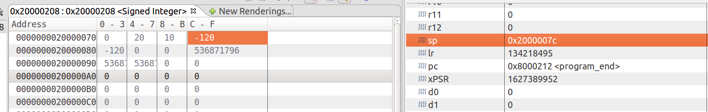

“” should be -6