實驗四 STM32 GPIO System

0410137 劉家麟 0416324 胡安鳳

# 實驗目的

* 了解STM32基本輸出入I/O port使用原理
* 設計簡易LED跑馬燈程式
* 了解按鈕與指撥開關使用原理

# 實驗原理

請參考上課GPIO講義與STM32L4x6 Reference manual。

# 實驗步驟

## Lab4.1: LED pattern displayer

參考講義上的教學完成4個GPIO output初始化，並在麵包板上完成4個為**Active Low**的LED燈電路(當GPIO輸出’1’時燈暗，’0’代表燈亮)。

Please Refer to the tutorial on the lecture slide for finishing the initialization of GPIO output and constructing 4 active low LED circuits. (Turn off the LED when GPIO output “1”, and turn on when GPIO output “0”)

Note: LED需連接至實驗板上的PB3, PB4, PB5, PB6

Note: Please connect the LEDs to PB3, PB4, PB5, PB6 on board.

完成依以下Pattern閃爍的跑馬燈程式。

Please complete the program below and let the LEDs blink as the pattern requirement defined.

### Pattern requirement

1代表LED亮，0代表LED暗

“1” represents that LED is on, and “0” represents LED is off.

初始狀態：最右邊的LED亮

Initial state: The rightest LED is on.

|  |  |  |  |
| --- | --- | --- | --- |
| 0 | 0 | 0 | 1 |

接著**每一秒鐘**LED依序往左位移，此時會有2個LED亮

Then the LED shift left in order every one second. At this time, there should be two LED illuminated.

|  |  |  |  |
| --- | --- | --- | --- |
| 0 | 0 | 1 | 1 |

|  |  |  |  |
| --- | --- | --- | --- |
| 0 | 1 | 1 | 0 |

|  |  |  |  |
| --- | --- | --- | --- |
| 1 | 1 | 0 | 0 |

當LED亮至最左邊時的下一秒改變位移方向，由左至右

Change the shifting direction to right when the LEDs’ state is “1 0 0 0”.

|  |  |  |  |
| --- | --- | --- | --- |
| 1 | 0 | 0 | 0 |

|  |  |  |  |
| --- | --- | --- | --- |
| 1 | 1 | 0 | 0 |

當回至初始狀態後在改變位移方向，並重複以上步驟

Change the shifting direction to left when the LEDs’ state back to the initial state (0 0 0 1). Repeat the process above.

完成以下程式碼，並利用leds這個變數紀錄目前位移數值，與DisplayLED函式輸出leds數值顯示至4個LED上。

Please complete the program below and use the variable “leds” to record the LEDs’ states. Using function “DisplayLED” to output the “leds” value to the LEDs to display.

Note: 需用位移指令LSL或LSR進行數值位移

Note: You may need to use LSL or LSR instructions to shift bits.

|  |
| --- |
| .data  leds: .byte 0    .text  .global main    main:  BL GPIO_init  MOVS R1, #1  LDR R0, =leds  STRB R1, [R0]  Loop:  //TODO: Write the display pattern into leds variable    BL DisplayLED  BL Delay  B Loop    GPIO_init:  //TODO: Initial LED GPIO pins as output  BX LR  DisplayLED :    BX LR    Delay:  //TODO: Write a delay 1sec function  BX LR |

## GPIO_init

Declare the GPIO port B at text section

|  |
| --- |
| **.text**  **.global** main /*Start from manual p75 of GPIO Address data*/  .equ RCC_AHB2ENR , 0x4002104C  .equ GPIOB_MODER , 0x48000400  .equ GPIOB_OTYPER , 0x48000404  .equ GPIOB_OSPEEDR, 0x48000408  .equ GPIOB_PUPDR , 0x4800040C  .equ GPIOB_ODR , 0x48000414  .equ onesec, 800000 |

And use their address to set up the mode in GPIO_init

Reference: <http://www.nimblemachines.com/stm32-gpio/>

For example, we set PB3 to PB6 input mode.

|  |
| --- |
| //enable the port b GPIOB_MODER for output mode, chiech is 01 (GPOM)  ldr r0, =GPIOB_MODER  ldr r1, [r0] //get originally initilized reset value 0xFFFFFEBF  mov r2, 0x00001540 //0001010101(mode6 to mode4)000000  //clear pb6~pb3 to zero  and r1,r1, 0xFFFFC03F //FFFF1100000000111111 from manual p25  orr r1,r1,r2 //get the value of FFFF|11|00000000|111111 or 0000|00|01010101|000000  str r1,[r0] |

1. **DisplayLED**

We initialized LEDS with 0xfff3

|  |
| --- |
| **first_led:**  mov r1, 0xfff3  strh r1, [r2]  bx lr |

Then, run in a loop which divides display leds into switch_left and switch_right.

|  |
| --- |
| **Loop:**  //**TODO**: Write the display pattern into leds variable  **switch_left:**  mov r3, 0x0  b goleft  **switch_right:**  mov r3, 0x0  b goright  B Loop |

In goleft, we do delays and keep left shift LEDs pattern. And do inversely in goright.

|  |
| --- |
| **goleft:**  push {r3}  ldr r3, =onesec  bl Delay  lsl r1, r1, #1  /*cmp r1, 0xffffff38cmp r1, 0b11111111111111111111111100111000 //leftboundary*/  pop {r3}  cmp r3, #3  it eq  moveq r1,0xff3f //special case of shift logic  strh r1,[r2] //store to output value  add r3, r3, #1  cmp r3,#4  beq switch_right  bne goleft |

1. **Demo**

<https://youtu.be/wrXtI7e3BcE>

## Lab4.2 Push button

初始化GPIO PC13為Pull-up input，並設計一程式Polling實驗板上的User button狀態，當button按下再放開可以控制Lab4.1跑馬燈的停止與啟動(按一次停止再按一次啟動…)。

Please initialize GPIO PC13 as pull-up input and design a program to polling the state of the user button on board. Controlling the scrolling of the LEDs by a click on button (click once to stop scrolling and once more to restart scrolling)

Note: 開發板上的User button是連接在PC13上，請自行參考講義或STM32L476 datasheet完成GPIOC初始化。

Note: The user button on board is connected to PC13. Please refer to the lecture slides or STM32L476 datasheet to complete the initialization of GPIOC.

### 開關彈跳

使用軟體方式，解決按鍵彈跳問題。

Please solve the button bounce problem using software debounce.

按鍵開關之機械彈跳現象：

按鍵是機械裝置，按壓後，在穩定之前，內部連結會在幾毫秒間來回彈跳。在消除彈跳的這段時間裡，low和high的訊號都會偵測到，造成誤判。

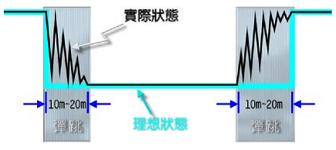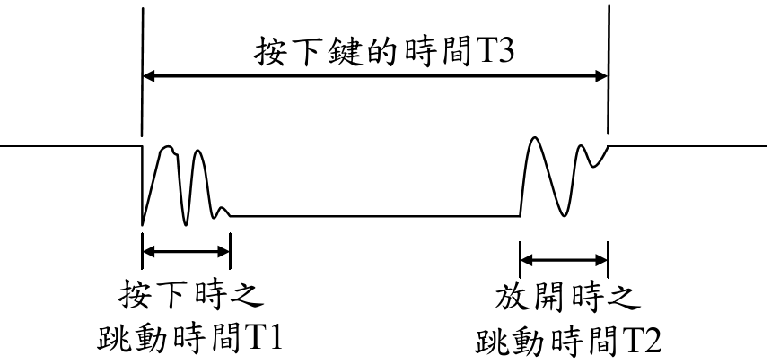

1. **Initialize PC13**

Declaration

|  |
| --- |
| .equ GPIOC_MODER , 0x48000800  .equ GPIOC_OTYPER , 0x48000804  .equ GPIOC_OSPEEDR, 0x48000808  .equ GPIOC_PUPDR , 0x4800080c  .equ GPIOC_IDR , 0x48000810 |

Initialization

|  |
| --- |
| //enable the port c GPIOC_MODER for input mode  ldr r0, =GPIOC_MODER  ldr r1, [r0]  //clear pc13 to zero  and r1, r1, 0xf3ffffff  str r1, [r0] |

1. **Debouncing**

Because there’s debouncing problem, we check the button every cycle, and set a threshold for it. If it achieved the threshold, we view it as stable.

|  |
| --- |
| **check_button:** //check every cycle, and accumulate 1  ldr r5, [r4] //fetch the data from button  lsr r5, r5, #13  and r5, r5, 0x1 //filter the signal  cmp r5, #0  it eq  addeq r0, r0 ,#1 //accumulate until the threshold  cmp r5, #1 //not stable, go back to accumulate again  it eq  moveq r0, #1  cmp r0, #1000 //threshold achieved BREAKDOWN!  it eq  eoreq r6, r6, #1 //r6^=1  b check_end |

1. **Demo**

<https://youtu.be/NvKnooI8_20>

## Lab4.3 密碼鎖

利用麵包板連接DIP switch的active low電路並連接P0~P3至實驗板的GPIO Pin (同學可自行決定連接的Pin)

Please use breadboard to construct an active low DIP switch circuit and connect P0~P3 to GPIO pins on board. (You could choose the pins by yourselves)

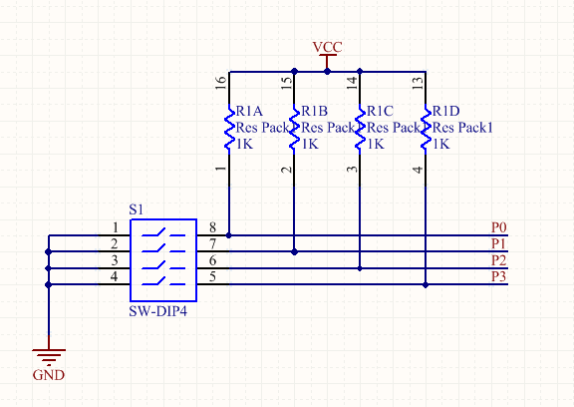

在程式中宣告一個password 1byte全域變數並實做一個簡易的4bit密碼鎖程式，其流程如下:

Please declare a 1 byte global variable “password” and implement a simple 4 bits coded lock. Referring to the process below:

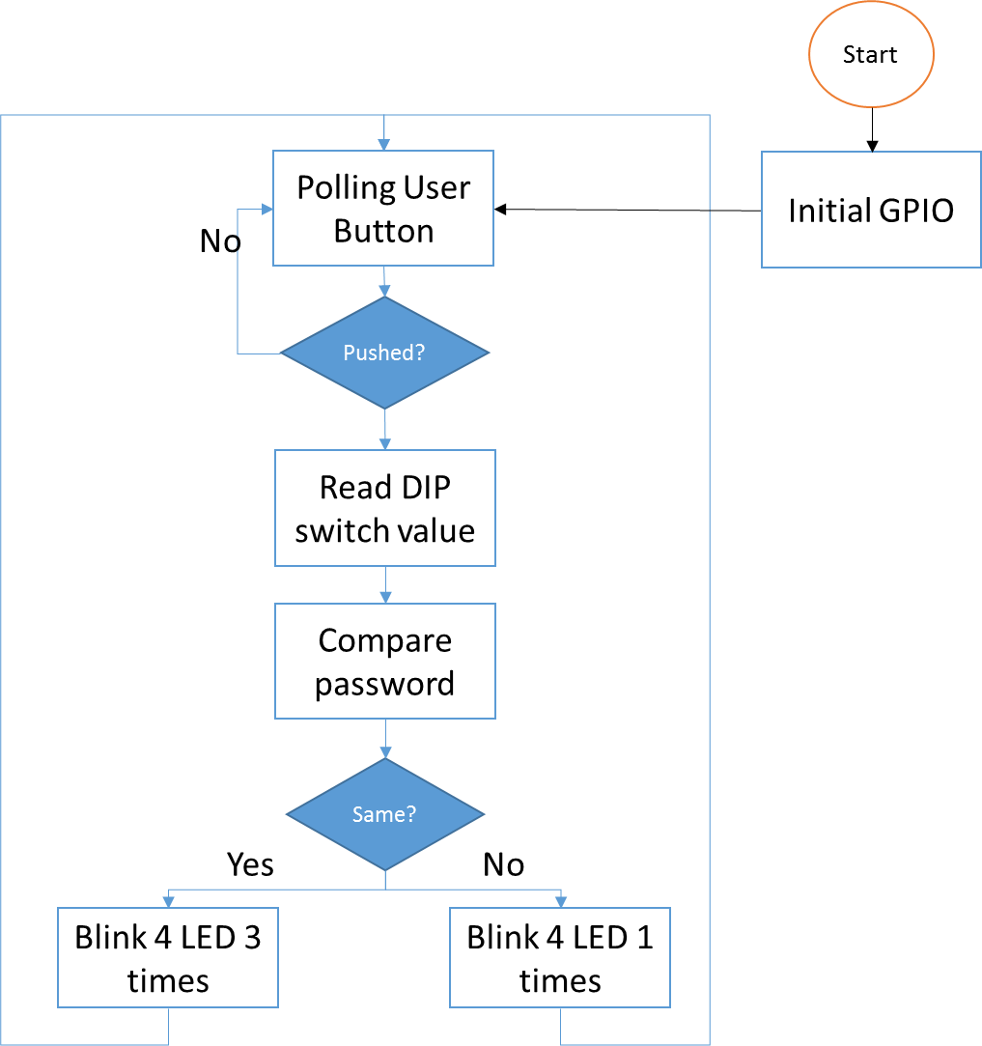

Note: DIP switch ON代表’1’, OFF代表’0’，若使用者輸入“ON ON OFF OFF”則代表”1100”。Blink時間間隔0.5s

Note: Defining DIP switch ON as “1”, OFF as “0”. Thus, when user input “ON ON OFF OFF”, it’s code is “1 1 0 0”. Please set the blink frequency to 0.5s.