實驗五 7-Seg LED

# 實驗目的

* 了解MAX7219使用原理
* 設計7-Seg LED程式

# 實驗原理

請參考上課lab5_note講義。

# 實驗步驟

## Lab5.1: Max7219與7-Seg LED練習—without code B decode mode

將stm32的3.3V接到7-Seg LED板的VCC，GND接到GND，並選擇三個GPIO接腳分別接到DIN、CS和CLK。

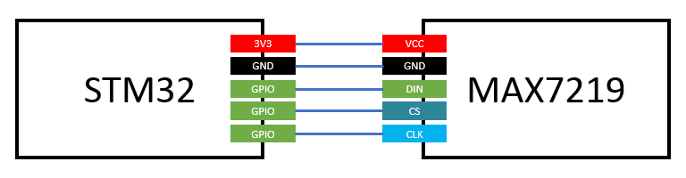

完成以下程式碼，並利用GPIO控制Max7219並在7-Seg LED上顯的第一位依序顯示0, 1, 2, 3, 4, 5, 6, 7, 8, 9, A, b, C, d, E, F (時間間隔1秒)，範例影片如下：

<https://goo.gl/ZDZcdl>

Note:由於decode mode無法顯示AbCdF等字，因此請將decode mode關掉。(參考lab5_note講義的table 6)

Connect 3.3V and GND pin on STM32 to VCC and GND port on MAX7219. Choose three GIPO ports on STM32 for DIN, CS and CLK on MAX7219.

Complete the code giving below and display 0, 1, 2, 3…, 9, A, b, C, d, E, F to the first digit of 7-Seg LED at 1 second interval. Example video link is giving above.

Note: Due to the fact that decode mode is unable to display alphabets, please disable decode mode(ref: lab5_note table 6).

|  |
| --- |
| .syntax unified  .cpu cortex-m4  .thumb  .data  arr: .byte 0x0, 0x0, 0x0, 0x0, 0x0, 0x0, 0x0, 0x0, 0x0, 0x0, 0x0, 0x0, 0x0, 0x0, 0x0, 0x0 //TODO: put 0 to F 7-Seg LED pattern here  .text  .global main  main:  BL GPIO_init  BL max7219_init  loop:  BL Display0toF  B loop  GPIO_init:  //TODO: Initialize three GPIO pins as output for max7219 DIN, CS and CLK  BX LR  Display0toF:  //TODO: Display 0 to F at first digit on 7-SEG LED. Display one per second.  BX LR  MAX7219Send:  //input parameter: r0 is ADDRESS , r1 is DATA  //TODO: Use this function to send a message to max7219  BX LR  max7219_init:  //TODO: Initialize max7219 registers  BX LR  Delay:  //TODO: Write a delay 1sec function  BX LR |

## Lab5.2: Max7219與7-Seg LED練習—use code B decode mode

利用GPIO控制Max7219並在7-Seg LED上顯示自己的學號，例如學號為1234567則顯示下圖：

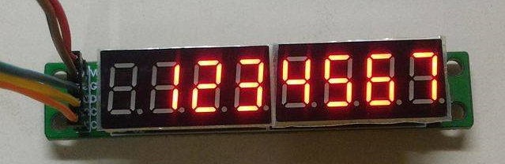

完成以下程式碼，將放在student_id array 裡的學號顯示到7-seg LED上。

Note: 請使用decode mode

Using GPIO output to display your student ID on 7-Seg LED. Picture above is showing the case that your student ID is 1234567.

Complete the code giving below. Put your student ID in **student_id array** and display it to 7-Seg LED.

Note: Please enable decode mode.

|  |
| --- |
| .syntax unified  .cpu cortex-m4  .thumb  .data  student_id: .byte 1, 2, 3,4, 5, 6, 7 //TODO: put your student id here  .text  .global main  main:  BL GPIO_init  BL max7219_init  //TODO: display your student id on 7-Seg LED  Program_end:  B Program_end    GPIO_init:  //TODO: Initialize three GPIO pins as output for max7219 DIN, CS and CLK  BX LR  MAX7219Send:  //input parameter: r0 is ADDRESS , r1 is DATA  //TODO: Use this function to send a message to max7219  BX LR  max7219_init:  //TODO: Initial max7219 registers.  BX LR |

## Lab5.3 Max7219與7-SEG LED練習—顯示Fibonacci數

請設計一組語程式偵測實驗板上的User button，當User button按N次時7-Seg LED上會顯示fib(N)的值。User button長按1秒則將數值歸零。

fib(0) = 0、fib(1) = 1、fib(2) = 1 、…

若fib(N) $≥$ 100000000則顯示-1。

範例影片如下：

<https://goo.gl/6DF6eY>

Note: 請記得處理User button開關彈跳的問題。

Design a program to detect user button on STM32 pressed. When user button is pressed N times, display fib(N) on 7-Seg LED. When user button is held down for 1 second, set displayed number to 0. Example video link is given above.

fib(0) = 0, fib(1) = 1, fib(2) = 1, ……

if fib(N) $≥$ 100000000 then display -1.

Note: Please remember to deal with the bouncing problem.