實驗七 STM32 Clock and Timer

# 實驗目的

* 瞭解STM32的各種clock source使用與修改
* 瞭解STM32的timer使用原理
* 瞭解STM32的PWM使用原理與應用

# 實驗原理

## Timer and Counter

請參考上課009-MCSL-CounterTimer講義。

## Timer PWM output mode

在STM32系統中要利用Timer產生PWM輸出，主要通過capture/compare mode register(TIMx_CCMR1)與TIMx_CCRx registers設定並利用TIMx_CCER啟動之。

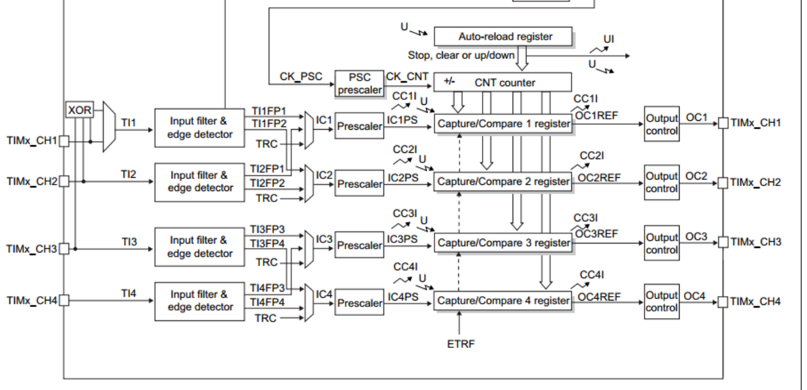

而一般PWM有分mode1與mode2兩種模式，而在計數器上數模式時其對應的輸出為

* PWM mode1: Channel is active as long as TIMx_CNT<TIMx_CCR1 else inactive.
* PWM mode2: Channel is inactive as long as TIMx_CNT<TIMx_CCR1 else active.

另外依不同的特殊用途又可分Combined PWM mode與Asymmetric PWM mode。

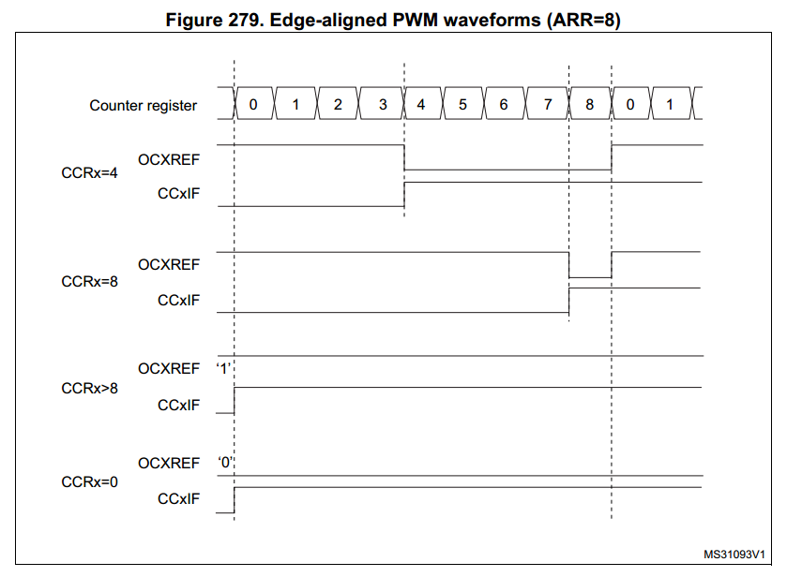

在ARR設定為8時，不同CCR值設定下OCxREF所對應的訊號輸出

以上圖範例來說當CCRx=4,ARR=8可以得到duty cycle(在單位時間內1準位與0準位的比例)為50%的波形，CCRx=8,ARR=8可得duty cycle= 1-1/8=87.5%的波形。

要輸出比較複雜的PWM與不同duty cycle波形也可以利用Asymmetric PWM mode來達成。

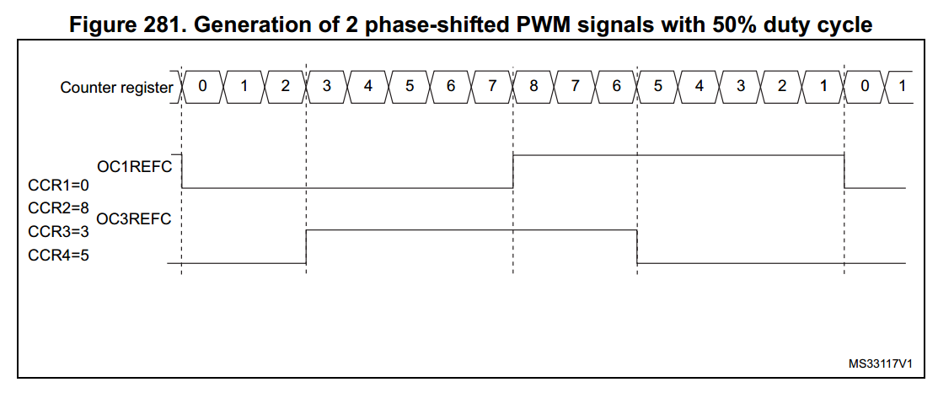

其他PWM設定細節用途請參閱Reference manual chapter 27.3.9 PWM mode

# 實驗步驟

## Modify system initial clock(20%)

* 請利用先前lab所實作的GPIO_init與delay_1s，可呼叫之前的assembly function或是用C重新實作，初始化GPIO與delay。
* 修改SYSCLK的clock source以及相關的prescaler使得CPU frequency(HCLK)為1MHz。
* 觀察修改前後LED燈閃爍的頻率。
* 當使用者按下user button便依以下順序改變CPU system clock(HCLK)， 1MHz -> 6MHz -> 10MHz ->16MHz -> 40MHz ->1MHz ->…

|  |
| --- |
| main.c |
| void GPIO_init();  void 4MHz_delay_1s();  void SystemClock_Config(){  //TODO: Change the SYSCLK source and set the corresponding Prescaler value.  }  int main(){  SystemClock_Config();  GPIO_init();  while(1){  if (user_press_button())  {  //TODO: Update system clock rate  }  GPIOA->BSRR = (1<<5);  4MHz_delay_1s ();  GPIOA->BRR = (1<<5);  4MHz_delay_1s ();  }  } |

Note: 有些CPU頻率設定須由PLLCLK內的倍頻器與除頻器達成，此時須將SYSCLK source改成PLLCLK並依以下流程設定RCC_PLLCFGR register設定。

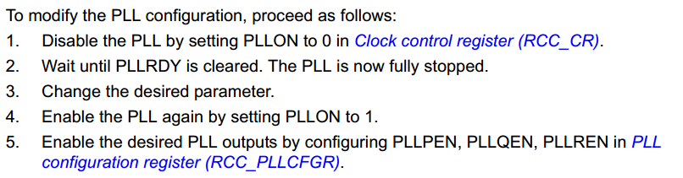

其中PLL clock頻率計算為f(VCO clock) = f(PLL clock input) × (PLLN / PLLM)

最終可輸出給system clock頻率為f(PLL_R) = f(VCO clock) / PLLR

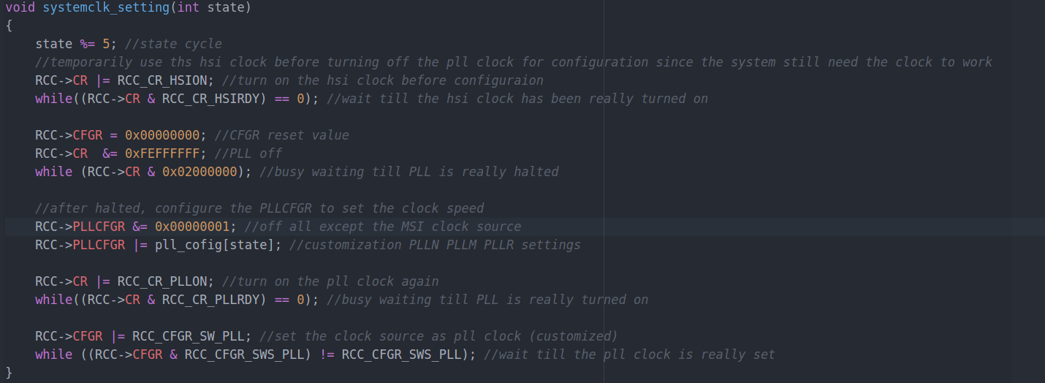

After these things were done, just keep looping , detcting the button input and change the state (state%5) for cycle

use the following table for timer configuration

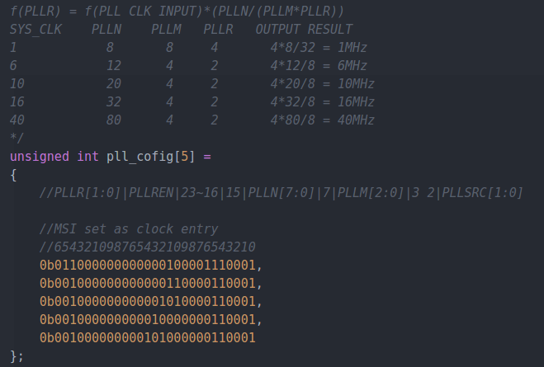

## 計時器(30%)

完成以下的main.c中的Timer_init()與Timer_start(); 並使用STM32 timer實做一個計時器會從0上數(Upcounting) TIME_SEC秒的時間。顯示到小數點以下第二位，結束時7-SEG LED停留在TIME_SEC的數字。(建議使用擁用比較高counter resolution 的TIM2~TIM5 timer)，請使用polling的方式取得 timer CNT register值並換算成時間顯示到7-SEG LED上。

* 1. TIME_SEC 10000.00 (超過範圍請直接顯示0.00)

例如 TIME_SEC 為12.7時的demo影片：<https://goo.gl/F9hh35>

Note: 7-SEG LED驅動請利用之前Lab所實作的GPIO_init()、max7219_init()與Display ()函式呈現(須改成可呈現2個小數位)。

|  |
| --- |
| main.c |
| **#include** "stm32l476xx.h"  **#define** TIME_SEC 12.70  **extern void** GPIO_init();  **extern void** max7219_init();  **extern void** Display();  **void** **Timer_init**( TIM_TypeDef *timer)  {  //**TODO**: Initialize timer  }  **void** **Timer_start**(TIM_TypeDef *timer){  //**TODO**: start timer and show the time on the 7-SEG LED.  }  **int** **main**()  {  GPIO_init();  max7219_init();  Timer_init();  Timer_start();  **while**(1)  {  //**TODO**: Polling the timer count and do lab requirements  }  } |

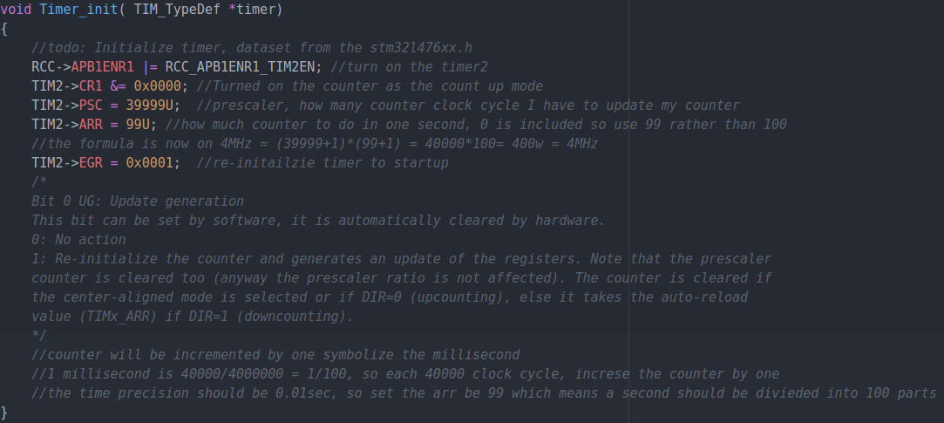CR1 turned on as the count up mode, set the prescalar to 39999 symbolizes that every 40000 cpu cycle we have to count up the counter by one. And ARR be 99 means that as long as counter exceeds 99 , reload the value, so we may divide one second in 100 part, that we can satisfy the time precision.

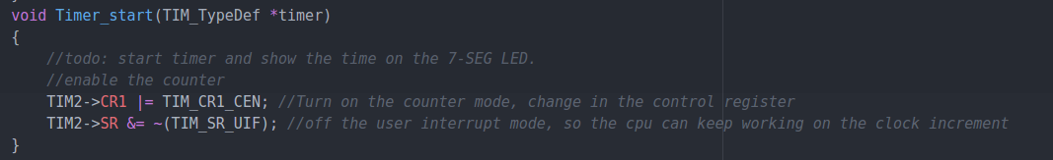Of the interrupt mode for start counting since once the counter overflows, the SR_UIF is triggered.

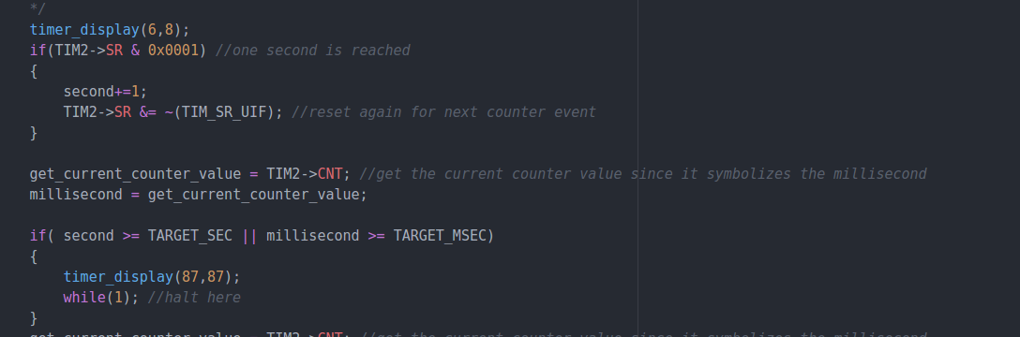If the status register lsb is triggered, symbolizes that the counter has overflowed-→one second has reached, so just upcount the counter by one.

And reset the UIF(TIM2→SR&= ~(TIM_SR_UIF)) to make counter run again.

We may also use the TIM2→CNT to fetch value of current counter.

Once the target time has reached, just halted there and display the target time for correctness.

## Music keypad(35%)

蜂鳴器分為有源(自激式)蜂鳴器和無源(他激式)蜂鳴器。有源蜂鳴器將驅動電路直接設計到蜂鳴器中，因此只需提供直流電壓就可以發出聲音，但其缺點是聲音的頻率無法更改。無源蜂鳴器外部需提供震盪波形才會發出聲音，其聲音的頻率就是輸入波的頻率。我們這次LAB使用的是無源蜂鳴器。

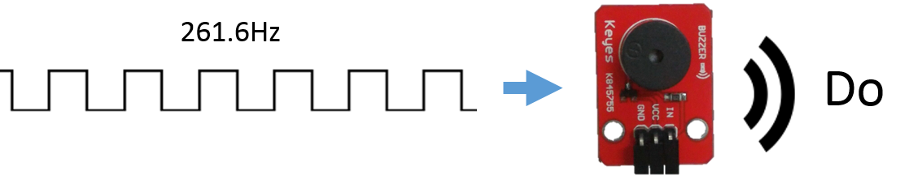



蜂鳴器的VCC接3.3V、GND接GND、IN接GPIO腳位。

請利用timer產生並輸出Duty cycle為**50%的PWM訊號**，並以Lab6中的keypad為鍵盤，當使用者在按下不同keypad按鍵時產生特定頻率(參考下表)的PWM方波給蜂鳴器，沒按鍵或按到沒功能的鍵時請不要發出聲音。本次實驗會需要設定GPIOx_AFRH、GPIOx_AFRL、TIMx_CCER、TIMx_CCMR1、TIMx_CCR1…等registers。

Note: 參考[RM0351 Reference manual](http://www.st.com/resource/en/reference_manual/dm00083560.pdf)瞭解這些register的功能完成此次實驗。並利用[STM32L476xx](http://www.st.com/resource/en/datasheet/stm32l476rg.pdf)找到timer channel所對應的腳位。

|  |  |  |  |  |
| --- | --- | --- | --- | --- |
|  | X0 | X1 | X2 | X3 |
| Y0 | Do | Re | Mi |  |
| Y1 | Fa | So | La |  |
| Y2 | Si | HDo |  |  |
| Y3 |  |  |  |  |

Keypad 對應音名

|  |  |  |  |  |  |  |  |  |
| --- | --- | --- | --- | --- | --- | --- | --- | --- |
| 音名 | Do | Re | Mi | Fa | So | La | Si | HDo |
| 頻率(Hz) | 261.6 | 293.7 | 329.6 | 349.2 | 392.0 | 440.0 | 493.9 | 523.3 |

音名頻率對應表

Note: GPIO Pin設為PWM output時需設定為alternate function(AF) Mode，並根據所對應使用的timer設定AFRH與AFRL register，設定方式細節請參考reference manual與datasheet。

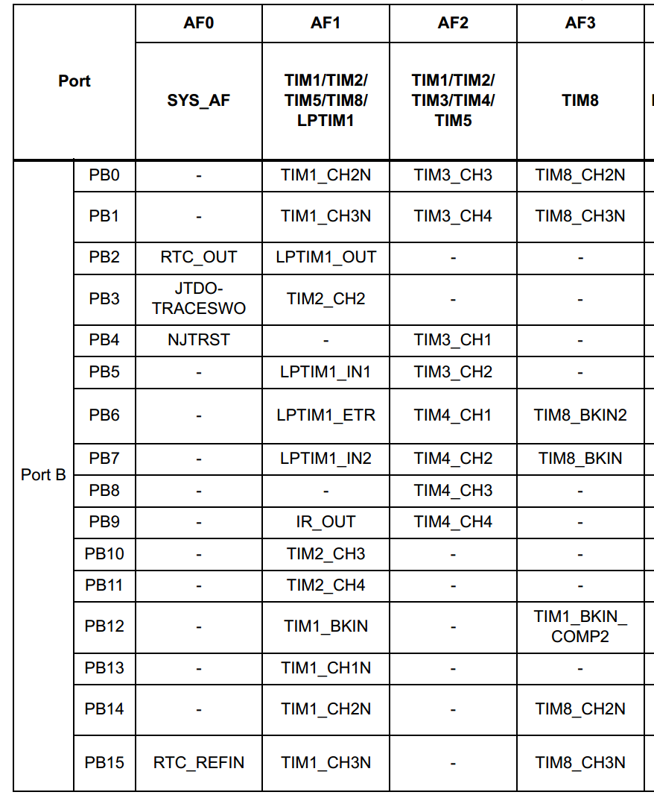

PortB AF mode selection table

範例：<https://goo.gl/4MuIFv>

|  |
| --- |
| extern void GPIO_init();  void GPIO_init_AF(){  //TODO: Initial GPIO pin as alternate function for buzzer. You can choose to use C or assembly to finish this function.  }  void Timer_init(){  //TODO: Initialize timer  }  void PWM_channel_init(){  //TODO: Initialize timer PWM channel  }  int main(){  GPIO_init();  GPIO_init_AF();  Timer_init();  PWM_channel_init();  //TODO: Scan the keypad and use PWM to send the corresponding frequency square wave to buzzer.  } |

第三題主要分為以下幾個部分

1. Keypad_init();  
   這個部分主要跟lab6差不多，但是因為要配合alternate function會用到的timer channel腳位，所以把input GPIO修改為PB 7, 6, 5, 4

|  |
| --- |
| RCC->AHB2ENR |= 0b00000000000000000000000000000110; //open port B and port C  GPIOC->MODER &= 0b11111111111111111111111100000000; //pc 3 2 1 0 as input of keypad  GPIOC->MODER |= 0b00000000000000000000000001010101;  GPIOC->PUPDR &= 0b11111111111111111111111100000000;  GPIOC->PUPDR |= 0b00000000000000000000000001010101;  GPIOC->OSPEEDR &= 0b11111111111111111111111100000000;  GPIOC->OSPEEDR |= 0b00000000000000000000000001010101;  GPIOC->ODR |= 0b00000000000000000000000000001111;  GPIOB->MODER &= 0b11111111111111110000000011111111; //pb 7 6 5 4 as output of keypad  GPIOB->PUPDR &= 0b11111111111111110000000011111111;  GPIOB->PUPDR |= 0b00000000000000001010101000000000; |

1. GPIO_init_AF();  
   這個部分在設定alternate function，去查了表對照之後決定用PB3配合TIM2_CH2，所以去設AF1  
   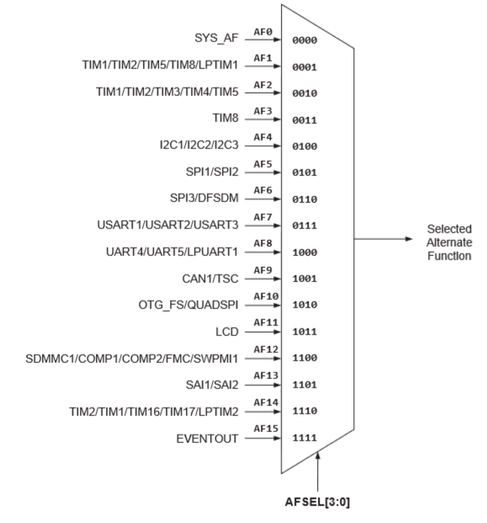

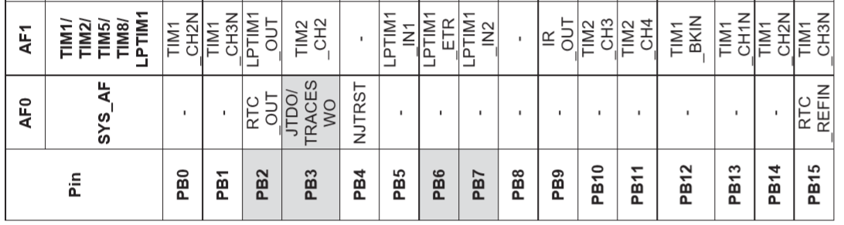

|  |
| --- |
| //PB3 TIM2_CH2  GPIOB->AFR[0] &= ~GPIO_AFRL_AFSEL3;//AFR[0] LOW  GPIOB->AFR[0] |= (0b0001<<GPIO_AFRL_AFSEL3_Pos);//PB3 Alternate function mode |

1. Timer_init();  
   同lab7-2的timer init
2. PWM_channel_init();  
   我們用的是TIM2的CH2，所以PWM的部分就是選compare 2

|  |
| --- |
| //**TODO**: Initialize timer PWM channel  TIM2->CCMR1 &= ~TIM_CCMR1_OC2M;  TIM2->CCMR1 |= (0b0110 << TIM_CCMR1_OC2M_Pos);  TIM2->CCMR1 &= ~TIM_CCMR1_OC2PE;//OCxPE  TIM2->CCMR1 |= (0b1 << TIM_CCMR1_OC2PE_Pos);  TIM2->CCR2 = 50;  TIM2->CCER |= TIM_CCER_CC2E; |

1. Keypad_scan();  
   這部分就是結合lab6 (稍微修改讀input的地方，因為改成PB7,6,5,4)，讀到keypad value後就去找對應的Frequceny再去設定timer的prescaler value，然後start timer，放開時stop timer。

以下為控制timer的部分 (包含音高與duty cycle)

|  |
| --- |
| prev = curr;  curr = key_val;  // ring while keep press same button  **if** (curr == prev)  check = 100;  **else**  check = curr;  **switch** (check)  {  **case** 1:  freq = DO;  set_timer();  TIM2->CR1 |= TIM_CR1_CEN;  **break**;  **case** 2:  freq = RE;  set_timer();  TIM2->CR1 |= TIM_CR1_CEN;  **break**;  **case** 3:  freq = MI;  set_timer();  TIM2->CR1 |= TIM_CR1_CEN;  **break**;  **case** 4:  freq = FA;  set_timer();  TIM2->CR1 |= TIM_CR1_CEN;  **break**;  **case** 5:  freq = SO;  set_timer();  TIM2->CR1 |= TIM_CR1_CEN;  **break**;  **case** 6:  freq = LA;  set_timer();  TIM2->CR1 |= TIM_CR1_CEN;  **break**;  **case** 7:  freq = SI;  set_timer();  TIM2->CR1 |= TIM_CR1_CEN;  **break**;  **case** 8:  freq = HDO;  set_timer();  TIM2->CR1 |= TIM_CR1_CEN;  **break**;  **case** 14: //duty cycle -5  duty_cycle = duty_cycle == 10 ? duty_cycle : duty_cycle - 5;  **break**;  **case** 15: //duty cycle +5  duty_cycle = duty_cycle == 90 ? duty_cycle : duty_cycle + 5;  **break**;  **case** 100: //empty loop  **break**;  **default**: //stop timer  TIM2->CR1 &= ~TIM_CR1_CEN;  freq = -1;  **break**;  } |

### Music音色實驗(15%)

在前一實驗中的keypad增加2個功能按鈕用以調整PWM輸出的Duty cycle(範圍10%~90%，每按一次鍵調整5%)，觀察是否會影響蜂鳴器所發出的聲音大小或音色。

Note: 須注意頻率與duty cycle的關係來設定timer ARR與CCR registers。可用LED測試duty cycle是否有改變，成功應會看到LED隨著duty cycle不同而有明暗變化。

此部分的code，已在上面完成。

可以觀察到調高duty cycle時，音色聽起來比較尖銳偏高。

