Microprocessor Lab 3 report
Group 3 0410137 劉家麟 0416324 胡安鳳

Problem1. Postfix expression evaluation
1.Defition and abstraction of the problem

The definition and the problem can be found at
http://www.geeksforgeeks.org/stack-set-4-evaluation-postfix-expression/
which is quite different from the normal infix notation

2.Pseudo code and workflow of this problem

get_strlen(expr[i])

for(i <length of the expression) i=string iterator
{
if(is_integer(expr[i]))
{
atoi_getvalue(start_from_i);
}
else if(is_minus_sign)
{

if(is_space(get_next_char()))
{
//then this is the minus operation
postfix_evaluation_minus();
}
else
{
//this is the signed part of the number
stack_push(atoi_getvalue(start_from_i));
//which get a minus integer
}
}
else if(is_plus_sigm)
{
stack_push(postfix_evaluation_plus());
}
else //if this is a space
{
i++ just iterate to the next
}
}
then we’re done

Detailed code can be found at:
https://pastebin.com/jTQn34h7

3. Testcases and result
“-100 10 20 + - 10 +”should be -120
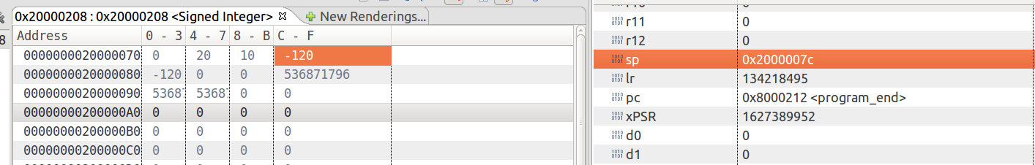
“” should be -6

