Microprocessor Lab 2 Report
0410137 劉家麟 0416324 胡安鳳

Problem1 Hamming distance
1.Problem definition and algorithm abstract

Hamming distance is the different bits between two numbers represented in binary.
e.g. 63=(111111)bin 64=(1000000)bin, then the Hamming distance is
0111111
1000000 distance = 7
It is a traditional bit manipulation problem.
The algorithm is as simple as just XOR(the instruction in ARM is EOR) the two number since once there is a different bit, XOR will make it be 1.

The c code is represented as follow

int bitCount(unsigned int n)
{

int counter = 0;
while(n)
{
counter += n % 2;
n >>= 1;
}
return counter;
}
Once the number has a bit , %2will cause the remainder be 1, by this method we can accumulate it into the counter of counting the bits.
Finally we >>= the number again and again till it reaches 0.

The ARM assembly is represented as follows
hamm:
//TODO
eor R0, R0, R1 //xor for how many bits are 1
add R4, R0, #0 //n=r0

whileloop:
cmp R4, #0 //while(n)
beq return

// counter as r3, the result of n%2 (which is the same as n&1) save at R5
and R5, R4, #1 //R5 for increment value in R3
add R3, R3, R5 // counter+=n%2

lsr R4 ,R4 ,#1 //n>>=1
b whileloop

return:
bx lr

2.Test cases tested
e.g. a=0x1000 =1000000000000
b=0x3f =0000000111111
a xor b =1000000111111 stored in r0
The correct answer should be 7 ,stored in r3
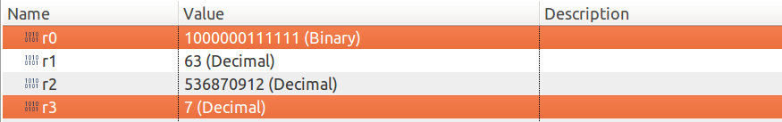

e.g. a=39 = 0100111
b=125 = 1111101
a xor b = 1011010 store in r0
The correct answer should be 4 ,stored in r3
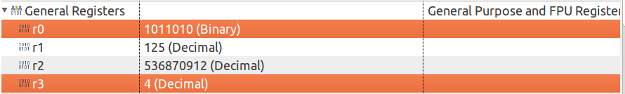

3.About the error of 0x55AA and 0xAA55
Reference link https://alisdair.mcdiarmid.org/arm-immediate-value-encoding/
The 0x55aa and 0xaa55 cannot be encoded by the method of link provided up, namely the ROTATING METHOD of using 12 bits immediate value(in ARM instruction architecture ) to represent larger immediate value.

Here's the bit layout of an ARM data processing instruction:

But ARM doesn't use the 12-bit immediate value as a 12-bit number. Instead, it's an 8-bit number with a4-bit rotation, like this:
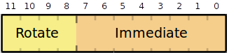
Which, in conclusion, cannot represent the value of 0x55aa and 0xaa55.
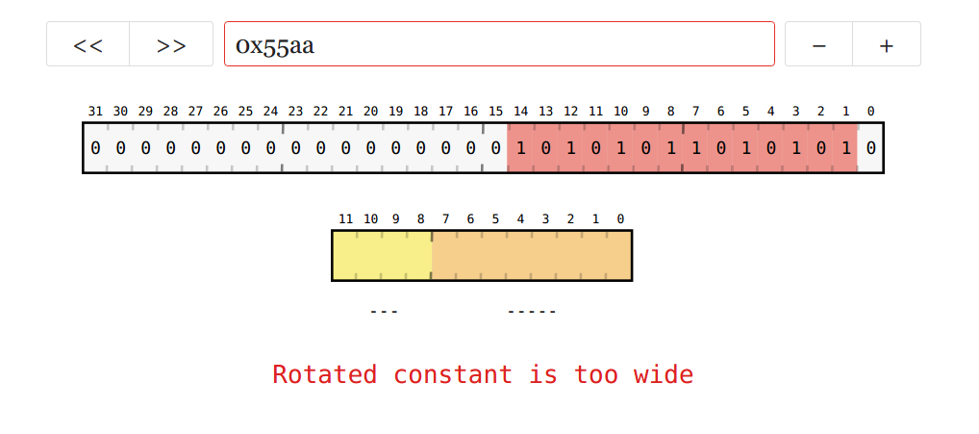
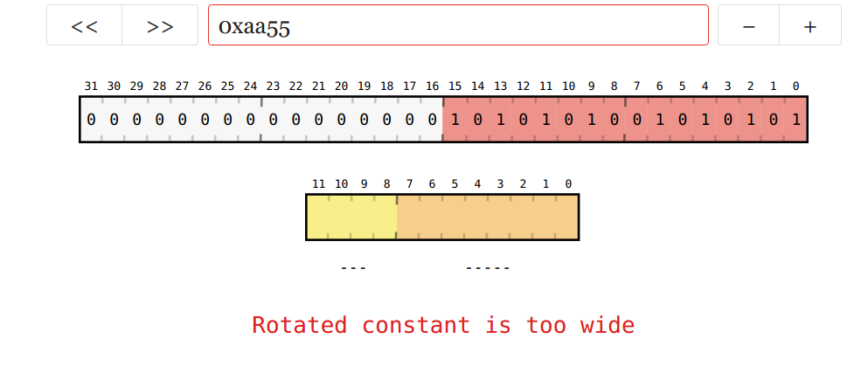

4.Rethink of 3

Q:So how do we represented other values that are not accepted before?

A:Maybe we can use more register to represent then(by decomposition) mov some accepted value to 2 or even more registers to addup (or some linear combinations) to form the unaccepted immediate value aforementioned.

Problem2 Fibonacci Sequence

1.Problem definition and algorithm abstract
The well known mathematical sequence defined as:
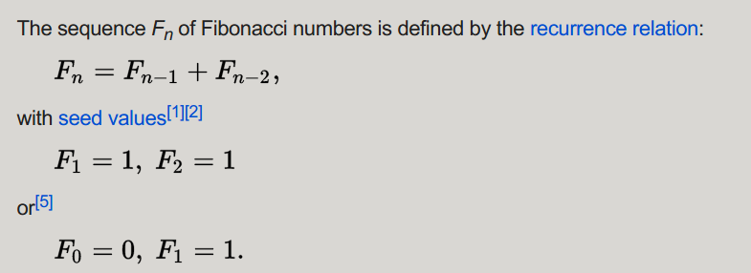

(source wikipedia)

In a nutshell, I write a checker named cmp_greater_than_1: and cmp_less_than100:
to check if the input value is in the range, other wise, minus r4 by 1 (r4 is originally initialized with 0) and return.

If it is really in the range, then go to Fibonacci main function, by using the loop method (the recursion may be too difficult to implement in ARM assembly)

Initialize the first →sec→fib, where fib=first+sec

Then move the 3 continuous numbers forward till reaches end.
By using the cmp, we may get the result of cmp value to branch, acquiring the method of conditional move like if/else or looping condition check in C.

Finally, a BVS instruction , which means BEANCH IF OVERFLOW SET SIGNED
since we use adds, the Z V C N flags in ARM assembly will be updated and this BVS can successfully get flags with en eye to determining whether to branch or not.

The rest of detailed algorithm concepts have been written in the comments of the source code.
fib:
//TODO
//check if N is in the range, let r4= -1 for OUT_OF_RANGE

cmp_greater_than1:
cmp r0, #1
bge cmp_less_than100
//if OUT_OF_RANGE
movs r4, #0
sub r4, r4, #1
b return

cmp_less_than100:
cmp r0, #100
ble fibonacci_main
//if OUT_OF_RANGE
movs r4, #0
sub r4, r4, 1
b return //br for better manipulation??

fibonacci_main:

movs r4, #1 //first prototype for special-testcase judge

cmp r0, #1 //fibonacci f(1)=1 --> 1 1 2 3 5 8 13...
beq return
cmp r0, #2
beq return

movs r1, #1 //first
movs r2, #1 //second
movs r4, #0 //fib(n)

movs r5, #2 //fibonacci counnter start at 2 (modification for overflow detection)

for_loop:
adds r4, r1, r2 //third=fir+sec adds will update the flag!! FOR SURE
movs r1, r2 //fir=sec
movs r2, r4//sec=third

add r5, r5, #1//increment the counter by 1

bvs overflow_return //f(48)will cause overflow in 32bit intege

cmp r5, r0 //compare if it is still in the fib range
blt for_loop//back to loop again

return:
bx lr

overflow_return:
movs r4, #0
subs r4, r4, #2
bx lr
2.Test cases tested
(1) f(46) = 1836311903

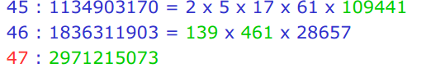

(2) f(47) exceeds the value of 2^31-1 can represents so we set r4 = -2

(3) f(200) is not in the range
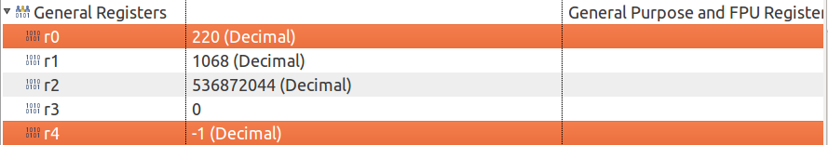
Does not store in r0, directly back to main (r5 will be only stored in Fibonacci main function)

3.Overflow detection

Mentioned above with BVS instruction and its explanation.
Reference

https://community.arm.com/processors/b/blog/posts/condition-codes-1-condition-flags-and-codes

4.Problem encountered and solutions

(1) I first found that the bvs instruction was in vain, nonetheless it turned out to be that add was used instead of adds, only the adds will update the Z C V N flags in arm architecture.
(2) bvs by branching if a register is overflow, once a register exceeds 2^31-1(and in Fibonacci is fibonacci(47)) the overflow flag sould be set and set r4 to be -2.

However, I originally set the group of 3 numbers in the order of fib,fir,sec where sec=fib+fir. Problem is that even though fib is only f(45), sec will be f(47)
The V flag will still be set, causing the r4 value to be -2, which is totally wrong.

So I debug by using the order of fir sec fibo, where fibo=fir+sec, once the fibo reaches the f(47) it triggers the flag and cause the bvs to branch, terminating the Fibonacci function and set r4=-2.

Problem3 Bubble Sort

1.Problem definition and algorithm abstract

Bubble sort, sometimes referred to as sinking sort, is a simple sorting algorithm that repeatedly steps through the list to be sorted, compares each pair of adjacent items and swaps them if they are in the wrong order.

Pseudocode implementation
The algorithm can be expressed as (0-based array):
void bubble_sort(int arr[], int len)
{
int i, j, temp;
for (i = 0; i < len - 1; i++)
for (j = 0; j < len - 1 - i; j++)
if (arr[j] > arr[j + 1])
{
temp = arr[j];
arr[j] = arr[j + 1];
arr[j + 1] = temp;
}
}

The ARM assembly is represented as follow
More detailed code explanations have been written in the comments part.
do_sort:
//TODO arr from 0 to 7

movs r3, #7 //i<len-1-i part
movs r1, #0 //int i=0
for_loop_outer: //i=[0,6]

movs r2, #0 //int j=0
sub r9, r3, r1//len-1-i
for_loop_inner:
add r4, r0, r2 //offset in byte get arr+j address, store in r4
ldrb r5, [r4]//dereference to get value r5 as arr[j]

add r6, r4, #1 //offset in byte get arr+j address ,store in r6
ldrb r7, [r6]

cmp r5,r7
blt swap
swap_is_done:
//j++ then j<len-1-i
add r2, r2, #1
//r9 as len-1-i r9 = r3(7 which is len-1 )- r1 (which is i)
cmp r2,r9
blt for_loop_inner

//i++ then i< len -1
add r1, r1, #1
cmp r1, #7
blt for_loop_outer

b return //job is done

swap: //using r8 as temp value for swapping use STRB for storing in memory
movs r8, r5
movs r5, r7
movs r7, r8

//store the fucking value back in memory
strb r5, [r4]
strb r7, [r6]
b swap_is_done

return:
bx lr
2. Result

Since the data store is 0x_ _ which is a byte, so it fits perfectly into the memory block where a block is 4 bytes, so we can easily see the array are successfully sorted descending.
Address 0x20000000~0x20000007 stores arr1 and 0x20000008~0x2000000F
stores arr2.
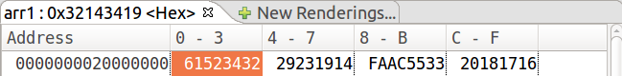
Or sorting in ascending order by bgt
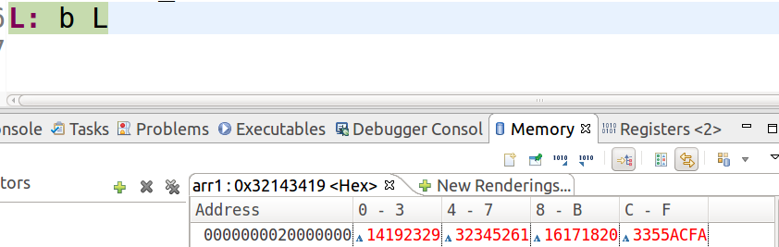

3.Problem encountered and solutions
(1) Originally the program terminated immediately after swap, and it turned out that
I should back to the loop using branch rather than writing nothing, otherwise, the program will keep going to the end.
swap: //using r8 as temp value for swapping use STRB for storing in memory
movs r8, r5
movs r5, r7
movs r7, r8

//store the fucking value back in memory
strb r5, [r4]
strb r7, [r6]
b swap_is_done(without this, program will keep going till return (bx lr to main funtion), through this error, I realize that the ARM assembly is executing in sequence order)
(2) There are i and j , j is in the inner loop, once the inner loop terminated, j should be reset to 0. I once forgot to do this and the memory pointer went so far away to arr2 , causing the result error.
for_loop_outer: //i=[0,6]

movs r2, #0 //int j=0
sub r9, r3, r1//len-1-i
for_loop_outer:
Had it been the C code, it may cause the segmentation fault of ERROR_OUT_OF_RANGE

