# Intro. to Machine Learning Project3

Comparison b/w KDTree , Decision Tree and Naive Bayes Classifier

0416324 An-Fong Hwu

## Build environment (Note, this report is written in md-like format)

* Ubuntu 16.04 LTS 64bit

*

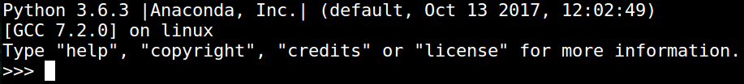

* Packages including sklearn, numpy, scipy

where sklearn is for the training /validation model, numpy and scipy for the numerical and statistical analysis.

* Intel Core i7-5700HQ 2.9GHz 4C8T

* DDR3 -1866 16GB dual channel

## Iris data set

* Probability Distribution Plot of the iris_dataset

*

