Project Initiation Document

BI3ip16 – individual project

Alfie sargent-Robotics

2017

Contents

0. Project Details 1

1. Glossary 1

2. Introduction 2

3. Assumptions 2

4. Product Breakdown structure 3  
5. Sponsorship Details……………………………………………………………………………………………………………….3

6. Gantt chart 4

## Project Details

**Project: Virtual reality fire fighter simulation**

**Authors: Alfie Sargent**

**Date: 02/10/2017**

## Glossary

|  |  |
| --- | --- |
| Term | Description/Explanation |
| VR | Virtual Reality |
| ECG | Electrocardiogram |
|  |  |

## Introduction

A Virtual Reality simulation for the training of fire fighters using either the HTC Vive or Oculus Rift programmed in Unity or Unreal Engine 4. The simulation will consist of 3 levels (subject to change) which will place the user in different scenarios at differing levels of simulated fidelity. They will have a timer and multiple obstacles they will have to complete to finish the simulation. Dependent on the order they overcome the obstacles, the time they do them in and how they overcome them will give them a rating based from a scoring algorithm as well as advice on what to do next time. Furthermore, biometric data will also be gathered as the user proceeds through the simulation. The data gathered from the test itself and the biometric data from each test subject will be analysed and an ideal fidelity level will be ascertained. The biometric data that will be gathered will also be paired with a questionnaire that the user will fill out to determine that the data gathered is valid.

Furthermore, biometric data will also be gathered from the user to determine certain physical properties of the test subject as they proceed throughout the simulation. This data will be analysed and displayed to the user at the end of the simulation, suggesting areas that they can improve in physically.

Lastly, the simulation will be multi-sensory, introducing not just a visual experience for the user but potentially smell and touch stimulations to make the simulation more realistic and engaging. Each level will have an option for the user to choose certain simulation fidelity and the biometric data gathered will be analysed to determine which situation was the most engaging and therefore most valuable in a training simulation. The levels of fidelity will be introduced in different orders to different test subjects to determine which type of sensory inputs produce the best results correlating with the biometric data gathered as well as the performance of the user in the simulation.

The main aim for this project is to determine what sensory inputs produce the best performance from users through the biometric and performance data gathered. The testing of this project will require a large group of “novice” applicants (the control group) and a group of professional firefighters (the test group) so that the data gathered is more valid.

The applications for such a simulation are huge, ranging from new recruitment opportunities for the fire fighting service, ensuring that they are hiring the best possible person for the job. Furthermore, it will also provide an environment in which current fire fighters can practice without possible injury and reducing the cost of their training.

## Assumptions

***Hardware*** *The following assumptions are made:*

* An HTC Vive or and Oculus rift will be provided by Thales for the projects development.
* The VR equipment will have to be powered via AC mains.
* A computer capable of operating the VR equipment will be provided by Thales for the projects development.
* An environment for the simulation will be provided.
* The biometric data analysis equipment will be made available by the university, potentially an ECG (details for this will be provided at a later date)

***Software****The following assumptions are made:*

* The programme for the project will be made using Unity or Unreal engine 4.
* The programme will require a high powered PC to run due to the requirements of the VR equipment.
* The software for the biometric sensors has already been made.

***Client/Administration****The following assumptions are made:*

* *A* budget of £75 is available
* Components will be sourced through COTS approved sources
* Where applicable, in house components will be used
* Clone/copy components are strictly prohibited throughout the project development
* Where possible, components will be sourced from RS components and Farnell element.
* Monthly sessions will be held with both my supervisor and Thales coordinator to determine the projects progress and to offer advice.
* Thales will be provided with a project debrief at the end of the project.
* A standardised testing environment will be used for the development of the system to minimise potential risks.

## Product Breakdown structure

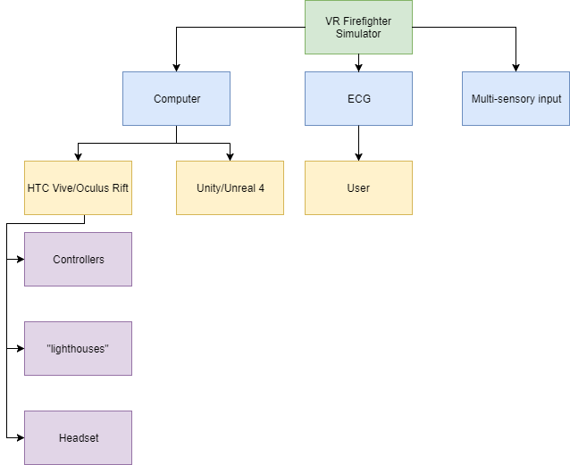

1. Sponsorship Details

This project is being sponsored and assisted by Thales. They will be providing a lot of the equipment that would otherwise be unattainable due to the budget constraints. As a result, Thales requires a small document briefing them of the projects development as well as a demonstration at the end of the project. Furthermore, Thales will also be providing support through monthly sessions and giving advice on how the project should proceed. More details about their involvement will follow as the project progresses.

## Gantt chart

*Document is available.*

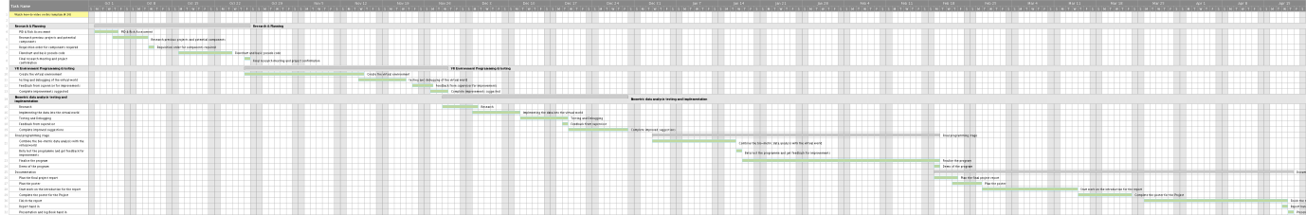

***Signed:*** 