Working on the Concordian’s website has not been an easy task for Supergeil INC to accomplish, there have been multiple processes that have been made in order to stand where the re-launched website is currently

The phases that built the Concordian’s website were worked with discipline and determination, bringing Supergeil INC not only together as a team but as people; on the other hand, the requirements phase was the most important phases of all since it gave the team specific subjects to work on.

The design phase brought a lot of ideas regarding how the website should look like and a prototype was made in respect to what our stakeholders wanted.

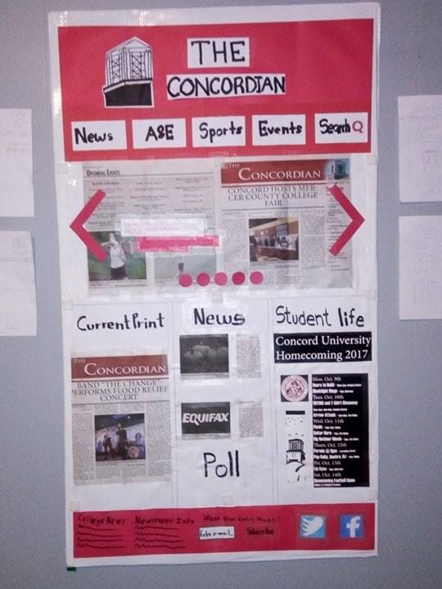 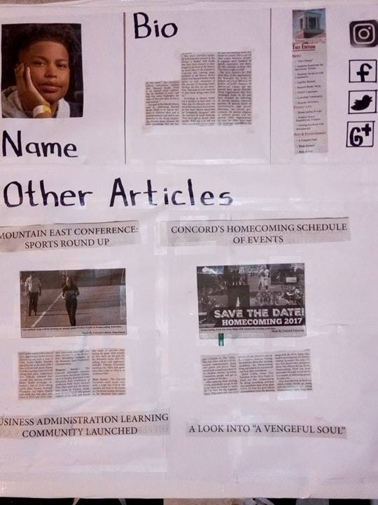 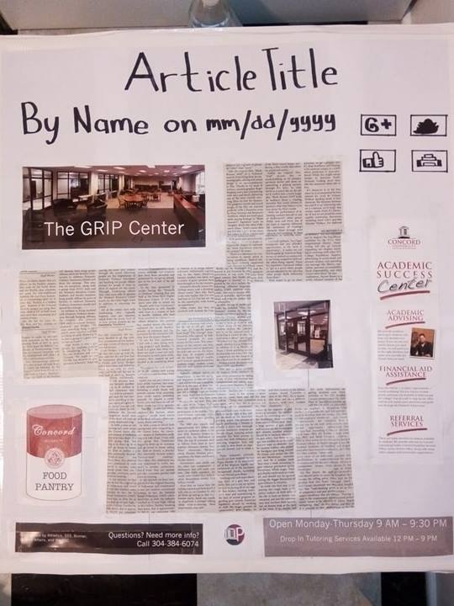

The first iteration was a phase were the team started to interact with wordpress and XAMMP resources.

* + My assigned tasks were to add the Instagram button and start hyperlinking some of the pages together
  + The completed tasks were, adding the Instagram button and start hyperlinking some of the pages together and perfecting some elements of the website so that it looks better
  + No problems to report
  + The estimates for the tasks are around 90 to 120 minutes depending on the task (depends on a meetings length) but the actual time is either more or less than four/fourteen minutes for each task assigned.
  + The future tasks from my point of view would be to write a manual on how to do certain things that might be difficult for future maintenance and developing teams for the following semesters.