**Bitacora_2 28/03/19**

Color.

The topic I was searching on the web, because of the homework the teacher gave us, was color, more specifically the color theory and how those the color affects a design, not only an application but anything we see on the daily basics, and how to properly arrange this color to please or modify the user perspective to your liking. To satisfy my curiosity I turn to one of my favorite sources of knowledge (please keep in mind I don’t use this with researches of projects or studies, just to satisfy my mind or vague questions I have) YouTube, in which I found several options that seems to answer my questions.

My little research showed several important points:

1.- it’s based on the color theory (as expected)

2.-And more interesting, color have a psychological respond on us

To regards of the point one, the colors are chosen of the color wheel* in different kinds of arrangements, been this agreement: monochromatic, analogous, complementary, triadic and tetradic (all self-explanatory up to complementary that use a geometrical shape to define what color should be chosen). The other three parts of each color are hue, saturation and value (hue been the actual color, saturation how strong or vivid the color is and value how dark the color can get). But more importantly (at least to me) each combination of colors has a respond on us and those affecting how we see o perceive whatever it put in front of us. I won’t put all the info I found because this reflection would be to long.

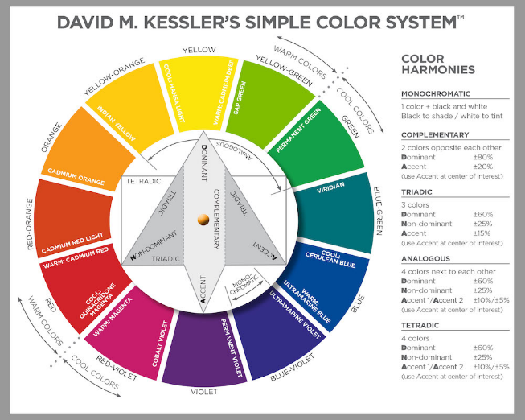*

Links of the videos seen:

<https://www.youtube.com/results?search_query=Graphic+Design%3A+Color>

<https://www.youtube.com/watch?v=ZaZHDNTCKTc>