**Abstract:**

We are currently living a global pandemic that has driven mayor lifestyle changes for the vast majority of people around the globe. This as a part of a healthcare framework established by local governments for each country.

This has had until now unprecedented effects in various areas, with distinct outcomes, both good and bad.

For one side, economic level activity has hit rock bottom for various economies both from first and third world countries, this has led to general deceleration in expenditure and investment levels, with the corresponding drop on level of employment and revenues.

However, on the bright side of the equation, this lack of economic activity and general mobility has led to a general diminish of pollution levels and its related health issues as well.

This reflection motivated us to study the effects of pollution in health concerns throughout the history, of course our first intent was to study the actual moment, however we quickly came across the limitation of lack of present data in this department. Also, it is very probable that the result wouldn’t be very surprising.

Instead, the team decided to analyze the effects of world accords on global pollution, we quickly though of the Kioto accords which is the most known global accord on health/pollution concerns issued by the UN. So, we did research and found that the main expectation of the accord was to reduce at least 5% contaminating emissions for the 2008/2012 period when compared to the level of emissions of 1990.

Making the analysis we found that the vast majority of the countries improved significantly vs 1990 emissions by far more than 5%, however there was no direct correlation between pollution improvement and having signed the accords or not, both groups of countries (those who signed and ratified and those who didn’t) showed improvement over the period analyzed.

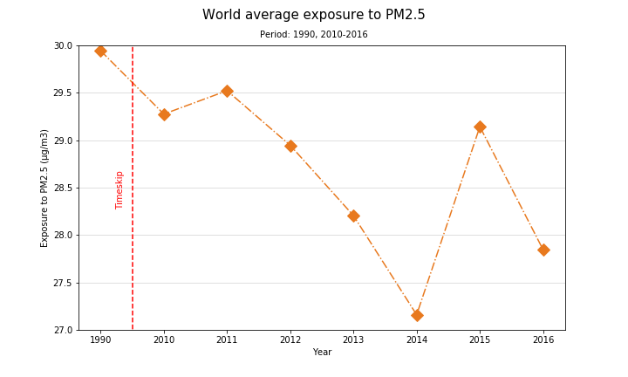

Also, we checked the correlation of pollution levels and pollution related health issues for a significant number of countries and found that there are some regions where a high level of pollution does not correlate directly with a higher volume of pollution related deaths. This applied mainly for first world countries mostly in Europe, where pollution levels are higher than in other areas, but health issues are not concerning.

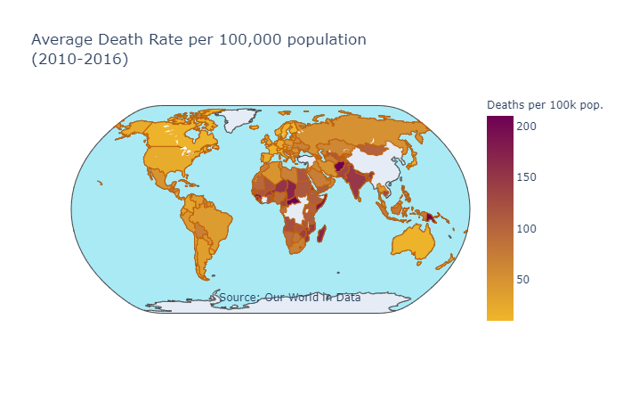

We came to the conclusion that there should be another factor in play that we were not seeing in the visuals, like health infrastructure; we assumed that first world countries might have significant levels of pollution but also have great public health architecture which would bias the analysis.

This would not happen for example in Africa and India where we see a very direct correlation between these two factors, mainly driven by poor public health programs and infrastructure we believe.

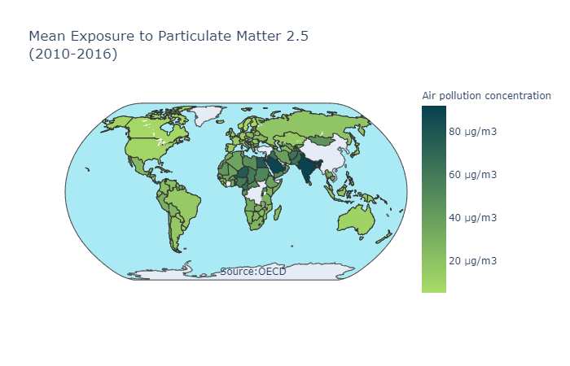

We also came to the conclusion that it was very weird that some first world economies like the U.S. show very low levels of pollution overall, we think that despite being a significant improvement in pollution thought the years for most countries, some of them might be misreporting, following their particular interests. We came to this conclusion by looking the G20 and G7 graphs. We expected to see that the most industrialized and powerful economies had also significant levels of pollution, however this was not the case.

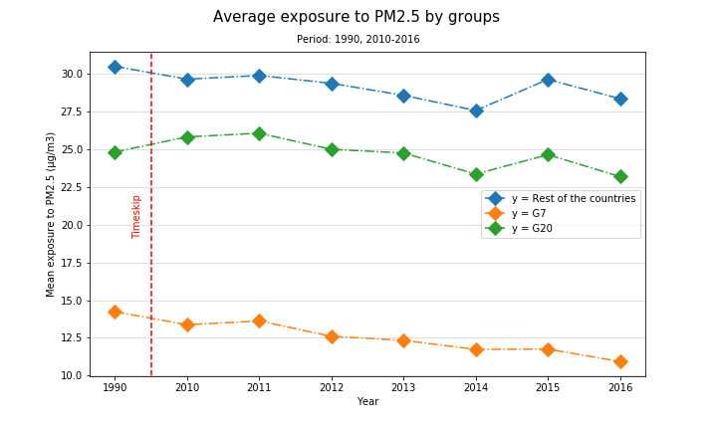

In order to get to a final verdict about this, more research would have to be done, to see what other factors could be influencing here. There are factors like weather conditions, public programs and even culture that could be impacting here.

However, we were very happy to see how almost all the world is making progress addressing pollution levels and pollution related health concerns, we believe that in spite of growing as a global economy we are also addressing these crucial problems along with everything else. Also, as economy is evolving and becoming more complex and incorporates newer and greener technologies, it seems to be relieving the environment of the heavy load that we have given it in the past years. Another important point is that this is happening in spite of countries being coerced into it by global accords, everyone seems to be doing their part on their own, which is very promising.