FINAL PROJECT REPORT
SmartAttend
An AI-Powered Attendance Management System with Facial Recognition and Proxy-Attendance Detection
Software Engineering Team Project
University of Energy and Natural Resources, Sunyani
GitHub repository: [insert repo URL]
Date: [Insert Submission Date]

Table of Contents
1. Executive Summary
2. Problem Statement & Objectives
3. Requirements Summary (SRS)
4. System Design (Use Case Diagram)
5. Implementation Summary
6. Version Control & Collaboration
7. Testing & Quality Assurance
8. Agile Project Management
9. Challenges & Lessons Learned
10. Team Contributions
11. Conclusion

1. Executive Summary
SmartAttend is a fully software-based attendance management system built to solve a specific, real gap in simple digital check-in systems: proving not just who is checking in, but where they actually are. The system combines facial recognition (via a standard device camera, using the face-api.js model), GPS geofencing against a lecturer-defined venue, and rule-based anomaly detection to flag suspicious attendance patterns for human review. The team built a fully working prototype covering registration, session management, check-in, a live lecturer dashboard, and attendance reporting, backed by automated tests and a documented Agile process.

2. Problem Statement & Objectives
Manual and simple digital attendance systems are vulnerable to proxy attendance — for example, a student checking in from their hostel rather than the actual lecture hall. SmartAttend was scoped specifically to close this gap while remaining a pure software solution with no hardware procurement. See docs/proposal/ and docs/srs/ for the full problem statement and objectives.

3. Requirements Summary
Full requirements are documented in docs/srs/SmartAttend_SRS.docx (FR-1 through FR-7) and extended with FR-8 (Presence Verification) after the team identified the location-verification gap during requirements discussion — see docs/srs/requirements-changelog.md for that reasoning.

4. System Design — Use Case Diagram
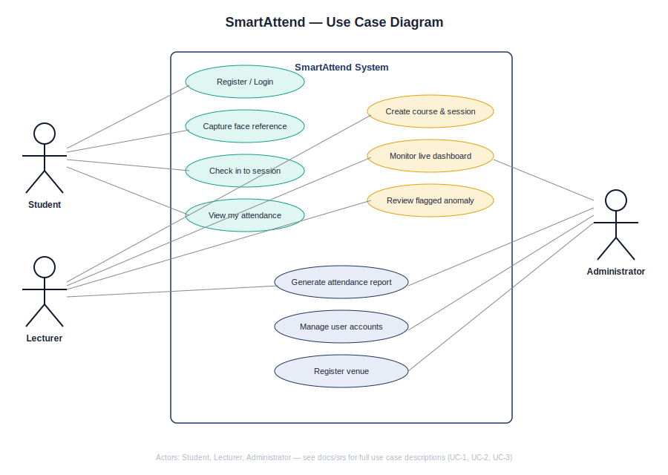
Full UML set (Class, Activity, Sequence, ERD, Architecture, UI mockups) is in docs/uml/ and docs/ui-mockups/.

5. Implementation Summary
Tech stack:
- Backend: Node.js, Express, better-sqlite3, JWT auth, bcrypt password hashing
- Frontend: HTML/CSS/JS, Chart.js for analytics, face-api.js (TensorFlow.js) for in-browser facial recognition
- Database: SQLite (schema designed to be portable to Postgres — see docs/architecture-notes.md)
Key features implemented:
- Facial-recognition check-in (real face-api.js model, not a placeholder)
- GPS geofencing against a lecturer-defined venue
- Rule-based anomaly detection: location mismatch, duplicate face, low-confidence match, missed re-verification
- Live lecturer dashboard with flag review/resolution
- CSV and PDF attendance reports, with a trend chart
- Admin user and venue management
- Rate limiting and password-reset flow
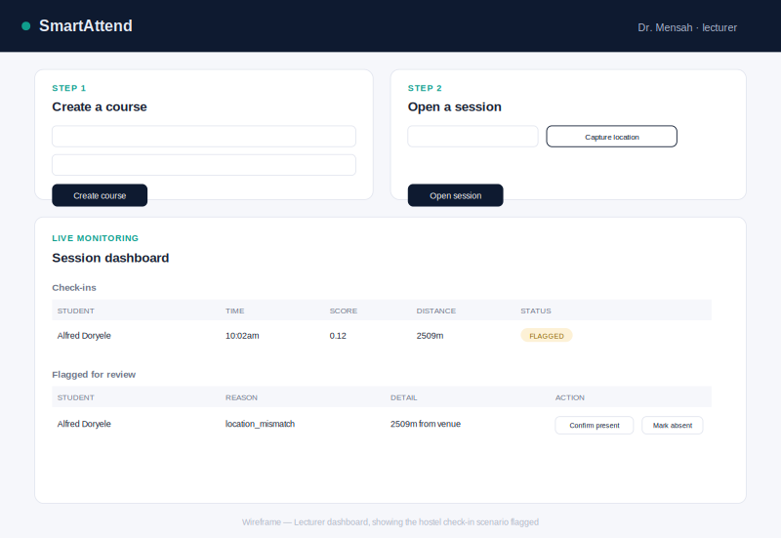
Lecturer dashboard, showing the exact hostel check-in scenario the team designed the anomaly-detection layer to catch.

6. Version Control & Collaboration
The team used a main/dev/feature-branch Git workflow (see the GitHub Setup Guide). Each of the 10 roles worked on an independently owned feature branch, merged into dev via reviewed Pull Requests. GitHub repository link: [insert URL]. Commit history and per-member contributions are visible in the repository's Insights tab.

7. Testing & Quality Assurance
11 automated tests (node:test) cover face-matching logic, distance calculations, and the full anomaly-detection pipeline including the specific hostel check-in scenario. 12 manual functional test cases covering registration, auth, sessions, and reporting are logged in docs/test-plan/test-cases-and-results.csv (10 passed; 2 failures traced to a pending branch merge, documented in docs/test-plan/bug-report.md as BUG-01 and resolved before final submission). Full traceability from requirements to test results is in docs/test-plan/verification-validation-report.docx.

8. Agile Project Management
The team worked from a product backlog (docs/agile/product-backlog.md) organized into sprints (docs/agile/sprint-plans/, docs/agile/sprint-reviews/), with weekly meetings logged in docs/agile/meeting-records/.

9. Challenges & Lessons Learned
[Team to fill in during the retrospective — e.g. what was harder than expected (the location-verification design took real back-and-forth to get right), what the team would do differently, and what surprised the team about the scope of "just an attendance system."]

10. Team Contributions
[Insert the team table from README.md with member names against each of the 10 roles, plus a one-line summary of what each person actually built, pulled from their individual Pull Requests.]

11. Conclusion
SmartAttend meets its stated objectives: a working, tested, pure-software attendance system that verifies both identity and physical presence, addressing proxy attendance in a way that plain digital check-in systems cannot. The system is explicit about its own limitations — it is a strong deterrent and flagging system, not an unbeatable one — which the team can defend directly if asked during the presentation.

