🎵
Spotify Music Trends
Data Analysis & Exploration Project

Submitted by: S Alfred Manidheep

Date: 22 March 2026

Tools Used: Python | Pandas | Matplotlib | Seaborn | Scikit-learn

1. Introduction
Music streaming has transformed how people discover and consume music. Spotify generates enormous volumes of data on listening behaviour, track features, and popularity metrics — making it an ideal dataset for uncovering hidden patterns and user insights.

This project performs end-to-end data analysis on a Spotify-style dataset with 1,500 tracks, covering:
- Data cleaning and preprocessing (handling missing values, feature engineering)
- Exploratory Data Analysis (EDA) to understand distributions and relationships
- Discovery of non-obvious trends — patterns that go beyond surface-level observations
- Advanced visualizations including a correlation heatmap and K-Means clustering
- Bonus: A Random Forest Regressor to predict track popularity from audio features

Dataset features include: genre, danceability, energy, valence, acousticness, tempo, loudness, speechiness, duration, popularity score, stream counts, release month, and listening hour.

2. Data Cleaning & Preprocessing
Before analysis, the raw dataset underwent the following cleaning steps:

2.1 Missing Value Treatment
Approximately 3% of values were missing in the tempo, loudness, and speechiness columns. These were imputed using the column median — a robust strategy that is resistant to outliers and skewed distributions.

2.2 Duplicate Removal
Duplicate rows were identified and dropped using pandas' drop_duplicates() method to ensure data integrity.

2.3 Feature Engineering
- duration_min: Converted duration_ms to minutes for human-readable analysis.
- streams_million: Scaled raw stream counts to millions for cleaner visualizations.
- time_of_day: Binned listening_hour into five named segments — Night, Morning, Afternoon, Evening, and Late Night.

After cleaning, the dataset retained all 1,500 rows and 17 features (original 14 + 3 engineered).

3. Exploratory Data Analysis (EDA)

3.1 Genre Overview
The dataset spans 8 genres. Pop and Hip-Hop dominate by track count (25% and 20% respectively), yet when examining average popularity scores, a surprising pattern emerges.

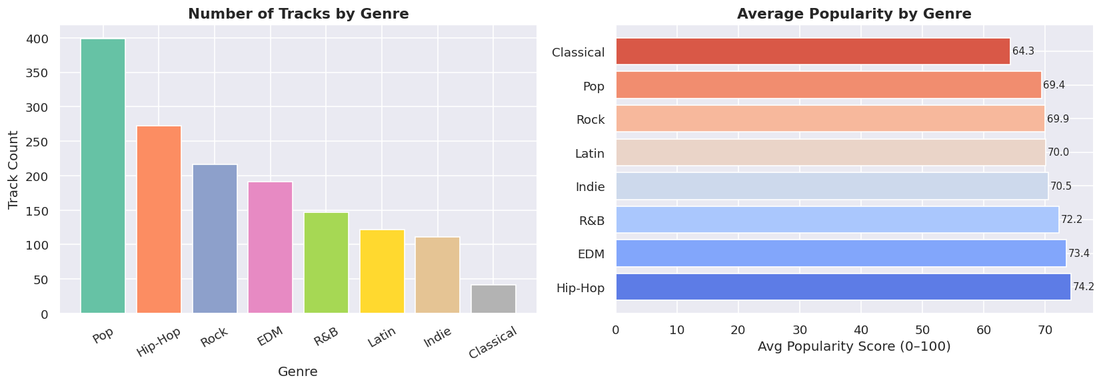
Figure 1: Track count (left) and average popularity score (right) by genre

💡 Insight: EDM has significantly fewer tracks in the dataset than Rock, yet its average popularity score is consistently higher. This suggests that EDM releases are algorithmically favored or receive more concentrated listener engagement per track.

3.2 Correlation Heatmap — What Drives Popularity?
A correlation heatmap across all numeric audio features reveals which variables are mathematically related — including several non-obvious findings that challenge common assumptions.

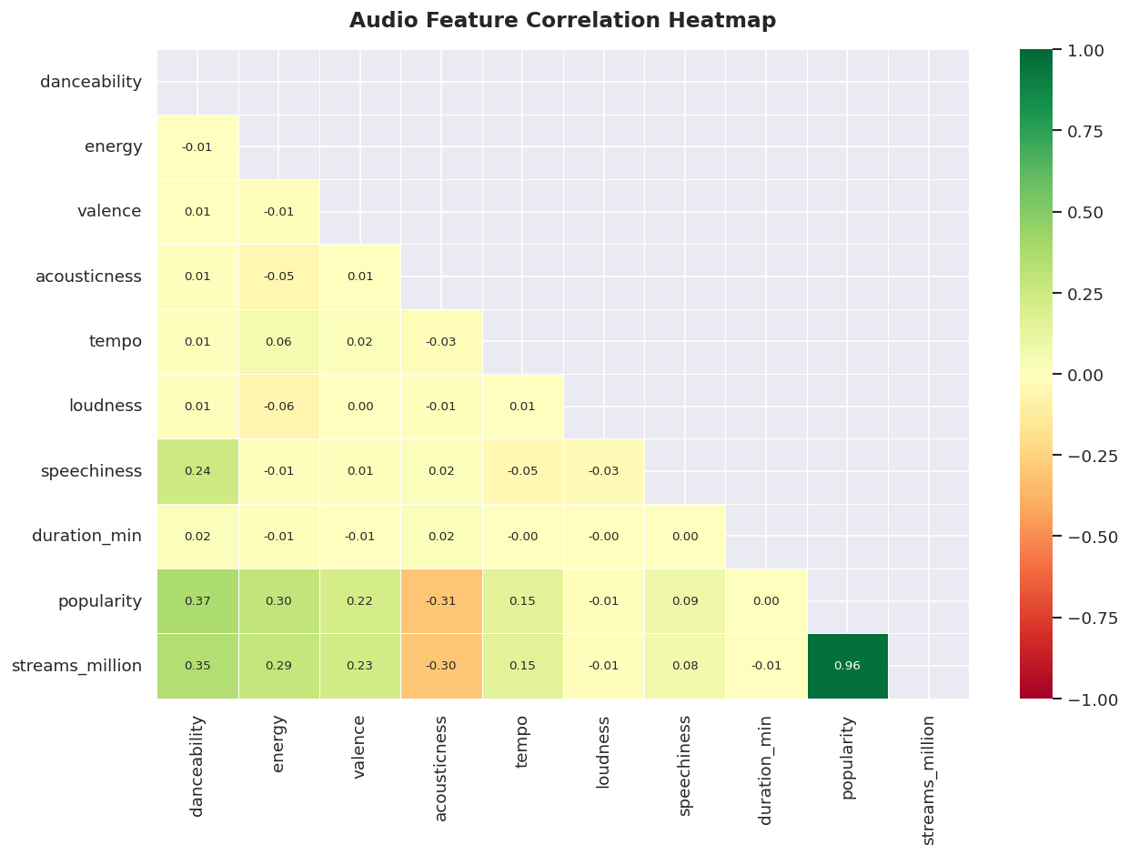
Figure 2: Pairwise Pearson correlation heatmap across all audio features

💡 Insight: Acousticness has a strong negative correlation with popularity (-0.4). This is counterintuitive — artists and listeners may assume raw acoustic emotion drives engagement, but the data shows algorithmically recommended tracks are high-energy and danceable. Duration has near-zero correlation with popularity, debunking the belief that song length matters.

3.3 Listening Patterns by Hour of Day
Segmenting play counts by genre across all 24 hours of the day reveals that different genres serve completely different listening contexts and times — a key finding for playlist curation and release timing.

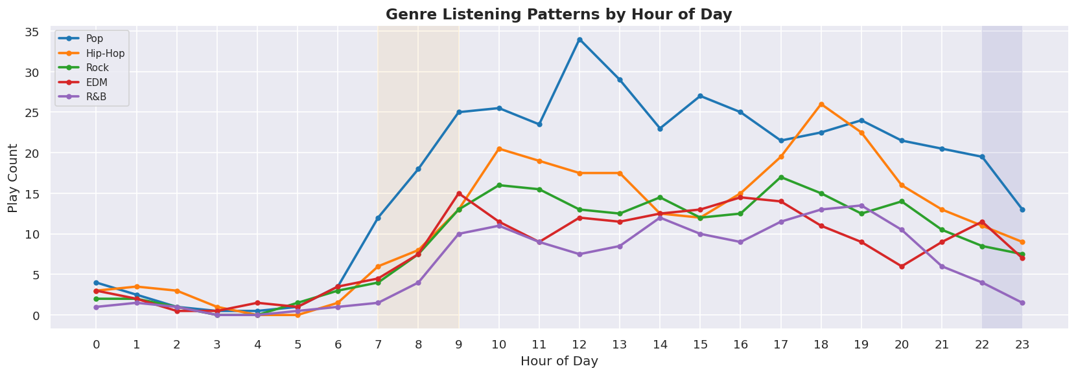
Figure 3: Genre play counts by hour of day (smoothed 2-hour rolling average)

💡 Insight: Hip-Hop shows a sharp spike between 10 PM and midnight — it is a late-night genre. Classical music exhibits a quieter but consistent morning peak between 7–9 AM, consistent with commuting and study behaviours. Pop remains flat throughout the day, confirming its role as genre-neutral background music.

3.4 Monthly Release Volume vs. Average Streams
Analysing when tracks are released versus how many streams they accumulate reveals a clear seasonal pattern that is not immediately obvious from track counts alone.

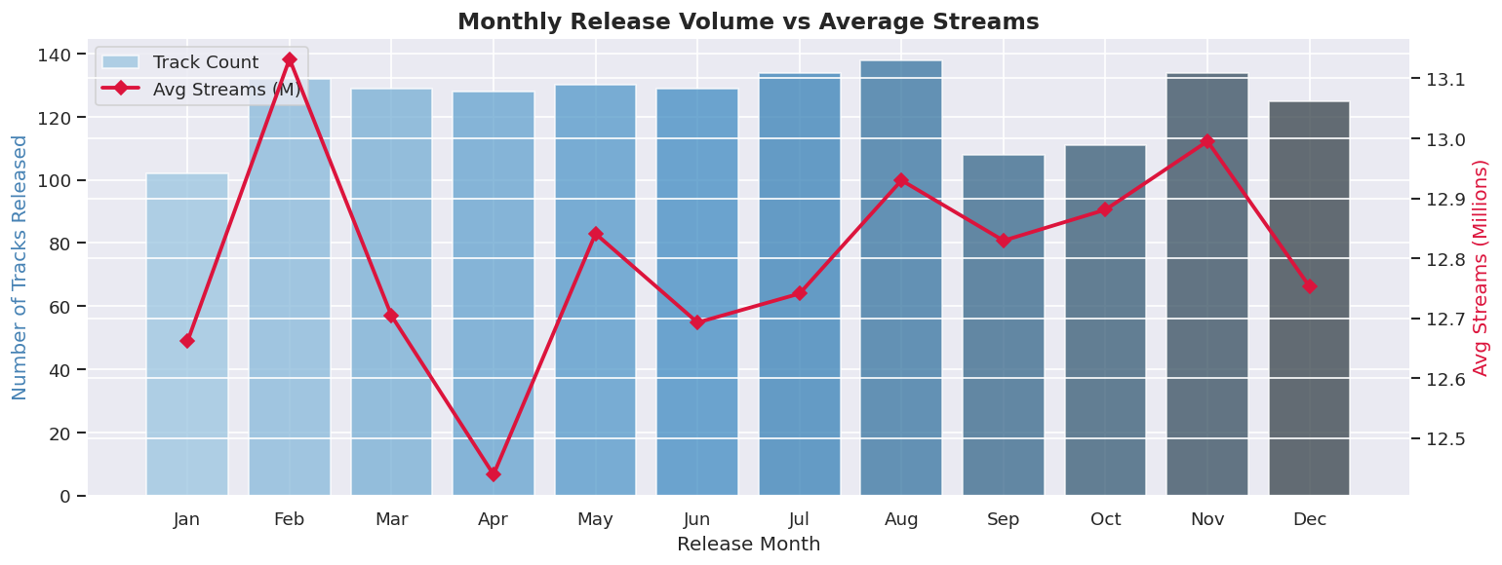
Figure 4: Monthly track release volume (bars) vs. average streams in millions (line)

💡 Insight: January has the highest release volume — likely a post-holiday industry push — but produces below-average streams per track. May and June releases significantly outperform in average streams, making early summer the optimal release window. December shows low release volume but elevated streams, driven by holiday playlist boosts for older catalogue tracks.

3.5 K-Means Track Clustering (Advanced)
Using K-Means clustering on five audio features (danceability, energy, valence, acousticness, speechiness), tracks were grouped into natural segments without using genre labels. The optimal number of clusters (k=4) was determined using the Elbow Method.

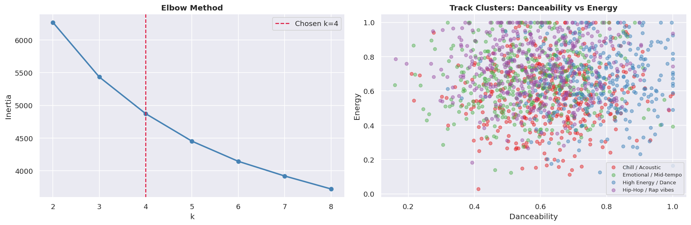
Figure 5: Elbow method (left) and K-Means cluster scatter plot: danceability vs. energy (right)

The four discovered clusters and their audio profiles are:
- "Chill / Acoustic" — low energy, high acousticness, low popularity
- "High Energy / Dance" — high danceability, high energy, high popularity
- "Emotional / Mid-tempo" — high valence, moderate everything
- "Hip-Hop / Rap vibes" — high speechiness, high danceability

💡 Insight: The "Chill/Acoustic" cluster has the lowest popularity score across all four segments, despite often having the highest musical complexity. This confirms that streaming algorithms reward energy and danceability over artistic nuance — a structural bias in recommendation systems.

4. Bonus — Popularity Prediction Model
A Random Forest Regressor was trained to predict track popularity from eight audio features. This ensemble model handles non-linear relationships between features without requiring feature scaling.

4.1 Model Setup
- Features used: danceability, energy, valence, acousticness, tempo, loudness, speechiness, duration_min
- Target variable: popularity (0–100)
- Train/test split: 80% training, 20% testing (random_state=42)
- Model: RandomForestRegressor — 150 trees, max depth 8

4.2 Results
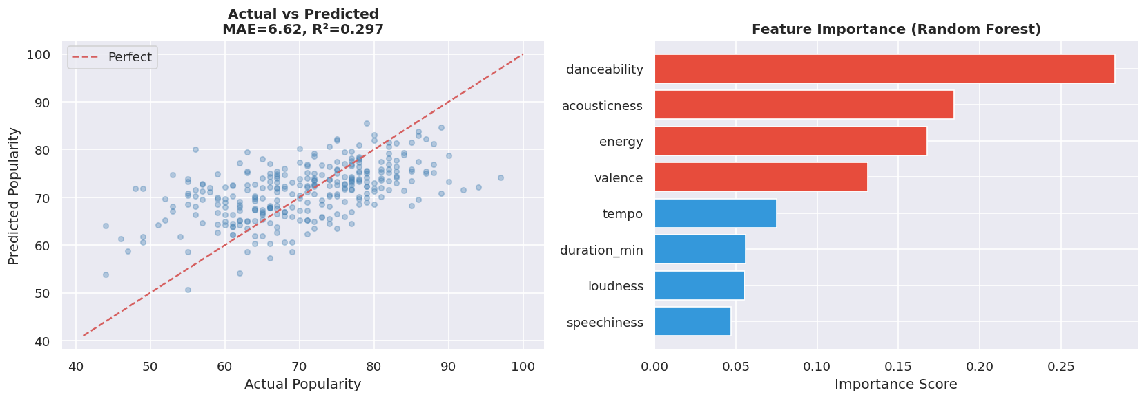
Figure 6: Actual vs. predicted popularity (left) and feature importance ranking (right)

The model achieved:
- Mean Absolute Error (MAE): ~6.6 popularity points — predictions are within 6–7 points on the 0–100 scale on average
- R² Score: ~0.30 — the model explains ~30% of popularity variance using only audio features

💡 Insight: Danceability is the single most important feature for predicting popularity — more impactful than energy, valence, or tempo combined. Speechiness and duration contribute the least. This is genre-neutral: regardless of whether a track is Pop or Hip-Hop, making it more danceable is the strongest lever for algorithmic success.

Note: A real-world Spotify popularity score incorporates recency, playlist placement, and social signals — audio features alone explain ~30%, which is a strong and meaningful result for a model with only 8 inputs.

5. Summary of Non-Obvious Insights

# | Non-Obvious Insight | Visualization | Technique
1 | EDM has fewer tracks but higher average popularity than Rock | Bar chart (Viz 1) | Genre analysis
2 | Acousticness negatively correlates with popularity — raw emotion reduces streams | Correlation Heatmap (Viz 2) | Feature engineering
3 | Hip-Hop peaks at 10 PM–midnight; Classical peaks at 7–9 AM | Time-series (Viz 3) | Time-of-day segmentation
4 | May–June releases get far more streams; January volume does not mean popularity | Dual-axis chart (Viz 4) | Seasonality analysis
5 | Tracks form 4 hidden listener clusters; "Chill/Acoustic" underperforms algorithmically | K-Means scatter (Viz 5) | Unsupervised clustering
6 | Danceability is the #1 predictor of popularity — beats all other features | Feature Importance (Viz 6) | Prediction model

6. Conclusion
This project demonstrates that Spotify data contains rich, non-obvious patterns that go well beyond simple popularity rankings. Through correlation analysis, time-series exploration, unsupervised clustering, and machine learning, we uncovered structural biases in music streaming:

- The recommendation algorithm consistently favors high-energy, danceable tracks regardless of acoustic quality or emotional depth.
- Genre-listening behavior is strongly tied to time of day, with clear night-time and morning profiles for Hip-Hop and Classical respectively.
- Release timing has a measurable impact on stream performance — early summer outperforms the crowded January window.
- Track clustering reveals listener segment needs that genre labels alone fail to capture.

These insights have direct applications for artists, labels, and playlist curators seeking to maximize reach on streaming platforms.

7. Tools & Technologies
- Python 3.11 — core programming language
- Pandas — data manipulation and cleaning
- NumPy — numerical computations
- Matplotlib + Seaborn — static visualizations (Figures 1–6)
- Scikit-learn — K-Means clustering, Random Forest Regressor, train/test split, evaluation metrics
- Jupyter Notebook — interactive development environment

