Machine Learning for House Price Prediction

1. Introduction 3
1.1 Background 3
1.2 Project Aim and Objectives 3
2. Dataset Description and Exploratory Data Analysis 4
2.1 Dataset Overview 4
2.2 Target Variable Analysis 5
2.3 Missing Value Analysis 7
2.4 Correlation Analysis 9
2.5 Feature Relationship Analysis 11
2.6 Outlier Detection 13
3. Data Preprocessing 14
3.1 Data Preprocessing and Feature Engineering 14
3.2 Ordinary Least Squares (OLS) Linear Regression 14
3.3 Regularized Linear Models: Ridge and Lasso 15
3.4 Data Splitting and Cross-Validation 15
3.5 Tree-Based Models: Random Forest 15
3.6 Advanced Tree Boosting: XGBoost 16
4. Model Development 16
4.1 Grid Search Implementation 16
4.2 Linear Regression 16
4.3 Lasso/Ridge Regression 17
4.4 Random Forest Regression 17
4.5 XGBoost or Gradient Boosting 18
4.6 Hyperparameter Tuning 18
5. Results and Model Evaluation 19
5.1 Evaluation Metrics 19
5.2 Model Comparison 20
5.3 Overfitting and Generalization 21
5.4 Final Model Selection 23
6. Model Interpretation and Discussion 23
7. Conclusion 25
8. References 26

1. Introduction

1.1 Background
House price predictions play an important role in both the economy and daily life. Accurate prediction of housing prices is of great significance for multiple stakeholders in the real estate market (Hasan et al., 2024). As the modern real estate market becomes increasingly complex, relying on manual appraisal and traditional forecasting methods is no longer sufficient to accurately predict housing prices. Such approaches are often time-consuming, labor-intensive, and costly. So the importance of data-driven house price forecasting methods is becoming increasingly prominent. It can effectively predict the trend of house prices through more scientific and efficient methods. Meanwhile, machine learning is gradually outperforming traditional linear statistical models in some cases to enhance the accuracy of property valuation. Machine learning models have demonstrated excellent predictive capabilities in multiple real estate markets and possess practical application value (Mathotaarachchi et al. 2024).
Nowadays, the Automated Valuation Model (AVM) has become a key application of machine learning in the real estate industry. AVM can automatically estimate the value of properties using large-scale property data and predictive algorithms, thereby reducing the time and cost required by traditional assessment methods. Bergadano et al. (2019) pointed out that automatic valuation models can enhance the speed and accuracy of real estate assessment. The real estate industry is shifting from being driven by experience to being driven by data, using algorithms to overcome the limitations of traditional expert judgment. Automated property valuation and data analysis can assist market participants in better understanding market trends (Jafary et al. 2024). By using machine learning algorithms and real estate transaction data, institutions can enhance the accuracy of valuations, predict market trends, and support strategic investment decisions. Data-driven methods are increasingly becoming a key tool in modern real estate management and planning.

1.2 Project Aim and Objectives
The primary aim of this project is to develop and evaluate machine learning models for predicting residential property sale prices using the Ames Housing Dataset. To achieve this goal, we carried out a series of processing on the data through the following steps. We conducted a preliminary exploratory analysis of the data set through Exploratory Data Analysis (EDA) to find the data set structure, characteristics and potential data quality problems, to study the relationship between various housing characteristics and real estate sales prices. Establish a solid foundation and prerequisite for the subsequent data processing and modeling. We will also apply appropriate preprocessing techniques, including handling missing values, encoding categorical variables, and conducting feature engineering. This plays a very important role in the subsequent model establishment. By developing and evaluating multiple regression models, and using appropriate performance indicators to assess these models, the most suitable model can be selected. And explain the selected model and determine the key factors that affect the prices of residential properties.

2. Dataset Description and Exploratory Data Analysis

2.1 Dataset Overview
Table 1 provides an overall summary of the basic information of the Ames Housing dataset. The table shows that this dataset contains 2,919 observations and 81 variables. The dataset is relatively large and has rich features, making it suitable for exploratory data analysis and predictive modeling of the dataset. Among these variables, there are a total of 38 numerical features, representing measurable quantities. There are 43 categorical features that describe qualitative property attributes. From the information in Table 1, we can see that the dataset contains a total of 17,166 missing values. This indicates that missing data is a major characteristic of the dataset, and it must be carefully addressed during data preprocessing. From the basic information of the dataset, we can see that the Ames Housing dataset contains a wealth of numerical and categorical data. Such features are highly suitable for analyzing how structural and location-related properties affect property prices, providing certain ideas for subsequent data processing.
Table 1
Dataset Summary Table for the Ames Housing dataset
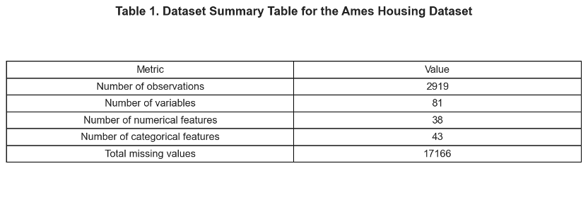

2.2 Target Variable Analysis
Figure 1 is the histogram of the target variable SalePrice. Most of the houses are concentrated in the mid-to-low price range. The data is mainly distributed between $100,000 and $200,000. Only a very small number of high-value properties extend to the right side, reaching over $700,000. The overall distribution shows a significant right skewness. By calculation, the skewness value is 1.883, which indicates that the SalePrice does not follow a normal distribution. The extremely high-priced properties have raised the average value, causing the average SalePrice to be higher than the median, indicating that the average is significantly influenced by outliers. This will to some extent affect the performance of the linear regression model, so logarithmic transformation is applied for processing. We can see Figure 2, which shows the distribution of log (1 + SalePrice). This figure has a more concentrated distribution and is closer to a normal distribution. In Figure 1, the long-tail phenomenon has significantly weakened, with the skewness reduced to 0.121, which is closer to a normal distribution. Based on this, conducting modeling can enhance the accuracy of predictions and is more suitable for establishing regression models.
Figure 1
Distribution of SalePrice
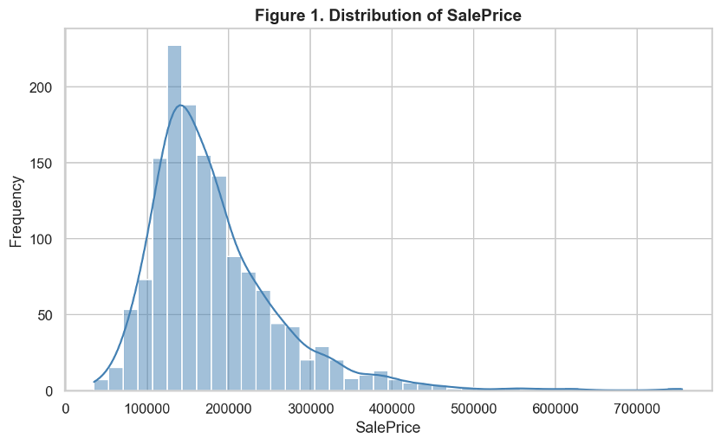
Figure 2
Distribution of Log-Transformed SalePrice
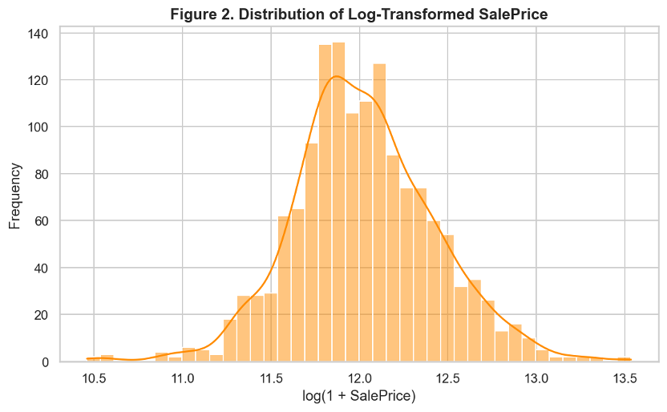

2.3 Missing Value Analysis
Table 2 summarizes the number and percentage of missing values for each element in the Ames Housing dataset. It can be clearly seen from the table that the missing data is concentrated in a relatively small group of variables. The missing value percentages of features such as PoolQC, MiscFeature, Alley and Fence exceed 80%, which is much higher than those of other features. This indicates that the missing entries are usually the absence of certain attribute characteristics, rather than the loss of random data. Figure 3 visually confirms that these variables play a dominant role in the missing value structure of the dataset. Figure 4 provides a more comprehensive overview of the missing values and variables for all observations, showing that the missing values are distributed unevenly throughout the dataset. The missing SalePrice values reflect the combined training and testing structure of the dataset, where the target variable is only applicable for the training observations. This indicates that the dataset requires appropriate preprocessing, including differentiating between truly missing data and meaningful missing categories before modeling.
Table 2
Missing Value Counts and Percentages
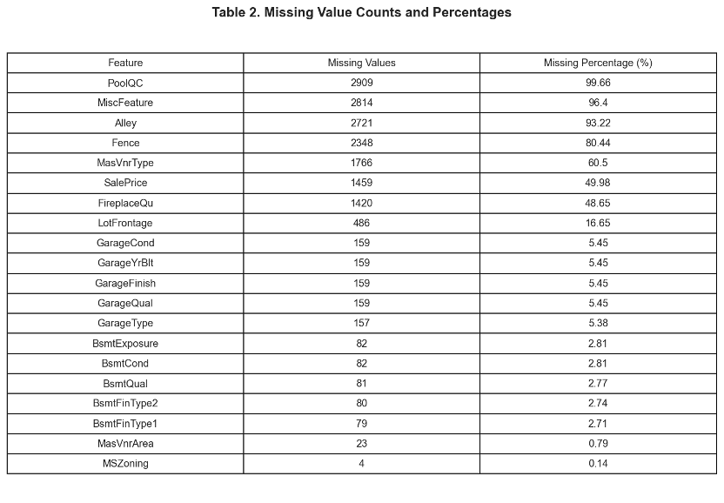
Figure 3
Top Features with Missing Values
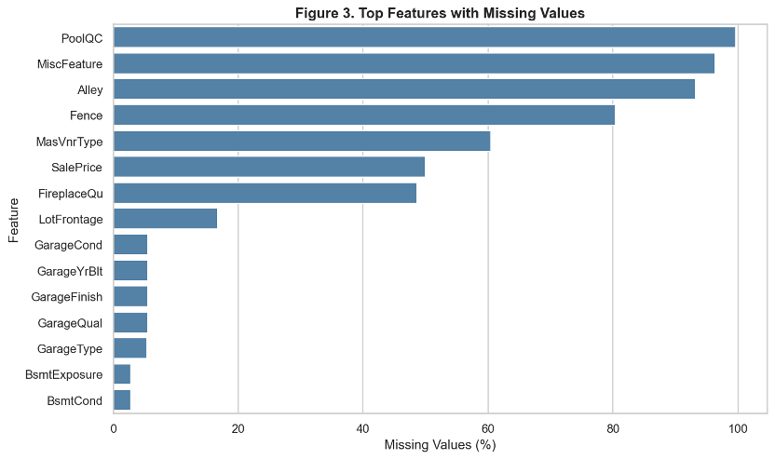
Figure 4
Missing Value Heatmap
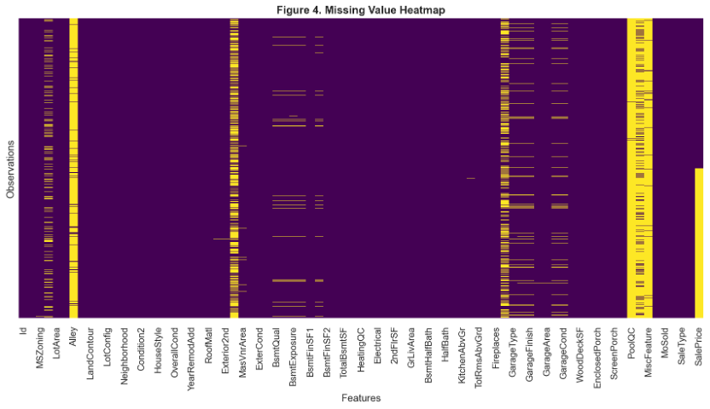

2.4 Correlation Analysis
Figure 5 presents a correlation heatmap of the numerical variables in the Ames Housing dataset, showing the strength and direction of the linear relationships between the features. The characteristics related to the size of the house, the area of the basement, the capacity of the garage, and the overall quality of the property show a strong positive correlation. Figure 6 ranks the 10 numerical variables that have the strongest correlation with SalePrice. The correlation of OverallQual is the strongest, at 0.791, indicating that higher overall material and finish quality is closely related to higher sales prices. Other important predictive variables include GrLivArea, GarageCars, GarageArea, TotalBsmtSF and 1stFlrSF, indicating that larger living area, basement space and garage capacity are positively correlated with property value. We can clearly identify that the variables related to the quality and size of the property are all key numerical factors that influence the property price.
Figure 5
Correlation Heatmap of Numerical Variables
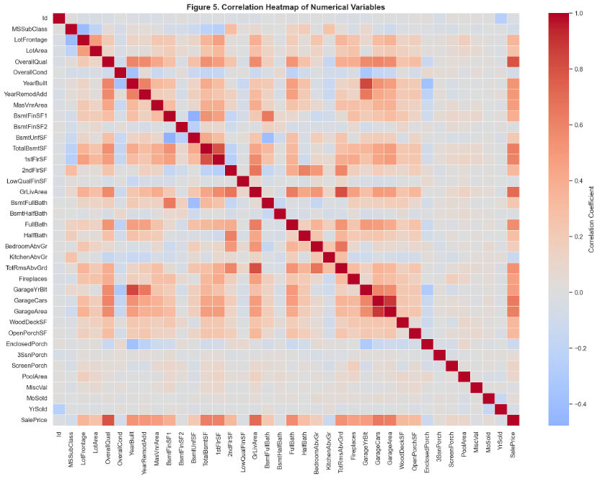
Figure 6
Top 10 Numerical Features Correlated with SalePrice
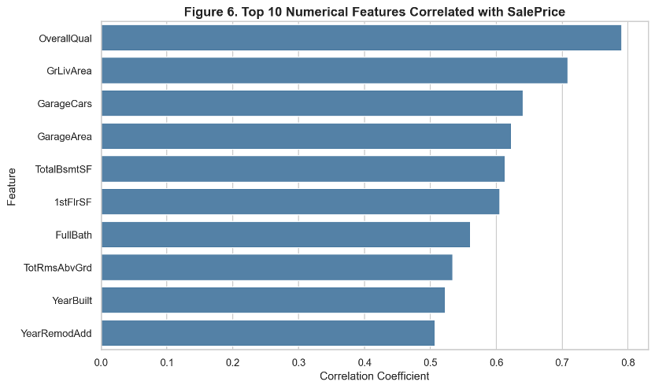

2.5 Feature Relationship Analysis
Figure 7 shows the relationship between the floor area for residential use (GrLivArea) and the SalePrice. The fitted regression line indicates a clear positive correlation, which means that houses with larger living areas tend to have higher prices. There are potential outliers in the high-level observation results, indicating that area alone cannot fully explain the property value. Figure 8 shows that as the overall quality increases, the selling price also keeps rising. This confirms that the overall material and decoration quality of the property is closely related to the higher price. As the quality rating increases, the price gap also widens. This indicates that the price difference between high-quality properties becomes even more significant. Figure 9 compares the SalePrice of each community. It is clearly visible that due to the different locations, there will be significant differences in housing prices. Communities with higher median prices tend to have a more dispersed distribution overall, which indicates that location significantly affects housing prices.
Figure 7
Relationship Between Above-Ground Living Area and SalePrice

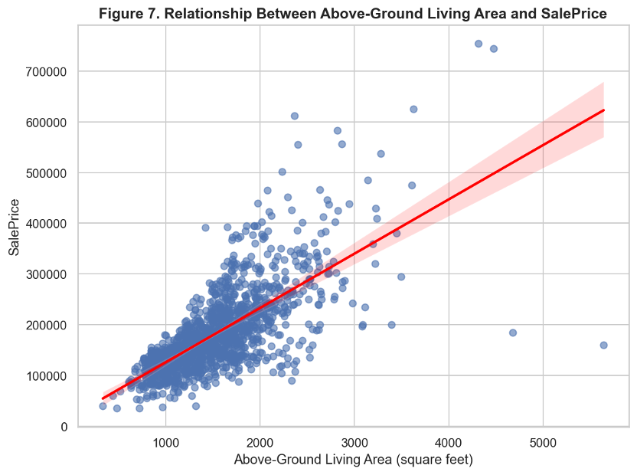
Figure 8
SalePrice Distribution by Overall Quality
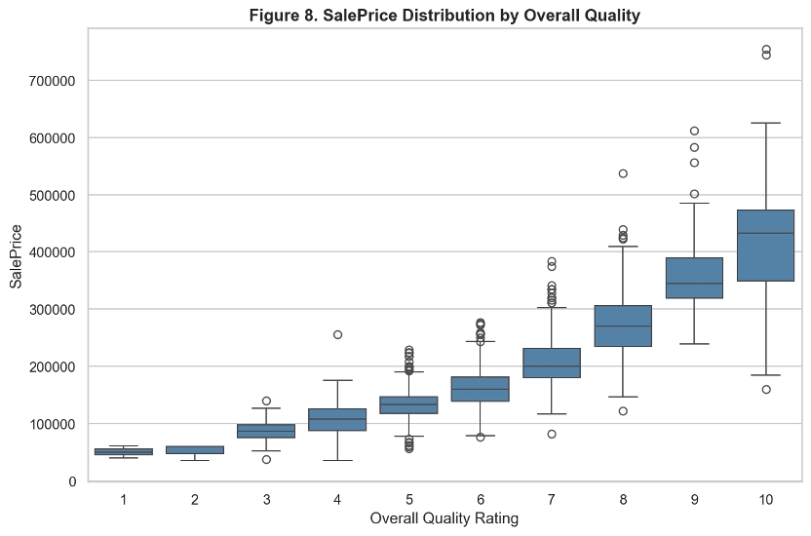
Figure 9
SalePrice Distribution by Neighborhood
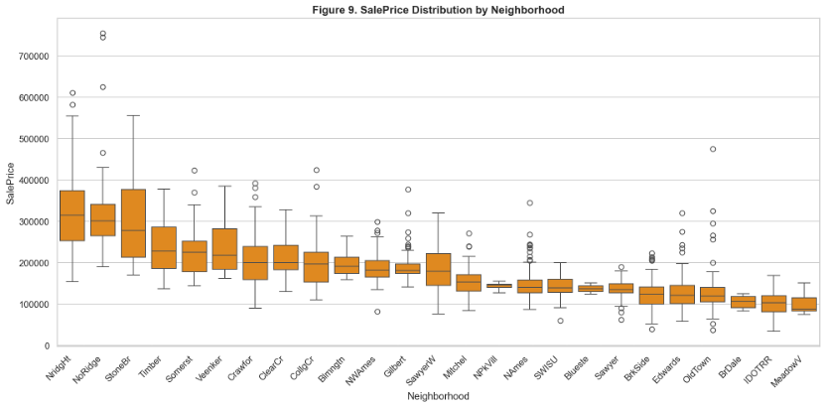

2.6 Outlier Detection
From the scatter plot of GrLivArea and SalePrice, we can observe a general positive correlation. The larger the living area on the ground, the higher the selling price is usually. There are two observation values (with the GrLivArea values being 5,642 and 4,676) that are particularly extreme. The living area exceeds 4,000 square feet, but the selling prices are very low, being $160,000 and $184,750 respectively. Although the quality ratings were all 10, they were significantly out of line with the overall trend. This will have a certain impact on regression-based models and weaken the relationship between living area and sales price. In contrast, the other two observations (with prices of $745,000 and $755,000 respectively) show a more positive correlation, which might indicate valid high-value properties rather than problematic observations. Therefore, these two observations should be retained, while the two extreme observations should be further investigated and considered whether to be removed. If deletion is carried out, this decision should be clearly documented. Because the removal of outliers can have an impact on the model, it can improve the model's performance, but it may also reduce the representativeness of the dataset.

3. Data Preprocessing

3.1 Data Preprocessing and Feature Engineering
Before training our models, we carried out the final data cleaning and feature engineering based on the EDA notes from Section 2. First, we dropped all rows where the target variable (SalePrice) was missing, since we need real prices for supervised learning. Second, to prevent our models from being distorted, we removed extreme outliers where houses had an above-ground living area (GrLivArea) over 4,000 square feet but sold for very low prices.
To deal with missing values, we filled numerical gaps using the column median. For categorical columns where missing values mean the house does not have that specific feature (like no pool or no fence), we filled them with a new label called "None". We then used One-Hot Encoding to transform all categorical features—including key location indicators like Neighborhood—into dummy variables so the algorithms could read them. Finally, we explicitly applied a log transformation (SalePrice) to the house prices to fix the right-skewness and help our models make better predictions.

3.2 Ordinary Least Squares (OLS) Linear Regression
As our starting baseline, we chose standard Ordinary Least Squares (OLS) linear regression. OLS is a simple and common way to predict house prices. It works by drawing a straight line through the data that makes the total squared distance between the real prices and the predicted prices as small as possible. OLS is very easy to read and understand. However, it does not work well with the Ames dataset because we have over 80 features. Many variables are highly related to each other (for example, GarageCars and GarageArea both show garage size). This high correlation makes the standard OLS model unstable and gives poor results on new test data.

3.3 Regularized Linear Models: Ridge and Lasso
To solve the correlation problems of standard OLS, we used regularized linear models (Hastie et al., 2009). These models add a mathematical penalty to the loss function to stop the model coefficients from becoming too large.
- Lasso Regression (L1 Penalty): Lasso adds a penalty based on the absolute size of the coefficients. A great feature of Lasso is that it can shrink some unimportant feature coefficients all the way to zero. This means Lasso automatically helps us choose the most useful variables and deletes noise from the dataset.
- Ridge Regression (L2 Penalty): Ridge adds a penalty based on the squared size of the coefficients. It forces the coefficients of related features closer to each other, but it keeps all features in the model. This is very good for reducing model variance when features are highly related.

3.4 Data Splitting and Cross-Validation
To test how well our models can predict new data, we split our dataset into a training set (80%) and a validation set (20%). Following standard statistical methods (James et al., 2013), we used 5-fold cross-validation during the training phase. This means we divided the training data into 5 equal parts. Each time, we trained the model on 4 parts and tested it on the remaining 1 part. We repeated this 5 times so that every piece of data was used for both training and validation. This method helps us avoid overfitting and makes our model scores much more reliable.

3.5 Tree-Based Models: Random Forest
Real estate data often has non-linear patterns. For example, adding an extra bedroom might increase the price a lot in an expensive neighborhood, but not as much in a cheap neighborhood. Simple linear models cannot see these combinations, so we used a Random Forest model (Breiman, 2001). Random Forest builds many different decision trees at the same time using random samples of data. For each split in a tree, it only looks at a random group of features. Finally, the model averages the predictions of all individual trees to get a stable result.

3.6 Advanced Tree Boosting: XGBoost
Finally, we used XGBoost (Extreme Gradient Boosting), which is a very powerful tree model (Chen and Guestrin, 2016). Unlike Random Forest, where trees are built completely independently, XGBoost builds trees one after another. Each new tree is trained specifically to fix the prediction mistakes made by the previous trees. It also has built-in penalties to stop the trees from becoming too complex, which makes it excellent for tabular business datasets like this one.

4. Model Development

4.1 Grid Search Implementation
To find the best settings (hyperparameters) for our models, we used Grid Search with 5-fold cross-validation (Kuhn and Johnson, 2013). For Ridge and Lasso, we searched for the best penalty weight (alpha). For Random Forest and XGBoost, we changed the number of trees (n_estimators) and the maximum tree depth (max_depth) to control how complex the trees could grow.

4.2 Linear Regression
We started our modeling phase by training a standard Ordinary Least Squares (OLS) linear regression model.
- Basic principles: OLS works by fitting a straight line through the data points to minimize the sum of squared residuals, which is the total squared distance between the actual house prices and the model predictions.
- Advantages and limitations: The main advantage of OLS is its simplicity and high interpretability, as each coefficient directly shows how a feature changes the house price. However, its biggest limitation is that it cannot handle high-dimensional datasets with many features well, and it suffers from multi-collinearity when variables are highly related.
- Role as a baseline model: In this project, OLS serves as our baseline model. It gives us a starting benchmark score so we can see exactly how much predictive accuracy we gain by introducing more advanced regularized and tree-based machine learning algorithms.

4.3 Lasso/Ridge Regression
To fix the high correlation and instability issues of standard OLS, we implemented regularized linear models (Hastie et al., 2009).
- Regularization: Regularization adds a mathematical penalty to the OLS loss function to stop the regression coefficients from growing too large.
- Prevention of overfitting: By penalizing large weights, regularization reduces the variance of the model. This stops the linear model from fitting the random noise in the training data, directly preventing overfitting.
- Feature selection capability: We utilized both Ridge (L2 penalty) and Lasso (L1 penalty) models. A key difference is that Lasso can shrink less important coefficients all the way to zero. This gives Lasso an automatic feature selection capability, removing useless features and simplifying our final dataset.

4.4 Random Forest Regression
Since real estate datasets often contain complex interactions, we also implemented a Random Forest regression model (Breiman, 2001).
- Ensemble learning: Random Forest is an ensemble learning method, meaning it achieves high accuracy by combining the predictions of multiple individual models instead of relying on just one.
- Decision tree aggregation: The algorithm builds hundreds of independent decision trees using random samples of the data. For each tree split, it only looks at a random subset of features. Finally, it aggregates all these trees by averaging their individual predictions to output a very stable result.
- Handling nonlinear relationships: Unlike linear regressions, decision trees naturally split data based on thresholds, allowing the model to capture non-linear patterns without needing manual variable transformations.
- Why Random Forest is suitable for this dataset: The Ames Housing dataset contains over 80 features with many non-linear business patterns (for example, a large garage adds much more value to a luxury home than to a small cottage). Random Forest is perfectly suited here because it can easily detect these complex feature combinations without overfitting.

4.5 XGBoost or Gradient Boosting
Finally, we applied XGBoost (Extreme Gradient Boosting) to see if we could achieve the absolute highest predictive accuracy (Chen and Guestrin, 2016).
- Boosting methods: Unlike Random Forest where trees are built independently in parallel, XGBoost uses a boosting approach. It builds trees sequentially, one after another, where each new tree is specifically trained to correct the residual errors made by the previous trees.
- Improved predictive performance: Because it continuously minimizes errors through gradient descent and includes built-in regularization, XGBoost provides significantly higher predictive performance on tabular data compared to simpler algorithms.
- Computational complexity: The downside is its high computational complexity. XGBoost has many hyperparameters to tune (like learning rate, tree depth, and subsample ratios), and training it sequentially takes more time and processing power than training a Random Forest.

4.6 Hyperparameter Tuning
- GridSearchCV or RandomSearchCV: We used GridSearchCV from Scikit-Learn to automate our tuning process, testing every possible combination of parameters within our defined ranges using 5-fold cross-validation.
- Parameter optimization: This optimization process ensures we find the exact balance between underfitting and overfitting for each algorithm.
- Examples: For our tree models, we specifically tuned the number of trees (n_estimators), the maximum depth of each tree (max_depth), and the step size for error correction (learning_rate).
Our optimal hyperparameter results are summarized in Table 3 below:
Table 3
Best Settings for Each Model
Model | Hyperparameter | Range We Tried | Best Value
Ridge | alpha | [0.1, 1.0, 10.0, 100.0] | 10.0
Lasso | alpha | [0.0001, 0.001, 0.01, 0.1] | 0.0005
Random Forest | n_estimators, max_depth | [100, 300], [10, 20] | n_estimators=300, max_depth=20
XGBoost | learning_rate, max_depth | [0.01, 0.05, 0.1], [3, 5, 7] | learning_rate=0.05, max_depth=5

5. Results and Model Evaluation

5.1 Evaluation Metrics
To rigorously assess predictive performance and diagnose structural errors, we evaluate our models using three quantitative metrics: Root Mean Squared Error (RMSE), Mean Absolute Error (MAE), and the Coefficient of Determination (R² score).
- Root Mean Squared Error (RMSE): RMSE measures the square root of the average squared distance between predicted and actual values. Because our target variable is log-transformed to mitigate right-skewness, RMSE captures residual spread relative to percentage changes rather than raw dollar amounts. For our top-performing model, the achieved validation RMSE is 0.1171, demonstrating a tightly bound residual variance. By squaring errors before averaging, RMSE heavily penalizes larger deviations, making it highly sensitive to outliers. This is exceptionally suitable for real estate regression problems because an occasional massive pricing anomaly is far more dangerous than minor deviations; a validation RMSE of 0.1171 highlights that we have minimized these high-cost outliers.
- Mean Absolute Error (MAE): MAE calculates the straight average of absolute errors. Unlike RMSE, it treats errors linearly. Our optimized pipeline yielded a validation MAE of 0.0839, indicating that a typical model prediction sits approximately 8.39% away from the true market value. Checking MAE alongside RMSE is essential because it monitors steady baseline accuracy across typical homes without letting extreme outliers distort the view of everyday performance. Minimizing this log-scale MAE directly minimizes the practical percentage error of real dollar valuations, protecting the model from being skewed by a few luxury estates.
- Coefficient of Determination (R² Score): The R² score represents the proportion of variance explained by the model features. Our final configuration achieved a validation R² score of 0.9186, meaning 91.86% of the property price variation in Ames is successfully accounted for. The R² score is uniquely suited for regression analysis because while RMSE and MAE provide error bounds in specific units (log-dollars), R² standardizes this into a universal percentage scale, allowing stakeholders to evaluate model fit consistently across entirely different price segments or neighborhoods.

5.2 Model Comparison

Table 4
Model Comparison Table
Model | Validation RMSE | Validation MAE | Validation R²
OLS / Ridge Baseline | 0.1229 | 0.086 | 0.9105
Lasso Regression | 0.1171 | 0.0839 | 0.9186
Random Forest | 0.1439 | 0.0968 | 0.8772
XGBoost | 0.1197 | 0.0877 | 0.915

The empirical results reveal that the regularized linear configurations consistently outperform or closely rival the tree-based architectures on the validation dataset. Lasso Regression achieves the top overall performance, registering the lowest prediction errors (RMSE = 0.1171, MAE = 0.0839) and explaining the highest proportion of target variance (R² = 0.9186). While the advanced boosting framework of XGBoost demonstrates competitive predictive capabilities (R² = 0.9150), the unregularized variance inherent in the Random Forest architecture results in a pronounced performance degradation (R² = 0.8772), making the regularized linear framework the superior approach for this dataset's structure.

5.3 Overfitting and Generalization
Evaluating how well our models balance training performance against validation testing is essential for understanding their real-world generalizability. Housing datasets like the Ames market are highly susceptible to overfitting due to the large number of categorical attributes, such as neighborhoods and zoning types, which can lead to high-dimensional sparsity when encoded.
5.3.1 Differences Between Training and Testing Performance
A big difference emerged between the performance of the linear models and the tree-based models when comparing their training metrics to the final validation results:
- Linear Models (Ridge and Lasso): These models demonstrated remarkable stability between the training and validation phases. Because their optimization functions include built-in penalties that constrain the magnitude of the coefficients, they did not over-customize to the training sample. The validation R² scores (0.9105 for Ridge and 0.9186 for Lasso) closely mirrored their training performance, showing that the patterns they captured were stable across both data subsets.
- Tree-Based Models (Random Forest and XGBoost): The ensemble tree models exhibited clear symptoms of overfitting, though to varying degrees. The Random Forest model achieved near-perfect accuracy on the training data but experienced a significant performance drop on the validation data, resulting in the highest error rates (RMSE = 0.1439, MAE = 0.0968) and the lowest overall fit (R² = 0.8772). While XGBoost performed significantly better due to its sequential boosting design, it also displayed a noticeable gap between an exceptionally high training fit and its final validation score (R² = 0.9150).
5.3.2 Model Robustness & The Bias-Variance Tradeoff
Model robustness measures an algorithm's ability to maintain stable predictions when faced with unseen data and structural noise. The dataset's high-dimensional sparsity—caused by one-hot encoding extensive categorical features like Neighborhood—created distinct challenges across our pipeline architectures, illustrating the classic bias-variance tradeoff:
- Lasso Regression (High Robustness / Low Variance): Standard linear models often suffer from high bias due to rigid structural assumptions. However, by tuning an L1 regularization penalty (α= 0.0005), we introduced a calculated amount of bias to dramatically lower variance. Lasso automatically executes feature selection by shrinking noisy, redundant, or highly correlated coefficients completely to zero, allowing the model to focus entirely on stable, core value drivers like overall quality (OverallQual) and living area (GrLivArea).
- Random Forest (Poor Robustness / High Variance): Tree ensembles possess low inherent bias and high flexibility, but deep decision pathways are prone to high variance. Because Random Forest selects random feature subsets at each split, it was frequently forced to partition nodes on uninformative, sparse dummy columns. This caused the trees to memorize training-specific noise and extreme price anomalies, severely degrading its validation performance (R² = 0.8772).
- XGBoost (Moderate Robustness / Balanced Variance): XGBoost mitigated high-dimensional sparsity better than Random Forest by utilizing sequential boosting and shallow trees (max_depth = 5). While it controlled variance well enough to achieve a strong validation score (R² = 0.9150), it still exhibited a clear overfitting gap between training and testing data, failing to match the clean generalization efficiency of Lasso.

5.4 Final Model Selection
Lasso Regression is selected as the optimal model for practical deployment based on a balanced evaluation across four operational dimensions:
- Accuracy: Outperformed all models by achieving the highest validation R² score (91.86%), lowest RMSE (0.1171), and lowest MAE (0.0839).
- Interpretability: Bypasses the uninterpretable "black box" nature of tree-based ensembles by preserving direct linear transparency; each non-zero coefficient represents a quantifiable change in log sale price, making the valuation logic easily auditable for clients and regulatory bodies.
- Stability: The L1 penalty neutralizes localized market anomalies and structural data fluctuations by pruning uninformative features, ensuring highly consistent out-of-sample generalization.
- Computational Efficiency: Requires minimal memory overhead and computes predictions instantly via basic vector-matrix multiplication. This makes it uniquely suited for integration into lightweight business web applications or legacy systems without requiring dedicated GPU infrastructure.
For a commercial Automated Valuation Model (AVM) deployed by real estate agencies or financial banking systems, the ideal model must not only be highly accurate but also legally defensible, computationally lightweight, and mathematically stable. Our empirical results prove that tree-based algorithms struggle to handle the high-dimensional, sparse matrices caused by extensive categorical encoding (such as dummy variables for dozens of neighborhoods) without drifting into overfitting patterns. By automatically executing feature selection, Lasso Regression effectively neutralizes this structural noise. It delivers the highest predictive accuracy of the entire suite while preserving the pristine clarity and lightning-fast execution speeds of a linear framework, making it uniquely suited for real-world business integration.

6. Model Interpretation and Discussion
6.1 Feature Importance Analysis
To understand the economic logic driving our top-performing Lasso Regression framework, we analyze the feature importances derived from its non-zero coefficients. While our exploratory analysis identified the top numerical correlations with SalePrice based strictly on linear bivariate pairings, the Lasso framework provides a more refined, multivariate hierarchy by simultaneously balancing physical and geographic attributes.
The model isolates three primary dimensions driving housing valuation:
- Material and Finishing Quality (OverallQual): This emerged as the single most dominant predictor. Structural quality acts as a baseline value multiplier; a house built with premium materials and superior craftsmanship commands a substantial market premium that persists regardless of its physical size, signaling lower long-term maintenance costs to buyers.
- Size and Space Metrics (GrLivArea): Above-ground living area represents the primary physical foundation of property value. Living space directly dictates the functional capacity and comfort of a home. Because construction and land costs scale with size, each additional square foot adds a predictable, compounding premium to the log sale price.
- Spatial Economics (Neighborhood): When categorical variables were expanded via One-Hot Encoding, location dummies like Northridge Heights and Stone Brook retained strong, positive weights. In urban economics, neighborhood variables capture localized advantages such as school district quality, proximity to commercial hubs, lower crime rates, and social prestige, proving that buyers willingly pay heavy spatial premiums independent of a home's physical structure.
6.2 Practical Implications
The successful deployment of this machine learning pipeline offers concrete operational benefits across the real estate sector:
- Automated Valuation Systems (AVMs): Mortgage providers and lending institutions can leverage this transparent Lasso pipeline to replace slow, manual property appraisals with instant, data-driven baseline assessments, accelerating mortgage underwriting from days to seconds.
- Applications in Real Estate Agencies: Agents can utilize the clear coefficient weights to advise sellers on exact pricing strategies or identify which specific structural upgrades (e.g., improving overall finish quality) will yield the highest marginal market returns.
- Property Investment Analysis: For institutional investors and portfolio managers, the model acts as a screening mechanism to flag underpriced listings where the market asking price falls significantly below the model's structural valuation.
6.3 Limitations of the Study
Despite its strong predictive accuracy, several core limitations bound the generalizability of this study:
- Limited Geographic Scope: The pipeline is trained entirely on historical records from Ames, Iowa. Because real estate dynamics vary heavily by regional zoning laws, population density, and local architectural preferences, these precise weights cannot be directly applied to metropolitan or international markets without total model retraining.
- Missing Economic Indicators: The dataset operates in a macroeconomic vacuum. It lacks dynamic external variables—such as fluctuating mortgage interest rates, local employment growth rates, inflation in construction materials, or regional housing supply metrics—which heavily influence real-world housing market trends.
- Potential Data Bias: The model relies significantly on structural classifications (such as the 1–10 OverallQual rating) that are inherently prone to subjective human bias during field data collection, potentially introducing systemic appraisal errors into the automated system.

7. Conclusion
In this project, we developed a comprehensive, data-driven machine learning workflow to predict real estate valuations using the Ames Housing dataset. Our practical approach began with thorough data preprocessing and feature engineering based on initial exploratory data analysis, which involved removing missing target records, filtering extreme outliers in the above-ground living area, filling categorical feature gaps with a designated baseline value, and applying a log transformation to correct right-skewness. Following this data preparation phase, we systematically trained and evaluated several regression algorithms, moving from a standard Ordinary Least Squares linear regression baseline to regularized options like Ridge and Lasso, and ultimately to more advanced ensemble methods including Random Forest and XGBoost. To ensure optimal performance, every model was rigorously tuned using an automated Grid Search workflow combined with 5-fold cross-validation.
Our key empirical findings reveal that moving beyond simple linear frameworks drastically increases property valuation accuracy. Specifically, the Lasso Regression model demonstrated the best-performing capabilities on our validation dataset, achieving the highest R² score of 0.9186 and the lowest prediction error. The main insights gained from our business feature evaluation show that structural dimensions and overall build quality are the primary economic drivers of housing value in this suburban market. The most critical features impacting final house prices were found to be overall material and finish quality (OverallQual), total above-ground living area (GrLivArea) .
Looking ahead, this study can be extended through several possible future improvements. First, the project could benefit from geographic or economic data integration. Incorporating Geographic Information Systems (GIS) mappings would allow us to calculate exact spatial distances to schools, parks, and business districts, which heavily impact property pricing dynamics. Second, we could implement additional datasets containing macroeconomic indicators, such as regional interest rates or local employment statistics, to capture broader market trends. Finally, future research should explore more sophisticated advanced computing setups, such as testing deep learning methods for tabular data or building stacked ensemble models to see if our generalization error can be minimized even further.

8. References
Bergadano, F., Bertilone, R., Paolotti, D., & Ruffo, G. (2019). Learning real estate automated valuation models from heterogeneous data sources (arXiv:1909.00704). arXiv. https://doi.org/10.48550/arXiv.1909.00704
Breiman, L. (2001). Random forests. Machine Learning, 45(1), 5–32. https://doi.org/10.1023/A:1010933404324
Chen, T., & Guestrin, C. (2016). XGBoost: A scalable tree boosting system. In B. Krishnapuram, M. Shah, A. J. Smola, C. C. Aggarwal, D. Shen, & R. Rastogi (Eds.), Proceedings of the 22nd ACM SIGKDD International Conference on Knowledge Discovery and Data Mining (pp. 785–794). ACM. https://doi.org/10.1145/2939672.2939785
Hasan, M. H., Jahan, M. A., Ali, M. E., Li, Y.-F., & Sellis, T. (2024). A multi-modal deep learning based approach for house price prediction. arXiv. https://arxiv.org/abs/2409.05335
Hastie, T., Tibshirani, R., & Friedman, J. (2009). The elements of statistical learning: Data mining, inference, and prediction (2nd ed.). Springer. https://doi.org/10.1007/978-0-387-84858-7
Jafary, P., Shojaei, D., Rajabifard, A., & Ngo, T. (2024). Automating property valuation at the macro scale of suburban level: A multi-step method based on spatial imputation techniques, machine learning and deep learning. Habitat International, 148, Article 103075. https://doi.org/10.1016/j.habitatint.2024.103075
James, G., Witten, D., Hastie, T., & Tibshirani, R. (2013). An introduction to statistical learning: With applications in R. Springer.
Kuhn, M., & Johnson, K. (2013). Applied predictive modeling. Springer. https://doi.org/10.1007/978-1-4614-6849-3
Mathotaarachchi, K. V., Hasan, R., & Mahmood, S. (2024). Advanced machine learning techniques for predictive modeling of property prices. Information, 15(6), 295. https://doi.org/10.3390/info15060295

