# Table of content

1. Table of content 1

2. Tables 1

2.1. dataset mtcars 1

2.2. dataset iris 1

3. plot examples 2

3.1. plot 2 3

3.2. Table of tables 4

3.3. Table of graphics 4

# Tables

## dataset mtcars

| mpg | cyl | disp | hp |
| --- | --- | --- | --- |
| 21.0 | 6 | 160 | 110 |
| 21.0 | 6 | 160 | 110 |
| 22.8 | 4 | 108 | 93 |
| 21.4 | 6 | 258 | 110 |
| 18.7 | 8 | 360 | 175 |
| 18.1 | 6 | 225 | 105 |

2.1 - Table 1: data mtcars

## dataset iris

| Sepal.Length | Sepal.Width | Petal.Length | Petal.Width | Species |
| --- | --- | --- | --- | --- |
| 5.1 | 3.5 | 1.4 | 0.2 | setosa |
| 4.9 | 3.0 | 1.4 | 0.2 | setosa |
| 4.7 | 3.2 | 1.3 | 0.2 | setosa |
| 4.6 | 3.1 | 1.5 | 0.2 | setosa |
| 5.0 | 3.6 | 1.4 | 0.2 | setosa |
| 5.4 | 3.9 | 1.7 | 0.4 | setosa |

2.2 - Table 2: data iris

# plot examples

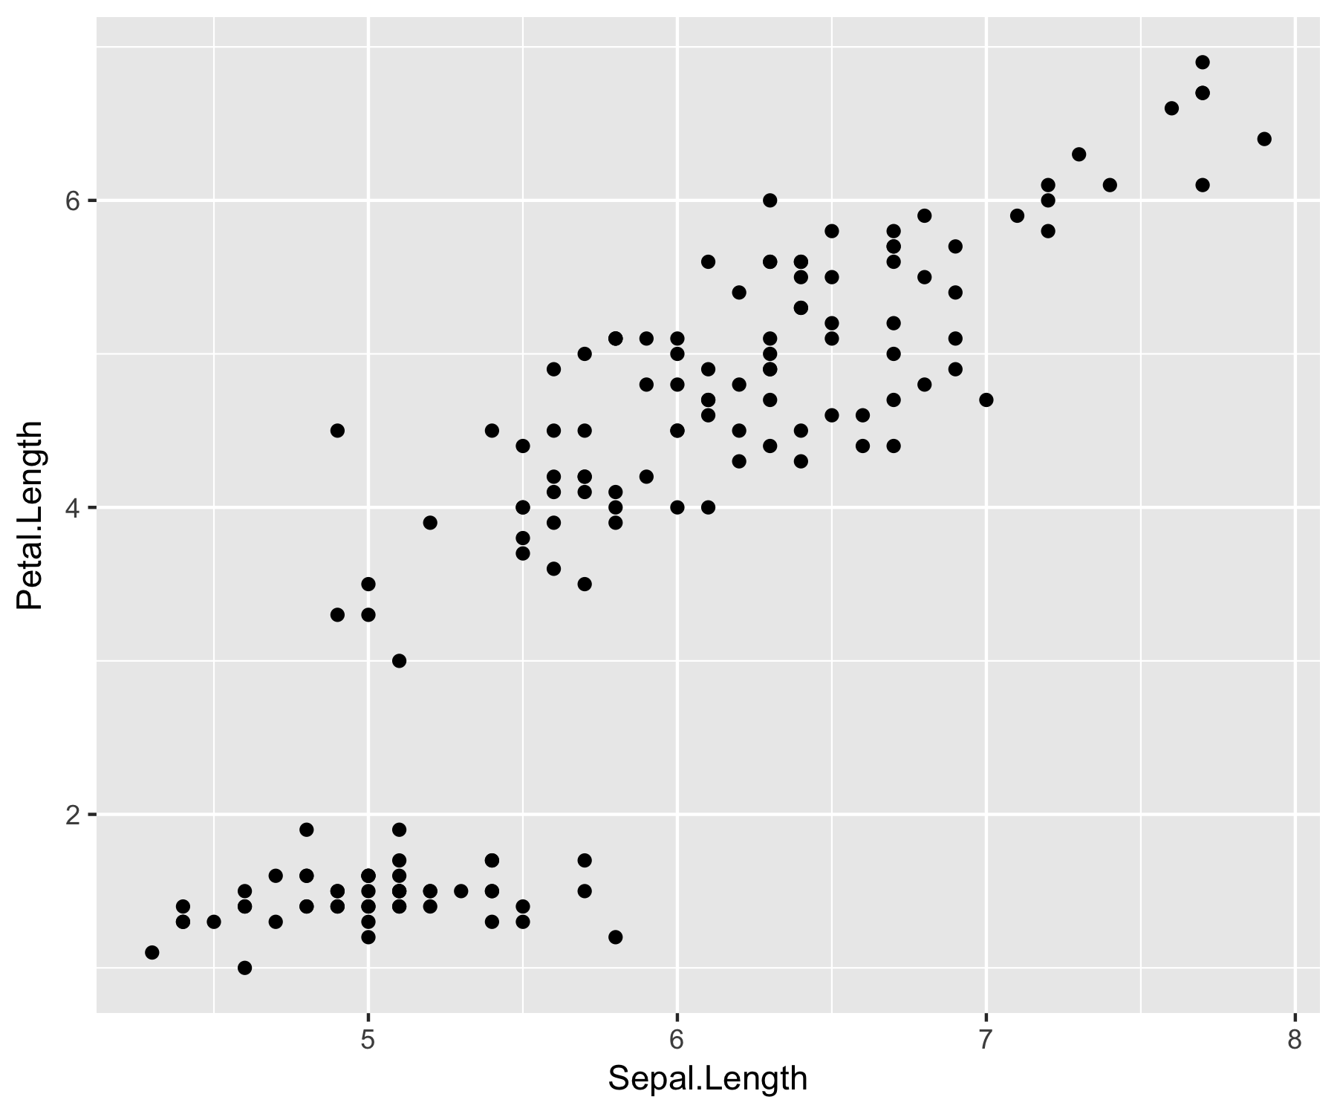

3 - Fig. 1: graph example 1

## plot 2

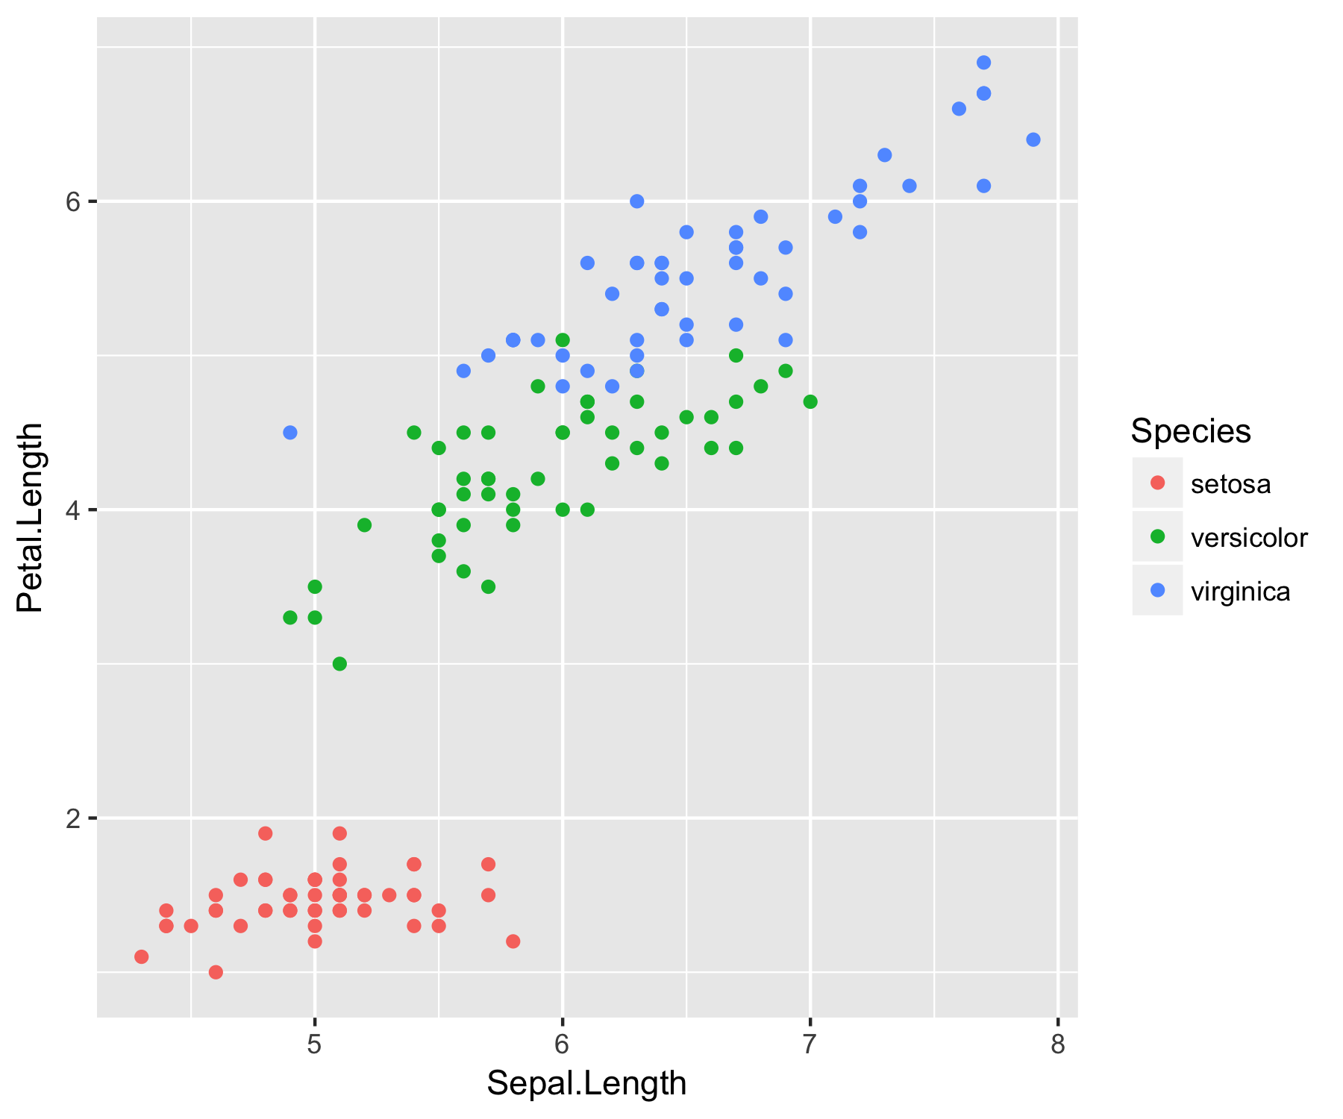

3.1 - Fig. 2: graph example 2

## Table of tables

2.1 - Table 1: data mtcars 1

2.2 - Table 2: data iris 1

## Table of graphics

3 - Fig. 1: graph example 1 2

3.1 - Fig. 2: graph example 2 3