FLipMouse

alternative computer input device

User Manual

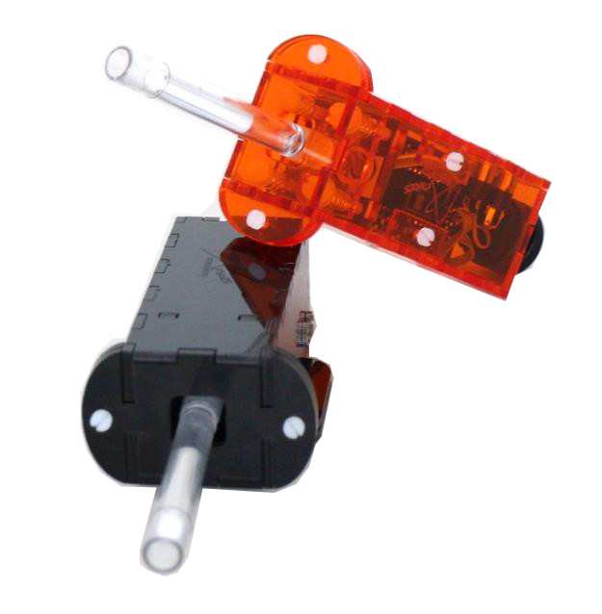



# 

# Preface

The FLipMouse is an open source Assistive Technology module developed by the AsTeRICS Academy project of the University of Applied Sciences, Technikum Wien. The FLipMouse allows control of a computer’s mouse cursor as well as typing desired keyboard keys for people who cannot use standard computer input devices. The FLipMouse device can be actuated with minimal finger- or lip-movements and/or sip & puff activities, via a dedicated joystick- or mouthpiece.

The FLipMouse Graphical User Interface (GUI) is a software application intended for use in conjunction with the FLipMouse device. This user manual includes a description of the Graphical User Interface for the configuration of the different functions of the FLipmouse – as well as explanations of how to use those features. A configured FLipmouse module can be used on any computer without installation of special software as well, because the FLipMouse module behaves exactly like a standard mouse and keyboard which is plugged into the computer.

However, the communication between the FLipMouse module and the FLipMouse GUI application requires installation of a dedicated driver software which creates a communication port (also known as “COM-Port”). The necessary steps for the installation are described on page 4.

The AsTeRICS Academy project.

<http://www.asterics-academy.net>



“Flip”, the vagabound grasshopper,   
cartoon character by Waldemar Bonsels

# Contents

Driver Installation 4

The User Interface 8

Features 14

Cursor Movement 14

Alternative Actions 16

Sip/Puff Actions 22

Buttons Actions 24

View Raw Data 25

Index 27

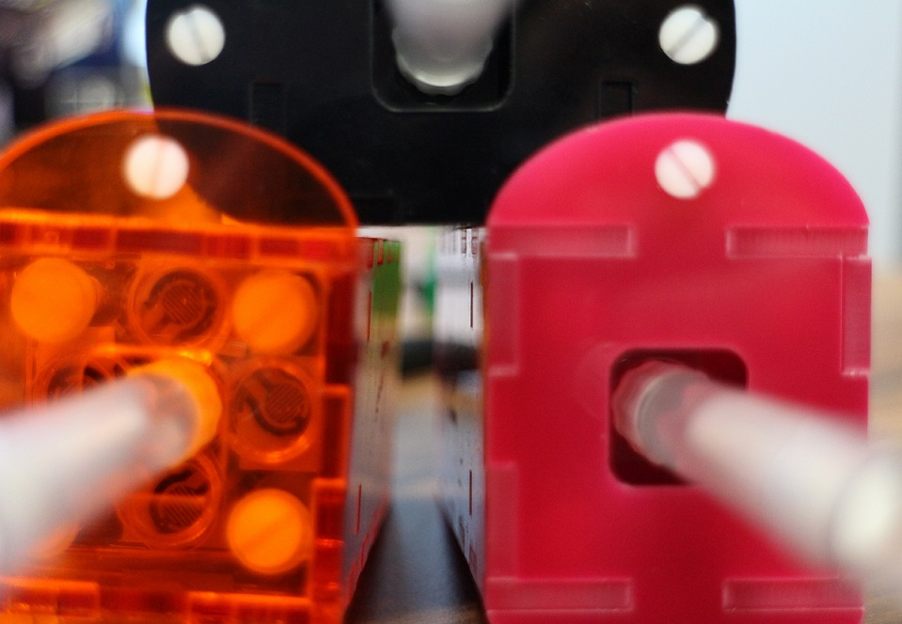

# Hardware overview

The FLipMouse device consists of a microcontroller and several electronic components (like pressure- and force sensors, momentary switches, LEDs etc.) These components are mounted on a custom-made Printed Circuit Board (PCB) which is fixed in a plastic enclosure made from acrylic glass, using a laser cutter.

All design files for electronics and enclosure - as well as the software source code for the microcontroller firmware and the graphical configuration software (FLipMouse GUI) are available as open source. These design- and source code files are part of the AsTeRICS code repository (see: <http://www.asterics.org>) and are separately distributed via the AsTeRICS Academy project website. A construction kit containing a detailed manual for building a FLipMouse from its parts is in preparation and will be made available via the AsTeRICS Academy homepage as well.

**The hardware features of the FLipMouse:**

* A zero-way-joystick: very low forces are sufficient to create up/down/left/right movement
  + The zero-way-joystick can be used with fingers or toes etc.
  + It can also be used as a mouthpiece (actuated by lips / mouth movements).
  + If desired, sip / puff activities into the mouthpiece can trigger additional functions
* One function selection switch, to change the active configuration of functions
* Two 3,5mm jack plug sockets for attaching external switches to trigger additional functions
* Indicator Leds for active configuration, calibration procedure etc.
* Additional upgrade modules for future extension (e.g. universal infrared remote control)

The FLipMouse offers several internal memory slots to store different functional mappings, for example: One slot could hold a configuration where the joystick controls the mouse cursor, another slot could change the joystick function to selected keyboard keys; different mouse clicks could be created by sip / puff actions or the external switches; etc. etc. – there are many possibilities !

The slots can be switched via a desired user input.

Using the FlipMouse GUI application, all those mappings can be defined, viewed and stored into the FLipMouse’s memory, where they stay also when the power supply / USB cable is removed. When you plug in your FLipMouse the next time, the stored slots and settings will be available – no matter if you use another computer or operating system !

# Driver Installation

For the FLipMouse GUI to work, the application needs to be able to send and receive information to/from the FLipMouse device. The information transfer occurs through a communication port (COM port) that is installed on the computer. To install a COM port, please visit the following link and save the installation file:

<https://www.pjrc.com/teensy/serial_install.exe>

When prompted, save the file to the desired location on your computer by clicking “Save” in the bottom right corner.

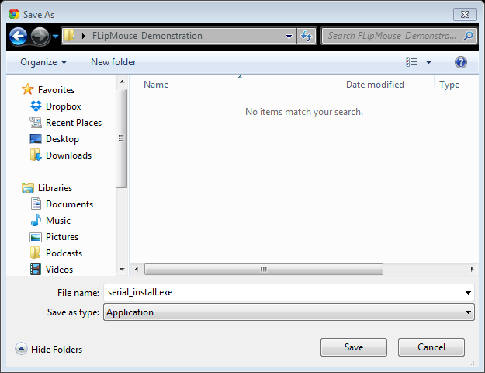

After the file has been successfully saved, start it via a double-click to begin the installation process. The following window will appear after opening the file:

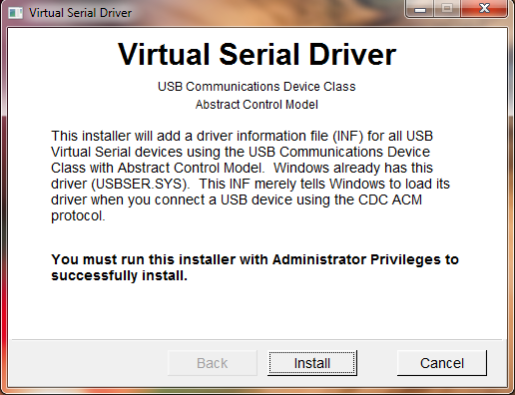

Please make sure you have Administrator Privileges, and click the install button. (If your current user account does not provide Administrator Privileges, right-click the serial_install.exe file and select “Run as Administrator”.

When the installation is complete, the following window will appear:

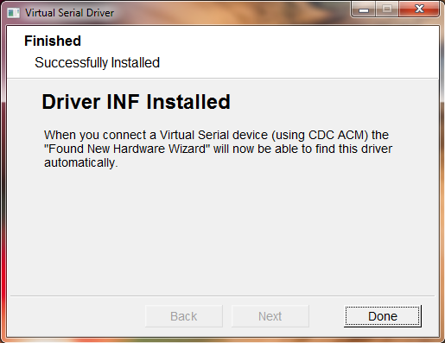

The installation process is now finished; please click the “Done” button.

After finishing installation, please connect your FLipMouse device using a mini USB cable.

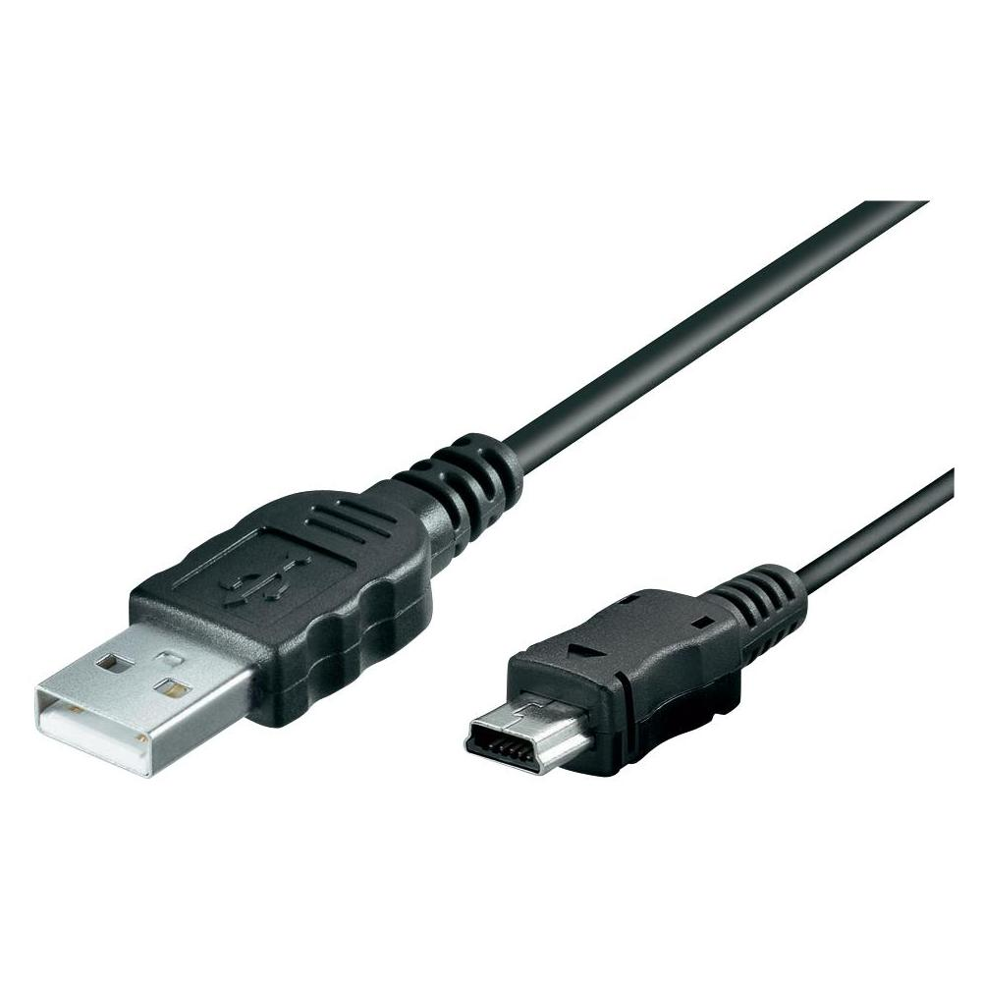

Connect this end to a USB port in your computer

Connect this end to the FlipMouse

After making sure that the device is securely connected to the computer, you may check if the device’s COM port is successfully detected. The detection might take a couple of seconds.

To check if a COM port is detected, go to Control Panel on your computer, and select Device Manager. A window similar to the one below should be opened:

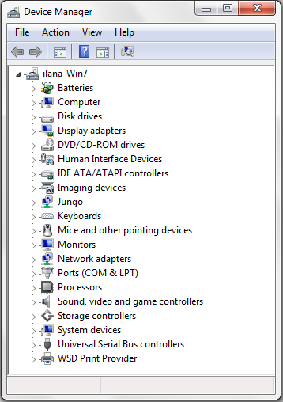

The COM port for your FlipMouse should be here. You can click on “Ports” to extend the list of ports connected to your computer.

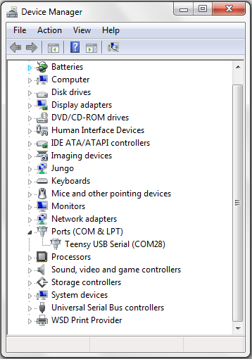

The port name is shown here. In this example it is “COM28”, however the number is arbitrary and gets automatically selected by your computer.

If you see a COM port as in the example above – congratulations! You are now ready to use the FLipMouse GUI.

# The User Interface

To begin using the FLipMouse user interface, you must open (start) the FLipMouseGUI.exe file.

After opening the file, the following window will be displayed:

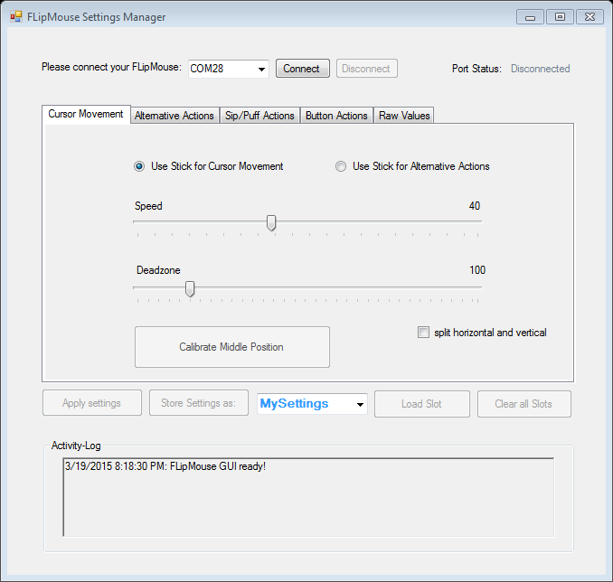

#### Connecting the FLipMouse Device

In order to be able to use the features of the FLipMouse GUI, the FLipMouse device must be connected to the application. To connect the device, follow the following steps:

1. Make sure your device is securely connected to your computer.
2. Select the appropriate COM port (communication port) in the combo box at the top of the application window. If the combo box appears empty, it means that no port has been detected. In this case, please reconnect the device and wait for the COM ports to be updated, and then click on the drop menu to refresh the COM port list or restart the application.
3. Once the COM port is selected, click the Connect button on the right hand side of the combo box. When the device is connected, a confirmation message will appear in the activity log at the bottom of the application window, like the example below:

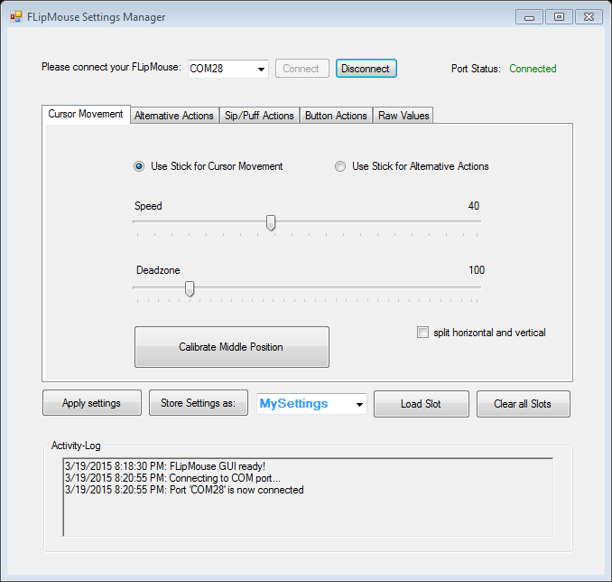

#### Port Status

The port status is located at the top right hand corner of the application window. It displays whether the device is currently connected or disconnected from the user interface. The functions of the user interface may only be used if the port status is “connected”.

#### Activity Log

The activity log is located at the bottom of the application window. It provides messages in accordance to the use of the application.

#### Applying Settings

The settings selected for the various features will not be automatically changed. After you are done fine tuning the features of the FLipMouse to your liking, you may click “Apply settings”. Once the settings have been applied, you will receive a confirmation message in the activity log, and you will be able to use the FLipMouse with the new configuration.

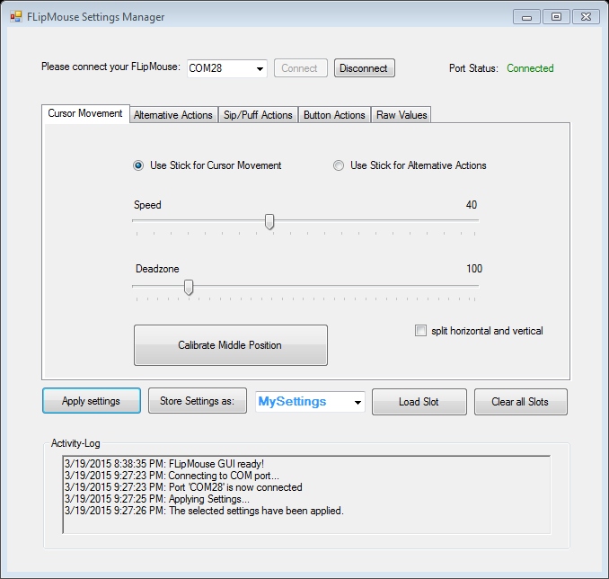

#### Saving, Loading and Clearing Slots

If you have selected FLipMouse settings that you would like to use again, you may save them as a memory slot, which you can later re-load and use.

When you save a new slot, you can first give it a name that will help you remember the configuration. To write in a new name, click on the click on the drop down menu on the right of the “Store Settings as” button.

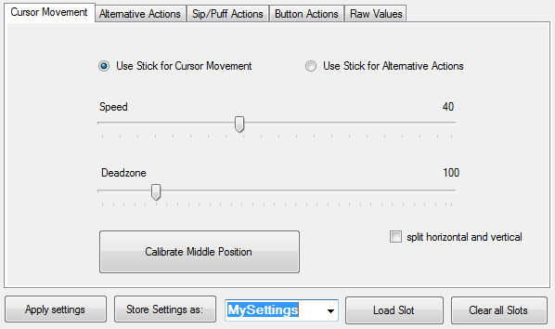

Clicking will highlight the default text, as seen above. You may now the type the new name, which will replace the default text. After typing in the new name, click the “Store Settings as” button.

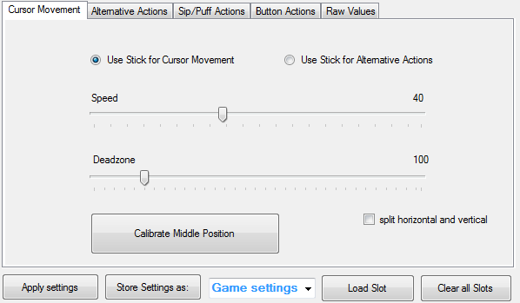

The new name in this example is “Game settings”, which can save the settings for the required input actions when playing a particular computer game

Click this button to save the the configuration under the name entered in blue on the right

When your new configuration is saved, confirmation messages will appear in the activity log:

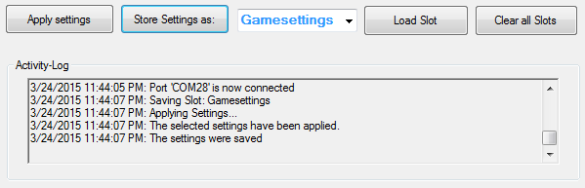

When you store the settings, there is no need to apply them first, because the “store settings” button applies the settings before saving the configuration (as you can see in the activity log shown in the above image). You can save more than one configuration of settings. To save multiple setting configurations, simply change settings for the new configuration and repeat the above steps to save the new setting configuration under a different name.

When you wish to use a particular configuration of the settings which you have saved before, expand the drop down menu by clicking the black arrow and choose the desired configuration. Once you have chosen it, click on “Load Slot”, and the saved settings will appear in the application.

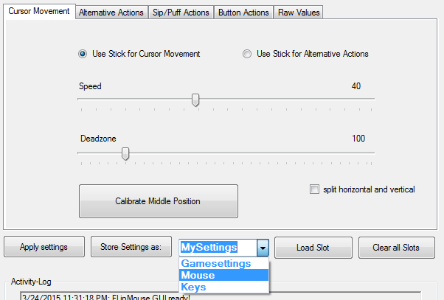

Click “Load Slot” to begin using the saved configuration

Click here to expand the drop down menu and select the slot with the desired configuration

When a slot is loaded, you will receive the following confirmation messages in the activity log:

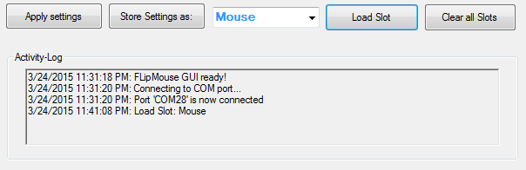

If you would like to change the settings of a saved configuration, follow the next steps:

1. Load the slot (as described above) that you want to change.
2. After the slot is loaded, change the settings as you wish.
3. Click “Store settings as” to re-save the changes to the slot. You will receive the same confirmation messages in the activity log as when you save a slot for the first time (see image in previous page).

If you no longer wish to use any of the saved configurations, you may delete all of them at once by clicking “Clear all slots”.

Confirmation that the slots have been cleared

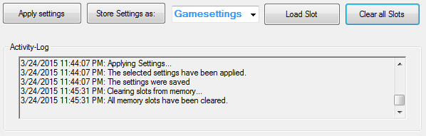

# Features

## Cursor Movement

Cursor movement is the default tab of the user interface. On this tab, you will be able to change the function of the FLipMouse stick, change the speed and deadzone of the FLipMouse, and calibrate the middle position.

#### FLipMouse stick function

By default, the FLipMouse stick is used like a joystick to induce cursor movements. However, stick movements can also be reassigned to other functions, such as pressing the key ‘A’ when the stick is pushed up.

To continue using the FLipMouse stick for cursor movements, make sure “Use Stick for Cursor Movement” is selected, as in the image below. If you would like to assign alternative actions to the stick, please select the “Use Stick for Alternative Actions” option by clicking on the appropriate text or the circle on the left side of the text.



Drag the thumbs of the scroll bars to change the speed and deadzone of the FLipMouse

#### Speed

When using the stick for cursor movement, the cursor can be moved at different speeds. The speed scroll bar displays the selected speed for the FLipMouse and it is also represented by a number on the top right of the scroll bar. A smaller value results in slower speed, and a larger value results in faster speed. To change the speed, click and drag the thumb to the left for slower speed and right for higher speed.

#### Deadzone

The deadzone of a FLipMouse changes the sensitivity of the stick movements. When the deadzone value is very low, very slight stick movements can cause cursor movement, or execute an assigned alternative function if “Use stick for alternative function” is selected. If the default sensitivity is too strong, the deadzone may be increased so that a greater stick movement will be necessary to cause cursor movement. Changing the deadzone is similar to changing speed. Click and drag the thumb of the scroll bar to the left for smaller deadzone and right for a bigger deadzone.

#### Split horizontal and vertical

Moving the cursor on the computer is possible both horizontally (left or right movements, also known as x axis) or vertically (up or down movements, also known as y axis). The speed and deadzone values for horizontal or vertical movements can be individually changed. In order to do that, you may select to split the features by clicking on “split horizontal and vertical”, as shown below.

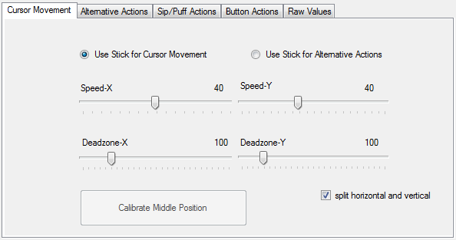

If you decide that splitting the horizontal and vertical movements is not necessary, simply unselect “split horizontal and vertical”, and the speed and deadzone will go back to the default state.

#### Middle point calibration

##### When using the stick for cursor movement, the cursor should stay in place when the FLipMouse is not used. Sometimes the rest position of the mouse may become inaccurate and cause unwanted cursor movements, even if the stick is not used. If the cursor starts moving wrongly, the middle point should be calibrated by pressing the “Calibrate Middle Position” button. Once you click on the “Calibrate Middle Position” button, please try not to move or touch the FLipMouse stick, otherwise the calibration will be done incorrectly. When the button is clicked, the red or rightmost LED light bulb will flash, following by flashing of all of the bulbs. This will last for two seconds, and the device will be calibrated once the bulbs stop flashing, two seconds after the calibration is initialized. When the FLipMouse is successfully calibrated, a confirmation message will appear in the activity log.

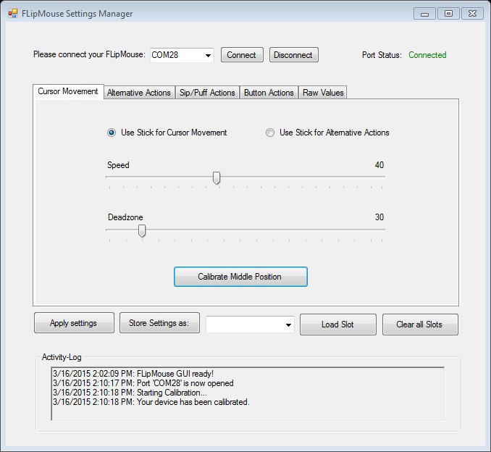

Calibration can also be assigned as an action in response to button pressing, sip/puff actions, or alternative FLipMouse stick actions.

## Alternative Actions

When “Use stick for alternative actions” is selected in the Cursor Movement tab, you may use the Alternative Actions tab to assign alternative actions to the movement of the FLipMouse stick.

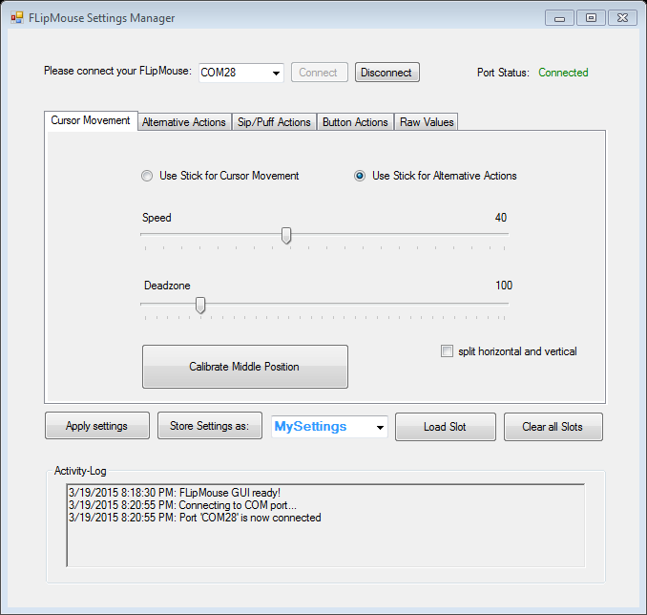

There are four possible FLipMouse stick movements to assign alternative functions to: up, down, right, left. Accordingly, there are four drop down menus from which you may choose an alternative action for each stick movement. To see the options, you must press on the arrow of the drop down menu.

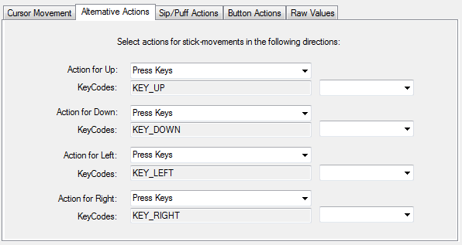

Press here to see more options!

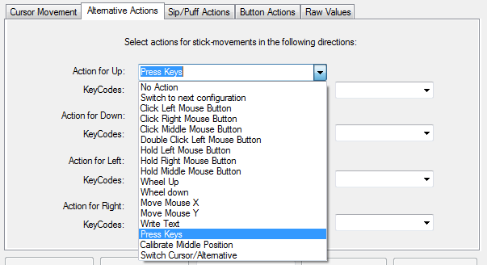

#### Pressing keys

By default, alternative actions for all four possible stick movements are preselected as key presses.

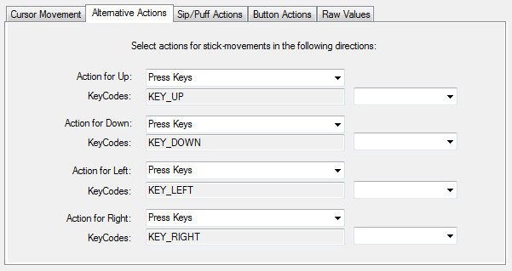

This gray text field is read-only and is automatically filled when selecting a key combination from the drop down menu on the right

This drop down menu includes all the possible key presses.

When a key is selected from the drop down of possible key presses, it is added to the key code field and once the settings are applied, it the key will be pressed whenever the stick is moved to the respective direction. If you would like to change the assigned key, you must select “clear keycodes” before selecting a new key. If you do not clear the keycode prior to reselecting, both keys will be pressed when the stick movement is executed.

Sometimes pressing multiple keys is the desired outcome, so if you would like to press multiple keys at once, simply select the appropriate keys and they will be added to the key code.

Common key combinations include: KEY_CTRL + KEY_ALT + KEY_ DELETE

KEY_CTRL + Z: triggers undo function

KEY_CTRL + C: triggers copy function

KEY_CTRL + V: triggers paste function

#### No action

If “No action” is selected from the function menu, then no action will be done when executing a particular movement. For example, consider the following case:

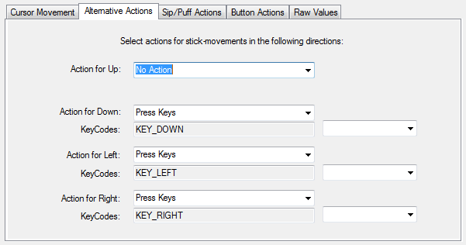

In the picture, “No action” is selected for “Action for Up”. This means that if you move the FLipMouse stick in the upwards direction, nothing will happen.

#### Click left/middle/right mouse buttons

FLipMouse stick movements can act as mouse buttons. You may assign any desired stick movement direction to trigger a right click, a middle click or a left click.

#### Double click left mouse button

Double clicking the left mouse button may be necessary in cases such as opening a file. However, producing a double click with the regular click mouse button function may not be convenient, so you may assign a double click of the left mouse button instead.

#### Hold left/middle/right mouse buttons

The click mouse button options imitate a quick mouse click, however sometimes it is necessary to continue pressing a particular mouse button (for example, when dragging a file, continuously pressing the left mouse click is necessary). For this purpose, the FLipMouse application allows assigning a button holding function to one of the stick movement directions.

#### Wheel up/down

The options “Wheel up” or “Wheel down” emulate a scroll wheel, otherwise known as the mouse wheel. The picture below displays an example of a scroll wheel. Triggering the “Wheel up” option results in upwards scrolling, while “wheel down” results in downward scrolling.

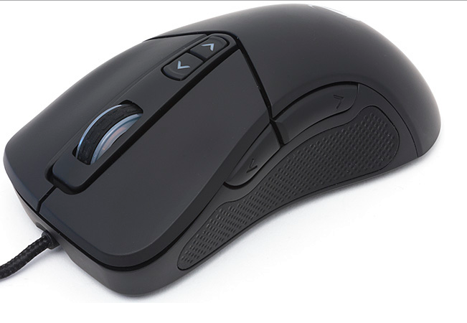

Scroll wheel on a typical computer mouse; allows scrolling in both directions

#### Mouse move X or Y

As mentioned on page 14, the cursor movements on the computer screen occur in both vertical and horizontal direction, where vertical movements are movements across the X axis and horizontal movements are movements across the Y axis. The “Move mouse X” and “Move mouse Y” emulate computer mouse movements and when triggered they result in mouse movements in the selected axis

These two options also require a speed parameter to indicate how quickly the cursor should move in each case. The input field for the speed parameter appears once the mouse move option is selected.

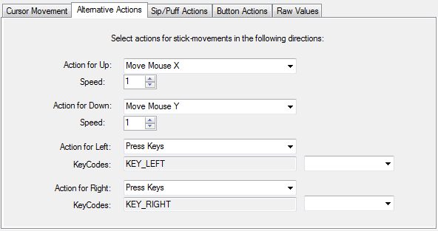

Speed parameters for each of the mouse movement options. Press the upwards or downward arrows to increase or decrease the speed, or press on the number to type in the speed manually

Mouse movements are assigned for two actions

#### Write text

The “Write text” option allows you to type a particular text excerpt each time you perform an action (for example, write “Hello” when you move the FLipMouse stick up).

When you select “Write text”, a blank text box will appear under the drop down menu as shown below:

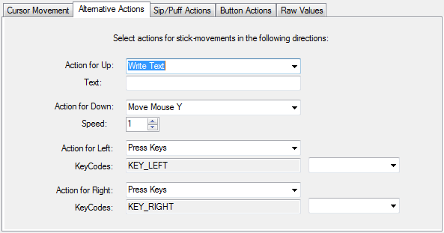

Write text here

Click on the text box and type the desired text.

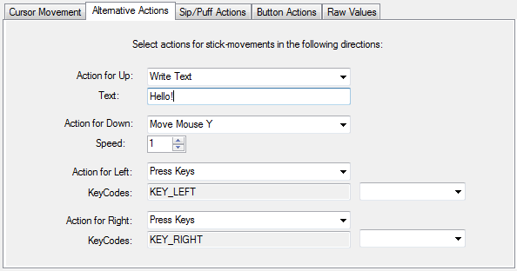

In this example, “Hello!” will be written each time the FlipMouse will be moved upwards

#### Calibrate middle position

For an extended description of calibration please refer to page 15 where the “Middle point calibration” button is described. You may assign the action of the calibration of the middle position to one of the alternative actions, instead of having to use the calibration button on the cursor movements tab every time you need to calibrate the middle position of the FLipMouse stick. To assign this action, simply choose it from the drop down menu.

#### Switch cursor/alternative

This action is equivalent to the following options in the cursor movement tab:

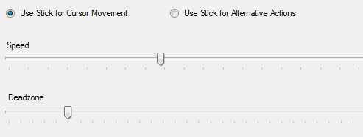

This option allows switching between using the FLipMouse stick to perform cursor movements and using the stick for alternative assigned actions. Although this option can be assigned as one of the alternative actions for the FLipMouse stick, it is better if it is assigned either to the buttons or the sip/puff actions (see next sections). If it is assigned as alternative actions, you will only be able to switch it once (from alternative actions to cursor movement but not vice versa).

#### Switch to next configuration

This action is only relevant if you saved multiple FLipMouse setting configurations to memory slots as described on page 11. Once you have multiple configurations saved, you can assign the action of switching between the configurations saved on different slots in the application. When you switch from one configuration to next, the built in LED bulbs will change accordingly.

There are three built in LEDs (red, yellow-orange, green), which will display the binary number for the slot position of the configuration that you have selected. In other words, if you saved two configurations: Game settings and Mouse, game settings will be position 1 and Mouse will be position 2. The following are the configuration of the LEDs for each position number:

Position 1 will be displayed as 1 shining bulb:

Position 2 will be displayed as 1 shining bulb:

Position 3 will be displayed as 2 shining bulbs:

Position 4 will be displayed as 1 shining bulb:

Position 5 will be displayed as 2 shining bulbs:

Position 6 will be displayed as 2 shining bulbs:

Position 7 will be displayed as 3 shining bulbs:

The bulbs only allow unique displays for 7 different slots; however you may save on more than 7 slots.

## Sip/Puff Actions

When using the FLipMouse stick with the mouth, the user can trigger functions by sipping or puffing through the tube. The tube is connected to a pressure sensor, which outputs a number that corresponds to the detected pressure. When the user sips, the sensor value decreases, and when the user puffs the value increases.

You may assign an action for sipping or puffing in the same manner as assigning alternative actions in the previous section. The difference for sip/puff actions is that you can select the threshold for the sipping and/or puffing according to how strongly you would prefer to sip or puff. When the FLipMouse is connected, you can check how the pressure values change in the Sip/Puff Actions tab prior to assigning the threshold.

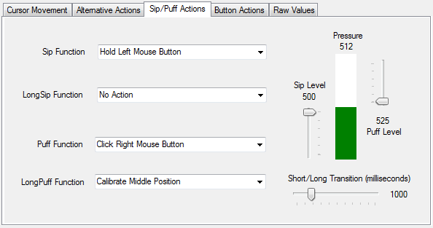

Use these scroll bars to adjust the threshold pressure for sip (left) or puff (right)

Observe pressure changes here (green bar increase/decrease)

Select sipping and puffing actions here

#### Long sipping and puffing

The actions triggered by sipping/puffing will be performed right after the assigned threshold is crossed. However, there is also an option to trigger a second option when sipping/puffing for a long time. The specific length of time that will be required can be adjusted for up to 5000 milliseconds (5 seconds).

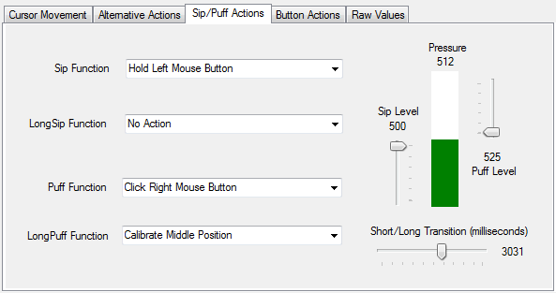

Choose long sip or puff action from this drop down menu

Drag the thumb of the scroll bar to increase or decrease the time required to trigger a long puff/sip action

Beware that executing a long sip or puff will also first trigger a regular sip/puff action, if it is assigned. If you do not want to trigger another action before triggering a long sip/puff action, please select “No action” for the regular sip/puff actions.

## Buttons Actions

The FLipMouse has one built in button that is ready to use on its side (referred as “Button 1” in the application), as well as two plugs where two extra buttons may be plugged (will be referred as buttons 2 and 3 in the application). These three buttons can have all of the possible actions that may be can also be assigned in the sip/puff and alternative actions tab. Please refer to the Alternative Actions section for explanation of the possible actions for the buttons and their assignment.

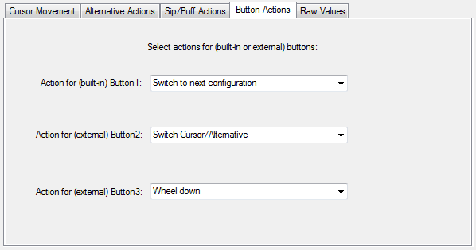

## 

## View Raw Data

The FLipMouse stick is connected to four sensors for each movement direction (up, down, left, right). The numeric value of each of those sensors is displayed in the Raw Data tab. When the stick is moved, the sensor values change. Specifically, a movement in each direction increases the respective sensor value. The sensor values also depend on how tightly the device is assembled, therefore when assembling the FLipMouse, the raw sensor data can be used as guidance.

By default, the raw data tab looks like this:

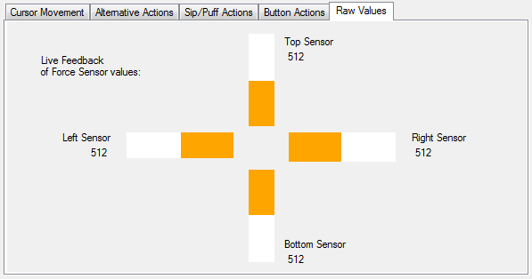

Prior to the connection of the FLipMouse device to the application, all sensors are set as 512, however these are not “real sensor values”. The sensor values will synchronize with the real sensor values once the FLipMouse is connected to the application.

# Index

Activity Log, 9, 10, 12, 13, 16

Calibrate, 14, 15, 22

COM port, 4, 6, 7, 8, 9

Cursor, 14, 15

Deadzone, 14

Keycodes, 18

Load, 11, 12, 13

Port Status, 9

Sensor, 23, 25, 26

Slots, 13, 22

Speed, 14, 15, 20