## Tutorials for VirtualBox network modes

http://www.virtualbox.org/manual/ch06.html

## Configure gateway network adapter on host computer

The network adapter on the host computer that connects to the Internet must be configured to be the gateway for the VirtualBox Host-Only Network.

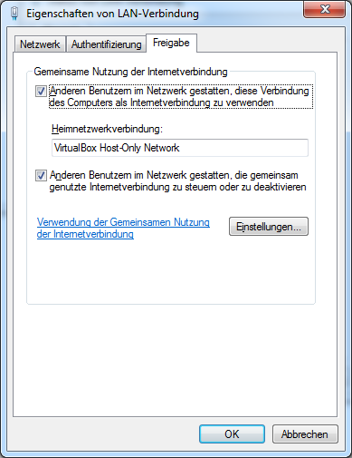

## Setup Host-only networking

<http://www.thomas-krenn.com/de/wiki/Netzwerkkonfiguration_in_VirtualBox#Host-only_networking>

## Configure VM-Image to use Host-Only networking

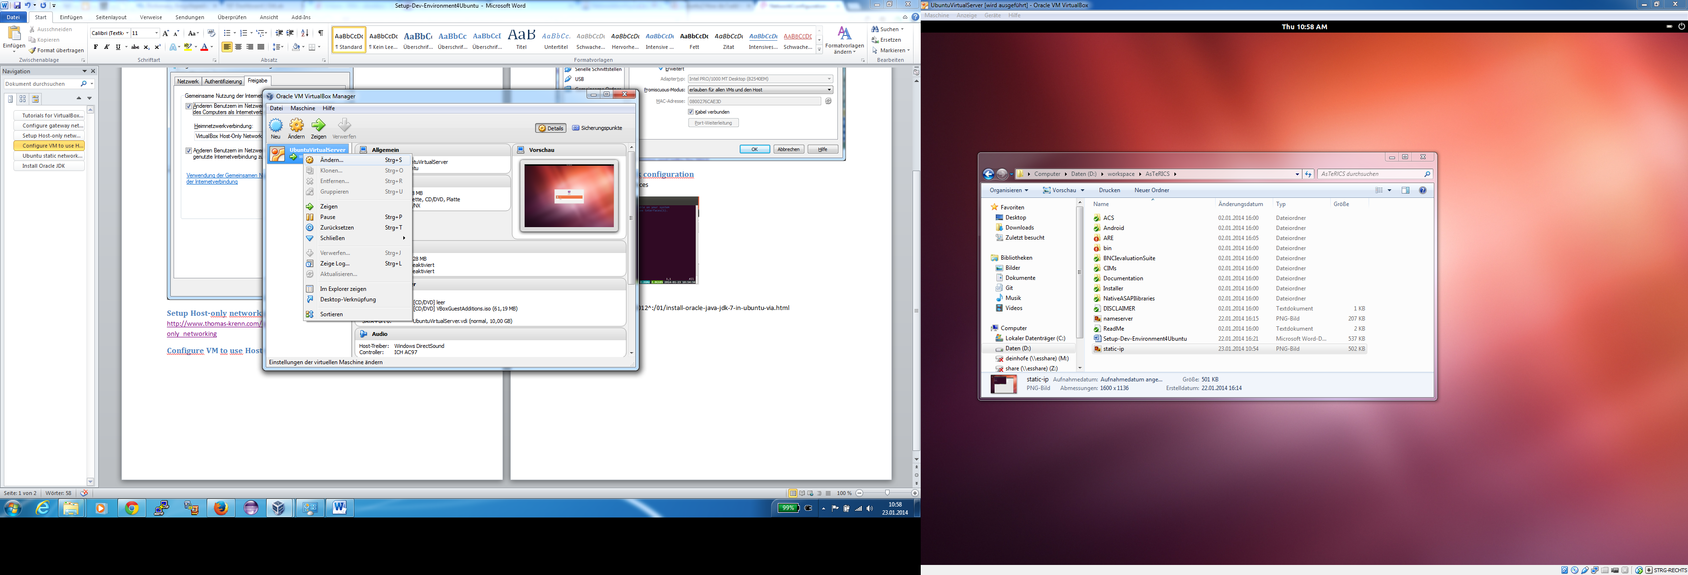

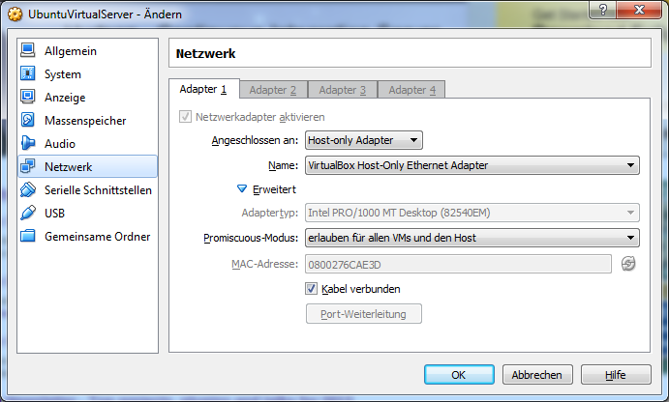

## Ubuntu static network configuration

sudo vi /etc/network/interfaces

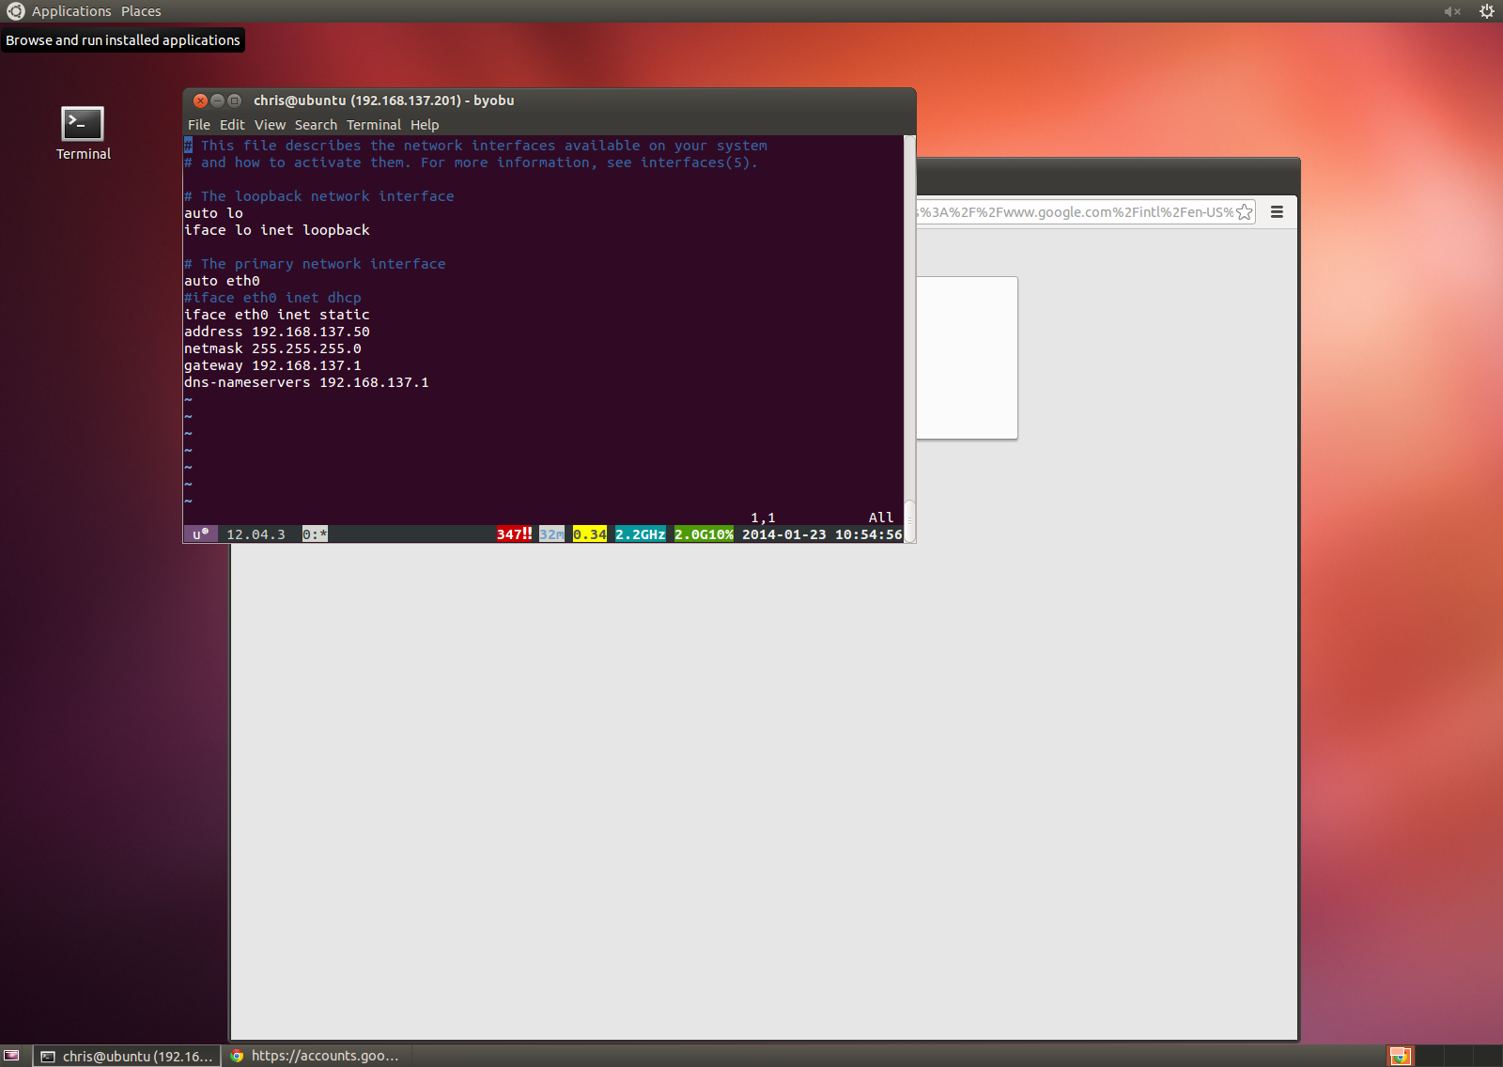

## Install Oracle JDK

<http://www.webupd8.org/2012/01/install-oracle-java-jdk-7-in-ubuntu-via.html>

## Install and configure Eclipse Kepler for Ubuntu

http://wiki.ubuntuusers.de/Eclipse