STARVIVORS
MVP HUD and UI Layout Guide
Neon Tactical Vector direction - standalone reference for future ChatGPT/Codex sessions

This document locks the current MVP HUD direction for STARVIVORS. It is designed to be pasted into or uploaded to a new session as visual and functional context for the in-game interface.
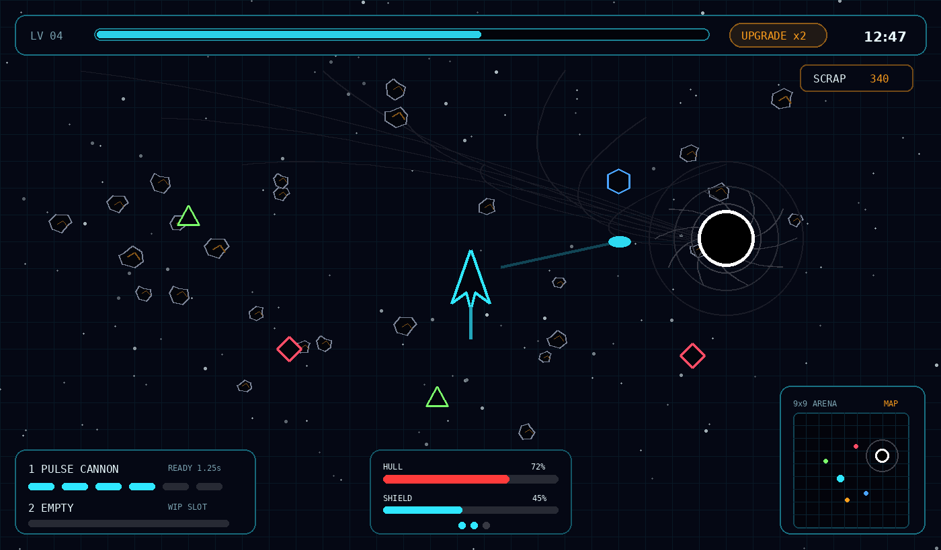
Full HUD mockup: gameplay view with top XP/timer bar, scrap readout, weapon panel, hull/shield panel, and minimap.

1. Locked HUD Direction
The MVP HUD uses the Neon Tactical Vector visual language: dark tactical sci-fi base, cyan structural lines, white information text, orange action/resource highlights, and red danger states.
- Readable at high speed and low visual clutter.
- HUD panels are translucent so the arena remains visible.
- XP and upgrade state are the highest priority information.
- Minimap replaces off-screen black hole indicators.
- The black hole is also communicated naturally through gravity pull, debris movement, and world-space flow lines.

2. HUD Zone Layout
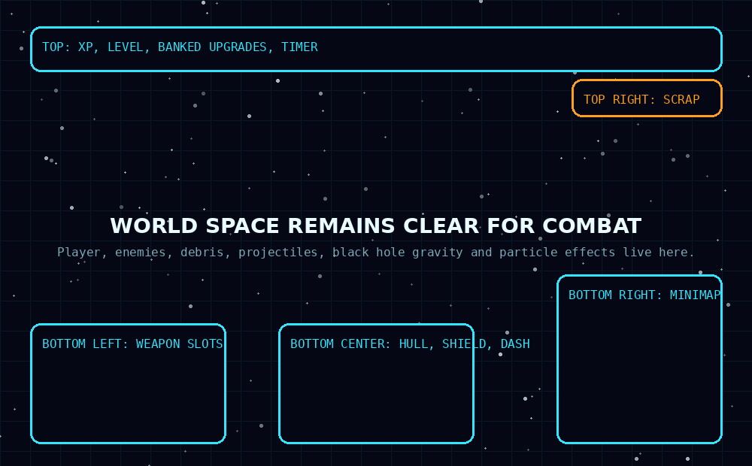
HUD zones: top progression, bottom-left weapons, bottom-center survival, top-right scrap, bottom-right minimap.

Top Zone - Progression and Time
The top bar contains level, XP progress, banked upgrade count, and the run timer. This bar should remain visible at all times.
- XP bar spans most of the top width.
- Level appears at the left of the XP bar.
- Banked upgrades appear as an orange capsule button, for example: UPGRADE x2.
- Timer appears at the far right of the top bar.

Bottom-Left Zone - Weapons
The bottom-left panel displays the two weapon slots. The active MVP Interceptor example shows Pulse Cannon in slot 1 and an empty WIP slot 2.
- Weapon names should be short and uppercase.
- Cooldown/charge state should be visual first, text second.
- WIP or empty slots may be visible but must be clearly labeled and not mistaken for broken content.

Bottom-Center Zone - Survival
Hull, defensive shield, and dash pips sit near the player eye-line. This should be separate from Bulwark Ramming Shield charge, which belongs to the weapon panel because it acts like a weapon resource.
- Hull uses red.
- Defensive shield uses cyan.
- Dash pips use cyan when ready and muted gray when unavailable.

Top-Right Zone - Scrap
Scrap is shown in a compact top-right panel. It is important but lower priority than XP, survival, and weapon state.

Bottom-Right Zone - Minimap
The minimap is the strategic awareness tool for the 9x9 viewport arena. It replaces off-screen black hole arrows or warnings.

3. Minimap Design
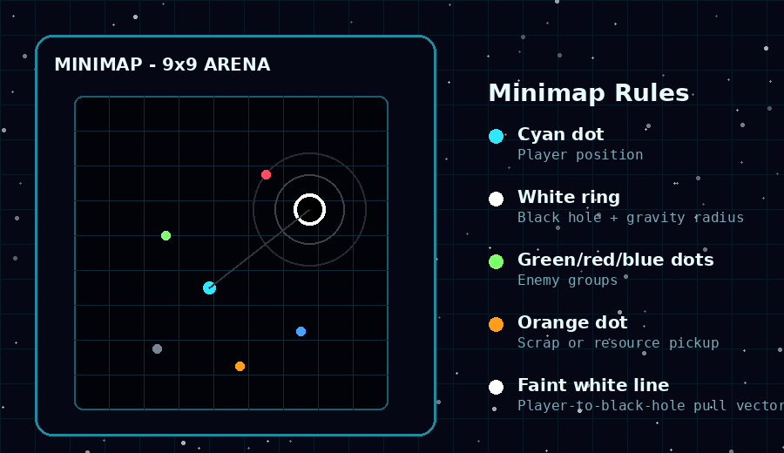
Minimap detail: player, black hole, gravity radius, enemies, pickups, and faint pull vector.
The minimap shows the full 9x9 arena as a small grid. It should be readable at a glance and never become a decorative radar that distracts from combat.
- Cyan dot: player.
- Black dot with white ring: black hole.
- Faint white ring: black hole gravity radius or threat radius.
- Colored dots: enemies by broad type, not every exact unit when density is high.
- Orange dot: scrap/resource pickup or important loot.
- Faint white line: optional pull vector or relationship between player and nearest black hole.
Black hole danger should be communicated through both minimap information and world-space behavior. Nearby debris should visibly accelerate and spiral toward the black hole as the player approaches its gravity influence.

4. Full HUD Mockup Notes
The mockup demonstrates how the HUD should sit over active gameplay without covering the center combat area. The player, enemies, debris, projectiles, and black hole remain visible in world space.
- The center of the screen is reserved for player movement and immediate threats.
- Panel corners are rounded but restrained, with thin cyan borders.
- Panels should use dark translucent fill rather than solid opaque blocks.
- Orange indicates action or resource value: banked upgrades, scrap, map label.
- White is reserved for critical neutral information and black hole event rings.
- Red is reserved for danger and hull state.

5. Upgrade UI Rules
The banked upgrade system affects the HUD directly. The game does not auto-pause when XP fills. Instead, the player banks upgrades infinitely and chooses when to spend them.
- When no upgrade is available, the top bar does not show the orange upgrade capsule.
- When one or more upgrades are banked, the orange capsule appears: UPGRADE x1, UPGRADE x2, etc.
- Clicking the capsule or pressing the upgrade hotkey opens the upgrade overlay and pauses gameplay.
- After selecting an upgrade, one banked upgrade is spent. If more remain, the player may choose another or return to combat.

6. Bulwark HUD Variant
Bulwark needs an additional weapon-resource readout because the Ramming Shield is both offense and temporary collision protection. This should appear in the bottom-left weapon panel, not in the bottom-center survival panel.
- Slot 1 label: RAMMING SHIELD.
- Charge bar uses orange because it is an active weapon resource.
- Low charge can flicker or dim, but should not use red unless the shield is fully depleted and the player is exposed.
- Regular defensive shield remains cyan in the bottom-center survival panel.

7. Implementation Notes for Codex
- Implement HUD as modular components: TopProgressBar, WeaponPanel, SurvivalPanel, ResourcePanel, MinimapPanel.
- Do not hardcode random UI colors across files; use a central Neon Tactical palette.
- The minimap should read world state and scale positions from the 9x9 arena to minimap coordinates.
- Only show WIP labels in HUD when they describe intentionally inactive slots; WIP content should not enter active random gameplay pools.
- Keep HUD layout responsive, but design the MVP first for desktop 16:9 gameplay.

8. Locked MVP HUD Summary
The MVP HUD is locked as a Neon Tactical Vector combat interface. The top bar tracks XP, banked upgrades, and time. Weapons live bottom-left. Hull, shield, and dash live bottom-center. Scrap lives top-right. A bottom-right minimap shows the 9x9 arena, black holes, enemies, and important pickups. The black hole is not handled through off-screen arrows; it is communicated through the minimap and through natural world-space gravity effects.

