STARVIVORS
MVP Visual Identity Guide - Locked Direction
Chosen style: Neon Tactical Vector
This document locks the MVP visual direction for STARVIVORS. It is intended to be pasted into future ChatGPT/Codex sessions as the visual source of truth. The style prioritizes gameplay readability, geometric silhouettes, strong contrast, and particle impact without requiring traditional art assets.

1. Locked Visual Direction
- Dark tactical sci-fi base.
- Neon arcade readability.
- Geometric vector ships and enemies.
- Bright weapon effects with restrained glow.
- High-contrast black hole visuals: black void, white event ring.
- Clean HUD using cyan, white, and orange accents.
- Particles are used for impact, feedback, and physical motion, not decoration.

2. MVP Palette
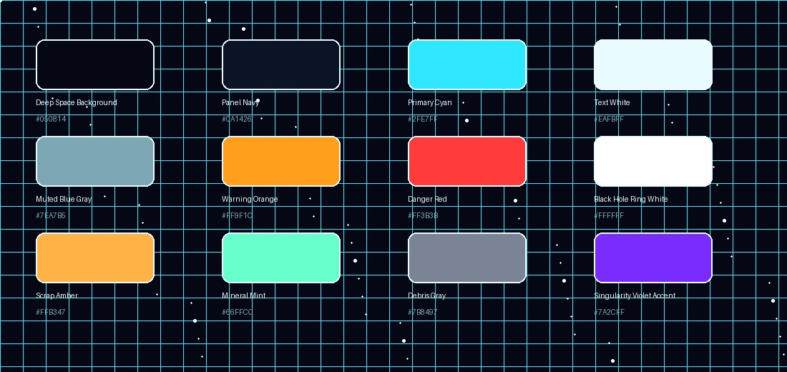
Use | Color | Hex
Deep Space Background |  | #050814
Panel Navy |  | #0A1426
Primary Cyan |  | #2FE7FF
Text White |  | #EAFBFF
Muted Blue Gray |  | #7EA7B5
Warning Orange |  | #FF9F1C
Danger Red |  | #FF3B3B
Black Hole Ring White |  | #FFFFFF
Scrap Amber |  | #FFB347
Mineral Mint |  | #66FFCC
Debris Gray |  | #7B8497
Singularity Violet Accent |  | #7A2CFF

3. Player Ship Visual Rules
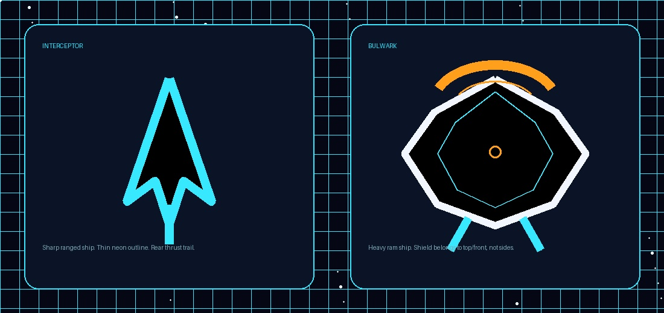

Interceptor
- Sharp triangular dart silhouette.
- Cyan outline with dark interior fill.
- Rear cyan-white thrust trail.
- Reads as fast, fragile, ranged, and precise.
- Pulse Cannon fires from the nose/front point.

Bulwark
- Heavy ship-like armored hull, not just a shield icon.
- Broad geometric body with internal cyan structural lines.
- Ramming shield is on the top/front of the ship.
- Shield appears as an orange-white arc/crescent at the nose/front.
- Rear/side thrusters are visible so it still reads as a spacecraft.
- Reads as durable, forceful, melee, and impact-driven.

4. Black Hole Visual Rules
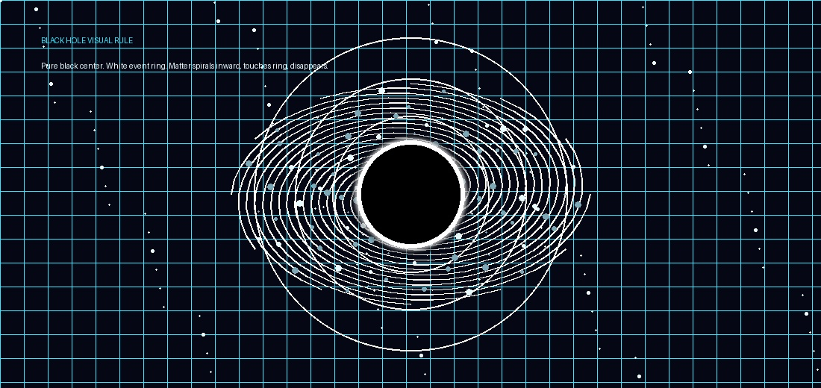
- The black hole center is fully black.
- The event horizon is a bright white ring.
- No colorful accretion disk for MVP.
- Matter, debris, particles, and visual fragments are dragged radially inward or spiral/orbit slowly.
- Objects disappear when they contact or cross the white ring.
- Outer gravity indicators should be faint white circles or subtle field lines.
- The effect should feel threatening and readable, not decorative or noisy.

5. Enemies, Debris, and Pickups
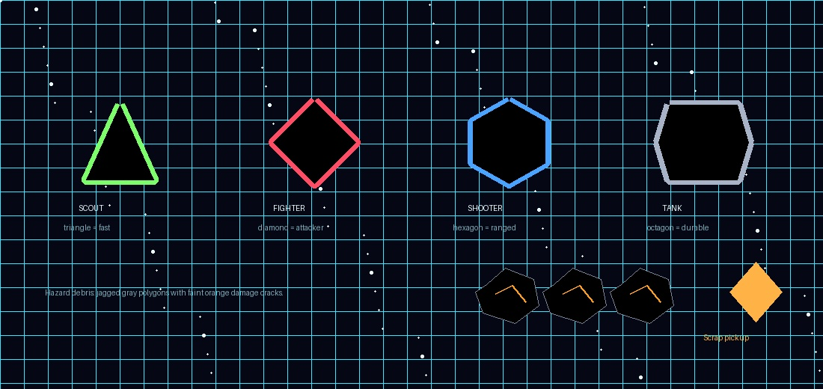

Enemy Shape Language
- Triangles communicate fast chasers or scouts.
- Diamonds communicate standard attackers.
- Hexagons communicate shooters or technical enemies.
- Squares/octagons communicate tanks and durable enemies.
- Stars should be reserved for elites or bosses later.
- Enemy identity should be readable from silhouette first, color second.

Hazard Debris
- Hazard debris is jagged gray polygon wreckage.
- It may show faint orange cracks or sparks when damaged.
- It is physically dangerous and visually distinct from collectible scrap.

Scrap and Minerals
- Scrap pickups use amber/gold diamond-like shapes.
- Minerals use mint/cyan crystal shapes and are WIP unless implemented.
- Collectibles should sparkle lightly but not resemble hostile debris.

6. Weapon and Particle Rules

Pulse Cannon
- Cyan-white glowing oval or compact energy pulse.
- Short cyan trail.
- Small circular pulse burst on impact.
- Starting fire rate is deliberately slow, around 1.25 seconds per shot.
- Each shot should feel readable and valuable early in the run.

Ramming Shield
- Shield state is communicated by the front/top arc brightness.
- Charged shield: bright orange-white crescent.
- Low shield: dimmer or flickering arc.
- Empty shield: arc nearly disappears or shifts toward warning red.
- Ram impact uses a burst of orange-white particles and short streaks.

Particle Philosophy
- Particles must communicate action: hits, deaths, rams, pickup collection, black hole pull, shield recharge, and debris breakup.
- Avoid constant decorative particle noise that hides enemies or projectiles.
- Impact particles can be bright; ambient particles should be subtle.

7. UI and WIP Tag Rules
- HUD style: dark translucent panels, thin cyan borders, white text.
- Warnings use orange. Critical danger uses red.
- XP bar belongs at the top of the screen.
- Banked upgrades must be clearly visible as UPGRADE xN.
- WIP content may be shown in menus, but must be visibly tagged WIP and must not be selectable unless implemented.
- Implemented, MVP, WIP, Locked, Future, and Disabled should each have consistent visual tags.

8. Codex Implementation Notes
- Represent the visual style as data/constants rather than hardcoded random colors.
- Create ShapeRenderer, BlackHoleRenderer, ParticleRenderer, and UIRenderer modules.
- Keep black hole visual rendering separate from black hole physics.
- Keep ship silhouette data separate from ship stats.
- Only implement Neon Tactical Vector for MVP. Do not maintain multiple visual themes in active gameplay.
- WIP content can exist in registries but must not enter active gameplay pools unless enabled.

9. Final MVP Visual Lock
The MVP visual style for STARVIVORS is locked as Neon Tactical Vector. The Interceptor is a cyan dart-like ranged ship. The Bulwark is a heavy ship-like ram vessel with its ramming shield on the top/front. The black hole is a pure black void with a white event ring; matter is pulled inward or spirals until disappearing at the ring. The rest of the game uses simple geometric silhouettes, strong readability, cyan/white/orange HUD language, and particles only where they improve feedback.

