By: Alfredo Martinez

Date: 2/1/2018

**Clustering Stocks Data for Portfolio Diversification and Management**

**Introduction**

Asset selection and allocation are critical challenges financial institutions and investors deal with every year, as the market changes, assets move from one place to another, continually creating new portfolios. A popular and proven method used today when it comes to minimizing risk and maximizing return comes from building a well-diversified portfolio of stocks. An approach to cover the challenges of making a well-diversified portfolio and finding risk levels on assets is through clustering of shares based on historical risk and other metric values.

**Purpose**

The purpose is to group stocks base on similar data values, so these stocks can be pick from within the given groups by the clustering model, giving the investor an easy, time effective way to find a clearer picture on how a stock compares to others as far of risk levels and other key features.

**Client**

The clients are general market investors who want a data-driven system that can quickly analyze and give back specific details about different stocks.

**Dataset**

The two different data sets used came from Quandl and Nasdaq websites.

Quandl Dataset

The dataset consisted of 3,996 different codes, each representing a different company stock from different countries. There were 14 quantitative variables present for each share

Nasdaq Dataset

The dataset included 2,457 different North America Stocks consisting of 8 different quantitative and qualitative variables

Combine Dataset: Open-Filter-Combine-Historical Stock Prices

After all available company codes were open, the historical prices data set consisted of 6,553,424 data points and 24 different qualitative and quantitative variables.

**Cleaning and Wrangling Data**

The early first steps to working with both of the data files consisted of building each of them separately into data frames. The data frames were joined into one single filtered data frame comprising of all North America stock companies that were within both datasets. After doing this, the new data frames returned a value of 1,135 stocks companies.

For the new data frame, a for loop was used to iterate and open all the historical prices and quantitative variables available for each stock. After obtaining the new processed data frame, this was saved to the local disc as a (.csv) file and reopen to a new data frame for faster access.

For the new file, the most significant steps taking to clean our data consisted of:

1. Drop the unnecessary columns for the type of analysis.
   1. Certain features in the document had almost no values (NaN), others had irrelevant data or merely added much value to our end goal analysis.
2. Build the ‘Date’ column into a DateTime format.
   1. The column was originally set as object values and was changed to a time series datetime64[ns] value to set and keep track of the historical data for each company.
3. Build feature ‘publicly traded years’ for each company.
   1. The feature was built before any other one as we needed the historical dates for each company.
4. The model and analysis was built to represent values for the year 2017
5. Slice ‘WIKI/’ out of ticker values, change features with scientific values to integer values.
   1. The step was done mainly for static reasons and to have a better visual of the values at hand
6. Calculate the average daily dollars traded, daily return, daily standard deviation, daily Sharpe ratio and dividend yield for each stock.
   1. Each feature gives a stock's data value concerning market risk.
7. Check feature values and set to the right format.
   1. The data points for Market Capitalization and Average Daily Returns were converted to float values as these were a more suited format for what they represented.

The results gave a data frame table with an index and seven different columns, from which index represented the stock label for each company, and the seven columns consisted of the built features relatively to market risk.

**Limitations**

Before further going through the analysis, it is important to point out that there are certain limitations into the work done in these project, but can certainly be extended to a closer representation of the entire market analysis. Some of the key limitations include:

1. The Usage of only North America companies in our analysis
2. A single year of data(2017), a year where the market was up
3. No examination of the market segment/industry for these companies

**Other Potential Datasets**

As cover before the data use for this work came directly from Quandl and Nasdaq websites. Both of the sites had different types of data which could potentially be used within the system as well. (e.g.) Nasdaq website at the moment contains other tables which can be directly downloaded and also used; some of these include files representing publicly traded companies in different exchanges, regions, industries and market caps. On the other hand, Quandl gives access several other records either at a premium price or free. (e.g.) Files with publicly traded companies financial ratios and statements.

**Analysis of Data/Model Build Up**

**Data Split**

Splitting our data was performed as to test whether the number of set clusters is still appropriate to unseen data. We split our data into a train (70 % of data) and test (30 % of data) objects.

**Data Scale**

To have our data work correctly in the clustering model we needed to scale our data since some features in the datasets had different magnitudes of numerical values.

The steps taking were performed in both our train and test data and consisted as follow:

1. Turning data frame’s features columns into a matrix of values.
2. Input the new matrix with values into our preprocessing scaling function. For this dataset, we used the standard Scaler with gives each feature a mean value of 0 and a variance of 1.

**Setting Number of Clusters**

The Elbow and The Silhouette Methods Analysis are implemented to trying to find an adequate amount of cluster to use. After running both methods, they gave insights towards a three-cluster as the most reasonable and efficient number of groups to level our data points.

**Elbow Method**

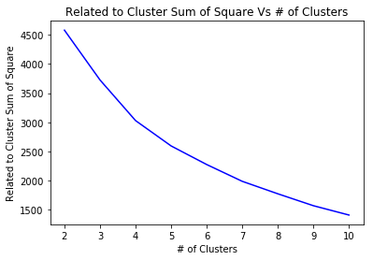

**Silhouette Method:**

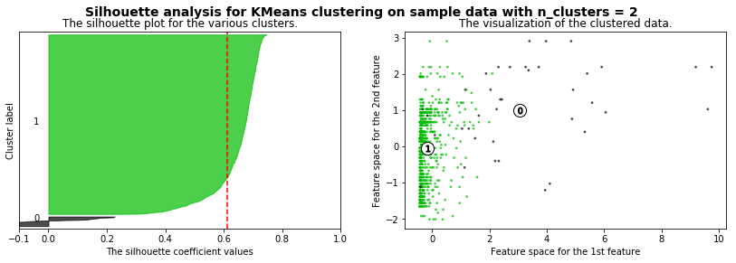

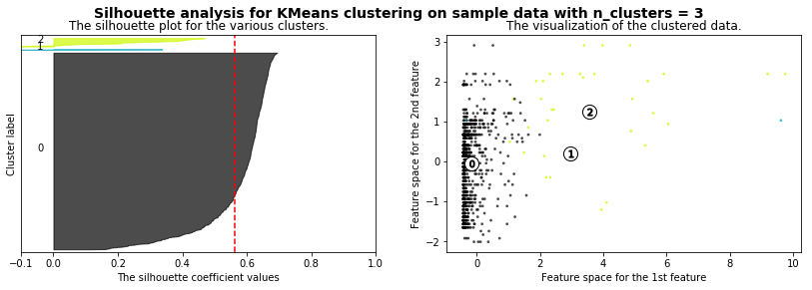

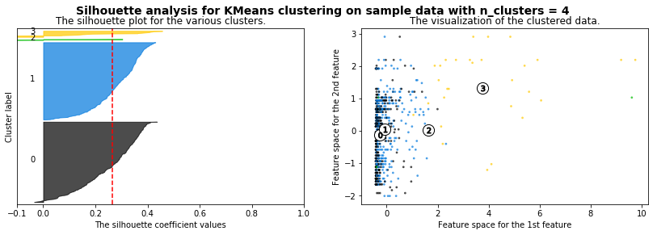

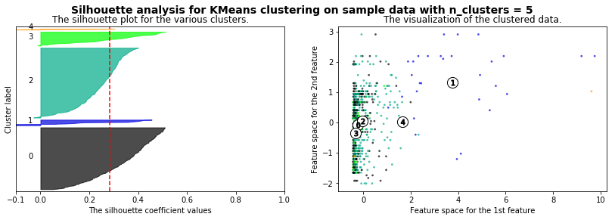

**Model**

K-means++

The apply model is base on K-means++ model, which in this case each of our data points belong to one of our five clusters nearest mean. K-means++ method is one of the most effective algorithms use today for choosing starting values; it is considered a smarter and more reliable method. This cover the shortcoming the standard k-means model currently have.

PCA

We use Principal Component Analysis to reduce the dimensionality of our classification algorithm and try to uncover any further type of relationship between our data. The number of components used for the analysis is set to a value of two, as our goal is to visualize out clustering groups in a two-dimensional plot.

**Groups Visualization:**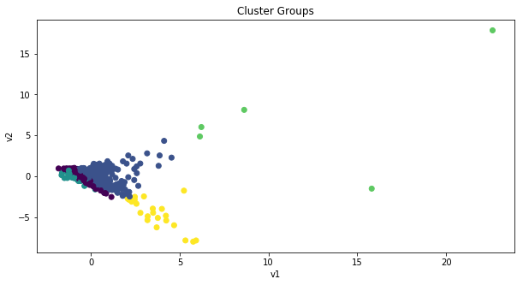

The plot does show some groups with a strong differentiation, while some of the clusters seem to have an overlap within some of their group values.

**Features’ Averages by Group**

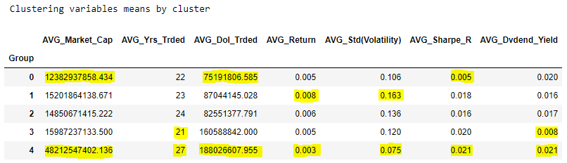

**Clusters Analysis Base on Feature Means**

**Group 0**

This group is represented as the one with the lowest average market capitalization and dollars traded, which might not be as easy to buy and sell, meaning they have a lack of liquidity, giving investors an idea on how fast they can expect to get their money back. Also, being the group with the lowest market capitalization show for a good significant room for growth in investments overtime.

**Group 1**

The group is represented as the one with the highest average daily return and average daily standard deviation (volatility) value. Stocks in this group are categorized as the highest ones in return on investments, but also the riskier concerning the change in price throughout the year.

**Group 2**

The stocks in this group shows an overall mid-level values for most stocks features. These can be seen as the best investments for those who want a mid-risk investments in which the stock fall in a neither too risky nor safe type of investment with a decent average return on investment and dividends pay out.

**Group 3**

On this group, we see the lowest average of years publicly traded and dividends amount. Assets in this category have the lowest track record doing business in the market and don’t have much to offer regarding dividends to customers.

**Group 4**

Stocks in the group had the highest averages in market capitalization, years publicly traded, Sharpe ratio and dividends pay out, also the lowest average in return and volatility. The shares in this category are big size companies which have a long history in the market, are very liquid. However, they show the lowest returns, but do offer low volatility and high performance in accordance to risk and return perspective from the Sharpe ratio and a tendency to pay a good percentage of dividends.