Class 4 R Intro
Alfred Phyo
Jan 15th, 2026
x <- 1:50
plot(x,sin(x))
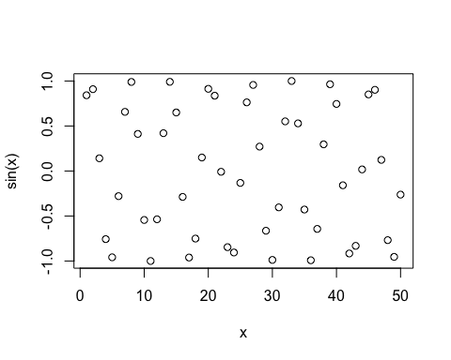
plot(x,sin(x),typ="l",col="dark green", lwd = 2)
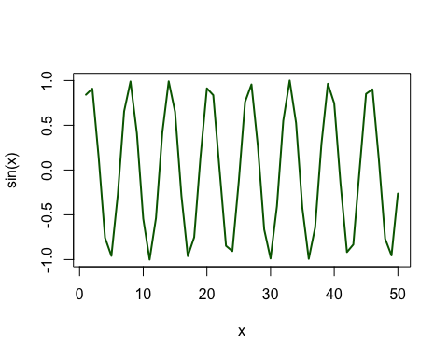
log(10,base = 10)
## [1] 1

