**1. Define Functions and Explain Their Importance**

A **function** is a reusable block of code that performs a specific task. Instead of writing the same logic multiple times, you define it once inside a function and call it wherever needed.

* **Reusability**: Write code once, reuse it many times.
* **Modularity**: Break complex problems into smaller pieces.
* **Readability**: Code is easier to read and maintain.
* **Testing**: Smaller chunks of code are easier to test.
* How to create and call function

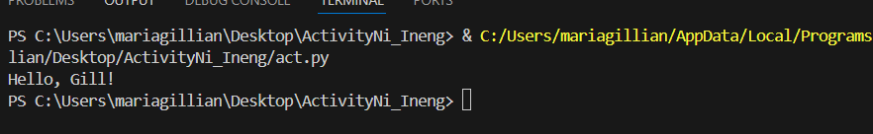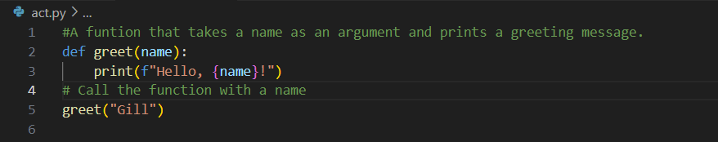A functions is a block of code which only runs when it is called. You can pass data, known as parameters, into a function. A function can return data as a result. In Python a function is defined using the “def” keyword:

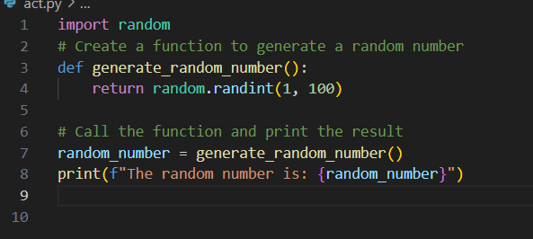2.Write a statement that generates a random number in the range of 1 through 100 and assigns it to a variable named "random”.



3. A program contains the following function

definition: def cube(num): return num * num * num

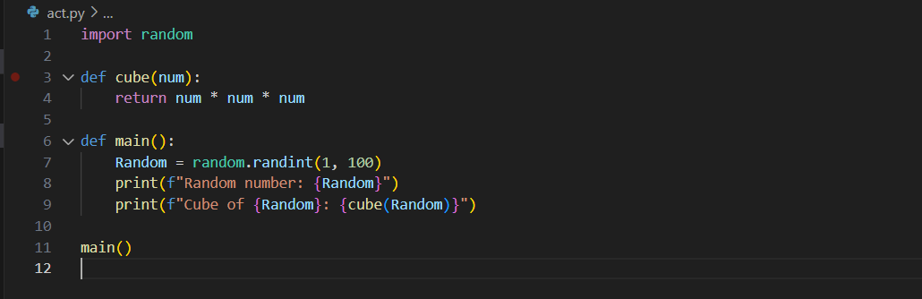

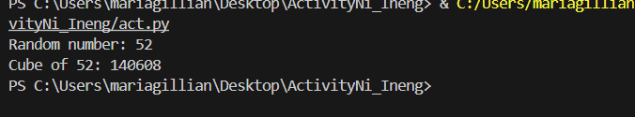

-In this program I show both of implementation of two function which is the random function that generates a random number(1,100) and the cube function that multiply its values into itself 3 times.