Name:

Section:

Activity

1.Loop

* What is the repetition structure?

-A repetition structure (or loop) allows a set of instructions to be executed repeatedly based on a condition or count. It helps automate repetitive tasks in programming.

* What is a condition-controlled loop?

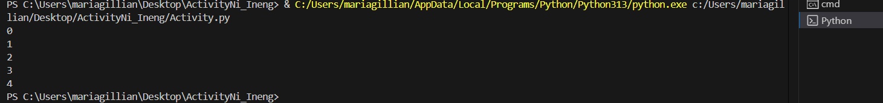-A condition-controlled loop keeps running **as long as a condition is true**. It checks the condition **before each iteration**.  
**Example using while loop:**

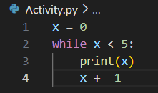

* What is a count- controlled loop?

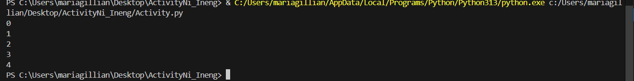-A count-controlled loop runs a specific number of times. It uses a counter to keep track of how many times the loop has executed.  
**Example using for loop:**

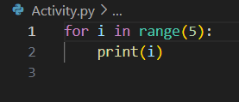

* Discuss while and for loops. Show examples of using loops for repetitive tasks.
* **while loop**: Repeats as long as a condition is true.

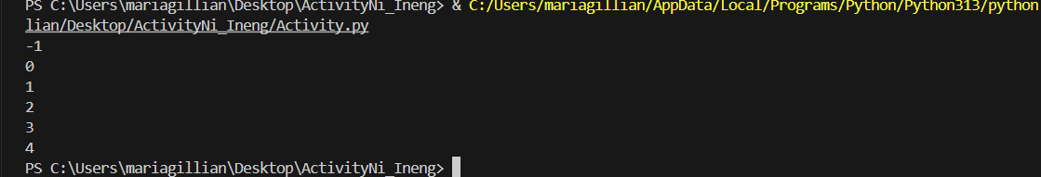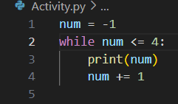

* **for loop**: Iterates over a sequence (like a list or range).

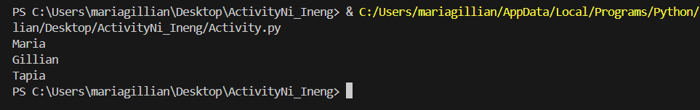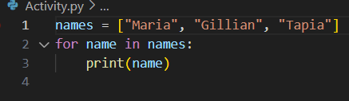

* What are nested loop?
* Nested loops are **loops inside other loops**. The inner loop completes all its iterations for each iteration of the outer loop.

**Example:**

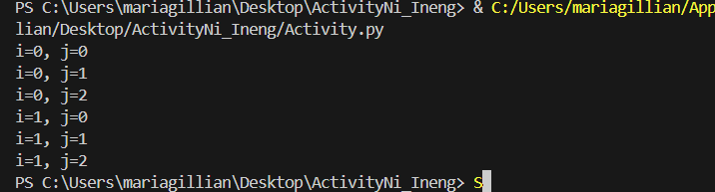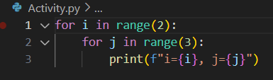

2. Calories Burned. Running on a particular treadmill you burn 4.2 calories per minute. Write a program that uses a loop to display the number of calories burned after 10, 15, 20, 25, and 30 minutes.

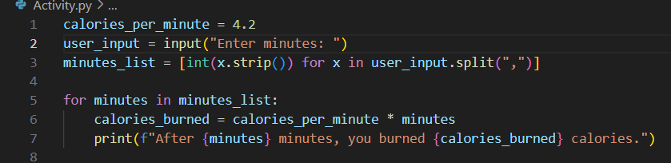

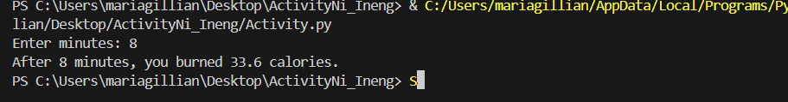

**3.** **Distance Traveled. The distance a vehicle travels can be calculated as follows: distance = speed x time For example, if a train travels 40 miles per hour for three hours, the distance traveled is 120 miles. Write a program that asks the user for the speed of a vehicle (in miles per hour) and the number of hours it has traveled. It should then use a loop to display the distance the vehicle has traveled for each hour of that time period. Here is an example of the desired sample output: What is the speed of the vehicle in mph? 40 (Enter) How many hours has it traveled? 3 (Enter) 1 hour is 40 miles 2 hours is 80 miles 3 hours is 120 miles?**

