1. Create new mysql database e.g. livecrm
2. Create a new user of your mysql database e.g. livecrm_user
3. Set a Password for new user e.g. livecrm_user
4. You can use below SQL statements to create new user (need to run with root privileges in mysql):
   1. CREATE USER 'livecrm_user'@'localhost' IDENTIFIED BY 'livecrm_user';
   2. GRANT ALL ON livecrm.* TO 'livecrm_user'@'localhost';
5. Export included SQL Schema file into newly created database (use mysql command line or phpmyadmin).
6. Create a new folder in root of your web server public html directory and move all contents of this package to that new folder.
7. Open file ***main.php*** (located in folder ***livefactory/config***) and modify below mentioned entries:

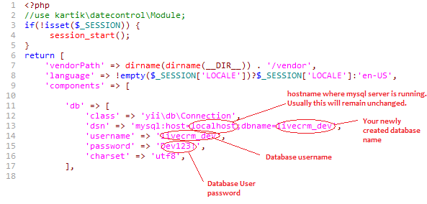

1. Save and close the file.
2. Test if your setup is meeting minimum requirements to run the application by executing below step:
   1. Run ***requirements.php*** file from installation folder on your web server. Access is through browser in following way:

http://<your server name>/<new folder name>/requirements.php

* 1. You should see a screen similar to below:

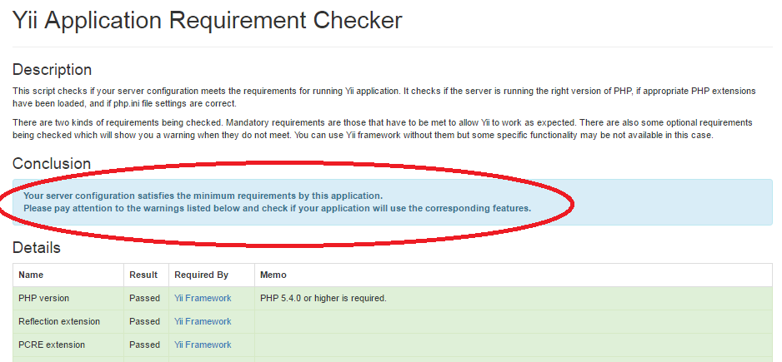

* 1. If everything is correct then you can proceed with the application access.

1. Now you are ready to run the CRM application.
2. You can access the CRM application using link:
   1. http://<your server name>/<new folder name>/
   2. e.g. http://localhost/livecrm/ (assuming you installed livecrm on localhost and unzipped all contents in a folder named livecrm)
3. Please drop in a mail to contact@liveobjects.org for any issues.