Supplementary Data
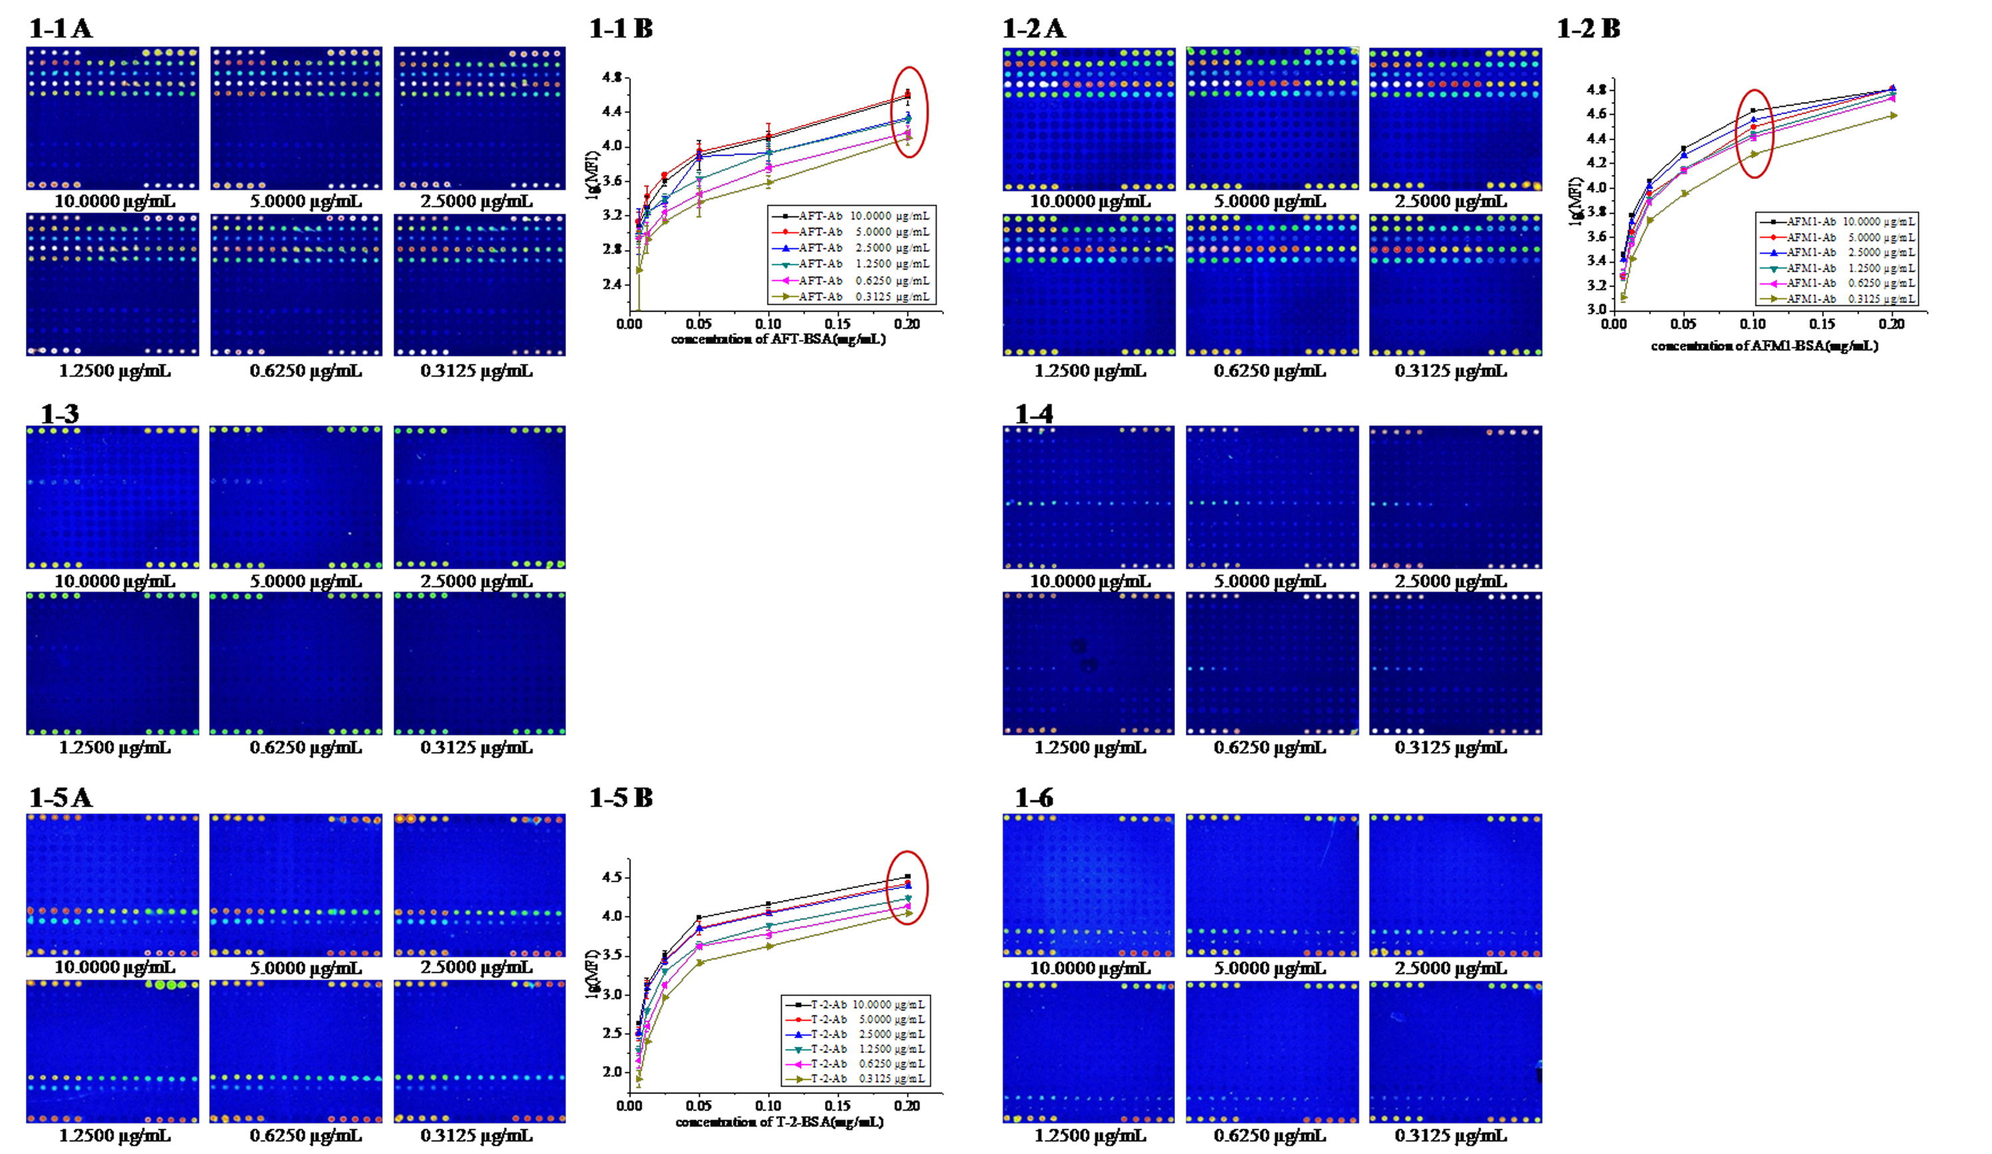
Fig. 1S. Optimization of the concentration of each antigen. 1-1A (AFT)，1-2A (AFM1)，1-3A (DON)，1-4A (OTA), 1-5A (T-2), and 1-6A (ZEN) were the hybridization images scanned among six various antibody concentration and all the probes (in Fig. 1B), respectively. 1-1B, 1-2B, 1-5B shown the hybridization curves among six various concentrations of AFT–BSA, AFM1–BSA, T-2–BSA and six different concentrations of AFT–Ab, AFM1–Ab, T-2–Ab, respectively.

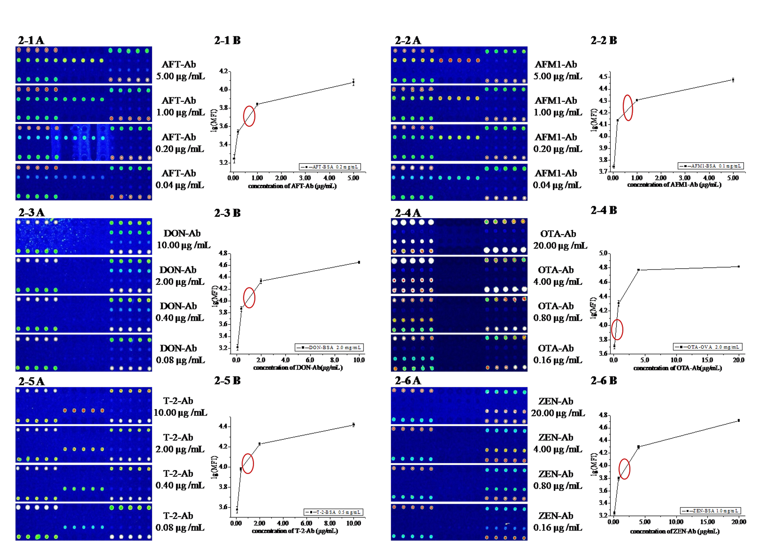
Fig. 2S. Optimization of the concentration of each Ab. 2-1A (AFT)，2-2A (AFM1)，2-3A (DON), 2-4A (OTA), 2-5A (T-2), 2-6A (ZEN) were the hybridization images scanned among four various antibody concentrations and all probes (in Fig. 1C), respectively. Correspondingly，2-1B (AFT)，2-2B (AFM1)，2-3B (DON), 2-4B (OTA), 2-5B (T-2), 2-6B (ZEN) were the hybridization curves.

Fig. 2S. Optimization of the concentration of each Ab. 2-1A (AFT)，2-2A (AFM1)，2-3A (DON), 2-4A (OTA), 2-5A (T-2), 2-6A (ZEN) were the hybridization images scanned among four various antibody concentrations and all probes (in Fig. 1C), respectively. Correspondingly，2-1B (AFT)，2-2B (AFM1)，2-3B (DON), 2-4B (OTA), 2-5B (T-2), 2-6B (ZEN) were the hybridization curves.

Fig. 2S. Optimization of the concentration of each Ab. 2-1A (AFT)，2-2A (AFM1)，2-3A (DON), 2-4A (OTA), 2-5A (T-2), 2-6A (ZEN) were the hybridization images scanned among four various antibody concentrations and all probes (in Fig. 1C), respectively. Correspondingly，2-1B (AFT)，2-2B (AFM1)，2-3B (DON), 2-4B (OTA), 2-5B (T-2), 2-6B (ZEN) were the hybridization curves.

 | *Table 1S. Test results by ELISA
 | Analyte |  | Ranges of dilution (ng/mL) |  |  |  | IC₅₀ (ng/mL)
 |  |  | Antigen |  | Antibody
 | AFB1 |  | 23.6–2360 |  | 190–1900 |  | 0.3–0.7
 | AFM1 |  | 125–1250 |  | 53.2–532 |  | 0.2–0.5
 | DON |  | 400–4000 |  | 35–3500 |  | 15–60
 | OTA |  | 125–1250 |  | 200–400 |  | 0.5
 | T-2 |  | 13.28–66.4 |  | 0.182–1.82 |  | 0.4
 | ZEN |  | 50.1–5010 |  | 50.6–506 |  | 0.2
 | *: The results were supplied by Huaan Magnech Bio-Tech Company Corp.
*Table 1S. Test results by ELISA*Table 1S. Test results by ELISA*Table 1S. Test results by ELISA*Table 1S. Test results by ELISA
*Table 1S. Test results by ELISA
Analyte | Ranges of dilution (ng/mL) |  | IC₅₀ (ng/mL)
Analyte | Antigen | Antibody | IC₅₀ (ng/mL)
AFB1 | 23.6–2360 | 190–1900 | 0.3–0.7
AFM1 | 125–1250 | 53.2–532 | 0.2–0.5
DON | 400–4000 | 35–3500 | 15–60
OTA | 125–1250 | 200–400 | 0.5
T-2 | 13.28–66.4 | 0.182–1.82 | 0.4
ZEN | 50.1–5010 | 50.6–506 | 0.2
*: The results were supplied by Huaan Magnech Bio-Tech Company Corp.
*Table 1S. Test results by ELISA
Analyte | Ranges of dilution (ng/mL) |  | IC₅₀ (ng/mL)
Analyte | Antigen | Antibody | IC₅₀ (ng/mL)
AFB1 | 23.6–2360 | 190–1900 | 0.3–0.7
AFM1 | 125–1250 | 53.2–532 | 0.2–0.5
DON | 400–4000 | 35–3500 | 15–60
OTA | 125–1250 | 200–400 | 0.5
T-2 | 13.28–66.4 | 0.182–1.82 | 0.4
ZEN | 50.1–5010 | 50.6–506 | 0.2
*: The results were supplied by Huaan Magnech Bio-Tech Company Corp.
*Table 1S. Test results by ELISA
Analyte | Ranges of dilution (ng/mL) |  | IC₅₀ (ng/mL)
Analyte | Antigen | Antibody | IC₅₀ (ng/mL)
AFB1 | 23.6–2360 | 190–1900 | 0.3–0.7
AFM1 | 125–1250 | 53.2–532 | 0.2–0.5
DON | 400–4000 | 35–3500 | 15–60
OTA | 125–1250 | 200–400 | 0.5
T-2 | 13.28–66.4 | 0.182–1.82 | 0.4
ZEN | 50.1–5010 | 50.6–506 | 0.2
*: The results were supplied by Huaan Magnech Bio-Tech Company Corp.
*Table 1S. Test results by ELISA
Analyte | Ranges of dilution (ng/mL) |  | IC₅₀ (ng/mL)
Analyte | Antigen | Antibody | IC₅₀ (ng/mL)
AFB1 | 23.6–2360 | 190–1900 | 0.3–0.7
AFM1 | 125–1250 | 53.2–532 | 0.2–0.5
DON | 400–4000 | 35–3500 | 15–60
OTA | 125–1250 | 200–400 | 0.5
T-2 | 13.28–66.4 | 0.182–1.82 | 0.4
ZEN | 50.1–5010 | 50.6–506 | 0.2
*: The results were supplied by Huaan Magnech Bio-Tech Company Corp.
*Table 1S. Test results by ELISA
Analyte | Ranges of dilution (ng/mL) |  | IC₅₀ (ng/mL)
Analyte | Antigen | Antibody | IC₅₀ (ng/mL)
AFB1 | 23.6–2360 | 190–1900 | 0.3–0.7
AFM1 | 125–1250 | 53.2–532 | 0.2–0.5
DON | 400–4000 | 35–3500 | 15–60
OTA | 125–1250 | 200–400 | 0.5
T-2 | 13.28–66.4 | 0.182–1.82 | 0.4
ZEN | 50.1–5010 | 50.6–506 | 0.2
*: The results were supplied by Huaan Magnech Bio-Tech Company Corp.
*Table 1S. Test results by ELISA
Analyte | Ranges of dilution (ng/mL) |  | IC₅₀ (ng/mL)
Analyte | Antigen | Antibody | IC₅₀ (ng/mL)
AFB1 | 23.6–2360 | 190–1900 | 0.3–0.7
AFM1 | 125–1250 | 53.2–532 | 0.2–0.5
DON | 400–4000 | 35–3500 | 15–60
OTA | 125–1250 | 200–400 | 0.5
T-2 | 13.28–66.4 | 0.182–1.82 | 0.4
ZEN | 50.1–5010 | 50.6–506 | 0.2
*: The results were supplied by Huaan Magnech Bio-Tech Company Corp.
Analyte |  | Ranges of dilution (ng/mL) |  |  |  | IC₅₀ (ng/mL)
 |  | Antigen |  | Antibody
AFB1 |  | 23.6–2360 |  | 190–1900 |  | 0.3–0.7
AFM1 |  | 125–1250 |  | 53.2–532 |  | 0.2–0.5
DON |  | 400–4000 |  | 35–3500 |  | 15–60
OTA |  | 125–1250 |  | 200–400 |  | 0.5
T-2 |  | 13.28–66.4 |  | 0.182–1.82 |  | 0.4
ZEN |  | 50.1–5010 |  | 50.6–506 |  | 0.2
*: The results were supplied by Huaan Magnech Bio-Tech Company Corp.

Table 2S. The working concentrations of six standards respectively when calibration curves plotted
Mycotoxin | Concentration of six standards（ng/mL）
Mycotoxin | 0 | 0.5× | ª1× | 2× | 4× | 8×
AFB1 | 0 | 0.5 | 1 | 2 | 4 | 8
AFM1 | 0 | 0.5 | 1 | 2 | 4 | 8
DON | 0 | 10 | 20 | 40 | 80 | 160
OTA | 0 | 40 | 80 | 160 | 320 | 640
T-2 | 0 | 0.5 | 1 | 2 | 4 | 8
ZEN | 0 | 1 | 2 | 4 | 8 | 16
a: 1× concentration of six standards respectively was inferred as IC₅₀ in theory.

Table 3S. LOD analysis using immunochip in comparison with other technologies
Analyte | Detection Method | LOD (ng/mL) | References
AFB1 | immunochip | 0.01 | in our study
AFB1 | surface plasmon resonance sensor | 3.00 | Daly et al., 2000
AFB1 | HPLC | 0.16 | Ghali et al., 2009
AFB1 | LC/APPI-MS/MS | 1.00 | Capriotti et al., 2010
AFM1 | immunochip | 0.24 | in our study
AFM1 | ELISA | 0.04 | Pei et al., 2009
DON | immunochip | 15.45 | in our study
DON | HPLC | 125.00 | Omurtag and Beyoğlu, 2007
DON | LC/APPI-MS/MS | 50.00 | Capriotti et al., 2010
OTA | immunochip | 15.39 | in our study
OTA | surface plasmon resonance sensor | 100.00 | Yu and Lai, 2004
OTA | LC/APPI-MS/MS | 3.00 | Capriotti et al., 2010
T-2 | immunochip | 0.05 | in our study
T-2 | ELISA | 4.00 | Wang et al., 2010
T-2 | LC/APPI-MS/MS | 20.00 | Capriotti et al., 2010
ZEN | immunochip | 0.01 | in our study
ZEN | LC/APPI-MS/MS | 20.00 | Capriotti et al., 2010
ZEN | HPLC | 1.56 | Wu et al., 2011

