UAS-AKH.R

Ridson Alfarizal

2022-06-21

library(survival)  
library(survminer)

## Loading required package: ggplot2

## Loading required package: ggpubr

##   
## Attaching package: 'survminer'

## The following object is masked from 'package:survival':  
##   
## myeloma

library(tidyverse)

## ── Attaching packages ─────────────────────────────────────── tidyverse 1.3.1 ──

## ✔ tibble 3.1.6 ✔ dplyr 1.0.8  
## ✔ tidyr 1.2.0 ✔ stringr 1.4.0  
## ✔ readr 2.1.2 ✔ forcats 0.5.1  
## ✔ purrr 0.3.4

## ── Conflicts ────────────────────────────────────────── tidyverse_conflicts() ──  
## ✖ dplyr::filter() masks stats::filter()  
## ✖ dplyr::lag() masks stats::lag()

# Data --------------------------------------------------------------------  
dat <- readxl::read_xlsx("D:/__SEMESTER 6/AKH/UAS AKH/Data_UAS_AKH_2022(1935).xlsx")  
glimpse(dat)

## Rows: 686  
## Columns: 12  
## $ `ID pasien Kanker-XY` <dbl> 1, 2, 3, 4, 5, 6, 7, 8, 9, 10, 11, …  
## $ `Umur saat awal diagnosis (tahun)` <dbl> 38, 52, 47, 40, 64, 49, 53, 61, 43,…  
## $ `Ukuran tumor (mm)` <dbl> 18, 20, 30, 24, 19, 56, 52, 22, 30,…  
## $ `Stadium tumor` <dbl> 3, 1, 2, 1, 2, 1, 2, 2, 2, 2, 1, 2,…  
## $ `Jumlah simpul tumor` <dbl> 5, 1, 1, 3, 1, 3, 9, 2, 1, 1, 2, 9,…  
## $ `Jumlah reseptor hormon Type-A` <dbl> 141, 78, 422, 25, 19, 356, 6, 6, 22…  
## $ `Jumlah reseptor hormon Type-B` <dbl> 105, 14, 89, 11, 9, 64, 29, 173, 0,…  
## $ `Tanggal awal diagnosis` <dttm> 2012-01-03, 2012-09-10, 2012-02-27…  
## $ `Tanggal akhir diagnosis` <dttm> 2018-04-03, 2018-03-09, 2016-02-22…  
## $ `Jenis kelamin pasien` <chr> "Perempuan", "Perempuan", "Perempua…  
## $ `Menjalani terapi hormon` <chr> "Tidak", "Tidak", "Tidak", "Tidak",…  
## $ `Status akhir pasien` <chr> "Masih hidup", "Masih hidup", "Meni…

dat <- dat %>%  
 setNames(  
 c(  
 "id", "umur", "uk_tmr", "std_tmr", "n_simpul_tmr",  
 "n_res_horA", "n_res_horB", "tgl_awal", "tgl_akhir", "jk",  
 "terapi", "status"  
 )  
 ) %>%  
 mutate(  
 std_tmr = factor(std_tmr, levels = 1:3),  
 jk = factor(jk, levels = c("Perempuan", "Laki-laki")),  
 terapi = factor(terapi, levels = c("Tidak", "Ya")),  
 status = ifelse(status == "Masih hidup", 0, 1),  
 time = as.numeric(tgl_akhir - tgl_awal),  
 kat_umur = case_when(  
 # termasuk 0 dan 49  
 between(umur, 0, 49) ~ "< 50 Tahun",  
 umur >= 50 ~ "≥ 50 Tahun"  
 ),  
 kat_reshorA = case_when(  
 between(n_res_horA, 0, 43) ~ "rendah",  
 n_res_horA > 43 ~ "tinggi"  
 ),  
 kat_reshorB = case_when(  
 between(n_res_horB, 0, 76) ~ "rendah",  
 n_res_horB > 76 ~ "tinggi"  
 )  
 )  
glimpse(dat)

## Rows: 686  
## Columns: 16  
## $ id <dbl> 1, 2, 3, 4, 5, 6, 7, 8, 9, 10, 11, 12, 13, 14, 15, 16, 17…  
## $ umur <dbl> 38, 52, 47, 40, 64, 49, 53, 61, 43, 74, 58, 38, 52, 43, 5…  
## $ uk_tmr <dbl> 18, 20, 30, 24, 19, 56, 52, 22, 30, 20, 18, 20, 25, 30, 2…  
## $ std_tmr <fct> 3, 1, 2, 1, 2, 1, 2, 2, 2, 2, 1, 2, 2, 2, 1, 1, 2, 2, 2, …  
## $ n_simpul_tmr <dbl> 5, 1, 1, 3, 1, 3, 9, 2, 1, 1, 2, 9, 13, 3, 1, 2, 2, 3, 2,…  
## $ n_res_horA <dbl> 141, 78, 422, 25, 19, 356, 6, 6, 22, 462, 74, 24, 31, 45,…  
## $ n_res_horB <dbl> 105, 14, 89, 11, 9, 64, 29, 173, 0, 240, 67, 34, 196, 11,…  
## $ tgl_awal <dttm> 2012-01-03, 2012-09-10, 2012-02-27, 2011-11-15, 2011-11-…  
## $ tgl_akhir <dttm> 2018-04-03, 2018-03-09, 2016-02-22, 2012-04-11, 2016-12-…  
## $ jk <fct> Perempuan, Perempuan, Perempuan, Perempuan, Laki-laki, La…  
## $ terapi <fct> Tidak, Tidak, Tidak, Tidak, Ya, Ya, Tidak, Ya, Tidak, Ya,…  
## $ status <dbl> 0, 0, 1, 0, 0, 0, 1, 0, 0, 0, 0, 1, 1, 0, 0, 0, 1, 1, 0, …  
## $ time <dbl> 2282, 2006, 1456, 148, 1863, 1933, 416, 2556, 2563, 2372,…  
## $ kat_umur <chr> "< 50 Tahun", "≥ 50 Tahun", "< 50 Tahun", "< 50 Tahun", "…  
## $ kat_reshorA <chr> "tinggi", "tinggi", "tinggi", "rendah", "rendah", "tinggi…  
## $ kat_reshorB <chr> "tinggi", "rendah", "tinggi", "rendah", "rendah", "rendah…

dat %>%  
 is.na() %>%  
 colSums()

## id umur uk_tmr std_tmr n_simpul_tmr n_res_horA   
## 0 0 0 0 0 0   
## n_res_horB tgl_awal tgl_akhir jk terapi status   
## 0 0 0 0 0 0   
## time kat_umur kat_reshorA kat_reshorB   
## 0 0 0 0

# Kaplan meier ------------------------------------------------------------  
# kelompok umur  
x <- 0.3  
ggsurvplot(  
 survfit(Surv(time, status) ~ kat_umur, data = dat),  
 conf.int = T,  
 ylim = c(x, 1),  
 pval = T,  
 pval.method = T,  
 pval.method.coord = c(1, x + 0.18),  
 pval.coord = c(1, x + 0.1),  
 xlab = "Time (days)",  
 legend.title = "Kelompok Umur",  
 legend.labs = c("< 50 Tahun", "≥ 50 Tahun")  
)

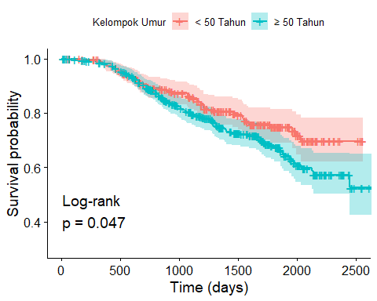

# jumlah resepetor hormon A  
x <- 0.1  
ggsurvplot(  
 survfit(Surv(time, status) ~ kat_reshorA, data = dat),  
 conf.int = T,  
 ylim = c(x, 1),  
 pval = T,  
 pval.method = T,  
 pval.method.coord = c(1, x + 0.18),  
 pval.coord = c(1, x + 0.1),  
 xlab = "Time (days)",  
 legend.title = str_wrap("Kategori Jumlah Reseptor Hormon Type-A", 25),  
 legend.labs = c("Tinggi", "Rendah")  
)

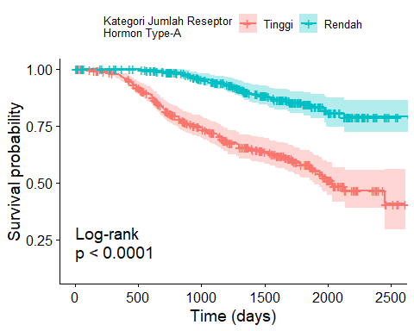

# jumlah reseptor hormon B  
ggsurvplot(  
 survfit(Surv(time, status) ~ kat_reshorB, data = dat),  
 conf.int = T,  
 ylim = c(x, 1),  
 pval = T,  
 pval.method = T,  
 pval.method.coord = c(1, x + 0.18),  
 pval.coord = c(1, x + 0.1),  
 xlab = "Time (days)",  
 legend.title = str_wrap("Kategori Jumlah Reseptor Hormon Type-B", 25),  
 legend.labs = c("Tinggi", "Rendah")  
)

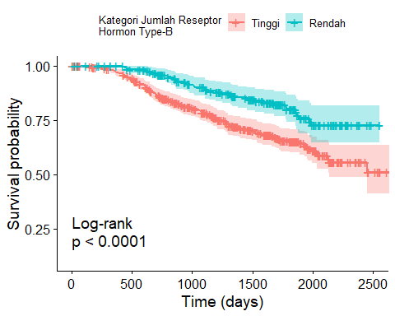

# jenis kelamin  
x <- 0.35  
ggsurvplot(  
 survfit(Surv(time, status) ~ jk, data = dat),  
 conf.int = T,  
 ylim = c(x, 1),  
 pval = T,  
 pval.method = T,  
 pval.method.coord = c(1, x + 0.18),  
 pval.coord = c(1, x + 0.1),  
 xlab = "Time (days)",  
 legend.title = "Jenis Kelamin",  
 legend.labs = c("Perempuan", "Laki-laki")  
)

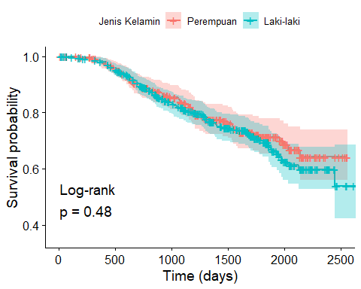

# terapi hormon  
ggsurvplot(  
 survfit(Surv(time, status) ~ terapi, data = dat),  
 conf.int = T,  
 ylim = c(x, 1),  
 pval = T,  
 pval.method = T,  
 pval.method.coord = c(1, x + 0.18),  
 pval.coord = c(1, x + 0.1),  
 xlab = "Time (days)",  
 legend.title = "Status Menjalani Terapi Hormon",  
 legend.labs = unique(dat$terapi)  
)

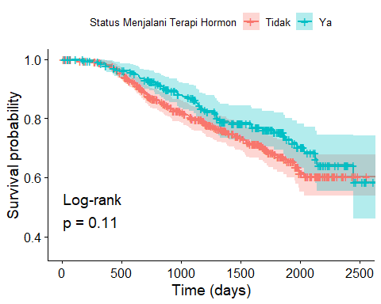

# stadium tumor  
ggsurvplot(  
 survfit(Surv(time, status) ~ std_tmr, data = dat),  
 conf.int = T,  
 ylim = c(x, 1),  
 pval = T,  
 pval.method = T,  
 pval.method.coord = c(1, x + 0.18),  
 pval.coord = c(1, x + 0.1),  
 xlab = "Time (days)",  
 legend.title = "Stadium Tumor",  
 legend.labs = c(1:3)  
)

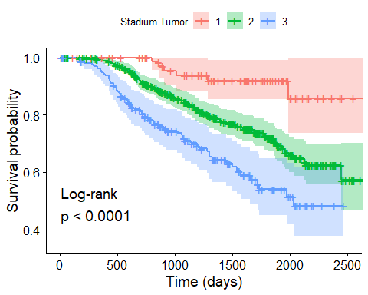

# jumlah simpul tumor  
ggplot(dat, aes(x = n_simpul_tmr, fill = factor(status))) +  
 geom_histogram() +  
 labs(x = "Jumlah Simpur Tumor", y = "Banyaknya Pasien") +  
 theme(legend.position = "none") +  
 facet_grid(  
 ~status,  
 labeller = as_labeller(  
 c("0" = "Masih Hidup", "1" = "Meninggal")  
 )  
 )

## `stat_bin()` using `bins = 30`. Pick better value with `binwidth`.

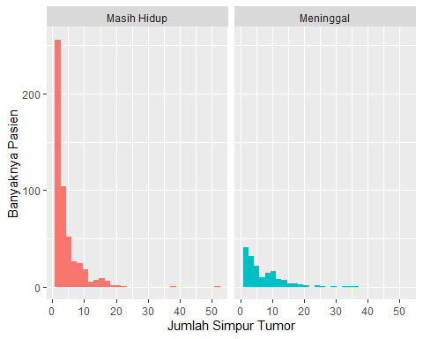

# ukuran tumor  
ggplot(dat, aes(x = uk_tmr, fill = factor(status))) +  
 geom_histogram() +  
 labs(x = "Ukuran Tumor", y = "Banyaknya Pasien") +  
 theme(legend.position = "none") +  
 facet_grid(  
 ~status,  
 labeller = as_labeller(  
 c("0" = "Masih Hidup", "1" = "Meninggal")  
 )  
 )

## `stat_bin()` using `bins = 30`. Pick better value with `binwidth`.

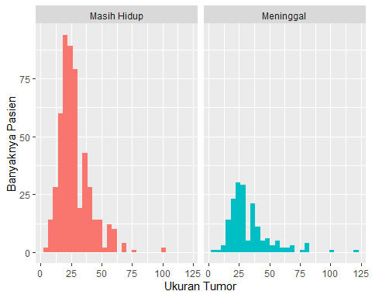

# donut chart  
hsize <- 2  
dat %>%   
 group_by(status) %>%   
 summarise(n = n()) %>%   
 mutate(p = n/sum(n)) %>%   
 ggplot(aes(x = hsize, y = p, fill = factor(status))) +  
 geom_col(color = "white", width = 0.8, size = 1.5) +  
 geom_text(  
 aes(label = scales::percent(p, accuracy = 0.01)),  
 color = 'black',  
 fontface = 2,  
 position = position_stack(vjust = 0.5)  
 ) +  
 coord_polar(theta = "y") +  
 xlim(c(1, hsize + 0.5)) +  
 scale_fill_manual(  
 'Status',  
 values = c("#67CFC5", "#D9B05E"),  
 labels = c('Masih Hidup', 'Meninggal')  
 ) +  
 scale_y_continuous(expand = c(0, 0)) +  
 labs(  
 title = NULL,  
 fill = NULL  
 ) +  
 theme(  
 plot.title = element_text(size = rel(1.3), face = "bold"),  
 # legend.position = ,  
 panel.background = element_rect(fill = "white"),  
 panel.grid = element_blank(),  
 axis.title = element_blank(),  
 axis.ticks = element_blank(),  
 axis.text = element_blank()  
 )

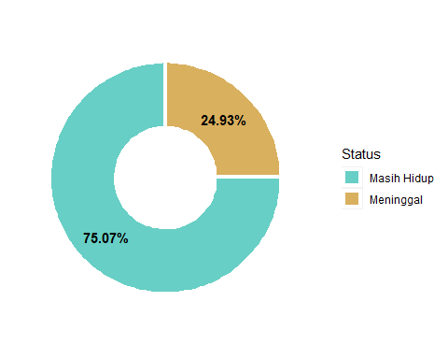

# Cox PH model ------------------------------------------------------------  
mcox <- coxph(Surv(time, status) ~ kat_umur + jk + uk_tmr + std_tmr +  
 n_simpul_tmr + kat_reshorA + kat_reshorB + terapi, data = dat)  
summary(mcox)

## Call:  
## coxph(formula = Surv(time, status) ~ kat_umur + jk + uk_tmr +   
## std_tmr + n_simpul_tmr + kat_reshorA + kat_reshorB + terapi,   
## data = dat)  
##   
## n= 686, number of events= 171   
##   
## coef exp(coef) se(coef) z Pr(>|z|)   
## kat_umur≥ 50 Tahun 0.788548 2.200199 0.254945 3.093 0.00198 **   
## jkLaki-laki -0.390518 0.676706 0.247915 -1.575 0.11521   
## uk_tmr 0.012918 1.013001 0.004888 2.643 0.00823 **   
## std_tmr2 0.646542 1.908929 0.429212 1.506 0.13198   
## std_tmr3 0.863773 2.372094 0.446920 1.933 0.05327 .   
## n_simpul_tmr 0.060146 1.061992 0.010026 5.999 1.98e-09 ***  
## kat_reshorAtinggi -1.153691 0.315470 0.204526 -5.641 1.69e-08 ***  
## kat_reshorBtinggi -0.190779 0.826315 0.198487 -0.961 0.33647   
## terapiYa -0.338055 0.713156 0.169999 -1.989 0.04675 *   
## ---  
## Signif. codes: 0 '***' 0.001 '**' 0.01 '*' 0.05 '.' 0.1 ' ' 1  
##   
## exp(coef) exp(-coef) lower .95 upper .95  
## kat_umur≥ 50 Tahun 2.2002 0.4545 1.3349 3.6264  
## jkLaki-laki 0.6767 1.4777 0.4163 1.1001  
## uk_tmr 1.0130 0.9872 1.0033 1.0228  
## std_tmr2 1.9089 0.5239 0.8231 4.4273  
## std_tmr3 2.3721 0.4216 0.9879 5.6957  
## n_simpul_tmr 1.0620 0.9416 1.0413 1.0831  
## kat_reshorAtinggi 0.3155 3.1699 0.2113 0.4710  
## kat_reshorBtinggi 0.8263 1.2102 0.5600 1.2193  
## terapiYa 0.7132 1.4022 0.5111 0.9951  
##   
## Concordance= 0.759 (se = 0.017 )  
## Likelihood ratio test= 133 on 9 df, p=<2e-16  
## Wald test = 127.4 on 9 df, p=<2e-16  
## Score (logrank) test = 150.2 on 9 df, p=<2e-16

AIC(mcox)

## [1] 1940.944

logLik(mcox)

## 'log Lik.' -961.4718 (df=9)

# uji asumsi PH  
# tolak Ho asumsi PH tidak terpenuhi  
test.ph <- cox.zph(mcox)  
test.ph

## chisq df p  
## kat_umur 1.5302 1 0.21609  
## jk 0.4053 1 0.52436  
## uk_tmr 0.0122 1 0.91199  
## std_tmr 3.5028 2 0.17353  
## n_simpul_tmr 0.5872 1 0.44350  
## kat_reshorA 11.0745 1 0.00088  
## kat_reshorB 2.4028 1 0.12112  
## terapi 0.3183 1 0.57261  
## GLOBAL 15.8207 9 0.07072

ggcoxzph(test.ph[6])

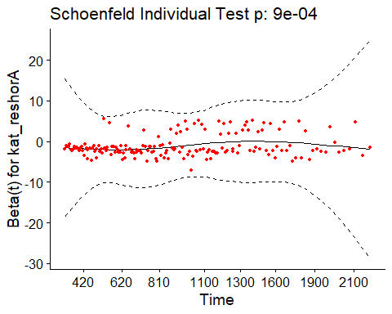

# stratified cox --------------------------------------------------------------  
scox <- coxph(Surv(time, status) ~ kat_umur + jk + uk_tmr + std_tmr +  
 n_simpul_tmr + kat_reshorB + terapi + strata(kat_reshorA),  
data = dat  
)  
summary(scox)

## Call:  
## coxph(formula = Surv(time, status) ~ kat_umur + jk + uk_tmr +   
## std_tmr + n_simpul_tmr + kat_reshorB + terapi + strata(kat_reshorA),   
## data = dat)  
##   
## n= 686, number of events= 171   
##   
## coef exp(coef) se(coef) z Pr(>|z|)   
## kat_umur≥ 50 Tahun 0.804894 2.236459 0.256697 3.136 0.00172 **   
## jkLaki-laki -0.402320 0.668767 0.249066 -1.615 0.10624   
## uk_tmr 0.012936 1.013020 0.004777 2.708 0.00677 **   
## std_tmr2 0.644822 1.905647 0.429442 1.502 0.13322   
## std_tmr3 0.837362 2.310265 0.447527 1.871 0.06133 .   
## n_simpul_tmr 0.065430 1.067618 0.010627 6.157 7.41e-10 ***  
## kat_reshorBtinggi -0.221126 0.801615 0.199385 -1.109 0.26741   
## terapiYa -0.338811 0.712617 0.170518 -1.987 0.04693 *   
## ---  
## Signif. codes: 0 '***' 0.001 '**' 0.01 '*' 0.05 '.' 0.1 ' ' 1  
##   
## exp(coef) exp(-coef) lower .95 upper .95  
## kat_umur≥ 50 Tahun 2.2365 0.4471 1.3523 3.6988  
## jkLaki-laki 0.6688 1.4953 0.4105 1.0896  
## uk_tmr 1.0130 0.9871 1.0036 1.0226  
## std_tmr2 1.9056 0.5248 0.8213 4.4216  
## std_tmr3 2.3103 0.4329 0.9610 5.5539  
## n_simpul_tmr 1.0676 0.9367 1.0456 1.0901  
## kat_reshorBtinggi 0.8016 1.2475 0.5423 1.1849  
## terapiYa 0.7126 1.4033 0.5102 0.9954  
##   
## Concordance= 0.682 (se = 0.021 )  
## Likelihood ratio test= 69.07 on 8 df, p=8e-12  
## Wald test = 81.24 on 8 df, p=3e-14  
## Score (logrank) test = 85.74 on 8 df, p=3e-15

AIC(scox)

## [1] 1762.271

cox.zph(scox)

## chisq df p  
## kat_umur 1.8026 1 0.18  
## jk 0.6928 1 0.41  
## uk_tmr 0.0357 1 0.85  
## std_tmr 1.2180 2 0.54  
## n_simpul_tmr 0.3024 1 0.58  
## kat_reshorB 0.3524 1 0.55  
## terapi 0.4169 1 0.52  
## GLOBAL 4.1688 8 0.84

scox_rendah <- coxph(Surv(time, status) ~ kat_umur + jk + uk_tmr + std_tmr +  
 n_simpul_tmr + kat_reshorB + terapi,  
data = dat %>% dplyr::filter(kat_reshorA == "rendah")  
)  
summary(scox_rendah)

## Call:  
## coxph(formula = Surv(time, status) ~ kat_umur + jk + uk_tmr +   
## std_tmr + n_simpul_tmr + kat_reshorB + terapi, data = dat %>%   
## dplyr::filter(kat_reshorA == "rendah"))  
##   
## n= 368, number of events= 133   
##   
## coef exp(coef) se(coef) z Pr(>|z|)   
## kat_umur≥ 50 Tahun 0.800457 2.226558 0.290061 2.760 0.00579 **   
## jkLaki-laki -0.530123 0.588533 0.284983 -1.860 0.06286 .   
## uk_tmr 0.011327 1.011391 0.005753 1.969 0.04899 *   
## std_tmr2 1.337409 3.809160 1.010579 1.323 0.18570   
## std_tmr3 1.537106 4.651111 1.015685 1.513 0.13019   
## n_simpul_tmr 0.065657 1.067861 0.012775 5.139 2.76e-07 ***  
## kat_reshorBtinggi -0.074264 0.928427 0.245064 -0.303 0.76186   
## terapiYa -0.396468 0.672692 0.199863 -1.984 0.04729 *   
## ---  
## Signif. codes: 0 '***' 0.001 '**' 0.01 '*' 0.05 '.' 0.1 ' ' 1  
##   
## exp(coef) exp(-coef) lower .95 upper .95  
## kat_umur≥ 50 Tahun 2.2266 0.4491 1.2611 3.9313  
## jkLaki-laki 0.5885 1.6991 0.3367 1.0288  
## uk_tmr 1.0114 0.9887 1.0000 1.0229  
## std_tmr2 3.8092 0.2625 0.5256 27.6081  
## std_tmr3 4.6511 0.2150 0.6353 34.0494  
## n_simpul_tmr 1.0679 0.9365 1.0415 1.0949  
## kat_reshorBtinggi 0.9284 1.0771 0.5743 1.5009  
## terapiYa 0.6727 1.4866 0.4547 0.9953  
##   
## Concordance= 0.688 (se = 0.023 )  
## Likelihood ratio test= 51.65 on 8 df, p=2e-08  
## Wald test = 56.22 on 8 df, p=3e-09  
## Score (logrank) test = 60.83 on 8 df, p=3e-10

AIC(scox_rendah)

## [1] 1383.371

logLik(scox_rendah)[1]

## [1] -683.6853

scox_tinggi <- coxph(Surv(time, status) ~ kat_umur + jk + uk_tmr + std_tmr +  
 n_simpul_tmr + kat_reshorB + terapi,  
data = dat %>% dplyr::filter(kat_reshorA == "tinggi")  
)  
summary(scox_tinggi)

## Call:  
## coxph(formula = Surv(time, status) ~ kat_umur + jk + uk_tmr +   
## std_tmr + n_simpul_tmr + kat_reshorB + terapi, data = dat %>%   
## dplyr::filter(kat_reshorA == "tinggi"))  
##   
## n= 318, number of events= 38   
##   
## coef exp(coef) se(coef) z Pr(>|z|)   
## kat_umur≥ 50 Tahun 0.930636 2.536122 0.543753 1.712 0.08699 .   
## jkLaki-laki -0.021738 0.978497 0.510135 -0.043 0.96601   
## uk_tmr 0.017265 1.017415 0.009169 1.883 0.05970 .   
## std_tmr2 0.377206 1.458204 0.492732 0.766 0.44395   
## std_tmr3 0.509611 1.664643 0.649690 0.784 0.43281   
## n_simpul_tmr 0.065734 1.067943 0.021307 3.085 0.00203 **  
## kat_reshorBtinggi -0.501721 0.605487 0.343718 -1.460 0.14438   
## terapiYa -0.127512 0.880283 0.345771 -0.369 0.71230   
## ---  
## Signif. codes: 0 '***' 0.001 '**' 0.01 '*' 0.05 '.' 0.1 ' ' 1  
##   
## exp(coef) exp(-coef) lower .95 upper .95  
## kat_umur≥ 50 Tahun 2.5361 0.3943 0.8736 7.362  
## jkLaki-laki 0.9785 1.0220 0.3600 2.659  
## uk_tmr 1.0174 0.9829 0.9993 1.036  
## std_tmr2 1.4582 0.6858 0.5551 3.830  
## std_tmr3 1.6646 0.6007 0.4659 5.948  
## n_simpul_tmr 1.0679 0.9364 1.0243 1.113  
## kat_reshorBtinggi 0.6055 1.6516 0.3087 1.188  
## terapiYa 0.8803 1.1360 0.4470 1.734  
##   
## Concordance= 0.696 (se = 0.043 )  
## Likelihood ratio test= 22.06 on 8 df, p=0.005  
## Wald test = 28.4 on 8 df, p=4e-04  
## Score (logrank) test = 30.9 on 8 df, p=1e-04

AIC(scox_tinggi)

## [1] 390.2568

logLik(scox_tinggi)[1]

## [1] -187.1284

# Model Parametrik --------------------------------------------------------  
# log normal  
mlnorm <- survreg(Surv(time, status) ~ jk + kat_umur + uk_tmr + std_tmr +  
 n_simpul_tmr + kat_reshorA + kat_reshorB + terapi,  
data = dat,  
dist = "lognormal"  
)  
summary(mlnorm)

##   
## Call:  
## survreg(formula = Surv(time, status) ~ jk + kat_umur + uk_tmr +   
## std_tmr + n_simpul_tmr + kat_reshorA + kat_reshorB + terapi,   
## data = dat, dist = "lognormal")  
## Value Std. Error z p  
## (Intercept) 8.46748 0.25447 33.27 < 2e-16  
## jkLaki-laki 0.20164 0.16653 1.21 0.226  
## kat_umur≥ 50 Tahun -0.41858 0.16904 -2.48 0.013  
## uk_tmr -0.00814 0.00324 -2.51 0.012  
## std_tmr2 -0.32068 0.21120 -1.52 0.129  
## std_tmr3 -0.50133 0.22803 -2.20 0.028  
## n_simpul_tmr -0.04012 0.00808 -4.96 7.0e-07  
## kat_reshorAtinggi 0.71743 0.11842 6.06 1.4e-09  
## kat_reshorBtinggi 0.14061 0.11839 1.19 0.235  
## terapiYa 0.20107 0.10399 1.93 0.053  
## Log(scale) -0.11560 0.05878 -1.97 0.049  
##   
## Scale= 0.891   
##   
## Log Normal distribution  
## Loglik(model)= -1543.2 Loglik(intercept only)= -1613.5  
## Chisq= 140.52 on 9 degrees of freedom, p= 8.1e-26   
## Number of Newton-Raphson Iterations: 5   
## n= 686

AIC(mlnorm)

## [1] 3108.396

logLik(mlnorm)[1]

## [1] -1543.198

# log logistic  
mllogis <- survreg(Surv(time, status) ~ jk + kat_umur + uk_tmr + std_tmr +  
 n_simpul_tmr + kat_reshorA + kat_reshorB + terapi,  
data = dat,  
dist = "loglogis"  
)  
summary(mllogis)

##   
## Call:  
## survreg(formula = Surv(time, status) ~ jk + kat_umur + uk_tmr +   
## std_tmr + n_simpul_tmr + kat_reshorA + kat_reshorB + terapi,   
## data = dat, dist = "loglogis")  
## Value Std. Error z p  
## (Intercept) 8.45175 0.26302 32.13 < 2e-16  
## jkLaki-laki 0.20467 0.16070 1.27 0.2028  
## kat_umur≥ 50 Tahun -0.43747 0.16417 -2.66 0.0077  
## uk_tmr -0.00803 0.00306 -2.63 0.0087  
## std_tmr2 -0.33244 0.22924 -1.45 0.1470  
## std_tmr3 -0.48099 0.24352 -1.98 0.0482  
## n_simpul_tmr -0.04023 0.00759 -5.30 1.2e-07  
## kat_reshorAtinggi 0.69651 0.12028 5.79 7.0e-09  
## kat_reshorBtinggi 0.11409 0.11818 0.97 0.3344  
## terapiYa 0.20649 0.10272 2.01 0.0444  
## Log(scale) -0.71143 0.06412 -11.10 < 2e-16  
##   
## Scale= 0.491   
##   
## Log logistic distribution  
## Loglik(model)= -1546.6 Loglik(intercept only)= -1617.3  
## Chisq= 141.54 on 9 degrees of freedom, p= 5e-26   
## Number of Newton-Raphson Iterations: 5   
## n= 686

AIC(mllogis)

## [1] 3115.15

logLik(mllogis)[1]

## [1] -1546.575