Tutorial: SIC Assembler in Flutter (Two-Pass Assembly)
1. Introduction
This tutorial introduces a Flutter-based assembler application designed for the Simplified Instructional Computer (SIC) architecture. The assembler implements the two-pass assembly process, a common method for translating assembly language programs into executable machine code. This tutorial will guide you through the steps involved in using the assembler and understanding its output.
2. Features of the Assembler
- Two-Pass Assembly: The assembler performs two passes to generate the final machine code:
  - Pass 1: Constructs the symbol table, mapping labels (e.g., "ALPHA", "ONE") to their corresponding memory addresses.
  - Pass 2: Uses the symbol table and the provided opcode table (OP Tab) to resolve addresses and generate the final machine code.
- File Selection: The app provides user-friendly file selection dialogs for choosing the SIC assembly source code file and the operation code table file.
- Output Generation: Three outputs are generated:
  - Symbol Table: A listing of labels and their assigned memory addresses.
  - Intermediate Code: The assembly code with addresses added and unresolved references marked.
  - Opcode File: The final machine code in a standard object file format.
- User Interface: The application provides a straightforward and intuitive interface with clear buttons for triggering assembly and resetting the input fields.
3. Tech Stack
- Flutter: The cross-platform UI framework used for building the assembler application.
- Dart: The programming language used to implement the assembler logic.
- File I/O: Dart functions for reading and writing files.
4. How to Use the Assembler
Step 1: Select Source Code and OP Tab Files
- Source Code: Choose your SIC assembly language source code file (e.g., input.txt) using the file picker dialog.
- OP Tab: Select the operation code table file (e.g., optab.txt) that maps SIC instructions to their machine code.
Example Source Code:
PROG START 1000
- LDA NUM1
- ADD NUM2
- STA SUM
- LDA SUM
- SUB NUM2
- STA DIFF
NUM1 WORD 5
NUM2 WORD 3
SUM WORD 0
DIFF WORD 0
- END -
Example OP Tab:
ADD 18
AND 40
COMP 28
DIV 24
J 3C
JEQ 30
JGT 34
JLT 38
JSUB 48
LDA 00
LDCH 50
LDL 08
LDX 04
MUL 20
OR 44
RD D8
RSUB 4C
STA 0C
STCH 54
STL 14
STSW E8
STX 10
SUB 1C
TD E0
TIX 2C
WD DC
Step 2: Click 'Process'
After selecting the input files, click the "Process" button to initiate the assembly process. The assembler performs both passes, generating the outputs.
Step 3: View the Output
The output will be displayed in three sections:
- Symbol Table: Displays the labels and their memory addresses.
- Intermediate Output: Shows your assembly code with addresses and placeholders for unresolved symbols.
- Opcode Output: The final machine code in a standard object file format.

INTERMEDIATE OUTPUT
PROG START 1000
1000 - LDA NUM1
1003 - ADD NUM2
1006 - STA SUM
1009 - LDA SUM
100c - SUB NUM2
100f - STA DIFF
1012 NUM1 WORD 5
1015 NUM2 WORD 3
1018 SUM WORD 0
101b DIFF WORD 0
101e - END -

SYMTAB

NUM1 1012
NUM2 1015
SUM 1018
DIFF 101b

OPCODE

H^PROG ^001000^00001e
T^001000^1e^001012^181015^0C1018^001018^1C1015^0C101b^000005^000003^000000^000000
E^001000

Step 4: Reset
To start over with new files, click the "Reset" button to clear the current inputs and outputs.
APP VIEW
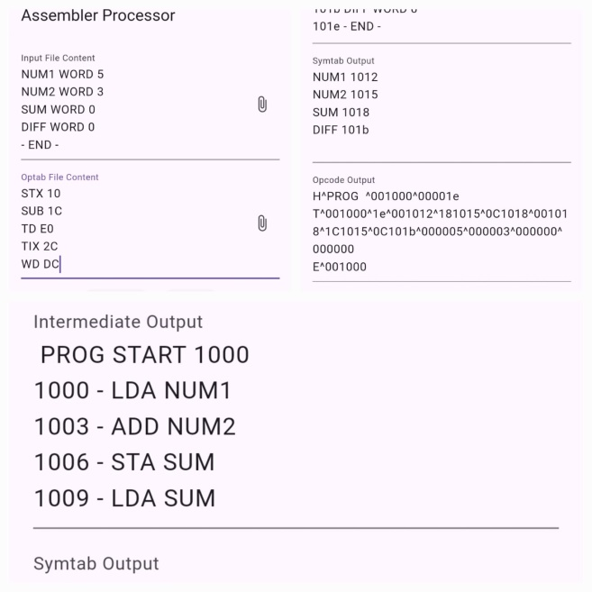
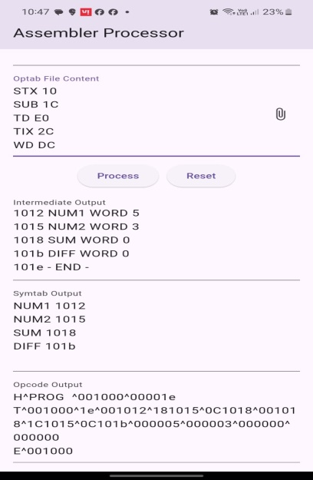

5. Requirements
To Run APK File
- Android 10 or above required
To Run Dart Code
- Update pubspec.yaml file
dependencies:
file_picker: ^8.1.2
5. Conclusion
This tutorial has provided a step-by-step guide to using a Flutter-based assembler for the SIC architecture. By understanding the two-pass assembly process and the generated outputs, you can efficiently translate SIC assembly language programs into executable machine code.
- Android Version: Android 10 or above is required.

6. Further Exploration
- Error Handling: Implement error handling to catch invalid inputs, missing opcodes, or symbol table conflicts.
- Object Code Format: Explore different object code formats (e.g., relocatable object files) and how they are generated.
- Architecture Dependence: Explore how assembly language and the assembly process differ for different computer architectures.

