|  |  |
| --- | --- |
| **Campus Ciudad de México**  **School of Engineering and Sciences**  **Department of Mechatronics** | **TE2019 Digital Signal Processing Laboratory**  Student’s 1 name and ID: Alfredo Zhu Chen - A01651980__  Student’s 2 name and ID: Luis Arturo Dan Fong - A016506720_  Lab # 1 Introduction to MATLAB  Date: 19/02/2021 |

# INTRODUCTION

The experiment consists of a MATLAB script in which creates a series of notes based on different given frequencies to recreate a specific melody and display 12 graphs, each representing the song’s notes. Likewise, this first laboratory navigates the student through the elements of the MATLAB software to perform calculations, signal generation and writing audio data.

**OBJECTIVES**

1. To identify the principal elements and functionalities of the MATLAB software package

2. To use essential MATLAB functions to perform calculations, signal generation, loading, and writing data.

3. To appreciate MATLAB as a development, simulation, and testing environment for digital signal processing

# MATERIALS & METHODS

The materials used in this laboratory were:

* Word File with the instructions and frequencies
* A computer with MATLAB software installed
* Calculator



Figure 1. Matlab Software

For this experiment, we manually obtained the frequencies for each note, depending on the wavelengths provided by the instruction file. In order to do this, we used equation 1, which $f$ stands for the note frequency, $v$ the velocity in the aire(343m/s) and $λ$ for the wavelength of the note.

$f=v/λ [ Hz]$ (1)

Then, we decided to test one fundamental frequency first(Do) and then replicate the code for the other notes (Figure 2). At first, we declared several values to be used for the other frequencies, such as time(t), amplitude(A), sampling rate(Fs), and note frequency(fdo). A sinusoidal waveform is defined with the previous parameters in order to produce the note.

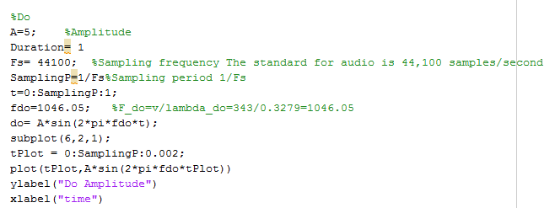

Figure 2. First test with fundamental frequency Do

To plot each sinusoidal waveform for the fundamental frequencies, a figure with 6x2 subplots is created to store them. A smaller sequence of tPlot is created to clearly see the waveform and the signal can be shown with plot command.



Figure 3. Plotting a frequency note

Finally, each note is stacked like a new row into the matrix notes_seq so that the sequence of notes can be produced with a for loop. Pause of 0.4s are inserted between tones to make each tone distinguishable.

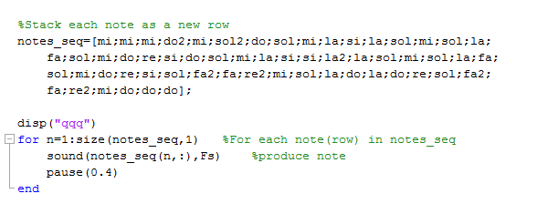

Figure 4. Generating sequence of notes

# RESULTS AND DISCUSSION

We realized that the method most suitable for this experiment was to obtain the frequencies by using the wavelength of each note. After using equation 1 and considering a velocity of sound equals to 343m/s, the frequencies results are as follows.

Table 1. Wavelength of fundamental frequencies

|  |  |  |
| --- | --- | --- |
| Musical note | Wavelength [m] | Frequency [Hz ] |
| Do | 0.3279 | 1046.05 |
| Do# | 0.3095 | 1108.23 |
| Re | 0.2921 | 1174.25 |
| Re# | 0.2757 | 1244.10 |
| Mi | 0.2603 | 1317.71 |
| Fa | 0.2457 | 1396.01 |
| Fa# | 0.2319 | 1479.08 |
| Sol | 0.2189 | 1566.92 |
| Sol# | 0.2066 | 1660.21 |
| La | 0.1950 | 1758.97 |
| La# | 0.1840 | 1864.13 |
| Si | 0.1737 | 1974.66 |

The plot of each fundamental frequency is shown in the next figure.

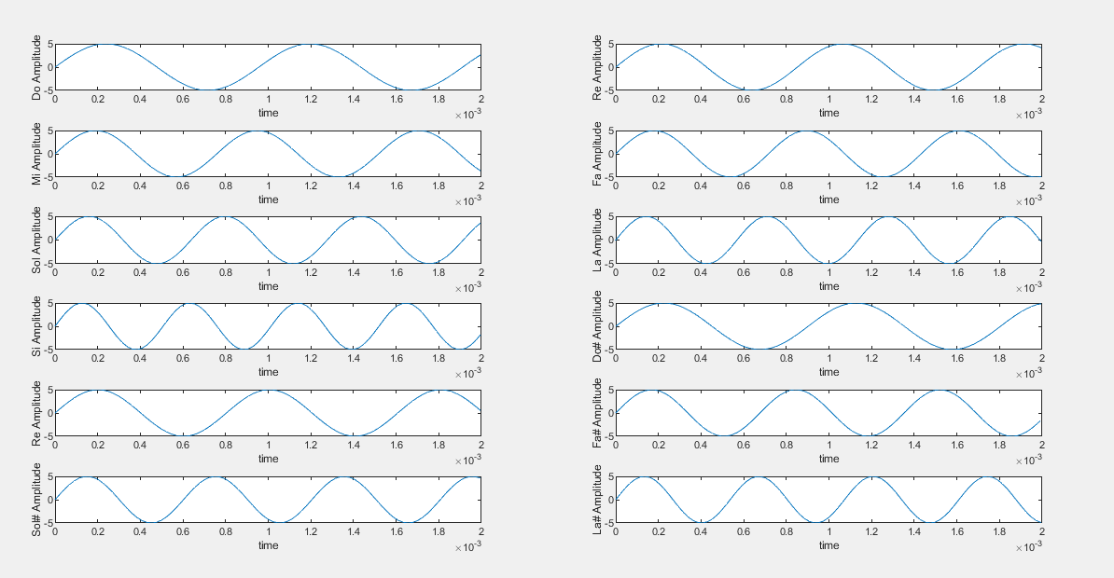

Figure 5 plot of each note

Once the program was finished and tested we realized that the notes shown in the laboratory brief were meant to be a song. However, we come to the conclusion that the notes weren’t in the correct order, causing the song to be quite confusing. After some talks with the professor, we were told the song that was meant to be played was “Happy Birthday”. (The result of the song can be appreciated by running the lab1 file in the same folder, please try to maintain low volume as possible to test if is adequate for listening)

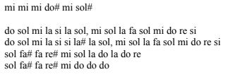

Figure 4. Song sequence

# CONCLUSION

In conclusion, this experiment was really helpful to understand the basic concepts and elements of the MATLAB software, although we realized that there's a big gap between the theoretical and practical parts of an experiment, because even though our math was correct and the frequencies used were the optimal for audio playing, the song wasn't understandable. At the same time, the objectives were achieved because we were able to perform calculations, signal generation and writing data to produce a sequence of notes.