Dynamic Network Planning Questionnaire

Name:   
Date:   
Occupation and position:

Question 1

You are a service provider responsible for the maintenance of a road segment in a regional network. To this end, you have studied the impact on traffic of four possible alternatives. This results in the following congestion figures, expressed in hours of traffic time lost (TTL), caused by each alternative.

|  |  |  |  |  |
| --- | --- | --- | --- | --- |
|  | **Alternative A** | **Alternative B** | **Alternative C** | **Alternative D** |
| *TTL* | 352.000 | 578.000 | 440.000 | 370.000 |

1. Can you specify the order in which you would choose from the various alternatives? Please rank them from 1 (best) to 4 (worst).

|  |  |
| --- | --- |
| Answer: | Rank: |
| Alternative A |  |
| Alternative B |  |
| Alternative C |  |
| Alternative D |  |

1. Please motivate your ranking.

Question 2

In addition you perform cost computation, resulting in the following figures:

|  |  |  |  |  |
| --- | --- | --- | --- | --- |
|  | **Alternative A** | **Alternative B** | **Alternative C** | **Alternative D** |
| *TTL* | 352.000 | 578.000 | 440.000 | 370.000 |
| *Profit* | € 1.450.000 | € 2.108.000 | € 1.500.000 | € 1.739.000 |

1. Can you specify the order in which you would choose from the various alternatives? Please rank them from 1 (best) to 4 (worst).

|  |  |
| --- | --- |
| Answer: | Rank: |
| Alternative A |  |
| Alternative B |  |
| Alternative C |  |
| Alternative D |  |

1. Please motivate your ranking.

Question 3

The road authority decides to implement a traffic penalty payment that charges the service provider 1 euro for each hour of TTL. After some recalculation you find out that this has the following impact on your project:

|  |  |  |  |  |
| --- | --- | --- | --- | --- |
|  | **Alternative A** | **Alternative B** | **Alternative C** | **Alternative D** |
| *TTL* | 352.000 | 578.000 | 440.000 | 370.000 |
| *Profit* | € 1.098.000 | € 1.529.000 | € 1.060.000 | € 1.369.000 |

1. Can you specify the order in which you would choose from the various alternatives? Please rank them from 1 (best) to 4 (worst).

|  |  |
| --- | --- |
| Answer: | Rank: |
| Alternative A |  |
| Alternative B |  |
| Alternative C |  |
| Alternative D |  |

1. Please motivate your ranking.

Question 4

You are aware of the possibility that your project execution might be delayed and you are wondering how much that will affect the figures from before. Therefore you decide to also consider this delay in your computations:

|  |  |  |  |  |  |  |
| --- | --- | --- | --- | --- | --- | --- |
| **Situation** | **Risk of delay** |  | **Alt. A** | **Alt. B** | **Alt. C** | **Alt. D** |
| **Project as planned** | 67% | *TTL* | 352.000 | 578.000 | 440.000 | 370.000 |
| *Profit* | € 1.098.000 | € 1.529.000 | € 1.060.000 | € 1.369.000 |
|  | | | | | | |
| **Project is delayed** | 33% | *TTL* | 443.000 | 885.000 | 440.000 | 503.000 |
| *Profit* | € 1.006.000 | € 1.223.000 | € 1.060.000 | € 1.236.000 |

1. Can you specify the order in which you would choose from the various alternatives? Please rank them from 1 (best) to 4 (worst).

|  |  |
| --- | --- |
| Answer: | Rank: |
| Alternative A |  |
| Alternative B |  |
| Alternative C |  |
| Alternative D |  |

1. Please motivate your ranking.

Question 5

You have chosen four potential periods in which you can perform your project. Using quarterly figures, you determine the following prospects regarding four possible maintenance periods:

|  |  |  |  |  |  |  |
| --- | --- | --- | --- | --- | --- | --- |
| **Situation** | **Risk of delay** |  | **Period 1** | **Period 2** | **Period 3** | **Period 4** |
| **Project as planned** | 67% | *TTL* | 370.000 | 416.000 | 333.000 | 615.000 |
| *Profit* | € 1.369.000 | € 1.323.000 | € 1.406.000 | € 1.124.000 |
|  | | | | | | |
| **Project is delayed** | 33% | *TTL* | 503.000 | 571.000 | 493.000 | 809.000 |
| *Profit* | € 1.236.000 | € 1.168.000 | € 1.246.000 | € 930.000 |

In addition, you also possess information regarding the TTL figures of the previous year.

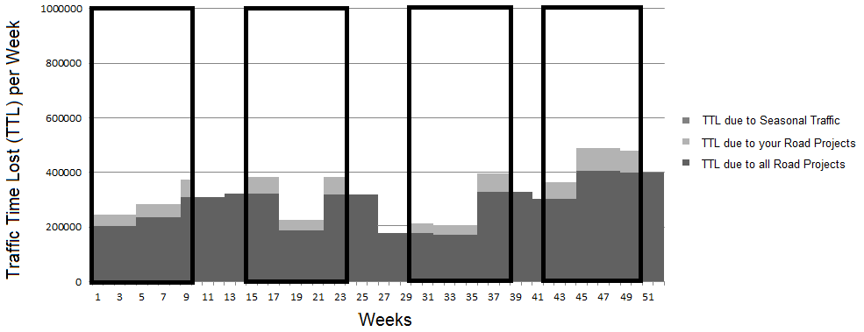

1. Can you specify the order of periods in which you prefer to perform the maintenance? Please rank them from 1 (best) to 4 (worst).

|  |  |
| --- | --- |
| Answer: | Rank: |
| Period 1 |  |
| Period 2 |  |
| Period 3 |  |
| Period 4 |  |

1. Please motivate your ranking.

Question 6

Other service providers are also working in this region and they, in combination with your project, cause additional traffic hindrance:

|  |  |  |  |  |  |  |
| --- | --- | --- | --- | --- | --- | --- |
| **Situation** | **Risk of delay** |  | **Period 1** | **Period 2** | **Period 3** | **Period 4** |
| **Project as planned** | 67% | *TTL* | 370.000 | 416.000 | 333.000 | 615.000 |
| *Profit* | € 1.369.000 | € 1.323.000 | € 1.406.000 | € 1.124.000 |
|  | | | | | | |
| **Project is delayed** | 33% | *TTL* | 503.000 | 571.000 | 493.000 | 809.000 |
| *Profit* | € 1.236.000 | € 1.168.000 | € 1.246.000 | € 930.000 |

|  |  |  |  |  |  |  |
| --- | --- | --- | --- | --- | --- | --- |
| **Situation** | **Risk of delay** |  | **Period 1** | **Period 2** | **Period 3** | **Period 4** |
| **Project as planned** | 67% | *TTL Ind.* | 370.000 | 416.000 | 333.000 | 615.000 |
| *TTL Net.* | 990.000 | 2.033.000 | 3.966.000 | 1.302.000 |
| *Profit* | € 1.171.000 | € 916.000 | € 613.000 | € 863.000 |
|  | | | | | | |
| **Project is delayed** | 33% | *TTL Ind.* | 414.000 | 471.000 | 406.000 | 667.000 |
| *TTL Net.* | 2.030.000 | 2.662.000 | 6.545.000 | 1.436.000 |
| *Profit* | € 919.000 | € 736.000 | € 24.000 | € 785.000 |

In this table, the individual TTL denotes the TTL caused solely by your project, ignoring others. The network TTL captures the ‘combined effect’ of multiple service providers working concurrently in the same region. Next to this table, you are also given a plot of the TTL distribution over time.

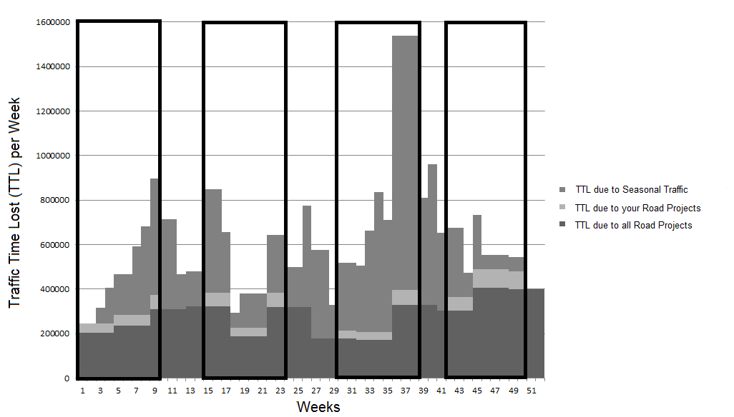

1. Can you specify the order in which you would choose from the various periods? Please rank them from 1 (best) to 4 (worst).

|  |  |
| --- | --- |
| Answer: | Rank: |
| Period 1 |  |
| Period 2 |  |
| Period 3 |  |
| Period 4 |  |

1. Please motivate your ranking.

Question 7

You have chosen the third period and you wish to reduce the incurred traffic time losses. Through communication with the other contractors, you have been able to create the following joint schedule:



1. a) If you were given the opportunity to change plans made by others, what project(s) would you modify? Can you rank the projects based on which one you would modify first (1) to last (4)?

|  |  |
| --- | --- |
| Project: | Rank: |
| Contractor 2: B1-A |  |
| Contractor 2: B14-B |  |
| Contractor 3: B15-A |  |
| Contractor 5: B13-A |  |

1. Please motivate your ranking.

**Thank you very much for completing this questionnaire!**