Civil Service Form No. 6
Revised 2020
Republic of the Philippines
Department of Education
Region IV A – CALABARZON
SCHOOLS DIVISION OFFICE OF CITY OF SAN PEDRO
APPLICATION FOR LEAVE
1. OFFICE/DEPARTMENT:
2. NAME:
(Last)
(First)
(Middle)
${LASTNAME}
${FIRSTNAME}
${MIDNAME}
${DATE_FILING}
${POSITION}
${SALARY}
3. DATE OF FILING:
4. POSITION:
.
5. SALARY:
6. DETAILS OF APPLICATION
6.A TYPE OF LEAVE TO BE AVAILED OF
6.B DETAILS OF LEAVE
In case of Vacation/Special Privilege Leave:
${type_vacation} Vacation Leave (Sec. 51, Rule XVI, Omnibus Rules Implementing E.O. No. 292)
${type_mandatory} Mandatory/Forced Leave (Sec. 25, Rule XVI, Omnibus Rules Implementing E.O. No. 292
${type_sick} Sick Leave (Sec. 43, Rule XVI, Omnibus Rules Implementing E.O. No. 292)
${type_maternity} Maternity Leave (R.A. No. 11210 / IRR issued by CSC, DOLE and SSS)
${type_paternity} Paternity Leave (R.A. No. 8187 / CSC MC No. 71, s. 1998, as amended)
${detail_vacation_abroad} Abroad (Specify)
In case of Sick Leave:
${detail_sick_hospital} In Hospital (Specify Illness)
${type_special_privilege} Special Privilege Leave (Sec. 21, Rule XVI, Omnibus Rules Implementing E.O. No. 292)
${type_solo_parent} Solo Parent Leave (RA No. 8972 / CSC MC No. 8, s. 2004)
${type_study} Study Leave (Sec. 68, Rule XVI, Omnibus Rules Implementing E.O. No. 292)
${type_vawc}10-Day VAWC Leave (RA No. 9262 / CSC MC No. 15, s. 2005)
${type_rehab} Rehabilitation Privilege (Sec. 55, Rule XVI, Omnibus Rules Implementing E.O. No. 292
${type_women} Special Leave Benefits for Women (RA No. 9710 / CSC MC No. 25, s. 2010)
${type_calamity} Special Emergency (Calamity) Leave (CSC MC No. 2, s. 2012, as amended)
${type_adoption} Adoption Leave (R.A. No. 8552)
In case of Study Leave:
${detail_study_masters} Completion of Master's Degree
${detail_study_bar} BAR/Board Examination Review
Other purpose:
Others:
${type_monetization} Monetization of Leave Credits
${type_terminal} Terminal Leave
_____________________________________
6.C NUMBER OF WORKING DAYS APPLIED FOR
6.D COMMUTATION
${commutation_no} Not Requested
${commutation_yes} Requested
__________________________________
INCLUSIVE DATES
(Signature of Applicant)
7. DETAILS OF ACTION ON APPLICATION
7.A CERTIFICATION OF LEAVE CREDITS
As of _______________________
7.B RECOMMENDATION
For approval
For disapproval due to
7.C APPROVED FOR:
_______ days with pay
_______ days without pay
_______ others (Specify)
7.D DISAPPROVED DUE TO:
_______________________________________
___________________________________________
___________________________________________
OFFICE OF THE SCHOOLS DIVISION SUPERINTENDENT

${OFFICE}

${detail_vacation_phil} Within the Philippines
${sick_hospital_specify}
${vacation_specify}
(Specify Illness)
In case of Special Leave Benefits for Women:
${sick_outpatient_specify}
${detail_sick_outpatient} Out Patient (Specify Illness)

${women_specify}

${type_others}

${day}

${SIGNAME}
${date}

Sick Leave
Total Earned
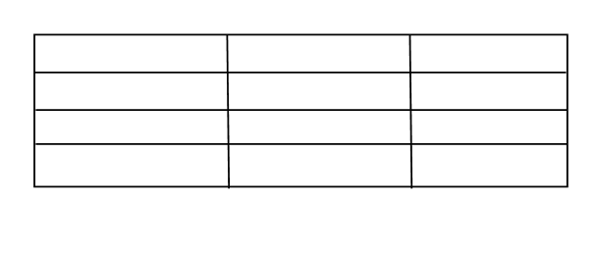
Vacation Leave

Less this application

Balance
${RECOMMENDING_POSITION}
${RECOMMENDING_NAME}
___________________________________________________________
_________________________________________________________
${VOLC_NAME}

${VOLC_POS}

${FINAL_POSITION}
${FINAL_NAME}

OFFICER-IN-CHARGE

