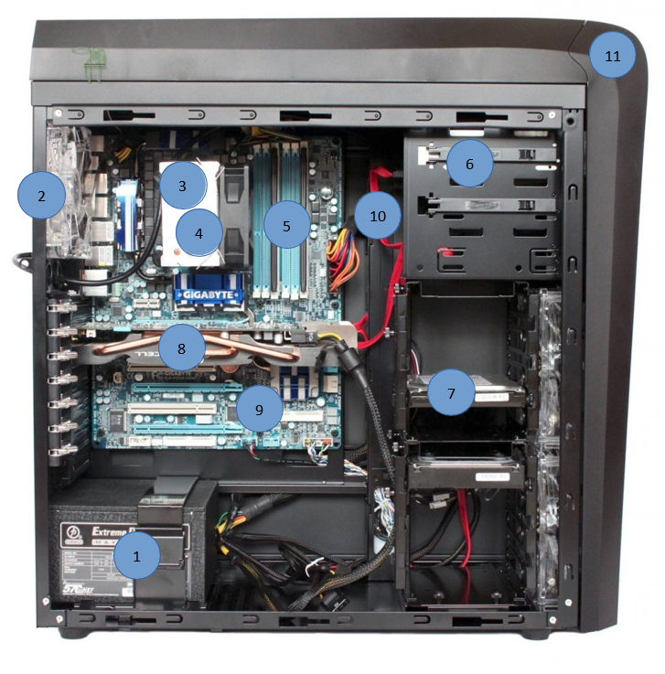

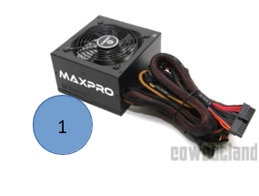

|  |  |  |  |
| --- | --- | --- | --- |
| **1** | **NOM** | **FONCTION** | **INVENTAIRE** |
|  |  |  |

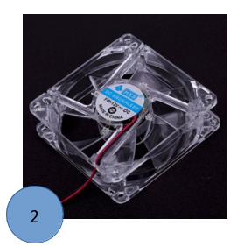

|  |  |  |  |
| --- | --- | --- | --- |
| **2** | **NOM** | **FONCTION** | **INVENTAIRE** |
|  |  |  |

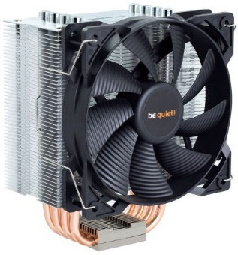

3

|  |  |  |  |
| --- | --- | --- | --- |
| **3** | **NOM** | **FONCTION** | **INVENTAIRE** |
|  |  |  |

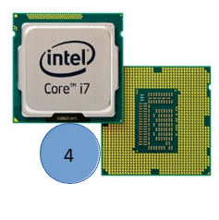

|  |  |  |  |
| --- | --- | --- | --- |
| **4** | **NOM** | **FONCTION** | **INVENTAIRE** |
|  |  |  |

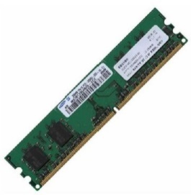

5

|  |  |  |  |
| --- | --- | --- | --- |
| **5** | **NOM** | **FONCTION** | **INVENTAIRE** |
|  |  |  |

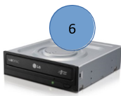

|  |  |  |  |
| --- | --- | --- | --- |
| **6** | **NOM** | **FONCTION** | **INVENTAIRE** |
|  |  |  |

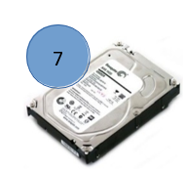

|  |  |  |  |
| --- | --- | --- | --- |
| **7** | **NOM** | **FONCTION** | **INVENTAIRE** |
|  |  |  |

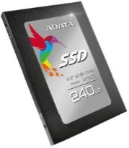

|  |  |  |  |
| --- | --- | --- | --- |
| **7.1** | **NOM** | **FONCTION** | **INVENTAIRE** |
|  |  |  |



8

|  |  |  |  |
| --- | --- | --- | --- |
| **8** | **NOM** | **FONCTION** | **INVENTAIRE** |
|  |  |  |

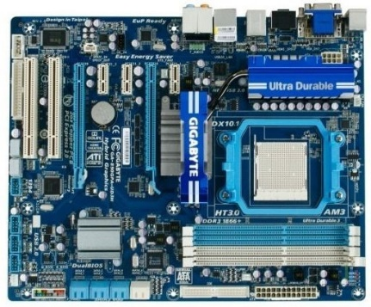

9

|  |  |  |  |
| --- | --- | --- | --- |
| **9** | **NOM** | **FONCTION** | **INVENTAIRE** |
|  |  |  |

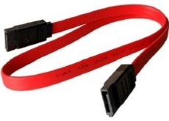

10

|  |  |  |  |
| --- | --- | --- | --- |
| **10** | **NOM** | **FONCTION** | **INVENTAIRE** |
|  |  |  |

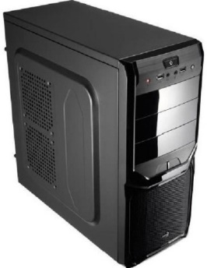

|  |  |  |  |
| --- | --- | --- | --- |
| **11** | **NOM** | **FONCTION** | **INVENTAIRE** |
|  |  |  |