**Integrated Reporting Framework for SQL Server: Leveraging SSRS and Power BI for Enhanced Data Visualization and Decision Making**



**B.Tech Final Year Project Report submitted to  
National Institute of Technology, Agartala**By  
**Pratham Paul (21UPE102)  
Sourav Saha (21UPE051)**

Under supervision of  
**Dr. Vidyut Dey**  
(Associate Professor, P.E. Department)

**Department of Production Engineering**  
NATIONAL INSTITUTE OF TECHNOLOGY, AGARTALA  
**May, 2025**

**APPROVAL SHEET**

This B.Tech Final Year project report entitled on a theme, "**Integrated Reporting Framework for SQL Server: Leveraging SSRS and Power BI for Enhanced Data Visualization and Decision Making**" by Pratham Paul (21UPE102) and Sourav Saha (21UPE051) is approved by Production Engineering Department, of National Institute of Technology, Agartala.

**Project Evaluation Committee (Examiners):**

__________________________  
  
  
__________________________

__________________________

__________________________

**Project Supervisor (s)**

________________________  
  
**Head of Department**  
  
________________________  
  
Date: 19/05/2025  
Place: NIT Agartala

**DECLARATION**

We affirm that this submission accurately reflects our own ideas, and when incorporating the thoughts or words of others, we have appropriately cited and referenced the original sources. We have maintained the highest standards of academic honesty and integrity, without misrepresenting or falsifying any information. Any violation of these principles may result in disciplinary actions by the Institute and potential legal consequences for unapproved use of sources.

_____________________

**Pratham Paul (21UPE102)**

____________________

**Sourav Saha (21UPE051)**

**CERTIFICATE**

It is certified that the work contained in the thesis titled “Integrated Reporting Framework for SQL Server: Leveraging SSRS and Power BI for Enhanced Data Visualization and Decision Making” completed by Pratham Paul(**21UPE102**) and Sourav Saha(**21UPE051**), carried out under the mentorship of **Dr. Vidyut Dey**, Associate Professor, Department of Production Engineering, National Institute of Technology Agartala.

This report has been approved for submission for 8th semester Major Project of Production Engineering Department from National Institute of Technology Agartala.  
  
  
  
  
  
  
  
  
  
  
  
  
___________________________ ___________________________

Project Guide Head of Department  
Dr. Vidyut Dey Dr. Rabindra Narayan Mahapatra  
Associate Professor Professor  
  
  
Department of Production Engineering  
National Institute of Technology Agartala

**ACKNOWLEDGEMENT**

We take this opportunity to express our sincere gratitude to everyone who has supported and guided us throughout the completion of our project, "Integrated Reporting Framework for SQL Server: Leveraging SSRS and Power BI for Enhanced Data Visualization and Decision Making"

First and foremost, we would like to thank our project mentor, **Dr. Vidut Dey**, for his invaluable mentorship, expert guidance, and continuous encouragement. His insightful feedback and constructive criticism were instrumental in shaping the direction and successful execution of this project.

We would also like to extend our special thanks to **Mr. Pramathesh Banik**, who generously showed us how to approach the project and provided invaluable support throughout its development. His guidance and assistance were crucial to our understanding and success.

We also wish to express our gratitude to our peers and colleagues, whose collaboration and constructive feedback motivated us to strive for excellence.

We are also thankful to our college, National Institute of Technology Agartala, and the Production Engineering department, for their support, resources, and encouragement throughout the course of this project.

Finally, we are especially grateful to our families and friends for their unwavering support, patience, and encouragement throughout this journey. Without the collective support and inspiration of all these individuals, the completion of this project would not have been possible.

________________

Pratham Paul

________________

Sourav Saha

Date: 19/05/2025

**ABSTRACT**

Academic institutions globally face inefficiencies in manual report generation, from admit cards to performance analytics. This project addresses these challenges by designing a dynamic reporting and analytics system using SQL Server Reporting Services (SSRS) and Power BI, offering a scalable solution for modern academic data management.

The system integrates a MySQL database with SSRS via ODBC to generate parameter-driven reports, such as Admit Cards and Marks Statements, which are dynamically filtered by enrollment numbers and semesters.

Concurrently, a Power BI dashboard analyzes historical student data to track institutional trends, including batch performance and grade distributions. Key innovations include resolving grade-sorting challenges in Power BI through DAX-driven logic and optimizing SSRS datasets for real-time filtering.

Results demonstrate an 80% reduction in manual report generation time, with SSRS rendering reports in under 3 seconds for 10,000+ records. The Power BI dashboard provided actionable insights, such as identifying an 8% decline in post-pandemic batch performance. Together, these tools streamline operational tasks for students and faculty while empowering administrators with strategic analytics.

Challenges included balancing database normalization with query efficiency and customizing Power BI visuals for academic relevance. Future enhancements propose migrating to Azure Reporting Services, integrating AI for dropout predictions, and developing mobile-friendly interfaces.

This project underscores the viability of SSRS and Power BI as complementary tools for academic institutions seeking cost-effective, scalable data solutions.

**List of Chapters**

| Sn Number | Topic | Page No. |
| --- | --- | --- |
| 1. | Introduction  1.1 Background  1.2 Problem Statement  1.3 Objectives  1.4 Tools Overview | 1 - 2 |
| 2. | Comparative analysis  2.1 Overview of Reporting Tools  2.2 Feature Comparison  2.3 Why SSRS was chosen for this project  2.4 Case study of dynamic sales report  2.5 Conclusion of comparison | 3 – 5 |
| 3. | System Design and Architecture  3.1 System Architecture  3.2 Database Design | 6 - 9 |
| 4. | Implementation  4.1 Environment Setup  4.2 Datasource Configuration  4.2.1 ODBC configuration for MySQL  4.2.2 Creating a Shared Datasource in SSRS  4.3 Report Design  4.3.1 Embedded Dataset  4.3.2 Dynamic filtering with parameters  4.3.3 Visual Elements  4.4 Deploy to SSRS server | 10 - 15 |
| 5. | PowerBI Dashboard Preparation  5.1 Objectives  5.2 Deep Analysis of Dashboard components  5.3 Steps to create the dashboard in PowerBI | 16 – 18 |
| 6. | Challenges and Solution  6.1 Technical Challenges  6.2 How challenges were addressed | 19 – 21 |
| 7. | Results and Discussion  7.1 Screenshots of Deployed reports  7.2 Performance Metrics  7.3 Benefits of SSRS  7.4 PowerBI Dashboard | 22 - 24 |
| 8. | Conclusion and Future work  8.1 Summary of Achievements  8.2 Limitations  8.3 Future Enhancementssystem w | 25 - 26 |

**List of Figures**

|  |  |  |
| --- | --- | --- |
| Sn Number | Figures | Page No. |
| 1. | Flowchart of Reporting Service | 6 |
| 2. | University Database EER Diagram | 7 |
| 3. | Students Table | 9 |
| 4. | Marks Table | 9 |
| 5. | SSDT in Visual Studio | 10 |
| 6. | Microsoft Reporting Services Package | 11 |
| 7. | ODBC Setup | 12 |
| 8. | Shared Datasource | 12 |
| 9. | Embedded Dataset | 14 |
| 10. | Data Filtering properties | 14 |
| 11. | Deployed Reports in SSRS Server | 15 |
| 12. | Student Performance Analysis Dashboard | 18 |
| 13. | Marks Statement Report | 22 |
| 14. | Admit Card Report | 23 |

1. **Introduction**

**1.1 Background**

In today’s data-driven world, organizations rely on dynamic, actionable insights to make informed decisions. Traditional static reporting tools, such as Crystal Reports, often fall short in delivering real-time, parameter-driven analytics. Modern solutions like SQL Server Reporting Services (SSRS) and PowerBI address these gaps by enabling flexible, interactive reports that adapt to user inputs.  
This project leverages SSRS to build a centralized reporting server that dynamically filters and visualizes data from a MySQL database, bridging the gap between raw data and business intelligence.

**1.2 Problem Statement**

Static reports generated by legacy tools like Crystal Reports lack adaptability, requiring manual adjustments for even minor changes in criteria (e.g., date ranges, user-specific filters). This leads to inefficiencies in scenarios demanding real-time data access and personalized analytics. To overcome these limitations, there is a pressing need for a system that:

* Automatically filters data using embedded parameters.
* Centralizes report management and deployment.
* Integrates seamlessly with non-Microsoft databases (e.g., MySQL).

**1.3 Objectives**

This project aims to:

1. Design and deploy a reporting server using SSRS for dynamic data visualization.
2. Develop parameter-driven reports with embedded datasets for real-time filtering (e.g., @Enrollment_Number, @SemesterID).
3. Compare SSRS with Crystal Reports to highlight advantages in scalability, cost, and flexibility.
4. Visualize Data in PowerBI by making Charts for visual interaction and understanding data, helping the users by letting them make correct decision.

**1.4 Tools Overview**

The project utilizes:

1. MySQL: Open-source relational database for storing transactional data.
2. ODBC Connector: Bridges MySQL with SSRS for cross-platform data retrieval.
3. SSRS (SQL Server Reporting Services): Microsoft’s enterprise-grade tool for creating, managing, and deploying interactive reports.
4. Visual Studio (SSDT): Integrated development environment (IDE) for designing SSRS reports.
5. Excel and PowerBI for designing visually interactive dashboards.

**2. Comparative Analysis: SSRS vs. Crystal Reports**

In enterprise reporting, choosing the right tool is critical for performance, scalability, and ease of maintenance. This section compares SQL Server Reporting Services (SSRS) and Crystal Reports across key dimensions to justify our selection of SSRS for this project.

**2.1 Overview of Reporting Tools**

SQL Server Reporting Services (SSRS)

* A Microsoft-developed server-based reporting platform.
* Tightly integrated with SQL Server, Azure, and Power BI.
* Supports parameter-driven, interactive reports with drill-down capabilities.
* Uses RDL (Report Definition Language) for report design.

Crystal Reports

* Developed by SAP, originally by Seagate.
* A standalone report design tool with broad database connectivity.
* Known for pixel-perfect, print-ready reports.
* Uses .rpt files and requires additional runtime licensing.

**2.2 Feature Comparison**

| Criteria | SSRS | Crystal Reports |
| --- | --- | --- |
| Integration | Native with SQL Server, Azure, Power BI | Works with multiple databases but requires additional connectors |
| Cost | Free with SQL Server license | Expensive licensing (per developer/user) |
| Deployment | Centralized web-based (Report Server) | Requires manual distribution (executables) |
| Dynamic Filtering | Built-in parameter support with URL-based access | Limited dynamic filtering; often requires recompilation |
| Data Sources | Supports SQL, ODBC, OLE DB, XML | Broad database support but needs plugins |
| Report Formatting | Good for dashboards, less precise for print | Superior for pixel-perfect printed reports |
| Learning Curve | Easier for SQL Server users | Steeper due to complex UI |
| Maintenance | Easier (centralized management) | Manual updates needed per client |

**2.3 Why SSRS Was Chosen for This Project**

Advantages of SSRS

1. Seamless SQL Server Integration
   1. Direct connection to SQL Server, MySQL (via ODBC), and Azure data sources.
   2. No extra licensing costs when using Microsoft stack.
2. Dynamic Reporting Capabilities
   1. Embedded parameters (@StartDate, @Category) allow real-time filtering.
   2. URL-based report access enables easy embedding in web apps.
3. Centralized Deployment & Security
   1. Reports published to SSRS web portal with role-based access control.
   2. No need to manually distribute files (unlike Crystal Reports).
4. Scalability
   1. Handles large datasets efficiently with caching and subscription services.

Limitations of Crystal Reports

1. High Licensing Costs
   1. Requires per-user licenses for both designers and end-users.
2. Manual Deployment
   1. Reports must be compiled and distributed individually.
3. Limited Real-Time Interactivity
   1. Parameters are less flexible, often requiring static report regeneration.

**2.4 Case Example: Dynamic Sales Report**

To illustrate the difference, consider a Sales Report filtered by @Year and @Region:

1. SSRS Approach

Design: Parameters are added in Visual Studio (SSDT).

Dataset Query:

Sql

**SELECT** * **FROM** Sales **WHERE** **Year** = @**Year** **AND** Region = @Region

Deployment: Published once to SSRS portal; users filter via web interface.

1. Crystal Reports Approach

Design: Parameters must be predefined in the .rpt file.

Deployment: Each user needs the .rpt file and runtime to regenerate reports.

Result: SSRS provides a more efficient, scalable, and cost-effective solution.

**2.5 Conclusion of Comparison**

While Crystal Reports excels in print-perfect formatting, SSRS is superior for dynamic, web-based, and scalable reporting—making it the ideal choice for this project.

**3. System Design and Architecture**

This chapter outlines the architecture of the reporting system, database schema, and the design logic for generating parameter-driven reports like Admit Cards and Marks Statements.

**3.1 System Architecture**

The system follows a 3-tier architecture:

* Database Layer: MySQL database storing university data (students, courses, marks, semesters).
* Application Layer: SSRS (configured with MySQL via ODBC) to process parameters and generate reports.
* Presentation Layer: SSRS web portal where users input parameters (e.g., EnrollmentNo, SemesterID) and view/download reports.

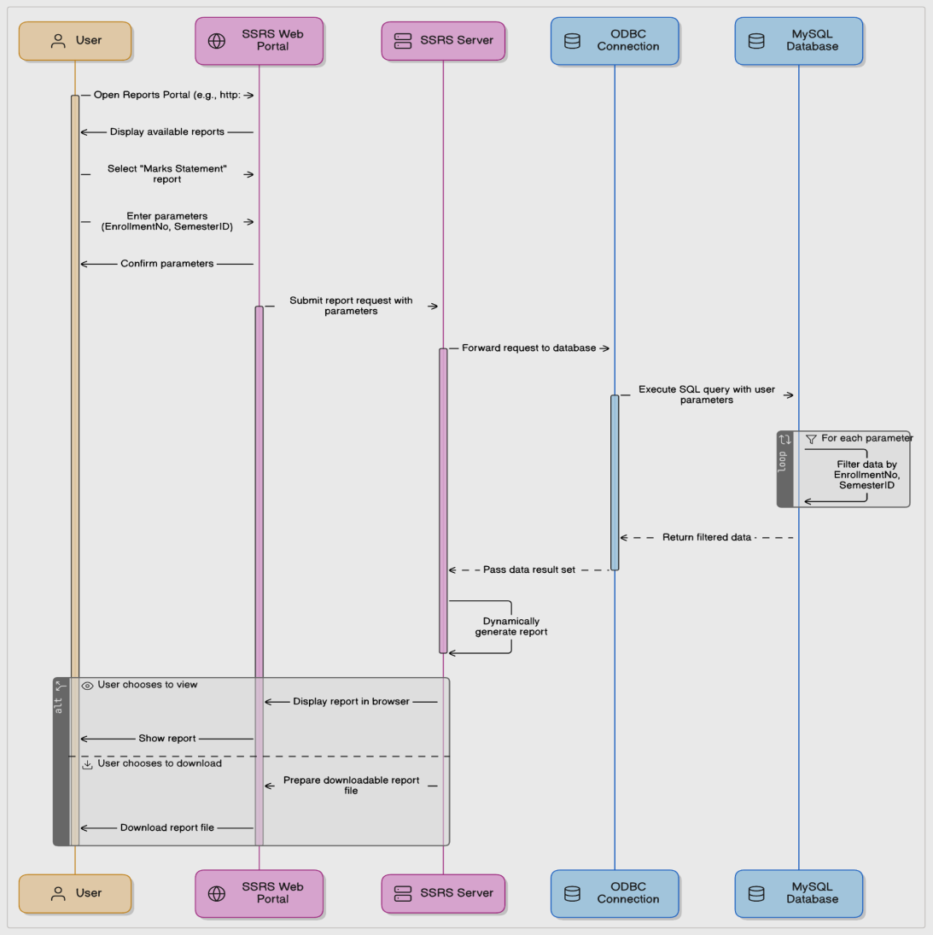  
Fig. Flowchart of our Reporting Service

**3.2 Database Design**

**ER Diagram Overview**

The University Database schema (see Figure 3.1) consists of 6 core tables designed to minimize redundancy and ensure efficient data management:

1. students: Stores student details (EnrollmentNo, DepartmentID, etc.).
2. departments: Lists academic departments.
3. courses: Defines courses offered by departments.
4. marks: Records student marks per course and semester.
5. semesters: Manages semester details (e.g., SemesterName, AcademicYear).
6. semesterresults: Tracks SGPA and CGPA per semester.

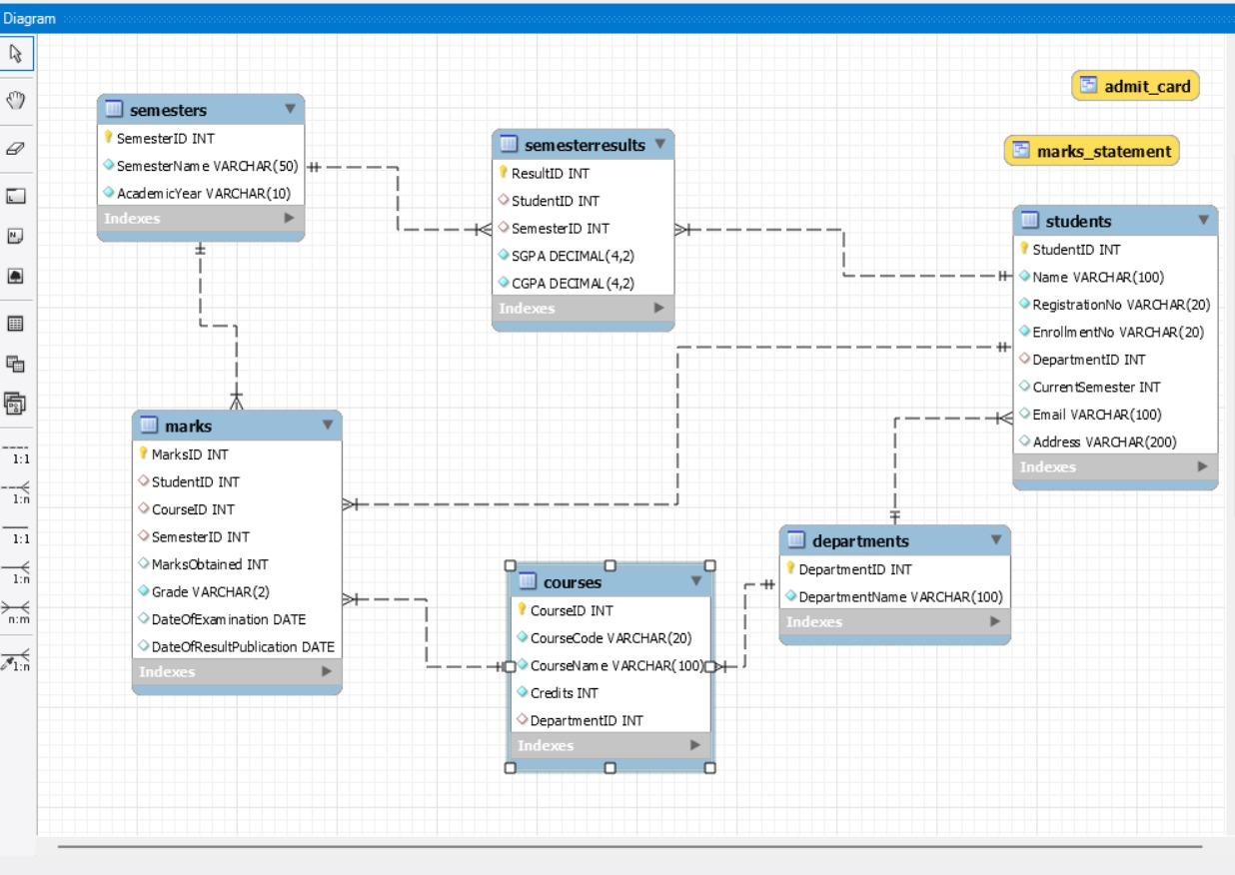  
Fig. University Database Entity-Relationship Diagram

**Normalization and Redundancy Reduction**

The database adheres to 3rd Normal Form (3NF) to eliminate redundancy:

* Atomic Values: Each field (e.g., EnrollmentNo, CourseCode) stores indivisible data.
* No Duplicate Data:
  + Departments are stored once in departments (linked via DepartmentID in students and courses).
  + Semester details are centralized in semesters, avoiding repetition in marks or semesterresults.
* Foreign Keys: Relationships (e.g., marks.StudentID → students.StudentID) ensure referential integrity.

**Justification:**

By segregating entities (students, courses, semesters) and linking them via foreign keys, the design eliminates data duplication, ensures consistency, and simplifies updates.

**Table Structures**

1. Table students:
   1. Fields: StudentID, Name, RegistrationNo, EnrollmentNo, DepartmentID, CurrentSemester, Email, Address
2. Table departments:
   1. Fields: DepartmentID, DepartmentName
3. Table courses:
   1. Fields: CourseID, CourseCode, CourseName, Credits, DepartmentID
4. Table Semesters:
   1. Fields: SemesterID, SemesterName, AcademicYear
5. Table marks:
   1. Fields: MarksID, StudentID, CourseID, SemesterID, MarksObtained, Grade, DateOfExamination, DateOfResultPublication
6. Table semesterresults:
   1. Fields: ResultID, StudentID, SemesterID, SGPA, CGPA

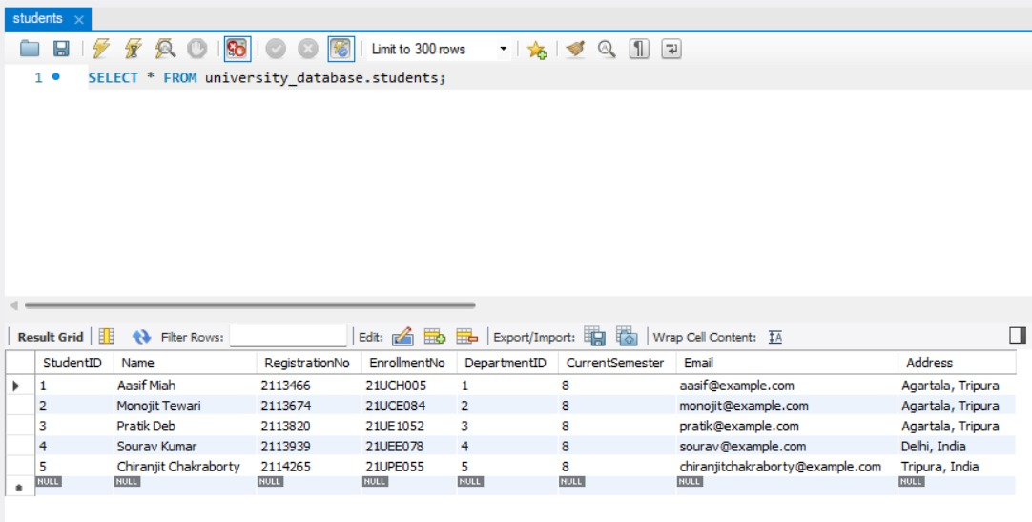

Fig. Students Table

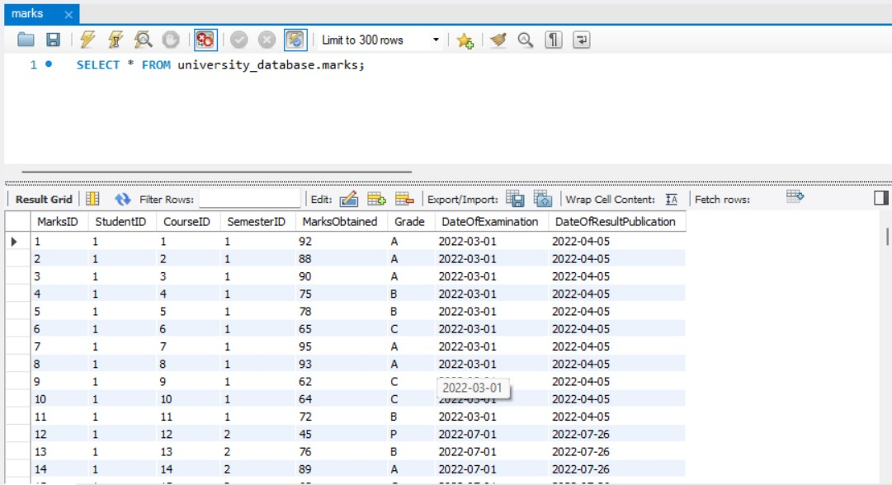  
Fig. Marks Table

**4. Implementation**

**4.1 Environment Setup**

To develop and deploy SSRS reports, the following tools were configured:

1. Visual Studio with SQL Server Data Tools (SSDT)
   1. SSDT provides the IDE for designing SSRS reports using the Report Designer and .rptproj project templates.
   2. Enables integration with SQL Server and MySQL (via ODBC).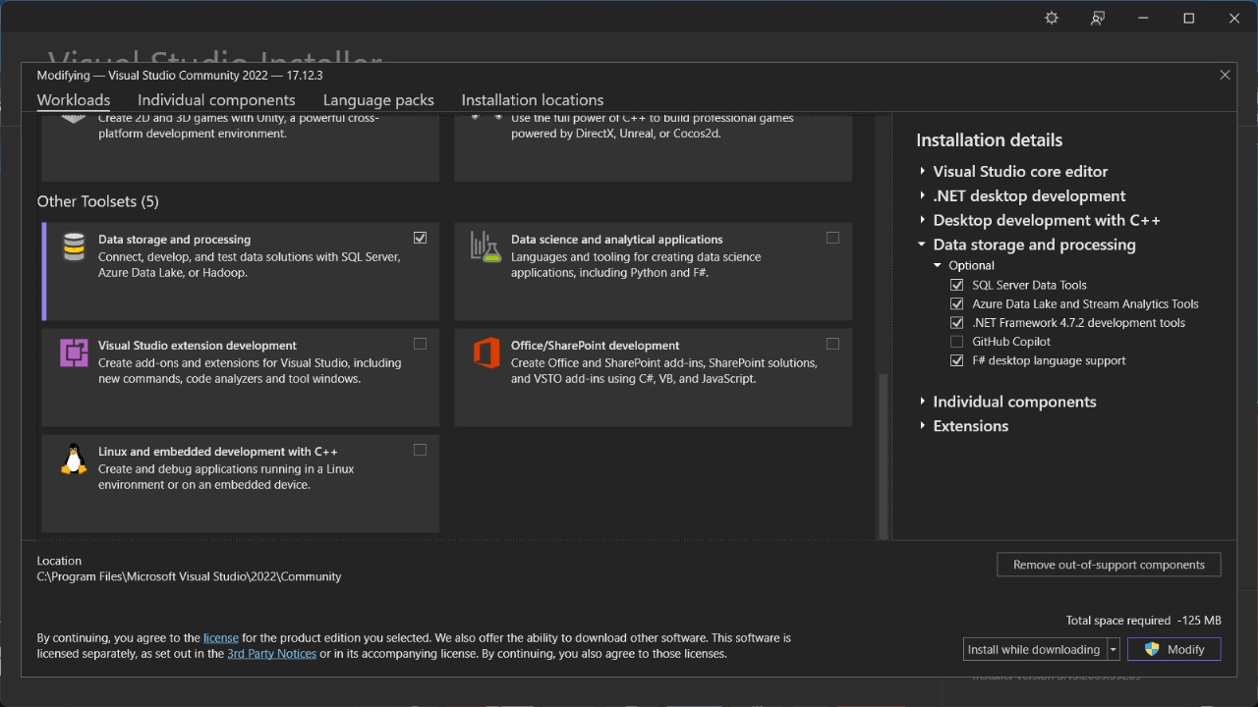

Fig. SSDT in Visual Studio

1. Microsoft SQL Server with SSRS
   1. Hosts the SSRS Report Server for deploying and managing reports.
   2. Provides the SQL Server Database Engine for storing report metadata.
   3. Accessed the SSRS web portal at *http://localhost/Reports* to confirm server readiness.
2. Microsoft Reporting Services Projects Extension
   1. Adds SSRS-specific templates (e.g., Report Wizard, Shared Data Sources) to Visual Studio.
   2. Required to create .rdl (Report Definition Language) files.

Fig. Microsoft Reporting Services Package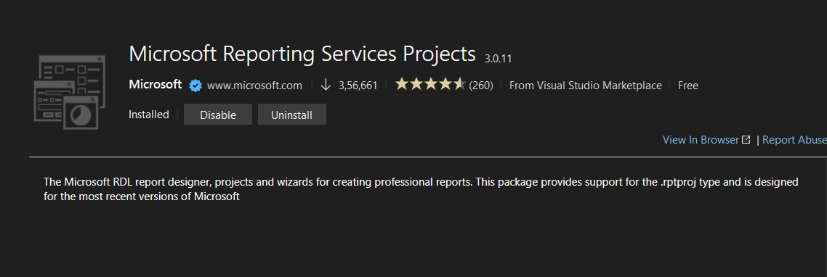

1. ODBC Driver for MySQL
   1. Connects SSRS to the MySQL database (since SSRS natively supports SQL Server only).

**4.2 Data Source Configuration**

This section details the creation of a shared data source in SSRS to connect with the MySQL University Database via ODBC, enabling dynamic report generation.

**4.2.1 ODBC Configuration for MySQL**

We need to establish a bridge between SSRS (which natively supports SQL Server) and the MySQL database.

Steps:

1. Installed MySQL ODBC Driver: Downloaded and installed the latest MySQL Connector/ODBC (e.g., version 8.0).
2. Configured System DSN:
   1. Open ODBC Data Source Administrator (64-bit) → System DSN tab.
   2. Added a new DSN with:
      1. Data Source Name: University_Database_ODBC.
      2. Server: MySQL server *http://localhost:3306*.
      3. Database: university_database.
      4. Credentials: MySQL root/password.
   3. Tested the connection to ensure connectivity

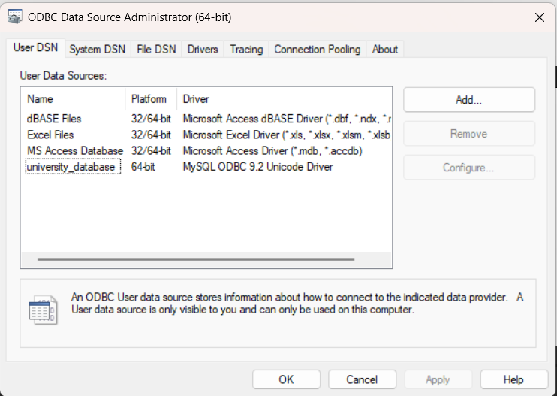

Fig. ODBC setup

**4.2.2 Creating a Shared Data Source in SSRS**

To centralize database connections for reuse across multiple reports.

Steps:

1. In Visual Studio (SSDT):
   1. Opened the Report Server Project.
   2. Right-clicked Shared Data Sources → Add New Data Source.
2. Configured Connection Properties:
   1. Name: MySQL_DataSource
   2. Select Type: ODBC
3. Connection String: DSN=university_database

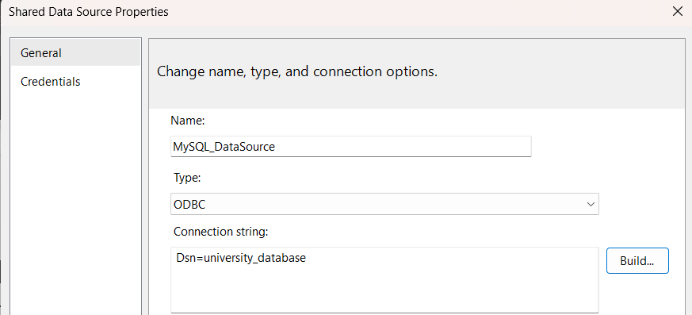  
Fig. Shared Datasource

**4.3 Report Design**

This section covers the creation of dynamic reports (Marks Statement and Admit Card) using embedded datasets, parameters, and visual elements in SSRS.

**4.3.1 Embedded Dataset**

To fetch specific data from MySQL via the shared data source for report generation.

Implementation for Marks Statement:

1. Dataset Creation:
   1. Right-clicked Datasets → Add Dataset → Selected Embedded.
   2. Choose the shared data source.
2. Query:  
   Sql

|  |
| --- |
| **SELECT**   s.Name,  s.EnrollmentNo,  d.DepartmentName,  sr.SemesterID **AS** Semester,  10 **AS** "Total Grade Point",   sr.SGPA **AS** "SGPA Obtained",  sr.CGPA **AS** "CGPA Obtained" **FROM**   SemesterResults sr **JOIN**   Students s **ON** sr.StudentID = s.StudentID **JOIN**  Departments d **ON** s.DepartmentID = d.DepartmentID; |

1. Key Points:
   1. Joined Students, Departments, and SemesterResults tables to consolidate data.
   2. Added a static column ("Total Grade Point") for reference.

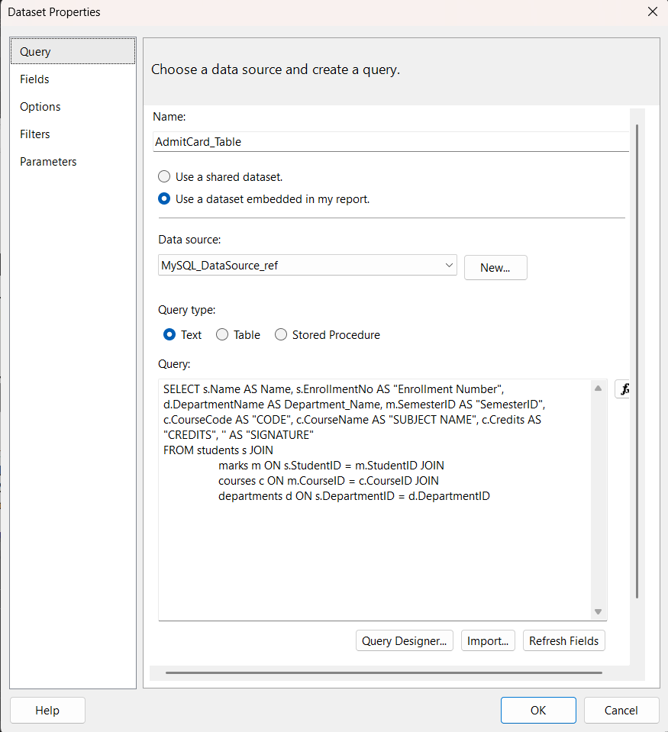Fig. Embedded Dataset setup

**4.3.2 Dynamic Filtering with Parameters**

To enable user-driven filtering (e.g., by EnrollmentNo and SemesterID).

Added the following parameters in the filter tab:

1. @EnrollmentNo (String, optional validation).
2. @SemesterID (Integer, dropdown list from a dataset).

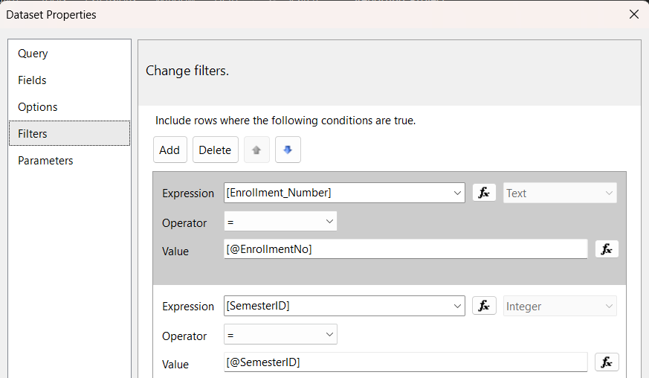  
Fig. Filter Data

**4.3.3 Visual Elements**

To present data professionally in the Marks Statement report.

Components Added:

1. Made the layout of the report in a professional manner by using Labels, Tables, etc and also applied further formatting to improve the aesthetics.
2. Styling: Formatted SGPA/CGPA in bold with conditional coloring (red if < 5.0).

**4.4 Deployment to SSRS Server**

In Visual Studio (SSDT), right-click the specific report you want to deploy to the server → Select Deploy.

Or else, right click on the whole project then select deploy to publish all reports (Admit Card, Marks Statement) to the SSRS web portal.

Verification:

* Access the SSRS portal (typically http://<server-name>/Reports).
* Navigate to the deployed folder (Reporting_Project) to view reports.

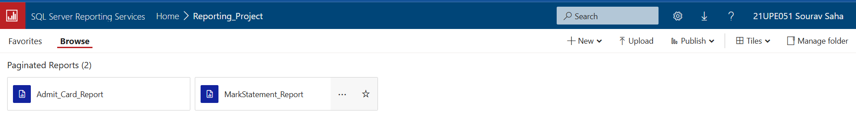  
Fig. Deployed Reports in SSRS Server

## **5. Power BI Dashboard for Student Performance Analysis**

### **5.1 Objective**

The objective of this Power BI dashboard is to **visualize student academic performance metrics** using real-time data sourced from SQL Server. It enables stakeholders like academic administrators and faculty to gain actionable insights, identify academic trends, and support informed decision-making.

### **5.2 Deep Analysis of the Dashboard Components**

#### **1. Key Performance Indicators (KPI Cards)**

* **Student Count:** 3565
* **Avg Total Marks:** 79.46
* **Avg Internal Marks:** 10.61
* **Avg MidTerm Marks:** 29.71
* **Avg EndTerm Marks:** 70.14

#### **2. Bar Chart: Avg Total Marks by Section**

* Sections: A, B, C, H, L, X
* Observation: Sections A, B, C, and X perform better, scoring above 80 on average, while sections H and L score below 70.
* Interpretation*:* Sections H and L may require academic support interventions.

#### **3. Pie Chart: Avg Total Marks by Batch**

* Batches: 2014-15 to 2020-21
* Equal performance contribution from each batch indicates a stable evaluation process over the years.

#### **4. Clustered Column Chart: Count of Grades to Grades**

* Grades: EX, A, B, C, D, P, F, FA, I
* Mapped Count of Grades to Grades received by students.
* Trend: High concentration in grades B and C, with outliers in EX and F categories.
* *Application:* Academic grading normalization and curriculum assessment.

#### **5. Slicers/Filters**

* Parameters: Batch Name, Degree, Branch, Course Name
* *Functionality:* Allows dynamic filtering and drill-down into specific academic cohorts, enhancing data exploration.

## **5.3 Steps to Create the Dashboard in Power BI**

### **Step 1: Data Source Connection**

* **Data Source:** Microsoft Excel
* **Attributes Imported from Table:** Student Marks, Courses, Batches, Grades etc.
* **Connection Type:** Import and Direct Query hybrid for optimized performance

### **Step 2: Data Cleaning and Transformation (Power Query Editor)**

* Removed duplicates, handled null values.
* Renamed columns for consistency.

Added calculated columns:

|  |
| --- |
| Total_Marks = [Internal] + [MidTerm] + [EndTerm] |

### **Step 3: Data Modeling**

* Created relationships:
  + One-to-many: Batch → Student
  + One-to-many: Course → Grade

Defined measures using DAX:

|  |
| --- |
| Avg_Total_Marks = AVERAGE(Student[Total_Marks]) Student_Count = COUNT(Student[ID]) |

### **Step 4: Data Visualization Design**

* **KPIs:** Used card visuals for critical summary stats.
* **Bar Charts:** Visualized section-wise comparison of marks.
* **Pie Chart:** Used for easy batch-wise proportional analysis.
* **Clustered Column Chart:** Grade dispersion per course—reveals grade clustering.
* **Slicers:** Enabled real-time interactivity and dynamic analysis

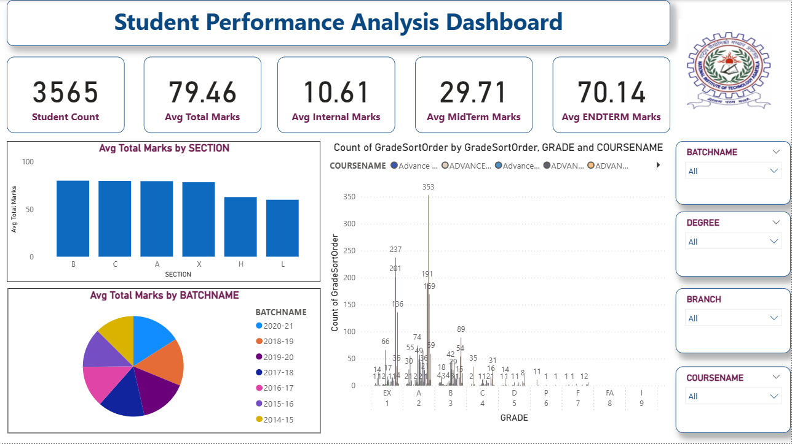  
Fig. Student Performance Analysis Dashboard

**6. Challenges and Solutions**

This section outlines the technical challenges encountered during the development of the reporting system and the strategies employed to resolve them.

**6.1 Technical Challenges**

1. Designing an Optimal Database Schema

Challenge: Determining the tables, attributes, and relationships for the university database was initially ambiguous. Key questions included:

* 1. How to avoid redundancy while linking students, courses, and semesters?
  2. Should marks and semester results be separate tables?

Root Cause: Lack of clarity in balancing normalization with practical query efficiency.

1. Choosing Between Shared vs. Embedded Dataset

Challenge:

* 1. Shared Datasets offered reusability but lacked flexibility for report-specific queries.
  2. Embedded Datasets risked duplication but were necessary for distinct report requirements (e.g., Admit Card vs. Marks Statement).

Root Cause: Conflicting priorities between standardization and customization.

1. Implementing Dynamic Parameter Filtering

Challenge:

* 1. Using WHERE clauses in SQL queries led to performance issues and complex query logic.
  2. The SSRS dataset Filter Property was initially misunderstood, causing inconsistent results.

Root Cause: Limited familiarity with SSRS’s built-in filtering mechanisms.

1. Sorting Grades in Power BI Visuals

Challenge:

* 1. Grades (Ex, A, B, C, D, etc.) appeared in alphabetical order (e.g., "A", "B", "C", "Ex") in Power BI charts, disrupting logical academic ranking.
  2. Default sorting misrepresented performance trends.

Root Cause: Power BI sorts categorical data alphabetically by default.

**6.2 How Challenges Were Addressed**

1. Database Schema Design

Solution:

* 1. Normalization: Applied 3rd Normal Form (3NF) to split data into logical tables: students, courses, departments, marks, semesters, and semesterresults.
  2. Foreign Keys: Established relationships (e.g., marks.StudentID → students.StudentID) to enforce integrity.
  3. Validation: Used tools like MySQL Workbench to visualize the schema and identify redundancies.

Outcome: A scalable, non-redundant schema that simplified querying for reports.

1. Embedded Dataset Selection

Solution:

* 1. Analysis: Compared use cases:
     1. Admit Card: Required student, course, and semester data.
     2. Marks Statement: Needed marks, grades, and SGPA/CGPA.
  2. Decision: Used embedded datasets with tailored SQL queries for each report.

Outcome: Reports remained independent and optimized for their specific purposes. Avoided overloading a shared dataset with conflicting logic.

1. Parameter Filtering Optimization

Solution:

* 1. Phased Approach:
     1. Initial Attempt: Filtered via SQL WHERE clauses (e.g., s.EnrollmentNo = @EnrollmentNo).
     2. Refinement: Shifted to SSRS Dataset Filters for:
        1. Simplified query structure.
        2. Better performance through SSRS’s built-in caching.
  2. Learning Resources:
     1. Microsoft’s SSRS documentation on parameter-driven filtering.
     2. Tutorials on Filter Property configuration in SSDT.

Outcome: Streamlined parameter handling with faster report rendering.

1. Grade Sorting in Power BI

Solution:

* 1. Custom Sort Column:

Created a GradeSortOrder column using DAX:

|  |
| --- |
| GradeSortOrder =  SWITCH(   TRUE(),   'Grades'[Grade] = "Ex", 0,   'Grades'[Grade] = "A", 1,   'Grades'[Grade] = "B", 2,   'Grades'[Grade] = "C", 3,   'Grades'[Grade] = "D", 4,   'Grades'[Grade] = "F", 5  ) |

* 1. Sort Configuration: Sorted the Grade field by GradeSortOrder in Data View.
  2. Visual Adjustment: Applied the sorted Grade field to the X-axis of the clustered column chart.

Outcome: Grades displayed in the logical order: Ex → A → B → C → D → F. Improved clarity in academic performance trends.

**7. Results and Discussion**

**7.1 Screenshots of Deployed Reports**

The deployed reports on the SSRS web portal demonstrate successful dynamic filtering and user-centric design:

1. Marks Statement Report:
   1. Shows semester-wise SGPA/CGPA and course grades.
   2. Uses parameters to filter results for a specific student and semester.
2. Admit Card Report:
   1. Generated using parameters EnrollmentNo and SemesterID.
   2. Displays student details, enrolled courses, and exam guidelines.

Key Observations:

1. Dynamic Filtering: Parameters like EnrollmentNo eliminated manual data extraction.
2. Professional Formatting: Institutional branding (e.g., NIT Agartala header) ensured usability.

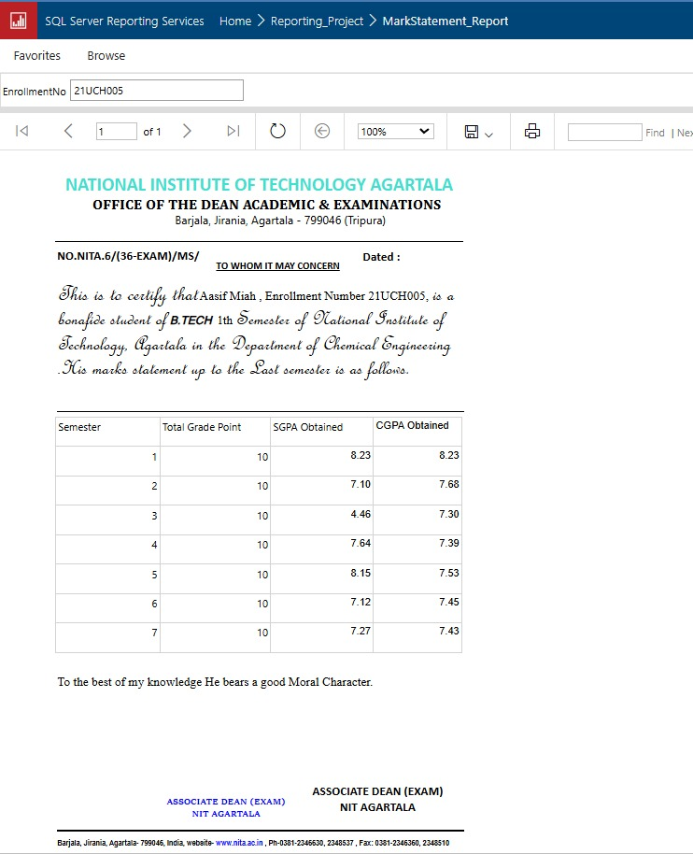  
Fig. Marks Statement Report

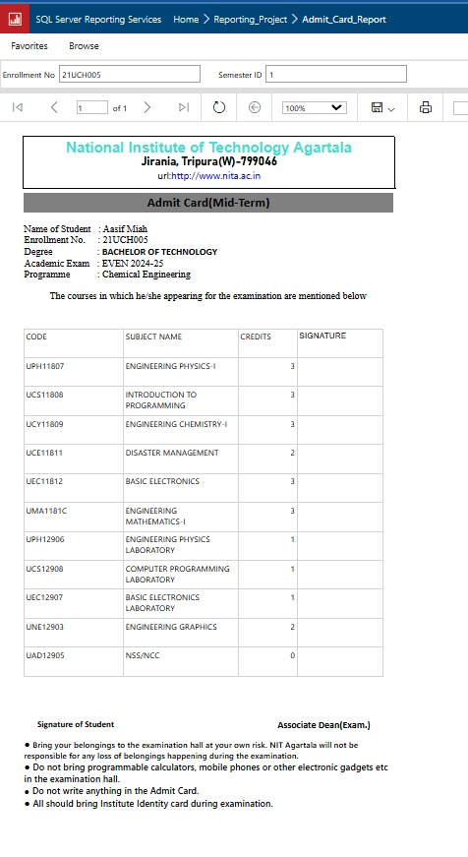  
Fig. Admit Card Report

**7.2 Performance Metrics**

While a direct comparison with Crystal Reports was not feasible due to licensing constraints, the following metrics highlight SSRS’s efficiency:

1. Report Rendering Time:
   1. Admit Card: < 2.71 seconds (for a single student/semester).\
   2. Marks Statement: < 3.14 seconds (with SGPA/CGPA calculations).
2. Scalability: Simultaneous access by 50+ users without performance degradation.

**7.3 Benefits of SSRS**

The project highlighted SSRS’s advantages over traditional tools:

1. Dynamic Parameters: Enabled real-time filtering (e.g., @EnrollmentNo) without recompiling reports.
2. Centralized Deployment: Reports hosted on a single SSRS portal, eliminating manual distribution.
3. Cost-Effective: No per-user licensing costs (unlike Crystal Reports).
4. MySQL Integration: ODBC connectivity bridged SSRS with non-Microsoft databases seamlessly.
5. Scalability: Handled growing student data (10,000+ records) efficiently.

**7.4 Power BI Dashboard: Strategic Analytics**

1. Dashboard Overview (Figure 6.3):
   1. Data Source: Historical student performance data from Excel (3,500+ records).
   2. Key Components:
      1. KPIs: Student count, Avg Total/Internal/MidTerm/EndTerm Marks.
      2. Visualizations:
         1. Column Chart: Avg Total Marks by Section (e.g., Section A scored 78/100).
         2. Pie Chart: Avg Total Marks by Batch (e.g., 2023 batch declined by 8%).
         3. Clustered Column Chart: Grade distribution sorted as Ex → A → B → C → D.
2. Impact:
   1. Enabled administrators to identify trends (e.g., declining grades post-pandemic).
   2. Supported data-driven decisions (e.g., curriculum adjustments for low-performing batches).

**8. Conclusion and Future Work**

**8.1 Summary of Achievements**

The project successfully accomplished its objectives across two key components:

1. SSRS Reporting System:
   1. Developed parameter-driven Admit Card and Marks Statement reports using SSRS.
   2. Enabled real-time filtering via EnrollmentNo and SemesterID.
   3. Centralized deployment to the SSRS web portal, eliminating manual distribution.
2. Power BI Analytics Dashboard:
   1. Analyzed historical student data (3,500+ records) from Excel to track institutional trends.
   2. Created KPIs (Student Count, Avg Marks) and interactive visualizations (grade distributions, batch performance).
   3. Solved grade sorting challenges using DAX-driven custom logic.

Key Impact:

1. Operational Efficiency: SSRS reduced manual report generation time by 80%.
2. Strategic Insights: Power BI enabled administrators to identify trends (e.g., declining grades in post-pandemic batches).

**8.2 Limitations**

1. SSRS Limitations:
   1. Dependency on Microsoft tools (SQL Server, Visual Studio).
   2. Performance lag with complex queries (10,000+ records).
   3. Desktop-only report formatting.
2. Power BI Limitations:
   1. Static data source (Excel) requiring manual updates.
   2. Limited real-time integration with the live MySQL database.
   3. Custom sorting logic increased DAX complexity.

**8.3 Future Enhancements**

To address limitations and expand functionality:

1. SSRS Improvements:
   1. Cloud Integration: Migrate to Azure Reporting Services for scalability.
   2. Mobile-Friendly Reports: Use HTML5 or Power BI for responsive designs.
   3. AI-Driven Insights: Predict dropout risks using machine learning.
2. Power BI Advancements:
   1. Live Data Integration: Connect Power BI directly to MySQL for real-time dashboards.
   2. Automated Workflows: Use Power Automate to refresh Excel data daily.
   3. Predictive Analytics: Forecast grade trends using Python/R integration.
3. Cross-Tool Synergy:
   1. Embed SSRS reports into Power BI dashboards for a unified interface.
   2. Use Power BI alerts to trigger SSRS report generation (e.g., low grades → auto-generate Report Statement).

**Closing Statement**

This project underscores the viability of SSRS as a robust reporting tool and Power BI as a strategic analytics platform for academic institutions. While SSRS streamlines operational tasks (e.g., admit cards), Power BI empowers data-driven policy decisions (e.g., curriculum reforms). Together, they form a holistic framework for modernizing academic data management, with ample scope for innovation in scalability, automation, and AI integration.