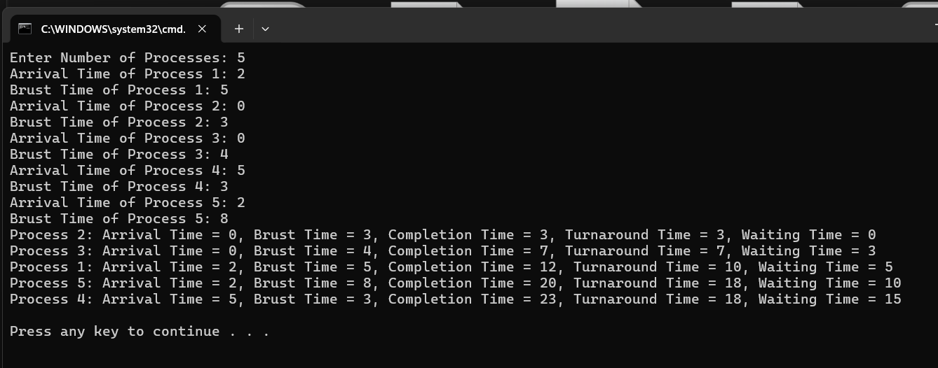
Figure: Input/Output Test of First Come First Serve CPU Scheduling Algorithm

