LRU Pseudo Code:
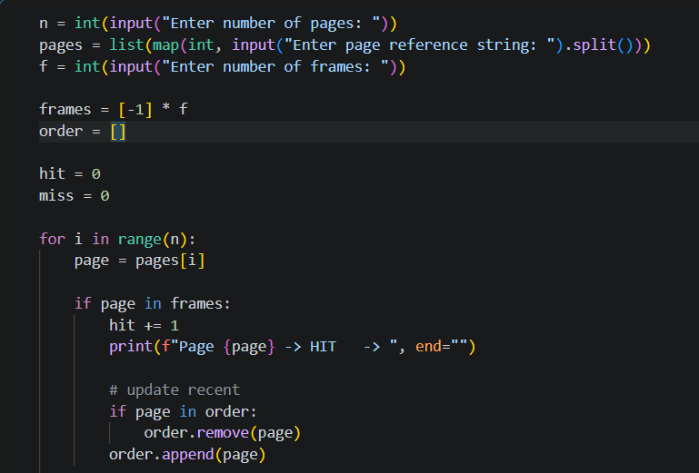
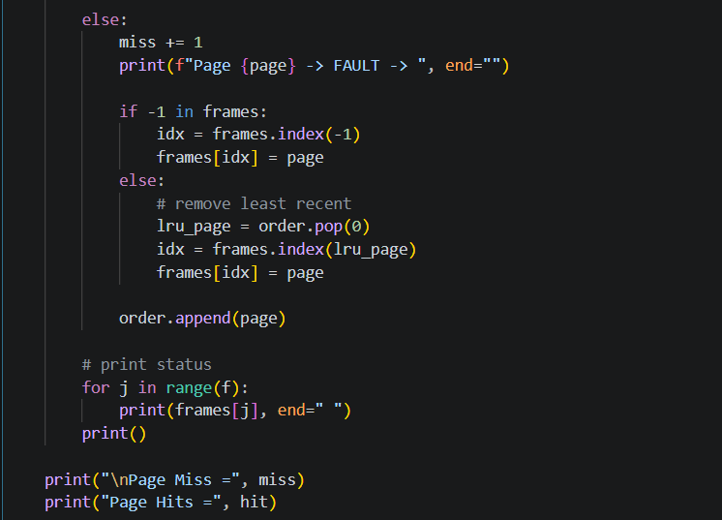
Input/Output:
Number of Pages: 10
Page String: 7 0 1 2 0 3 0 4 2 3
Frame Size: 3
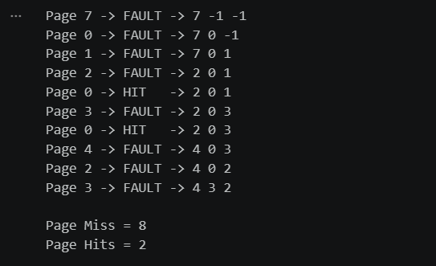

Optimal Pseudo Code:
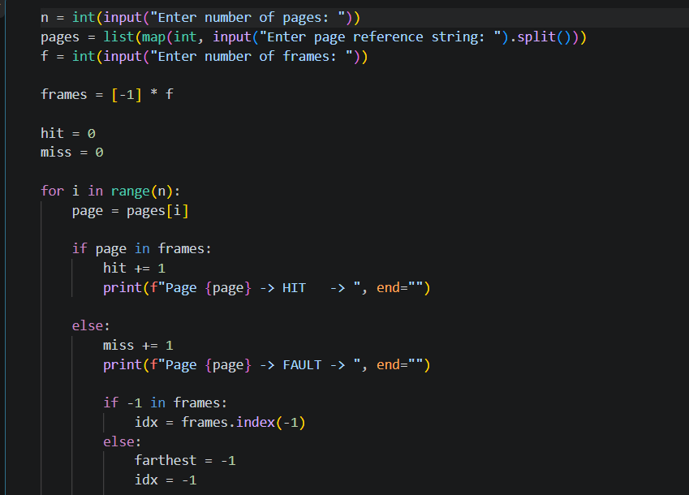
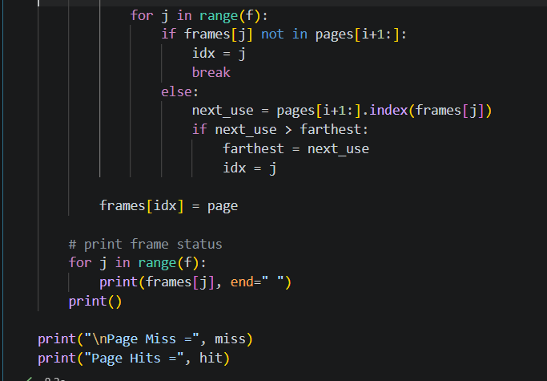
Input/Output:
Number of Pages: 10
Page String: 7 0 1 2 0 3 0 4 2 3
Frame Size: 3
