First Fit:
Pseudo Code:
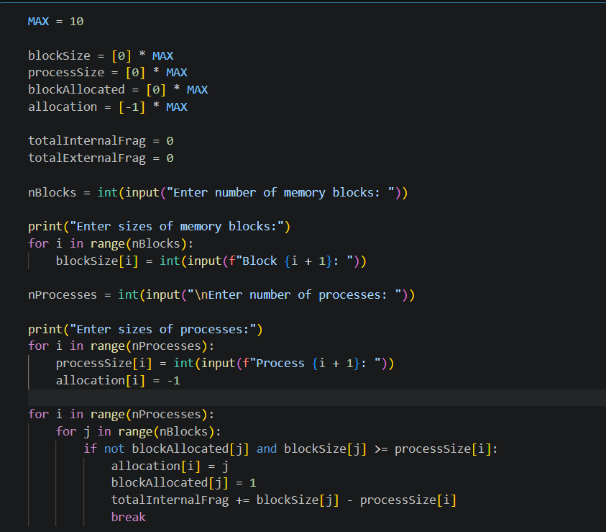
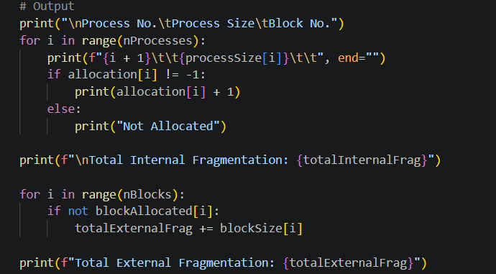
Input:
Enter number of memory blocks: 5
Block 1: 100
Block 2: 500
Block 3: 200
Block 4: 300
Block 5: 600
Enter number of processes: 4
Process 1: 212
Process 2: 417
Process 3: 112
Process 4: 426
Output:
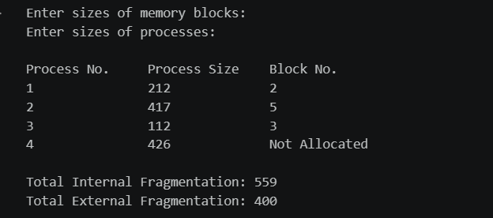

Next Fit:
Pseudo Code:
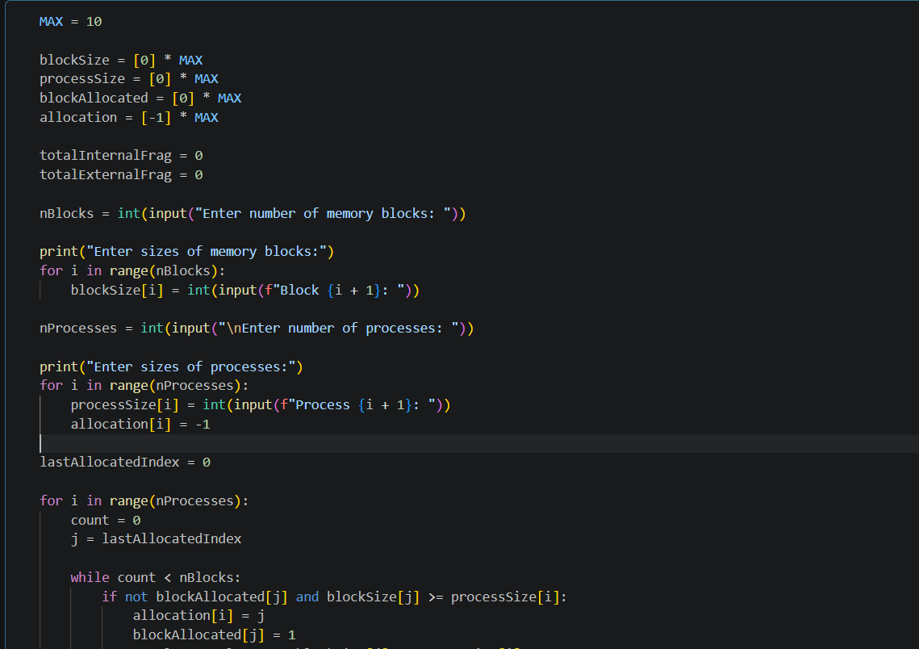
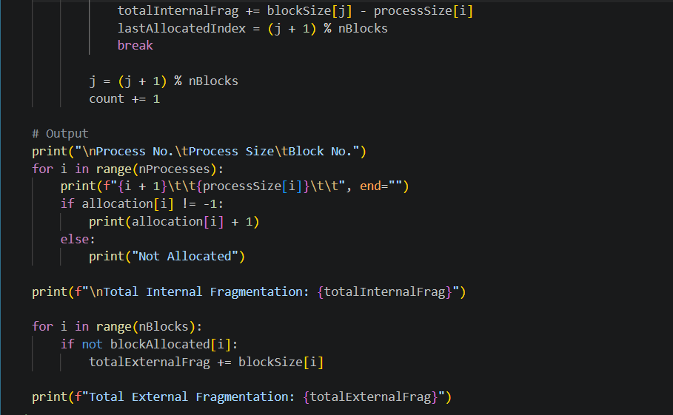
Input:
Enter number of memory blocks: 5
Block 1: 100
Block 2: 500
Block 3: 200
Block 4: 300
Block 5: 600
Enter number of processes: 4
Process 1: 212
Process 2: 417
Process 3: 112
Process 4: 426
Output:
