Problem 1: Write and run a shell script to add two numbers given by user.
Pseudo Code:
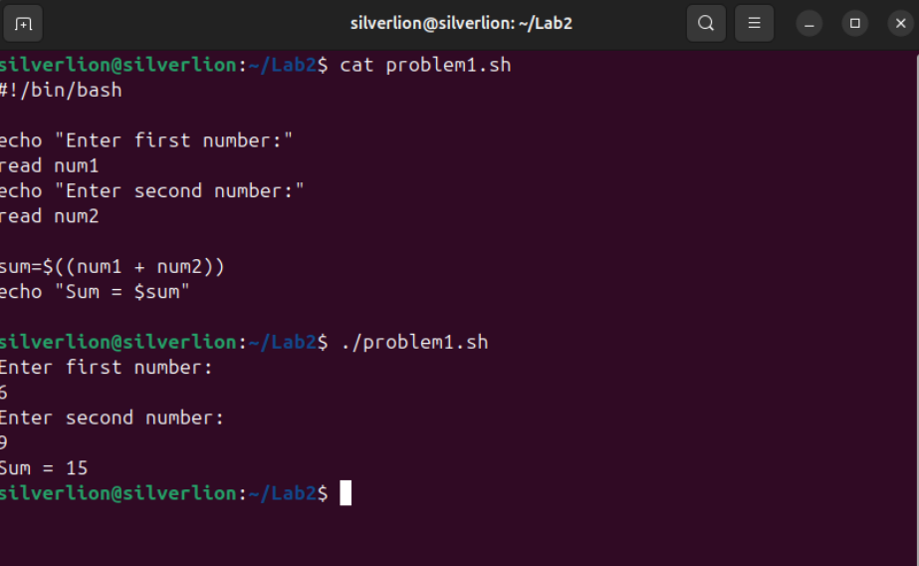
Problem 2: Write a shell script to check whether a given number is even or odd
Pseudo Code:
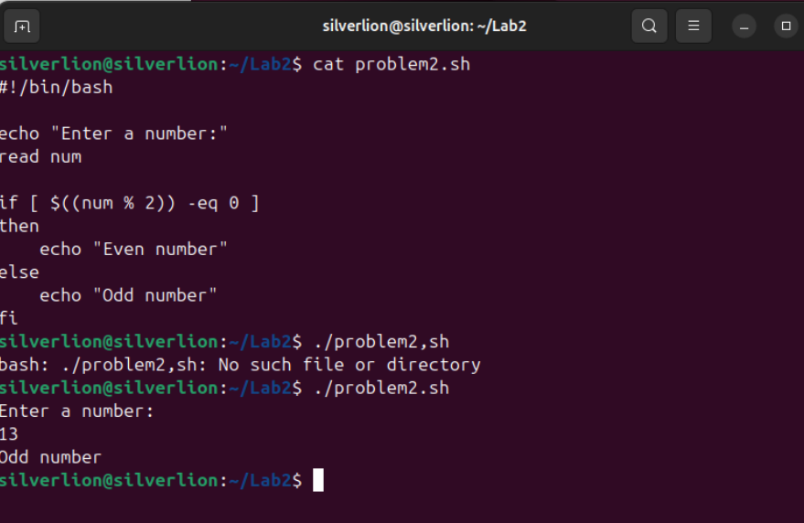

Problem 3: Write a shell script to print the sum of all numbers from 1 to 100 using a for loop
Pseudo Code:
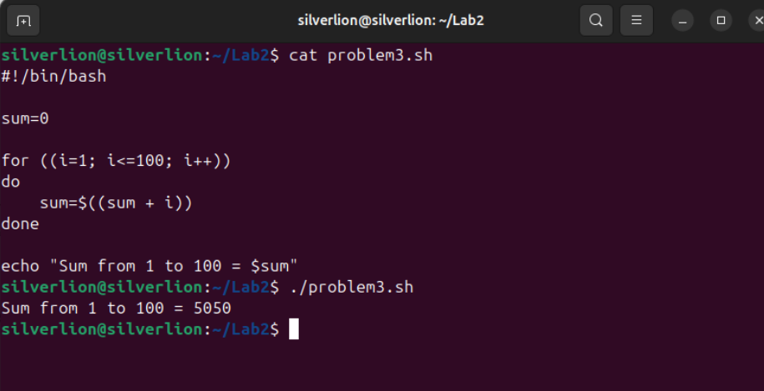
Problem 4: Write a shell scrip to calculate the factorial of a number using a while loop
Pseudo Code:
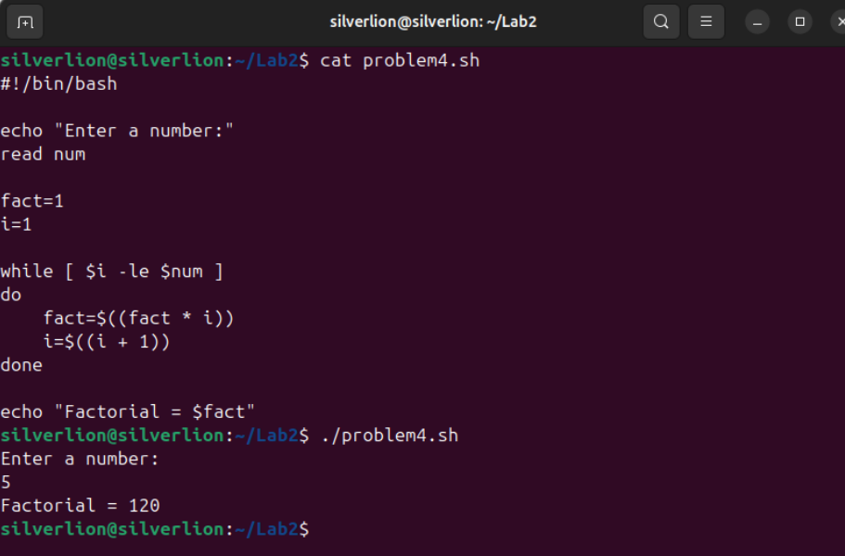
Problem 5: Write a shell scrip that keeps taking user input until the word “exit” is entered
Pseudo Code:
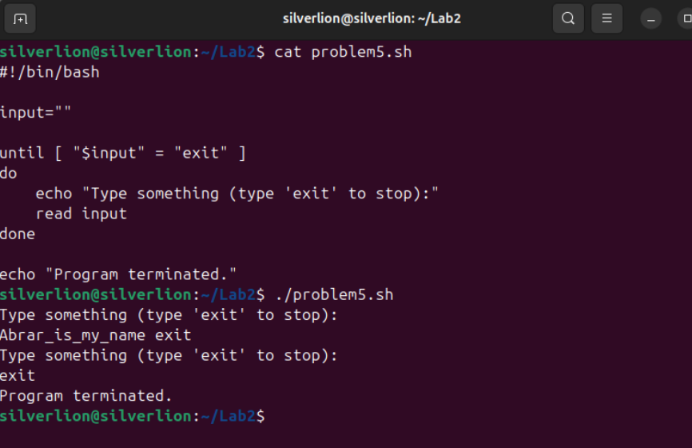
Problem 6: Write a shell script to check if a file exists in the current directory
Pseudo Code:
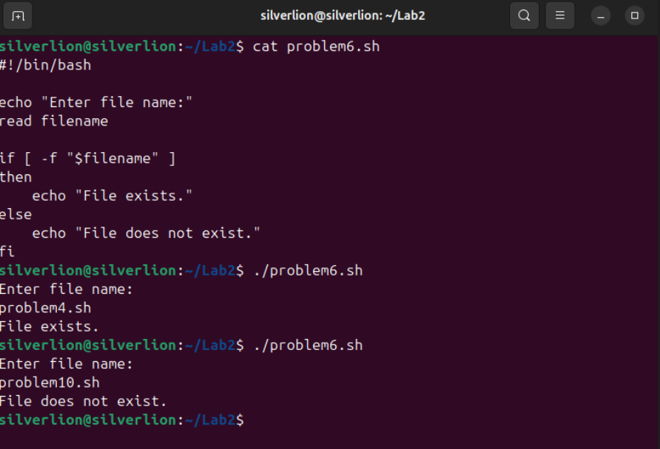
Problem 7: Write a shell script to display the largest of three numbers entered by the user
Pseudo Code:
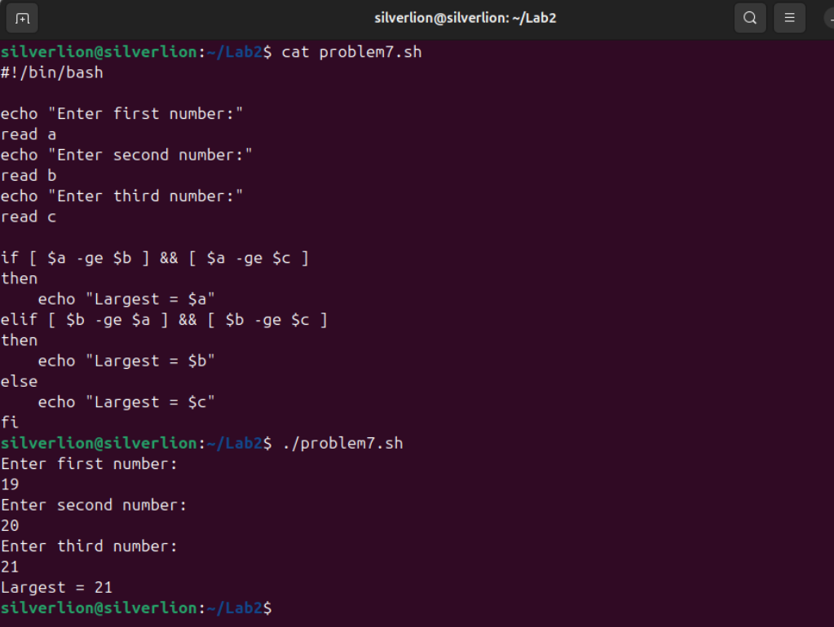
Problem 8: Write a shell script to print all even numbers between 1 and 50.
Pseudo Code:
