ASSIGNMENT : 2(a)

- Create version control account on GitHub and using Git commands to create repository and push your code to GitHub.

Git
- Definition : Git is a distributed version control system designed to handle everything from small to very large projects efficiently. It helps developers track changes in the source code during software development.
- Purpose : It allows you to manage your project’s history, collaborate with a team, and roll back to earlier versions if needed.
- Key Features :
  - Tracks changes in code.
  - Enables collaboration by merging code from multiple developers.
  - Works offline as it keeps the entire repository on your local machine.

GitHub
- Definition : GitHub is a web-based platform built around Git. It provides a graphical interface, hosting service, and collaboration tools for Git repositories.
- Purpose : It enables developers to store Git repositories in the cloud and share them with others. GitHub adds features like issue tracking, pull requests, and project management tools.
- Key Features :
  - Repository hosting in the cloud.
  - Collaboration tools for teams (e.g., pull requests and code reviews).
  - Integration with CI/CD pipelines and other development tools.

Differences between Git and GitHub
Aspect | Git | GitHub
Type | Version control tool. | Cloud-based platform built on Git.
Usage | Installed and runs locally on your system. | Accessed through a web interface or API.
Collaboration | Requires manual setup for sharing. | Simplifies collaboration with pull requests and online hosting.
Hosting | Does not host repositories online. | Hosts repositories in the cloud.

- Git Architecture :
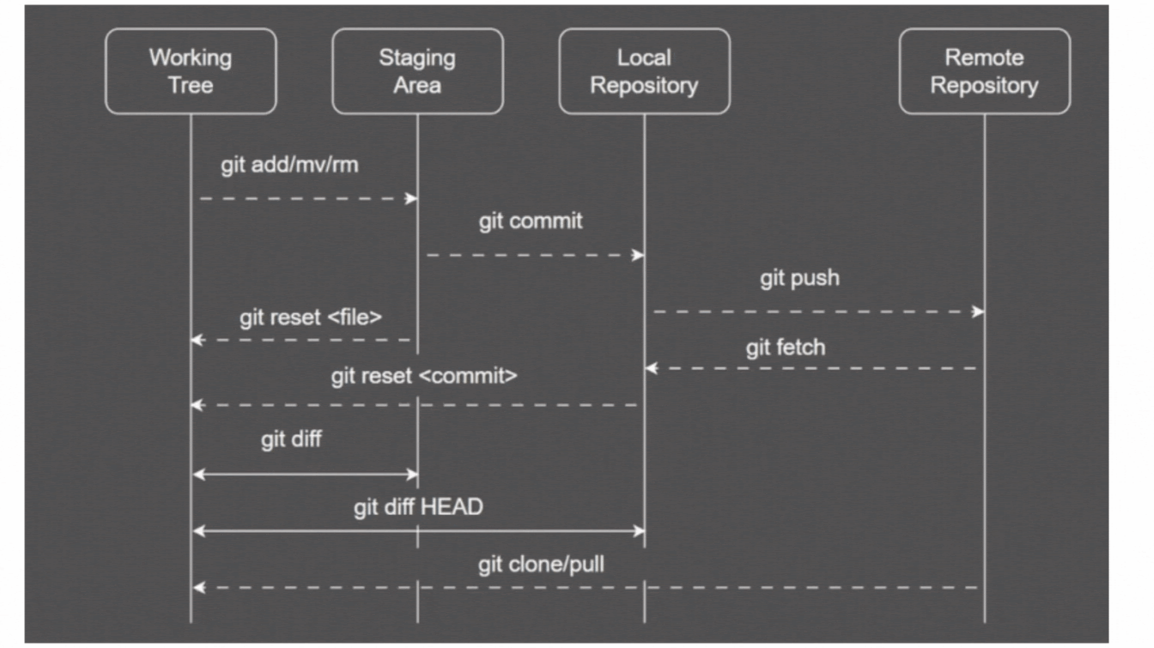

The three main components in Git each serve distinct roles:
- Working Directory: This is the actual directory where project files are located. Modifications made to files in the working directory are considered 'untracked' until explicitly staged for commit.
- Staging Area (Index): The staging area acts as an intermediate step between the working directory and the .git directory. Files in the staging area are 'staged' to be included in the next commit. This allows for a selective and controlled approach to committing changes.
- .git Directory (Local Repository): The .git directory serves as the core container for Git's version control system, containing metadata, object database, and configuration information. The .git directory stores committed snapshots, manages the project's history, and facilitates various Git operations.
In addition to these three components, Git leverages Remote repositories:
- Remote Repositories: Remote repositories serve as centralized hubs where team members can push and pull changes, ensuring a synchronized and collaborative development process.

- Git Commands Executed On Git Bash :

