**Total Points 100**

Alexander Gonzales

**Grading Rubric chapter1_5.cpp**

10 points max for Comments

10 points max for Coding Style

10 points max for Code Efficiency

10 points max for Correct Execution

10 points max for Output Style  
**50 Total Points**

/**********************************************************************

Program Author: Alexander Gonzales

Program Date: 10/28/2016

Program Description: Chapter 1-5 Summary Assignment

**********************************************************************/

#include <iostream>

#include <fstream>

#include <iomanip> // for output manipulation

#include <cstdlib>

#include <cmath> // for rounding

using namespace std;

int main()

{

string fname = "name"; //setup the strings for reading the file

string lname = "unknown";

double rate, totalInterest, amount, interest, interest2;

int recordCount, years;

int year = 1;

cout << "Welcome to the Certificate of deposit report program\n"; //output to console start of program

ifstream inputFile ("data.txt"); //open input file

ofstream outputFile ("depositreport.txt"); //open output file

if(inputFile.fail()) //if unable to open display error and exit

{

cout << "\t!!FAILED Open of Input File!!: data.txt\n";

exit(1);

}

if(outputFile.fail()) //if unable to open display error and exit

{

cout << "\t!!FAILED Open of Output File!!: depositreport.txt\n";

exit(1);

}

//output to console start processing records

cout << "Starting to process records\n";

outputFile << fixed << setprecision(5) << showpoint;

//output report file the report header

outputFile << setw(50) << "Certificate of Deposit Report\n\n";

outputFile << left

<< setw(25) << "Name"

<< right

<< setw(5) << "Rate"

<< setw(17) << "Balance"

<< setw(5) << "Year"

<< setw(16) << "Interest\n";

outputFile << "-----------------------------------------------------------------\n";

//loop until there are no more input lines

recordCount = 0;

while(inputFile >> fname >> lname >> amount >> years >> rate)

{

//increment record counter

recordCount ++;

//set total interest to zero

totalInterest = 0;

interest2 = 0;

//output to console the record number you #include <cstdlib>are processing

cout << "processing record: " << recordCount << endl;

//output to report file the first last name and rate

//for loop thru the number of years

for(int i = 1; i <= years; i++)

{

//calculate interest

if (amount < 1000)//if statement for amount under 1000 due to spacing error

{

interest = (rate * amount)/100;

outputFile << fixed << setprecision(2)

<< left

<< setw(25) << fname + " " +lname

<< right

<< setw(5) << rate << "%"

<< setw(10) << "$" << amount

<< setw(3) << " " << year

<< setw(10) << "$" << interest << "\n";

amount = interest + amount;

totalInterest = interest + interest2;

interest2 = totalInterest;

year ++;

}

if (amount >= 1000)//if statement for amount over 1000 due to spacing error

{

interest = (rate * amount)/100;

outputFile << fixed << setprecision(2)

<< left

<< setw(25) << fname + " " +lname

<< right

<< setw(5) << rate << "%"

<< setw(10) << "$" << amount

<< setw(3) << year

<< setw(10) << "$" << interest << "\n";

amount = interest + amount;

totalInterest = interest + interest2;

interest2 = totalInterest;

year ++;

}

}

year = 1;

if (totalInterest < 100) //if statement for formatting if total interest is under 100 due to spacing error

{

outputFile << fixed << setprecision(2)

<<"===================================================================\n"

<< left

<< setw(25) << " "

<< right

<< setw(5) << " Total"

<< setw(10) << " $" << amount

<< setw(3)

<< setw(10) << "\t\t$" << totalInterest << "\n\n";

}

if (totalInterest >= 100) //if statement for formatting if total interest is equal or over 100 due to spacing error

{

outputFile << fixed << setprecision(2)

<<"===================================================================\n"

<< left

<< setw(25) << " "

<< right

<< setw(5) << " Total"

<< setw(10) << " $" << amount

<< setw(3)

<< setw(10) << "\t$" << totalInterest << "\n\n";

}

}

//close both input and output files

outputFile.close();

inputFile.close();

return 0;

}

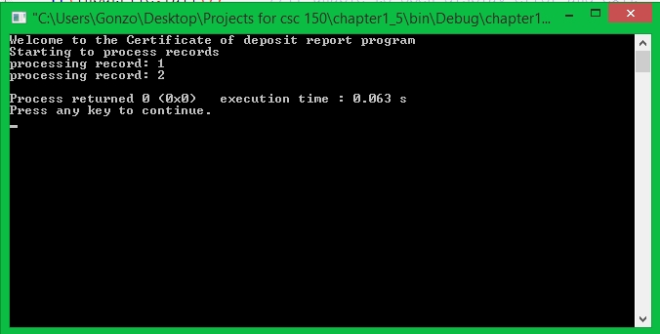

**depositreport.txt:**

**Certificate of Deposit Report**

**Name Rate Balance Year Interest**

**-----------------------------------------------------------------**

**Billy Batson 3.00% $3000.00 1 $90.00**

**Billy Batson 3.00% $3090.00 2 $92.70**

**Billy Batson 3.00% $3182.70 3 $95.48**

**Billy Batson 3.00% $3278.18 4 $98.35**

**===================================================================**

**Total $3376.53 $376.53**

**Jimmy Olson 1.50% $500.00 1 $7.50**

**Jimmy Olson 1.50% $507.50 2 $7.61**

**===================================================================**

**Total $515.11 $15.11**

**Data.txt:**

**Billy Batson 3000.00 4 3.00**

**Jimmy Olson 500.00 2 1.50**