CONTIGUOUS MEMORY
ALLOCATION SIMULATOR
Operating Systems Mini Project

A Python and Streamlit based simulation of contiguous memory allocation strategies

Submitted By
____________________________

Course: Operating Systems
Academic Project Report

Table of Contents
1. Introduction
2. Problem Statement
3. Objectives
4. System Requirements
5. Input and Output
6. System Flowchart
7. Algorithms Used
8. System Design
9. Project Structure
10. Implementation
11. User Interface
12. Input Validation
13. Test Case
14. Results
15. Algorithm Comparison
16. Memory Utilization
17. Advantages
18. Limitations
19. Future Enhancements
20. Conclusion
21. References

1. Introduction
Memory management is one of the fundamental responsibilities of an operating system. When processes need to be loaded into memory, the operating system must decide where each process should be placed while making effective use of the available memory.
This project implements a Contiguous Memory Allocation Simulator that demonstrates three classical memory allocation strategies: First Fit, Best Fit, and Worst Fit.
The simulator accepts memory block sizes and process sizes as input and shows how each process is allocated. It also displays unallocated processes, remaining memory, memory utilization, and a comparison of the three algorithms.
The project is implemented in Python with a Streamlit-based graphical user interface.

2. Problem Statement
The objective of this project is to develop a simulator that demonstrates how contiguous memory allocation algorithms assign processes to available memory blocks.
The simulator accepts memory block sizes and process sizes, allocates processes using First Fit, Best Fit, or Worst Fit, identifies processes that cannot be allocated, calculates remaining memory, displays memory utilization, and compares the three allocation algorithms.

3. Objectives
1. To understand contiguous memory allocation.
2. To implement First Fit allocation.
3. To implement Best Fit allocation.
4. To implement Worst Fit allocation.
5. To visualize the allocation of processes into memory blocks.
6. To calculate remaining and used memory.
7. To compare the behavior of different allocation strategies.
8. To provide an interactive graphical interface for experimentation.

4. System Requirements
Hardware Requirements:
• Computer/Laptop
• Minimum 4 GB RAM
• Keyboard and mouse
• Display
Software Requirements:
• Windows/Linux/macOS
• Python 3.x
• Streamlit
• Web browser
• Visual Studio Code or another Python-compatible editor

5. Input and Output
Inputs:
• Memory block sizes in KB
• Process sizes in KB
• Allocation algorithm
Example input:
Memory Blocks: 100, 500, 200, 300, 600
Processes: 212, 417, 112, 426
Outputs:
• Process allocation
• Allocated and unallocated processes
• Remaining memory in every block
• Used memory
• Memory utilization
• Memory visualization
• Algorithm comparison

6. System Flowchart
The overall flow of the simulator is shown below.
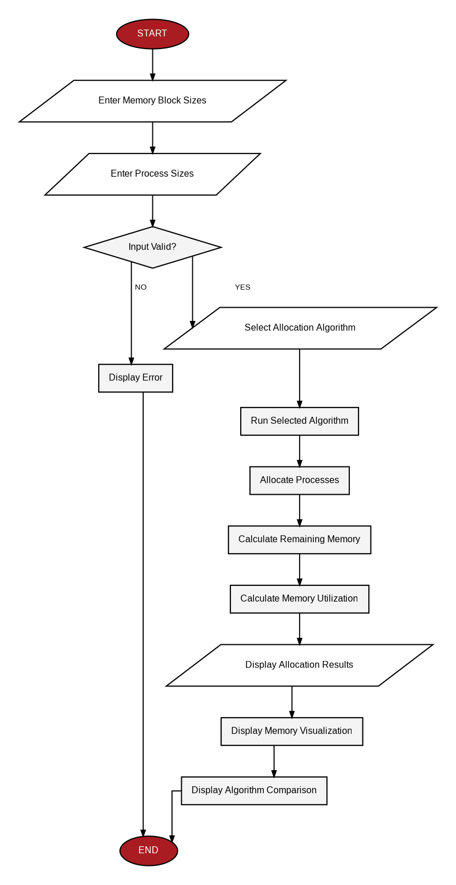
Figure 1: System flowchart of the Contiguous Memory Allocation Simulator.

7. Algorithms Used

7.1 First Fit
First Fit searches the memory blocks from the beginning and allocates a process to the first block that is large enough to contain it.
Procedure:
- Start from the first memory block.
- Check whether the block can accommodate the process.
- If sufficient space is available, allocate the process.
- Reduce the remaining size of the selected block.
- If the block is insufficient, continue to the next block.
- If no suitable block is found, the process remains unallocated.
FOR each process:
FOR each memory block:
IF block is large enough:
allocate process
reduce remaining block size
BREAK

7.2 Best Fit
Best Fit searches all available memory blocks and allocates the process to the smallest block that is large enough.
FOR each process:
Find the smallest block that can contain it
IF such a block exists:
allocate process
reduce remaining block size

7.3 Worst Fit
Worst Fit searches the available memory blocks and allocates the process to the largest suitable block.
FOR each process:
Find the largest block that can contain it
IF such a block exists:
allocate process
reduce remaining block size

8. System Design

8.1 Algorithm Module
File: algorithms.py
This module contains first_fit(), best_fit(), and worst_fit(). Each function receives memory blocks and process sizes and returns process allocation and remaining memory.

8.2 Graphical User Interface
File: app.py
The Streamlit application provides input fields, algorithm selection, simulation controls, result tables, memory visualization, metrics, comparison charts, and input validation.

9. Project Structure
OsProject/
├── app.py
├── algorithms.py
├── requirements.txt
├── README.md
├── PROJECT.md
└── contiguous_memory_allocation_flowchart.png
File | Purpose
app.py | Streamlit graphical interface and result display
algorithms.py | First Fit, Best Fit, and Worst Fit implementations
requirements.txt | Python dependency list
README.md | Project overview and setup information
PROJECT.md | Detailed project documentation
contiguous_memory_allocation_flowchart.png | System flowchart

10. Implementation
The project uses Python for implementation. The core algorithm module contains three allocation functions.
def first_fit(blocks, processes):
memory = blocks.copy()
allocation = [-1] * len(processes)
for i in range(len(processes)):
for j in range(len(memory)):
if memory[j] >= processes[i]:
allocation[i] = j
memory[j] -= processes[i]
break
return allocation, memory
def best_fit(blocks, processes):
memory = blocks.copy()
allocation = [-1] * len(processes)
for i in range(len(processes)):
best_index = -1
for j in range(len(memory)):
if memory[j] >= processes[i]:
if best_index == -1 or memory[j] < memory[best_index]:
best_index = j
if best_index != -1:
allocation[i] = best_index
memory[best_index] -= processes[i]
return allocation, memory
def worst_fit(blocks, processes):
memory = blocks.copy()
allocation = [-1] * len(processes)
for i in range(len(processes)):
worst_index = -1
for j in range(len(memory)):
if memory[j] >= processes[i]:
if worst_index == -1 or memory[j] > memory[worst_index]:
worst_index = j
if worst_index != -1:
allocation[i] = worst_index
memory[worst_index] -= processes[i]
return allocation, memory

11. User Interface
The graphical interface contains a project header, memory configuration inputs, process configuration inputs, allocation strategy selection, simulation controls, result tables, metrics, memory visualization, and comparison charts.
- Memory Configuration
- Allocation Strategy
- Process Allocation Results
- Memory Visualization
- Algorithm Comparison

12. Input Validation
The application validates user input before running an algorithm. It handles empty input, non-numeric values, zero or negative values, and extra commas.
Examples:
100, 500, abc, 300
100, 500, -200, 300
100, 500,, 300

13. Test Case
The following test data was used:
Memory Blocks:
100, 500, 200, 300, 600
Processes:
212, 417, 112, 426
Total memory: 1700 KB
Total process memory: 1167 KB

14. Results

14.1 First Fit
Process | Size | Block
P1 | 212 KB | B2
P2 | 417 KB | B5
P3 | 112 KB | B2
P4 | 426 KB | Unallocated
Remaining memory: B1 = 100 KB, B2 = 176 KB, B3 = 200 KB, B4 = 300 KB, B5 = 183 KB.
Allocated processes: 3 | Unallocated processes: 1

14.2 Best Fit
Process | Size | Block
P1 | 212 KB | B4
P2 | 417 KB | B2
P3 | 112 KB | B3
P4 | 426 KB | B5
Remaining memory: B1 = 100 KB, B2 = 83 KB, B3 = 88 KB, B4 = 88 KB, B5 = 174 KB.
Allocated processes: 4 | Unallocated processes: 0

14.3 Worst Fit
Process | Size | Block
P1 | 212 KB | B5
P2 | 417 KB | B2
P3 | 112 KB | B5
P4 | 426 KB | Unallocated
Remaining memory: B1 = 100 KB, B2 = 83 KB, B3 = 200 KB, B4 = 300 KB, B5 = 276 KB.
Allocated processes: 3 | Unallocated processes: 1

15. Algorithm Comparison
Algorithm | Allocated Processes | Unallocated Processes
First Fit | 3 | 1
Best Fit | 4 | 0
Worst Fit | 3 | 1
The application presents this comparison through a table and graphical charts. The comparison demonstrates that different allocation strategies can produce different memory distributions for the same input.

16. Memory Utilization
Memory utilization is calculated using:
Memory Utilization = (Used Memory / Total Memory) × 100
For the example input, total memory is 1700 KB and total process memory is 1167 KB. Best Fit allocates all four processes, giving approximately 68.65% memory utilization. First Fit and Worst Fit allocate 741 KB, giving approximately 43.59% utilization.

17. Advantages
- Simple and interactive interface.
- Demonstrates important operating-system memory allocation concepts.
- Supports three classical allocation algorithms.
- Allows custom memory and process inputs.
- Provides visual representation of memory blocks.
- Provides algorithm comparison.
- Includes input validation.
- Easy to run and modify.

18. Limitations
- The simulator models partition-based contiguous allocation and does not represent a complete operating-system memory manager.
- It does not simulate virtual memory.
- It does not simulate paging or segmentation.
- It does not model real hardware memory.
- Allocation results depend on the order of processes and memory blocks entered by the user.

19. Future Enhancements
- Adding more allocation algorithms.
- Adding internal/external fragmentation analysis.
- Adding animated allocation visualization.
- Adding memory deallocation.
- Adding process arrival and termination.
- Adding allocation history.
- Exporting simulation results to CSV or PDF.
- Adding more detailed performance statistics.

20. Conclusion
The Contiguous Memory Allocation Simulator demonstrates how First Fit, Best Fit, and Worst Fit algorithms allocate processes to memory blocks. The project provides an interactive way to observe process allocation, remaining memory, memory utilization, and differences between allocation strategies. Through this implementation, the project demonstrates practical application of operating-system memory management concepts using Python and a graphical user interface.

21. References
- Operating Systems concepts and memory-management material provided as part of the course.
- Python documentation.
- Streamlit documentation.

