crewAI

Introduction :
CrewAI enables you to create AI teams where each agent has specific roles, tools, and goals, working together to accomplish complex tasks.

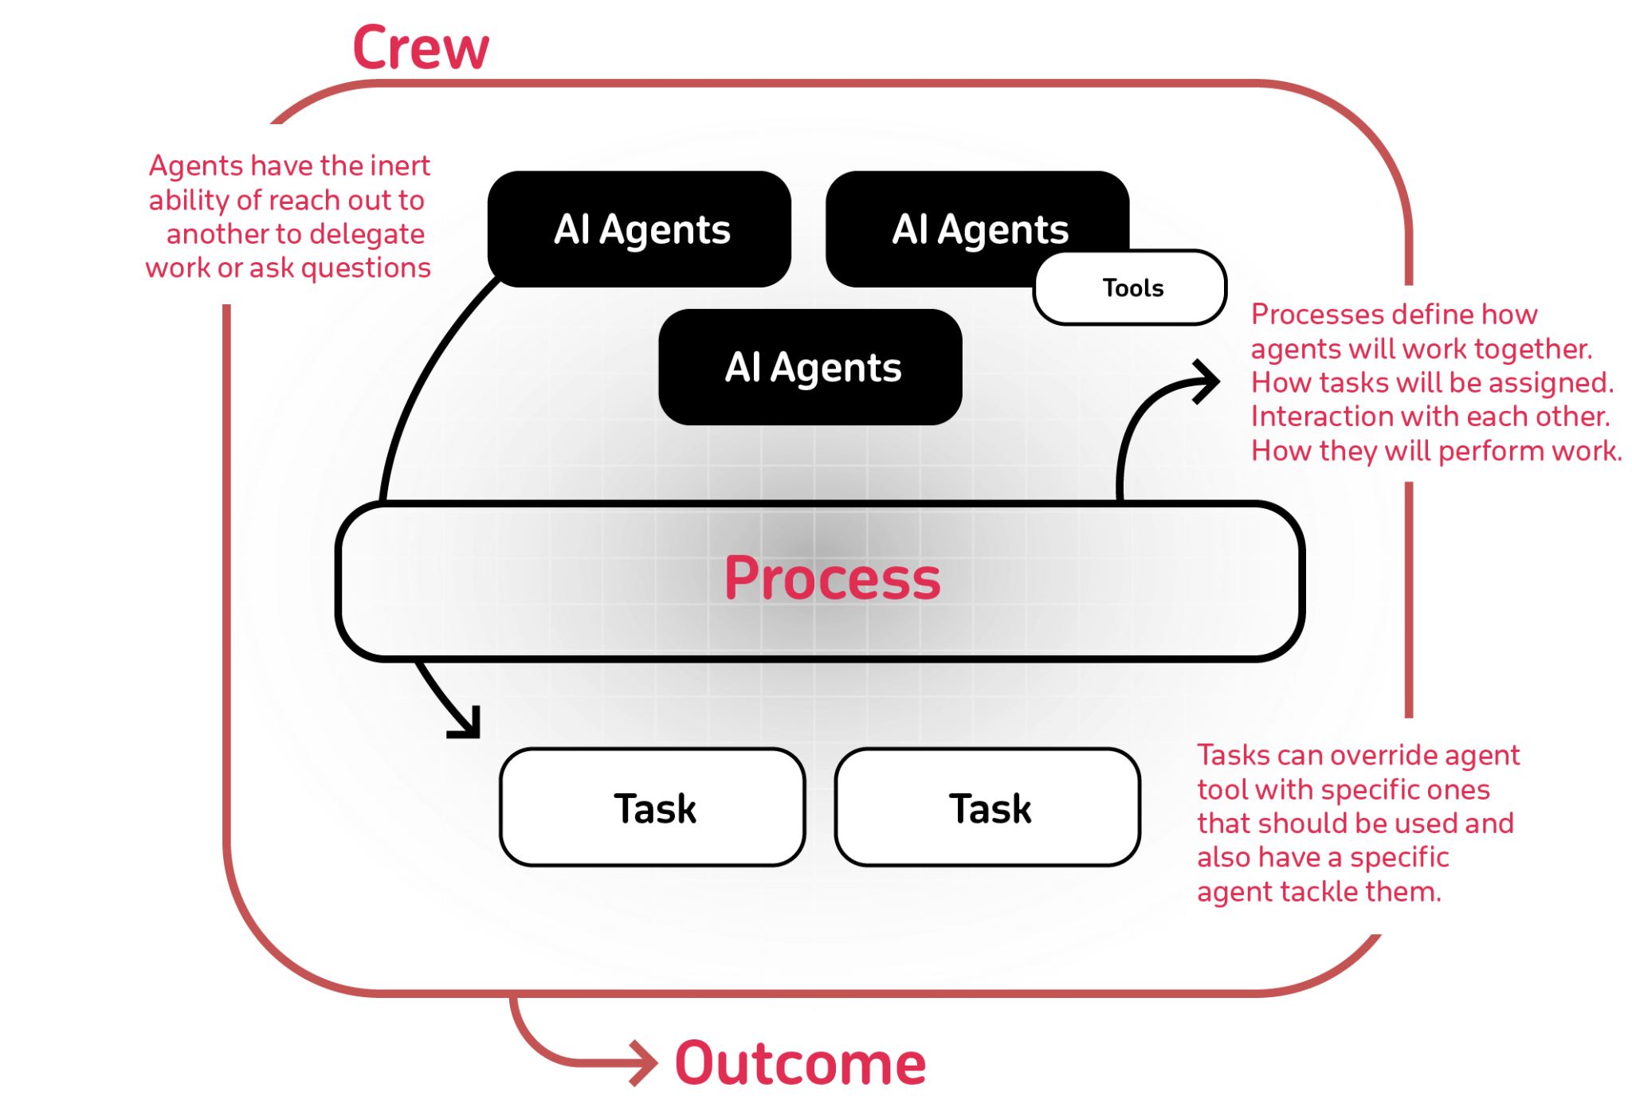

Description of Components of Crew

Component | Description | Key Features
Crew | The top-level organization | • Manages AI agent teams  • Oversees workflows  • Ensures collaboration  • Delivers outcomes
AI Agents | Specialized team members | • Have specific roles (researcher, writer)  • Use designated tools  • Can delegate tasks  • Make autonomous decisions
Process | Workflow management system | • Defines collaboration patterns  • Controls task assignments  • Manages interactions  • Ensures efficient execution
Tasks | Individual assignments | • Have clear objectives  • Use specific tools  • Feed into larger process  • Produce actionable results

How It All Works Together :
- The Crew organizes the overall operation
- AI Agents work on their specialized tasks
- The Process ensures smooth collaboration
- Tasks get completed to achieve the goal

Key Features :
- Role-Based Agents: Create specialized agents with defined roles, expertise, and goals - from researchers to analysts to writers
- Flexible Tools: Equip agents with custom tools and APIs to interact with external services and data sources
- Intelligent Collaboration: Agents work together, sharing insights and coordinating tasks to achieve complex objectives
- Task Management: Define sequential or parallel workflows, with agents automatically handling task dependencies

Why Choose CrewAI?
🧠 Autonomous Operation: Agents make intelligent decisions based on their roles and available tools
📝 Natural Interaction: Agents communicate and collaborate like human team members
🛠️ Extensible Design: Easy to add new tools, roles, and capabilities
🚀 Production Ready: Built for reliability and scalability in real-world applications

Installation:
CrewAI requires Python >=3.10 and <3.13. Here’s how to check your version with command “python3 –version”.

Install CrewAI with all recommended tools using either method:
“pip install crewai crewai-tools”

Agents:
- Detailed guide on creating and managing agents within the CrewAI framework.

Overview of an Agent
- In the CrewAI framework, an Agent is an autonomous unit that can:

- Perform specific tasks
- Make decisions based on its role and goal
- Use tools to accomplish objectives
- Communicate and collaborate with other agents
- Maintain memory of interactions
- Delegate tasks when allowed

Important Attributes of AI Agent:

Attribute | Parameter | Type | Description
Role | role | str | Defines the agent’s function and expertise within the crew.
Goal | goal | str | The individual objective that guides the agent’s decision-making.
Backstory | backstory | str | Provides context and personality to the agent, enriching interactions.
LLM (optional) | llm | Union[str, LLM, Any] | Language model that powers the agent. Defaults to the model specified in OPENAI_MODEL_NAME or “gpt-4”.
Tools (optional) | tools | List[BaseTool] | Capabilities or functions available to the agent. Defaults to an empty list.
Verbose (optional) | verbose | bool | Enable detailed execution logs for debugging. Default is False.

Example:
from crewai import Agent
from crewai_tools import SerperDevTool
# Create an agent with all available parameters
agent = Agent(
role="Senior Data Scientist",
goal="Analyze and interpret complex datasets to provide actionable insights",
backstory="With over 10 years of experience in data science and machine learning, "
"you excel at finding patterns in complex datasets.",
llm="gpt-4", # Default: OPENAI_MODEL_NAME or "gpt-4"
function_calling_llm=None, # Optional: Separate LLM for tool calling
memory=True, # Default: True
verbose=False, # Default: False
allow_delegation=False, # Default: False
max_iter=20, # Default: 20 iterations
max_rpm=None, # Optional: Rate limit for API calls
max_execution_time=None, # Optional: Maximum execution time in seconds
max_retry_limit=2, # Default: 2 retries on error
allow_code_execution=False, # Default: False
code_execution_mode="safe", # Default: "safe" (options: "safe", "unsafe")
respect_context_window=True, # Default: True
use_system_prompt=True, # Default: True
tools=[SerperDevTool()], # Optional: List of tools
knowledge_sources=None, # Optional: List of knowledge sources
embedder_config=None, # Optional: Custom embedder configuration
system_template=None, # Optional: Custom system prompt template
prompt_template=None, # Optional: Custom prompt template
response_template=None, # Optional: Custom response template
step_callback=None, # Optional: Callback function for monitoring
)

Tasks :

- In the CrewAI framework, a Task is a specific assignment completed by an Agent.
Tasks provide all necessary details for execution, such as a description, the agent responsible, required tools, and more, facilitating a wide range of action complexities.
Tasks within CrewAI can be collaborative, requiring multiple agents to work together. This is managed through the task properties and orchestrated by the Crew’s process, enhancing teamwork and efficiency.

Task Execution Flow
Tasks can be executed in two ways:
- Sequential: Tasks are executed in the order they are defined
- Hierarchical: Tasks are assigned to agents based on their roles and expertise
The execution flow is defined when creating the crew:
crew = Crew(
agents=[agent1, agent2],
tasks=[task1, task2],
process=Process.sequential # or Process.hierarchical
)

Important Task Attributes:

Attribute | Parameters | Type | Description
Description | description | str | A clear, concise statement of what the task entails.
Expected Output | expected_output | str | A detailed description of what the task’s completion looks like.
Name (optional) | name | Optional[str] | A name identifier for the task.
Agent (optional) | agent | Optional[BaseAgent] | The agent responsible for executing the task.
Tools (optional) | tools | List[BaseTool] | The tools/resources the agent is limited to use for this task.

Example:
from crewai import Task
research_task = Task(
description="""
Conduct a thorough research about AI Agents.
Make sure you find any interesting and relevant information given
the current year is 2024.
""",
expected_output="""
A list with 10 bullet points of the most relevant information about AI Agents
""",
agent=researcher
)
reporting_task = Task(
description="""
Review the context you got and expand each topic into a full section for a report.
Make sure the report is detailed and contains any and all relevant information.
""",
expected_output="""
A fully fledge reports with the mains topics, each with a full section of information.
Formatted as markdown without '```'
""",
agent=reporting_analyst,
output_file="report.md"
)

Crews:

What is a Crew?
- A crew in crewAI represents a collaborative group of agents working together to achieve a set of tasks. Each crew defines the strategy for task execution, agent collaboration, and the overall workflow.

Crew Attributes:

Attribute | Parameters | Description
Tasks | tasks | A list of tasks assigned to the crew.
Agents | agents | A list of agents that are part of the crew.
Process (optional) | process | The process flow (e.g., sequential, hierarchical) the crew follows. Default is sequential.
Verbose (optional) | verbose | The verbosity level for logging during execution. Defaults to False.
Manager LLM (optional) | manager_llm | The language model used by the manager agent in a hierarchical process. Required when using a hierarchical process.

Example:
from crewai import Crew
# Example crew execution
crew = Crew(
agents=[research_agent, writer_agent],
tasks=[research_task, write_article_task],
verbose=True
)
crew_output = crew.kickoff()
# Accessing the crew output
print(f"Raw Output: {crew_output.raw}")
if crew_output.json_dict:
print(f"JSON Output: {json.dumps(crew_output.json_dict, indent=2)}")
if crew_output.pydantic:
print(f"Pydantic Output: {crew_output.pydantic}")
print(f"Tasks Output: {crew_output.tasks_output}")
print(f"Token Usage: {crew_output.token_usage}")

