Three Types of Agent Workflows:

Code-Based :
LangChain, Langraph, LlamaIndex, smolagent,autogen
- Code-based agent workflows, designed for developers, are explored, highlighting prominent frameworks such as LangChain, LangFlow, and LlamaIndex. Their specific functionalities, including LangFlow's reaction capabilities and LlamaIndex's document indexing features, are detailed.

Code-based Agent Workflows (For developers)

Agents | Framework | Description | Link
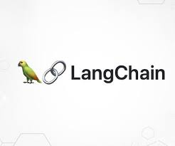 | LangChain | A widely adopted framework for developing applications utilizing Large Language Models (LLMs). | 🔗 LangChain
 | LangGraph | An extension of LangChain designed for managing stateful, multi-step workflows. | 🔗 LangGraph
 | LlamaIndex | A system dedicated to the indexing and retrieval of external documents. | 🔗 LlamaIndex
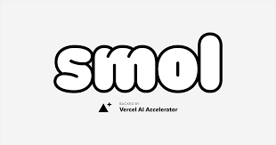 | smol-ai/developer | A lightweight, open-source framework for agent development. | 🔗 Smol Developer
 | AutoGen (Microsoft) | A framework for orchestrating conversations among multiple agents. | 🔗 AutoGen

Low-Code :
CrewAI,hangflow,n8n,agno
- Low-code frameworks like Pretext, POE, and LangFlow are highlighted for their ease of use and hybrid approach, allowing both visual building blocks and custom code integration for users with varying coding expertise.

Low-code Agent Workflows (Visual builders + code)

Agents | Framework | Description | Link
 | CrewAI | A framework for orchestrating role-based Large Language Model (LLM) agents. | 🔗 CrewAI
 | LangFlow | A visual drag-and-drop builder designed for creating LangChain workflows. | 🔗 LangFlow
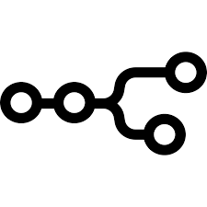 | n8n | A visual automation tool that facilitates workflow creation through a node-based interface. | 🔗 n8n
 | Agno | An LLMOps (Large Language Model Operations) and no-code/low-code platform for agent orchestration. | 🔗 Agno

No-Code :
google vertex ai ,microsoft copilot,openai custom gpt ,manus

- No-code frameworks, such as Microsoft Power Automate, are introduced as options for users requiring no coding skills, offering a user-friendly interface for building agent workflows.

No-code Agent Workflows (For non-programmers)

Agents | Platform | Description | Link
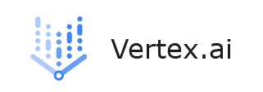 | Google Vertex AI | Google's enterprise-grade machine learning and agent development platform | 🔗 Vertex AI
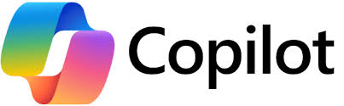 | Microsoft Copilot | An artificial intelligence productivity assistant integrated into Microsoft tools | 🔗 Microsoft Copilot
 | OpenAI Custom GPTs | A platform for creating personalized GPT agents via a user interface, | 🔗 Custom GPTs
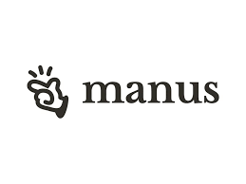 | Manus | A no-code AI agent platform that facilitates visual drag-and-drop workflow development | 🔗 Manus

The simplest AI Agents coding library: Smolagents

Subscribed

