1. Overview
This document explains the end-to-end execution flow of the Data Genie (QueryAI) application. It describes how a natural language question from a user is securely converted into SQL, executed on a protected database, and returned as structured results (tables or charts).
The system follows an agent-based architecture, where:
- Databases are accessed only by local agents
- The Cloud Server orchestrates communication
- Redis is used for schema caching
- WebSockets (Socket.IO) enable real-time interactions
This design ensures security, performance, and scalability, making the platform suitable for enterprise environments.
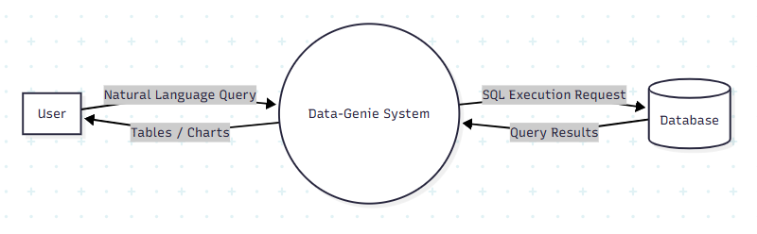
Basic Flow Diagram

2. Actors Involved
Component | Description
User | End user interacting with the system
Web UI | Browser-based frontend
Cloud Server | Flask + Socket.IO orchestration layer
Redis | In-memory schema cache
LLM Service | SQL generation engine
Local Agent | Secure database executor
Database | Target DB (MySQL / PostgreSQL / MSSQL, etc.)

3. System Architecture

3.1 Architecture Description
The system is divided into three logical zones:
- Client Zone
  - Web UI
  - User interaction
- Cloud Orchestration Zone
  - Cloud Server (Flask + Socket.IO)
  - Redis (Schema Cache)
  - LLM Service
- Private Network Zone
  - Local Agent
  - Database
The Cloud Server never directly connects to databases.
All database interactions are securely handled by the Local Agent.

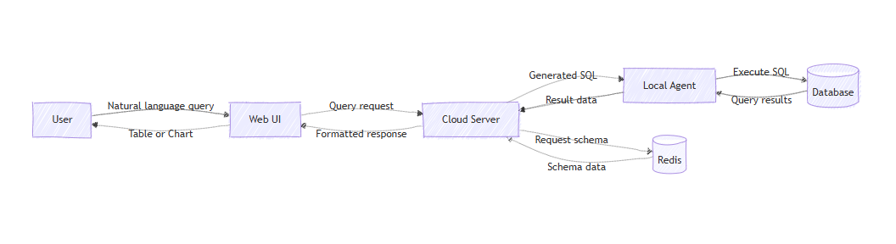
4. End-to-End Execution Flow

Data Flow Diagram

4.1 Agent Registration & Initialization
- The Local Agent starts and establishes a WebSocket connection with the Cloud Server.
- The agent registers itself using a unique agent_id.
- The Cloud Server marks the agent status as CONNECTED.
- All connected Web UI clients are notified about the available agent.

4.2 Database Discovery Flow
- The Web UI requests the list of databases for a selected agent.
- The Cloud Server forwards the request to the Local Agent.
- The Local Agent loads its configured database connections.
- The database list is sent back to the Cloud Server.
- The Cloud Server forwards the list to the Web UI.

4.3 Schema Cache Lookup
When a database is selected, the Cloud Server checks Redis using the key: schema:{agent_id}:{db_name}
- If the schema exists → reused
- If missing → schema is requested from the agent
This avoids repeated metadata calls and speeds up query execution.

4.4 Schema Fetch & Caching (Cache Miss)
- The Local Agent connects to the selected database.
- The agent fetches:
  - Table names
  - Column metadata
  - Optional sample rows
- The schema data is returned to the Cloud Server.
- The Cloud Server caches the schema in Redis with a defined TTL.

4.5 User Query Submission
- The User enters a natural language question (English).
- The Web UI sends the following payload to the Cloud Server:
  - User query
  - agent_id
  - db_name
  - Optional selected tables

4.6 SQL Generation (LLM Phase)
- The Cloud Server retrieves schema data (Redis or Agent).
- Schema + sample data + conversation context are sent to the LLM Service.
- The LLM generates a database-specific SQL query.
- Generated SQL is returned to the Cloud Server.

4.7 SQL Execution via Agent
- The Cloud Server sends the generated SQL to the Local Agent.
- The Local Agent executes SQL on the Database.
- Query results are collected and formatted.

4.8 Result Propagation
- The Local Agent sends results to the Cloud Server.
- The Cloud Server forwards:
  - Result data
  - Execution status
  - Timing & metadata
- The Web UI renders results as:
  - Tables
  - Charts

4.9 Completion & Logging
- The User views the final output.
- Query history and audit logs are updated for traceability and debugging.

5. Summary Flow

Step 1: User Query Initiation
The execution flow begins when the user submits a natural language query through the Web UI. The query is expressed in plain English and does not require any knowledge of SQL or database schema.
Example:
“Show total revenue by region for the last quarter.”
This approach enables business users and analysts to access database insights without technical expertise.

Step 2: Request Transmission from Web UI to Cloud Server
Once the user submits the query, the Web UI packages the request and sends it to the Cloud Server using HTTP or WebSocket (Socket.IO).
The request payload includes:
- Natural language query
- Selected agent_id
- Selected database name
- Optional user-selected tables or filters
The Web UI acts only as a presentation layer and does not perform any business logic or database interaction.

Step 3: Schema Cache Lookup (Redis)
Upon receiving the request, the Cloud Server checks whether the database schema is already available in the Redis cache.
The schema is identified using the following key format:
Schema:{agent_id}:{db_name}
Cache Scenarios:
- Cache Hit:
The schema is retrieved directly from Redis and reused.
- Cache Miss:
The Cloud Server initiates a schema fetch request to the Local Agent.
This mechanism significantly reduces latency and avoids repeated database metadata queries.
Step 4: Schema Retrieval from Database (Cache Miss Scenario)
If the schema is not available in Redis:
- The Cloud Server sends a schema request to the Local Agent.
- The Local Agent establishes a secure connection with the target database.
- The agent extracts:
  - Table names
  - Column names and data types
  - Optional sample rows
- The extracted schema information is returned to the Cloud Server.
- The Cloud Server stores the schema in Redis with a defined Time-To-Live (TTL).
This ensures that subsequent queries can reuse the schema efficiently.

Step 5: Schema and Context Preparation for LLM
The Cloud Server prepares the input context for the LLM. This context typically includes:
- Database schema (tables, columns, relationships)
- Sample data (if available)
- User’s natural language query
- Prior conversation context (for follow-up queries)
Providing structured schema context ensures accurate interpretation of user intent by the LLM.

Step 6: SQL Generation Using LLM
The prepared context is sent to the LLM Service for processing.
The LLM:
- Analyzes the user’s intent
- Maps intent to relevant tables and columns
- Generates a database-specific SQL query
The generated SQL query is returned to the Cloud Server for execution.

Step 7: SQL Validation and Safety Controls
Before execution, the Cloud Server may apply validation and safety checks such as:
- SQL syntax validation
- Restricting queries to read-only (SELECT) operations
- Enforcing row limits and execution timeouts
These controls ensure database safety and prevent unintended data modification.

Step 8: Secure SQL Execution via Local Agent
The validated SQL query is forwarded to the Local Agent.
- The Local Agent executes the query against the target database.
- The database processes the query and returns the result set.
- The Local Agent formats the results into a structured response.
At no point does the Cloud Server directly access the database.

Step 9: Result Transmission to Cloud Server
The Local Agent sends the execution response back to the Cloud Server, including:
- Query result data
- Execution status (success or failure)
- Execution time and metadata
This information supports monitoring, logging, and audit requirements.

Step 10: Result Rendering in Web UI
The Cloud Server forwards the processed response to the Web UI.
The Web UI:
- Displays results in tabular format
- Optionally renders visualizations such as charts
- Enables users to ask follow-up questions
This completes the user interaction cycle.

Step 11: Logging and Audit Trail
After completion:
- Query details are logged
- Execution metadata is stored
- Audit trails are maintained for traceability and compliance
These logs support debugging, analytics, and governance requirements.
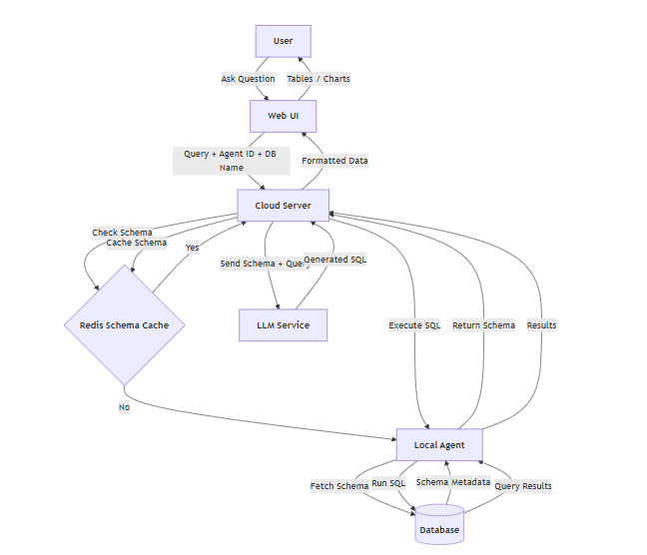

6. Sequence Diagram
sequence_diagram_data_genie.png <= click here

- The Local Agent registers itself with the Cloud Server and becomes available for use.
- The Web UI requests the list of databases associated with the selected agent.
- The Cloud Server checks Redis for a cached schema of the selected database.
- If the schema is not cached, the Local Agent fetches schema metadata from the Database and the Cloud Server caches it in Redis.
- The User submits a natural language query through the Web UI.
- The Cloud Server sends the query and schema context to the LLM Service for SQL generation.
- The generated SQL is securely executed by the Local Agent on the Database.
- Query results are returned from the Local Agent to the Cloud Server.
- The Cloud Server forwards formatted results to the Web UI for visualization.

