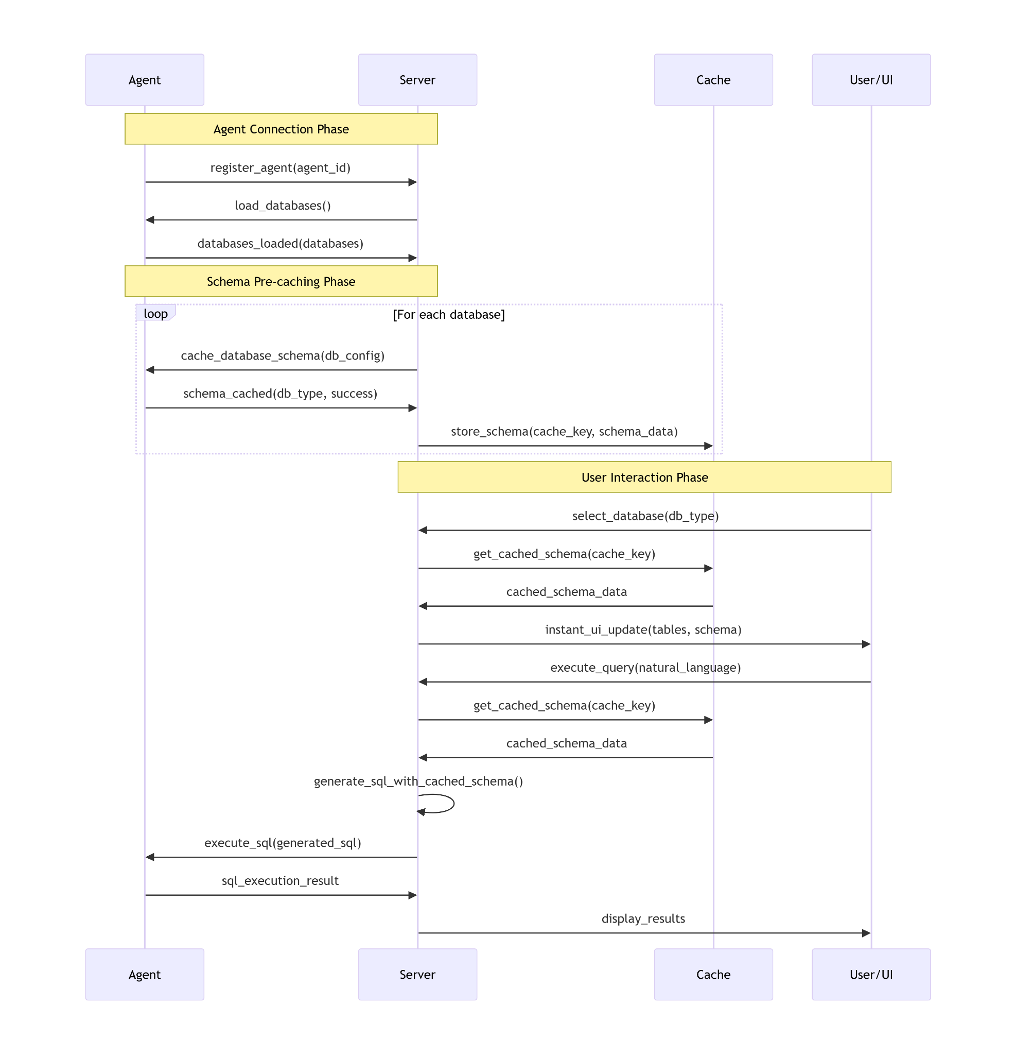

- Working on end-to-end pipeline:
- Agent → Server → Redis (schema caching)
- User DB selection → Instant schema load
- LLM SQL generation using cached schema
- Query execution via Agent

