# Desktop Assistant Using python

**A Project Report**

Submitted in partial fulfilment of the

Requirements for the award of the Degree of

**BACHELOR OF SCIENCE (INFORMATION TECHNOLOGY)**

## BY

**Mr. SHYAMSUNDAR RAMVILAS CHAUHAN**

**Under the esteemed guidance of**

**Asst. prof. Bhavika Mulchandani**



**DEPARTMENT OF INFORMATION TECHNOLOGY**

## KAMALADEVI COLLEGE OF ARTS & COMMERCE

(Affiliated to University of Mumbai)

VITTHALWADI EAST -421306

MAHARASHTRA

2024-2025

# PROFORMA FOR THE APROVAL PROPOSAL

PNR No.: Roll No.:

1. Name of the student:

SHYAMSUNDAR RAMVILAS CHAUHAN

1. Title of the Project

Desktop Assistant Using Python

1. Name of the guide

Asst. Prof. Bhavika Mulchandani

1. Teaching experience of the Guide :- 5Years

5.Is this your first Submission ? Yes() No()

Signature of the student Signature of the Guide Date:…………. Date:……………

Signature of the HOD

Date:…………

**Kamaladevi college of arts &commerce**

***(Affiliated to University ofMumbai)***  ***Vitthalwadi East Maharshtra-421306***



CERTIFICATE

This is to certify that the project entitled **DESKTOP ASSITANT** is a bonafied work of SHYAMSUNDAR RAMVILAS CHAUHAN bearing seat no __________& submitted in partial fulfillment of the requirement for the award of degree of **BACHLOR OF**

**SCIENCE** in **INFORMATION TECHNOLGY** from **University of Mumbai**

Internal Guide External Examiner coordinator

Date college seal

# DECLARATION

I hereby declare that the project entitled, **“ARTIFICIAL INTELLIGENCE”** done at **place where the project is done,** has not been in any cases duplicated to submit to any other university for the award of any degree. To the best of my knowledge other than me, no one has submitted to any other university.

The project is done in partial fulfilment of the requirements for the award of

degree of **BACHLEOR OF SCIENCE(INFORMATION TECHNOLOGY)** to be submitted as final semester project as part of our curriculum.

Name and signature of the student

Shyamsundar Ramvilas Chauhan

# ACKNOWLWDGEMENT

I extend my sincere gratitude to the management of **Kamaladevi College of** **Arts & Commerce** for providing me with the opportunity to undertake and complete this project work.

I would like to express my heartfelt thanks to **Dr. Simmi Singh**, the Principal of **Kamaladevi College**, for her generous cooperation and support throughout the completion of our project.

Special appreciation goes to **Asst. Prof. Ashwini Rane**, Head of Computer Science, for offering valuable guidance at every stage of this project work.

I am deeply thankful to our project guide, **Asst. Prof. Bhavika Mulchandani**, for her unwavering efforts, constant support, and encouraging contributions throughout the project.

Lastly, I would like to express my gratitude to our friends and family for their continuous support, motivation, and encouragement.

**Shyamsundar Chauhan**

# 

# 

# ABSTRACT

As we know Python is an emerging language so it becomes easy to write a script for Voice Assistant in Python. The instructions for the assistant can be handled as per the requirement of user. Speech recognition is the process of converting speech into text. This is commonly used in voice assistants like Alexa, Siri, etc. In

Python there is an API called Speech Recognition which allows us to convert speech into text. It was an interesting task to make my own assistant. It became

easier to perform many tasks like playing music, opening your favourite IDE with the help of a single voice command. In the current scenario, advancement in technologies are such that they can perform any task with same effectiveness or can say more effectively than us. By making this project, I realized that the concept of AI in every field is decreasing human effort and saving time.

Functionalities of this project include:

1. It can open PDF.
2. It can open favourate IDE.
3. It can open command prompt.
4. It can play music.
5. It can open Wikipedia.
6. It can open websites like Google, YouTube, etc., in a web browser.
7. It can open Notepad.
8. It can open any folder

Now the basic question arises in mind that how it is an AI? The virtual assistant that I have created is like if it is not an A.I, but it is the output of a bundle of the statement. But fundamentally, the main purpose of A.I machines is that it can perform human tasks with the same efficiency or even more efficiently than humans. It is a fact that my virtual assistant is not a very good example of A.I., but it is an A.I

**LIST OF FIGURES :**

|  |  |  |
| --- | --- | --- |
| Sr.no | Figure name | Page no |
| 1.  2.  3. | DFD Diagram DFD level 0  DFD level 1  DFD LEVEL 2 | 10  10  11  12 |
| 4. | USE Case Diagram | 13 |
| 5. | Class Diagram | 14 |
| 6. | Activity Diagram | 15 |
| 7. | ER Diagram | 16 |

**Table Of Content**

|  |  |  |
| --- | --- | --- |
| **Sr.no** | **Content** | **Page no** |
| **1** | Introduction  1.1 Background  1.2 Objectives  1.3 Scope, Purpose, Applicability  1.3.1 Scope  1.3.2 Purpose  1.3.3 Applicability  1.4 Organization of project | 1-4 |
| **2** | Survey of technology  2.1 Existing System  2.2 Study of different technique  2.3 Proposed System | 5-6 |
| **3** | Requirement and analysis  3.1 Problem definition  3.2 Requirement specification  3.3 Software requirement  3.4 Hardware requirement  3.5 Advantages and limitation | 7-9 |
| **4** | System design  4.1 Data flow diagram  4.1.1 DFD level 0 4.1.2 DFD level 1  4.1.3 DFD level 2  4.2 Use Case Diagram  4.3 Class Diagram  4.4 Activity Diagram  4.5 ER Diagram | 10-16 |

|  |  |  |
| --- | --- | --- |
|  |  |  |
| **5** | Implementation and Testing  5.1 Code  5.2 Modification and Improvement  5.3 Test Case | 17-24 |
| **6** | Result and Discussion  6.1 Test Reports | 25-26 |
| **7** | Conclusion and future scope  7.1 Summary of project  7.2 Learning Experience  7.3 Future Scope  7.4 Conclusion | 27-28 |
|  | References | 29 |
|  |  |  |

# Chapter 1

# Introduction

Artificial Intelligence when used with machines, it shows us the capability of thinking like humans. In this, a computer system is designed in such a way that typically requires interaction from human. As we know Python is an emerging language so it becomes easy to write a script for Voice Assistant in Python. The instructions for the assistant can be handled as per the requirement of user. Speech recognition is the Alexa, Siri, etc. In Python there is an API called Speech Recognition which allows us to convert speech into text. It was an interesting task to make my own assistant. It became easier to send emails without typing any word, Searching on Google without opening the browser, and performing many other daily tasks like playing music, opening your favourite IDE with the help of a single voice command. In the current scenario, advancement in technologies are such that they can perform any task with same effectiveness or can say more effectively than us. By making this project, I realized that the concept of AI in every field is decreasing human effort and saving time.

As the voice assistant is using Artificial Intelligence hence the result that it is providing are highly accurate and efficient. The assistant can help to reduce human effort and consumes time while performing any task, they removed the concept of typing completely and behave as another individual to whom we are talking and asking to perform task. The assistant is no less than a human assistant but we can say that this is more effective and efficient to perform any task. The libraries and packages used to make this assistant focuses on the time complexities and reduces time.

The functionalities include , It can send emails, It can read PDF, It can send text on WhatsApp, It can open command prompt, your favorite IDE, notepad etc., It can play music, It can do Wikipedia searches for you, It can open websites like Google, YouTube, etc., in a web browser, It can give weather forecast, It can give desktop reminders of your choice. It can have some basic conversation.

Tools and technologies used are PyCharm IDE for making this project, and I created all py files in PyCharm. Along with this I used following modules and libraries in my project. pyttsx3, SpeechRecognition, Datetime, Wikipedia, Smtplib, pywhatkit, pyjokes, pyPDF2, pyautogui, pyQt etc. I have created a live GUI for interacting with the AI as it gives a design and interesting look while having the conversation.

**1.1 Background :**

Now a days recommender system are on the rise. Chat GPT, Snapchat AI, Presentation AI all use recommender system to carry out their activities. So, this project has been undertaken by me to create one such recommendation system which will predict any type of answer based on the user question.

**1.2 Objectivies :**

The objectives for an AI project report can vary depending on the specific project, but here are some common objectives:

1. **Problem Solving**: The primary objective of AI is to solve complex problems. [The focus is not on creating AI programs that mimic humans, but rather on developing AI that makes our lives easier.](https://www.elements-magazine.com/8-aims-and-objectives-of-artificial-intelligence/)
2. **Task Completion**: AI should be capable of completing multiple tasks. [The challenge lies in programming AI systems to perform more than one task, understanding and applying rules that a human would know.](https://www.elements-magazine.com/8-aims-and-objectives-of-artificial-intelligence/)
3. **Business Integration**: AI is becoming a crucial tool for companies, helping streamline processes like customer service operations. [The objective is to continue integrating AI into as many low-level tasks as possible.](https://www.elements-magazine.com/8-aims-and-objectives-of-artificial-intelligence/)

1. [**Data Analysis**: With the boom in big data, AI is expected to play a significant role in analyzing this data, leading to more data-driven research, advertisements, and content](https://www.elements-magazine.com/8-aims-and-objectives-of-artificial-intelligence/)

[**Improving Efficiency**: Some common objectives for machine learning projects include improving customer satisfaction, increasing revenue, reducing costs, increasing efficiency, and automating manual processes.](https://nexocode.com/blog/posts/ai-project-scoping-how-to-define-the-scope-of-ml-project/)

**1.3 Scope , Purpose , Applicability**

**1.3.1 Scope :**

The scope of an AI project report refers to the specific boundaries or extent of the project. It defines what is included and what is excluded from the project. The scope of an AI project report typically includes:

**Project Goals and Objectives :** This defines the overall purpose of the project and the desired outcome.

**Deliverables :** This outlines the specific products, services, or results that will be produced during the project.

**Requirements :** This identifies the constraints, dependencies, and assumptions that must be considered during the project

The scope of an AI project report is crucial as it helps in managing the project effectively. It ensures that the project stays on track and that all the necessary tasks are completed within the specified time frame. It also helps in preventing scope creep, which can lead to delays and cost overruns.

**1.3.2 Purpose :**

The purpose of an AI project report is to provide a comprehensive overview of the project, including its status, progress, achievements, and any other pertinent details. It serves as a communication tool, tracking the various occurrences throughout the project life cycle. The report fosters open communication, promotes accountability among team members, and provides data for evaluation and improvement strategies. It also promotes transparency, providing stakeholders and team members with a clear view of the project’s direction, challenges, achievements, and expected results.

**1.3.3 Applicability**

[**Voice Assistant**: AI can function as a voice assistant, understanding natural language commands, processing information, and providing personalized assistance to users in a seamless and intuitive manner .](https://www.jetir.org/papers/JETIRFX06069.pdf)

It can open command prompt, your favourite IDE, notepad etc.

[**Efficiency and Accuracy**: As the voice assistant uses Artificial Intelligence, the results it provides are highly accurate and efficient.](https://www.studocu.com/in/document/anna-university/computer-science/documentation-for-jarvis/38890156) [It can help reduce human effort and save time while performing any task.](https://www.jetir.org/papers/JETIRFX06069.pdf)

[**Content Creation**: AI is a sophisticated software tool that uses artificial intelligence (AI) to assist in content creation. It can produce a variety of content types, including long-form content, social media posts, email subject lines, ad copy, meta descriptions, and more.](https://www.studocu.com/in/document/indian-institute-of-technology-delhi/cloud-computing-technology-fundamentals/project-report-for-jarvis-ai-in-python/24773272)

[**Web Browsing**: opening the browser, and perform many other daily tasks like playing music.](https://www.studocu.com/in/document/anna-university/computer-science/documentation-for-jarvis/38890156)

[**Learning Tool**: By making this project, students realized that the concept of AI in every field is decreasing human effort and saving time.](https://www.studocu.com/in/document/anna-university/computer-science/documentation-for-jarvis/38890156)

**1.4 Organization of project**

This report is composed of the following sections :

**Chapter 1 : Introduction**

This chapter explains how AI are recommended to the user. It also tells about the advantages and disadvantages and will also show the scope and applicability of the project

**Chapter 2 : Survey of Technology**

In this chapter we explore the previous or existing system, And the technology used to create this platform.

**Chapter 3 : System Analysis**

This chapter consist of all software and hardware required to create and execute the project.

**Chpter 4 : System Design**

This chapter presents different design model like data flow diagram of the project. It also consists of several other diagrams as the use case diagram, activity diagram, ER diagram, Class diagram etc.

# CHAPTER 2

# SURVEY OF TECHNOLOGY

**2.1 Existing System**

We are familiar with many existing voice assistants like Alexa, Siri, Google Assistant, Cortana which uses concept of language processing, and voice recognition. They listens the command given by the user as per their requirements and performs that specific function in a very efficient and effective manner. As these voice assistants are using Artificial Intelligence hence the result that they are providing are highly accurate and efficient. These assistants can help to reduce human effort and consumes time while performing any task, they removed the concept of typing completely and behave as another individual to whom we are talking and asking to perform task. These assistants are no less than a human assistant but we can say that they are more effective and efficient to perform any task. The algorithm used to make these assistant focuses on the time complexities and reduces time. But for using these assistants one should have an account (like Google account for Google assistant, Microsoft account for Cortana) and can use it with internet connection only because these assistants are going to work with internet connectivity. They are integrated with many devices like, phones, laptops, and speakers etc.

**2.2 Study of different techniques :**

Natural Language Processing (NLP): AI uses NLP to understand and interpret human language in a valuable way. It’s crucial for understanding user commands and generating human-like responses.

Speech Recognition: This technique is used to convert spoken language into written text1. This is particularly useful for voice-activated commands.

Reinforcement Learning: AI uses reinforcement learning to make sequences of decisions. It uses trial and error to come up with solutions to problems.

Deep Learning Models: AI uses deep learning models for various tasks. For example, it uses models like ChatGPT for text generation.

Various Libraries and APIs: AI uses various Python libraries and RESTful APIs for different tasks3. For example, TensorFlow and Keras are used for building the AI models.

Multiple AI Techniques: AI uses multiple AI techniques to perform a variety of tasks. For example, it can interpret and generate images, audio, and video.

**2.3 Proposed System :**

It was an interesting task to make my own assistant. It became easier to send emails without typing any word, Searching on Google without opening the browser, and performing many other daily tasks like playing music, opening your favourite IDE with the help of a single voice command. AI is different from other traditional voice assistants in terms that it is specific to desktop and user does not need to make account to use this, it does not require any internet connection while getting the instructions to perform any specific task.

The IDE used in this project is PyCharm. All the python files were created in PyCharm and all the necessary packages were easily installable in this IDE. For this project following modules and libraries were used i.e. pyttsx3, SpeechRecognition, Datetime, Wikipedia, Smtplib, pywhatkit, pyjokes, pyPDF2, pyautogui, pyQt etc. I have created a live GUI for interacting with the AI as it gives a design and interesting look while having the conversation.

With the advancement AI can perform any task with same effectiveness or can say more effectively than us. By making this project, I realized that the concept of AI in every field is decreasing human effort and saving time.

Functionalities of this project include, It can send emails, It can read PDF, It can send text on WhatsApp, It can open command prompt, your favorite IDE, notepad etc., It can play music, It can do Wikipedia searches for you, It can open websites like Google, YouTube, etc., in a web browser, It can give weather forecast, It can give desktop reminders of your choice. It can have some basic conversation.

# Chapter 3 REQUIREMENT AND ANALYSIS

**3.1 Problem Statement :**

The need for an intelligent personal assistant that can perform various tasks efficiently and accurately, reducing human effort and saving time.

**3.2 Requirement Specification:**

**Voice Assistant:** The system should be able to understand and interpret natural language commands, processing information, and providing personalized assistance to users.

**Speech Recognition:** The system should be able to convert spoken language into written text. This is particularly useful for voice-activated commands.

**Content Creation:** The system should be capable of generating a variety of content types, including long-form content, social media posts, email subject lines, ad copy, meta descriptions, and more.

**Web Browsing:** opening the browser, and perform many other daily tasks like playing music.

**Learning Tool:** The system should be designed in such a way that it helps students realize that the concept of AI in every field is decreasing human effort and saving time.

**Efficiency and Accuracy:** As the system uses Artificial Intelligence, the results it provides should be highly accurate and efficient

**3.3 Hardware Requirements :**

1. [**Computer System**: A computer system capable of running the required software and processing voice commands is necessary. The system should have enough processing power to handle the computations required by the AI algorithms.](https://www.studocu.com/in/document/indian-institute-of-technology-delhi/cloud-computing-technology-fundamentals/project-report-for-jarvis-ai-in-python/24773272)

1. [**Microphone**: Since AI is a voice-activated system, a good quality microphone is essential for accurately capturing voice commands.](https://www.studocu.com/in/document/indian-institute-of-technology-delhi/cloud-computing-technology-fundamentals/project-report-for-jarvis-ai-in-python/24773272)

1. [**Speakers**: To hear AI’s responses, you’ll need a speaker.](https://www.studocu.com/in/document/indian-institute-of-technology-delhi/cloud-computing-technology-fundamentals/project-report-for-jarvis-ai-in-python/24773272)

1. [**Internet Connection**: While not a hardware requirement per se, a stable internet connection is often necessary for accessing online resources and APIs](https://www.studocu.com/in/document/indian-institute-of-technology-delhi/cloud-computing-technology-fundamentals/project-report-for-jarvis-ai-in-python/24773272)

**3.4 Software Requirements :**

• OPERATING SYSTEM : WINDOWS 7 OR ABOVE • TECHNOLOFY : PYTHON 3.7 OR ABOVE

**3.5 Advantage and limitations :**

**Advantages:**

**Efficiency:** AI can automate tasks and processes, granting humans more time for creative and meaningful endeavors. It’s proficient in tasks such as information synthesis and content generation, thus potentially increasing efficiency and productivity across various industries.

**Data Analysis:** AI excels at analyzing data and recognizing patterns. It can provide tailored services and relevant recommendations, precisely aligned to individual preferences and needs.

**Knowledge Accessibility**: AI is designed to act as an AI assistant, sharing its expertise on a myriad of subjects. This enhances the availability of specialized knowledge and skills.

**Consistency:** AI operates consistently without experiencing human limitations like fatigue. AI has the potential to provide unwavering assistance, ensuring quality remains constant even at scale.

**Cost-Effective:** In specific scenarios, AI automation can reduce costs compared to human labor and expertise. AI may present cost-saving opportunities when deployed judiciously.

**Limitations of AI:**

**Job Displacement:** Poor deployment of AI automation could disrupt economies and lead to the displacement of human jobs.

**Reinforcing Biases:** AI systems, including AI, risk perpetuating harmful biases if not properly managed.

**Language Diversity:** The AI can work with a limited number of languages hence it is not language diversity friendly.

**Costly to Implement:** It is extremely costly to make and the equipment is quite expensive.

**Noisy Environment:** It fails to operate efficiently in a noisy environment.

# Chapter 4 SYSTEM DESIGN

**4.1 Data flow diagram(DFD) :**

A data flow diagram (DFD) is a graphical illustration of the “flow” of data through an information system, modelling its process aspects. A DFD is often used as a initial step to create an overview of the system without going into great detail, Which can later be elaborated. DFD can also be used for the visualization of structured design.

**4.1.1 DFD level 0 :**

A Level 0 Data Flow Diagram (DFD), also known as a context diagram, is the highest level DFD. It provides an overview of the entire system. The Level 0 DFD represents the system as a single process, showing its relationship to external entities. It’s designed to be an abstraction view, with input and output data indicated by incoming/outgoing arrows. This diagram does not go into details as marking all the processes. The purpose of a Level 0 DFD is to express the system scope at a high level and to prevent users from delving into complex details. It’s a useful tool for providing a broad overview of the system.

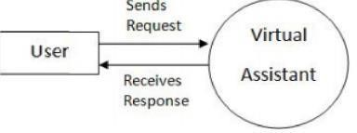

**4.1.2 DFD level 1 :**

The level 1 DFD shows how the system is seprated into sub-system (process). Each of which deals with one or more of the data flows to or form an external agent, and which together provide all of the functionality of the structure as a whole.

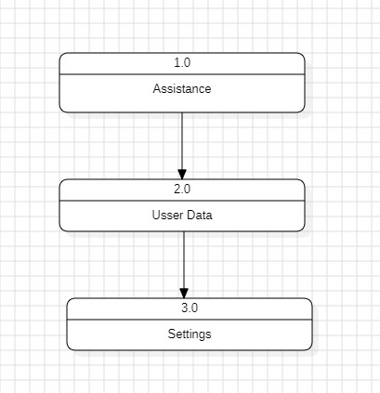

**4.1.3 DFD level 2 :**

A level 2 data flow diagram (DFD) offers a more through looak at the process that make up an information system that a level 1 DFD does. It can be used to map or record the specific makeup oa a system

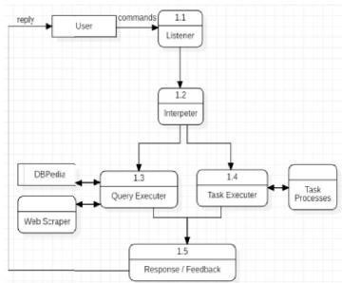

To model a system, the most significant aspect is to capture the dynamic activity. Dynamic activity means the behaviour of the system when it is operating. Only static behaviour is not adequate to model a system rather dynamic behaviour is more important than static behaviour

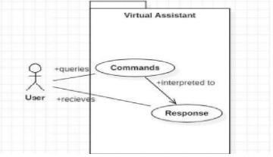

Class diagram is not a dynamic diagram it is a static diagram. It represents the static view. It is not only used for visualizing, describing and documenting different aspects of a system but also for constructing executable code of the siftware application

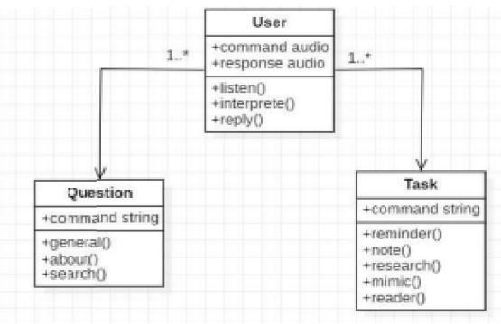

Activity diagram is another important diagram in UML. To depict the dynamic aspect of the system. It is basically a flowchart to represent the flow from one activity to another activity. The activity can be describe as a process of the system.

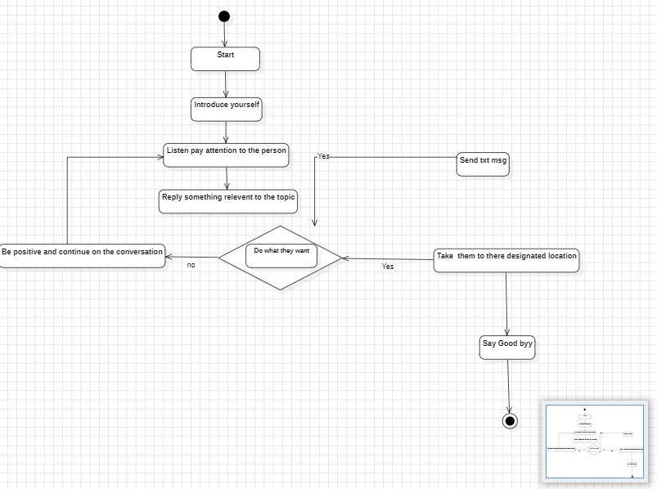

**4.5 ER diagram :**

An entity-relationship model(Er model) describes interconnected things of internet in a specific domain of knowledge. A basis ER model is composed of entity types (which classify the things of interest) and specifies relations that can exist between instance of those entity.

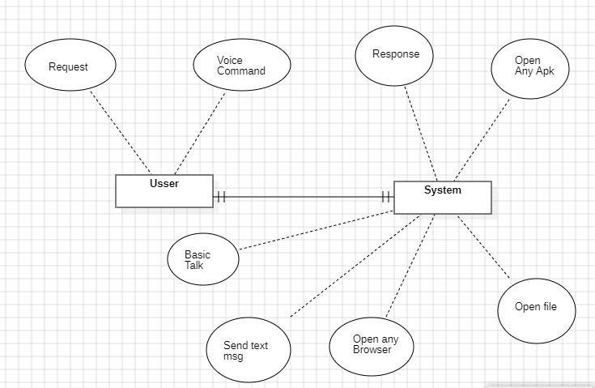

# Chapter 5 IMPLEMENTATION AND TESTING

**5.1 Program code**

import time

import speech_recognition as sr import os import webbrowser import win32com.client import datetime import openai from config import apikey import pyautogui #for volume import psutil #for battery import speedtest

from twilio.rest import Client

speaker = win32com.client.Dispatch("SAPI.SPvoice") speaker.speak("Welcome to Arsalan A I")

chatStr = "" from gui import play_gif play_gif

def chat(query): global chatStr print(chatStr) openai.api_key = apikey

chatStr += f"Arsalan: {query}\n Arsalan A.I: " response = openai.ChatCompletion.create(

model="gpt-3.5-turbo-1106", messages=[

{"role": "system", "content": "You are a helpful assistant."},

{"role": "user", "content": query}

]

)

speaker.speak(response['choices'][0]['message']['content']) chatStr += f"{response['choices'][0]['message']['content']}\n" return response['choices'][0]['message']['content']

def ai(prompt):

openai.api_key = apikey

text = f"OpenAI response for Prompt: {prompt} \n *************************\n\n" response = openai.ChatCompletion.create(

model="gpt-3.5-turbo", # replace with the name of a current model messages=[

{"role": "system", "content": "You are a helpful assistant."},

{"role": "user", "content": prompt}

]

)

print(response['choices'][0]['message']['content']) text += response['choices'][0]['message']['content'] if not os.path.exists("Openai"): os.mkdir("Openai")

with open(f"Openai/{''.join(prompt.split('Artificial intelligence')[1:]).strip()}.txt", "w") as f:

f.write(text)

def takeCommand(): r = sr.Recognizer() with sr.Microphone() as source:

audio = r.listen(source) try:

print("Recognizing...")

query = r.recognize_google(audio, language="en-in") print(f"User said: {query}") return query

except Exception as e: return "Some Error Occurred. Sorry from Arsalan AI"

if name == ' main ': print('Welcome to Arsalan A.I') while True:

print("Listening...")

query = takeCommand()

sites = [["youtube", "https://[www.youtube.com"]](http://www.youtube.com/), ["wikipedia",

"https://[www.wikipedia.com"]](http://www.wikipedia.com/),

["google", "https://[www.google.com"]](http://www.google.com/), ["instagram",

"https://[www.instagram.com"]](http://www.instagram.com/)] for site in sites:

if f"Open {site[0]}".lower() in query.lower(): speaker.speak(f"Opening {site[0]} sir...")

webbrowser.open(site[1])

if "the time" in query:

hour = datetime.datetime.now().strftime("%H") min = datetime.datetime.now().strftime("%M") sec = datetime.datetime.now().strftime("%S")

speaker.speak(f"Sir time is {hour} hour {min} minutes and {sec} seconds")

elif "using Artificial intelligence".lower() in query.lower():

ai(prompt=query)

elif "play music" in query: music_dir = "C:\\Users\\arsla\\Music" songs = os.listdir(music_dir) print(songs)

os.startfile(os.path.join(music_dir, songs[0]))

elif "increase volume" in query: pyautogui.press("volumeup")

speaker.speak("increasing the volume sir")

elif "decrease volume" in query: speaker.speak("Decreasing the volume sir")

pyautogui.press("volumedown")

elif "mute the volume" in query or "mute" in query: speaker.speak("Now the volume is mute sir") pyautogui.press("volumemute")

elif "open visual" in query: speaker.speak("Opening the visual sir")

codepath = "C:\\Users\\arsla\\AppData\\Local\\Programs\\Microsoft VS Code\\code" os.startfile(codepath)

elif "open photo" in query: speaker.speak("Searching for best photo that present in your pc wait ") R_dir = "E:\R" photo = os.listdir(R_dir) print(photo)

os.startfile(os.path.join(R_dir, photo[17]))

elif "open camera" in query:

speaker.speak("Opening the Camera sir")

camerapath = "C:\\Users\\arsla\\OneDrive\\Desktop\\Camera" os.startfile(camerapath)

elif "open profile" in query:

speaker.speak("Enter usser name to find profile") name = input("Enter ussername here : ") speaker.speak("Opening instagram profile sir") webbrowser.open([f"www.instagram.com/{](http://www.instagram.com/)name}")

elif "take screenshot" in query: speaker.speak("sir, please tell me the name for this screenshot file")

name = takeCommand().lower()

speaker.speak("please sir hold the screen for few seconds, i am taking screenshot") time.sleep(3) img = pyautogui.screenshot() img.save(f"{name}.png")

speaker.speak("i am done sir, the screenshot is saved in your main folder.")

elif "how much battery we have" in query:

battery = psutil.sensors_battery() percentage = battery.percent

speaker.speak(f"Sir our system have {percentage} percent battery")

elif "exit" in query:

speaker.speak("Good by") exit()

else: print("Chatting...")

chat(query)

**Output :**

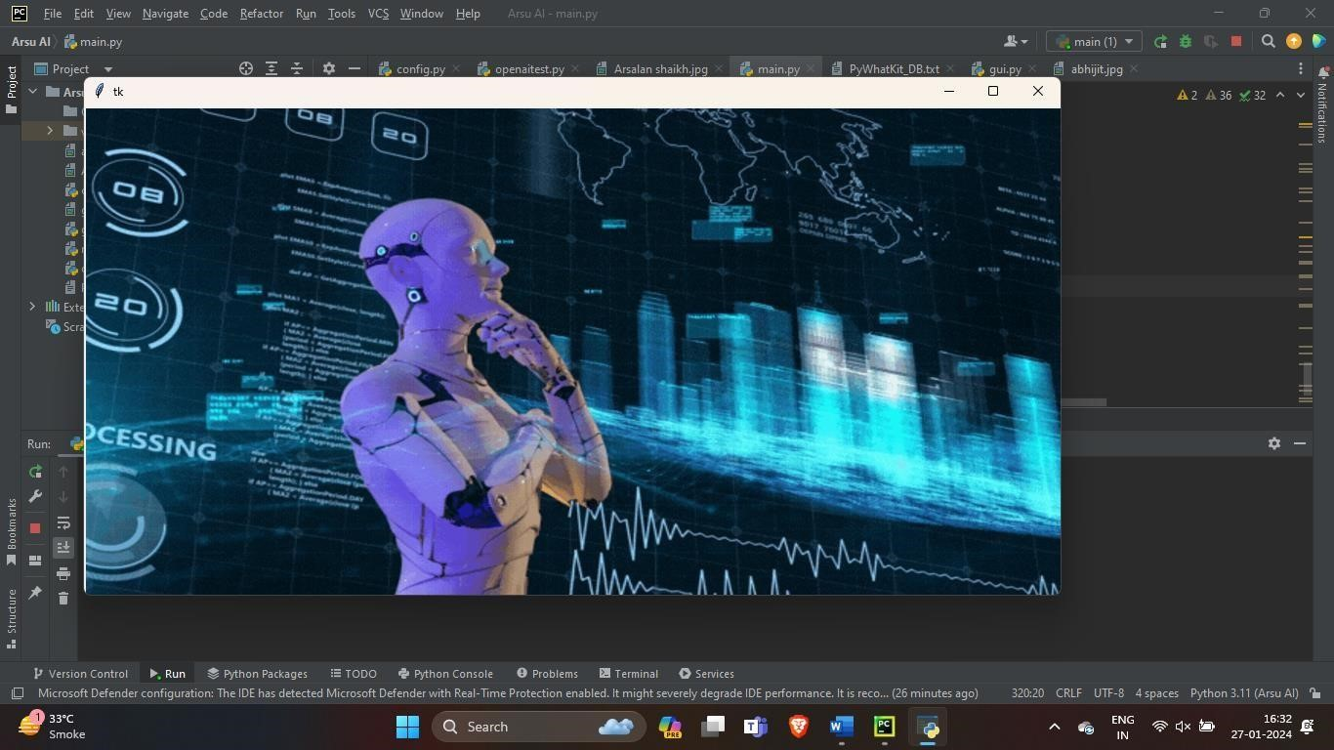

**Live GUI**

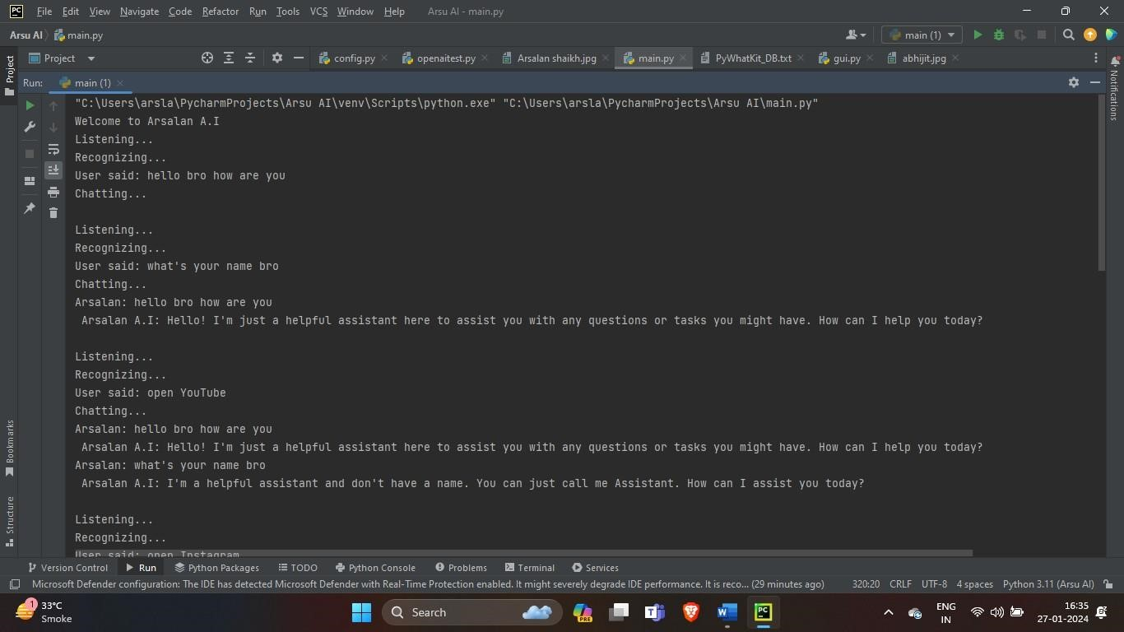

**First Output**

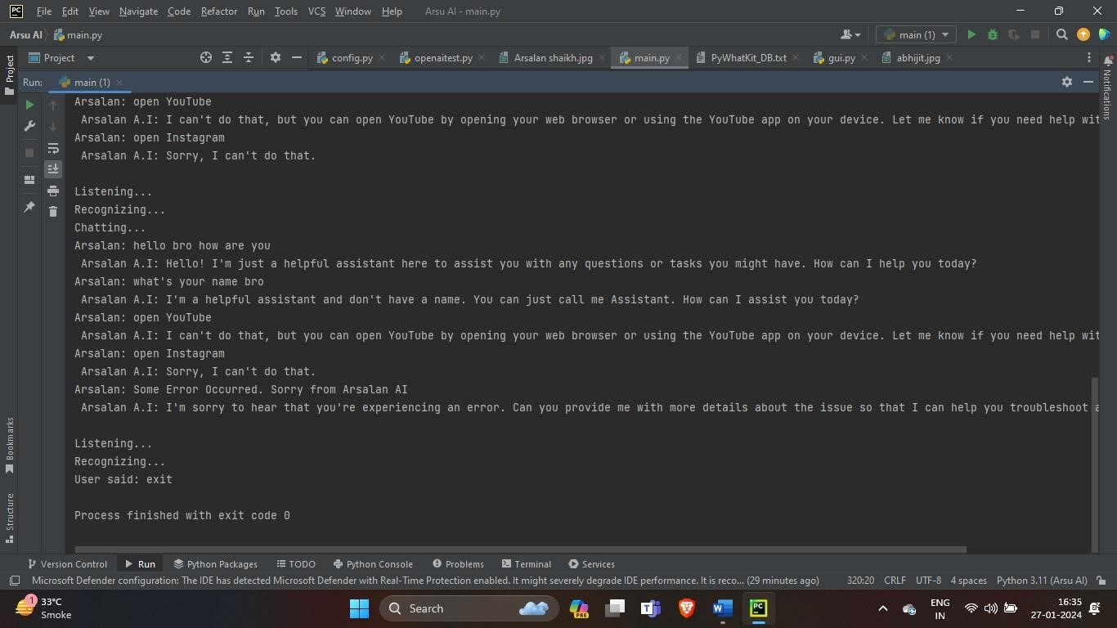

## Second Output

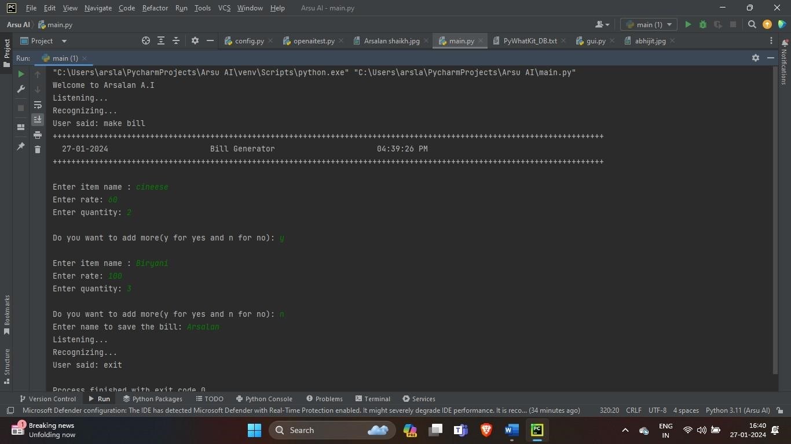

## Third output

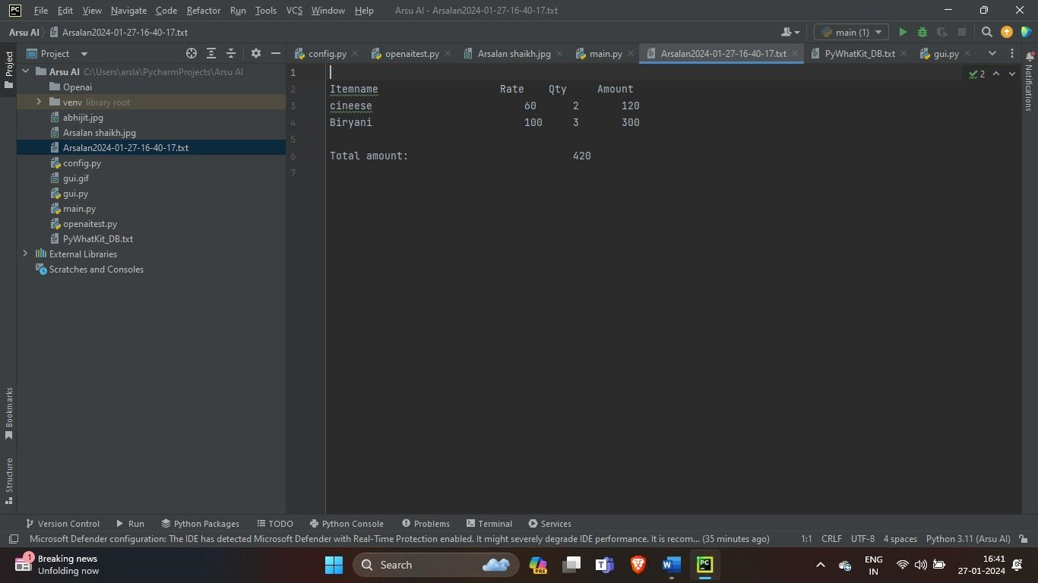

## Fourth output

**5.2 Modification and Improvement**

AI incorporates an advanced voice recognition feature, which is central to its functionality. This feature is powered by a sophisticated machine learning algorithm that has been trained on a diverse range of human voices. This allows AI to accurately interpret voice commands from users, regardless of their accent or speech patterns. The voice recognition feature is highly responsive, ensuring that AI can carry out commands quickly and efficiently. Furthermore, continuous updates and improvements are made to this feature to enhance its accuracy and reliability, providing users with a seamless and intuitive experience when interacting with AI.

**5.3 Test Cases**

Test cases are specific conditions or variables under which a tester will determine whether a system under test satisfies requirements and works correctly. Here are some hypothetical test cases for a AI :

**Voice Recognition Accuracy:** Test the system’s ability to accurately recognize and interpret voice commands from users. This could involve testing with a variety of accents, speech patterns, and background noise levels.

**Response Time:** Measure the time it takes for AI to respond to a user’s command. The system should be able to process commands and respond in a timely manner.

**Task Execution:** Test the system’s ability to correctly execute tasks based on user commands. This could involve tasks like setting reminders, sending emails, or retrieving information.

**Error Handling:** Test how the system handles errors or unexpected inputs from users. AI should be able to gracefully handle errors and provide useful feedback to the user.

**System Integration:** Test how well AI integrates with other systems or applications. For example, if AI is supposed to control smart home devices, test its ability to interact with these devices.

**Security:** Test the system’s security measures. AI should protect user data and privacy.

# Chapter 6 Result and Discussion

Our project is only a suggested solution to a current problem and tries to attain predictive analysis which are a trend in today’s date. This package shall prove to be prove to be a powerful package in satisfying all the requirements of the people who try to do Recommendation Systems. The objective of this software is to provide a framework that enables the any person looking for predictions in any field. Recommendation system is a very beneficial project in today’s time. As observed there have been instances of predicting anything arbitrarily. Hence, to benefit such activities this system will thus prove to be extremely beneficial. It was a great experience to design and implement the recommendation systems by using PYTHON and DEEP LEARNING and to work o its documentation. While working on these project, I have learned many things especially how to apply to concepts of DEEP LEARNNG into real life problems. It helped me learning working in different environments and increased my interest in this very field.



## Fig 6.1 Result GUI



**Fig 6.2 CMD Result**

**Chapter 7**

# CONCLUSION

**7.1 Summary of project :**

This project uses AI-powered personal assistant systems built on Python and introduces state-of-the-art enhancements to language recognition features. This AI voice assistant uses voice recognition technology, natural language processing, and Artificial Intelligence (AI) to respond to people

**7.2 Learning Experience :**

It was a great experience to design and implement the Recommendation Systems by using PYTHON, and DEEP LEARNING and to work on its documentation. While working on this project, I have learned many things especially how to apply to concepts of DEEP LEARNING into real life problems. It helped me learning working in different environments and increased my interest in this very field

**7.3. FUTURE SCOPE :**

7.3.1. Make AI to learn more on its own and develop a new skill in it.

7.3.2. AI android app can also be developed.

7.3.3. Make more AI voice terminals.

7.3.4. Voice commands can be encrypted to maintain security

**7.4 Conclusion :**

AI is a very helpful voice assistant without any doubt as it saves time of the user by conversational interactions, its effectiveness and efficiency. But while working on this project, there were some limitations encountered and also realized some scope of enhancement in the future which are mentioned below:

**7.4.1 LIMITATIONS**

9.1.1. Security is somewhere an issue, there is no voice command encryption in this project.

9.1.2. Background voice can interfere

9.1.3. Misinterpretation because of accents and may cause inaccurate results.

9.1.4. AI cannot be called externally anytime like other traditional assistants like Google Assistant can be called just by saying, “Ok Google!”

# REFERENCES

1. **Snapchat AI :**

These AI was developed by [Evan Spiegel, Bobby Murphy, and Reggie Brown w](https://en.wikipedia.org/wiki/Snapchat)ith the help of python programming language. It is one type of chat assistant

1. **Chat GPT :**

This AI was developed by open AI and it was launched in November 30,2022. With the help of python programming language. It is one type of chat assistant

1. **SIRI The AI assistant :**

SRI was developed by Apple inc. It is developed in feb 2010 . The SIRI AI is made with the help of Python programming language. It is one type of voice assistant