A Hidden Markov Model for Collaborative Filtering
Algorithm Steps:

Step 1: Construct a dynamic HMM:
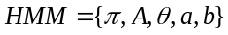
Where ; ; 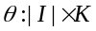; ; . K represents the number of hidden states. 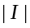 is the number of items.

Step 2: Initialize the parameters of HMM:
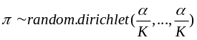
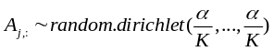
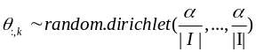
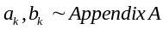

Step 3: Expectation Step
a. Calculate the emission probability.
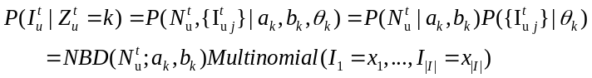
b. Calculate 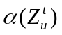 via one forward pass over the data sequence.
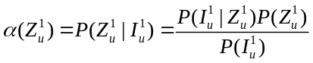
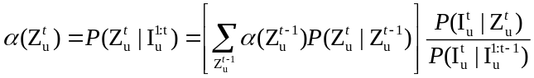
c. Calculate 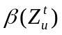 in the backward direction over the data sequence.
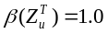
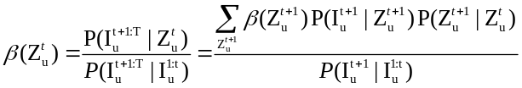
d. Calculate the posterior distribution.
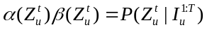
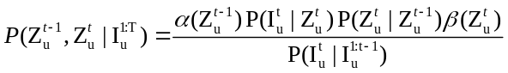

Step 4: Maximization Step
a. Calculate the paramters by the MAPs.
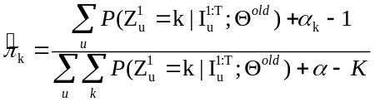
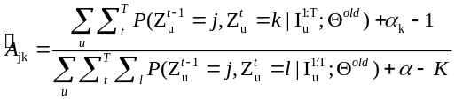
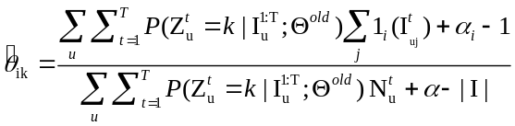
b. Calculate the parameters a and b in NBD (Appendix A).
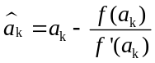
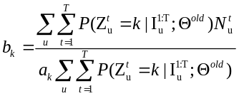

Step 5. Calculate the expected log likelihood:
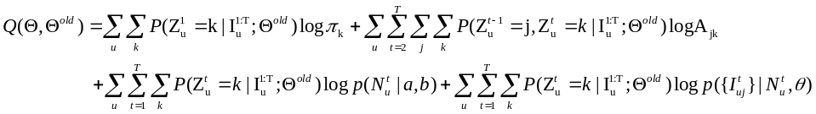

Step 6. Perform steps 4 to steps 5 until reaching convergence or the specified number of iterations T.

Step 7. Prediction and recommendation
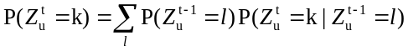

Experiments on last.fm dataset
We partition this dataset with a fixed time period (month, week or day). The dataset range from 1 +k*0 to d+k*0 time periods are used for training, and the dataset in the (d+k*0+1)’th time period for testing. Then the dataset range from 1+k*1 to d+k*1 time periods are used for training, and the dataset in the (d+k*1+1)’th time period for testing, and so on. The number of training and testing is N.
This dataset span 54 months. When the fixed time period is month, d is equal to 30, k is 1 and N is equal to 24. That is to say, the dataset range from 1 to 30 time periods are used for training, and the dataset in the 31 time period for testing. Then the dataset range from 2 to 31 time periods are used for training, and the dataset in the 32nd time period for tesing, and so on.
Algorithms | Top5 |  |  | Top10
 | P | R | F | P | R | F
Artists listened to by >100 users included |  |  |  | 964 users and 1345 artists
HMM* (K=30) | 0.0373 | 0.0230 | 0.0285 | 0.0329 | 0.0406 | 0.0364
User-User Similarity | 0.0556 | 0.0299 | 0.0389 | 0.0496 | 0.0534 | 0.0514
Artists listened to by >200 users included |  |  |  | 972 users and 466 artists
HMM*(K=30) | 0.0387 | 0.0490 | 0.0433 | 0.0347 | 0.0877 | 0.0497
User-User Similarity | 0.0476 | 0.0590 | 0.0527 | 0.0429 | 0.1063 | 0.0612

Appendix A
Negative Binomial Distri bution (NBD) was introduced to model the number of items.
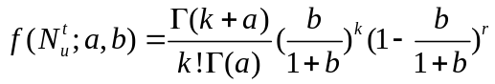
The log-likelihood function can be expressed
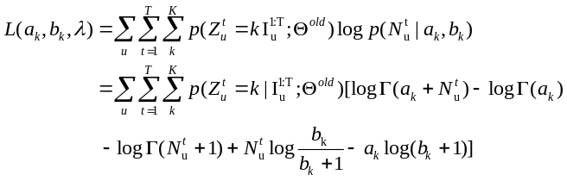
We take the partial derivatives with respect to r and p and set them equal to zero:
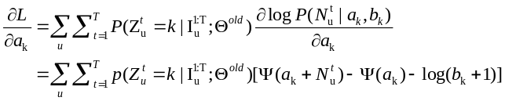
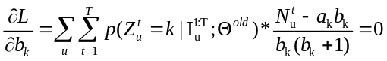
where 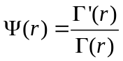 is the digamma function.
We can get
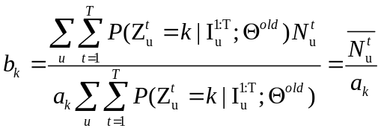
where 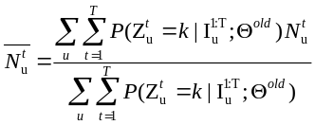

Substituting this in the equation (1.3) gives:
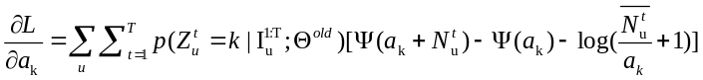

This equation cannot be solved in closed form. Newton’s method is used to get the numerical solution.
Assume
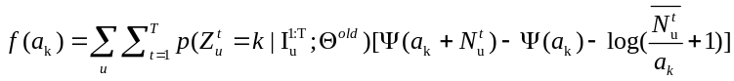
Its derivative:
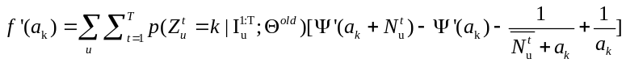

The process is repeated as
