ECPM PHASE 2 THE GIST
The Gist: The Routing Environment from Zero
Efe Bekteş
Why we built it, how every part works, and what happens next.
Repo: github.com/itu-itis25-bektes23/ecpm

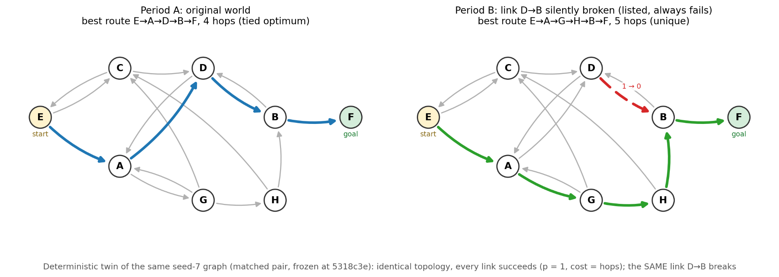
This document assumes no background, neither in the research area nor in the project. Each section first explains why a choice was made, then how it works, and ties it back to the one question the whole project is trying to answer. Every figure has a short setup before it and a takeaway after it, so the text around the pictures carries the full argument on its own.

1. The aim: does the model build a map, or memorize a path?
Large language models read text about environments, for example logs of a game or records of a network, and afterwards they often answer questions about those environments correctly. The problem is that two very different mechanisms can produce those correct answers. The first is a genuine internal model of how the environment works, usually called a world model: the model has effectively reconstructed the map. The second is memorization: the model has stored one familiar sequence of events and replays it. As long as nothing in the environment changes, the two are indistinguishable from the outside, because both reproduce the data they were shown.
That is our aim: to build a test that tells these two mechanisms apart. The key insight is that they come apart the moment the world changes. A memorizer keeps replaying the old sequence even after it stops working. A model holder notices the mismatch, identifies what changed, keeps the rest of its knowledge intact, and produces a new plan. So the decisive experiment is an intervention: change one rule of the world secretly, then measure four abilities separately. Does the model notice that something changed? Can it point to exactly what changed? Does it preserve its correct knowledge about everything that did not change? And does it adapt its plan?
Takeaway: a static test cannot separate understanding from memorization, because both explain the observed data equally well. Only a change in the world separates them. Every design choice in the rest of this document exists to make that intervention clean, fair, and measurable.

2. Why this world: a small network of eight nodes
First the vocabulary, because it is short. A node is a location. A link is a one way connection between two locations. Each link has a success probability: how often a send along it actually works. A packet starts at one node and tries to reach a designated goal node. At every node the acting agent picks one outgoing link, each attempt costs one unit, and a failed attempt leaves the packet where it was, ready to retry. Formally this is a Markov Decision Process, a standard mathematical setup for sequential decisions where the next situation depends only on the current one. The name matters only because it means the mathematics is textbook material rather than something we invented.
Why a synthetic world instead of a real dataset? Two reasons. Contamination: a pretrained language model may already have seen real maps, games, and networks during training, so success on them would not prove that it learned anything from our data. A randomly generated world guarantees that the only possible source of knowledge is the logs we show. Ground truth: because we generate the world, we hold a complete answer key at all times, including the exact best route and its exact cost, so grading never involves guesswork.
Why exactly eight nodes? It is a balance. The world must be large enough to contain genuinely different alternative routes and meaningful statistics, otherwise there is nothing to learn and nothing to replan. It must be small enough that a fair amount of evidence fits into a prompt and the results stay interpretable. Eight nodes with about fifteen links sits in that band. One structural rule is enforced during generation: every node except the goal has at least two outgoing links. Without it, breaking a link could leave no alternative at all, and the question we care about, does the model find the other way, would sometimes have no answer.
Why the packet routing story specifically? The PI feedback asked us to frame the graph as a resource allocation or network problem and to ground it in existing literature instead of inventing a toy. Two classic papers supply exactly this setting: Bertsekas and Tsitsiklis (1991) analyze this class of problems, called stochastic shortest paths, and Boyan and Littman (1994) study packet routing under changing links, which is precisely our intervention. The framing also brings a large practical bonus. Because a failed send keeps the packet in place, crossing a link takes on average 1 divided by p attempts. That turns the search for the best route into an ordinary shortest path computation, solvable exactly with Dijkstra's algorithm. We get the perfect baseline for free, with no training and no approximation. The figure below is the actual generated world used in our examples.
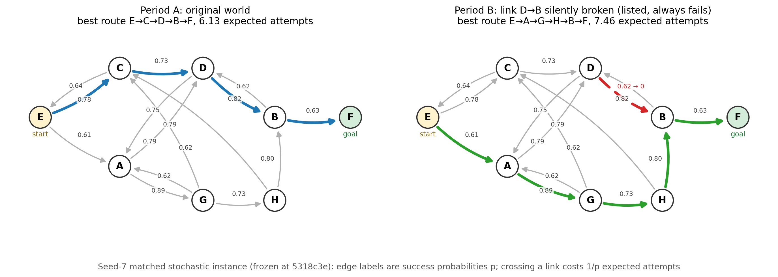
Takeaway: the packet starts at E and wants to reach F. The old best route was E, C, D, B, F, costing 6.13 expected attempts. The red dashed link from D to B has been silently broken: it is still listed as a choice, it just always fails now. A packet that keeps trying it never arrives, so the true best route detours through A, G, and H, at 7.46 expected attempts. Nothing announces this change. Discovering it from repeated failures is the entire test.

3. What the model sees, and why we control it so tightly
The model never sees the map. It sees only logs of attempts, because the aim is learning from experience, not reading a specification. But if the evidence were collected carelessly, a failure of the model could always be excused: maybe it simply never saw enough about the part that mattered. To remove that excuse, the data collection is balanced. Every state and action pair, meaning every link at every node, is attempted at least k times before the change and at least k times after it, with episodes starting from random nodes so every corner of the world is genuinely visited. The counts are recorded, so the balance can be verified by anyone.
One more control: the actions carry opaque labels. If the action at node C were called go to D, then reading the label would replace learning, and prior knowledge of English would leak into the result. Instead the actions are called a1, a2, and so on, assigned in shuffled order, so the only way to know where a button leads is to have watched what happened when it was pressed.
Finally, the same collected events are rendered in five different formats. This serves a second question of the project: does the way information is presented change how well the model learns from it? Comparing a shuffled pile of atomic facts against ordered step by step trajectories is only fair if both contain exactly the same events, so all five renderings are generated from one shared log, shown below.
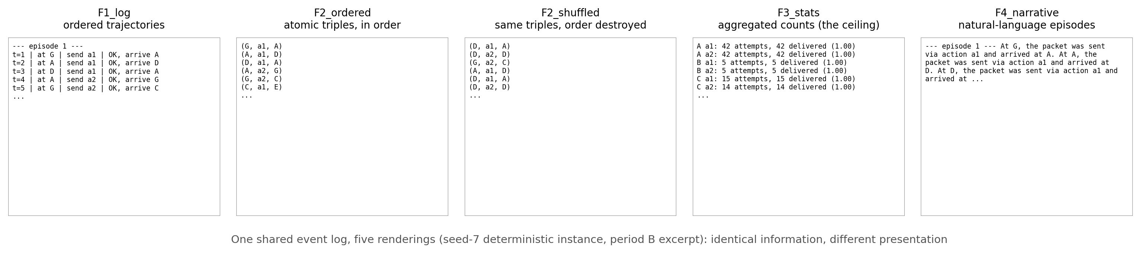
Takeaway: the raw log and the narrative preserve order and context, the shuffled triples destroy order while keeping every fact, and the aggregated statistics hand the finished world model over directly, which makes that format a ceiling to compare against. Any performance difference between formats is therefore about presentation alone, because the underlying information is identical.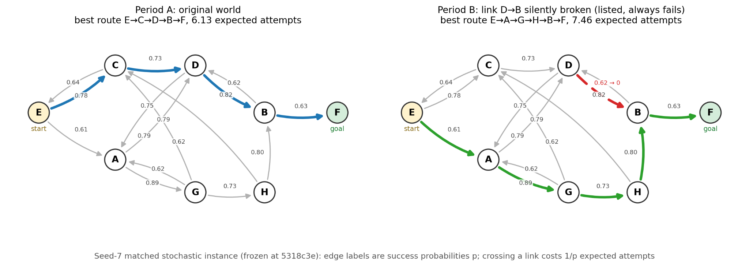

4. The experiment: change the world secretly
The mechanics are simple. We generate a world and freeze it: this is the world before, called M0. We copy it and apply exactly one change to the copy: this is the world after, called M1. The change is recorded in a hidden answer key that states which link changed, its old probability, its new probability, and where it sat on the best route. The model sees balanced evidence from both worlds and is asked the four questions from section 1. The evaluator grades the answers against the key.
The change itself comes in five varieties, and each exists for a reason. The silent break is the main condition: the probability of one link on the best route drops to zero, but the link stays listed as a choice. This is the hardest and most informative case, because nothing signals the break and the model must infer it from repeated failures, which is exactly what separates a map holder from a memorizer. Hard removal is the easy control: the same link simply disappears from the menu of choices, so detection becomes trivial, and comparing the two calibrates how much of the difficulty comes from inference. The no change condition catches false alarms: a model that always cries change would score perfectly on detection without understanding anything, and this condition makes that strategy worthless. The irrelevant change degrades a link that is not on the best route: the correct plan stays exactly the same, which tests whether the model can localize precisely and stay calm instead of overreacting. Degradation weakens a link on the route without killing it, testing sensitivity to subtle change rather than only to catastrophe.
Two further safeguards. The broken link is chosen at random, but only among links whose break keeps the goal reachable, so the task is always replanning and never impossibility. And every random decision in the whole pipeline is driven by recorded seeds, so any instance can be regenerated exactly, by anyone, at any time.
Takeaway: with controls in both directions, a case where nothing changed and a case where something unimportant changed, a good score cannot be achieved by guessing or by always alarming. It can only come from actually tracking the world.

5. Grading: run the plan, never ask the model
Why not simply ask the model whether its new plan is good? Because of a result from the assigned reading on imperfect world models: a model can predict individual transitions quite well and still plan badly, since planning tends to exploit precisely the small errors in its learned picture of the world. Self assessment inherits those same errors. So every plan is judged by execution: we run it in the simulator and let reality decide.
The model can state its plan in two formats. A node list names the places in order, for example E, A, D, B, F. This is the harder and more revealing format, because the action labels are opaque, so naming destinations proves the model learned which action leads where. An action list names the buttons it would press, for example a2, a1, a2, a2, which matches exactly the vocabulary of the evidence and is therefore the more natural format. An action list is first translated into a node route, and from that point both formats flow through the same grader, shown below. It reports three numbers: whether the plan is valid at all, its exact expected cost, and its regret. Regret is the cost of the model's plan minus the cost of the perfect plan, so zero means the model planned perfectly and larger numbers measure exactly how much its mistake costs.
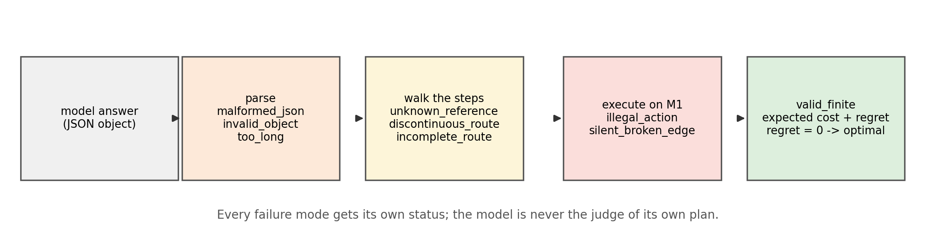
Takeaway: the model is never the judge of its own plan. This decision is now fixed: the frozen contract (Section 7 of INTERFACE.md, commit 5318c3e) adopts explicit state and action steps, at most 32 of them, which both proves the model learned where each button leads and stays in the vocabulary of the evidence. Any route whose regret is exactly zero counts as optimal, and every failure mode has its own status, so a malformed answer, an illegal action, a silently broken link, a discontinuous route, and an incomplete route are never conflated. The contract was part of the interface sign off, so the prompts and the grader agree on it before anything is run.

6. Why two difficulty levels
A failure in the full task could have two very different causes: the model could not reason about the structure of the world, or it could not handle statistical noise. To tell these apart, the benchmark runs at two levels that share the exact same map. In the deterministic level every link works every time, so a single failed attempt is complete proof of a break, and the only remaining challenge is the reasoning itself. This level acts as a capability gate: it is cheap to run, and a model that fails it has no business attempting the expensive version. The stochastic level is the real benchmark: links fail 5 to 40 percent of the time even when healthy, so a single drop proves nothing and the model must infer the break statistically, from the count of failures.
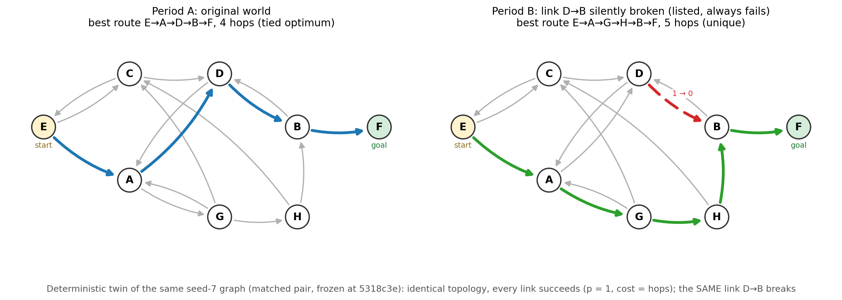
Takeaway: the two levels share identical topology for the same seed, and since the v2.1.1 freeze they are matched further: the same start, the same goal, and the same broken link (matched construction; 794 of 1,000 seeds are eligible). The best routes can still differ between the levels, but that residual difference is the uncertainty manipulation itself, so results are worded as a gap on matched anchors, with the same-route subset (652 of 794 seeds) reported as a robustness slice.

7. What happens next
The environment half of the project, everything described above, is implemented, tested, and published in the repository. The experiment half now begins, and it follows a fixed order because each step depends on the previous one. The answer formats and grading rules are now frozen in a written contract, signed off at commit 5318c3e after two independent review rounds, the file INTERFACE.md, so that the two halves of the team can work in parallel without breaking each other's code. Then the prompts are written: they render the collected evidence into text the model reads. Then the grader is built: it parses the model's answers and computes the metrics. Detection accuracy asks how often the model correctly says whether anything changed. Localization accuracy asks how often it names the exact link. Preservation checks its knowledge of the untouched links before and after. Regret measures the quality of its new plan, and broken link usage measures behavior directly: among visits to the broken node, how often does the model still choose the dead link. Then come the first model runs, across several model sizes, to see whether these abilities grow with scale.
After the first results, the plan widens. Many seeds and repetitions turn single demonstrations into statistics. The five evidence formats are compared to answer the presentation question from section 3. A route ranking analysis orders all possible routes once by the model's learned beliefs and once by the truth, measuring how expensive the model's preference errors actually are. External validation moves the same questions onto established benchmarks such as Manhattan taxi navigation, to show the findings are not an artifact of our world. And a second, even simpler deterministic environment, generated as random finite state machines, can serve as an independent capability gate.
Takeaway: everything in the Done column exists today and is reproducible from the repository. The interface contract is signed off, and the Next column has started: a pilot harness already runs the whole pipeline end to end in dry run, and the first real model calls wait only on API access. Every metric it will compute is already defined against the answer keys the environment produces.

8. Sizing the runs: compute, networks, and repetitions
A natural question once the environment exists: how much compute do the experiments need, and where does it actually go? The environment itself is essentially free. Generating a world, breaking a link, and running simulator rollouts is plain Python on a CPU, taking milliseconds, so simulator repetitions can number in the tens of thousands at no cost. The expensive unit is one language model call: every test instance means feeding a few thousand tokens of evidence into a model and reading its answers, and that is where the GPU budget goes. All sizing decisions below are therefore counted in model calls, not in simulations.
Why many networks instead of one? A result measured on a single graph measures that graph, not the ability: a particular topology can be accidentally easy or accidentally unfair. So the main run samples about 30 different graph seeds, and with five conditions per seed that gives 150 instances per sweep but only 30 independent networks, five repeated measurements per graph. The graph seed is therefore the unit of clustering: condition contrasts are computed within seed, and uncertainty is reported with seed clustered bootstrap intervals. The worst case 95 percent margin is about 17.9 percentage points for one cell of 30 seeds, and about 8.0 points for claims that legitimately pool across conditions. Why not repeat thousands of times instead? Precision grows only with the square root of the sample size, so pushing one cell from 30 seeds to 3,000 shrinks that margin from about 18 points to about 2, at a hundred times the cost. For a first paper that budget is far better spent on more cells: more seeds, all five conditions, several evidence formats, and several model sizes. Two further savings: running models at temperature zero makes one call per question sufficient, verified by a small repeat audit that is reported separately rather than folded into the bootstrap, and because every instance is regenerated exactly from recorded seeds, every model and every format can be shown literally identical instances, so comparisons are paired and reach significance with far fewer samples.
Phase | Design | Model calls | Purpose
Pilot | 5 seeds, deterministic, 2 formats | About 100 | Catch prompt and parser bugs
Main | 30 seeds, 5 conditions, 2 modes, 3 formats | 3,000 to 5,000 per model | Headline numbers with confidence margins
Ablations | Vary data budget k, network size, change draws | A few thousand | Learning curves and robustness

One thing deliberately not on this list is redesigning the network now. The baseline must come from the fixed eight node configuration that the interface freeze locks in; changing the design first would break the contract before it is ever used. The interesting variations come afterwards, one factor at a time: the data budget k per state and action pair, which produces the learning curve and is arguably the headline plot, the network size and density, and multiple change draws on the same graph, which separate variation within a map from variation between maps.
Takeaway: efficiency has three faces here. Performance is the five metrics of section 7 with confidence margins over seeds. Sample efficiency is those same metrics as a function of the data budget k. Compute efficiency is simply tokens per instance per model. The recipe is hundreds of instances per cell rather than thousands, one call each, paired across everything, and ablations only after the baseline exists.

