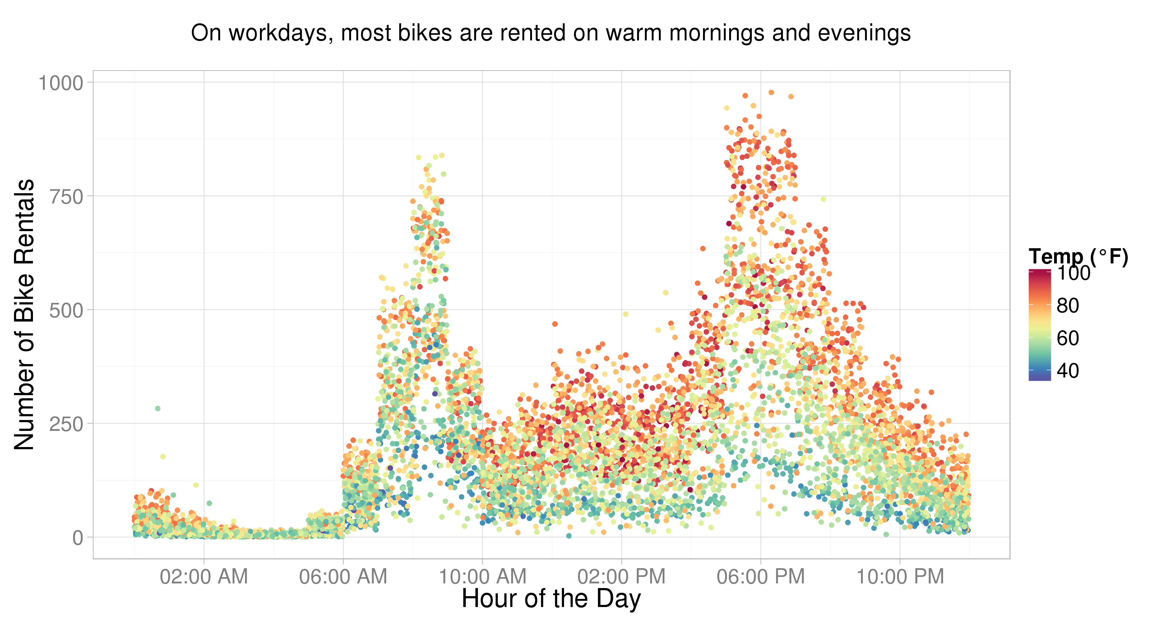
Benjamin Chen

The Premise
http://www.kaggle.com/c/bike-sharing-demand

“Bike sharing systems are a means of renting bicycles where the process of obtaining membership, rental, and bike return is automated via a network of kiosk locations throughout a city. Using these systems, people are able rent a bike from a one location and return it to a different place on an as-needed basis. Currently, there are over 500 bike-sharing programs around the world.
The data generated by these systems makes them attractive for researchers because the duration of travel, departure location, arrival location, and time elapsed is explicitly recorded. Bike sharing systems therefore function as a sensor network, which can be used for studying mobility in a city. In this competition, participants are asked to combine historical usage patterns with weather data in order to forecast bike rental demand in the Capital Bikeshare program in Washington, D.C.”
The Raw DataSet
The data columns were as follows: datetime, season, holiday, weekday or not, weather, temperature, “feels like” temperature, humidity, and windspeed, number of non-registered user rentals initiated, number of registered user rentals initiated and the number of total rentals.
Data Transformation
The data is split for analysis into a training set of the first 90% of the data, instead of randomly because the application is forecasting. Conforming to Google Prediction API input guidelines, the columns that are not the output nor in the training set (number of non-registered user rentals initiated and number of registered user rentals initiated) are removed.

Prediction Results
After going through the Google Prediction API,

Complications in the Process
bumping up to the API restrictions: rate limit, transparency
different process: wasted time trying to analyze results when I have no control over the analytics process (lower priority)
training takes a while

Further Work
Any further progress would be made on residual analysis with visualizations to fine-tune my data transformation process, and refining the code to be easier to use and configure.

