**MADT Lab #3**

**Calculator App**

You will need to use „Android Studio” IDE in order to create Calculator application. Application should meet the following requirements:

**Common part:**

1. Variables, functions and other elements should have meaningful names (e.g. *txtName* vs *EditText1*);
2. Code should follow ***Java***coding standards;

**Special part:**

1. Calculator GUI should look as follows:

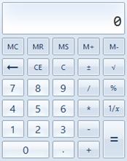

1. Application should implement following arithmetical operations: Sum, Subtraction, Multiplication, Division, Square Root.
2. Calculator should implement following operations: Back, Clear, Sigh change;
3. Button labels should be taken from resource file