Understanding Halal Awareness Among Hospitality and Tourism Students: A Pilot Survey Study
Salem Alhabshi
Florida International University

Abstract
This pilot study examines halal awareness among hospitality and tourism students using a survey instrument that measures self-reported familiarity, definitional knowledge, recognition of halal cues, menu-based scenario judgment, perceived relevance, and confidence. The final sample included 20 students, including 8 domestic U.S. students and 12 international students. Five knowledge items were scored using a rubric in which correct answers received 3 points, close to correct answers received 1 point, and incorrect or "I am not sure" responses received 0 points. The findings show that self-reported familiarity was generally high, yet objective knowledge was uneven. Only 5% of respondents selected the fully correct definition of halal food, although 65% chose a partially correct option. International students obtained higher mean knowledge scores (M = 8.67, SD = 2.67) than domestic U.S. students (M = 5.88, SD = 3.83), but the difference was not statistically significant in this small pilot sample, t(11.51) = 1.79, p = .100. The results suggest that halal familiarity does not always translate into accurate menu interpretation and that hospitality and tourism programs may benefit from stronger instruction on halal concepts, menu labeling, and service communication.
Keywords: halal awareness, hospitality and tourism students, menu recognition, cultural background, hospitality education

Introduction
The growth of halal hospitality and tourism has increased the importance of accurate halal knowledge in multicultural service environments. In hospitality and foodservice settings, halal often functions as a credence attribute: guests cannot always verify compliance directly, so they rely on menu descriptions, certification marks, ingredient transparency, and employee knowledge when making decisions (Adekunle & Filson, 2020). For that reason, halal is not only a religious and dietary issue, but also a communication and trust issue. In non-Muslim majority destinations, limited understanding of halal requirements can weaken guest confidence, create avoidable service barriers, and reduce the ability of hospitality businesses to serve Muslim travelers effectively (Jia & Zhang, 2021).
This issue is especially relevant in hospitality and tourism education because today’s students are tomorrow’s service professionals, supervisors, and menu decision makers. Research on hospitality education has shown that intercultural readiness, including cultural intelligence and communication competence, influences how students respond to diverse guest needs (Lee & Hwang, 2024; Liu et al., 2022). At the same time, halal hospitality scholarship has called for more research in underexplored populations and settings, particularly in non-Muslim majority contexts where halal understanding may be uneven or based on partial knowledge (Al-Ansi et al., 2023).
The present study addresses that gap through a survey of hospitality and tourism students. Rather than focusing only on whether students have heard the term halal, the survey measures several related dimensions: self-reported familiarity, knowledge of the correct definition, recognition of the most useful halal cue, menu-based judgment, perceived relevance of halal knowledge in the field, and confidence in identifying halal options. The purpose of the study is to examine how well hospitality and tourism students understand halal food and whether domestic U.S. and international students differ in their performance on these survey measures.

Literature Review
Existing research suggests that halal awareness cannot be reduced to simple familiarity with the term. It also includes definitional understanding, recognition of halal-related symbols, and the ability to distinguish permissible from non permissible food items. Yazawa and Kikuoka (2023) found that only a limited proportion of university students in Japan could clearly explain halal food, while many reported little or no knowledge. Their study is especially relevant because it measured understanding through recognition tasks rather than self report alone. Similarly, Rahman et al. (2022) treated halal awareness as a measurable construct and showed that awareness is connected to factors such as religious belief, attitudes, and halal certificate or logo cues.
A second stream of literature emphasizes that halal functions as a trust-based market signal. Adekunle and Filson (2020) argued that halal markets are shaped by information asymmetry because customers often cannot directly verify halal compliance and must instead rely on signals such as certification, labeling, and operational transparency. Anam et al. (2018) likewise showed that halal logos act as external cues that influence perceptions of product quality, while consumer knowledge affects how those cues are interpreted. Relatedly, the relevance of halal-related cues is not limited to Muslim consumers, as prior research has also examined non-Muslim consumers’ intention to purchase halal food products (Lim et al., 2022). In hospitality settings, this means that confusion about halal is not only a knowledge problem but also a service and communication problem.
A third theme concerns cultural background and intercultural readiness in hospitality education. Lee and Hwang (2024) found that among American hospitality students, ethnocentrism increased intercultural communication apprehension while cultural intelligence reduced it. Liu et al. (2022) also highlighted the need for culturally responsive training in hospitality education. In the halal context, Jia and Zhang (2021) showed that non-Muslim majority destinations often face knowledge based barriers when serving Muslim consumers, but these barriers can be reduced through better communication and service design.
Taken together, the literature suggests that halal understanding among students should be examined as a practical combination of food knowledge, cue recognition, and menu judgment rather than as simple name recognition. This perspective matches the design of the present survey, which tests whether students can define halal accurately, identify the most useful halal cue, respond to realistic menu scenarios, and reflect on the relevance of halal knowledge in hospitality and tourism settings.

Conceptual Basis and Hypothesis
This study does not use a formal behavioral theory such as the Theory of Planned Behavior because the survey instrument is designed to assess knowledge and recognition rather than attitudes, norms, perceived control, or behavioral intention. Instead, the study is grounded in a simpler conceptual basis drawn from two related ideas in the literature: consumer knowledge and intercultural readiness. Consumer knowledge research argues that understanding should be viewed as expertise rather than simple familiarity, because accurate knowledge improves judgment and interpretation (Alba & Hutchinson, 1987). In hospitality education, intercultural readiness literature suggests that students with broader cross-cultural exposure may be better prepared to interpret diverse guest needs and service cues (Lee & Hwang, 2024; Liu et al., 2022).
Applied to halal food, this means that students who have had greater cultural exposure to halal concepts may be better able to define halal, identify reliable halal indicators, and avoid incorrect assumptions based only on item names or the absence of pork. Because international students often come from more culturally varied food environments and may have had greater prior exposure to halal concepts, the survey was designed to compare domestic U.S. and international students on objective knowledge items.
H1: International hospitality and tourism students will demonstrate higher halal knowledge and more accurate menu recognition than domestic U.S. students.

Methods
The study used a quantitative cross-sectional survey design. The survey was distributed as a convenience sample through university email, university WhatsApp groups, and peer sharing among students in the major, and participation was voluntary. The instrument was developed for hospitality and tourism students and contained nine items. Question 1 identified student status as domestic U.S. or international. Question 2 measured self-reported familiarity with the term halal. Questions 3 through 7 assessed objective knowledge through multiple choice items on the meaning of halal food, the most useful source for identifying halal items, and three menu-based scenarios involving a beef burger without bacon, a chicken burger, and seafood pasta. Questions 8 and 9 measured perceived relevance and self confidence using five point response scales.
The final dataset included 20 responses: 8 domestic U.S. students and 12 international students. Consistent with the study rubric, only Questions 3 through 7 were scored. Correct responses received 3 points, close to correct responses received 1 point, and incorrect or "I am not sure" responses received 0 points. This produced a possible knowledge score range of 0 to 15. Descriptive statistics were used to summarize item level patterns, and a Welch independent samples t-test was used to compare total knowledge scores between domestic U.S. and international students.
The scoring approach is important because several items were intentionally designed to distinguish fully correct understanding from limited but relevant understanding. For example, selecting "Answers A & B" for the definition item reflected partial recognition that halal involves dietary rules and the avoidance of pork or alcohol, but it did not demonstrate the most accurate definition. Likewise, selecting "It is halal" for some menu scenarios reflected a plausible but incomplete interpretation when the stronger answer was that more information was needed.
The scoring approach in this study reflects a conservative, service-oriented interpretation of halal identification in hospitality settings. Rather than treating uncertified meat items as halal based on broader assumptions, the survey prioritized verifiable cues such as halal certification or halal labeling. Under this approach, menu items such as a beef burger without bacon or a chicken burger were scored as requiring more information rather than being automatically classified as halal. This decision was intended to reflect the safest and most operationally reliable standard for hospitality and tourism practice, where staff and managers must communicate menu information in a way that minimizes ambiguity for diverse Muslim guests. This approach does not attempt to resolve theological differences in halal interpretation. Instead, it adopts a cautious classification standard suitable for menu communication and guest service contexts.

Results
Self reported familiarity with halal was relatively high. Overall, 65% of respondents described themselves as very familiar with the term, while only one respondent reported not being familiar at all. Students also generally agreed that knowledge of halal dietary needs is relevant in hospitality and tourism settings (overall M = 4.35 out of 5, SD = 0.93), although confidence in identifying halal menu options was more moderate (overall M = 3.65, SD = 1.14).
Objective knowledge results showed a more uneven pattern. On the definition item, only 5% of respondents selected the fully correct answer, while 65% selected the close to correct option. Sixty percent correctly identified halal certification or halal labeling as the most useful source for determining whether a food item is halal. For the menu scenarios, 45% correctly answered that more information was needed for a beef burger without bacon, 30% correctly answered that more information was needed for a chicken burger, and 50% correctly identified seafood pasta as halal under the study rubric.
The total knowledge score for the full sample averaged 7.55 out of 15 (SD = 3.39). International students obtained a higher mean knowledge score (M = 8.67, SD = 2.67) than domestic U.S. students (M = 5.88, SD = 3.83), as shown in Figure 1. A Welch independent samples t-test showed that this difference did not reach statistical significance in the present pilot sample, t(11.51) = 1.79, p = .100, although the effect size was large (Cohen's d = 0.88). Thus, the observed pattern was in the expected direction, but H1 was not statistically supported at conventional levels.
At the item level, international students also outperformed domestic U.S. students on most knowledge items, especially the definition of halal and the beef burger scenario, as illustrated in Figure 2. However, both groups showed confusion on some menu-based items, particularly the chicken burger scenario, where many respondents chose the close to correct response "It is halal" instead of the stronger answer that more information was needed.
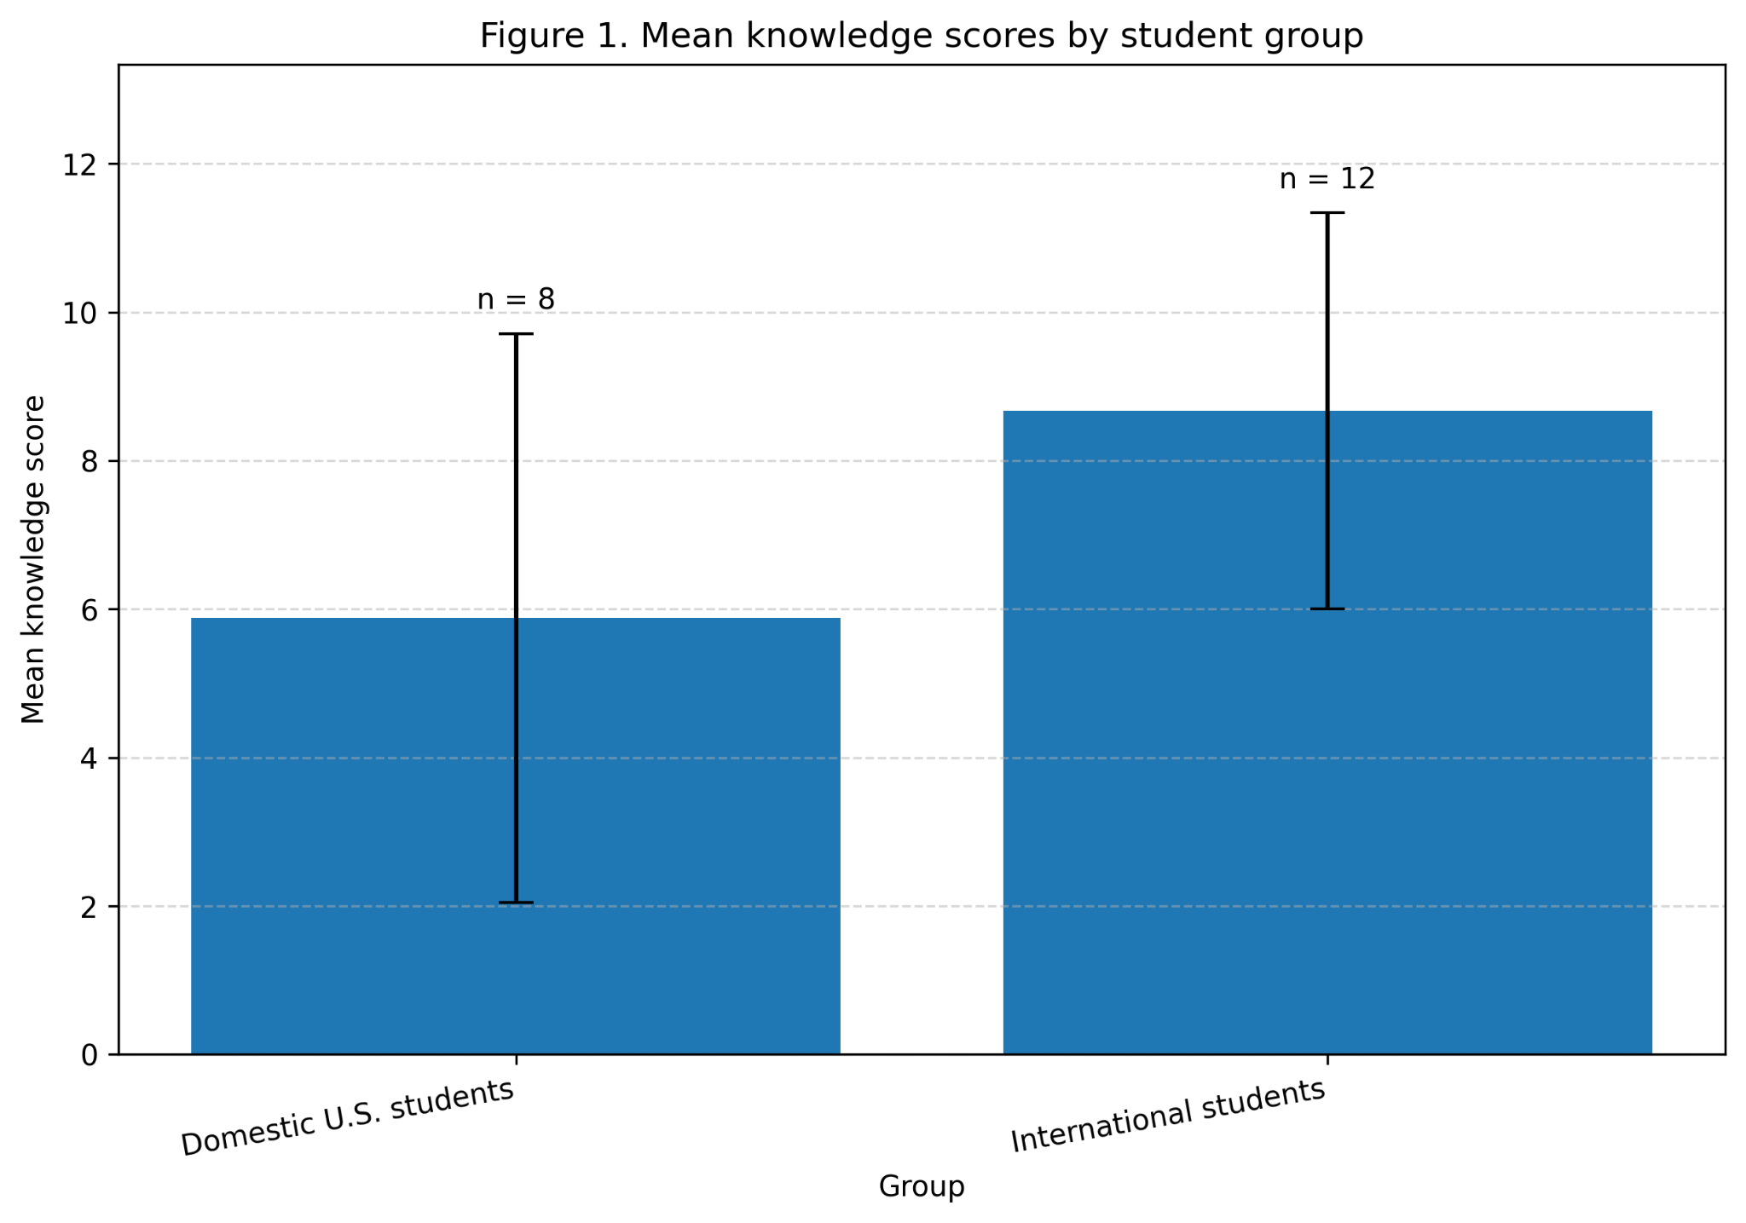
Note. Error bars represent ±1 standard deviation. Sample sizes are shown above the bars.

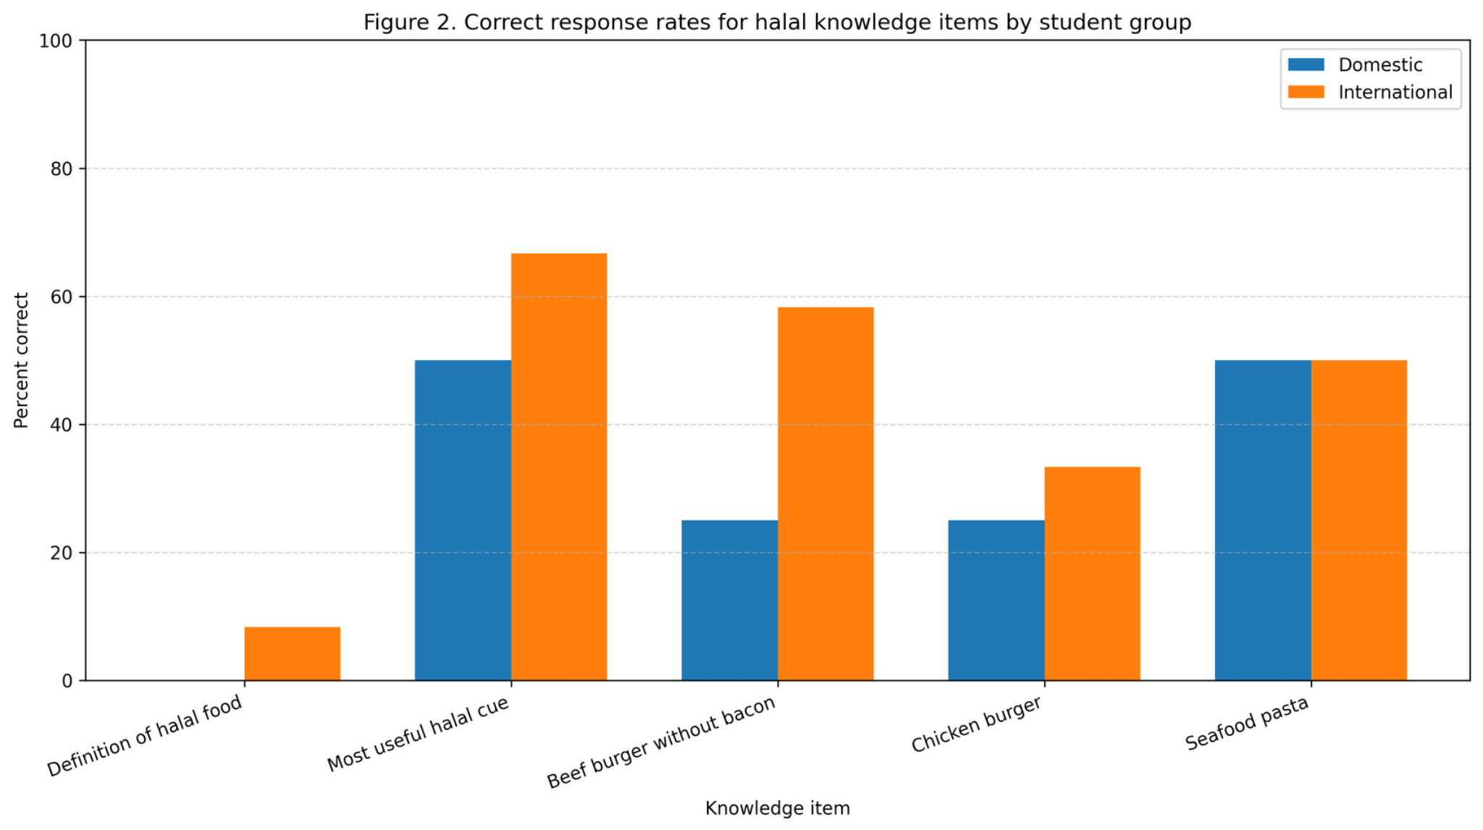
Note. Percentages reflect fully correct responses only for Questions 3 to 7 under the study rubric.

Discussion
The results suggest that halal awareness among hospitality and tourism students is uneven rather than uniformly strong. The high level of self-reported familiarity did not fully translate into accurate performance on the objective items, which supports the view that familiarity and knowledge should not be treated as the same construct. This pattern is consistent with previous studies showing that halal understanding among students may be partial, recognition based, and shaped by prior exposure rather than complete conceptual understanding (Rahman et al., 2022; Yazawa & Kikuoka, 2023).
The strongest finding is that respondents were often better at recognizing a partially correct answer than a fully correct one. For example, most respondents understood that halal involves more than a random food preference, yet only one respondent selected the most accurate definition. Likewise, many students chose plausible but incomplete answers in the menu scenarios. This matters in hospitality practice because employees may feel generally familiar with halal while still making incorrect assumptions at the point of service.
The group comparison also points in an important direction. International students obtained higher knowledge scores on average, but the pilot sample was too small to confirm a statistically significant difference. Even so, the descriptive pattern is consistent with the study’s conceptual expectation that greater cultural exposure may support stronger halal knowledge and menu recognition. Future research with a larger sample should test this relationship more rigorously and include additional background variables such as religion, prior exposure to halal dining, and work experience in foodservice.
One possible explanation is that some international respondents who did not select “very familiar” may have been non-Muslim students. If so, their stronger performance on the knowledge and menu recognition items may suggest that practical exposure or cross-cultural experience can support halal understanding even when self-reported familiarity is not especially high. However, religion was not measured in the survey, so this interpretation remains speculative and should be treated with caution.
For hospitality and tourism education, the practical implication is straightforward: halal should not be presented only as a vague cultural term. Students would benefit from concrete training on what halal means, why certification matters, when menu wording is insufficient, and how menu design and service communication can more clearly signal inclusion and reduce ambiguity when additional information is needed (Norris et al., 2026). These lessons are directly relevant to menu design, guest trust, and inclusive service in multicultural destinations.

Conclusion
This study examined halal awareness among hospitality and tourism students using a survey instrument aligned with practical foodservice scenarios. The paper treats halal awareness as a combination of familiarity, definitional knowledge, cue recognition, menu-based judgment, perceived relevance, and confidence. The survey results show that students generally recognize the importance of halal knowledge in hospitality and tourism, but their objective understanding is less consistent.
International students performed better on average than domestic U.S. students, although the difference was not statistically significant in this small pilot sample. More importantly, the results show that self-reported familiarity alone is not enough to judge halal competence. Hospitality and tourism programs should therefore strengthen instruction on halal concepts, menu transparency, and service communication so that future professionals can respond more accurately and more confidently to Muslim guest needs.
The study is limited by its convenience sample, modest size, and the use of a single survey instrument. In addition, the scoring rubric was developed specifically for this pilot study and was not previously validated. Nevertheless, it offers a useful starting point for future research and provides preliminary evidence that halal knowledge deserves more explicit attention in hospitality and tourism education.

References
Adekunle, B., & Filson, G. (2020). Understanding halal food market: Resolving asymmetric information. Food Ethics, 5, Article 13. https://doi.org/10.1007/s41055-020-00072-7
Al-Ansi, A., Olya, H. G. T., & Han, H. (2023). Two decades of research on halal hospitality and tourism: A review and research agenda. International Journal of Contemporary Hospitality Management, 35(6), 2017–2055. https://doi.org/10.1108/IJCHM-12-2021-1515
Alba, J. W., & Hutchinson, J. W. (1987). Dimensions of consumer expertise. Journal of Consumer Research, 13(4), 411–454. https://doi.org/10.1086/209080
Anam, J., Sany Sanuri, B. M. M., & Ismail, B. L. O. (2018). Conceptualizing the relation between halal logo, perceived product quality and the role of consumer knowledge. Journal of Islamic Marketing, 9(4), 727–746. https://doi.org/10.1108/JIMA-02-2017-0019
Jia, X., & Zhang, C. (2021). Turning impediment into attraction: A supplier perspective on halal food in non-Islamic destinations. Journal of Destination Marketing & Management, 19, 100517. https://doi.org/10.1016/j.jdmm.2020.100517
Lee, J., & Hwang, J. (2024). Antecedents of American hospitality students’ intercultural communication apprehension: Effect of ethnocentrism, cultural intelligence and core self-evaluations. Journal of Hospitality, Leisure, Sport & Tourism Education, 34, 100464. https://doi.org/10.1016/j.jhlste.2023.100464
Lim, Y. H., Lada, S., Ullah, R., & Abdul Adis, A. A. (2022). Non-Muslim consumers’ intention to purchase halal food products in Malaysia. Journal of Islamic Marketing, 13(3), 586–607. https://doi.org/10.1108/JIMA-06-2020-0172
Liu, Y., Liu, J., & King, B. (2022). Intercultural communicative competence: Hospitality industry and education perspectives. Journal of Hospitality, Leisure, Sport & Tourism Education, 30, 100371. https://doi.org/10.1016/j.jhlste.2022.100371
Norris, C. L., Slevitch, L., Bauman, M. J., Park, S., Lee, J., & Gamor, E. (2026). A seat at the table: Designing menus that signal inclusion. International Journal of Hospitality Management, 133, 104425. https://doi.org/10.1016/j.ijhm.2025.104425
Rahman, F. B. A., Osman, S., Ismail, F. H. I., Azman, A., Termizi, N. A., & Dahri, S. Z. (2022). The implementation of halal food awareness among undergraduate students. Journal of Tourism, Hospitality & Culinary Arts, 14(1), 335–347. https://fhtm.uitm.edu.my/images/jthca/Vol14Issue1/Chap_26.pdf
Yazawa, A., & Kikuoka, T. (2023). Knowledge of halal foods by university students enrolled in a dietitian training course in Japan. Journal of Hospitality & Tourism Education, 35(2), 179–186. https://doi.org/10.1080/10963758.2021.1963741

