

UnduFin-FSI v5
Report date | Oct 1, 2020 8:16:02 PM

Contents
1. Global Definitions
1.1. Parameters
2. Component 1
2.1. Definitions
2.2. Geometry 1
2.3. Materials
2.4. Laminar Flow
2.5. Multibody Dynamics
2.6. Multiphysics
2.7. Mesh 1
3. Study 1
3.1. Time Dependent
3.2. Solver Configurations
4. Results
4.1. Datasets
4.2. Derived Values
4.3. Tables
4.4. Default Plots
4.5. Plot Groups

- Global Definitions
Date | Sep 30, 2020 11:33:29 PM

Global settings
Name | UnduFin-FSI v5.mph
Path | C:\Users\PC Mart\Documents\Thesis\Comsol\unduFin-FSI_v5.mph
Version | COMSOL Multiphysics 5.5 (Build: 359)
Unit system | SI

Used products
COMSOL Multiphysics
CAD Import Module
Multibody Dynamics Module

  - Parameters
Parameters 1
Name | Expression | Value | Description
H | 17.5 [cm] | 0.175 m | mebrane length
L | 20 [cm] | 0.2 m | link length
D | 14.6 [cm] | 0.146 m | length between two joints
hmin | 0 [cm] | 0 m | min mounting distance of mebrane
hmax | H + hmin | 0.175 m | max mounting distance of mebrane
A | 15 [degree] | 0.2618 rad | ampluitude
f | 1 [Hz] | 1 Hz | frequency
phi | 40[degree] | 0.69813 rad | phase shift
U | 0 [degree] | 0 rad | angular ofset
N | 3 | 3 | number of fin rays
ncycle | 4 | 4 | Number of loading cycles
tmax | ncycle/f | 4 s | Total loading time
tstep | 0.1/f | 0.1 s | Sampling time interval
mth | 3[mm] | 0.003 m
Lth | 3[mm] | 0.003 m | link thikness
Lw | 0.6 | 0.6 | link width

- Component 1
Date | Sep 30, 2020 11:09:54 PM

Settings
Description | Value
Unit system | Same as global system
Geometry shape order | Automatic

Spatial frame coordinates
First | Second | Third
x | y | z

Material frame coordinates
First | Second | Third
X | Y | Z

Geometry frame coordinates
First | Second | Third
Xg | Yg | Zg

Mesh frame coordinates
First | Second | Third
Xm | Ym | Zm

  - Definitions
    - Variables

Variables 1
Selection
Geometric entity level | Entire model

Name | Expression | Unit | Description
th1 | q1(t) | rad | link 1 rotation
th2 | q1(t) | rad | link 2 rotation
th3 | q1(t) | rad | link 3 rotation
un_soild | fsip1.u_solid*(nX) + fsip1.v_solid*(nY) + fsip1.w_solid*(nZ) | m

    - Functions

joint1
Function name | q1
Function type | Analytic

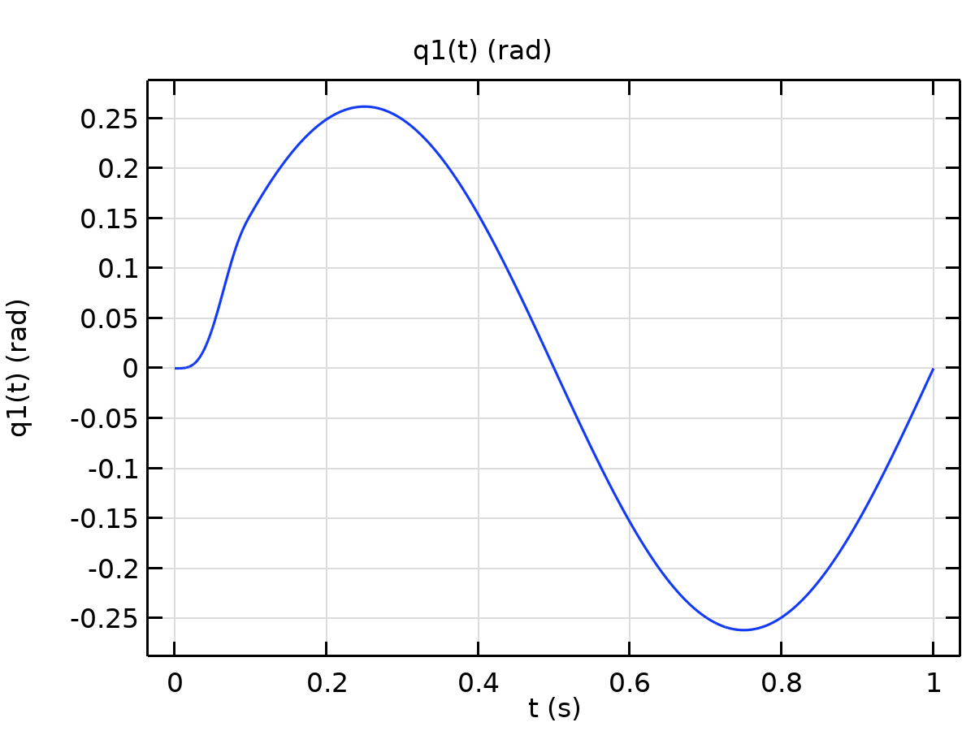
joint1
Definition
Description | Value
Expression | A*sin(2*pi*f*t*step1(t))
Arguments | t

Units
Description | Value
Arguments | s
Function | rad

Step 1
Function name | step1
Function type | Step

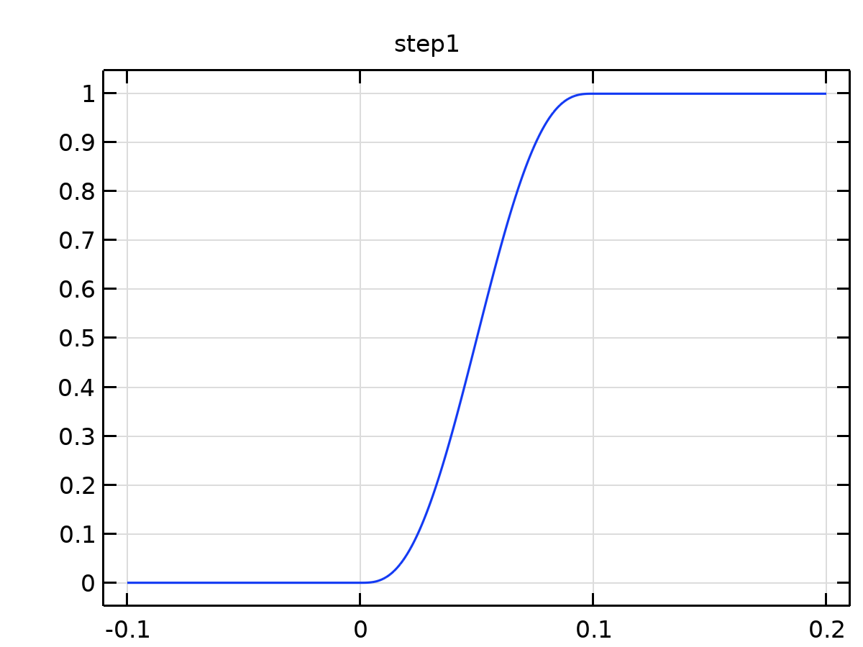
Step 1
Parameters
Description | Value
Location | 0.05
From | 0
To | 1

    - Selections

Fluid
Selection type
Explicit

Selection
Boundaries 10–23, 31–40, 43–46

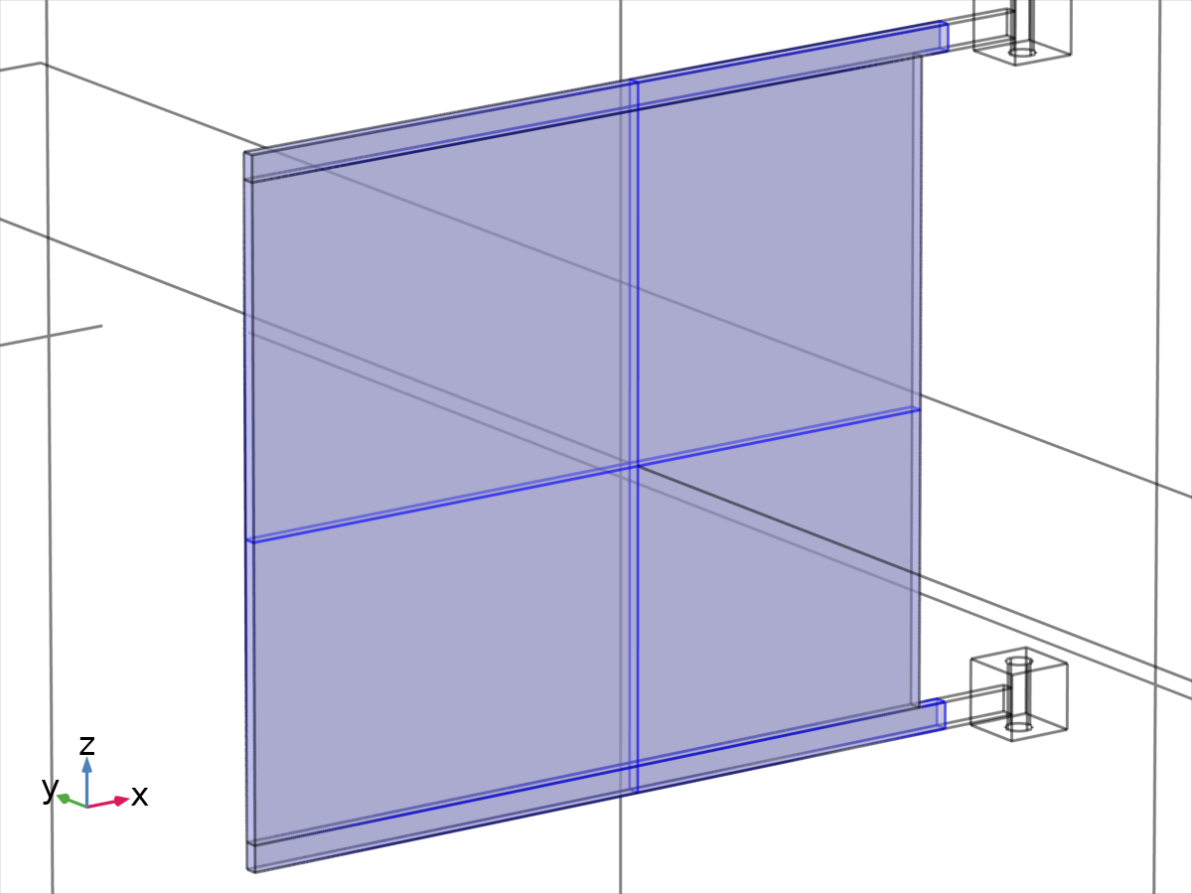
Fluid

Soild
Selection type
Explicit

Selection
Boundaries 49–53, 55–56, 58–64

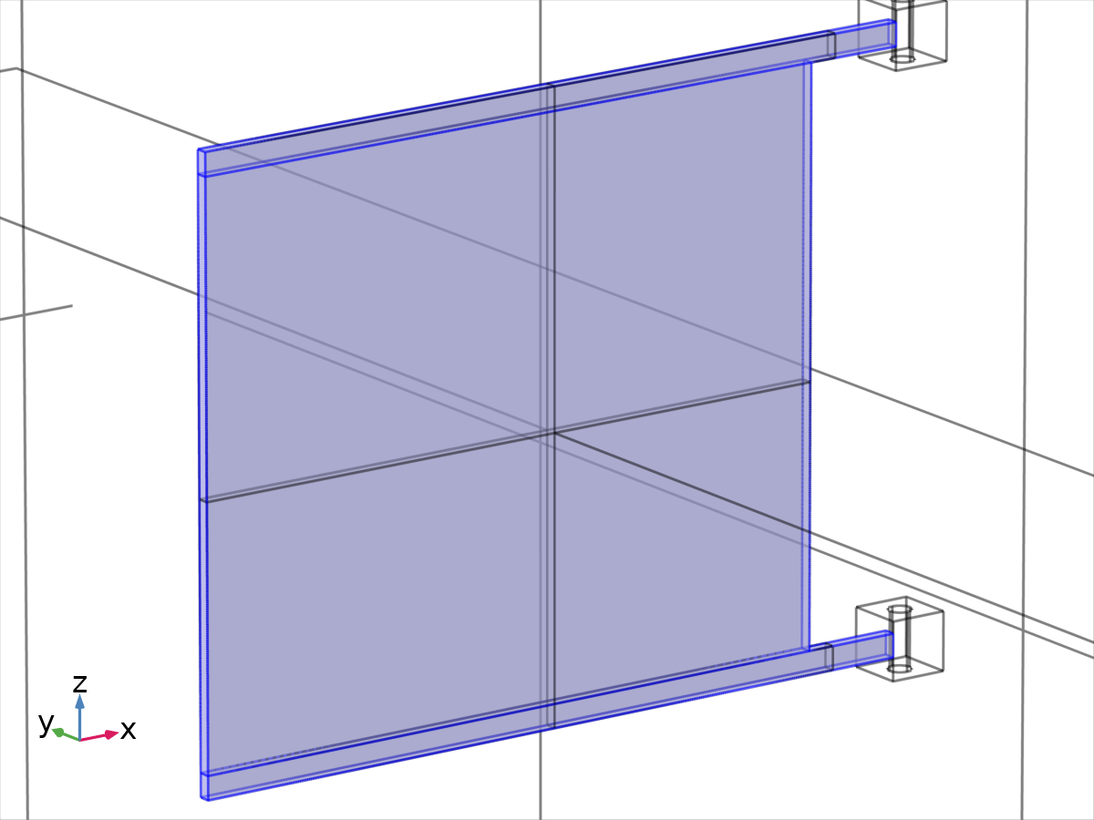
Soild

Explicit 1
Selection type
Explicit

Selection
Boundaries 65–67, 69, 75, 77–78, 81, 83, 85

Explicit props
Description | Value
Group by continuous tangent | On

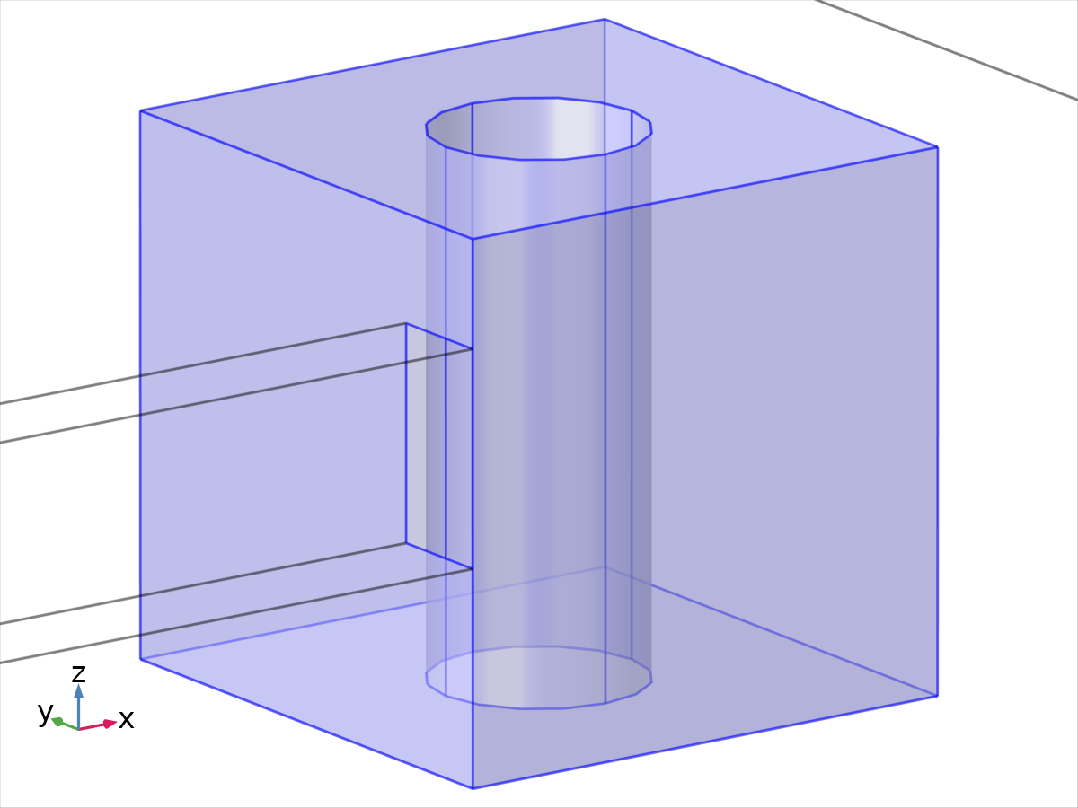
Explicit 1

Explicit 2
Selection type
Explicit

Selection
Boundaries 70–72, 74, 76, 79–80, 82, 84, 86

Explicit props
Description | Value
Group by continuous tangent | On

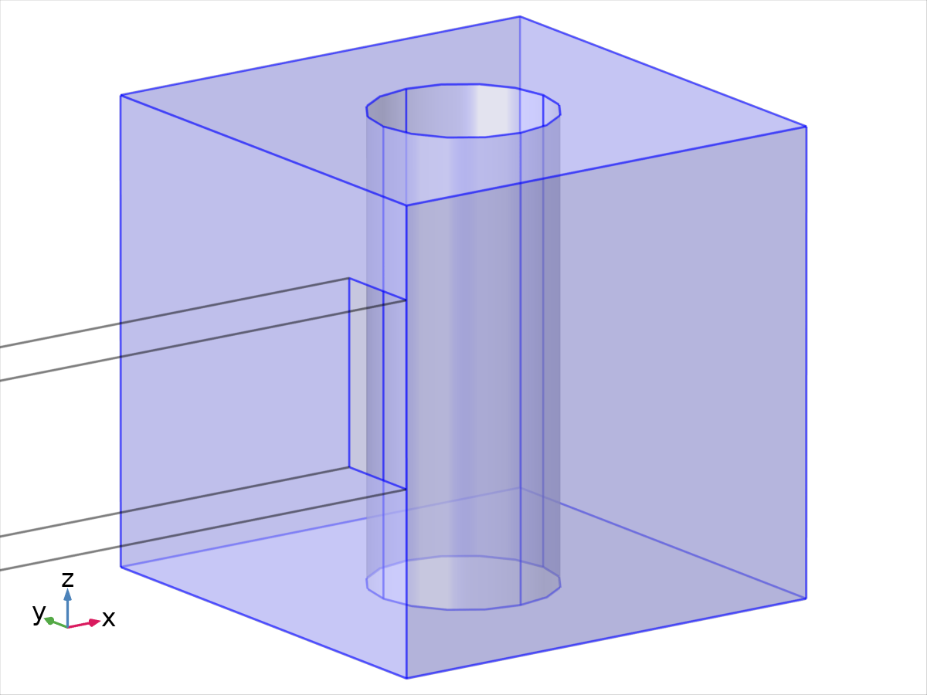
Explicit 2
    - Probes

Global Variable Probe 1
Probe type | Global variable probe

Expression
Description | Value
Expression | -intop1(spf.T_stressx)
Table and plot unit | N
Description | Fsway

Table and window settings
Description | Value
Output table
Plot window | Probe Plot 1

Global Variable Probe 2
Probe type | Global variable probe

Expression
Description | Value
Expression | -intop1(spf.T_stressy)
Table and plot unit | N
Description | Fheave

Table and window settings
Description | Value
Output table
Plot window | Probe Plot 1

Global Variable Probe 3
Probe type | Global variable probe

Expression
Description | Value
Expression | -intop1(spf.T_stressz)
Table and plot unit | N
Description | Fsurge

Table and window settings
Description | Value
Output table
Plot window | Probe Plot 1

    - Nonlocal Couplings

Integration 1
Coupling type | Integration
Operator name | intop1

Selection
Geometric entity level | Boundary
Name | Fluid
Selection | Named sel1: Geometry geom1: Dimension 2: Boundaries 10–23, 31–40, 43–46

Selection
    - Pairs

Identity Boundary Pair 1a
Pair type | Identity pair
Pair name | ap1

Source selection
Geometric entity level | Boundary
Selection | Geometry geom1: Dimension 2: Boundaries 10–23, 31–40, 43–46

Destination selection
Geometric entity level | Boundary
Selection | Geometry geom1: Dimension 2: Boundaries 49–53, 55–56, 58–64

Settings
Name | Value
Search method | fast
Extrapolation tolerance | 1e-4

Source selection
Destination selection
    - Coordinate Systems

Boundary System 1
Coordinate system type | Boundary system
Tag | sys1

Coordinate names
First | Second | Third
t1 | t2 | n

    - Moving Mesh

Deforming Domain 1
Tag | free1

Selection
Geometric entity level | Domain
Selection | Geometry geom1: Dimension 3: Domains 1–4

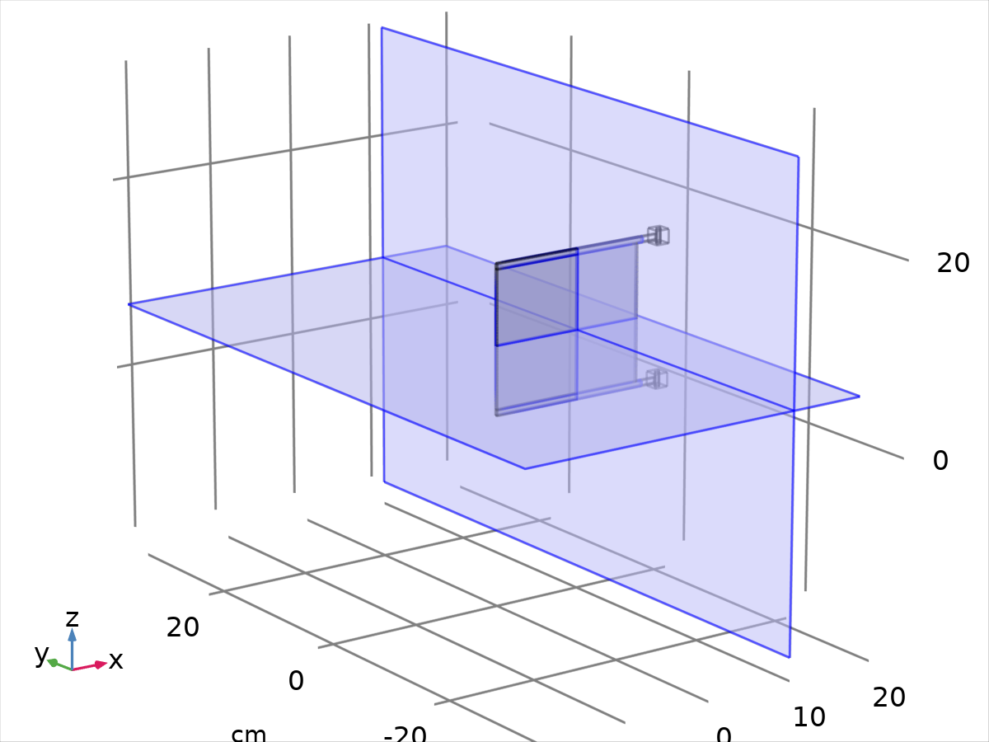
Selection
Initial deformation
Description | Value
Initial deformation | {0, 0, 0}

Prescribed Mesh Displacement 1
Tag | disp1

Selection
Geometric entity level | Boundary
Name | Fluid
Selection | Named sel1: Geometry geom1: Dimension 2: Boundaries 10–23, 31–40, 43–46

Selection
Prescribed mesh displacement
Description | Value
Prescribed mesh displacement | {fsip1.u_solid, fsip1.v_solid, fsip1.w_solid}

  - Geometry 1
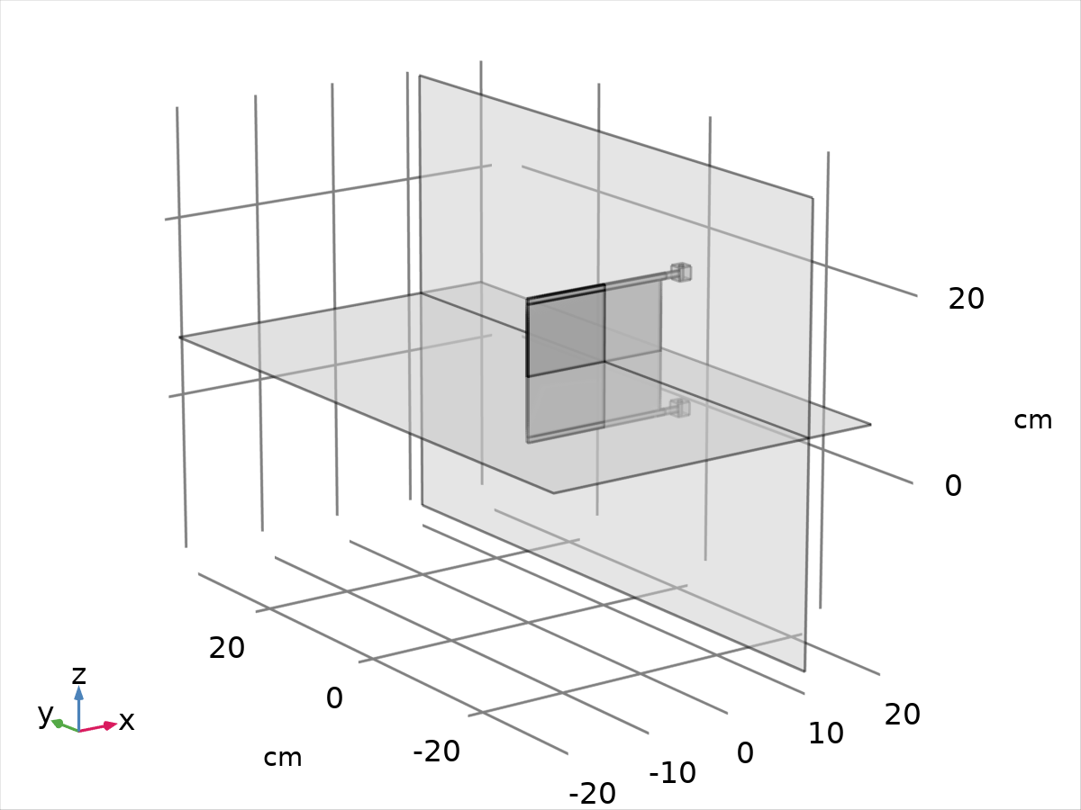
Geometry 1
Units
Length unit | cm
Angular unit | rad

Geometry statistics
Description | Value
Space dimension | 3
Number of domains | 9
Number of boundaries | 86
Number of edges | 180
Number of vertices | 104

    - link1 (blk1)
Position
Description | Value
Position | {0, 0, 0}

Axis
Description | Value
Axis type | z - axis

Size and shape
Description | Value
Width | L
Depth | Lth
Height | Lw

    - membrane1 (blk2)
Position
Description | Value
Position | {0, 0, Lw}

Axis
Description | Value
Axis type | z - axis

Size and shape
Description | Value
Width | H
Depth | mth
Height | D

    - link2 (blk3)
Position
Description | Value
Position | {0, 0, Lw + D}

Axis
Description | Value
Axis type | z - axis

Size and shape
Description | Value
Width | L
Depth | Lth
Height | Lw

    - membrane2 (blk4)
Position
Description | Value
Position | {0, 0, 2*Lw + D}

Axis
Description | Value
Axis type | z - axis

Size and shape
Description | Value
Width | H
Depth | mth
Height | D

    - link3 (blk5)
Position
Description | Value
Position | {0, 0, 2*Lw + 2*D}

Axis
Description | Value
Axis type | z - axis

Size and shape
Description | Value
Width | L
Depth | Lth
Height | Lw

    - Block 10 (blk6)
Position
Description | Value
Position | {L, 0, -Lw}

Axis
Description | Value
Axis type | z - axis

Size and shape
Description | Value
Width | 1.5
Depth | 1.5
Height | 1.5

    - Block 11 (blk7)
Position
Description | Value
Position | {L, 0, D}

Axis
Description | Value
Axis type | z - axis

Size and shape
Description | Value
Width | 1.5
Depth | 1.5
Height | 1.5

    - Block 12 (blk8)
Position
Description | Value
Position | {L, 0, 2*D + Lw}

Axis
Description | Value
Axis type | z - axis

Size and shape
Description | Value
Width | 1.5
Depth | 1.5
Height | 1.5

    - Cylinder 1 (cyl1)
Position
Description | Value
Position | {L + 0.75, 1.25*Lw, -1}

Axis
Description | Value
Axis type | z - axis

Size and shape
Description | Value
Radius | 0.3
Height | 2

    - Cylinder 2 (cyl2)
Position
Description | Value
Position | {L + 0.75, 1.25*Lw, D - 0.25}

Axis
Description | Value
Axis type | z - axis

Size and shape
Description | Value
Radius | 0.3
Height | 2

    - Cylinder 3 (cyl3)
Position
Description | Value
Position | {L + 0.75, 1.25*Lw, 2*D + 0.25}

Axis
Description | Value
Axis type | z - axis

Size and shape
Description | Value
Radius | 0.3
Height | 2

    - Copy 1 (copy1)
Settings
Description | Value
Keep input objects | On
x | 0
y | 0
z | 0

    - Block 6 (blk9)
Position
Description | Value
Position | {-0.09*L, 0, D/2}
Base | Center

Axis
Description | Value
Axis type | z - axis

Size and shape
Description | Value
Width | 2*L
Depth | 4*D + 3/4*D
Height | 2*L + 1/2*L

    - Work Plane 1 (wp1)
Plane definition
Description | Value
Plane | zy - plane

Unite objects
Description | Value
Unite objects | On

Plane Geometry (sequence2D)
    - Work Plane 2 (wp2)
Unite objects
Description | Value
Unite objects | On

Plane Geometry (sequence2D)
    - Partition Domains 1 (pard1)
Settings
Description | Value
Work plane

    - Partition Domains 2 (pard2)
Settings
Description | Value
Work plane

    - Form Assembly (fin)
Settings
Description | Value
Action | Form an assembly
Repair tolerance | Relative
Relative repair tolerance | 2.0E-10

    - Ignore Faces 1 (igf1)
Settings
Description | Value
Keep input for mesh control | On

  - Materials
    - Material 3
Material 3
Selection
Geometric entity level | Domain
Selection | Geometry geom1: Dimension 3: Domains 1–4

Material parameters
Name | Value | Unit
Density | 1022 | kg/m³
Dynamic viscosity | 1 | Pa·s

Basic Settings
Description | Value
Density | 1022
density_symmetry | 0
Dynamic viscosity | 1
dynamicviscosity_symmetry | 0

    - Material 4
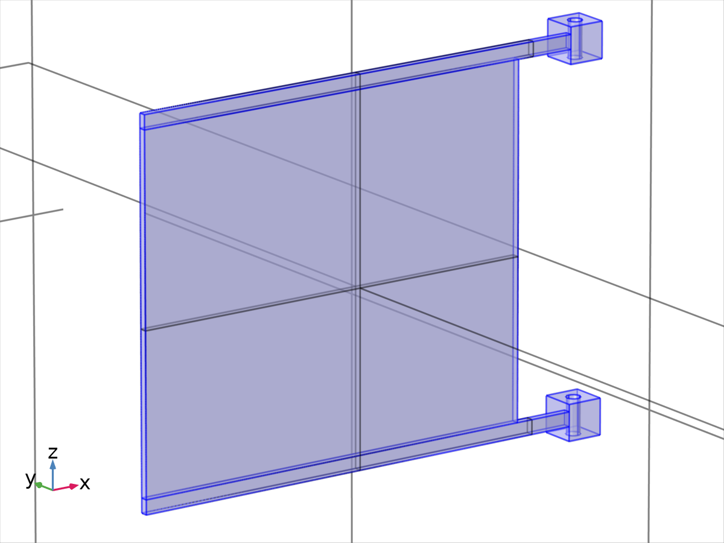
Material 4
Selection
Geometric entity level | Domain
Selection | Geometry geom1: Dimension 3: Domains 5–9

Material parameters
Name | Value | Unit
Density | 2780 | kg/m³
Young's modulus | 7.31e10 | Pa
Poisson's ratio | 0.33 | 1

Basic Settings
Description | Value
Density | 2780
density_symmetry | 0
Young's modulus | 7.31e10
youngsmodulus_symmetry | 0
Poisson's ratio | 0.33
poissonsratio_symmetry | 0

  - Laminar Flow
Used products
COMSOL Multiphysics

Laminar Flow
Selection
Geometric entity level | Domain
Selection | Geometry geom1: Dimension 3: Domains 1–4

Equations
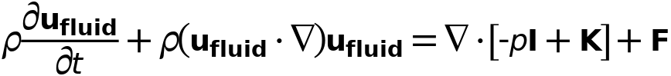
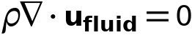
    - Interface settings

Discretization
Settings
Description | Value
Discretization of fluids | P1 + P1

Physical model
Settings
Description | Value
Neglect inertial term (Stokes flow) | Off
Compressibility | Incompressible flow
Enable porous media domains | Off
Include gravity | Off
Reference temperature | User defined
Reference temperature | 293.15[K]
Reference pressure level | 1[atm]

Turbulence
Settings
Description | Value
Turbulence model type | None

Consistent stabilization
Settings
Description | Value
Streamline diffusion | On
Crosswind diffusion | On
Use dynamic subgrid time scale | On

Inconsistent stabilization
Settings
Description | Value
Isotropic diffusion | Off

Advanced settings
Settings
Description | Value
Use pseudo time stepping for stationary equation form | Automatic from physics
CFL number expression | Automatic

    - Variables
Name | Expression | Unit | Description | Selection | Details
spf.usePseudoTimeStepping | 0 | 1 | Help variable | Global | + operation
spf.Tref | model.input.Tref | K | Reference temperature | Global | Meta
spf.dz | 1 | m | Thickness | Domains 1–4
spf.pref | 1[atm] | Pa | Reference pressure level | Domains 1–4
spf.pA | p+spf.pref | Pa | Absolute pressure | Domains 1–4
spf.hasWF | 0 |  | Help variable | Boundaries 1–5, 7–23, 25–26, 28, 30–48
spf.hasWF_u | 0 |  | Help variable | Boundaries 6, 24, 27, 29
spf.hasWF_d | 0 |  | Help variable | Boundaries 6, 24, 27, 29
spf.dt_CFL | 1/max(spf.maxOp(sqrt(emetric_spatial(u_fluid-d(x,TIME),v_fluid-d(y,TIME),w_fluid-d(z,TIME)))),eps) | s | Time step, CFL=1 | Global
spf.CFL_number | timestep/spf.dt_CFL |  | CFL number | Global
spf.localCFLvalue | 1.3^min(niterCMP,9)+if(niterCMP>=25,9*1.3^min(-25+niterCMP,9),0)+if(niterCMP>=45,90*1.3^min(-45+niterCMP,9),0) |  | Local CFL number | Domains 1–4
spf.locCFL | CFLCMP | 1 | Local CFL number | Domains 1–4
spf.geometryLengthScale | 0.10825000000000001 | m | Geometry length scale | Domains 1–4
spf.time_step_inv | max(sqrt(emetric_spatial(u_fluid,v_fluid,w_fluid)*2^gmg_level^2),spf.nu/spf.geometryLengthScale^2) | Hz | Inverse time step | Domains 1–4
spf.tsti | nojac(spf.time_step_inv/spf.locCFL) | 1/s | Help variable | Domains 1–4
spf.nx | nx | 1 | Normal vector, x component | Boundaries 6, 24, 27, 29
spf.ny | ny | 1 | Normal vector, y component | Boundaries 6, 24, 27, 29
spf.nz | nz | 1 | Normal vector, z component | Boundaries 6, 24, 27, 29
spf.nx | dnx | 1 | Normal vector, x component | Boundaries 1–5, 7–23, 25–26, 28, 30–48
spf.ny | dny | 1 | Normal vector, y component | Boundaries 1–5, 7–23, 25–26, 28, 30–48
spf.nz | dnz | 1 | Normal vector, z component | Boundaries 1–5, 7–23, 25–26, 28, 30–48
spf.nxmesh | nxmesh | 1 | Normal vector, x component | Boundaries 6, 24, 27, 29
spf.nymesh | nymesh | 1 | Normal vector, y component | Boundaries 6, 24, 27, 29
spf.nzmesh | nzmesh | 1 | Normal vector, z component | Boundaries 6, 24, 27, 29
spf.nxmesh | dnxmesh | 1 | Normal vector, x component | Boundaries 1–5, 7–23, 25–26, 28, 30–48
spf.nymesh | dnymesh | 1 | Normal vector, y component | Boundaries 1–5, 7–23, 25–26, 28, 30–48
spf.nzmesh | dnzmesh | 1 | Normal vector, z component | Boundaries 1–5, 7–23, 25–26, 28, 30–48

    - Fluid Properties 1
Fluid Properties 1
Selection
Geometric entity level | Domain
Selection | Geometry geom1: Dimension 3: All domains

Equations
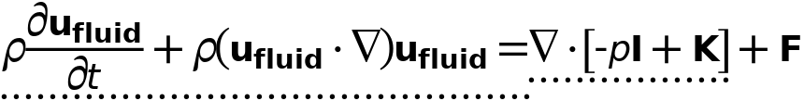
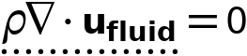
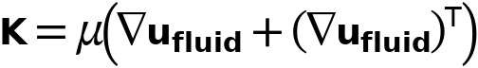

Fluid properties
Settings
Description | Value
Density | From material
 | Newtonian
Dynamic viscosity | From material

Properties from material
Property | Material | Property group
Density | Material 3 | Basic
Dynamic viscosity | Material 3 | Basic

Variables
Name | Expression | Unit | Description | Selection | Details
spf.mu | material.mu | Pa·s | Dynamic viscosity | Domains 1–4 | Meta
spf.rho | subst(material.rho,spf.fp1.minput_temperature,spf.Trho,spf.fp1.minput_pressure,spf.prho) | kg/m³ | Density | Domains 1–4 | Meta
u_fluidxt | u_fluidxTIME-u_fluidxx*d(x,TIME)-u_fluidxy*d(y,TIME)-u_fluidxz*d(z,TIME) | 1/s² | Gradient of u_fluid, x component, first time derivative | Domains 1–4
u_fluidyt | u_fluidyTIME-u_fluidyx*d(x,TIME)-u_fluidyy*d(y,TIME)-u_fluidyz*d(z,TIME) | 1/s² | Gradient of u_fluid, y component, first time derivative | Domains 1–4
u_fluidzt | u_fluidzTIME-u_fluidzx*d(x,TIME)-u_fluidzy*d(y,TIME)-u_fluidzz*d(z,TIME) | 1/s² | Gradient of u_fluid, z component, first time derivative | Domains 1–4
u_fluidxtt | d(u_fluidxTIME-u_fluidxx*d(x,TIME)-u_fluidxy*d(y,TIME)-u_fluidxz*d(z,TIME),TIME)-d(u_fluidxTIME-u_fluidxx*d(x,TIME)-u_fluidxy*d(y,TIME)-u_fluidxz*d(z,TIME),x)*d(x,TIME)-d(u_fluidxTIME-u_fluidxx*d(x,TIME)-u_fluidxy*d(y,TIME)-u_fluidxz*d(z,TIME),y)*d(y,TIME)-d(u_fluidxTIME-u_fluidxx*d(x,TIME)-u_fluidxy*d(y,TIME)-u_fluidxz*d(z,TIME),z)*d(z,TIME) | 1/s³ | Gradient of u_fluid, x component, second time derivative | Domains 1–4
u_fluidytt | d(u_fluidyTIME-u_fluidyx*d(x,TIME)-u_fluidyy*d(y,TIME)-u_fluidyz*d(z,TIME),TIME)-d(u_fluidyTIME-u_fluidyx*d(x,TIME)-u_fluidyy*d(y,TIME)-u_fluidyz*d(z,TIME),x)*d(x,TIME)-d(u_fluidyTIME-u_fluidyx*d(x,TIME)-u_fluidyy*d(y,TIME)-u_fluidyz*d(z,TIME),y)*d(y,TIME)-d(u_fluidyTIME-u_fluidyx*d(x,TIME)-u_fluidyy*d(y,TIME)-u_fluidyz*d(z,TIME),z)*d(z,TIME) | 1/s³ | Gradient of u_fluid, y component, second time derivative | Domains 1–4
u_fluidztt | d(u_fluidzTIME-u_fluidzx*d(x,TIME)-u_fluidzy*d(y,TIME)-u_fluidzz*d(z,TIME),TIME)-d(u_fluidzTIME-u_fluidzx*d(x,TIME)-u_fluidzy*d(y,TIME)-u_fluidzz*d(z,TIME),x)*d(x,TIME)-d(u_fluidzTIME-u_fluidzx*d(x,TIME)-u_fluidzy*d(y,TIME)-u_fluidzz*d(z,TIME),y)*d(y,TIME)-d(u_fluidzTIME-u_fluidzx*d(x,TIME)-u_fluidzy*d(y,TIME)-u_fluidzz*d(z,TIME),z)*d(z,TIME) | 1/s³ | Gradient of u_fluid, z component, second time derivative | Domains 1–4
v_fluidxt | v_fluidxTIME-v_fluidxx*d(x,TIME)-v_fluidxy*d(y,TIME)-v_fluidxz*d(z,TIME) | 1/s² | Gradient of v_fluid, x component, first time derivative | Domains 1–4
v_fluidyt | v_fluidyTIME-v_fluidyx*d(x,TIME)-v_fluidyy*d(y,TIME)-v_fluidyz*d(z,TIME) | 1/s² | Gradient of v_fluid, y component, first time derivative | Domains 1–4
v_fluidzt | v_fluidzTIME-v_fluidzx*d(x,TIME)-v_fluidzy*d(y,TIME)-v_fluidzz*d(z,TIME) | 1/s² | Gradient of v_fluid, z component, first time derivative | Domains 1–4
v_fluidxtt | d(v_fluidxTIME-v_fluidxx*d(x,TIME)-v_fluidxy*d(y,TIME)-v_fluidxz*d(z,TIME),TIME)-d(v_fluidxTIME-v_fluidxx*d(x,TIME)-v_fluidxy*d(y,TIME)-v_fluidxz*d(z,TIME),x)*d(x,TIME)-d(v_fluidxTIME-v_fluidxx*d(x,TIME)-v_fluidxy*d(y,TIME)-v_fluidxz*d(z,TIME),y)*d(y,TIME)-d(v_fluidxTIME-v_fluidxx*d(x,TIME)-v_fluidxy*d(y,TIME)-v_fluidxz*d(z,TIME),z)*d(z,TIME) | 1/s³ | Gradient of v_fluid, x component, second time derivative | Domains 1–4
v_fluidytt | d(v_fluidyTIME-v_fluidyx*d(x,TIME)-v_fluidyy*d(y,TIME)-v_fluidyz*d(z,TIME),TIME)-d(v_fluidyTIME-v_fluidyx*d(x,TIME)-v_fluidyy*d(y,TIME)-v_fluidyz*d(z,TIME),x)*d(x,TIME)-d(v_fluidyTIME-v_fluidyx*d(x,TIME)-v_fluidyy*d(y,TIME)-v_fluidyz*d(z,TIME),y)*d(y,TIME)-d(v_fluidyTIME-v_fluidyx*d(x,TIME)-v_fluidyy*d(y,TIME)-v_fluidyz*d(z,TIME),z)*d(z,TIME) | 1/s³ | Gradient of v_fluid, y component, second time derivative | Domains 1–4
v_fluidztt | d(v_fluidzTIME-v_fluidzx*d(x,TIME)-v_fluidzy*d(y,TIME)-v_fluidzz*d(z,TIME),TIME)-d(v_fluidzTIME-v_fluidzx*d(x,TIME)-v_fluidzy*d(y,TIME)-v_fluidzz*d(z,TIME),x)*d(x,TIME)-d(v_fluidzTIME-v_fluidzx*d(x,TIME)-v_fluidzy*d(y,TIME)-v_fluidzz*d(z,TIME),y)*d(y,TIME)-d(v_fluidzTIME-v_fluidzx*d(x,TIME)-v_fluidzy*d(y,TIME)-v_fluidzz*d(z,TIME),z)*d(z,TIME) | 1/s³ | Gradient of v_fluid, z component, second time derivative | Domains 1–4
w_fluidxt | w_fluidxTIME-w_fluidxx*d(x,TIME)-w_fluidxy*d(y,TIME)-w_fluidxz*d(z,TIME) | 1/s² | Gradient of w_fluid, x component, first time derivative | Domains 1–4
w_fluidyt | w_fluidyTIME-w_fluidyx*d(x,TIME)-w_fluidyy*d(y,TIME)-w_fluidyz*d(z,TIME) | 1/s² | Gradient of w_fluid, y component, first time derivative | Domains 1–4
w_fluidzt | w_fluidzTIME-w_fluidzx*d(x,TIME)-w_fluidzy*d(y,TIME)-w_fluidzz*d(z,TIME) | 1/s² | Gradient of w_fluid, z component, first time derivative | Domains 1–4
w_fluidxtt | d(w_fluidxTIME-w_fluidxx*d(x,TIME)-w_fluidxy*d(y,TIME)-w_fluidxz*d(z,TIME),TIME)-d(w_fluidxTIME-w_fluidxx*d(x,TIME)-w_fluidxy*d(y,TIME)-w_fluidxz*d(z,TIME),x)*d(x,TIME)-d(w_fluidxTIME-w_fluidxx*d(x,TIME)-w_fluidxy*d(y,TIME)-w_fluidxz*d(z,TIME),y)*d(y,TIME)-d(w_fluidxTIME-w_fluidxx*d(x,TIME)-w_fluidxy*d(y,TIME)-w_fluidxz*d(z,TIME),z)*d(z,TIME) | 1/s³ | Gradient of w_fluid, x component, second time derivative | Domains 1–4
w_fluidytt | d(w_fluidyTIME-w_fluidyx*d(x,TIME)-w_fluidyy*d(y,TIME)-w_fluidyz*d(z,TIME),TIME)-d(w_fluidyTIME-w_fluidyx*d(x,TIME)-w_fluidyy*d(y,TIME)-w_fluidyz*d(z,TIME),x)*d(x,TIME)-d(w_fluidyTIME-w_fluidyx*d(x,TIME)-w_fluidyy*d(y,TIME)-w_fluidyz*d(z,TIME),y)*d(y,TIME)-d(w_fluidyTIME-w_fluidyx*d(x,TIME)-w_fluidyy*d(y,TIME)-w_fluidyz*d(z,TIME),z)*d(z,TIME) | 1/s³ | Gradient of w_fluid, y component, second time derivative | Domains 1–4
w_fluidztt | d(w_fluidzTIME-w_fluidzx*d(x,TIME)-w_fluidzy*d(y,TIME)-w_fluidzz*d(z,TIME),TIME)-d(w_fluidzTIME-w_fluidzx*d(x,TIME)-w_fluidzy*d(y,TIME)-w_fluidzz*d(z,TIME),x)*d(x,TIME)-d(w_fluidzTIME-w_fluidzx*d(x,TIME)-w_fluidzy*d(y,TIME)-w_fluidzz*d(z,TIME),y)*d(y,TIME)-d(w_fluidzTIME-w_fluidzx*d(x,TIME)-w_fluidzy*d(y,TIME)-w_fluidzz*d(z,TIME),z)*d(z,TIME) | 1/s³ | Gradient of w_fluid, z component, second time derivative | Domains 1–4
u_fluidt | u_fluidTIME-u_fluidx*d(x,TIME)-u_fluidy*d(y,TIME)-u_fluidz*d(z,TIME) | m/s² | Velocity field, first time derivative, x component | Domains 1–4
v_fluidt | v_fluidTIME-v_fluidx*d(x,TIME)-v_fluidy*d(y,TIME)-v_fluidz*d(z,TIME) | m/s² | Velocity field, first time derivative, y component | Domains 1–4
w_fluidt | w_fluidTIME-w_fluidx*d(x,TIME)-w_fluidy*d(y,TIME)-w_fluidz*d(z,TIME) | m/s² | Velocity field, first time derivative, z component | Domains 1–4
u_fluidtt | d(u_fluidTIME-u_fluidx*d(x,TIME)-u_fluidy*d(y,TIME)-u_fluidz*d(z,TIME),TIME)-d(u_fluidTIME-u_fluidx*d(x,TIME)-u_fluidy*d(y,TIME)-u_fluidz*d(z,TIME),x)*d(x,TIME)-d(u_fluidTIME-u_fluidx*d(x,TIME)-u_fluidy*d(y,TIME)-u_fluidz*d(z,TIME),y)*d(y,TIME)-d(u_fluidTIME-u_fluidx*d(x,TIME)-u_fluidy*d(y,TIME)-u_fluidz*d(z,TIME),z)*d(z,TIME) | m/s³ | Velocity field, second time derivative, x component | Domains 1–4
v_fluidtt | d(v_fluidTIME-v_fluidx*d(x,TIME)-v_fluidy*d(y,TIME)-v_fluidz*d(z,TIME),TIME)-d(v_fluidTIME-v_fluidx*d(x,TIME)-v_fluidy*d(y,TIME)-v_fluidz*d(z,TIME),x)*d(x,TIME)-d(v_fluidTIME-v_fluidx*d(x,TIME)-v_fluidy*d(y,TIME)-v_fluidz*d(z,TIME),y)*d(y,TIME)-d(v_fluidTIME-v_fluidx*d(x,TIME)-v_fluidy*d(y,TIME)-v_fluidz*d(z,TIME),z)*d(z,TIME) | m/s³ | Velocity field, second time derivative, y component | Domains 1–4
w_fluidtt | d(w_fluidTIME-w_fluidx*d(x,TIME)-w_fluidy*d(y,TIME)-w_fluidz*d(z,TIME),TIME)-d(w_fluidTIME-w_fluidx*d(x,TIME)-w_fluidy*d(y,TIME)-w_fluidz*d(z,TIME),x)*d(x,TIME)-d(w_fluidTIME-w_fluidx*d(x,TIME)-w_fluidy*d(y,TIME)-w_fluidz*d(z,TIME),y)*d(y,TIME)-d(w_fluidTIME-w_fluidx*d(x,TIME)-w_fluidy*d(y,TIME)-w_fluidz*d(z,TIME),z)*d(z,TIME) | m/s³ | Velocity field, second time derivative, z component | Domains 1–4
pxt | pxTIME-pxx*d(x,TIME)-pxy*d(y,TIME)-pxz*d(z,TIME) | kg/(m²·s³) | Gradient of p, x component, first time derivative | Domains 1–4
pyt | pyTIME-pyx*d(x,TIME)-pyy*d(y,TIME)-pyz*d(z,TIME) | kg/(m²·s³) | Gradient of p, y component, first time derivative | Domains 1–4
pzt | pzTIME-pzx*d(x,TIME)-pzy*d(y,TIME)-pzz*d(z,TIME) | kg/(m²·s³) | Gradient of p, z component, first time derivative | Domains 1–4
pxtt | d(pxTIME-pxx*d(x,TIME)-pxy*d(y,TIME)-pxz*d(z,TIME),TIME)-d(pxTIME-pxx*d(x,TIME)-pxy*d(y,TIME)-pxz*d(z,TIME),x)*d(x,TIME)-d(pxTIME-pxx*d(x,TIME)-pxy*d(y,TIME)-pxz*d(z,TIME),y)*d(y,TIME)-d(pxTIME-pxx*d(x,TIME)-pxy*d(y,TIME)-pxz*d(z,TIME),z)*d(z,TIME) | kg/(m²·s⁴) | Gradient of p, x component, second time derivative | Domains 1–4
pytt | d(pyTIME-pyx*d(x,TIME)-pyy*d(y,TIME)-pyz*d(z,TIME),TIME)-d(pyTIME-pyx*d(x,TIME)-pyy*d(y,TIME)-pyz*d(z,TIME),x)*d(x,TIME)-d(pyTIME-pyx*d(x,TIME)-pyy*d(y,TIME)-pyz*d(z,TIME),y)*d(y,TIME)-d(pyTIME-pyx*d(x,TIME)-pyy*d(y,TIME)-pyz*d(z,TIME),z)*d(z,TIME) | kg/(m²·s⁴) | Gradient of p, y component, second time derivative | Domains 1–4
pztt | d(pzTIME-pzx*d(x,TIME)-pzy*d(y,TIME)-pzz*d(z,TIME),TIME)-d(pzTIME-pzx*d(x,TIME)-pzy*d(y,TIME)-pzz*d(z,TIME),x)*d(x,TIME)-d(pzTIME-pzx*d(x,TIME)-pzy*d(y,TIME)-pzz*d(z,TIME),y)*d(y,TIME)-d(pzTIME-pzx*d(x,TIME)-pzy*d(y,TIME)-pzz*d(z,TIME),z)*d(z,TIME) | kg/(m²·s⁴) | Gradient of p, z component, second time derivative | Domains 1–4
pt | pTIME-px*d(x,TIME)-py*d(y,TIME)-pz*d(z,TIME) | Pa/s | Pressure, first time derivative | Domains 1–4
ptt | d(pTIME-px*d(x,TIME)-py*d(y,TIME)-pz*d(z,TIME),TIME)-d(pTIME-px*d(x,TIME)-py*d(y,TIME)-pz*d(z,TIME),x)*d(x,TIME)-d(pTIME-px*d(x,TIME)-py*d(y,TIME)-pz*d(z,TIME),y)*d(y,TIME)-d(pTIME-px*d(x,TIME)-py*d(y,TIME)-pz*d(z,TIME),z)*d(z,TIME) | Pa/s² | Pressure, second time derivative | Domains 1–4
spf.Trho | spf.Tref | K | Temperature for density evaluation | Domains 1–4
spf.prho | spf.pref | Pa | Pressure for the evaluation of density | Domains 1–4
spf.rhoref | subst(material.rho,spf.fp1.minput_temperature,spf.Tref,spf.fp1.minput_pressure,spf.pref) | kg/m³ | Reference density | Domains 1–4 | Meta
spf.mumat | material.mu | Pa·s | Dynamic viscosity | Domains 1–4 | Meta
spf.srijxx | u_fluidx | 1/s | Strain rate tensor, xx component | Domains 1–4
spf.srijyx | 0.5*(v_fluidx+u_fluidy) | 1/s | Strain rate tensor, yx component | Domains 1–4
spf.srijzx | 0.5*(w_fluidx+u_fluidz) | 1/s | Strain rate tensor, zx component | Domains 1–4
spf.srijxy | 0.5*(u_fluidy+v_fluidx) | 1/s | Strain rate tensor, xy component | Domains 1–4
spf.srijyy | v_fluidy | 1/s | Strain rate tensor, yy component | Domains 1–4
spf.srijzy | 0.5*(w_fluidy+v_fluidz) | 1/s | Strain rate tensor, zy component | Domains 1–4
spf.srijxz | 0.5*(u_fluidz+w_fluidx) | 1/s | Strain rate tensor, xz component | Domains 1–4
spf.srijyz | 0.5*(v_fluidz+w_fluidy) | 1/s | Strain rate tensor, yz component | Domains 1–4
spf.srijzz | w_fluidz | 1/s | Strain rate tensor, zz component | Domains 1–4
spf.rrijxx | 0 | 1/s | Rotation rate tensor, xx component | Domains 1–4
spf.rrijyx | 0.5*(v_fluidx-u_fluidy) | 1/s | Rotation rate tensor, yx component | Domains 1–4
spf.rrijzx | 0.5*(w_fluidx-u_fluidz) | 1/s | Rotation rate tensor, zx component | Domains 1–4
spf.rrijxy | 0.5*(u_fluidy-v_fluidx) | 1/s | Rotation rate tensor, xy component | Domains 1–4
spf.rrijyy | 0 | 1/s | Rotation rate tensor, yy component | Domains 1–4
spf.rrijzy | 0.5*(w_fluidy-v_fluidz) | 1/s | Rotation rate tensor, zy component | Domains 1–4
spf.rrijxz | 0.5*(u_fluidz-w_fluidx) | 1/s | Rotation rate tensor, xz component | Domains 1–4
spf.rrijyz | 0.5*(v_fluidz-w_fluidy) | 1/s | Rotation rate tensor, yz component | Domains 1–4
spf.rrijzz | 0 | 1/s | Rotation rate tensor, zz component | Domains 1–4
spf.sr | sqrt(2*spf.srijxx^2+2*spf.srijxy^2+2*spf.srijxz^2+2*spf.srijyx^2+2*spf.srijyy^2+2*spf.srijyz^2+2*spf.srijzx^2+2*spf.srijzy^2+2*spf.srijzz^2+eps) | 1/s | Shear rate | Domains 1–4
spf.rr | sqrt(2*spf.rrijxx^2+2*spf.rrijxy^2+2*spf.rrijxz^2+2*spf.rrijyx^2+2*spf.rrijyy^2+2*spf.rrijyz^2+2*spf.rrijzx^2+2*spf.rrijzy^2+2*spf.rrijzz^2+eps) | 1/s | Rotation rate | Domains 1–4
spf.divu | u_fluidx+v_fluidy+w_fluidz | 1/s | Divergence of velocity field | Domains 1–4
spf.Fx | 0 | N/m³ | Volume force, x component | Domains 1–4 | + operation
spf.Fy | 0 | N/m³ | Volume force, y component | Domains 1–4 | + operation
spf.Fz | 0 | N/m³ | Volume force, z component | Domains 1–4 | + operation
spf.U | sqrt(u_fluid^2+v_fluid^2+w_fluid^2) | m/s | Velocity magnitude | Domains 1–4
spf.vorticityx | w_fluidy-v_fluidz | 1/s | Vorticity field, x component | Domains 1–4
spf.vorticityy | -w_fluidx+u_fluidz | 1/s | Vorticity field, y component | Domains 1–4
spf.vorticityz | v_fluidx-u_fluidy | 1/s | Vorticity field, z component | Domains 1–4
spf.vort_magn | sqrt(spf.vorticityx^2+spf.vorticityy^2+spf.vorticityz^2) | 1/s | Vorticity magnitude | Domains 1–4
spf.cellRe | 0.25*spf.rho*sqrt(emetric_spatial(u_fluid-d(x,TIME),v_fluid-d(y,TIME),w_fluid-d(z,TIME))/emetric2_spatial)/spf.mu | 1 | Cell Reynolds number | Domains 1–4
spf.nu | spf.mu/spf.rho | m²/s | Kinematic viscosity | Domains 1–4
spf.betaT | 0 | 1/Pa | Isothermal compressibility coefficient | Domains 1–4
spf.Qm | 0 | kg/(m³·s) | Source term | Domains 1–4 | + operation
spf.Fgtotx | 0 | N/m³ | Gravity force, x component | Domains 1–4 | + operation
spf.Fgtoty | 0 | N/m³ | Gravity force, y component | Domains 1–4 | + operation
spf.Fgtotz | 0 | N/m³ | Gravity force, z component | Domains 1–4 | + operation
spf.mu_eff | spf.mu+spf.muT | Pa·s | Dynamic viscosity | Domains 1–4
spf.muT | 0 | Pa·s | Turbulent dynamic viscosity | Domains 1–4
spf.T_stressx | spf.K_stressx-p*spf.nxmesh | N/m² | Total stress, x component | Boundaries 1–48 | + operation
spf.T_stressy | spf.K_stressy-p*spf.nymesh | N/m² | Total stress, y component | Boundaries 1–48 | + operation
spf.T_stressz | spf.K_stressz-p*spf.nzmesh | N/m² | Total stress, z component | Boundaries 1–48 | + operation
spf.K_stressx | spf.mu_eff*(2*u_fluidx*spf.nxmesh+(u_fluidy+v_fluidx)*spf.nymesh+(u_fluidz+w_fluidx)*spf.nzmesh) | N/m² | Viscous stress, x component | Boundaries 1–48 | + operation
spf.K_stressy | spf.mu_eff*((v_fluidx+u_fluidy)*spf.nxmesh+2*v_fluidy*spf.nymesh+(v_fluidz+w_fluidy)*spf.nzmesh) | N/m² | Viscous stress, y component | Boundaries 1–48 | + operation
spf.K_stressz | spf.mu_eff*((w_fluidx+u_fluidz)*spf.nxmesh+(w_fluidy+v_fluidz)*spf.nymesh+2*w_fluidz*spf.nzmesh) | N/m² | Viscous stress, z component | Boundaries 1–48 | + operation
spf.K_stress_tensorxx | 2*spf.mu_eff*u_fluidx | N/m² | Viscous stress tensor, xx component | Domains 1–4 | + operation
spf.K_stress_tensoryx | spf.mu_eff*(v_fluidx+u_fluidy) | N/m² | Viscous stress tensor, yx component | Domains 1–4 | + operation
spf.K_stress_tensorzx | spf.mu_eff*(w_fluidx+u_fluidz) | N/m² | Viscous stress tensor, zx component | Domains 1–4 | + operation
spf.K_stress_tensorxy | spf.mu_eff*(u_fluidy+v_fluidx) | N/m² | Viscous stress tensor, xy component | Domains 1–4 | + operation
spf.K_stress_tensoryy | 2*spf.mu_eff*v_fluidy | N/m² | Viscous stress tensor, yy component | Domains 1–4 | + operation
spf.K_stress_tensorzy | spf.mu_eff*(w_fluidy+v_fluidz) | N/m² | Viscous stress tensor, zy component | Domains 1–4 | + operation
spf.K_stress_tensorxz | spf.mu_eff*(u_fluidz+w_fluidx) | N/m² | Viscous stress tensor, xz component | Domains 1–4 | + operation
spf.K_stress_tensoryz | spf.mu_eff*(v_fluidz+w_fluidy) | N/m² | Viscous stress tensor, yz component | Domains 1–4 | + operation
spf.K_stress_tensorzz | 2*spf.mu_eff*w_fluidz | N/m² | Viscous stress tensor, zz component | Domains 1–4 | + operation
spf.K_stress_tensor_testxx | 2*spf.mu_eff*test(u_fluidx) | N/m² | Viscous stress tensor test, xx component | Domains 1–4 | + operation
spf.K_stress_tensor_testyx | spf.mu_eff*(test(v_fluidx)+test(u_fluidy)) | N/m² | Viscous stress tensor test, yx component | Domains 1–4 | + operation
spf.K_stress_tensor_testzx | spf.mu_eff*(test(w_fluidx)+test(u_fluidz)) | N/m² | Viscous stress tensor test, zx component | Domains 1–4 | + operation
spf.K_stress_tensor_testxy | spf.mu_eff*(test(u_fluidy)+test(v_fluidx)) | N/m² | Viscous stress tensor test, xy component | Domains 1–4 | + operation
spf.K_stress_tensor_testyy | 2*spf.mu_eff*test(v_fluidy) | N/m² | Viscous stress tensor test, yy component | Domains 1–4 | + operation
spf.K_stress_tensor_testzy | spf.mu_eff*(test(w_fluidy)+test(v_fluidz)) | N/m² | Viscous stress tensor test, zy component | Domains 1–4 | + operation
spf.K_stress_tensor_testxz | spf.mu_eff*(test(u_fluidz)+test(w_fluidx)) | N/m² | Viscous stress tensor test, xz component | Domains 1–4 | + operation
spf.K_stress_tensor_testyz | spf.mu_eff*(test(v_fluidz)+test(w_fluidy)) | N/m² | Viscous stress tensor test, yz component | Domains 1–4 | + operation
spf.K_stress_tensor_testzz | 2*spf.mu_eff*test(w_fluidz) | N/m² | Viscous stress tensor test, zz component | Domains 1–4 | + operation
spf.upwind_helpx | u_fluid-d(x,TIME) | m/s | Upwind term, x component | Domains 1–4 | + operation
spf.upwind_helpy | v_fluid-d(y,TIME) | m/s | Upwind term, y component | Domains 1–4 | + operation
spf.upwind_helpz | w_fluid-d(z,TIME) | m/s | Upwind term, z component | Domains 1–4 | + operation
spf.tau_vdxx | 2*spf.mu*spf.srijxx | Pa | Viscous stress tensor, xx component | Domains 1–4 | + operation
spf.tau_vdyx | 2*spf.mu*spf.srijyx | Pa | Viscous stress tensor, yx component | Domains 1–4 | + operation
spf.tau_vdzx | 2*spf.mu*spf.srijzx | Pa | Viscous stress tensor, zx component | Domains 1–4 | + operation
spf.tau_vdxy | 2*spf.mu*spf.srijxy | Pa | Viscous stress tensor, xy component | Domains 1–4 | + operation
spf.tau_vdyy | 2*spf.mu*spf.srijyy | Pa | Viscous stress tensor, yy component | Domains 1–4 | + operation
spf.tau_vdzy | 2*spf.mu*spf.srijzy | Pa | Viscous stress tensor, zy component | Domains 1–4 | + operation
spf.tau_vdxz | 2*spf.mu*spf.srijxz | Pa | Viscous stress tensor, xz component | Domains 1–4 | + operation
spf.tau_vdyz | 2*spf.mu*spf.srijyz | Pa | Viscous stress tensor, yz component | Domains 1–4 | + operation
spf.tau_vdzz | 2*spf.mu*spf.srijzz | Pa | Viscous stress tensor, zz component | Domains 1–4 | + operation
spf.Qvd | spf.tau_vdxx*u_fluidx+spf.tau_vdxy*u_fluidy+spf.tau_vdxz*u_fluidz+spf.tau_vdyx*v_fluidx+spf.tau_vdyy*v_fluidy+spf.tau_vdyz*v_fluidz+spf.tau_vdzx*w_fluidx+spf.tau_vdzy*w_fluidy+spf.tau_vdzz*w_fluidz | W/m³ | Viscous dissipation | Domains 1–4 | + operation
spf.epsilon_p | 1 | 1 | Porosity | Domains 1–4
spf.Fst_tensorxx | 0 | N/m² | Surface tension force, xx component | Domains 1–4 | + operation
spf.Fst_tensoryx | 0 | N/m² | Surface tension force, yx component | Domains 1–4 | + operation
spf.Fst_tensorzx | 0 | N/m² | Surface tension force, zx component | Domains 1–4 | + operation
spf.Fst_tensorxy | 0 | N/m² | Surface tension force, xy component | Domains 1–4 | + operation
spf.Fst_tensoryy | 0 | N/m² | Surface tension force, yy component | Domains 1–4 | + operation
spf.Fst_tensorzy | 0 | N/m² | Surface tension force, zy component | Domains 1–4 | + operation
spf.Fst_tensorxz | 0 | N/m² | Surface tension force, xz component | Domains 1–4 | + operation
spf.Fst_tensoryz | 0 | N/m² | Surface tension force, yz component | Domains 1–4 | + operation
spf.Fst_tensorzz | 0 | N/m² | Surface tension force, zz component | Domains 1–4 | + operation
spf.continuityEquation | spf.rho*spf.divu | kg/(m³·s) | Continuity equation | Domains 1–4
spf.contCoeff | spf.rho | kg/m³ | Help variable | Domains 1–4
spf.res_u | spf.rho*(u_fluidTIME-d(u_fluid,x)*d(x,TIME)-d(u_fluid,y)*d(y,TIME)-d(u_fluid,z)*d(z,TIME))+px+spf.rho*u_fluid*u_fluidx+spf.rho*v_fluid*u_fluidy+spf.rho*w_fluid*u_fluidz-(d(2*u_fluidx,x)+d(u_fluidy+v_fluidx,y)+d(u_fluidz+w_fluidx,z))*spf.mu-spf.Fx | N/m³ | Equation residual | Domains 1–4
spf.res_v | spf.rho*(v_fluidTIME-d(v_fluid,x)*d(x,TIME)-d(v_fluid,y)*d(y,TIME)-d(v_fluid,z)*d(z,TIME))+spf.rho*u_fluid*v_fluidx+py+spf.rho*v_fluid*v_fluidy+spf.rho*w_fluid*v_fluidz-(d(v_fluidx+u_fluidy,x)+d(2*v_fluidy,y)+d(v_fluidz+w_fluidy,z))*spf.mu-spf.Fy | N/m³ | Equation residual | Domains 1–4
spf.res_w | spf.rho*(w_fluidTIME-d(w_fluid,x)*d(x,TIME)-d(w_fluid,y)*d(y,TIME)-d(w_fluid,z)*d(z,TIME))+spf.rho*u_fluid*w_fluidx+spf.rho*v_fluid*w_fluidy+pz+spf.rho*w_fluid*w_fluidz-(d(w_fluidx+u_fluidz,x)+d(w_fluidy+v_fluidz,y)+d(2*w_fluidz,z))*spf.mu-spf.Fz | N/m³ | Equation residual | Domains 1–4
spf.res_p | spf.rho*spf.divu | kg/(m³·s) | Pressure equation residual | Domains 1–4

Shape functions
Name | Shape function | Unit | Description | Shape frame | Selection
u_fluid | Lagrange (Linear) | m/s | Velocity field, x component | Spatial | Domains 1–4
v_fluid | Lagrange (Linear) | m/s | Velocity field, y component | Spatial | Domains 1–4
w_fluid | Lagrange (Linear) | m/s | Velocity field, z component | Spatial | Domains 1–4
p | Lagrange (Linear) | Pa | Pressure | Spatial | Domains 1–4

Weak expressions
Weak expression | Integration order | Integration frame | Selection
spf.rho*(-(u_fluidTIME-u_fluidx*d(x,TIME)-u_fluidy*d(y,TIME)-u_fluidz*d(z,TIME))*test(u_fluid)-(v_fluidTIME-v_fluidx*d(x,TIME)-v_fluidy*d(y,TIME)-v_fluidz*d(z,TIME))*test(v_fluid)-(w_fluidTIME-w_fluidx*d(x,TIME)-w_fluidy*d(y,TIME)-w_fluidz*d(z,TIME))*test(w_fluid)) | 2 | Spatial | Domains 1–4
(p-spf.K_stress_tensorxx)*test(u_fluidx)-spf.K_stress_tensorxy*test(u_fluidy)-spf.K_stress_tensorxz*test(u_fluidz)-spf.K_stress_tensoryx*test(v_fluidx)+(p-spf.K_stress_tensoryy)*test(v_fluidy)-spf.K_stress_tensoryz*test(v_fluidz)-spf.K_stress_tensorzx*test(w_fluidx)-spf.K_stress_tensorzy*test(w_fluidy)+(p-spf.K_stress_tensorzz)*test(w_fluidz) | 2 | Spatial | Domains 1–4
spf.Fx*test(u_fluid)+spf.Fy*test(v_fluid)+spf.Fz*test(w_fluid) | 2 | Spatial | Domains 1–4
spf.rho*(-(d(u_fluid,x)*u_fluid+d(u_fluid,y)*v_fluid+d(u_fluid,z)*w_fluid)*test(u_fluid)-(d(v_fluid,x)*u_fluid+d(v_fluid,y)*v_fluid+d(v_fluid,z)*w_fluid)*test(v_fluid)-(d(w_fluid,x)*u_fluid+d(w_fluid,y)*v_fluid+d(w_fluid,z)*w_fluid)*test(w_fluid)) | 2 | Spatial | Domains 1–4
-spf.continuityEquation*test(p) | 2 | Spatial | Domains 1–4
spf.streamlinens | 2 | Spatial | Domains 1–4
spf.crosswindns | 2 | Spatial | Domains 1–4

    - Initial Values 1
Initial Values 1
Selection
Geometric entity level | Domain
Selection | Geometry geom1: Dimension 3: All domains

Initial values
Settings
Description | Value
Velocity field, x component | 0
Velocity field, y component | 0
Velocity field, z component | 0
Pressure | 0

Coordinate system selection
Settings
Description | Value
Coordinate system | Global coordinate system

Variables
Name | Expression | Unit | Description | Selection
spf.u_initx | 0 | m/s | Velocity field, x component | Domains 1–4
spf.u_inity | 0 | m/s | Velocity field, y component | Domains 1–4
spf.u_initz | 0 | m/s | Velocity field, z component | Domains 1–4
spf.p_init | 0 | Pa | Pressure | Domains 1–4

    - Wall 1
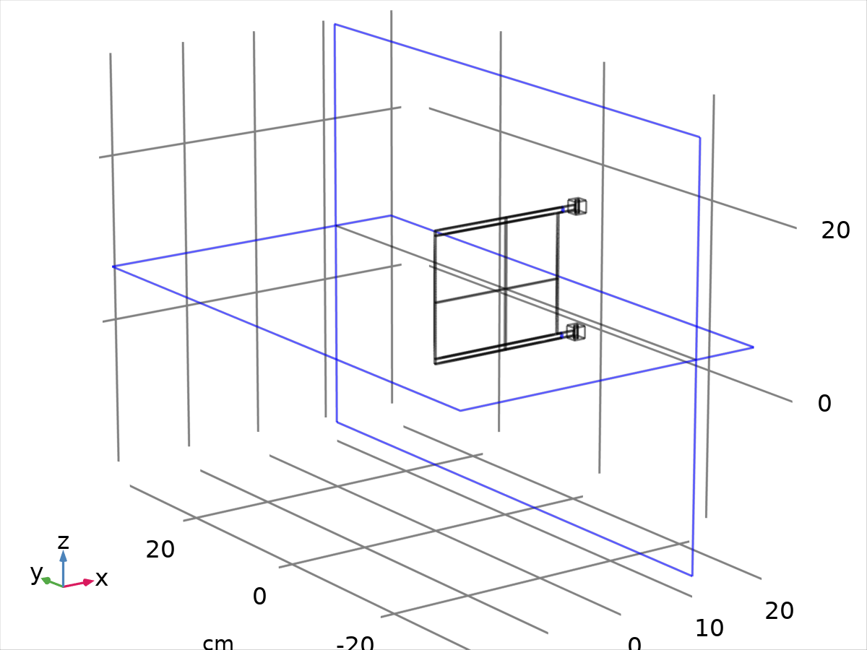
Wall 1
Selection
Geometric entity level | Boundary
Selection | Geometry geom1: Dimension 2: All boundaries

Equations


Boundary condition
Settings
Description | Value
Wall condition | Slip

Wall movement
Settings
Description | Value
Translational velocity | Automatic from frame

Constraint settings
Settings
Description | Value
Constraints | Default
Apply reaction terms on | Individual dependent variables
Constraint method | Elemental

Variables
Name | Expression | Unit | Description | Selection | Details
spf.ubndx | spf.utrx+spf.usx | m/s | Velocity at boundary, x component | Boundaries 1–5, 7–9, 25–26, 28, 30, 41–42, 47–48
spf.ubndy | spf.utry+spf.usy | m/s | Velocity at boundary, y component | Boundaries 1–5, 7–9, 25–26, 28, 30, 41–42, 47–48
spf.ubndz | spf.utrz+spf.usz | m/s | Velocity at boundary, z component | Boundaries 1–5, 7–9, 25–26, 28, 30, 41–42, 47–48
spf.usx | 0 | m/s | Velocity of sliding wall, x component | Boundaries 1–5, 7–9, 25–26, 28, 30, 41–42, 47–48
spf.usy | 0 | m/s | Velocity of sliding wall, y component | Boundaries 1–5, 7–9, 25–26, 28, 30, 41–42, 47–48
spf.usz | 0 | m/s | Velocity of sliding wall, z component | Boundaries 1–5, 7–9, 25–26, 28, 30, 41–42, 47–48
spf.utrx | 0 | m/s | Velocity of moving wall, x component | Boundaries 1–5, 7–9, 25–26, 28, 30, 41–42, 47–48
spf.utry | 0 | m/s | Velocity of moving wall, y component | Boundaries 1–5, 7–9, 25–26, 28, 30, 41–42, 47–48
spf.utrz | 0 | m/s | Velocity of moving wall, z component | Boundaries 1–5, 7–9, 25–26, 28, 30, 41–42, 47–48
spf.uLeakagex | 0 | m/s | Leakage velocity, x component | Boundaries 1–5, 7–9, 25–26, 28, 30, 41–42, 47–48 | + operation
spf.uLeakagey | 0 | m/s | Leakage velocity, y component | Boundaries 1–5, 7–9, 25–26, 28, 30, 41–42, 47–48 | + operation
spf.uLeakagez | 0 | m/s | Leakage velocity, z component | Boundaries 1–5, 7–9, 25–26, 28, 30, 41–42, 47–48 | + operation
spf.noSlipWall | 0 | 1 | Help variable | Boundaries 1–5, 7–9, 25–26, 28, 30, 41–42, 47–48
spf.un_here | u_fluid*nojac(spf.nxmesh)+v_fluid*nojac(spf.nymesh)+w_fluid*nojac(spf.nzmesh) | m/s | Intermediate variable | Boundaries 1–5, 7–9, 25–26, 28, 30, 41–42, 47–48
spf.u_herex | spf.un_here*nojac(spf.nxmesh) | m/s | Intermediate variable, x component | Boundaries 1–5, 7–9, 25–26, 28, 30, 41–42, 47–48
spf.u_herey | spf.un_here*nojac(spf.nymesh) | m/s | Intermediate variable, y component | Boundaries 1–5, 7–9, 25–26, 28, 30, 41–42, 47–48
spf.u_herez | spf.un_here*nojac(spf.nzmesh) | m/s | Intermediate variable, z component | Boundaries 1–5, 7–9, 25–26, 28, 30, 41–42, 47–48
spf.un_there | (spf.ubndx+spf.uLeakagex)*nojac(spf.nxmesh)+(spf.ubndy+spf.uLeakagey)*nojac(spf.nymesh)+(spf.ubndz+spf.uLeakagez)*nojac(spf.nzmesh) | m/s | Intermediate variable | Boundaries 1–5, 7–9, 25–26, 28, 30, 41–42, 47–48
spf.u_therex | spf.un_there*nojac(spf.nxmesh) | m/s | Intermediate variable, x component | Boundaries 1–5, 7–9, 25–26, 28, 30, 41–42, 47–48
spf.u_therey | spf.un_there*nojac(spf.nymesh) | m/s | Intermediate variable, y component | Boundaries 1–5, 7–9, 25–26, 28, 30, 41–42, 47–48
spf.u_therez | spf.un_there*nojac(spf.nzmesh) | m/s | Intermediate variable, z component | Boundaries 1–5, 7–9, 25–26, 28, 30, 41–42, 47–48
spf.unJump | spf.un_here-spf.un_there | m/s | Jump in normal velocity | Boundaries 1–5, 7–9, 25–26, 28, 30, 41–42, 47–48
spf.KStressn_avx | spf.K_stress_tensorxx*spf.nxmesh+spf.K_stress_tensorxy*spf.nymesh+spf.K_stress_tensorxz*spf.nzmesh | N/m² | Average viscous stress, x component | Boundaries 1–5, 7–9, 25–26, 28, 30, 41–42, 47–48
spf.KStressn_avy | spf.K_stress_tensoryx*spf.nxmesh+spf.K_stress_tensoryy*spf.nymesh+spf.K_stress_tensoryz*spf.nzmesh | N/m² | Average viscous stress, y component | Boundaries 1–5, 7–9, 25–26, 28, 30, 41–42, 47–48
spf.KStressn_avz | spf.K_stress_tensorzx*spf.nxmesh+spf.K_stress_tensorzy*spf.nymesh+spf.K_stress_tensorzz*spf.nzmesh | N/m² | Average viscous stress, z component | Boundaries 1–5, 7–9, 25–26, 28, 30, 41–42, 47–48
spf.KStressTestn_avx | spf.K_stress_tensor_testxx*spf.nxmesh+spf.K_stress_tensor_testxy*spf.nymesh+spf.K_stress_tensor_testxz*spf.nzmesh | N/m² | Average viscous stress, x component | Boundaries 1–5, 7–9, 25–26, 28, 30, 41–42, 47–48
spf.KStressTestn_avy | spf.K_stress_tensor_testyx*spf.nxmesh+spf.K_stress_tensor_testyy*spf.nymesh+spf.K_stress_tensor_testyz*spf.nzmesh | N/m² | Average viscous stress, y component | Boundaries 1–5, 7–9, 25–26, 28, 30, 41–42, 47–48
spf.KStressTestn_avz | spf.K_stress_tensor_testzx*spf.nxmesh+spf.K_stress_tensor_testzy*spf.nymesh+spf.K_stress_tensor_testzz*spf.nzmesh | N/m² | Average viscous stress, z component | Boundaries 1–5, 7–9, 25–26, 28, 30, 41–42, 47–48
spf.ujumpx | spf.u_herex-spf.u_therex | m/s | Velocity jump, x component | Boundaries 1–5, 7–9, 25–26, 28, 30, 41–42, 47–48
spf.ujumpy | spf.u_herey-spf.u_therey | m/s | Velocity jump, y component | Boundaries 1–5, 7–9, 25–26, 28, 30, 41–42, 47–48
spf.ujumpz | spf.u_herez-spf.u_therez | m/s | Velocity jump, z component | Boundaries 1–5, 7–9, 25–26, 28, 30, 41–42, 47–48
spf.contCoeffFace | down(spf.contCoeff) | kg/m³ | Help variable | Boundaries 1–5, 7–9, 25–26, 28, 30, 41–42, 47–48
spf.rhoFace | down(spf.rho) | kg/m³ | Density face value | Boundaries 1–5, 7–9, 25–26, 28, 30, 41–42, 47–48
spf.c_here | 36*nojac(down(spf.mu+spf.muT)/down(1))*spf.meshVol/spf.meshVolInt | Pa·s/m | Intermediate variable | Boundaries 1–5, 7–9, 25–26, 28, 30, 41–42, 47–48
spf.meshVol | meshvol_spatial | m² |  | Boundaries 1–5, 7–9, 25–26, 28, 30, 41–42, 47–48
spf.meshVolInt | down(meshvol_spatial) | m³ | Volume of interior mesh element | Boundaries 1–5, 7–9, 25–26, 28, 30, 41–42, 47–48
spf.sigma_dg_ns | 4*spf.c_here | Pa·s/m |  | Boundaries 1–5, 7–9, 25–26, 28, 30, 41–42, 47–48
spf.umxTnFace | (spf.upwind_helpx*spf.nxmesh+spf.upwind_helpy*spf.nymesh+spf.upwind_helpz*spf.nzmesh<0)*(spf.upwind_helpx*spf.nxmesh+spf.upwind_helpy*spf.nymesh+spf.upwind_helpz*spf.nzmesh) | m/s | Relative velocity on face | Boundaries 1–5, 7–9, 25–26, 28, 30, 41–42, 47–48
spf.upwind_ns | spf.rhoFace*spf.umxTnFace*spf.unJump*test(spf.un_here)/down(1)^2 | W/m² | Upwind term | Boundaries 1–5, 7–9, 25–26, 28, 30, 41–42, 47–48
spf.upwindCont | spf.contCoeffFace*spf.unJump*test(p) | kg²/(m³·s³) | Upwind term for continuity equation | Boundaries 1–5, 7–9, 25–26, 28, 30, 41–42, 47–48
spf.pFace | p | Pa | Pressure face value | Boundaries 1–5, 7–9, 25–26, 28, 30, 41–42, 47–48
spf.consFlux | -spf.pFace*test(spf.un_here) | W/m² | Conservative flux | Boundaries 1–5, 7–9, 25–26, 28, 30, 41–42, 47–48 | + operation

Weak expressions
Weak expression | Integration order | Integration frame | Selection
spf.KStressn_avx*test(spf.u_herex)+spf.KStressn_avy*test(spf.u_herey)+spf.KStressn_avz*test(spf.u_herez)+spf.KStressTestn_avx*spf.ujumpx+spf.KStressTestn_avy*spf.ujumpy+spf.KStressTestn_avz*spf.ujumpz-spf.sigma_dg_ns*spf.unJump*test(spf.un_here)+spf.upwind_ns+spf.upwindCont+spf.consFlux | 2 | Spatial | Boundaries 1–5, 7–9, 25–26, 28, 30, 41–42, 47–48

    - Pressure Point Constraint 1
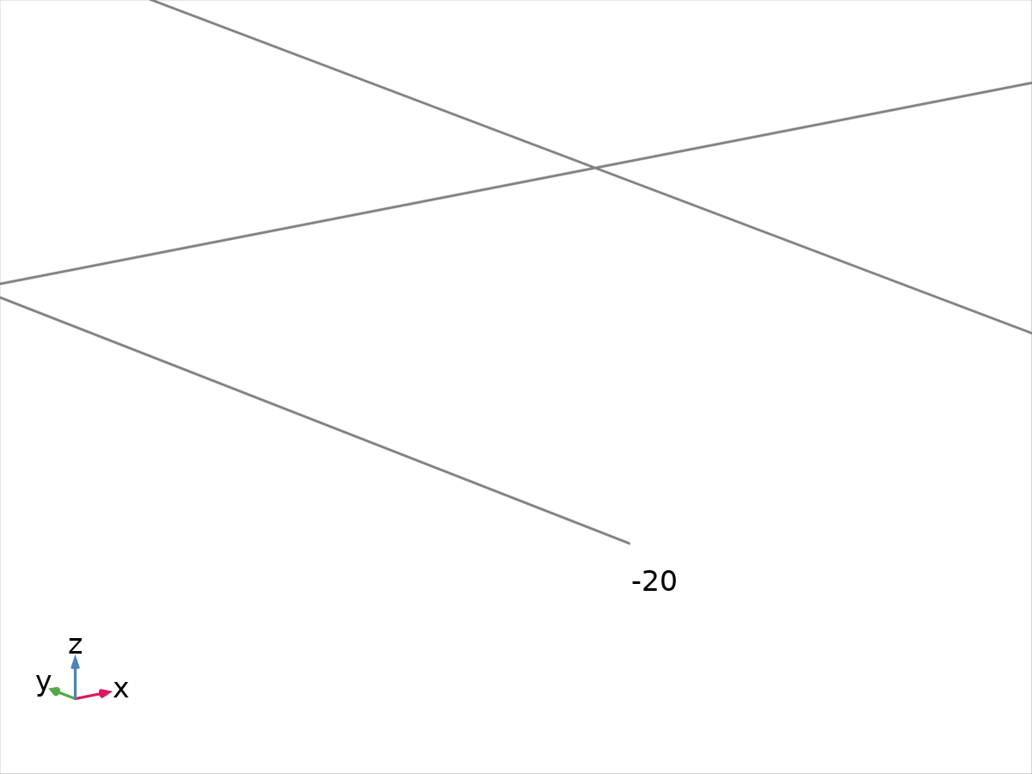
Pressure Point Constraint 1
Selection
Geometric entity level | Point
Selection | Geometry geom1: Dimension 0: Point 1

Equations
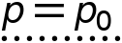

Pressure constraint
Settings
Description | Value
Pressure | 0

Constraint settings
Settings
Description | Value
Apply reaction terms on | Individual dependent variables
Use weak constraints | Off
Constraint method | Elemental

Variables
Name | Expression | Unit | Description | Selection
spf.p0 | 0 | Pa | Pressure | Point 1

Constraints
Constraint | Constraint force | Shape function | Selection | Details
-p+spf.p0 | test(-p) | Lagrange (Linear) | Point 1 | Elemental

  - Multibody Dynamics
Used products
COMSOL Multiphysics
Multibody Dynamics Module

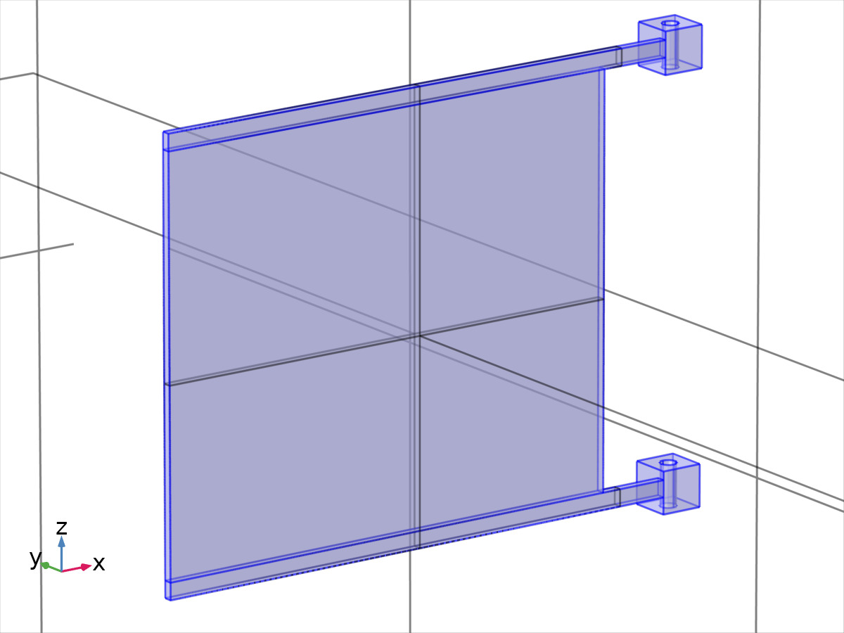
Multibody Dynamics
Selection
Geometric entity level | Domain
Selection | Geometry geom1: Dimension 3: Domains 5–9

Equations
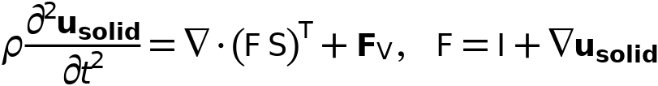
    - Interface settings

Physics symbols
Settings
Description | Value
Enable physics symbols | Off

Discretization
Settings
Description | Value
Displacement field | Linear
Compute boundary fluxes | Off
Value type when using splitting of complex variables | Complex

Initial values
Settings
Description | Value
Center of rotation, x component | 0
Center of rotation, y component | 0
Center of rotation, z component | 0
Displacement at center of rotation, x component | 0
Displacement at center of rotation, y component | 0
Displacement at center of rotation, z component | 0
Velocity at center of rotation, x component | 0
Velocity at center of rotation, y component | 0
Velocity at center of rotation, z component | 0
Axis of rotation, x component | 0
Axis of rotation, y component | 0
Axis of rotation, z component | 0
Angle of rotation | 0
Angular velocity, x component | 0
Angular velocity, y component | 0
Angular velocity, z component | 0

Automated model setup
Settings
Description | Value
Rigid domains selection | From physics interface
Include mass and moment of inertia node | Off

Results
Settings
Description | Value
Body defining reference frame | None

Joints summary
Joints | Source | Destination
Hinge Joint 1 | Fixed | Attachment 1
Hinge Joint 2 | Fixed | Attachment 2

Rigid body DOF summary
 | N | DOF | Prescribed | Constraints
Rigid bodies | 0 | 0 | 0 | 0
Hinge joints | 2 | 2 | 2 | 12
Total | - | 2 | 2 | 12
Net | - | 0 | - | 12

    - Variables
Name | Expression | Unit | Description | Selection | Details
mbd.nX | nX | 1 | Normal vector, X component | Boundaries 54, 57, 68, 73
mbd.nY | nY | 1 | Normal vector, Y component | Boundaries 54, 57, 68, 73
mbd.nZ | nZ | 1 | Normal vector, Z component | Boundaries 54, 57, 68, 73
mbd.nX | dnX | 1 | Normal vector, X component | Boundaries 49–53, 55–56, 58–67, 69–72, 74–86
mbd.nY | dnY | 1 | Normal vector, Y component | Boundaries 49–53, 55–56, 58–67, 69–72, 74–86
mbd.nZ | dnZ | 1 | Normal vector, Z component | Boundaries 49–53, 55–56, 58–67, 69–72, 74–86
mbd.nx | nx | 1 | Normal vector, x component | Boundaries 54, 57, 68, 73
mbd.ny | ny | 1 | Normal vector, y component | Boundaries 54, 57, 68, 73
mbd.nz | nz | 1 | Normal vector, z component | Boundaries 54, 57, 68, 73
mbd.nx | dnx | 1 | Normal vector, x component | Boundaries 49–53, 55–56, 58–67, 69–72, 74–86
mbd.ny | dny | 1 | Normal vector, y component | Boundaries 49–53, 55–56, 58–67, 69–72, 74–86
mbd.nz | dnz | 1 | Normal vector, z component | Boundaries 49–53, 55–56, 58–67, 69–72, 74–86
mbd.nXmesh | nXmesh | 1 | Normal vector (mesh), X component | Boundaries 54, 57, 68, 73
mbd.nYmesh | nYmesh | 1 | Normal vector (mesh), Y component | Boundaries 54, 57, 68, 73
mbd.nZmesh | nZmesh | 1 | Normal vector (mesh), Z component | Boundaries 54, 57, 68, 73
mbd.nXmesh | dnXmesh | 1 | Normal vector (mesh), X component | Boundaries 49–53, 55–56, 58–67, 69–72, 74–86
mbd.nYmesh | dnYmesh | 1 | Normal vector (mesh), Y component | Boundaries 49–53, 55–56, 58–67, 69–72, 74–86
mbd.nZmesh | dnZmesh | 1 | Normal vector (mesh), Z component | Boundaries 49–53, 55–56, 58–67, 69–72, 74–86
mbd.nxmesh | nxmesh | 1 | Normal vector (mesh), x component | Boundaries 54, 57, 68, 73
mbd.nymesh | nymesh | 1 | Normal vector (mesh), y component | Boundaries 54, 57, 68, 73
mbd.nzmesh | nzmesh | 1 | Normal vector (mesh), z component | Boundaries 54, 57, 68, 73
mbd.nxmesh | dnxmesh | 1 | Normal vector (mesh), x component | Boundaries 49–53, 55–56, 58–67, 69–72, 74–86
mbd.nymesh | dnymesh | 1 | Normal vector (mesh), y component | Boundaries 49–53, 55–56, 58–67, 69–72, 74–86
mbd.nzmesh | dnzmesh | 1 | Normal vector (mesh), z component | Boundaries 49–53, 55–56, 58–67, 69–72, 74–86
mbd.refpntx | 0 | m | Reference point for moment computation, x component | Global
mbd.refpnty | 0 | m | Reference point for moment computation, y component | Global
mbd.refpntz | 0 | m | Reference point for moment computation, z component | Global
u_solid_ref | u_solid | m | Displacement field, reference frame, x component | Domains 5–9
v_solid_ref | v_solid | m | Displacement field, reference frame, y component | Domains 5–9
w_solid_ref | w_solid | m | Displacement field, reference frame, z component | Domains 5–9
mbd.disp_ref | sqrt(u_solid_ref^2+v_solid_ref^2+w_solid_ref^2+eps) | m | Total displacement, reference frame | Domains 5–9
mbd.x_ref | X+u_solid_ref | m | Spatial coordinate, reference frame, x component | Domains 5–9
mbd.y_ref | Y+v_solid_ref | m | Spatial coordinate, reference frame, y component | Domains 5–9
mbd.z_ref | Z+w_solid_ref | m | Spatial coordinate, reference frame, z component | Domains 5–9
mbd.ut_ref | d(u_solid_ref,TIME) | m/s | Velocity, reference frame, x component | Domains 5–9
mbd.vt_ref | d(v_solid_ref,TIME) | m/s | Velocity, reference frame, y component | Domains 5–9
mbd.wt_ref | d(w_solid_ref,TIME) | m/s | Velocity, reference frame, z component | Domains 5–9
mbd.vel_ref | sqrt(mbd.ut_ref^2+mbd.vt_ref^2+mbd.wt_ref^2+eps) | m/s | Velocity magnitude, reference frame | Domains 5–9
mbd.diag | 0.958348188290665 | m | Bounding Box Diagonal | Global
mbd.isGeomNon | 1 | 1 | Geometric nonlinearity variable | Global
mbd.RFtotalx | mbd.sumreaction(mbd.RFx)+mbd.RFfsx+mbd.RFfdx | N | Total reaction force, x component | Global | + operation
mbd.RFtotaly | mbd.sumreaction(mbd.RFy)+mbd.RFfsy+mbd.RFfdy | N | Total reaction force, y component | Global | + operation
mbd.RFtotalz | mbd.sumreaction(mbd.RFz)+mbd.RFfsz+mbd.RFfdz | N | Total reaction force, z component | Global | + operation
mbd.RMtotalx | mbd.sumreaction(mbd.RMx)+mbd.RMmsx+mbd.RMmdx | N·m | Total reaction moment, x component | Global | + operation
mbd.RMtotaly | mbd.sumreaction(mbd.RMy)+mbd.RMmsy+mbd.RMmdy | N·m | Total reaction moment, y component | Global | + operation
mbd.RMtotalz | mbd.sumreaction(mbd.RMz)+mbd.RMmsz+mbd.RMmdz | N·m | Total reaction moment, z component | Global | + operation
xt | d(x,TIME) | m/s | Mesh velocity, x component | Global
yt | d(y,TIME) | m/s | Mesh velocity, y component | Global
zt | d(z,TIME) | m/s | Mesh velocity, z component | Global

    - Linear Elastic Material 1
Linear Elastic Material 1
Selection
Geometric entity level | Domain
Selection | Geometry geom1: Dimension 3: All domains

Equations
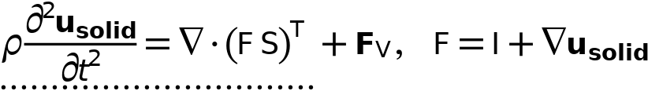
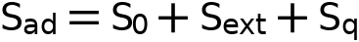
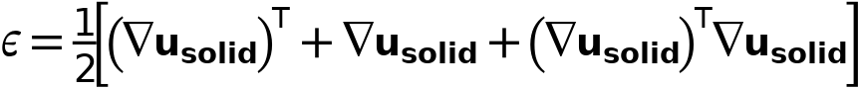
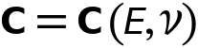

Linear elastic material
Settings
Description | Value
Solid model | Isotropic
Specify | Young's modulus and Poisson's ratio
Young's modulus | From material
Poisson's ratio | From material
Density | From material
Use mixed formulation | None

Geometric nonlinearity
Settings
Description | Value
Force linear strains | Off
Additive strain decomposition | Off

Energy dissipation
Settings
Description | Value
Calculate dissipated energy | Off

Coordinate system selection
Settings
Description | Value
Coordinate system | Global coordinate system

Properties from material
Property | Material | Property group
Young's modulus | Material 4 | Basic
Poisson's ratio | Material 4 | Basic
Density | Material 4 | Basic

Variables
Name | Expression | Unit | Description | Selection | Details
mbd.u_tX | u_solidTIME | m/s | Velocity, X component | Domains 5–9
mbd.u_tY | v_solidTIME | m/s | Velocity, Y component | Domains 5–9
mbd.u_tZ | w_solidTIME | m/s | Velocity, Z component | Domains 5–9
mbd.Wk_tot | root.comp1.mbd.lemm1.int3(mbd.Wk) | J | Total kinetic energy | Global | + operation
mbd.rho | material.rho | kg/m³ | Density | Domains 5–9 | Meta, * operation
u_solidTXt | u_solidTXTIME | 1/s | Tangential gradient of u_solid, X component, first time derivative | Boundaries 49–86
u_solidTYt | u_solidTYTIME | 1/s | Tangential gradient of u_solid, Y component, first time derivative | Boundaries 49–86
u_solidTZt | u_solidTZTIME | 1/s | Tangential gradient of u_solid, Z component, first time derivative | Boundaries 49–86
u_solidTXtt | u_solidTXTIMETIME | 1/s² | Tangential gradient of u_solid, X component, second time derivative | Boundaries 49–86
u_solidTYtt | u_solidTYTIMETIME | 1/s² | Tangential gradient of u_solid, Y component, second time derivative | Boundaries 49–86
u_solidTZtt | u_solidTZTIMETIME | 1/s² | Tangential gradient of u_solid, Z component, second time derivative | Boundaries 49–86
u_solidXt | u_solidXTIME | 1/s | Gradient of u_solid, X component, first time derivative | Domains 5–9
u_solidYt | u_solidYTIME | 1/s | Gradient of u_solid, Y component, first time derivative | Domains 5–9
u_solidZt | u_solidZTIME | 1/s | Gradient of u_solid, Z component, first time derivative | Domains 5–9
u_solidXtt | u_solidXTIMETIME | 1/s² | Gradient of u_solid, X component, second time derivative | Domains 5–9
u_solidYtt | u_solidYTIMETIME | 1/s² | Gradient of u_solid, Y component, second time derivative | Domains 5–9
u_solidZtt | u_solidZTIMETIME | 1/s² | Gradient of u_solid, Z component, second time derivative | Domains 5–9
v_solidTXt | v_solidTXTIME | 1/s | Tangential gradient of v_solid, X component, first time derivative | Boundaries 49–86
v_solidTYt | v_solidTYTIME | 1/s | Tangential gradient of v_solid, Y component, first time derivative | Boundaries 49–86
v_solidTZt | v_solidTZTIME | 1/s | Tangential gradient of v_solid, Z component, first time derivative | Boundaries 49–86
v_solidTXtt | v_solidTXTIMETIME | 1/s² | Tangential gradient of v_solid, X component, second time derivative | Boundaries 49–86
v_solidTYtt | v_solidTYTIMETIME | 1/s² | Tangential gradient of v_solid, Y component, second time derivative | Boundaries 49–86
v_solidTZtt | v_solidTZTIMETIME | 1/s² | Tangential gradient of v_solid, Z component, second time derivative | Boundaries 49–86
v_solidXt | v_solidXTIME | 1/s | Gradient of v_solid, X component, first time derivative | Domains 5–9
v_solidYt | v_solidYTIME | 1/s | Gradient of v_solid, Y component, first time derivative | Domains 5–9
v_solidZt | v_solidZTIME | 1/s | Gradient of v_solid, Z component, first time derivative | Domains 5–9
v_solidXtt | v_solidXTIMETIME | 1/s² | Gradient of v_solid, X component, second time derivative | Domains 5–9
v_solidYtt | v_solidYTIMETIME | 1/s² | Gradient of v_solid, Y component, second time derivative | Domains 5–9
v_solidZtt | v_solidZTIMETIME | 1/s² | Gradient of v_solid, Z component, second time derivative | Domains 5–9
w_solidTXt | w_solidTXTIME | 1/s | Tangential gradient of w_solid, X component, first time derivative | Boundaries 49–86
w_solidTYt | w_solidTYTIME | 1/s | Tangential gradient of w_solid, Y component, first time derivative | Boundaries 49–86
w_solidTZt | w_solidTZTIME | 1/s | Tangential gradient of w_solid, Z component, first time derivative | Boundaries 49–86
w_solidTXtt | w_solidTXTIMETIME | 1/s² | Tangential gradient of w_solid, X component, second time derivative | Boundaries 49–86
w_solidTYtt | w_solidTYTIMETIME | 1/s² | Tangential gradient of w_solid, Y component, second time derivative | Boundaries 49–86
w_solidTZtt | w_solidTZTIMETIME | 1/s² | Tangential gradient of w_solid, Z component, second time derivative | Boundaries 49–86
w_solidXt | w_solidXTIME | 1/s | Gradient of w_solid, X component, first time derivative | Domains 5–9
w_solidYt | w_solidYTIME | 1/s | Gradient of w_solid, Y component, first time derivative | Domains 5–9
w_solidZt | w_solidZTIME | 1/s | Gradient of w_solid, Z component, first time derivative | Domains 5–9
w_solidXtt | w_solidXTIMETIME | 1/s² | Gradient of w_solid, X component, second time derivative | Domains 5–9
w_solidYtt | w_solidYTIMETIME | 1/s² | Gradient of w_solid, Y component, second time derivative | Domains 5–9
w_solidZtt | w_solidZTIMETIME | 1/s² | Gradient of w_solid, Z component, second time derivative | Domains 5–9
u_solidt | u_solidTIME | m/s | Structural velocity field, X component | Domains 5–9
v_solidt | v_solidTIME | m/s | Structural velocity field, Y component | Domains 5–9
w_solidt | w_solidTIME | m/s | Structural velocity field, Z component | Domains 5–9
u_solidtt | u_solidTIMETIME | m/s² | Acceleration field, X component | Domains 5–9
v_solidtt | v_solidTIMETIME | m/s² | Acceleration field, Y component | Domains 5–9
w_solidtt | w_solidTIMETIME | m/s² | Acceleration field, Z component | Domains 5–9
mbd.gradUxX | u_solidX | 1 | Displacement gradient, xX component | Domains 5–9
mbd.gradUyX | v_solidX | 1 | Displacement gradient, yX component | Domains 5–9
mbd.gradUzX | w_solidX | 1 | Displacement gradient, zX component | Domains 5–9
mbd.gradUxY | u_solidY | 1 | Displacement gradient, xY component | Domains 5–9
mbd.gradUyY | v_solidY | 1 | Displacement gradient, yY component | Domains 5–9
mbd.gradUzY | w_solidY | 1 | Displacement gradient, zY component | Domains 5–9
mbd.gradUxZ | u_solidZ | 1 | Displacement gradient, xZ component | Domains 5–9
mbd.gradUyZ | v_solidZ | 1 | Displacement gradient, yZ component | Domains 5–9
mbd.gradUzZ | w_solidZ | 1 | Displacement gradient, zZ component | Domains 5–9
mbd.elogxx | log(mbd.stchp1)*mbd.LW11^2+log(mbd.stchp2)*mbd.LW12^2+log(mbd.stchp3)*mbd.LW13^2 | 1 | Logarithmic strain tensor, xx component | Domains 5–9
mbd.elogxy | log(mbd.stchp1)*mbd.LW11*mbd.LW21+log(mbd.stchp2)*mbd.LW12*mbd.LW22+log(mbd.stchp3)*mbd.LW13*mbd.LW23 | 1 | Logarithmic strain tensor, xy component | Domains 5–9
mbd.elogxz | log(mbd.stchp1)*mbd.LW11*mbd.LW31+log(mbd.stchp2)*mbd.LW12*mbd.LW32+log(mbd.stchp3)*mbd.LW13*mbd.LW33 | 1 | Logarithmic strain tensor, xz component | Domains 5–9
mbd.elogyy | log(mbd.stchp1)*mbd.LW21^2+log(mbd.stchp2)*mbd.LW22^2+log(mbd.stchp3)*mbd.LW23^2 | 1 | Logarithmic strain tensor, yy component | Domains 5–9
mbd.elogyz | log(mbd.stchp1)*mbd.LW21*mbd.LW31+log(mbd.stchp2)*mbd.LW22*mbd.LW32+log(mbd.stchp3)*mbd.LW23*mbd.LW33 | 1 | Logarithmic strain tensor, yz component | Domains 5–9
mbd.elogzz | log(mbd.stchp1)*mbd.LW31^2+log(mbd.stchp2)*mbd.LW32^2+log(mbd.stchp3)*mbd.LW33^2 | 1 | Logarithmic strain tensor, zz component | Domains 5–9
mbd.FdxX | 1+mbd.gradUxX | 1 | Deformation gradient, xX component | Domains 5–9
mbd.FdyX | mbd.gradUyX | 1 | Deformation gradient, yX component | Domains 5–9
mbd.FdzX | mbd.gradUzX | 1 | Deformation gradient, zX component | Domains 5–9
mbd.FdxY | mbd.gradUxY | 1 | Deformation gradient, xY component | Domains 5–9
mbd.FdyY | 1+mbd.gradUyY | 1 | Deformation gradient, yY component | Domains 5–9
mbd.FdzY | mbd.gradUzY | 1 | Deformation gradient, zY component | Domains 5–9
mbd.FdxZ | mbd.gradUxZ | 1 | Deformation gradient, xZ component | Domains 5–9
mbd.FdyZ | mbd.gradUyZ | 1 | Deformation gradient, yZ component | Domains 5–9
mbd.FdzZ | 1+mbd.gradUzZ | 1 | Deformation gradient, zZ component | Domains 5–9
mbd.Fdlx1 | mbd.FdxX | 1 | Deformation gradient, local, x1 component | Domains 5–9
mbd.Fdly1 | mbd.FdyX | 1 | Deformation gradient, local, y1 component | Domains 5–9
mbd.Fdlz1 | mbd.FdzX | 1 | Deformation gradient, local, z1 component | Domains 5–9
mbd.Fdlx2 | mbd.FdxY | 1 | Deformation gradient, local, x2 component | Domains 5–9
mbd.Fdly2 | mbd.FdyY | 1 | Deformation gradient, local, y2 component | Domains 5–9
mbd.Fdlz2 | mbd.FdzY | 1 | Deformation gradient, local, z2 component | Domains 5–9
mbd.Fdlx3 | mbd.FdxZ | 1 | Deformation gradient, local, x3 component | Domains 5–9
mbd.Fdly3 | mbd.FdyZ | 1 | Deformation gradient, local, y3 component | Domains 5–9
mbd.Fdlz3 | mbd.FdzZ | 1 | Deformation gradient, local, z3 component | Domains 5–9
mbd.D11 | mbd.E*(1-mbd.nu)/((1+mbd.nu)*(1-2*mbd.nu)) | Pa | Elasticity matrix, 11 component | Domains 5–9 | * operation
mbd.D12 | mbd.E*mbd.nu/((1+mbd.nu)*(1-2*mbd.nu)) | Pa | Elasticity matrix, 12 component | Domains 5–9 | * operation
mbd.D13 | mbd.E*mbd.nu/((1+mbd.nu)*(1-2*mbd.nu)) | Pa | Elasticity matrix, 13 component | Domains 5–9 | * operation
mbd.D14 | 0 | Pa | Elasticity matrix, 14 component | Domains 5–9 | * operation
mbd.D15 | 0 | Pa | Elasticity matrix, 15 component | Domains 5–9 | * operation
mbd.D16 | 0 | Pa | Elasticity matrix, 16 component | Domains 5–9 | * operation
mbd.D22 | mbd.E*(1-mbd.nu)/((1+mbd.nu)*(1-2*mbd.nu)) | Pa | Elasticity matrix, 22 component | Domains 5–9 | * operation
mbd.D23 | mbd.E*mbd.nu/((1+mbd.nu)*(1-2*mbd.nu)) | Pa | Elasticity matrix, 23 component | Domains 5–9 | * operation
mbd.D24 | 0 | Pa | Elasticity matrix, 24 component | Domains 5–9 | * operation
mbd.D25 | 0 | Pa | Elasticity matrix, 25 component | Domains 5–9 | * operation
mbd.D26 | 0 | Pa | Elasticity matrix, 26 component | Domains 5–9 | * operation
mbd.D33 | mbd.E*(1-mbd.nu)/((1+mbd.nu)*(1-2*mbd.nu)) | Pa | Elasticity matrix, 33 component | Domains 5–9 | * operation
mbd.D34 | 0 | Pa | Elasticity matrix, 34 component | Domains 5–9 | * operation
mbd.D35 | 0 | Pa | Elasticity matrix, 35 component | Domains 5–9 | * operation
mbd.D36 | 0 | Pa | Elasticity matrix, 36 component | Domains 5–9 | * operation
mbd.D44 | 0.5*mbd.E/(1+mbd.nu) | Pa | Elasticity matrix, 44 component | Domains 5–9 | * operation
mbd.D45 | 0 | Pa | Elasticity matrix, 45 component | Domains 5–9 | * operation
mbd.D46 | 0 | Pa | Elasticity matrix, 46 component | Domains 5–9 | * operation
mbd.D55 | 0.5*mbd.E/(1+mbd.nu) | Pa | Elasticity matrix, 55 component | Domains 5–9 | * operation
mbd.D56 | 0 | Pa | Elasticity matrix, 56 component | Domains 5–9 | * operation
mbd.D66 | 0.5*mbd.E/(1+mbd.nu) | Pa | Elasticity matrix, 66 component | Domains 5–9 | * operation
mbd.K | mbd.E/(3*(1-2*mbd.nu)) | N/m² | Bulk modulus | Domains 5–9 | * operation
mbd.Eequ | mbd.E | Pa | Equivalent Young's modulus | Domains 5–9
mbd.nuequ | mbd.nu | 1 | Equivalent Poisson's ratio | Domains 5–9
mbd.Gequ | mbd.G | N/m² | Equivalent shear modulus | Domains 5–9
mbd.cp | sqrt((mbd.K+4*mbd.G/3)/mbd.rho) | m/s | Equivalent speed of pressure wave | Domains 5–9
mbd.cs | sqrt(mbd.G/mbd.rho) | m/s | Equivalent speed of shear wave | Domains 5–9
mbd.E | material.E | Pa | Young's modulus | Domains 5–9 | Meta, * operation
mbd.nu | material.nu | 1 | Poisson's ratio | Domains 5–9 | Meta
mbd.G | 0.5*mbd.E/(1+mbd.nu) | N/m² | Shear modulus | Domains 5–9 | * operation
mbd.lambLame | mbd.E*mbd.nu/((1+mbd.nu)*(1-2*mbd.nu)) | N/m² | Lamé parameter λ | Domains 5–9
mbd.muLame | 0.5*mbd.E/(1+mbd.nu) | N/m² | Lamé parameter μ | Domains 5–9
mbd.Cgl11 | mbd.D11+mbd.D12+mbd.D13 | Pa | C:g tensor, local coordinate system, 11 component | Domains 5–9
mbd.Cgl12 | mbd.D14+mbd.D24+mbd.D34 | Pa | C:g tensor, local coordinate system, 12 component | Domains 5–9
mbd.Cgl13 | mbd.D16+mbd.D26+mbd.D36 | Pa | C:g tensor, local coordinate system, 13 component | Domains 5–9
mbd.Cgl22 | mbd.D12+mbd.D22+mbd.D23 | Pa | C:g tensor, local coordinate system, 22 component | Domains 5–9
mbd.Cgl23 | mbd.D15+mbd.D25+mbd.D35 | Pa | C:g tensor, local coordinate system, 23 component | Domains 5–9
mbd.Cgl33 | mbd.D13+mbd.D23+mbd.D33 | Pa | C:g tensor, local coordinate system, 33 component | Domains 5–9
mbd.eXX | 0.5*(2*u_solidX+u_solidX^2+v_solidX^2+w_solidX^2) | 1 | Strain tensor, XX component | Domains 5–9 | + operation
mbd.eXY | 0.5*(u_solidY+v_solidX+u_solidX*u_solidY+v_solidX*v_solidY+w_solidX*w_solidY) | 1 | Strain tensor, XY component | Domains 5–9 | + operation
mbd.eXZ | 0.5*(u_solidZ+w_solidX+u_solidX*u_solidZ+v_solidX*v_solidZ+w_solidX*w_solidZ) | 1 | Strain tensor, XZ component | Domains 5–9 | + operation
mbd.eYY | 0.5*(2*v_solidY+u_solidY^2+v_solidY^2+w_solidY^2) | 1 | Strain tensor, YY component | Domains 5–9 | + operation
mbd.eYZ | 0.5*(v_solidZ+w_solidY+u_solidY*u_solidZ+v_solidY*v_solidZ+w_solidY*w_solidZ) | 1 | Strain tensor, YZ component | Domains 5–9 | + operation
mbd.eZZ | 0.5*(2*w_solidZ+u_solidZ^2+v_solidZ^2+w_solidZ^2) | 1 | Strain tensor, ZZ component | Domains 5–9 | + operation
mbd.el11 | mbd.eXX | 1 | Strain tensor, local coordinate system, 11 component | Domains 5–9 | + operation
mbd.el12 | mbd.eXY | 1 | Strain tensor, local coordinate system, 12 component | Domains 5–9 | + operation
mbd.el13 | mbd.eXZ | 1 | Strain tensor, local coordinate system, 13 component | Domains 5–9 | + operation
mbd.el22 | mbd.eYY | 1 | Strain tensor, local coordinate system, 22 component | Domains 5–9 | + operation
mbd.el23 | mbd.eYZ | 1 | Strain tensor, local coordinate system, 23 component | Domains 5–9 | + operation
mbd.el33 | mbd.eZZ | 1 | Strain tensor, local coordinate system, 33 component | Domains 5–9 | + operation
mbd.evol | mbd.eXX+mbd.eYY+mbd.eZZ | 1 | Volumetric strain | Domains 5–9
mbd.J | mbd.FdxX*mbd.FdyY*mbd.FdzZ+mbd.FdxY*mbd.FdyZ*mbd.FdzX+mbd.FdxZ*mbd.FdyX*mbd.FdzY-mbd.FdxX*mbd.FdyZ*mbd.FdzY-mbd.FdxY*mbd.FdyX*mbd.FdzZ-mbd.FdxZ*mbd.FdyY*mbd.FdzX | 1 | Volume ratio | Domains 5–9
mbd.eX | mbd.eXX | 1 | Strain tensor, X component | Domains 5–9
mbd.eY | mbd.eYY | 1 | Strain tensor, Y component | Domains 5–9
mbd.eZ | mbd.eZZ | 1 | Strain tensor, Z component | Domains 5–9
mbd.Cl11 | 1+2*mbd.el11 | 1 | Cauchy-Green tensor, local coordinate system, 11 component | Domains 5–9
mbd.Cl12 | 2*mbd.el12 | 1 | Cauchy-Green tensor, local coordinate system, 12 component | Domains 5–9
mbd.Cl13 | 2*mbd.el13 | 1 | Cauchy-Green tensor, local coordinate system, 13 component | Domains 5–9
mbd.Cl22 | 1+2*mbd.el22 | 1 | Cauchy-Green tensor, local coordinate system, 22 component | Domains 5–9
mbd.Cl23 | 2*mbd.el23 | 1 | Cauchy-Green tensor, local coordinate system, 23 component | Domains 5–9
mbd.Cl33 | 1+2*mbd.el33 | 1 | Cauchy-Green tensor, local coordinate system, 33 component | Domains 5–9
mbd.eldev11 | mbd.el11-mbd.evol/3 | 1 | Deviatoric strain tensor, local coordinate system, 11 component | Domains 5–9
mbd.eldev12 | mbd.el12 | 1 | Deviatoric strain tensor, local coordinate system, 12 component | Domains 5–9
mbd.eldev13 | mbd.el13 | 1 | Deviatoric strain tensor, local coordinate system, 13 component | Domains 5–9
mbd.eldev22 | mbd.el22-mbd.evol/3 | 1 | Deviatoric strain tensor, local coordinate system, 22 component | Domains 5–9
mbd.eldev23 | mbd.el23 | 1 | Deviatoric strain tensor, local coordinate system, 23 component | Domains 5–9
mbd.eldev33 | mbd.el33-mbd.evol/3 | 1 | Deviatoric strain tensor, local coordinate system, 33 component | Domains 5–9
mbd.eel11 | 0.5*(-1+mbd.Cel11) | 1 | Elastic strain tensor, local coordinate system, 11 component | Domains 5–9
mbd.eel12 | 0.5*mbd.Cel12 | 1 | Elastic strain tensor, local coordinate system, 12 component | Domains 5–9
mbd.eel13 | 0.5*mbd.Cel13 | 1 | Elastic strain tensor, local coordinate system, 13 component | Domains 5–9
mbd.eel22 | 0.5*(-1+mbd.Cel22) | 1 | Elastic strain tensor, local coordinate system, 22 component | Domains 5–9
mbd.eel23 | 0.5*mbd.Cel23 | 1 | Elastic strain tensor, local coordinate system, 23 component | Domains 5–9
mbd.eel33 | 0.5*(-1+mbd.Cel33) | 1 | Elastic strain tensor, local coordinate system, 33 component | Domains 5–9
mbd.Felx1 | mbd.Fdlx1*mbd.Fiil11+mbd.Fdlx2*mbd.Fiil21+mbd.Fdlx3*mbd.Fiil31 | 1 | Elastic deformation gradient, local coordinate system, x1 component | Domains 5–9
mbd.Fely1 | mbd.Fdly1*mbd.Fiil11+mbd.Fdly2*mbd.Fiil21+mbd.Fdly3*mbd.Fiil31 | 1 | Elastic deformation gradient, local coordinate system, y1 component | Domains 5–9
mbd.Felz1 | mbd.Fdlz1*mbd.Fiil11+mbd.Fdlz2*mbd.Fiil21+mbd.Fdlz3*mbd.Fiil31 | 1 | Elastic deformation gradient, local coordinate system, z1 component | Domains 5–9
mbd.Felx2 | mbd.Fdlx1*mbd.Fiil12+mbd.Fdlx2*mbd.Fiil22+mbd.Fdlx3*mbd.Fiil32 | 1 | Elastic deformation gradient, local coordinate system, x2 component | Domains 5–9
mbd.Fely2 | mbd.Fdly1*mbd.Fiil12+mbd.Fdly2*mbd.Fiil22+mbd.Fdly3*mbd.Fiil32 | 1 | Elastic deformation gradient, local coordinate system, y2 component | Domains 5–9
mbd.Felz2 | mbd.Fdlz1*mbd.Fiil12+mbd.Fdlz2*mbd.Fiil22+mbd.Fdlz3*mbd.Fiil32 | 1 | Elastic deformation gradient, local coordinate system, z2 component | Domains 5–9
mbd.Felx3 | mbd.Fdlx1*mbd.Fiil13+mbd.Fdlx2*mbd.Fiil23+mbd.Fdlx3*mbd.Fiil33 | 1 | Elastic deformation gradient, local coordinate system, x3 component | Domains 5–9
mbd.Fely3 | mbd.Fdly1*mbd.Fiil13+mbd.Fdly2*mbd.Fiil23+mbd.Fdly3*mbd.Fiil33 | 1 | Elastic deformation gradient, local coordinate system, y3 component | Domains 5–9
mbd.Felz3 | mbd.Fdlz1*mbd.Fiil13+mbd.Fdlz2*mbd.Fiil23+mbd.Fdlz3*mbd.Fiil33 | 1 | Elastic deformation gradient, local coordinate system, z3 component | Domains 5–9
mbd.Cel11 | (mbd.Fiil11*mbd.Cl11+mbd.Fiil21*mbd.Cl12+mbd.Fiil31*mbd.Cl13)*mbd.Fiil11+(mbd.Fiil11*mbd.Cl12+mbd.Fiil21*mbd.Cl22+mbd.Fiil31*mbd.Cl23)*mbd.Fiil21+(mbd.Fiil11*mbd.Cl13+mbd.Fiil21*mbd.Cl23+mbd.Fiil31*mbd.Cl33)*mbd.Fiil31 | 1 | Elastic Cauchy-Green tensor, local coordinate system, 11 component | Domains 5–9
mbd.Cel12 | (mbd.Fiil11*mbd.Cl11+mbd.Fiil21*mbd.Cl12+mbd.Fiil31*mbd.Cl13)*mbd.Fiil12+(mbd.Fiil11*mbd.Cl12+mbd.Fiil21*mbd.Cl22+mbd.Fiil31*mbd.Cl23)*mbd.Fiil22+(mbd.Fiil11*mbd.Cl13+mbd.Fiil21*mbd.Cl23+mbd.Fiil31*mbd.Cl33)*mbd.Fiil32 | 1 | Elastic Cauchy-Green tensor, local coordinate system, 12 component | Domains 5–9
mbd.Cel13 | (mbd.Fiil11*mbd.Cl11+mbd.Fiil21*mbd.Cl12+mbd.Fiil31*mbd.Cl13)*mbd.Fiil13+(mbd.Fiil11*mbd.Cl12+mbd.Fiil21*mbd.Cl22+mbd.Fiil31*mbd.Cl23)*mbd.Fiil23+(mbd.Fiil11*mbd.Cl13+mbd.Fiil21*mbd.Cl23+mbd.Fiil31*mbd.Cl33)*mbd.Fiil33 | 1 | Elastic Cauchy-Green tensor, local coordinate system, 13 component | Domains 5–9
mbd.Cel22 | (mbd.Fiil12*mbd.Cl11+mbd.Fiil22*mbd.Cl12+mbd.Fiil32*mbd.Cl13)*mbd.Fiil12+(mbd.Fiil12*mbd.Cl12+mbd.Fiil22*mbd.Cl22+mbd.Fiil32*mbd.Cl23)*mbd.Fiil22+(mbd.Fiil12*mbd.Cl13+mbd.Fiil22*mbd.Cl23+mbd.Fiil32*mbd.Cl33)*mbd.Fiil32 | 1 | Elastic Cauchy-Green tensor, local coordinate system, 22 component | Domains 5–9
mbd.Cel23 | (mbd.Fiil12*mbd.Cl11+mbd.Fiil22*mbd.Cl12+mbd.Fiil32*mbd.Cl13)*mbd.Fiil13+(mbd.Fiil12*mbd.Cl12+mbd.Fiil22*mbd.Cl22+mbd.Fiil32*mbd.Cl23)*mbd.Fiil23+(mbd.Fiil12*mbd.Cl13+mbd.Fiil22*mbd.Cl23+mbd.Fiil32*mbd.Cl33)*mbd.Fiil33 | 1 | Elastic Cauchy-Green tensor, local coordinate system, 23 component | Domains 5–9
mbd.Cel33 | (mbd.Fiil13*mbd.Cl11+mbd.Fiil23*mbd.Cl12+mbd.Fiil33*mbd.Cl13)*mbd.Fiil13+(mbd.Fiil13*mbd.Cl12+mbd.Fiil23*mbd.Cl22+mbd.Fiil33*mbd.Cl23)*mbd.Fiil23+(mbd.Fiil13*mbd.Cl13+mbd.Fiil23*mbd.Cl23+mbd.Fiil33*mbd.Cl33)*mbd.Fiil33 | 1 | Elastic Cauchy-Green tensor, local coordinate system, 33 component | Domains 5–9
mbd.Fiil11 | 1 | 1 | Inelastic deformation gradient inverse, local coordinate system, 11 component | Domains 5–9 | Matrix multiplication
mbd.Fiil21 | 0 | 1 | Inelastic deformation gradient inverse, local coordinate system, 21 component | Domains 5–9 | Matrix multiplication
mbd.Fiil31 | 0 | 1 | Inelastic deformation gradient inverse, local coordinate system, 31 component | Domains 5–9 | Matrix multiplication
mbd.Fiil12 | 0 | 1 | Inelastic deformation gradient inverse, local coordinate system, 12 component | Domains 5–9 | Matrix multiplication
mbd.Fiil22 | 1 | 1 | Inelastic deformation gradient inverse, local coordinate system, 22 component | Domains 5–9 | Matrix multiplication
mbd.Fiil32 | 0 | 1 | Inelastic deformation gradient inverse, local coordinate system, 32 component | Domains 5–9 | Matrix multiplication
mbd.Fiil13 | 0 | 1 | Inelastic deformation gradient inverse, local coordinate system, 13 component | Domains 5–9 | Matrix multiplication
mbd.Fiil23 | 0 | 1 | Inelastic deformation gradient inverse, local coordinate system, 23 component | Domains 5–9 | Matrix multiplication
mbd.Fiil33 | 1 | 1 | Inelastic deformation gradient inverse, local coordinate system, 33 component | Domains 5–9 | Matrix multiplication
mbd.Ji | 1/(mbd.Fiil11*mbd.Fiil22*mbd.Fiil33+mbd.Fiil12*mbd.Fiil23*mbd.Fiil31+mbd.Fiil13*mbd.Fiil21*mbd.Fiil32-mbd.Fiil11*mbd.Fiil23*mbd.Fiil32-mbd.Fiil12*mbd.Fiil21*mbd.Fiil33-mbd.Fiil13*mbd.Fiil22*mbd.Fiil31) | 1 | Inelastic volume ratio | Domains 5–9
mbd.eil11 | 0 | 1 | Initial strain tensor, local coordinate system, 11 component | Domains 5–9 | + operation
mbd.eil12 | 0 | 1 | Initial strain tensor, local coordinate system, 12 component | Domains 5–9 | + operation
mbd.eil13 | 0 | 1 | Initial strain tensor, local coordinate system, 13 component | Domains 5–9 | + operation
mbd.eil22 | 0 | 1 | Initial strain tensor, local coordinate system, 22 component | Domains 5–9 | + operation
mbd.eil23 | 0 | 1 | Initial strain tensor, local coordinate system, 23 component | Domains 5–9 | + operation
mbd.eil33 | 0 | 1 | Initial strain tensor, local coordinate system, 33 component | Domains 5–9 | + operation
mbd.eiel11 | mbd.eil11 | 1 | Inelastic strain tensor, local coordinate system, 11 component | Domains 5–9 | + operation
mbd.eiel12 | mbd.eil12 | 1 | Inelastic strain tensor, local coordinate system, 12 component | Domains 5–9 | + operation
mbd.eiel13 | mbd.eil13 | 1 | Inelastic strain tensor, local coordinate system, 13 component | Domains 5–9 | + operation
mbd.eiel22 | mbd.eil22 | 1 | Inelastic strain tensor, local coordinate system, 22 component | Domains 5–9 | + operation
mbd.eiel23 | mbd.eil23 | 1 | Inelastic strain tensor, local coordinate system, 23 component | Domains 5–9 | + operation
mbd.eiel33 | mbd.eil33 | 1 | Inelastic strain tensor, local coordinate system, 33 component | Domains 5–9 | + operation
mbd.Ceil11 | (mbd.Cel22*mbd.Cel33-mbd.Cel23^2)/(mbd.Cel11*mbd.Cel22*mbd.Cel33+2*mbd.Cel12*mbd.Cel23*mbd.Cel13-mbd.Cel11*mbd.Cel23^2-mbd.Cel12^2*mbd.Cel33-mbd.Cel22*mbd.Cel13^2) | 1 | Elastic Cauchy-Green tensor inverse, local coordinate system, 11 component | Domains 5–9
mbd.Ceil12 | (mbd.Cel23*mbd.Cel13-mbd.Cel12*mbd.Cel33)/(mbd.Cel11*mbd.Cel22*mbd.Cel33+2*mbd.Cel12*mbd.Cel23*mbd.Cel13-mbd.Cel11*mbd.Cel23^2-mbd.Cel12^2*mbd.Cel33-mbd.Cel22*mbd.Cel13^2) | 1 | Elastic Cauchy-Green tensor inverse, local coordinate system, 12 component | Domains 5–9
mbd.Ceil13 | (mbd.Cel12*mbd.Cel23-mbd.Cel22*mbd.Cel13)/(mbd.Cel11*mbd.Cel22*mbd.Cel33+2*mbd.Cel12*mbd.Cel23*mbd.Cel13-mbd.Cel11*mbd.Cel23^2-mbd.Cel12^2*mbd.Cel33-mbd.Cel22*mbd.Cel13^2) | 1 | Elastic Cauchy-Green tensor inverse, local coordinate system, 13 component | Domains 5–9
mbd.Ceil22 | (mbd.Cel11*mbd.Cel33-mbd.Cel13^2)/(mbd.Cel11*mbd.Cel22*mbd.Cel33+2*mbd.Cel12*mbd.Cel23*mbd.Cel13-mbd.Cel11*mbd.Cel23^2-mbd.Cel12^2*mbd.Cel33-mbd.Cel22*mbd.Cel13^2) | 1 | Elastic Cauchy-Green tensor inverse, local coordinate system, 22 component | Domains 5–9
mbd.Ceil23 | (mbd.Cel12*mbd.Cel13-mbd.Cel11*mbd.Cel23)/(mbd.Cel11*mbd.Cel22*mbd.Cel33+2*mbd.Cel12*mbd.Cel23*mbd.Cel13-mbd.Cel11*mbd.Cel23^2-mbd.Cel12^2*mbd.Cel33-mbd.Cel22*mbd.Cel13^2) | 1 | Elastic Cauchy-Green tensor inverse, local coordinate system, 23 component | Domains 5–9
mbd.Ceil33 | (mbd.Cel11*mbd.Cel22-mbd.Cel12^2)/(mbd.Cel11*mbd.Cel22*mbd.Cel33+2*mbd.Cel12*mbd.Cel23*mbd.Cel13-mbd.Cel11*mbd.Cel23^2-mbd.Cel12^2*mbd.Cel33-mbd.Cel22*mbd.Cel13^2) | 1 | Elastic Cauchy-Green tensor inverse, local coordinate system, 33 component | Domains 5–9
mbd.Jel | sqrt(mbd.Cel11*mbd.Cel22*mbd.Cel33+2*mbd.Cel12*mbd.Cel23*mbd.Cel13-mbd.Cel11*mbd.Cel23^2-mbd.Cel12^2*mbd.Cel33-mbd.Cel22*mbd.Cel13^2) | 1 | Elastic volume ratio | Domains 5–9
mbd.mises | (3*mbd.II2s)^0.5 | N/m² | von Mises stress | Domains 5–9
mbd.Sl11 | mbd.Sil11+mbd.Ji*((mbd.Fiil11*(mbd.D11*mbd.eel11+mbd.D12*mbd.eel22+mbd.D13*mbd.eel33+2*mbd.D14*mbd.eel12+2*mbd.D15*mbd.eel23+2*mbd.D16*mbd.eel13)+mbd.Fiil12*(mbd.D14*mbd.eel11+mbd.D24*mbd.eel22+mbd.D34*mbd.eel33+2*mbd.D44*mbd.eel12+2*mbd.D45*mbd.eel23+2*mbd.D46*mbd.eel13)+mbd.Fiil13*(mbd.D16*mbd.eel11+mbd.D26*mbd.eel22+mbd.D36*mbd.eel33+2*mbd.D46*mbd.eel12+2*mbd.D56*mbd.eel23+2*mbd.D66*mbd.eel13))*mbd.Fiil11+(mbd.Fiil11*(mbd.D14*mbd.eel11+mbd.D24*mbd.eel22+mbd.D34*mbd.eel33+2*mbd.D44*mbd.eel12+2*mbd.D45*mbd.eel23+2*mbd.D46*mbd.eel13)+mbd.Fiil12*(mbd.D12*mbd.eel11+mbd.D22*mbd.eel22+mbd.D23*mbd.eel33+2*mbd.D24*mbd.eel12+2*mbd.D25*mbd.eel23+2*mbd.D26*mbd.eel13)+mbd.Fiil13*(mbd.D15*mbd.eel11+mbd.D25*mbd.eel22+mbd.D35*mbd.eel33+2*mbd.D45*mbd.eel12+2*mbd.D55*mbd.eel23+2*mbd.D56*mbd.eel13))*mbd.Fiil12+(mbd.Fiil11*(mbd.D16*mbd.eel11+mbd.D26*mbd.eel22+mbd.D36*mbd.eel33+2*mbd.D46*mbd.eel12+2*mbd.D56*mbd.eel23+2*mbd.D66*mbd.eel13)+mbd.Fiil12*(mbd.D15*mbd.eel11+mbd.D25*mbd.eel22+mbd.D35*mbd.eel33+2*mbd.D45*mbd.eel12+2*mbd.D55*mbd.eel23+2*mbd.D56*mbd.eel13)+mbd.Fiil13*(mbd.D13*mbd.eel11+mbd.D23*mbd.eel22+mbd.D33*mbd.eel33+2*mbd.D34*mbd.eel12+2*mbd.D35*mbd.eel23+2*mbd.D36*mbd.eel13))*mbd.Fiil13) | N/m² | Second Piola-Kirchhoff stress, local coordinate system, 11 component | Domains 5–9 | + operation
mbd.Sl12 | mbd.Sil12+mbd.Ji*((mbd.Fiil11*(mbd.D11*mbd.eel11+mbd.D12*mbd.eel22+mbd.D13*mbd.eel33+2*mbd.D14*mbd.eel12+2*mbd.D15*mbd.eel23+2*mbd.D16*mbd.eel13)+mbd.Fiil12*(mbd.D14*mbd.eel11+mbd.D24*mbd.eel22+mbd.D34*mbd.eel33+2*mbd.D44*mbd.eel12+2*mbd.D45*mbd.eel23+2*mbd.D46*mbd.eel13)+mbd.Fiil13*(mbd.D16*mbd.eel11+mbd.D26*mbd.eel22+mbd.D36*mbd.eel33+2*mbd.D46*mbd.eel12+2*mbd.D56*mbd.eel23+2*mbd.D66*mbd.eel13))*mbd.Fiil21+(mbd.Fiil11*(mbd.D14*mbd.eel11+mbd.D24*mbd.eel22+mbd.D34*mbd.eel33+2*mbd.D44*mbd.eel12+2*mbd.D45*mbd.eel23+2*mbd.D46*mbd.eel13)+mbd.Fiil12*(mbd.D12*mbd.eel11+mbd.D22*mbd.eel22+mbd.D23*mbd.eel33+2*mbd.D24*mbd.eel12+2*mbd.D25*mbd.eel23+2*mbd.D26*mbd.eel13)+mbd.Fiil13*(mbd.D15*mbd.eel11+mbd.D25*mbd.eel22+mbd.D35*mbd.eel33+2*mbd.D45*mbd.eel12+2*mbd.D55*mbd.eel23+2*mbd.D56*mbd.eel13))*mbd.Fiil22+(mbd.Fiil11*(mbd.D16*mbd.eel11+mbd.D26*mbd.eel22+mbd.D36*mbd.eel33+2*mbd.D46*mbd.eel12+2*mbd.D56*mbd.eel23+2*mbd.D66*mbd.eel13)+mbd.Fiil12*(mbd.D15*mbd.eel11+mbd.D25*mbd.eel22+mbd.D35*mbd.eel33+2*mbd.D45*mbd.eel12+2*mbd.D55*mbd.eel23+2*mbd.D56*mbd.eel13)+mbd.Fiil13*(mbd.D13*mbd.eel11+mbd.D23*mbd.eel22+mbd.D33*mbd.eel33+2*mbd.D34*mbd.eel12+2*mbd.D35*mbd.eel23+2*mbd.D36*mbd.eel13))*mbd.Fiil23) | N/m² | Second Piola-Kirchhoff stress, local coordinate system, 12 component | Domains 5–9 | + operation
mbd.Sl13 | mbd.Sil13+mbd.Ji*((mbd.Fiil11*(mbd.D11*mbd.eel11+mbd.D12*mbd.eel22+mbd.D13*mbd.eel33+2*mbd.D14*mbd.eel12+2*mbd.D15*mbd.eel23+2*mbd.D16*mbd.eel13)+mbd.Fiil12*(mbd.D14*mbd.eel11+mbd.D24*mbd.eel22+mbd.D34*mbd.eel33+2*mbd.D44*mbd.eel12+2*mbd.D45*mbd.eel23+2*mbd.D46*mbd.eel13)+mbd.Fiil13*(mbd.D16*mbd.eel11+mbd.D26*mbd.eel22+mbd.D36*mbd.eel33+2*mbd.D46*mbd.eel12+2*mbd.D56*mbd.eel23+2*mbd.D66*mbd.eel13))*mbd.Fiil31+(mbd.Fiil11*(mbd.D14*mbd.eel11+mbd.D24*mbd.eel22+mbd.D34*mbd.eel33+2*mbd.D44*mbd.eel12+2*mbd.D45*mbd.eel23+2*mbd.D46*mbd.eel13)+mbd.Fiil12*(mbd.D12*mbd.eel11+mbd.D22*mbd.eel22+mbd.D23*mbd.eel33+2*mbd.D24*mbd.eel12+2*mbd.D25*mbd.eel23+2*mbd.D26*mbd.eel13)+mbd.Fiil13*(mbd.D15*mbd.eel11+mbd.D25*mbd.eel22+mbd.D35*mbd.eel33+2*mbd.D45*mbd.eel12+2*mbd.D55*mbd.eel23+2*mbd.D56*mbd.eel13))*mbd.Fiil32+(mbd.Fiil11*(mbd.D16*mbd.eel11+mbd.D26*mbd.eel22+mbd.D36*mbd.eel33+2*mbd.D46*mbd.eel12+2*mbd.D56*mbd.eel23+2*mbd.D66*mbd.eel13)+mbd.Fiil12*(mbd.D15*mbd.eel11+mbd.D25*mbd.eel22+mbd.D35*mbd.eel33+2*mbd.D45*mbd.eel12+2*mbd.D55*mbd.eel23+2*mbd.D56*mbd.eel13)+mbd.Fiil13*(mbd.D13*mbd.eel11+mbd.D23*mbd.eel22+mbd.D33*mbd.eel33+2*mbd.D34*mbd.eel12+2*mbd.D35*mbd.eel23+2*mbd.D36*mbd.eel13))*mbd.Fiil33) | N/m² | Second Piola-Kirchhoff stress, local coordinate system, 13 component | Domains 5–9 | + operation
mbd.Sl22 | mbd.Sil22+mbd.Ji*((mbd.Fiil21*(mbd.D11*mbd.eel11+mbd.D12*mbd.eel22+mbd.D13*mbd.eel33+2*mbd.D14*mbd.eel12+2*mbd.D15*mbd.eel23+2*mbd.D16*mbd.eel13)+mbd.Fiil22*(mbd.D14*mbd.eel11+mbd.D24*mbd.eel22+mbd.D34*mbd.eel33+2*mbd.D44*mbd.eel12+2*mbd.D45*mbd.eel23+2*mbd.D46*mbd.eel13)+mbd.Fiil23*(mbd.D16*mbd.eel11+mbd.D26*mbd.eel22+mbd.D36*mbd.eel33+2*mbd.D46*mbd.eel12+2*mbd.D56*mbd.eel23+2*mbd.D66*mbd.eel13))*mbd.Fiil21+(mbd.Fiil21*(mbd.D14*mbd.eel11+mbd.D24*mbd.eel22+mbd.D34*mbd.eel33+2*mbd.D44*mbd.eel12+2*mbd.D45*mbd.eel23+2*mbd.D46*mbd.eel13)+mbd.Fiil22*(mbd.D12*mbd.eel11+mbd.D22*mbd.eel22+mbd.D23*mbd.eel33+2*mbd.D24*mbd.eel12+2*mbd.D25*mbd.eel23+2*mbd.D26*mbd.eel13)+mbd.Fiil23*(mbd.D15*mbd.eel11+mbd.D25*mbd.eel22+mbd.D35*mbd.eel33+2*mbd.D45*mbd.eel12+2*mbd.D55*mbd.eel23+2*mbd.D56*mbd.eel13))*mbd.Fiil22+(mbd.Fiil21*(mbd.D16*mbd.eel11+mbd.D26*mbd.eel22+mbd.D36*mbd.eel33+2*mbd.D46*mbd.eel12+2*mbd.D56*mbd.eel23+2*mbd.D66*mbd.eel13)+mbd.Fiil22*(mbd.D15*mbd.eel11+mbd.D25*mbd.eel22+mbd.D35*mbd.eel33+2*mbd.D45*mbd.eel12+2*mbd.D55*mbd.eel23+2*mbd.D56*mbd.eel13)+mbd.Fiil23*(mbd.D13*mbd.eel11+mbd.D23*mbd.eel22+mbd.D33*mbd.eel33+2*mbd.D34*mbd.eel12+2*mbd.D35*mbd.eel23+2*mbd.D36*mbd.eel13))*mbd.Fiil23) | N/m² | Second Piola-Kirchhoff stress, local coordinate system, 22 component | Domains 5–9 | + operation
mbd.Sl23 | mbd.Sil23+mbd.Ji*((mbd.Fiil21*(mbd.D11*mbd.eel11+mbd.D12*mbd.eel22+mbd.D13*mbd.eel33+2*mbd.D14*mbd.eel12+2*mbd.D15*mbd.eel23+2*mbd.D16*mbd.eel13)+mbd.Fiil22*(mbd.D14*mbd.eel11+mbd.D24*mbd.eel22+mbd.D34*mbd.eel33+2*mbd.D44*mbd.eel12+2*mbd.D45*mbd.eel23+2*mbd.D46*mbd.eel13)+mbd.Fiil23*(mbd.D16*mbd.eel11+mbd.D26*mbd.eel22+mbd.D36*mbd.eel33+2*mbd.D46*mbd.eel12+2*mbd.D56*mbd.eel23+2*mbd.D66*mbd.eel13))*mbd.Fiil31+(mbd.Fiil21*(mbd.D14*mbd.eel11+mbd.D24*mbd.eel22+mbd.D34*mbd.eel33+2*mbd.D44*mbd.eel12+2*mbd.D45*mbd.eel23+2*mbd.D46*mbd.eel13)+mbd.Fiil22*(mbd.D12*mbd.eel11+mbd.D22*mbd.eel22+mbd.D23*mbd.eel33+2*mbd.D24*mbd.eel12+2*mbd.D25*mbd.eel23+2*mbd.D26*mbd.eel13)+mbd.Fiil23*(mbd.D15*mbd.eel11+mbd.D25*mbd.eel22+mbd.D35*mbd.eel33+2*mbd.D45*mbd.eel12+2*mbd.D55*mbd.eel23+2*mbd.D56*mbd.eel13))*mbd.Fiil32+(mbd.Fiil21*(mbd.D16*mbd.eel11+mbd.D26*mbd.eel22+mbd.D36*mbd.eel33+2*mbd.D46*mbd.eel12+2*mbd.D56*mbd.eel23+2*mbd.D66*mbd.eel13)+mbd.Fiil22*(mbd.D15*mbd.eel11+mbd.D25*mbd.eel22+mbd.D35*mbd.eel33+2*mbd.D45*mbd.eel12+2*mbd.D55*mbd.eel23+2*mbd.D56*mbd.eel13)+mbd.Fiil23*(mbd.D13*mbd.eel11+mbd.D23*mbd.eel22+mbd.D33*mbd.eel33+2*mbd.D34*mbd.eel12+2*mbd.D35*mbd.eel23+2*mbd.D36*mbd.eel13))*mbd.Fiil33) | N/m² | Second Piola-Kirchhoff stress, local coordinate system, 23 component | Domains 5–9 | + operation
mbd.Sl33 | mbd.Sil33+mbd.Ji*((mbd.Fiil31*(mbd.D11*mbd.eel11+mbd.D12*mbd.eel22+mbd.D13*mbd.eel33+2*mbd.D14*mbd.eel12+2*mbd.D15*mbd.eel23+2*mbd.D16*mbd.eel13)+mbd.Fiil32*(mbd.D14*mbd.eel11+mbd.D24*mbd.eel22+mbd.D34*mbd.eel33+2*mbd.D44*mbd.eel12+2*mbd.D45*mbd.eel23+2*mbd.D46*mbd.eel13)+mbd.Fiil33*(mbd.D16*mbd.eel11+mbd.D26*mbd.eel22+mbd.D36*mbd.eel33+2*mbd.D46*mbd.eel12+2*mbd.D56*mbd.eel23+2*mbd.D66*mbd.eel13))*mbd.Fiil31+(mbd.Fiil31*(mbd.D14*mbd.eel11+mbd.D24*mbd.eel22+mbd.D34*mbd.eel33+2*mbd.D44*mbd.eel12+2*mbd.D45*mbd.eel23+2*mbd.D46*mbd.eel13)+mbd.Fiil32*(mbd.D12*mbd.eel11+mbd.D22*mbd.eel22+mbd.D23*mbd.eel33+2*mbd.D24*mbd.eel12+2*mbd.D25*mbd.eel23+2*mbd.D26*mbd.eel13)+mbd.Fiil33*(mbd.D15*mbd.eel11+mbd.D25*mbd.eel22+mbd.D35*mbd.eel33+2*mbd.D45*mbd.eel12+2*mbd.D55*mbd.eel23+2*mbd.D56*mbd.eel13))*mbd.Fiil32+(mbd.Fiil31*(mbd.D16*mbd.eel11+mbd.D26*mbd.eel22+mbd.D36*mbd.eel33+2*mbd.D46*mbd.eel12+2*mbd.D56*mbd.eel23+2*mbd.D66*mbd.eel13)+mbd.Fiil32*(mbd.D15*mbd.eel11+mbd.D25*mbd.eel22+mbd.D35*mbd.eel33+2*mbd.D45*mbd.eel12+2*mbd.D55*mbd.eel23+2*mbd.D56*mbd.eel13)+mbd.Fiil33*(mbd.D13*mbd.eel11+mbd.D23*mbd.eel22+mbd.D33*mbd.eel33+2*mbd.D34*mbd.eel12+2*mbd.D35*mbd.eel23+2*mbd.D36*mbd.eel13))*mbd.Fiil33) | N/m² | Second Piola-Kirchhoff stress, local coordinate system, 33 component | Domains 5–9 | + operation
mbd.SXX | mbd.Sl11 | N/m² | Second Piola-Kirchhoff stress, XX component | Domains 5–9
mbd.SXY | mbd.Sl12 | N/m² | Second Piola-Kirchhoff stress, XY component | Domains 5–9
mbd.SXZ | mbd.Sl13 | N/m² | Second Piola-Kirchhoff stress, XZ component | Domains 5–9
mbd.SYY | mbd.Sl22 | N/m² | Second Piola-Kirchhoff stress, YY component | Domains 5–9
mbd.SYZ | mbd.Sl23 | N/m² | Second Piola-Kirchhoff stress, YZ component | Domains 5–9
mbd.SZZ | mbd.Sl33 | N/m² | Second Piola-Kirchhoff stress, ZZ component | Domains 5–9
mbd.Sil11 | 0 | N/m² | Initial stress tensor, local coordinate system, 11 component | Domains 5–9 | + operation
mbd.Sil12 | 0 | N/m² | Initial stress tensor, local coordinate system, 12 component | Domains 5–9 | + operation
mbd.Sil13 | 0 | N/m² | Initial stress tensor, local coordinate system, 13 component | Domains 5–9 | + operation
mbd.Sil22 | 0 | N/m² | Initial stress tensor, local coordinate system, 22 component | Domains 5–9 | + operation
mbd.Sil23 | 0 | N/m² | Initial stress tensor, local coordinate system, 23 component | Domains 5–9 | + operation
mbd.Sil33 | 0 | N/m² | Initial stress tensor, local coordinate system, 33 component | Domains 5–9 | + operation
mbd.u_ttX | d(u_solidTIME,TIME) | m/s² | Acceleration, X component | Domains 5–9
mbd.u_ttY | d(v_solidTIME,TIME) | m/s² | Acceleration, Y component | Domains 5–9
mbd.u_ttZ | d(w_solidTIME,TIME) | m/s² | Acceleration, Z component | Domains 5–9
mbd.afX | 0 | m/s² | Frame acceleration, X component | Domains 5–9 | + operation
mbd.afY | 0 | m/s² | Frame acceleration, Y component | Domains 5–9 | + operation
mbd.afZ | 0 | m/s² | Frame acceleration, Z component | Domains 5–9 | + operation
mbd.accX | mbd.u_ttX | m/s² | Total acceleration, X component | Domains 5–9 | + operation
mbd.accY | mbd.u_ttY | m/s² | Total acceleration, Y component | Domains 5–9 | + operation
mbd.accZ | mbd.u_ttZ | m/s² | Total acceleration, Z component | Domains 5–9 | + operation
mbd.vel | sqrt(real(mbd.u_tX)^2+real(mbd.u_tY)^2+real(mbd.u_tZ)^2) | m/s | Velocity magnitude | Domains 5–9
mbd.acc | sqrt(real(mbd.accX)^2+real(mbd.accY)^2+real(mbd.accZ)^2) | m/s² | Total acceleration magnitude | Domains 5–9
mbd.u_tt | sqrt(real(mbd.u_ttX)^2+real(mbd.u_ttY)^2+real(mbd.u_ttZ)^2) | m/s² | Acceleration magnitude | Domains 5–9
mbd.disp | sqrt(real(u_solid)^2+real(v_solid)^2+real(w_solid)^2) | m | Total displacement | Domains 5–9
mbd.sl11 | mbd.sx | N/m² | Stress tensor, local coordinate system, 11 component | Domains 5–9
mbd.sl12 | mbd.sxy | N/m² | Stress tensor, local coordinate system, 12 component | Domains 5–9
mbd.sl13 | mbd.sxz | N/m² | Stress tensor, local coordinate system, 13 component | Domains 5–9
mbd.sl22 | mbd.sy | N/m² | Stress tensor, local coordinate system, 22 component | Domains 5–9
mbd.sl23 | mbd.syz | N/m² | Stress tensor, local coordinate system, 23 component | Domains 5–9
mbd.sl33 | mbd.sz | N/m² | Stress tensor, local coordinate system, 33 component | Domains 5–9
mbd.eelvol | mbd.eel11+mbd.eel22+mbd.eel33 | 1 | First invariant of elastic strain tensor | Domains 5–9
mbd.eeldev11 | mbd.eel11-(mbd.eel11+mbd.eel22+mbd.eel33)/3 | 1 | Deviatoric elastic strain tensor, local coordinate system, 11 component | Domains 5–9
mbd.eeldev12 | mbd.eel12 | 1 | Deviatoric elastic strain tensor, local coordinate system, 12 component | Domains 5–9
mbd.eeldev13 | mbd.eel13 | 1 | Deviatoric elastic strain tensor, local coordinate system, 13 component | Domains 5–9
mbd.eeldev22 | mbd.eel22-(mbd.eel11+mbd.eel22+mbd.eel33)/3 | 1 | Deviatoric elastic strain tensor, local coordinate system, 22 component | Domains 5–9
mbd.eeldev23 | mbd.eel23 | 1 | Deviatoric elastic strain tensor, local coordinate system, 23 component | Domains 5–9
mbd.eeldev33 | mbd.eel33-(mbd.eel11+mbd.eel22+mbd.eel33)/3 | 1 | Deviatoric elastic strain tensor, local coordinate system, 33 component | Domains 5–9
mbd.II2eel | 0.5*((mbd.eel11-(mbd.eel11+mbd.eel22+mbd.eel33)/3)^2+2*mbd.eel12^2+2*mbd.eel13^2+(mbd.eel22-(mbd.eel11+mbd.eel22+mbd.eel33)/3)^2+2*mbd.eel23^2+(mbd.eel33-(mbd.eel11+mbd.eel22+mbd.eel33)/3)^2) | 1 | Second invariant of deviatoric elastic strain tensor | Domains 5–9
mbd.Yser0 | 0 | 1/Pa | Instantaneous shear compliance, contribution | Domains 5–9 | + operation
mbd.Gpar0 | mbd.Gequ | N/m² | Instantaneous shear modulus, contribution | Domains 5–9 | + operation
mbd.G0 | 1/(1/mbd.Gpar0+mbd.Yser0) | N/m² | Instantaneous shear modulus | Domains 5–9
mbd.Qh | 0 | W/m³ | Total power dissipation density | Domains 5–9 | + operation
mbd.Wmddr | 0 | W/m³ | Damping dissipation rate density | Domains 5–9 | + operation
mbd.sysT11 | 1 | 1 | Transform to global system, 11 component | Domains 5–9
mbd.sysT21 | 0 | 1 | Transform to global system, 21 component | Domains 5–9
mbd.sysT31 | 0 | 1 | Transform to global system, 31 component | Domains 5–9
mbd.sysT12 | 0 | 1 | Transform to global system, 12 component | Domains 5–9
mbd.sysT22 | 1 | 1 | Transform to global system, 22 component | Domains 5–9
mbd.sysT32 | 0 | 1 | Transform to global system, 32 component | Domains 5–9
mbd.sysT13 | 0 | 1 | Transform to global system, 13 component | Domains 5–9
mbd.sysT23 | 0 | 1 | Transform to global system, 23 component | Domains 5–9
mbd.sysT33 | 1 | 1 | Transform to global system, 33 component | Domains 5–9
mbd.Ldx | (d(mbd.FdxX,TIME)*(mbd.FdyY*mbd.FdzZ-mbd.FdyZ*mbd.FdzY)+d(mbd.FdxY,TIME)*(mbd.FdyZ*mbd.FdzX-mbd.FdyX*mbd.FdzZ)+d(mbd.FdxZ,TIME)*(mbd.FdyX*mbd.FdzY-mbd.FdyY*mbd.FdzX))/(mbd.FdxX*mbd.FdyY*mbd.FdzZ+mbd.FdxY*mbd.FdyZ*mbd.FdzX+mbd.FdxZ*mbd.FdyX*mbd.FdzY-mbd.FdxX*mbd.FdyZ*mbd.FdzY-mbd.FdxY*mbd.FdyX*mbd.FdzZ-mbd.FdxZ*mbd.FdyY*mbd.FdzX) | 1/s | Rate of strain tensor, x component | Domains 5–9
mbd.Ldxy | 0.5*(d(mbd.FdxX,TIME)*(mbd.FdxZ*mbd.FdzY-mbd.FdxY*mbd.FdzZ)+d(mbd.FdxY,TIME)*(mbd.FdxX*mbd.FdzZ-mbd.FdxZ*mbd.FdzX)+d(mbd.FdxZ,TIME)*(mbd.FdxY*mbd.FdzX-mbd.FdxX*mbd.FdzY)+d(mbd.FdyX,TIME)*(mbd.FdyY*mbd.FdzZ-mbd.FdyZ*mbd.FdzY)+d(mbd.FdyY,TIME)*(mbd.FdyZ*mbd.FdzX-mbd.FdyX*mbd.FdzZ)+d(mbd.FdyZ,TIME)*(mbd.FdyX*mbd.FdzY-mbd.FdyY*mbd.FdzX))/(mbd.FdxX*mbd.FdyY*mbd.FdzZ+mbd.FdxY*mbd.FdyZ*mbd.FdzX+mbd.FdxZ*mbd.FdyX*mbd.FdzY-mbd.FdxX*mbd.FdyZ*mbd.FdzY-mbd.FdxY*mbd.FdyX*mbd.FdzZ-mbd.FdxZ*mbd.FdyY*mbd.FdzX) | 1/s | Rate of strain tensor, xy component | Domains 5–9
mbd.Ldxz | 0.5*(d(mbd.FdxX,TIME)*(mbd.FdxY*mbd.FdyZ-mbd.FdxZ*mbd.FdyY)+d(mbd.FdxY,TIME)*(mbd.FdxZ*mbd.FdyX-mbd.FdxX*mbd.FdyZ)+d(mbd.FdxZ,TIME)*(mbd.FdxX*mbd.FdyY-mbd.FdxY*mbd.FdyX)+d(mbd.FdzX,TIME)*(mbd.FdyY*mbd.FdzZ-mbd.FdyZ*mbd.FdzY)+d(mbd.FdzY,TIME)*(mbd.FdyZ*mbd.FdzX-mbd.FdyX*mbd.FdzZ)+d(mbd.FdzZ,TIME)*(mbd.FdyX*mbd.FdzY-mbd.FdyY*mbd.FdzX))/(mbd.FdxX*mbd.FdyY*mbd.FdzZ+mbd.FdxY*mbd.FdyZ*mbd.FdzX+mbd.FdxZ*mbd.FdyX*mbd.FdzY-mbd.FdxX*mbd.FdyZ*mbd.FdzY-mbd.FdxY*mbd.FdyX*mbd.FdzZ-mbd.FdxZ*mbd.FdyY*mbd.FdzX) | 1/s | Rate of strain tensor, xz component | Domains 5–9
mbd.Ldy | (d(mbd.FdyX,TIME)*(mbd.FdxZ*mbd.FdzY-mbd.FdxY*mbd.FdzZ)+d(mbd.FdyY,TIME)*(mbd.FdxX*mbd.FdzZ-mbd.FdxZ*mbd.FdzX)+d(mbd.FdyZ,TIME)*(mbd.FdxY*mbd.FdzX-mbd.FdxX*mbd.FdzY))/(mbd.FdxX*mbd.FdyY*mbd.FdzZ+mbd.FdxY*mbd.FdyZ*mbd.FdzX+mbd.FdxZ*mbd.FdyX*mbd.FdzY-mbd.FdxX*mbd.FdyZ*mbd.FdzY-mbd.FdxY*mbd.FdyX*mbd.FdzZ-mbd.FdxZ*mbd.FdyY*mbd.FdzX) | 1/s | Rate of strain tensor, y component | Domains 5–9
mbd.Ldyz | 0.5*(d(mbd.FdyX,TIME)*(mbd.FdxY*mbd.FdyZ-mbd.FdxZ*mbd.FdyY)+d(mbd.FdyY,TIME)*(mbd.FdxZ*mbd.FdyX-mbd.FdxX*mbd.FdyZ)+d(mbd.FdyZ,TIME)*(mbd.FdxX*mbd.FdyY-mbd.FdxY*mbd.FdyX)+d(mbd.FdzX,TIME)*(mbd.FdxZ*mbd.FdzY-mbd.FdxY*mbd.FdzZ)+d(mbd.FdzY,TIME)*(mbd.FdxX*mbd.FdzZ-mbd.FdxZ*mbd.FdzX)+d(mbd.FdzZ,TIME)*(mbd.FdxY*mbd.FdzX-mbd.FdxX*mbd.FdzY))/(mbd.FdxX*mbd.FdyY*mbd.FdzZ+mbd.FdxY*mbd.FdyZ*mbd.FdzX+mbd.FdxZ*mbd.FdyX*mbd.FdzY-mbd.FdxX*mbd.FdyZ*mbd.FdzY-mbd.FdxY*mbd.FdyX*mbd.FdzZ-mbd.FdxZ*mbd.FdyY*mbd.FdzX) | 1/s | Rate of strain tensor, yz component | Domains 5–9
mbd.Ldz | (d(mbd.FdzX,TIME)*(mbd.FdxY*mbd.FdyZ-mbd.FdxZ*mbd.FdyY)+d(mbd.FdzY,TIME)*(mbd.FdxZ*mbd.FdyX-mbd.FdxX*mbd.FdyZ)+d(mbd.FdzZ,TIME)*(mbd.FdxX*mbd.FdyY-mbd.FdxY*mbd.FdyX))/(mbd.FdxX*mbd.FdyY*mbd.FdzZ+mbd.FdxY*mbd.FdyZ*mbd.FdzX+mbd.FdxZ*mbd.FdyX*mbd.FdzY-mbd.FdxX*mbd.FdyZ*mbd.FdzY-mbd.FdxY*mbd.FdyX*mbd.FdzZ-mbd.FdxZ*mbd.FdyY*mbd.FdzX) | 1/s | Rate of strain tensor, z component | Domains 5–9
mbd.Lwx | 0 | 1/s | Spin tensor, x component | Domains 5–9
mbd.Lwxy | 0.5*(d(mbd.FdxX,TIME)*(mbd.FdxZ*mbd.FdzY-mbd.FdxY*mbd.FdzZ)+d(mbd.FdxY,TIME)*(mbd.FdxX*mbd.FdzZ-mbd.FdxZ*mbd.FdzX)+d(mbd.FdxZ,TIME)*(mbd.FdxY*mbd.FdzX-mbd.FdxX*mbd.FdzY)-d(mbd.FdyX,TIME)*(mbd.FdyY*mbd.FdzZ-mbd.FdyZ*mbd.FdzY)-d(mbd.FdyY,TIME)*(mbd.FdyZ*mbd.FdzX-mbd.FdyX*mbd.FdzZ)-d(mbd.FdyZ,TIME)*(mbd.FdyX*mbd.FdzY-mbd.FdyY*mbd.FdzX))/(mbd.FdxX*mbd.FdyY*mbd.FdzZ+mbd.FdxY*mbd.FdyZ*mbd.FdzX+mbd.FdxZ*mbd.FdyX*mbd.FdzY-mbd.FdxX*mbd.FdyZ*mbd.FdzY-mbd.FdxY*mbd.FdyX*mbd.FdzZ-mbd.FdxZ*mbd.FdyY*mbd.FdzX) | 1/s | Spin tensor, xy component | Domains 5–9
mbd.Lwxz | 0.5*(d(mbd.FdxX,TIME)*(mbd.FdxY*mbd.FdyZ-mbd.FdxZ*mbd.FdyY)+d(mbd.FdxY,TIME)*(mbd.FdxZ*mbd.FdyX-mbd.FdxX*mbd.FdyZ)+d(mbd.FdxZ,TIME)*(mbd.FdxX*mbd.FdyY-mbd.FdxY*mbd.FdyX)-d(mbd.FdzX,TIME)*(mbd.FdyY*mbd.FdzZ-mbd.FdyZ*mbd.FdzY)-d(mbd.FdzY,TIME)*(mbd.FdyZ*mbd.FdzX-mbd.FdyX*mbd.FdzZ)-d(mbd.FdzZ,TIME)*(mbd.FdyX*mbd.FdzY-mbd.FdyY*mbd.FdzX))/(mbd.FdxX*mbd.FdyY*mbd.FdzZ+mbd.FdxY*mbd.FdyZ*mbd.FdzX+mbd.FdxZ*mbd.FdyX*mbd.FdzY-mbd.FdxX*mbd.FdyZ*mbd.FdzY-mbd.FdxY*mbd.FdyX*mbd.FdzZ-mbd.FdxZ*mbd.FdyY*mbd.FdzX) | 1/s | Spin tensor, xz component | Domains 5–9
mbd.Lwy | 0 | 1/s | Spin tensor, y component | Domains 5–9
mbd.Lwyz | 0.5*(d(mbd.FdyX,TIME)*(mbd.FdxY*mbd.FdyZ-mbd.FdxZ*mbd.FdyY)+d(mbd.FdyY,TIME)*(mbd.FdxZ*mbd.FdyX-mbd.FdxX*mbd.FdyZ)+d(mbd.FdyZ,TIME)*(mbd.FdxX*mbd.FdyY-mbd.FdxY*mbd.FdyX)-d(mbd.FdzX,TIME)*(mbd.FdxZ*mbd.FdzY-mbd.FdxY*mbd.FdzZ)-d(mbd.FdzY,TIME)*(mbd.FdxX*mbd.FdzZ-mbd.FdxZ*mbd.FdzX)-d(mbd.FdzZ,TIME)*(mbd.FdxY*mbd.FdzX-mbd.FdxX*mbd.FdzY))/(mbd.FdxX*mbd.FdyY*mbd.FdzZ+mbd.FdxY*mbd.FdyZ*mbd.FdzX+mbd.FdxZ*mbd.FdyX*mbd.FdzY-mbd.FdxX*mbd.FdyZ*mbd.FdzY-mbd.FdxY*mbd.FdyX*mbd.FdzZ-mbd.FdxZ*mbd.FdyY*mbd.FdzX) | 1/s | Spin tensor, yz component | Domains 5–9
mbd.Lwz | 0 | 1/s | Spin tensor, z component | Domains 5–9
mbd.Ws | 0.5*((mbd.Sl11+mbd.Sil11)*mbd.eel11+2*(mbd.Sl12+mbd.Sil12)*mbd.eel12+2*(mbd.Sl13+mbd.Sil13)*mbd.eel13+(mbd.Sl22+mbd.Sil22)*mbd.eel22+2*(mbd.Sl23+mbd.Sil23)*mbd.eel23+(mbd.Sl33+mbd.Sil33)*mbd.eel33) | J/m³ | Elastic strain energy density | Domains 5–9 | + operation
mbd.Wh | mbd.Ws | J/m³ | Stored energy density | Domains 5–9 | + operation
mbd.Ws_tot | root.comp1.mbd.lemm1.int1(mbd.Ws) | J | Total elastic strain energy | Global | + operation
mbd.Wh_tot | root.comp1.mbd.lemm1.int2(mbd.Ws) | J | Total stored energy | Global | + operation
mbd.Wk | 0.5*(u_solidTIME^2+v_solidTIME^2+w_solidTIME^2)*mbd.rho | J/m³ | Kinetic energy density | Domains 5–9 | + operation
mbd.PxX | mbd.FdxX*mbd.SX+mbd.FdxY*mbd.SXY+mbd.FdxZ*mbd.SXZ | N/m² | First Piola-Kirchhoff stress, xX component | Domains 5–9
mbd.PyX | mbd.FdyX*mbd.SX+mbd.FdyY*mbd.SXY+mbd.FdyZ*mbd.SXZ | N/m² | First Piola-Kirchhoff stress, yX component | Domains 5–9
mbd.PzX | mbd.FdzX*mbd.SX+mbd.FdzY*mbd.SXY+mbd.FdzZ*mbd.SXZ | N/m² | First Piola-Kirchhoff stress, zX component | Domains 5–9
mbd.PxY | mbd.FdxX*mbd.SXY+mbd.FdxY*mbd.SY+mbd.FdxZ*mbd.SYZ | N/m² | First Piola-Kirchhoff stress, xY component | Domains 5–9
mbd.PyY | mbd.FdyX*mbd.SXY+mbd.FdyY*mbd.SY+mbd.FdyZ*mbd.SYZ | N/m² | First Piola-Kirchhoff stress, yY component | Domains 5–9
mbd.PzY | mbd.FdzX*mbd.SXY+mbd.FdzY*mbd.SY+mbd.FdzZ*mbd.SYZ | N/m² | First Piola-Kirchhoff stress, zY component | Domains 5–9
mbd.PxZ | mbd.FdxX*mbd.SXZ+mbd.FdxY*mbd.SYZ+mbd.FdxZ*mbd.SZ | N/m² | First Piola-Kirchhoff stress, xZ component | Domains 5–9
mbd.PyZ | mbd.FdyX*mbd.SXZ+mbd.FdyY*mbd.SYZ+mbd.FdyZ*mbd.SZ | N/m² | First Piola-Kirchhoff stress, yZ component | Domains 5–9
mbd.PzZ | mbd.FdzX*mbd.SXZ+mbd.FdzY*mbd.SYZ+mbd.FdzZ*mbd.SZ | N/m² | First Piola-Kirchhoff stress, zZ component | Domains 5–9
mbd.sx | ((mbd.Fdlx1*mbd.Sl11+mbd.Fdlx2*mbd.Sl12+mbd.Fdlx3*mbd.Sl13)*mbd.Fdlx1+(mbd.Fdlx1*mbd.Sl12+mbd.Fdlx2*mbd.Sl22+mbd.Fdlx3*mbd.Sl23)*mbd.Fdlx2+(mbd.Fdlx1*mbd.Sl13+mbd.Fdlx2*mbd.Sl23+mbd.Fdlx3*mbd.Sl33)*mbd.Fdlx3)/mbd.J | N/m² | Stress tensor, x component | Domains 5–9
mbd.sxy | ((mbd.Fdlx1*mbd.Sl11+mbd.Fdlx2*mbd.Sl12+mbd.Fdlx3*mbd.Sl13)*mbd.Fdly1+(mbd.Fdlx1*mbd.Sl12+mbd.Fdlx2*mbd.Sl22+mbd.Fdlx3*mbd.Sl23)*mbd.Fdly2+(mbd.Fdlx1*mbd.Sl13+mbd.Fdlx2*mbd.Sl23+mbd.Fdlx3*mbd.Sl33)*mbd.Fdly3)/mbd.J | N/m² | Stress tensor, xy component | Domains 5–9
mbd.sxz | ((mbd.Fdlx1*mbd.Sl11+mbd.Fdlx2*mbd.Sl12+mbd.Fdlx3*mbd.Sl13)*mbd.Fdlz1+(mbd.Fdlx1*mbd.Sl12+mbd.Fdlx2*mbd.Sl22+mbd.Fdlx3*mbd.Sl23)*mbd.Fdlz2+(mbd.Fdlx1*mbd.Sl13+mbd.Fdlx2*mbd.Sl23+mbd.Fdlx3*mbd.Sl33)*mbd.Fdlz3)/mbd.J | N/m² | Stress tensor, xz component | Domains 5–9
mbd.sy | ((mbd.Fdly1*mbd.Sl11+mbd.Fdly2*mbd.Sl12+mbd.Fdly3*mbd.Sl13)*mbd.Fdly1+(mbd.Fdly1*mbd.Sl12+mbd.Fdly2*mbd.Sl22+mbd.Fdly3*mbd.Sl23)*mbd.Fdly2+(mbd.Fdly1*mbd.Sl13+mbd.Fdly2*mbd.Sl23+mbd.Fdly3*mbd.Sl33)*mbd.Fdly3)/mbd.J | N/m² | Stress tensor, y component | Domains 5–9
mbd.syz | ((mbd.Fdly1*mbd.Sl11+mbd.Fdly2*mbd.Sl12+mbd.Fdly3*mbd.Sl13)*mbd.Fdlz1+(mbd.Fdly1*mbd.Sl12+mbd.Fdly2*mbd.Sl22+mbd.Fdly3*mbd.Sl23)*mbd.Fdlz2+(mbd.Fdly1*mbd.Sl13+mbd.Fdly2*mbd.Sl23+mbd.Fdly3*mbd.Sl33)*mbd.Fdlz3)/mbd.J | N/m² | Stress tensor, yz component | Domains 5–9
mbd.sz | ((mbd.Fdlz1*mbd.Sl11+mbd.Fdlz2*mbd.Sl12+mbd.Fdlz3*mbd.Sl13)*mbd.Fdlz1+(mbd.Fdlz1*mbd.Sl12+mbd.Fdlz2*mbd.Sl22+mbd.Fdlz3*mbd.Sl23)*mbd.Fdlz2+(mbd.Fdlz1*mbd.Sl13+mbd.Fdlz2*mbd.Sl23+mbd.Fdlz3*mbd.Sl33)*mbd.Fdlz3)/mbd.J | N/m² | Stress tensor, z component | Domains 5–9
mbd.sdevx | mbd.sx-(mbd.sx+mbd.sy+mbd.sz)/3 | N/m² | Deviatoric stress tensor, x component | Domains 5–9
mbd.sdevxy | mbd.sxy | N/m² | Deviatoric stress tensor, xy component | Domains 5–9
mbd.sdevxz | mbd.sxz | N/m² | Deviatoric stress tensor, xz component | Domains 5–9
mbd.sdevy | mbd.sy-(mbd.sx+mbd.sy+mbd.sz)/3 | N/m² | Deviatoric stress tensor, y component | Domains 5–9
mbd.sdevyz | mbd.syz | N/m² | Deviatoric stress tensor, yz component | Domains 5–9
mbd.sdevz | mbd.sz-(mbd.sx+mbd.sy+mbd.sz)/3 | N/m² | Deviatoric stress tensor, z component | Domains 5–9
mbd.SdevX | mbd.SX-(mbd.SX+mbd.SY+mbd.SZ)/3 | N/m² | Deviatoric second Piola-Kirchhoff stress, X component | Domains 5–9
mbd.SdevXY | mbd.SXY | N/m² | Deviatoric second Piola-Kirchhoff stress, XY component | Domains 5–9
mbd.SdevXZ | mbd.SXZ | N/m² | Deviatoric second Piola-Kirchhoff stress, XZ component | Domains 5–9
mbd.SdevY | mbd.SY-(mbd.SX+mbd.SY+mbd.SZ)/3 | N/m² | Deviatoric second Piola-Kirchhoff stress, Y component | Domains 5–9
mbd.SdevYZ | mbd.SYZ | N/m² | Deviatoric second Piola-Kirchhoff stress, YZ component | Domains 5–9
mbd.SdevZ | mbd.SZ-(mbd.SX+mbd.SY+mbd.SZ)/3 | N/m² | Deviatoric second Piola-Kirchhoff stress, Z component | Domains 5–9
mbd.I1s | mbd.sl11+mbd.sl22+mbd.sl33 | N/m² | First principal invariant of stress | Domains 5–9
mbd.I2s | 0.5*(mbd.I1s^2-mbd.sl11^2-2*mbd.sl12^2-2*mbd.sl13^2-mbd.sl22^2-2*mbd.sl23^2-mbd.sl33^2) | kg²/(m²·s⁴) | Second principal invariant of stress | Domains 5–9
mbd.I3s | mbd.sl11*mbd.sl22*mbd.sl33+2*mbd.sl12*mbd.sl23*mbd.sl13-mbd.sl11*mbd.sl23^2-mbd.sl12^2*mbd.sl33-mbd.sl22*mbd.sl13^2 | kg³/(m³·s⁶) | Third principal invariant of stress | Domains 5–9
mbd.II2s | 0.5*((mbd.sl11-(mbd.sl11+mbd.sl22+mbd.sl33)/3)^2+2*mbd.sl12^2+2*mbd.sl13^2+(mbd.sl22-(mbd.sl11+mbd.sl22+mbd.sl33)/3)^2+2*mbd.sl23^2+(mbd.sl33-(mbd.sl11+mbd.sl22+mbd.sl33)/3)^2) | kg²/(m²·s⁴) | Second invariant of stress deviator | Domains 5–9
mbd.II3s | (mbd.sl11-(mbd.sl11+mbd.sl22+mbd.sl33)/3)*(mbd.sl22-(mbd.sl11+mbd.sl22+mbd.sl33)/3)*(mbd.sl33-(mbd.sl11+mbd.sl22+mbd.sl33)/3)+2*mbd.sl12*mbd.sl23*mbd.sl13-(mbd.sl11-(mbd.sl11+mbd.sl22+mbd.sl33)/3)*mbd.sl23^2-mbd.sl12^2*(mbd.sl33-(mbd.sl11+mbd.sl22+mbd.sl33)/3)-(mbd.sl22-(mbd.sl11+mbd.sl22+mbd.sl33)/3)*mbd.sl13^2 | kg³/(m³·s⁶) | Third invariant of stress deviator | Domains 5–9
mbd.thetaL | atan2(sqrt(max(0.14814814814814814*mbd.II2s^3-mbd.II3s^2,eps)),mbd.II3s)/3 | rad | Lode angle | Domains 5–9
mbd.pm | -(mbd.sl11+mbd.sl22+mbd.sl33)/3 | N/m² | Pressure | Domains 5–9
mbd.curlUX | mbd.gradUzY-mbd.gradUyZ | 1 | Curl of displacement, X component | Domains 5–9
mbd.curlUY | mbd.gradUxZ-mbd.gradUzX | 1 | Curl of displacement, Y component | Domains 5–9
mbd.curlUZ | mbd.gradUyX-mbd.gradUxY | 1 | Curl of displacement, Z component | Domains 5–9
mbd.tresca | mbd.sp1-mbd.sp3 | N/m² | Tresca stress | Domains 5–9
mbd.RFx | reacf(u_solid) | N | Reaction force, x component | Domains 5–9
mbd.RFy | reacf(v_solid) | N | Reaction force, y component | Domains 5–9
mbd.RFz | reacf(w_solid) | N | Reaction force, z component | Domains 5–9
mbd.RMx | mbd.RFz*(y-mbd.refpnty)-mbd.RFy*(z-mbd.refpntz) | N·m | Reaction moment, x component | Domains 5–9
mbd.RMy | -mbd.RFz*(x-mbd.refpntx)+mbd.RFx*(z-mbd.refpntz) | N·m | Reaction moment, y component | Domains 5–9
mbd.RMz | mbd.RFy*(x-mbd.refpntx)-mbd.RFx*(y-mbd.refpnty) | N·m | Reaction moment, z component | Domains 5–9
mbd.Tax | mbd.sx*mbd.nx+mbd.sxy*mbd.ny+mbd.sxz*mbd.nz | N/m² | Traction (force/area), x component | Boundaries 49–86
mbd.Tay | mbd.sxy*mbd.nx+mbd.sy*mbd.ny+mbd.syz*mbd.nz | N/m² | Traction (force/area), y component | Boundaries 49–86
mbd.Taz | mbd.sxz*mbd.nx+mbd.syz*mbd.ny+mbd.sz*mbd.nz | N/m² | Traction (force/area), z component | Boundaries 49–86
mbd.stn | (mbd.sx*mbd.nx+mbd.sxy*mbd.ny+mbd.sxz*mbd.nz)*mbd.nx+(mbd.sxy*mbd.nx+mbd.sy*mbd.ny+mbd.syz*mbd.nz)*mbd.ny+(mbd.sxz*mbd.nx+mbd.syz*mbd.ny+mbd.sz*mbd.nz)*mbd.nz | N/m² | Normal stress | Boundaries 49–86
mbd.Tanx | ((mbd.sx*mbd.nx+mbd.sxy*mbd.ny+mbd.sxz*mbd.nz)*mbd.nx+(mbd.sxy*mbd.nx+mbd.sy*mbd.ny+mbd.syz*mbd.nz)*mbd.ny+(mbd.sxz*mbd.nx+mbd.syz*mbd.ny+mbd.sz*mbd.nz)*mbd.nz)*mbd.nx | N/m² | Normal component of traction, x component | Boundaries 49–86
mbd.Tany | ((mbd.sx*mbd.nx+mbd.sxy*mbd.ny+mbd.sxz*mbd.nz)*mbd.nx+(mbd.sxy*mbd.nx+mbd.sy*mbd.ny+mbd.syz*mbd.nz)*mbd.ny+(mbd.sxz*mbd.nx+mbd.syz*mbd.ny+mbd.sz*mbd.nz)*mbd.nz)*mbd.ny | N/m² | Normal component of traction, y component | Boundaries 49–86
mbd.Tanz | ((mbd.sx*mbd.nx+mbd.sxy*mbd.ny+mbd.sxz*mbd.nz)*mbd.nx+(mbd.sxy*mbd.nx+mbd.sy*mbd.ny+mbd.syz*mbd.nz)*mbd.ny+(mbd.sxz*mbd.nx+mbd.syz*mbd.ny+mbd.sz*mbd.nz)*mbd.nz)*mbd.nz | N/m² | Normal component of traction, z component | Boundaries 49–86
mbd.Tatx | mbd.sx*mbd.nx+mbd.sxy*mbd.ny+mbd.sxz*mbd.nz-((mbd.sx*mbd.nx+mbd.sxy*mbd.ny+mbd.sxz*mbd.nz)*mbd.nx+(mbd.sxy*mbd.nx+mbd.sy*mbd.ny+mbd.syz*mbd.nz)*mbd.ny+(mbd.sxz*mbd.nx+mbd.syz*mbd.ny+mbd.sz*mbd.nz)*mbd.nz)*mbd.nx | N/m² | Shear component of traction, x component | Boundaries 49–86
mbd.Taty | mbd.sxy*mbd.nx+mbd.sy*mbd.ny+mbd.syz*mbd.nz-((mbd.sx*mbd.nx+mbd.sxy*mbd.ny+mbd.sxz*mbd.nz)*mbd.nx+(mbd.sxy*mbd.nx+mbd.sy*mbd.ny+mbd.syz*mbd.nz)*mbd.ny+(mbd.sxz*mbd.nx+mbd.syz*mbd.ny+mbd.sz*mbd.nz)*mbd.nz)*mbd.ny | N/m² | Shear component of traction, y component | Boundaries 49–86
mbd.Tatz | mbd.sxz*mbd.nx+mbd.syz*mbd.ny+mbd.sz*mbd.nz-((mbd.sx*mbd.nx+mbd.sxy*mbd.ny+mbd.sxz*mbd.nz)*mbd.nx+(mbd.sxy*mbd.nx+mbd.sy*mbd.ny+mbd.syz*mbd.nz)*mbd.ny+(mbd.sxz*mbd.nx+mbd.syz*mbd.ny+mbd.sz*mbd.nz)*mbd.nz)*mbd.nz | N/m² | Shear component of traction, z component | Boundaries 49–86
mbd.stt | sqrt((mbd.sx*mbd.nx+mbd.sxy*mbd.ny+mbd.sxz*mbd.nz-((mbd.sx*mbd.nx+mbd.sxy*mbd.ny+mbd.sxz*mbd.nz)*mbd.nx+(mbd.sxy*mbd.nx+mbd.sy*mbd.ny+mbd.syz*mbd.nz)*mbd.ny+(mbd.sxz*mbd.nx+mbd.syz*mbd.ny+mbd.sz*mbd.nz)*mbd.nz)*mbd.nx)^2+(mbd.sxy*mbd.nx+mbd.sy*mbd.ny+mbd.syz*mbd.nz-((mbd.sx*mbd.nx+mbd.sxy*mbd.ny+mbd.sxz*mbd.nz)*mbd.nx+(mbd.sxy*mbd.nx+mbd.sy*mbd.ny+mbd.syz*mbd.nz)*mbd.ny+(mbd.sxz*mbd.nx+mbd.syz*mbd.ny+mbd.sz*mbd.nz)*mbd.nz)*mbd.ny)^2+(mbd.sxz*mbd.nx+mbd.syz*mbd.ny+mbd.sz*mbd.nz-((mbd.sx*mbd.nx+mbd.sxy*mbd.ny+mbd.sxz*mbd.nz)*mbd.nx+(mbd.sxy*mbd.nx+mbd.sy*mbd.ny+mbd.syz*mbd.nz)*mbd.ny+(mbd.sxz*mbd.nx+mbd.syz*mbd.ny+mbd.sz*mbd.nz)*mbd.nz)*mbd.nz)^2) | N/m² | Shear stress | Boundaries 49–86
mbd.Qh_tot | root.comp1.mbd.lemm1.int4(mbd.Qh) | W | Total power dissipation | Global | + operation
mbd.IX | -mbd.SX*mbd.u_tX-mbd.SXY*mbd.u_tY-mbd.SXZ*mbd.u_tZ | W/m² | Mechanical energy flux, X component | Domains 5–9
mbd.IY | -mbd.SXY*mbd.u_tX-mbd.SY*mbd.u_tY-mbd.SYZ*mbd.u_tZ | W/m² | Mechanical energy flux, Y component | Domains 5–9
mbd.IZ | -mbd.SXZ*mbd.u_tX-mbd.SYZ*mbd.u_tY-mbd.SZ*mbd.u_tZ | W/m² | Mechanical energy flux, Z component | Domains 5–9
mbd.nI | nX*mbd.IX+nY*mbd.IY+nZ*mbd.IZ | W/m² | Outward mechanical energy flux | Boundaries 49–53, 55–56, 58–67, 69–72, 74–86 | Meta
mbd.lemm1.nI | nX*mbd.IX+nY*mbd.IY+nZ*mbd.IZ | W/m² | Outward mechanical energy flux | Boundaries 49–53, 55–56, 58–67, 69–72, 74–86 | Meta

Shape functions
Name | Shape function | Unit | Description | Shape frame | Selection
u_solid | Lagrange (Linear) | m | Displacement field, X component | Material | Domains 5–9
v_solid | Lagrange (Linear) | m | Displacement field, Y component | Material | Domains 5–9
w_solid | Lagrange (Linear) | m | Displacement field, Z component | Material | Domains 5–9

Weak expressions
Weak expression | Integration order | Integration frame | Selection
-mbd.Sl11*test(mbd.el11)-2*mbd.Sl12*test(mbd.el12)-2*mbd.Sl13*test(mbd.el13)-mbd.Sl22*test(mbd.el22)-2*mbd.Sl23*test(mbd.el23)-mbd.Sl33*test(mbd.el33) | 2 | Material | Domains 5–9
mbd.rho*(-d(u_solidTIME,TIME)*test(u_solid)-d(v_solidTIME,TIME)*test(v_solid)-d(w_solidTIME,TIME)*test(w_solid)) | 2 | Material | Domains 5–9

    - Free 1
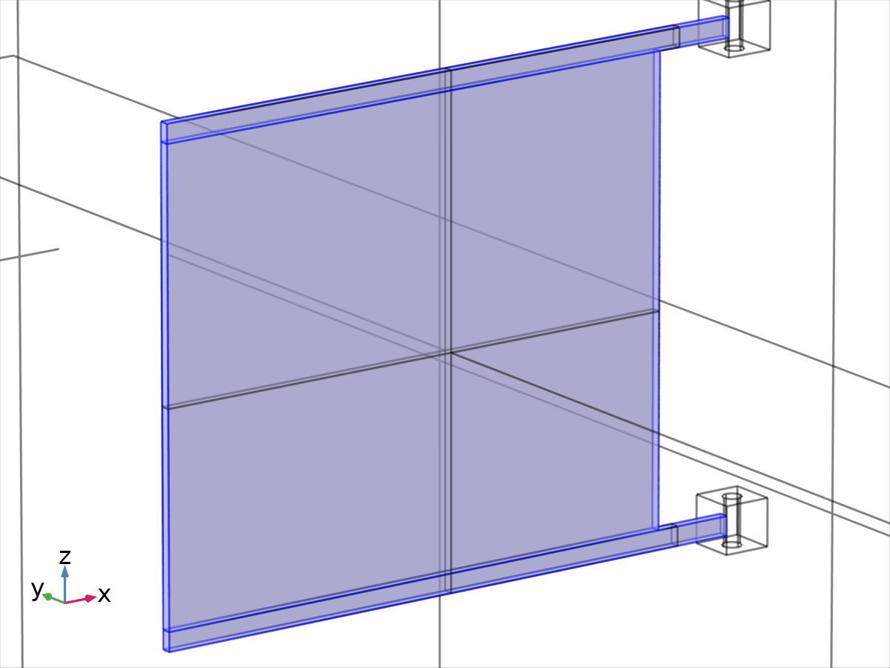
Free 1
Selection
Geometric entity level | Boundary
Selection | Geometry geom1: Dimension 2: All boundaries

    - Initial Values 1
Initial Values 1
Selection
Geometric entity level | Domain
Selection | Geometry geom1: Dimension 3: All domains

Equations
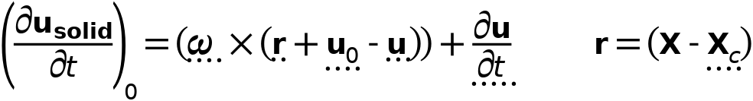

Initial values
Settings
Description | Value
Initial values | From physics interface node
Consistent initialization | Default

Coordinate system selection
Settings
Description | Value
Coordinate system | Global coordinate system

    - Attachment 1
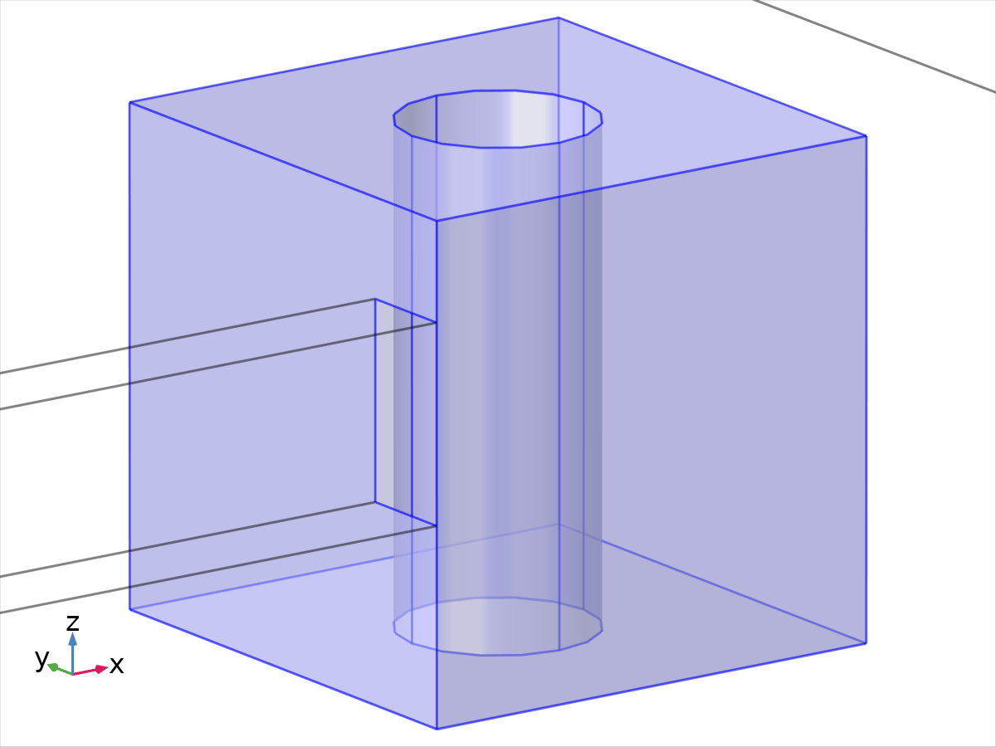
Attachment 1
Selection
Geometric entity level | Boundary
Name | Explicit 1
Selection | Named sel3: Geometry geom1: Dimension 2: Boundaries 65–67, 69, 75, 77–78, 81, 83, 85

Equations


Connection type
Settings
Description | Value
Connection type | Rigid

Constraint settings
Settings
Description | Value
Use weak constraints for rigid-flexible connection | Off

Variables
Name | Expression | Unit | Description | Selection | Details
mbd.att1.xcx | mbd.att1.int(X)/mbd.att1.area | m | Center of rotation, x component | Global
mbd.att1.xcy | mbd.att1.int(Y)/mbd.att1.area | m | Center of rotation, y component | Global
mbd.att1.xcz | mbd.att1.int(Z)/mbd.att1.area | m | Center of rotation, z component | Global
mbd.att1.rotxx | mbd.att1.a^2+mbd.att1.b^2-mbd.att1.c^2-mbd.att1.d^2 | 1 | Rotation matrix, xx component | Global
mbd.att1.rotyx | 2*(mbd.att1.b*mbd.att1.c+mbd.att1.a*mbd.att1.d) | 1 | Rotation matrix, yx component | Global
mbd.att1.rotzx | 2*(mbd.att1.b*mbd.att1.d-mbd.att1.a*mbd.att1.c) | 1 | Rotation matrix, zx component | Global
mbd.att1.rotxy | 2*(mbd.att1.b*mbd.att1.c-mbd.att1.a*mbd.att1.d) | 1 | Rotation matrix, xy component | Global
mbd.att1.rotyy | mbd.att1.a^2-mbd.att1.b^2+mbd.att1.c^2-mbd.att1.d^2 | 1 | Rotation matrix, yy component | Global
mbd.att1.rotzy | 2*(mbd.att1.c*mbd.att1.d+mbd.att1.a*mbd.att1.b) | 1 | Rotation matrix, zy component | Global
mbd.att1.rotxz | 2*(mbd.att1.b*mbd.att1.d+mbd.att1.a*mbd.att1.c) | 1 | Rotation matrix, xz component | Global
mbd.att1.rotyz | 2*(mbd.att1.c*mbd.att1.d-mbd.att1.a*mbd.att1.b) | 1 | Rotation matrix, yz component | Global
mbd.att1.rotzz | mbd.att1.a^2-mbd.att1.b^2-mbd.att1.c^2+mbd.att1.d^2 | 1 | Rotation matrix, zz component | Global
mbd.att1.Fx | mbd.att1.sum(mbd.att1.RFx) | N | Attachment force, x component | Global
mbd.att1.Fy | mbd.att1.sum(mbd.att1.RFy) | N | Attachment force, y component | Global
mbd.att1.Fz | mbd.att1.sum(mbd.att1.RFz) | N | Attachment force, z component | Global
mbd.att1.Mx | mbd.att1.sum(mbd.att1.RFz*(mbd.att1.rotyx*(X-mbd.att1.xcx)+mbd.att1.rotyy*(Y-mbd.att1.xcy)+mbd.att1.rotyz*(Z-mbd.att1.xcz))-mbd.att1.RFy*(mbd.att1.rotzx*(X-mbd.att1.xcx)+mbd.att1.rotzy*(Y-mbd.att1.xcy)+mbd.att1.rotzz*(Z-mbd.att1.xcz))) | N·m | Attachment moment, x component | Global
mbd.att1.My | mbd.att1.sum(-mbd.att1.RFz*(mbd.att1.rotxx*(X-mbd.att1.xcx)+mbd.att1.rotxy*(Y-mbd.att1.xcy)+mbd.att1.rotxz*(Z-mbd.att1.xcz))+mbd.att1.RFx*(mbd.att1.rotzx*(X-mbd.att1.xcx)+mbd.att1.rotzy*(Y-mbd.att1.xcy)+mbd.att1.rotzz*(Z-mbd.att1.xcz))) | N·m | Attachment moment, y component | Global
mbd.att1.Mz | mbd.att1.sum(mbd.att1.RFy*(mbd.att1.rotxx*(X-mbd.att1.xcx)+mbd.att1.rotxy*(Y-mbd.att1.xcy)+mbd.att1.rotxz*(Z-mbd.att1.xcz))-mbd.att1.RFx*(mbd.att1.rotyx*(X-mbd.att1.xcx)+mbd.att1.rotyy*(Y-mbd.att1.xcy)+mbd.att1.rotyz*(Z-mbd.att1.xcz))) | N·m | Attachment moment, z component | Global
mbd.att1.type | 1 |  | Attachment type | Global
mbd.att1.area | mbd.att1.int(1) | m² | Area | Global
mbd.att1.thx | 2*acos(min(max(mbd.att1.a,-1),1))*mbd.att1.b/sqrt(mbd.att1.b^2+mbd.att1.c^2+mbd.att1.d^2+eps) | rad | Rigid body rotation, x component | Global
mbd.att1.thy | 2*acos(min(max(mbd.att1.a,-1),1))*mbd.att1.c/sqrt(mbd.att1.b^2+mbd.att1.c^2+mbd.att1.d^2+eps) | rad | Rigid body rotation, y component | Global
mbd.att1.thz | 2*acos(min(max(mbd.att1.a,-1),1))*mbd.att1.d/sqrt(mbd.att1.b^2+mbd.att1.c^2+mbd.att1.d^2+eps) | rad | Rigid body rotation, z component | Global
mbd.att1.u_tx | d(mbd.att1.u,TIME) | m/s | Rigid body velocity, x component | Global
mbd.att1.u_ty | d(mbd.att1.v,TIME) | m/s | Rigid body velocity, y component | Global
mbd.att1.u_tz | d(mbd.att1.w,TIME) | m/s | Rigid body velocity, z component | Global
mbd.att1.u_ttx | d(mbd.att1.u_tx,TIME) | m/s² | Rigid body acceleration, x component | Global
mbd.att1.u_tty | d(mbd.att1.u_ty,TIME) | m/s² | Rigid body acceleration, y component | Global
mbd.att1.u_ttz | d(mbd.att1.u_tz,TIME) | m/s² | Rigid body acceleration, z component | Global
mbd.att1.q11 | d(mbd.att1.a,TIME) | 1/s | Intermediate variable, 1 component | Global
mbd.att1.q12 | d(mbd.att1.b,TIME) | 1/s | Intermediate variable, 2 component | Global
mbd.att1.q13 | d(mbd.att1.c,TIME) | 1/s | Intermediate variable, 3 component | Global
mbd.att1.q14 | d(mbd.att1.d,TIME) | 1/s | Intermediate variable, 4 component | Global
mbd.att1.q21 | mbd.att1.a | 1 | Intermediate variable, 1 component | Global
mbd.att1.q22 | -mbd.att1.b | 1 | Intermediate variable, 2 component | Global
mbd.att1.q23 | -mbd.att1.c | 1 | Intermediate variable, 3 component | Global
mbd.att1.q24 | -mbd.att1.d | 1 | Intermediate variable, 4 component | Global
mbd.att1.th_tx | 2*(mbd.att1.q12*mbd.att1.q21+mbd.att1.q11*mbd.att1.q22-mbd.att1.q14*mbd.att1.q23+mbd.att1.q13*mbd.att1.q24) | rad/s | Rigid body angular velocity, x component | Global
mbd.att1.th_ty | 2*(mbd.att1.q13*mbd.att1.q21+mbd.att1.q14*mbd.att1.q22+mbd.att1.q11*mbd.att1.q23-mbd.att1.q12*mbd.att1.q24) | rad/s | Rigid body angular velocity, y component | Global
mbd.att1.th_tz | 2*(mbd.att1.q14*mbd.att1.q21-mbd.att1.q13*mbd.att1.q22+mbd.att1.q12*mbd.att1.q23+mbd.att1.q11*mbd.att1.q24) | rad/s | Rigid body angular velocity, z component | Global
mbd.att1.th_ttx | d(mbd.att1.th_tx,TIME) | rad/s² | Rigid body angular acceleration, x component | Global
mbd.att1.th_tty | d(mbd.att1.th_ty,TIME) | rad/s² | Rigid body angular acceleration, y component | Global
mbd.att1.th_ttz | d(mbd.att1.th_tz,TIME) | rad/s² | Rigid body angular acceleration, z component | Global
mbd.att1.Usx | mbd.att1.rotxx*(X-mbd.att1.xcx)+mbd.att1.rotxy*(Y-mbd.att1.xcy)+mbd.att1.rotxz*(Z-mbd.att1.xcz)-X+mbd.att1.xcx+mbd.att1.u | m | Surface displacement, x component | Boundaries 65–67, 69, 75, 77–78, 81, 83, 85 | + operation
mbd.att1.Usy | mbd.att1.rotyx*(X-mbd.att1.xcx)+mbd.att1.rotyy*(Y-mbd.att1.xcy)+mbd.att1.rotyz*(Z-mbd.att1.xcz)-Y+mbd.att1.xcy+mbd.att1.v | m | Surface displacement, y component | Boundaries 65–67, 69, 75, 77–78, 81, 83, 85 | + operation
mbd.att1.Usz | mbd.att1.rotzx*(X-mbd.att1.xcx)+mbd.att1.rotzy*(Y-mbd.att1.xcy)+mbd.att1.rotzz*(Z-mbd.att1.xcz)-Z+mbd.att1.xcz+mbd.att1.w | m | Surface displacement, z component | Boundaries 65–67, 69, 75, 77–78, 81, 83, 85 | + operation
mbd.att1.RFx | if(mbd.att1.type==1,reacf(u_solid),0) | N | Reaction force, x component | Boundaries 65–67, 69, 75, 77–78, 81, 83, 85
mbd.att1.RFy | if(mbd.att1.type==1,reacf(v_solid),0) | N | Reaction force, y component | Boundaries 65–67, 69, 75, 77–78, 81, 83, 85
mbd.att1.RFz | if(mbd.att1.type==1,reacf(w_solid),0) | N | Reaction force, z component | Boundaries 65–67, 69, 75, 77–78, 81, 83, 85
mbd.att1.Eequ | if(mbd.att1.type==1,mbd.att1.int(mbd.Eequ)/mbd.att1.int(1),2.0E11) | Pa | Equivalent Young's modulus | Global

Constraints
Constraint | Constraint force | Shape function | Selection | Details
if(mbd.att1.type==1,1-mbd.att1.a^2-mbd.att1.b^2-mbd.att1.c^2-mbd.att1.d^2,0) | test(if(mbd.att1.type==1,1-mbd.att1.a^2-mbd.att1.b^2-mbd.att1.c^2-mbd.att1.d^2,0)) |  | Global | Elemental
-u_solid+mbd.att1.Usx | test(-u_solid+mbd.att1.Usx) | Lagrange (Linear) | Boundaries 65–67, 69, 75, 77–78, 81, 83, 85 | Elemental
-v_solid+mbd.att1.Usy | test(-v_solid+mbd.att1.Usy) | Lagrange (Linear) | Boundaries 65–67, 69, 75, 77–78, 81, 83, 85 | Elemental
-w_solid+mbd.att1.Usz | test(-w_solid+mbd.att1.Usz) | Lagrange (Linear) | Boundaries 65–67, 69, 75, 77–78, 81, 83, 85 | Elemental

    - Attachment 2
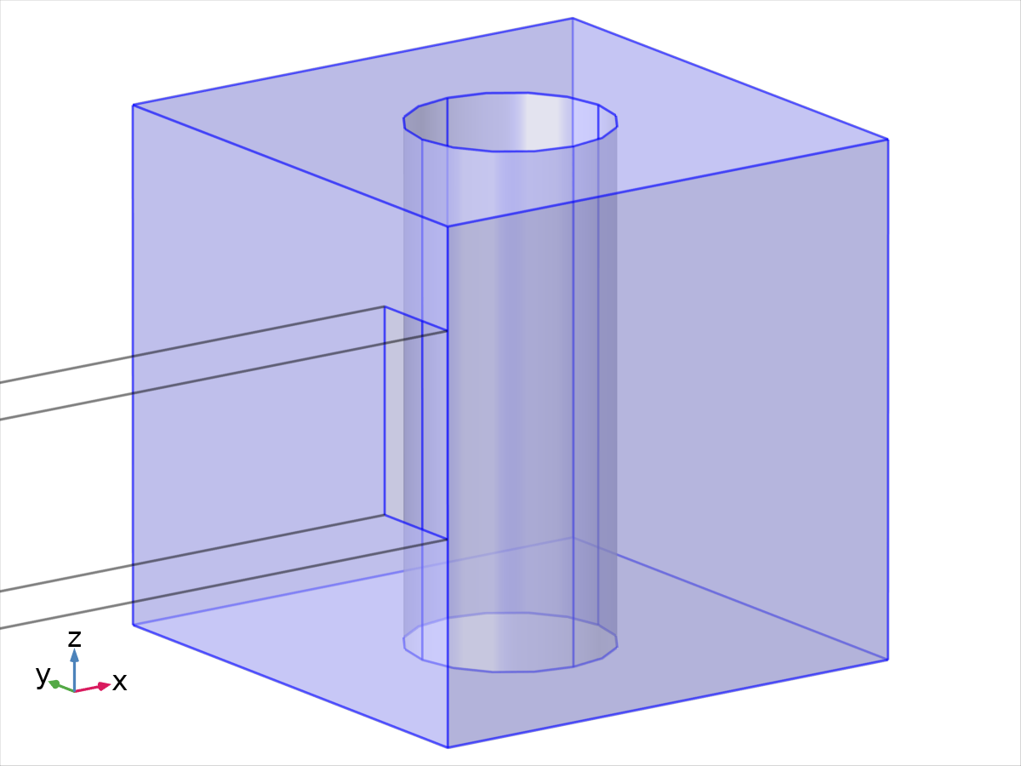
Attachment 2
Selection
Geometric entity level | Boundary
Name | Explicit 2
Selection | Named sel4: Geometry geom1: Dimension 2: Boundaries 70–72, 74, 76, 79–80, 82, 84, 86

Equations

Connection type
Settings
Description | Value
Connection type | Rigid

Constraint settings
Settings
Description | Value
Use weak constraints for rigid-flexible connection | Off

Variables
Name | Expression | Unit | Description | Selection | Details
mbd.att2.xcx | mbd.att2.int(X)/mbd.att2.area | m | Center of rotation, x component | Global
mbd.att2.xcy | mbd.att2.int(Y)/mbd.att2.area | m | Center of rotation, y component | Global
mbd.att2.xcz | mbd.att2.int(Z)/mbd.att2.area | m | Center of rotation, z component | Global
mbd.att2.rotxx | mbd.att2.a^2+mbd.att2.b^2-mbd.att2.c^2-mbd.att2.d^2 | 1 | Rotation matrix, xx component | Global
mbd.att2.rotyx | 2*(mbd.att2.b*mbd.att2.c+mbd.att2.a*mbd.att2.d) | 1 | Rotation matrix, yx component | Global
mbd.att2.rotzx | 2*(mbd.att2.b*mbd.att2.d-mbd.att2.a*mbd.att2.c) | 1 | Rotation matrix, zx component | Global
mbd.att2.rotxy | 2*(mbd.att2.b*mbd.att2.c-mbd.att2.a*mbd.att2.d) | 1 | Rotation matrix, xy component | Global
mbd.att2.rotyy | mbd.att2.a^2-mbd.att2.b^2+mbd.att2.c^2-mbd.att2.d^2 | 1 | Rotation matrix, yy component | Global
mbd.att2.rotzy | 2*(mbd.att2.c*mbd.att2.d+mbd.att2.a*mbd.att2.b) | 1 | Rotation matrix, zy component | Global
mbd.att2.rotxz | 2*(mbd.att2.b*mbd.att2.d+mbd.att2.a*mbd.att2.c) | 1 | Rotation matrix, xz component | Global
mbd.att2.rotyz | 2*(mbd.att2.c*mbd.att2.d-mbd.att2.a*mbd.att2.b) | 1 | Rotation matrix, yz component | Global
mbd.att2.rotzz | mbd.att2.a^2-mbd.att2.b^2-mbd.att2.c^2+mbd.att2.d^2 | 1 | Rotation matrix, zz component | Global
mbd.att2.Fx | mbd.att2.sum(mbd.att2.RFx) | N | Attachment force, x component | Global
mbd.att2.Fy | mbd.att2.sum(mbd.att2.RFy) | N | Attachment force, y component | Global
mbd.att2.Fz | mbd.att2.sum(mbd.att2.RFz) | N | Attachment force, z component | Global
mbd.att2.Mx | mbd.att2.sum(mbd.att2.RFz*(mbd.att2.rotyx*(X-mbd.att2.xcx)+mbd.att2.rotyy*(Y-mbd.att2.xcy)+mbd.att2.rotyz*(Z-mbd.att2.xcz))-mbd.att2.RFy*(mbd.att2.rotzx*(X-mbd.att2.xcx)+mbd.att2.rotzy*(Y-mbd.att2.xcy)+mbd.att2.rotzz*(Z-mbd.att2.xcz))) | N·m | Attachment moment, x component | Global
mbd.att2.My | mbd.att2.sum(-mbd.att2.RFz*(mbd.att2.rotxx*(X-mbd.att2.xcx)+mbd.att2.rotxy*(Y-mbd.att2.xcy)+mbd.att2.rotxz*(Z-mbd.att2.xcz))+mbd.att2.RFx*(mbd.att2.rotzx*(X-mbd.att2.xcx)+mbd.att2.rotzy*(Y-mbd.att2.xcy)+mbd.att2.rotzz*(Z-mbd.att2.xcz))) | N·m | Attachment moment, y component | Global
mbd.att2.Mz | mbd.att2.sum(mbd.att2.RFy*(mbd.att2.rotxx*(X-mbd.att2.xcx)+mbd.att2.rotxy*(Y-mbd.att2.xcy)+mbd.att2.rotxz*(Z-mbd.att2.xcz))-mbd.att2.RFx*(mbd.att2.rotyx*(X-mbd.att2.xcx)+mbd.att2.rotyy*(Y-mbd.att2.xcy)+mbd.att2.rotyz*(Z-mbd.att2.xcz))) | N·m | Attachment moment, z component | Global
mbd.att2.type | 1 |  | Attachment type | Global
mbd.att2.area | mbd.att2.int(1) | m² | Area | Global
mbd.att2.thx | 2*acos(min(max(mbd.att2.a,-1),1))*mbd.att2.b/sqrt(mbd.att2.b^2+mbd.att2.c^2+mbd.att2.d^2+eps) | rad | Rigid body rotation, x component | Global
mbd.att2.thy | 2*acos(min(max(mbd.att2.a,-1),1))*mbd.att2.c/sqrt(mbd.att2.b^2+mbd.att2.c^2+mbd.att2.d^2+eps) | rad | Rigid body rotation, y component | Global
mbd.att2.thz | 2*acos(min(max(mbd.att2.a,-1),1))*mbd.att2.d/sqrt(mbd.att2.b^2+mbd.att2.c^2+mbd.att2.d^2+eps) | rad | Rigid body rotation, z component | Global
mbd.att2.u_tx | d(mbd.att2.u,TIME) | m/s | Rigid body velocity, x component | Global
mbd.att2.u_ty | d(mbd.att2.v,TIME) | m/s | Rigid body velocity, y component | Global
mbd.att2.u_tz | d(mbd.att2.w,TIME) | m/s | Rigid body velocity, z component | Global
mbd.att2.u_ttx | d(mbd.att2.u_tx,TIME) | m/s² | Rigid body acceleration, x component | Global
mbd.att2.u_tty | d(mbd.att2.u_ty,TIME) | m/s² | Rigid body acceleration, y component | Global
mbd.att2.u_ttz | d(mbd.att2.u_tz,TIME) | m/s² | Rigid body acceleration, z component | Global
mbd.att2.q11 | d(mbd.att2.a,TIME) | 1/s | Intermediate variable, 1 component | Global
mbd.att2.q12 | d(mbd.att2.b,TIME) | 1/s | Intermediate variable, 2 component | Global
mbd.att2.q13 | d(mbd.att2.c,TIME) | 1/s | Intermediate variable, 3 component | Global
mbd.att2.q14 | d(mbd.att2.d,TIME) | 1/s | Intermediate variable, 4 component | Global
mbd.att2.q21 | mbd.att2.a | 1 | Intermediate variable, 1 component | Global
mbd.att2.q22 | -mbd.att2.b | 1 | Intermediate variable, 2 component | Global
mbd.att2.q23 | -mbd.att2.c | 1 | Intermediate variable, 3 component | Global
mbd.att2.q24 | -mbd.att2.d | 1 | Intermediate variable, 4 component | Global
mbd.att2.th_tx | 2*(mbd.att2.q12*mbd.att2.q21+mbd.att2.q11*mbd.att2.q22-mbd.att2.q14*mbd.att2.q23+mbd.att2.q13*mbd.att2.q24) | rad/s | Rigid body angular velocity, x component | Global
mbd.att2.th_ty | 2*(mbd.att2.q13*mbd.att2.q21+mbd.att2.q14*mbd.att2.q22+mbd.att2.q11*mbd.att2.q23-mbd.att2.q12*mbd.att2.q24) | rad/s | Rigid body angular velocity, y component | Global
mbd.att2.th_tz | 2*(mbd.att2.q14*mbd.att2.q21-mbd.att2.q13*mbd.att2.q22+mbd.att2.q12*mbd.att2.q23+mbd.att2.q11*mbd.att2.q24) | rad/s | Rigid body angular velocity, z component | Global
mbd.att2.th_ttx | d(mbd.att2.th_tx,TIME) | rad/s² | Rigid body angular acceleration, x component | Global
mbd.att2.th_tty | d(mbd.att2.th_ty,TIME) | rad/s² | Rigid body angular acceleration, y component | Global
mbd.att2.th_ttz | d(mbd.att2.th_tz,TIME) | rad/s² | Rigid body angular acceleration, z component | Global
mbd.att2.Usx | mbd.att2.rotxx*(X-mbd.att2.xcx)+mbd.att2.rotxy*(Y-mbd.att2.xcy)+mbd.att2.rotxz*(Z-mbd.att2.xcz)-X+mbd.att2.xcx+mbd.att2.u | m | Surface displacement, x component | Boundaries 70–72, 74, 76, 79–80, 82, 84, 86 | + operation
mbd.att2.Usy | mbd.att2.rotyx*(X-mbd.att2.xcx)+mbd.att2.rotyy*(Y-mbd.att2.xcy)+mbd.att2.rotyz*(Z-mbd.att2.xcz)-Y+mbd.att2.xcy+mbd.att2.v | m | Surface displacement, y component | Boundaries 70–72, 74, 76, 79–80, 82, 84, 86 | + operation
mbd.att2.Usz | mbd.att2.rotzx*(X-mbd.att2.xcx)+mbd.att2.rotzy*(Y-mbd.att2.xcy)+mbd.att2.rotzz*(Z-mbd.att2.xcz)-Z+mbd.att2.xcz+mbd.att2.w | m | Surface displacement, z component | Boundaries 70–72, 74, 76, 79–80, 82, 84, 86 | + operation
mbd.att2.RFx | if(mbd.att2.type==1,reacf(u_solid),0) | N | Reaction force, x component | Boundaries 70–72, 74, 76, 79–80, 82, 84, 86
mbd.att2.RFy | if(mbd.att2.type==1,reacf(v_solid),0) | N | Reaction force, y component | Boundaries 70–72, 74, 76, 79–80, 82, 84, 86
mbd.att2.RFz | if(mbd.att2.type==1,reacf(w_solid),0) | N | Reaction force, z component | Boundaries 70–72, 74, 76, 79–80, 82, 84, 86
mbd.att2.Eequ | if(mbd.att2.type==1,mbd.att2.int(mbd.Eequ)/mbd.att2.int(1),2.0E11) | Pa | Equivalent Young's modulus | Global

Constraints
Constraint | Constraint force | Shape function | Selection | Details
if(mbd.att2.type==1,1-mbd.att2.a^2-mbd.att2.b^2-mbd.att2.c^2-mbd.att2.d^2,0) | test(if(mbd.att2.type==1,1-mbd.att2.a^2-mbd.att2.b^2-mbd.att2.c^2-mbd.att2.d^2,0)) |  | Global | Elemental
-u_solid+mbd.att2.Usx | test(-u_solid+mbd.att2.Usx) | Lagrange (Linear) | Boundaries 70–72, 74, 76, 79–80, 82, 84, 86 | Elemental
-v_solid+mbd.att2.Usy | test(-v_solid+mbd.att2.Usy) | Lagrange (Linear) | Boundaries 70–72, 74, 76, 79–80, 82, 84, 86 | Elemental
-w_solid+mbd.att2.Usz | test(-w_solid+mbd.att2.Usz) | Lagrange (Linear) | Boundaries 70–72, 74, 76, 79–80, 82, 84, 86 | Elemental

    - Hinge Joint 1
Selection
Geometric entity level | Entire model

Equations


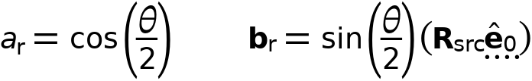


Attachment selection
Settings
Description | Value
Source | Fixed
Destination | Attachment 1
Use selection filter | Off

Center of joint
Settings
Description | Value
Center of joint | Centroid of destination
Offset | Off

Axis of joint
Settings
Description | Value
Axis of joint | Specify direction
Axis of joint, x component | 0
Axis of joint, y component | 0
Axis of joint, z component | 1

Joint elasticity
Settings
Description | Value
Joint elasticity | Rigid joint

Joint forces and moments
Settings
Description | Value
Joint forces and moments | Computed on destination

Coordinate system selection
Settings
Description | Value
Coordinate system | Global coordinate system

Variables
Name | Expression | Unit | Description | Selection | Details
mbd.hgj1.xcx | mbd.att1.xcx | m | Center of joint, x component | Global | + operation
mbd.hgj1.xcy | mbd.att1.xcy | m | Center of joint, y component | Global | + operation
mbd.hgj1.xcz | mbd.att1.xcz | m | Center of joint, z component | Global | + operation
mbd.hgj1.e10x | 0 | 1 | Initial joint axis, x component | Global
mbd.hgj1.e10y | 0 | 1 | Initial joint axis, y component | Global
mbd.hgj1.e10z | 1 | 1 | Initial joint axis, z component | Global
mbd.hgj1.e20x | (mbd.hgj1.e_auxz*mbd.hgj1.e10y-mbd.hgj1.e_auxy*mbd.hgj1.e10z)/sqrt((mbd.hgj1.e_auxz*mbd.hgj1.e10y-mbd.hgj1.e_auxy*mbd.hgj1.e10z)^2+(-mbd.hgj1.e_auxz*mbd.hgj1.e10x+mbd.hgj1.e_auxx*mbd.hgj1.e10z)^2+(mbd.hgj1.e_auxy*mbd.hgj1.e10x-mbd.hgj1.e_auxx*mbd.hgj1.e10y)^2) | 1 | Initial second axis, x component | Global
mbd.hgj1.e20y | (-mbd.hgj1.e_auxz*mbd.hgj1.e10x+mbd.hgj1.e_auxx*mbd.hgj1.e10z)/sqrt((mbd.hgj1.e_auxz*mbd.hgj1.e10y-mbd.hgj1.e_auxy*mbd.hgj1.e10z)^2+(-mbd.hgj1.e_auxz*mbd.hgj1.e10x+mbd.hgj1.e_auxx*mbd.hgj1.e10z)^2+(mbd.hgj1.e_auxy*mbd.hgj1.e10x-mbd.hgj1.e_auxx*mbd.hgj1.e10y)^2) | 1 | Initial second axis, y component | Global
mbd.hgj1.e20z | (mbd.hgj1.e_auxy*mbd.hgj1.e10x-mbd.hgj1.e_auxx*mbd.hgj1.e10y)/sqrt((mbd.hgj1.e_auxz*mbd.hgj1.e10y-mbd.hgj1.e_auxy*mbd.hgj1.e10z)^2+(-mbd.hgj1.e_auxz*mbd.hgj1.e10x+mbd.hgj1.e_auxx*mbd.hgj1.e10z)^2+(mbd.hgj1.e_auxy*mbd.hgj1.e10x-mbd.hgj1.e_auxx*mbd.hgj1.e10y)^2) | 1 | Initial second axis, z component | Global
mbd.hgj1.e30x | (mbd.hgj1.e20z*mbd.hgj1.e10y-mbd.hgj1.e20y*mbd.hgj1.e10z)/sqrt((mbd.hgj1.e20z*mbd.hgj1.e10y-mbd.hgj1.e20y*mbd.hgj1.e10z)^2+(-mbd.hgj1.e20z*mbd.hgj1.e10x+mbd.hgj1.e20x*mbd.hgj1.e10z)^2+(mbd.hgj1.e20y*mbd.hgj1.e10x-mbd.hgj1.e20x*mbd.hgj1.e10y)^2) | 1 | Initial third axis, x component | Global
mbd.hgj1.e30y | (-mbd.hgj1.e20z*mbd.hgj1.e10x+mbd.hgj1.e20x*mbd.hgj1.e10z)/sqrt((mbd.hgj1.e20z*mbd.hgj1.e10y-mbd.hgj1.e20y*mbd.hgj1.e10z)^2+(-mbd.hgj1.e20z*mbd.hgj1.e10x+mbd.hgj1.e20x*mbd.hgj1.e10z)^2+(mbd.hgj1.e20y*mbd.hgj1.e10x-mbd.hgj1.e20x*mbd.hgj1.e10y)^2) | 1 | Initial third axis, y component | Global
mbd.hgj1.e30z | (mbd.hgj1.e20y*mbd.hgj1.e10x-mbd.hgj1.e20x*mbd.hgj1.e10y)/sqrt((mbd.hgj1.e20z*mbd.hgj1.e10y-mbd.hgj1.e20y*mbd.hgj1.e10z)^2+(-mbd.hgj1.e20z*mbd.hgj1.e10x+mbd.hgj1.e20x*mbd.hgj1.e10z)^2+(mbd.hgj1.e20y*mbd.hgj1.e10x-mbd.hgj1.e20x*mbd.hgj1.e10y)^2) | 1 | Initial third axis, z component | Global
mbd.hgj1.e1x | mbd.hgj1.rot_srcxx*mbd.hgj1.e10x+mbd.hgj1.rot_srcxy*mbd.hgj1.e10y+mbd.hgj1.rot_srcxz*mbd.hgj1.e10z | 1 | Joint axis, x component | Global
mbd.hgj1.e1y | mbd.hgj1.rot_srcyx*mbd.hgj1.e10x+mbd.hgj1.rot_srcyy*mbd.hgj1.e10y+mbd.hgj1.rot_srcyz*mbd.hgj1.e10z | 1 | Joint axis, y component | Global
mbd.hgj1.e1z | mbd.hgj1.rot_srczx*mbd.hgj1.e10x+mbd.hgj1.rot_srczy*mbd.hgj1.e10y+mbd.hgj1.rot_srczz*mbd.hgj1.e10z | 1 | Joint axis, z component | Global
mbd.hgj1.e2x | mbd.hgj1.rot_srcxx*mbd.hgj1.e20x+mbd.hgj1.rot_srcxy*mbd.hgj1.e20y+mbd.hgj1.rot_srcxz*mbd.hgj1.e20z | 1 | Second axis, x component | Global
mbd.hgj1.e2y | mbd.hgj1.rot_srcyx*mbd.hgj1.e20x+mbd.hgj1.rot_srcyy*mbd.hgj1.e20y+mbd.hgj1.rot_srcyz*mbd.hgj1.e20z | 1 | Second axis, y component | Global
mbd.hgj1.e2z | mbd.hgj1.rot_srczx*mbd.hgj1.e20x+mbd.hgj1.rot_srczy*mbd.hgj1.e20y+mbd.hgj1.rot_srczz*mbd.hgj1.e20z | 1 | Second axis, z component | Global
mbd.hgj1.e3x | mbd.hgj1.rot_srcxx*mbd.hgj1.e30x+mbd.hgj1.rot_srcxy*mbd.hgj1.e30y+mbd.hgj1.rot_srcxz*mbd.hgj1.e30z | 1 | Third axis, x component | Global
mbd.hgj1.e3y | mbd.hgj1.rot_srcyx*mbd.hgj1.e30x+mbd.hgj1.rot_srcyy*mbd.hgj1.e30y+mbd.hgj1.rot_srcyz*mbd.hgj1.e30z | 1 | Third axis, y component | Global
mbd.hgj1.e3z | mbd.hgj1.rot_srczx*mbd.hgj1.e30x+mbd.hgj1.rot_srczy*mbd.hgj1.e30y+mbd.hgj1.rot_srczz*mbd.hgj1.e30z | 1 | Third axis, z component | Global
mbd.hgj1.e_auxx | 1+mbd.hgj1.e10x-(abs(mbd.hgj1.e10x)>=0.99) | 1 | Auxiliary axis, x component | Global
mbd.hgj1.e_auxy | mbd.hgj1.e10y+(abs(mbd.hgj1.e10x)>=0.99) | 1 | Auxiliary axis, y component | Global
mbd.hgj1.e_auxz | mbd.hgj1.e10z | 1 | Auxiliary axis, z component | Global
mbd.hgj1.uc_src | 0 | m | Source displacement at center of joint, x component | Global
mbd.hgj1.vc_src | 0 | m | Source displacement at center of joint, y component | Global
mbd.hgj1.wc_src | 0 | m | Source displacement at center of joint, z component | Global
mbd.hgj1.uc_dest | mbd.att1.rotxx*(mbd.hgj1.xcx-mbd.att1.xcx)+mbd.att1.rotxy*(mbd.hgj1.xcy-mbd.att1.xcy)+mbd.att1.rotxz*(mbd.hgj1.xcz-mbd.att1.xcz)-mbd.hgj1.xcx+mbd.att1.xcx+mbd.att1.u | m | Destination displacement at center of joint, x component | Global
mbd.hgj1.vc_dest | mbd.att1.rotyx*(mbd.hgj1.xcx-mbd.att1.xcx)+mbd.att1.rotyy*(mbd.hgj1.xcy-mbd.att1.xcy)+mbd.att1.rotyz*(mbd.hgj1.xcz-mbd.att1.xcz)-mbd.hgj1.xcy+mbd.att1.xcy+mbd.att1.v | m | Destination displacement at center of joint, y component | Global
mbd.hgj1.wc_dest | mbd.att1.rotzx*(mbd.hgj1.xcx-mbd.att1.xcx)+mbd.att1.rotzy*(mbd.hgj1.xcy-mbd.att1.xcy)+mbd.att1.rotzz*(mbd.hgj1.xcz-mbd.att1.xcz)-mbd.hgj1.xcz+mbd.att1.xcz+mbd.att1.w | m | Destination displacement at center of joint, z component | Global
mbd.hgj1.a_src | 1 | 1 | Source rotation, real part | Global
mbd.hgj1.b_src | 0 | 1 | Source rotation, imaginary part, x component | Global
mbd.hgj1.c_src | 0 | 1 | Source rotation, imaginary part, y component | Global
mbd.hgj1.d_src | 0 | 1 | Source rotation, imaginary part, z component | Global
mbd.hgj1.a_dest | mbd.att1.a | 1 | Destination rotation, real part | Global
mbd.hgj1.b_dest | mbd.att1.b | 1 | Destination rotation, imaginary part, x component | Global
mbd.hgj1.c_dest | mbd.att1.c | 1 | Destination rotation, imaginary part, y component | Global
mbd.hgj1.d_dest | mbd.att1.d | 1 | Destination rotation, imaginary part, z component | Global
mbd.hgj1.rot_srcxx | 1 | 1 | Source rotation matrix, xx component | Global
mbd.hgj1.rot_srcyx | 0 | 1 | Source rotation matrix, yx component | Global
mbd.hgj1.rot_srczx | 0 | 1 | Source rotation matrix, zx component | Global
mbd.hgj1.rot_srcxy | 0 | 1 | Source rotation matrix, xy component | Global
mbd.hgj1.rot_srcyy | 1 | 1 | Source rotation matrix, yy component | Global
mbd.hgj1.rot_srczy | 0 | 1 | Source rotation matrix, zy component | Global
mbd.hgj1.rot_srcxz | 0 | 1 | Source rotation matrix, xz component | Global
mbd.hgj1.rot_srcyz | 0 | 1 | Source rotation matrix, yz component | Global
mbd.hgj1.rot_srczz | 1 | 1 | Source rotation matrix, zz component | Global
mbd.hgj1.ar | cos(0.5*mbd.hgj1.thm) | 1 | Relative quaternion, real part | Global
mbd.hgj1.br | sin(0.5*mbd.hgj1.thm)*mbd.hgj1.e1x | 1 | Relative quaternion, imaginary part, x component | Global
mbd.hgj1.cr | sin(0.5*mbd.hgj1.thm)*mbd.hgj1.e1y | 1 | Relative quaternion, imaginary part, y component | Global
mbd.hgj1.dr | sin(0.5*mbd.hgj1.thm)*mbd.hgj1.e1z | 1 | Relative quaternion, imaginary part, z component | Global
mbd.hgj1.th_t | d(mbd.hgj1.thm,TIME) | rad/s | Relative angular velocity | Global
mbd.hgj1.th_tt | d(mbd.hgj1.th_t,TIME) | rad/s² | Relative angular acceleration | Global
mbd.hgj1.Fx | mbd.att1.Fx | N | Joint force, x component | Global | + operation
mbd.hgj1.Fy | mbd.att1.Fy | N | Joint force, y component | Global | + operation
mbd.hgj1.Fz | mbd.att1.Fz | N | Joint force, z component | Global | + operation
mbd.hgj1.rx | mbd.att1.xcx+mbd.att1.u-mbd.hgj1.xcx-mbd.hgj1.uc_src | m | Joint moment arm, x component | Global
mbd.hgj1.ry | mbd.att1.xcy+mbd.att1.v-mbd.hgj1.xcy-mbd.hgj1.vc_src | m | Joint moment arm, y component | Global
mbd.hgj1.rz | mbd.att1.xcz+mbd.att1.w-mbd.hgj1.xcz-mbd.hgj1.wc_src | m | Joint moment arm, z component | Global
mbd.hgj1.Mx | mbd.att1.Mx+mbd.hgj1.Fz*mbd.hgj1.ry-mbd.hgj1.Fy*mbd.hgj1.rz | N·m | Joint moment, x component | Global | + operation
mbd.hgj1.My | mbd.att1.My-mbd.hgj1.Fz*mbd.hgj1.rx+mbd.hgj1.Fx*mbd.hgj1.rz | N·m | Joint moment, y component | Global | + operation
mbd.hgj1.Mz | mbd.att1.Mz+mbd.hgj1.Fy*mbd.hgj1.rx-mbd.hgj1.Fx*mbd.hgj1.ry | N·m | Joint moment, z component | Global | + operation
mbd.hgj1.Fl1 | mbd.hgj1.Fx*mbd.hgj1.e1x+mbd.hgj1.Fy*mbd.hgj1.e1y+mbd.hgj1.Fz*mbd.hgj1.e1z | N | Joint force, local coordinate system, 1 component | Global
mbd.hgj1.Fl2 | mbd.hgj1.Fx*mbd.hgj1.e2x+mbd.hgj1.Fy*mbd.hgj1.e2y+mbd.hgj1.Fz*mbd.hgj1.e2z | N | Joint force, local coordinate system, 2 component | Global
mbd.hgj1.Fl3 | mbd.hgj1.Fx*mbd.hgj1.e3x+mbd.hgj1.Fy*mbd.hgj1.e3y+mbd.hgj1.Fz*mbd.hgj1.e3z | N | Joint force, local coordinate system, 3 component | Global
mbd.hgj1.Ml1 | mbd.hgj1.Mx*mbd.hgj1.e1x+mbd.hgj1.My*mbd.hgj1.e1y+mbd.hgj1.Mz*mbd.hgj1.e1z | N·m | Joint moment, local coordinate system, 1 component | Global
mbd.hgj1.Ml2 | mbd.hgj1.Mx*mbd.hgj1.e2x+mbd.hgj1.My*mbd.hgj1.e2y+mbd.hgj1.Mz*mbd.hgj1.e2z | N·m | Joint moment, local coordinate system, 2 component | Global
mbd.hgj1.Ml3 | mbd.hgj1.Mx*mbd.hgj1.e3x+mbd.hgj1.My*mbd.hgj1.e3y+mbd.hgj1.Mz*mbd.hgj1.e3z | N·m | Joint moment, local coordinate system, 3 component | Global
mbd.hgj1.Wspring | 0 | J | Energy stored in spring | Global | + operation
mbd.hgj1.Qdamper | 0 | W | Energy dissipation rate in damper | Global | + operation
mbd.hgj1.Qfriction | 0 | W | Energy dissipation rate due to friction | Global | + operation

Shape functions
Name | Shape function | Unit | Description | Shape frame | Selection
mbd.hgj1.th | ODE | rad | Relative rotation |  | Global

Constraints
Constraint | Constraint force | Shape function | Selection | Details
mbd.hgj1.uc_src-mbd.hgj1.uc_dest | test(mbd.hgj1.uc_src-mbd.hgj1.uc_dest) |  | Global | Elemental
mbd.hgj1.vc_src-mbd.hgj1.vc_dest | test(mbd.hgj1.vc_src-mbd.hgj1.vc_dest) |  | Global | Elemental
mbd.hgj1.wc_src-mbd.hgj1.wc_dest | test(mbd.hgj1.wc_src-mbd.hgj1.wc_dest) |  | Global | Elemental
-mbd.hgj1.b_dest+mbd.hgj1.a_src*mbd.hgj1.br+mbd.hgj1.d_src*mbd.hgj1.cr-mbd.hgj1.c_src*mbd.hgj1.dr+mbd.hgj1.b_src*mbd.hgj1.ar | test(-mbd.hgj1.b_dest+mbd.hgj1.a_src*mbd.hgj1.br+mbd.hgj1.d_src*mbd.hgj1.cr-mbd.hgj1.c_src*mbd.hgj1.dr+mbd.hgj1.b_src*mbd.hgj1.ar) |  | Global | Elemental
-mbd.hgj1.c_dest-mbd.hgj1.d_src*mbd.hgj1.br+mbd.hgj1.a_src*mbd.hgj1.cr+mbd.hgj1.b_src*mbd.hgj1.dr+mbd.hgj1.c_src*mbd.hgj1.ar | test(-mbd.hgj1.c_dest-mbd.hgj1.d_src*mbd.hgj1.br+mbd.hgj1.a_src*mbd.hgj1.cr+mbd.hgj1.b_src*mbd.hgj1.dr+mbd.hgj1.c_src*mbd.hgj1.ar) |  | Global | Elemental
-mbd.hgj1.d_dest+mbd.hgj1.c_src*mbd.hgj1.br-mbd.hgj1.b_src*mbd.hgj1.cr+mbd.hgj1.a_src*mbd.hgj1.dr+mbd.hgj1.d_src*mbd.hgj1.ar | test(-mbd.hgj1.d_dest+mbd.hgj1.c_src*mbd.hgj1.br-mbd.hgj1.b_src*mbd.hgj1.cr+mbd.hgj1.a_src*mbd.hgj1.dr+mbd.hgj1.d_src*mbd.hgj1.ar) |  | Global | Elemental

Prescribed Motion 1
Selection
Geometric entity level | Entire model

Equations
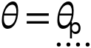

Prescribed rotational motion
Settings
Description | Value
Prescribed motion through | Rotation
Prescribed relative rotation | th1
Activation condition | Always active

Reaction force settings
Settings
Description | Value
Evaluate reaction forces | Off
Apply reaction only on joint variables | Off

Variables
Name | Expression | Unit | Description | Selection
mbd.hgj1.pm1.thp | th1 | rad | Prescribed relative rotation | Global

Constraints
Constraint | Constraint force | Shape function | Selection | Details
-mbd.hgj1.th+mbd.hgj1.pm1.thp | test(-mbd.hgj1.th+mbd.hgj1.pm1.thp) |  | Global | Elemental

    - Hinge Joint 2
Selection
Geometric entity level | Entire model

Equations

Attachment selection
Settings
Description | Value
Source | Fixed
Destination | Attachment 2
Use selection filter | Off

Center of joint
Settings
Description | Value
Center of joint | Centroid of destination
Offset | Off

Axis of joint
Settings
Description | Value
Axis of joint | Specify direction
Axis of joint, x component | 0
Axis of joint, y component | 0
Axis of joint, z component | 1

Joint elasticity
Settings
Description | Value
Joint elasticity | Rigid joint

Joint forces and moments
Settings
Description | Value
Joint forces and moments | Computed on destination

Coordinate system selection
Settings
Description | Value
Coordinate system | Global coordinate system

Variables
Name | Expression | Unit | Description | Selection | Details
mbd.hgj2.xcx | mbd.att2.xcx | m | Center of joint, x component | Global | + operation
mbd.hgj2.xcy | mbd.att2.xcy | m | Center of joint, y component | Global | + operation
mbd.hgj2.xcz | mbd.att2.xcz | m | Center of joint, z component | Global | + operation
mbd.hgj2.e10x | 0 | 1 | Initial joint axis, x component | Global
mbd.hgj2.e10y | 0 | 1 | Initial joint axis, y component | Global
mbd.hgj2.e10z | 1 | 1 | Initial joint axis, z component | Global
mbd.hgj2.e20x | (mbd.hgj2.e_auxz*mbd.hgj2.e10y-mbd.hgj2.e_auxy*mbd.hgj2.e10z)/sqrt((mbd.hgj2.e_auxz*mbd.hgj2.e10y-mbd.hgj2.e_auxy*mbd.hgj2.e10z)^2+(-mbd.hgj2.e_auxz*mbd.hgj2.e10x+mbd.hgj2.e_auxx*mbd.hgj2.e10z)^2+(mbd.hgj2.e_auxy*mbd.hgj2.e10x-mbd.hgj2.e_auxx*mbd.hgj2.e10y)^2) | 1 | Initial second axis, x component | Global
mbd.hgj2.e20y | (-mbd.hgj2.e_auxz*mbd.hgj2.e10x+mbd.hgj2.e_auxx*mbd.hgj2.e10z)/sqrt((mbd.hgj2.e_auxz*mbd.hgj2.e10y-mbd.hgj2.e_auxy*mbd.hgj2.e10z)^2+(-mbd.hgj2.e_auxz*mbd.hgj2.e10x+mbd.hgj2.e_auxx*mbd.hgj2.e10z)^2+(mbd.hgj2.e_auxy*mbd.hgj2.e10x-mbd.hgj2.e_auxx*mbd.hgj2.e10y)^2) | 1 | Initial second axis, y component | Global
mbd.hgj2.e20z | (mbd.hgj2.e_auxy*mbd.hgj2.e10x-mbd.hgj2.e_auxx*mbd.hgj2.e10y)/sqrt((mbd.hgj2.e_auxz*mbd.hgj2.e10y-mbd.hgj2.e_auxy*mbd.hgj2.e10z)^2+(-mbd.hgj2.e_auxz*mbd.hgj2.e10x+mbd.hgj2.e_auxx*mbd.hgj2.e10z)^2+(mbd.hgj2.e_auxy*mbd.hgj2.e10x-mbd.hgj2.e_auxx*mbd.hgj2.e10y)^2) | 1 | Initial second axis, z component | Global
mbd.hgj2.e30x | (mbd.hgj2.e20z*mbd.hgj2.e10y-mbd.hgj2.e20y*mbd.hgj2.e10z)/sqrt((mbd.hgj2.e20z*mbd.hgj2.e10y-mbd.hgj2.e20y*mbd.hgj2.e10z)^2+(-mbd.hgj2.e20z*mbd.hgj2.e10x+mbd.hgj2.e20x*mbd.hgj2.e10z)^2+(mbd.hgj2.e20y*mbd.hgj2.e10x-mbd.hgj2.e20x*mbd.hgj2.e10y)^2) | 1 | Initial third axis, x component | Global
mbd.hgj2.e30y | (-mbd.hgj2.e20z*mbd.hgj2.e10x+mbd.hgj2.e20x*mbd.hgj2.e10z)/sqrt((mbd.hgj2.e20z*mbd.hgj2.e10y-mbd.hgj2.e20y*mbd.hgj2.e10z)^2+(-mbd.hgj2.e20z*mbd.hgj2.e10x+mbd.hgj2.e20x*mbd.hgj2.e10z)^2+(mbd.hgj2.e20y*mbd.hgj2.e10x-mbd.hgj2.e20x*mbd.hgj2.e10y)^2) | 1 | Initial third axis, y component | Global
mbd.hgj2.e30z | (mbd.hgj2.e20y*mbd.hgj2.e10x-mbd.hgj2.e20x*mbd.hgj2.e10y)/sqrt((mbd.hgj2.e20z*mbd.hgj2.e10y-mbd.hgj2.e20y*mbd.hgj2.e10z)^2+(-mbd.hgj2.e20z*mbd.hgj2.e10x+mbd.hgj2.e20x*mbd.hgj2.e10z)^2+(mbd.hgj2.e20y*mbd.hgj2.e10x-mbd.hgj2.e20x*mbd.hgj2.e10y)^2) | 1 | Initial third axis, z component | Global
mbd.hgj2.e1x | mbd.hgj2.rot_srcxx*mbd.hgj2.e10x+mbd.hgj2.rot_srcxy*mbd.hgj2.e10y+mbd.hgj2.rot_srcxz*mbd.hgj2.e10z | 1 | Joint axis, x component | Global
mbd.hgj2.e1y | mbd.hgj2.rot_srcyx*mbd.hgj2.e10x+mbd.hgj2.rot_srcyy*mbd.hgj2.e10y+mbd.hgj2.rot_srcyz*mbd.hgj2.e10z | 1 | Joint axis, y component | Global
mbd.hgj2.e1z | mbd.hgj2.rot_srczx*mbd.hgj2.e10x+mbd.hgj2.rot_srczy*mbd.hgj2.e10y+mbd.hgj2.rot_srczz*mbd.hgj2.e10z | 1 | Joint axis, z component | Global
mbd.hgj2.e2x | mbd.hgj2.rot_srcxx*mbd.hgj2.e20x+mbd.hgj2.rot_srcxy*mbd.hgj2.e20y+mbd.hgj2.rot_srcxz*mbd.hgj2.e20z | 1 | Second axis, x component | Global
mbd.hgj2.e2y | mbd.hgj2.rot_srcyx*mbd.hgj2.e20x+mbd.hgj2.rot_srcyy*mbd.hgj2.e20y+mbd.hgj2.rot_srcyz*mbd.hgj2.e20z | 1 | Second axis, y component | Global
mbd.hgj2.e2z | mbd.hgj2.rot_srczx*mbd.hgj2.e20x+mbd.hgj2.rot_srczy*mbd.hgj2.e20y+mbd.hgj2.rot_srczz*mbd.hgj2.e20z | 1 | Second axis, z component | Global
mbd.hgj2.e3x | mbd.hgj2.rot_srcxx*mbd.hgj2.e30x+mbd.hgj2.rot_srcxy*mbd.hgj2.e30y+mbd.hgj2.rot_srcxz*mbd.hgj2.e30z | 1 | Third axis, x component | Global
mbd.hgj2.e3y | mbd.hgj2.rot_srcyx*mbd.hgj2.e30x+mbd.hgj2.rot_srcyy*mbd.hgj2.e30y+mbd.hgj2.rot_srcyz*mbd.hgj2.e30z | 1 | Third axis, y component | Global
mbd.hgj2.e3z | mbd.hgj2.rot_srczx*mbd.hgj2.e30x+mbd.hgj2.rot_srczy*mbd.hgj2.e30y+mbd.hgj2.rot_srczz*mbd.hgj2.e30z | 1 | Third axis, z component | Global
mbd.hgj2.e_auxx | 1+mbd.hgj2.e10x-(abs(mbd.hgj2.e10x)>=0.99) | 1 | Auxiliary axis, x component | Global
mbd.hgj2.e_auxy | mbd.hgj2.e10y+(abs(mbd.hgj2.e10x)>=0.99) | 1 | Auxiliary axis, y component | Global
mbd.hgj2.e_auxz | mbd.hgj2.e10z | 1 | Auxiliary axis, z component | Global
mbd.hgj2.uc_src | 0 | m | Source displacement at center of joint, x component | Global
mbd.hgj2.vc_src | 0 | m | Source displacement at center of joint, y component | Global
mbd.hgj2.wc_src | 0 | m | Source displacement at center of joint, z component | Global
mbd.hgj2.uc_dest | mbd.att2.rotxx*(mbd.hgj2.xcx-mbd.att2.xcx)+mbd.att2.rotxy*(mbd.hgj2.xcy-mbd.att2.xcy)+mbd.att2.rotxz*(mbd.hgj2.xcz-mbd.att2.xcz)-mbd.hgj2.xcx+mbd.att2.xcx+mbd.att2.u | m | Destination displacement at center of joint, x component | Global
mbd.hgj2.vc_dest | mbd.att2.rotyx*(mbd.hgj2.xcx-mbd.att2.xcx)+mbd.att2.rotyy*(mbd.hgj2.xcy-mbd.att2.xcy)+mbd.att2.rotyz*(mbd.hgj2.xcz-mbd.att2.xcz)-mbd.hgj2.xcy+mbd.att2.xcy+mbd.att2.v | m | Destination displacement at center of joint, y component | Global
mbd.hgj2.wc_dest | mbd.att2.rotzx*(mbd.hgj2.xcx-mbd.att2.xcx)+mbd.att2.rotzy*(mbd.hgj2.xcy-mbd.att2.xcy)+mbd.att2.rotzz*(mbd.hgj2.xcz-mbd.att2.xcz)-mbd.hgj2.xcz+mbd.att2.xcz+mbd.att2.w | m | Destination displacement at center of joint, z component | Global
mbd.hgj2.a_src | 1 | 1 | Source rotation, real part | Global
mbd.hgj2.b_src | 0 | 1 | Source rotation, imaginary part, x component | Global
mbd.hgj2.c_src | 0 | 1 | Source rotation, imaginary part, y component | Global
mbd.hgj2.d_src | 0 | 1 | Source rotation, imaginary part, z component | Global
mbd.hgj2.a_dest | mbd.att2.a | 1 | Destination rotation, real part | Global
mbd.hgj2.b_dest | mbd.att2.b | 1 | Destination rotation, imaginary part, x component | Global
mbd.hgj2.c_dest | mbd.att2.c | 1 | Destination rotation, imaginary part, y component | Global
mbd.hgj2.d_dest | mbd.att2.d | 1 | Destination rotation, imaginary part, z component | Global
mbd.hgj2.rot_srcxx | 1 | 1 | Source rotation matrix, xx component | Global
mbd.hgj2.rot_srcyx | 0 | 1 | Source rotation matrix, yx component | Global
mbd.hgj2.rot_srczx | 0 | 1 | Source rotation matrix, zx component | Global
mbd.hgj2.rot_srcxy | 0 | 1 | Source rotation matrix, xy component | Global
mbd.hgj2.rot_srcyy | 1 | 1 | Source rotation matrix, yy component | Global
mbd.hgj2.rot_srczy | 0 | 1 | Source rotation matrix, zy component | Global
mbd.hgj2.rot_srcxz | 0 | 1 | Source rotation matrix, xz component | Global
mbd.hgj2.rot_srcyz | 0 | 1 | Source rotation matrix, yz component | Global
mbd.hgj2.rot_srczz | 1 | 1 | Source rotation matrix, zz component | Global
mbd.hgj2.ar | cos(0.5*mbd.hgj2.thm) | 1 | Relative quaternion, real part | Global
mbd.hgj2.br | sin(0.5*mbd.hgj2.thm)*mbd.hgj2.e1x | 1 | Relative quaternion, imaginary part, x component | Global
mbd.hgj2.cr | sin(0.5*mbd.hgj2.thm)*mbd.hgj2.e1y | 1 | Relative quaternion, imaginary part, y component | Global
mbd.hgj2.dr | sin(0.5*mbd.hgj2.thm)*mbd.hgj2.e1z | 1 | Relative quaternion, imaginary part, z component | Global
mbd.hgj2.th_t | d(mbd.hgj2.thm,TIME) | rad/s | Relative angular velocity | Global
mbd.hgj2.th_tt | d(mbd.hgj2.th_t,TIME) | rad/s² | Relative angular acceleration | Global
mbd.hgj2.Fx | mbd.att2.Fx | N | Joint force, x component | Global | + operation
mbd.hgj2.Fy | mbd.att2.Fy | N | Joint force, y component | Global | + operation
mbd.hgj2.Fz | mbd.att2.Fz | N | Joint force, z component | Global | + operation
mbd.hgj2.rx | mbd.att2.xcx+mbd.att2.u-mbd.hgj2.xcx-mbd.hgj2.uc_src | m | Joint moment arm, x component | Global
mbd.hgj2.ry | mbd.att2.xcy+mbd.att2.v-mbd.hgj2.xcy-mbd.hgj2.vc_src | m | Joint moment arm, y component | Global
mbd.hgj2.rz | mbd.att2.xcz+mbd.att2.w-mbd.hgj2.xcz-mbd.hgj2.wc_src | m | Joint moment arm, z component | Global
mbd.hgj2.Mx | mbd.att2.Mx+mbd.hgj2.Fz*mbd.hgj2.ry-mbd.hgj2.Fy*mbd.hgj2.rz | N·m | Joint moment, x component | Global | + operation
mbd.hgj2.My | mbd.att2.My-mbd.hgj2.Fz*mbd.hgj2.rx+mbd.hgj2.Fx*mbd.hgj2.rz | N·m | Joint moment, y component | Global | + operation
mbd.hgj2.Mz | mbd.att2.Mz+mbd.hgj2.Fy*mbd.hgj2.rx-mbd.hgj2.Fx*mbd.hgj2.ry | N·m | Joint moment, z component | Global | + operation
mbd.hgj2.Fl1 | mbd.hgj2.Fx*mbd.hgj2.e1x+mbd.hgj2.Fy*mbd.hgj2.e1y+mbd.hgj2.Fz*mbd.hgj2.e1z | N | Joint force, local coordinate system, 1 component | Global
mbd.hgj2.Fl2 | mbd.hgj2.Fx*mbd.hgj2.e2x+mbd.hgj2.Fy*mbd.hgj2.e2y+mbd.hgj2.Fz*mbd.hgj2.e2z | N | Joint force, local coordinate system, 2 component | Global
mbd.hgj2.Fl3 | mbd.hgj2.Fx*mbd.hgj2.e3x+mbd.hgj2.Fy*mbd.hgj2.e3y+mbd.hgj2.Fz*mbd.hgj2.e3z | N | Joint force, local coordinate system, 3 component | Global
mbd.hgj2.Ml1 | mbd.hgj2.Mx*mbd.hgj2.e1x+mbd.hgj2.My*mbd.hgj2.e1y+mbd.hgj2.Mz*mbd.hgj2.e1z | N·m | Joint moment, local coordinate system, 1 component | Global
mbd.hgj2.Ml2 | mbd.hgj2.Mx*mbd.hgj2.e2x+mbd.hgj2.My*mbd.hgj2.e2y+mbd.hgj2.Mz*mbd.hgj2.e2z | N·m | Joint moment, local coordinate system, 2 component | Global
mbd.hgj2.Ml3 | mbd.hgj2.Mx*mbd.hgj2.e3x+mbd.hgj2.My*mbd.hgj2.e3y+mbd.hgj2.Mz*mbd.hgj2.e3z | N·m | Joint moment, local coordinate system, 3 component | Global
mbd.hgj2.Wspring | 0 | J | Energy stored in spring | Global | + operation
mbd.hgj2.Qdamper | 0 | W | Energy dissipation rate in damper | Global | + operation
mbd.hgj2.Qfriction | 0 | W | Energy dissipation rate due to friction | Global | + operation

Shape functions
Name | Shape function | Unit | Description | Shape frame | Selection
mbd.hgj2.th | ODE | rad | Relative rotation |  | Global

Constraints
Constraint | Constraint force | Shape function | Selection | Details
mbd.hgj2.uc_src-mbd.hgj2.uc_dest | test(mbd.hgj2.uc_src-mbd.hgj2.uc_dest) |  | Global | Elemental
mbd.hgj2.vc_src-mbd.hgj2.vc_dest | test(mbd.hgj2.vc_src-mbd.hgj2.vc_dest) |  | Global | Elemental
mbd.hgj2.wc_src-mbd.hgj2.wc_dest | test(mbd.hgj2.wc_src-mbd.hgj2.wc_dest) |  | Global | Elemental
-mbd.hgj2.b_dest+mbd.hgj2.a_src*mbd.hgj2.br+mbd.hgj2.d_src*mbd.hgj2.cr-mbd.hgj2.c_src*mbd.hgj2.dr+mbd.hgj2.b_src*mbd.hgj2.ar | test(-mbd.hgj2.b_dest+mbd.hgj2.a_src*mbd.hgj2.br+mbd.hgj2.d_src*mbd.hgj2.cr-mbd.hgj2.c_src*mbd.hgj2.dr+mbd.hgj2.b_src*mbd.hgj2.ar) |  | Global | Elemental
-mbd.hgj2.c_dest-mbd.hgj2.d_src*mbd.hgj2.br+mbd.hgj2.a_src*mbd.hgj2.cr+mbd.hgj2.b_src*mbd.hgj2.dr+mbd.hgj2.c_src*mbd.hgj2.ar | test(-mbd.hgj2.c_dest-mbd.hgj2.d_src*mbd.hgj2.br+mbd.hgj2.a_src*mbd.hgj2.cr+mbd.hgj2.b_src*mbd.hgj2.dr+mbd.hgj2.c_src*mbd.hgj2.ar) |  | Global | Elemental
-mbd.hgj2.d_dest+mbd.hgj2.c_src*mbd.hgj2.br-mbd.hgj2.b_src*mbd.hgj2.cr+mbd.hgj2.a_src*mbd.hgj2.dr+mbd.hgj2.d_src*mbd.hgj2.ar | test(-mbd.hgj2.d_dest+mbd.hgj2.c_src*mbd.hgj2.br-mbd.hgj2.b_src*mbd.hgj2.cr+mbd.hgj2.a_src*mbd.hgj2.dr+mbd.hgj2.d_src*mbd.hgj2.ar) |  | Global | Elemental

Prescribed Motion 1
Selection
Geometric entity level | Entire model

Equations

Prescribed rotational motion
Settings
Description | Value
Prescribed motion through | Rotation
Prescribed relative rotation | th1
Activation condition | Always active

Reaction force settings
Settings
Description | Value
Evaluate reaction forces | Off
Apply reaction only on joint variables | Off

Variables
Name | Expression | Unit | Description | Selection
mbd.hgj2.pm1.thp | th1 | rad | Prescribed relative rotation | Global

Constraints
Constraint | Constraint force | Shape function | Selection | Details
-mbd.hgj2.th+mbd.hgj2.pm1.thp | test(-mbd.hgj2.th+mbd.hgj2.pm1.thp) |  | Global | Elemental

  - Multiphysics
    - Fluid-Structure Interaction, Pair 1
Used products
COMSOL Multiphysics

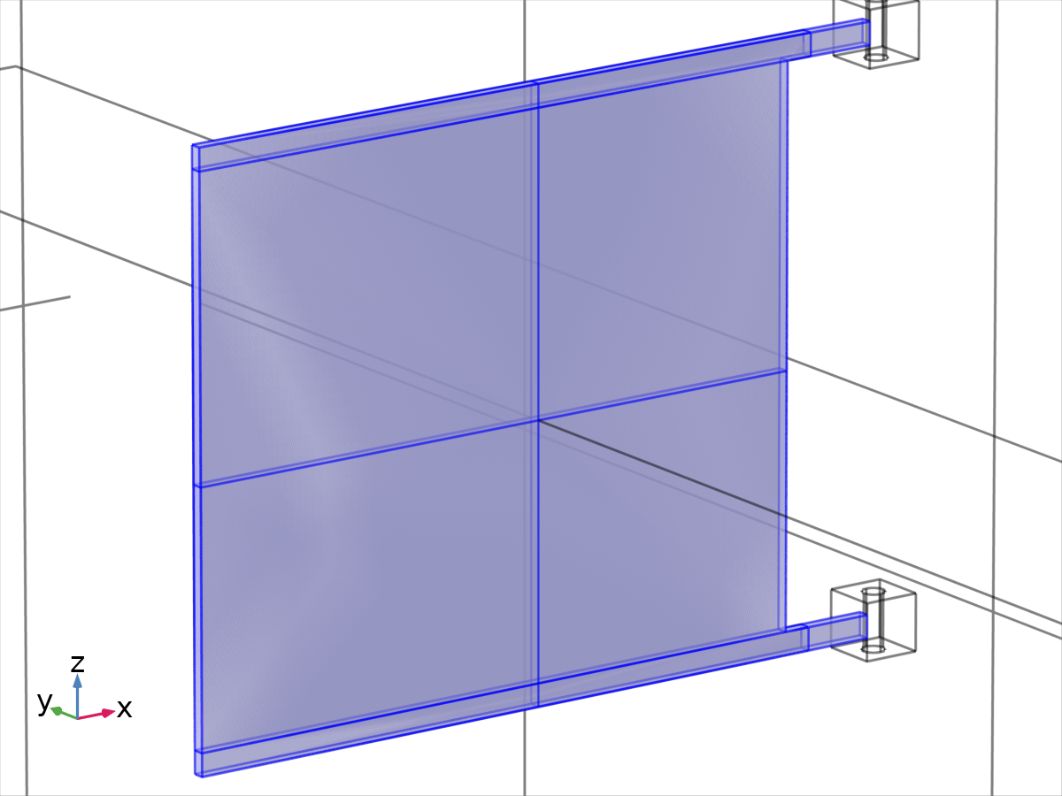
Fluid-Structure Interaction, Pair 1
Selection
Geometric entity level | Boundary
Selection | Geometry geom1: Dimension 2: All boundaries

Fixed geometry
Settings
Description | Value
Fixed geometry coupling type | Fully coupled

Pair selection
Settings
Description | Value
Pairs | Identity Boundary Pair 1a (ap1)

Coupled interfaces
Settings
Description | Value
Fluid | Laminar Flow (spf)
Structure | Multibody Dynamics (mbd)

Variables
Name | Expression | Unit | Description | Selection | Details
spf.usePseudoTimeStepping | 1 | 1 | Help variable | Global | + operation
spf.ubndx | fsip1.vWallx | m/s | Velocity at boundary, x component | Boundaries 10–23, 31–40, 43–46
spf.ubndy | fsip1.vWally | m/s | Velocity at boundary, y component | Boundaries 10–23, 31–40, 43–46
spf.ubndz | fsip1.vWallz | m/s | Velocity at boundary, z component | Boundaries 10–23, 31–40, 43–46
spf.ubndx | fsip1.vWallx | m/s | Velocity at boundary, x component | Boundaries 49–53, 55–56, 58–64
spf.ubndy | fsip1.vWally | m/s | Velocity at boundary, y component | Boundaries 49–53, 55–56, 58–64
spf.ubndz | fsip1.vWallz | m/s | Velocity at boundary, z component | Boundaries 49–53, 55–56, 58–64
fsip1.u_fluid | if(u_fluid_fld_act>0,u_fluid,dst2src_ap1(u_fluid)) | m/s | Velocity field, x component | Boundaries 10–23, 31–40, 43–46
fsip1.v_fluid | if(u_fluid_fld_act>0,v_fluid,dst2src_ap1(v_fluid)) | m/s | Velocity field, y component | Boundaries 10–23, 31–40, 43–46
fsip1.w_fluid | if(u_fluid_fld_act>0,w_fluid,dst2src_ap1(w_fluid)) | m/s | Velocity field, z component | Boundaries 10–23, 31–40, 43–46
fsip1.u_fluid | if(u_fluid_fld_act>0,u_fluid,src2dst_ap1(u_fluid)) | m/s | Velocity field, x component | Boundaries 49–53, 55–56, 58–64
fsip1.v_fluid | if(u_fluid_fld_act>0,v_fluid,src2dst_ap1(v_fluid)) | m/s | Velocity field, y component | Boundaries 49–53, 55–56, 58–64
fsip1.w_fluid | if(u_fluid_fld_act>0,w_fluid,src2dst_ap1(w_fluid)) | m/s | Velocity field, z component | Boundaries 49–53, 55–56, 58–64
fsip1.u_solid | if(u_solid_fld_act>0,u_solid,dst2src_ap1(u_solid)) | m | Displacement, 1 component | Boundaries 10–23, 31–40, 43–46
fsip1.v_solid | if(u_solid_fld_act>0,v_solid,dst2src_ap1(v_solid)) | m | Displacement, 2 component | Boundaries 10–23, 31–40, 43–46
fsip1.w_solid | if(u_solid_fld_act>0,w_solid,dst2src_ap1(w_solid)) | m | Displacement, 3 component | Boundaries 10–23, 31–40, 43–46
fsip1.u_solid | if(u_solid_fld_act>0,u_solid,src2dst_ap1(u_solid)) | m | Displacement, 1 component | Boundaries 49–53, 55–56, 58–64
fsip1.v_solid | if(u_solid_fld_act>0,v_solid,src2dst_ap1(v_solid)) | m | Displacement, 2 component | Boundaries 49–53, 55–56, 58–64
fsip1.w_solid | if(u_solid_fld_act>0,w_solid,src2dst_ap1(w_solid)) | m | Displacement, 3 component | Boundaries 49–53, 55–56, 58–64

Shape functions
Name | Shape function | Unit | Description | Shape frame | Selection
fsip1.vWallx | Lagrange (Linear) | m/s | Wall velocity, x component | Spatial | Boundaries 10–23, 31–40, 43–46, 49–53, 55–56, 58–64
fsip1.vWally | Lagrange (Linear) | m/s | Wall velocity, y component | Spatial | Boundaries 10–23, 31–40, 43–46, 49–53, 55–56, 58–64
fsip1.vWallz | Lagrange (Linear) | m/s | Wall velocity, z component | Spatial | Boundaries 10–23, 31–40, 43–46, 49–53, 55–56, 58–64

Weak expressions
Weak expression | Integration order | Integration frame | Selection
if(incontact_ap1>0,if(u_fluid_fld_act>0&&dst2src_ap1(u_fluid_fld_act<=0),(dst2src_ap1(mbd.u_tX)-fsip1.vWallx)*test(-fsip1.vWallx)+(dst2src_ap1(mbd.u_tY)-fsip1.vWally)*test(-fsip1.vWally)+(dst2src_ap1(mbd.u_tZ)-fsip1.vWallz)*test(-fsip1.vWallz),fsip1.vWallx*test(fsip1.vWallx)+fsip1.vWally*test(fsip1.vWally)+fsip1.vWallz*test(fsip1.vWallz)),fsip1.vWallx*test(fsip1.vWallx)+fsip1.vWally*test(fsip1.vWally)+fsip1.vWallz*test(fsip1.vWallz)) | 2 | Material | Boundaries 10–23, 31–40, 43–46
if(incontact_ap1>0,if(u_fluid_fld_act>0&&src2dst_ap1(u_fluid_fld_act<=0),(src2dst_ap1(mbd.u_tX)-fsip1.vWallx)*test(-fsip1.vWallx)+(src2dst_ap1(mbd.u_tY)-fsip1.vWally)*test(-fsip1.vWally)+(src2dst_ap1(mbd.u_tZ)-fsip1.vWallz)*test(-fsip1.vWallz),fsip1.vWallx*test(fsip1.vWallx)+fsip1.vWally*test(fsip1.vWally)+fsip1.vWallz*test(fsip1.vWallz)),fsip1.vWallx*test(fsip1.vWallx)+fsip1.vWally*test(fsip1.vWally)+fsip1.vWallz*test(fsip1.vWallz)) | 2 | Material | Boundaries 49–53, 55–56, 58–64
if(incontact_ap1,if(u_solid_fld_act>0&&dst2src_ap1(u_solid_fld_act)<=0,dst2src_ap1(-spf.T_stressx)*test(fsip1.u_solid)+dst2src_ap1(-spf.T_stressy)*test(fsip1.v_solid)+dst2src_ap1(-spf.T_stressz)*test(fsip1.w_solid),0),0) | 2 | Spatial | Boundaries 10–23, 31–40, 43–46
if(incontact_ap1,if(u_solid_fld_act>0&&src2dst_ap1(u_solid_fld_act)<=0,src2dst_ap1(-spf.T_stressx)*test(fsip1.u_solid)+src2dst_ap1(-spf.T_stressy)*test(fsip1.v_solid)+src2dst_ap1(-spf.T_stressz)*test(fsip1.w_solid),0),0) | 2 | Spatial | Boundaries 49–53, 55–56, 58–64

Constraints
Constraint | Constraint force | Shape function | Selection | Details
if(incontact_ap1,if(u_fluid_fld_act>0&&dst2src_ap1(u_fluid_fld_act)<=0,-fsip1.u_fluid+spf.ubndx,0),0) | if(incontact_ap1,if(u_fluid_fld_act>0&&dst2src_ap1(u_fluid_fld_act)<=0,test(-fsip1.u_fluid),0),0) | Lagrange (Linear) | Boundaries 10–23, 31–40, 43–46 | Elemental
if(incontact_ap1,if(u_fluid_fld_act>0&&dst2src_ap1(u_fluid_fld_act)<=0,-fsip1.v_fluid+spf.ubndy,0),0) | if(incontact_ap1,if(u_fluid_fld_act>0&&dst2src_ap1(u_fluid_fld_act)<=0,test(-fsip1.v_fluid),0),0) | Lagrange (Linear) | Boundaries 10–23, 31–40, 43–46 | Elemental
if(incontact_ap1,if(u_fluid_fld_act>0&&src2dst_ap1(u_fluid_fld_act)<=0,-fsip1.u_fluid+spf.ubndx,0),0) | if(incontact_ap1,if(u_fluid_fld_act>0&&src2dst_ap1(u_fluid_fld_act)<=0,test(-fsip1.u_fluid),0),0) | Lagrange (Linear) | Boundaries 49–53, 55–56, 58–64 | Elemental
if(incontact_ap1,if(u_fluid_fld_act>0&&src2dst_ap1(u_fluid_fld_act)<=0,-fsip1.v_fluid+spf.ubndy,0),0) | if(incontact_ap1,if(u_fluid_fld_act>0&&src2dst_ap1(u_fluid_fld_act)<=0,test(-fsip1.v_fluid),0),0) | Lagrange (Linear) | Boundaries 49–53, 55–56, 58–64 | Elemental
if(incontact_ap1,if(u_fluid_fld_act>0&&dst2src_ap1(u_fluid_fld_act)<=0,-fsip1.w_fluid+spf.ubndz,0),0) | if(incontact_ap1,if(u_fluid_fld_act>0&&dst2src_ap1(u_fluid_fld_act)<=0,test(-fsip1.w_fluid),0),0) | Lagrange (Linear) | Boundaries 10–23, 31–40, 43–46 | Elemental
if(incontact_ap1,if(u_fluid_fld_act>0&&src2dst_ap1(u_fluid_fld_act)<=0,-fsip1.w_fluid+spf.ubndz,0),0) | if(incontact_ap1,if(u_fluid_fld_act>0&&src2dst_ap1(u_fluid_fld_act)<=0,test(-fsip1.w_fluid),0),0) | Lagrange (Linear) | Boundaries 49–53, 55–56, 58–64 | Elemental

  - Mesh 1
Mesh statistics
Description | Value
Minimum element quality | 4.046E-4
Average element quality | 0.6441
Tetrahedron | 18719
Pyramid | 216
Prism | 976

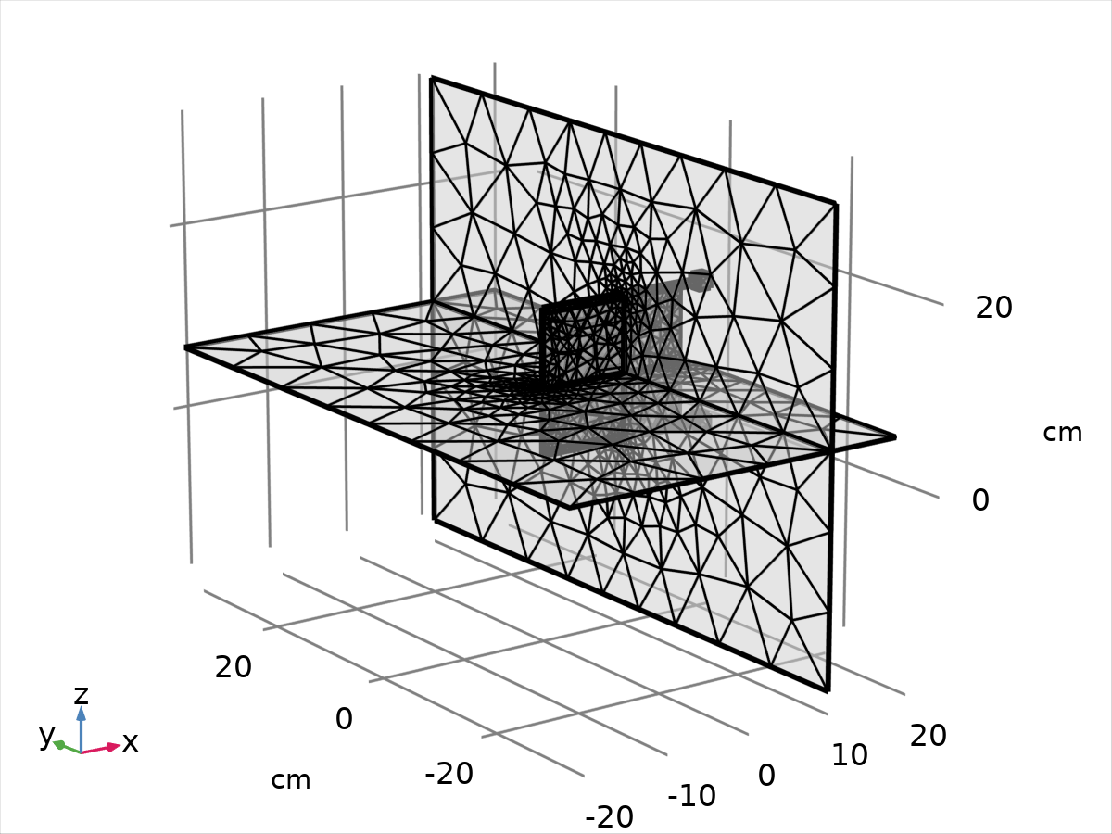
Mesh 1
    - Size (size)
Settings
Description | Value
Maximum element size | 13.2
Minimum element size | 2.77
Curvature factor | 0.8
Resolution of narrow regions | 0.3
Maximum element growth rate | 1.7
Predefined size | Coarser

    - Size 1 (size1)
Selection
Geometric entity level | Domain
Selection | Geometry geom1: Dimension 3: Domains 1–4

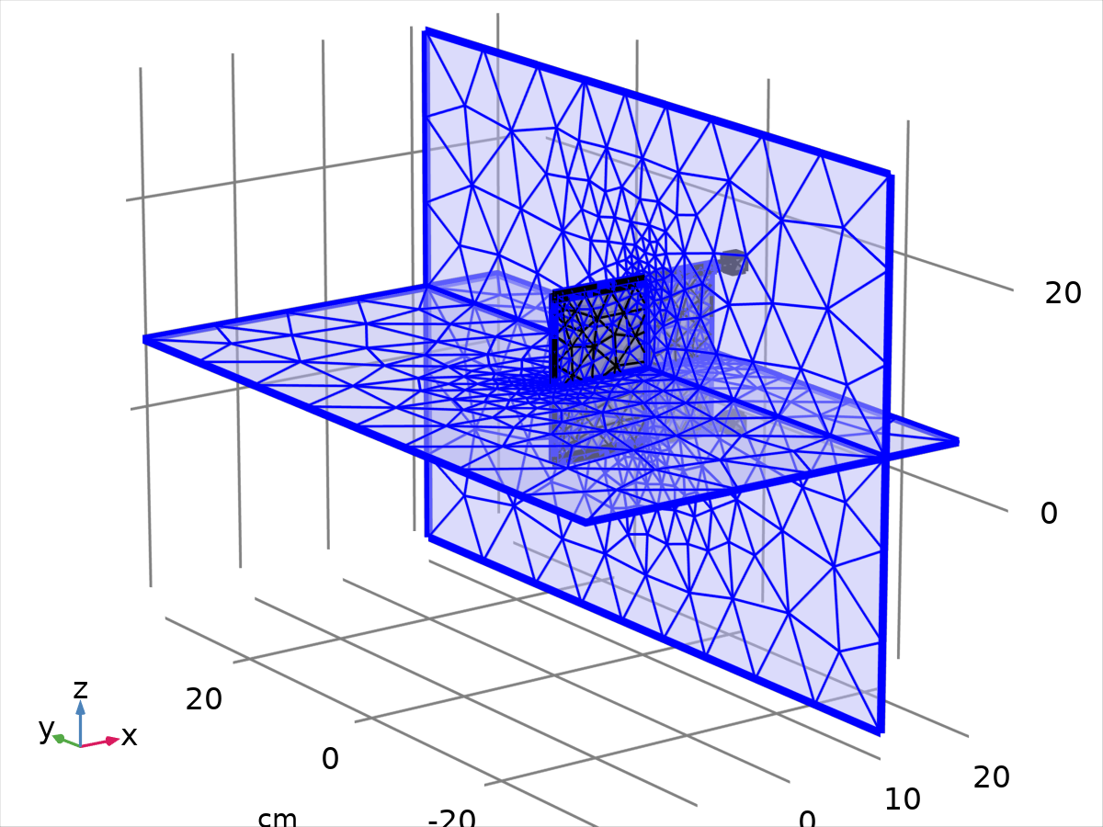
Size 1
Settings
Description | Value
Calibrate for | Fluid dynamics
Maximum element size | 9.31
Minimum element size | 2.33
Curvature factor | 0.9
Resolution of narrow regions | 0.4
Maximum element growth rate | 1.3
Predefined size | Extra coarse

    - Corner Refinement 1 (cr1)
Selection
Geometric entity level | Domain
Selection | Geometry geom1: Dimension 3: Domains 1–4

Corner Refinement 1
    - Free Tetrahedral 1 (ftet1)
Selection
Geometric entity level | Remaining

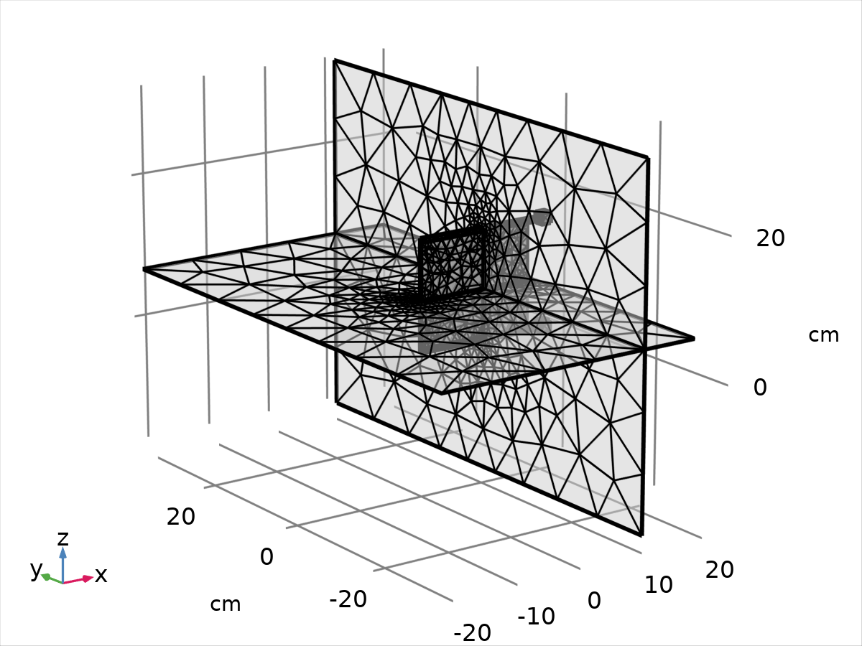
Free Tetrahedral 1
    - Boundary Layers 1 (bl1)
Selection
Geometric entity level | Domain
Selection | Geometry geom1: Dimension 3: Domains 1–4

Boundary Layers 1
Settings
Description | Value
Handling of sharp edges | Trimming

Boundary Layer Properties 1 (blp1)
Selection
Geometric entity level | Boundary
Selection | Geometry geom1: Dimension 2: Boundaries 10–23, 31–40, 43–46

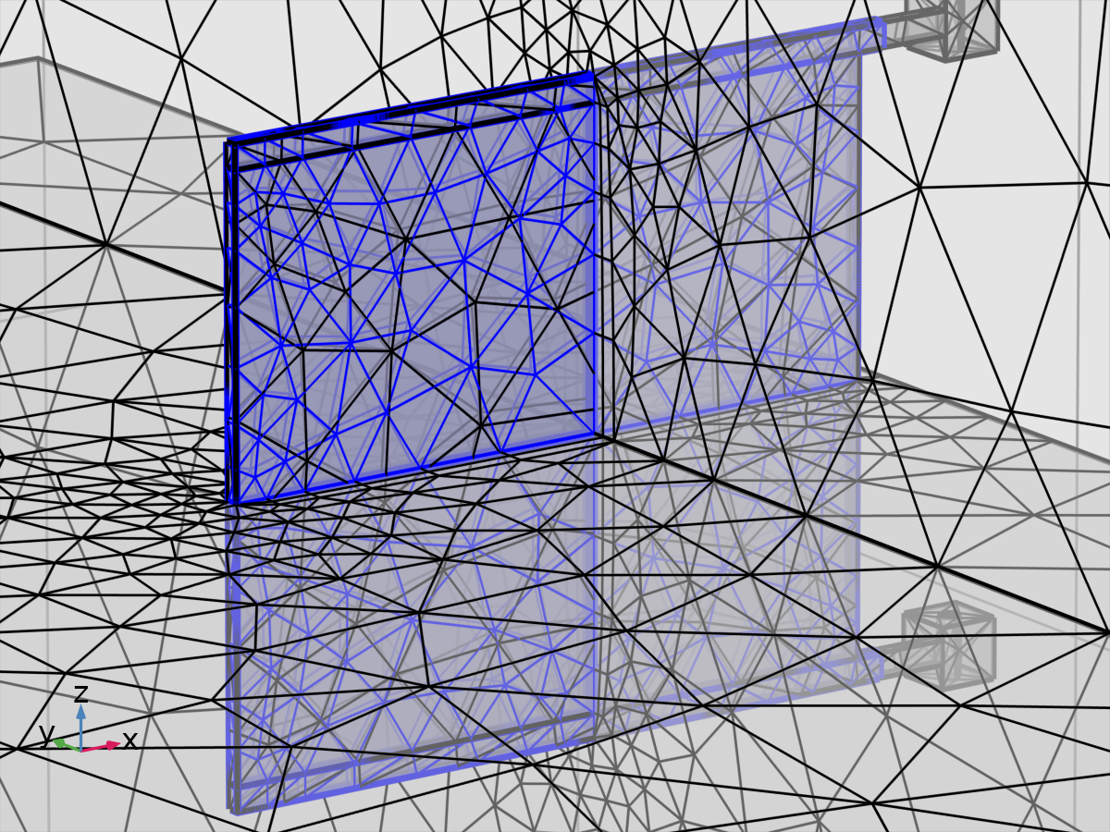
Boundary Layer Properties 1
Settings
Description | Value
Number of boundary layers | 2
Thickness adjustment factor | 5

- Study 1
Computation information
Computation time | 46 min 20 s
CPU | AMD64 Family 23 Model 8 Stepping 2, 8 cores
Operating system | Windows 10

  - Time Dependent
Times | Unit
range(0,tstep,(ncycle-1)/f) range((ncycle-1)/f,tstep/2,tmax) | s

Study settings
Description | Value
Include geometric nonlinearity | On

Study settings
Description | Value
Times | {0, 0.1, 0.2, 0.30000000000000004, 0.4, 0.5, 0.6000000000000001, 0.7000000000000001, 0.8, 0.9, 1, 1, 1.05, 1.1, 1.15, 1.2, 1.25, 1.3, 1.35, 1.4, 1.45, 1.5, 1.55, 1.6, 1.65, 1.7000000000000002, 1.75, 1.8, 1.85, 1.9, 1.9500000000000002, 2}

Physics and variables selection
Physics interface | Discretization
Laminar Flow (spf) | physics
Multibody Dynamics (mbd) | physics

Mesh selection
Geometry | Mesh
Geometry 1 (geom1) | mesh1

  - Solver Configurations
    - Solution 1

Compile Equations: Time Dependent (st1)
Study and step
Description | Value
Use study
Use study step

Log
<---- Compile Equations: Time Dependent in Study 1/Solution 1 (sol1) -----------
Started at Oct 1, 2020 3:07:45 PM.
Geometry shape order: Linear
Running on AMD64 Family 23 Model 8 Stepping 2, AuthenticAMD.
Using 1 socket with 8 cores in total on DESKTOP-8GPG15N.
Available memory: 16.30 GB.
Time: 2 s.
Physical memory: 2.7 GB
Virtual memory: 3.59 GB
Ended at Oct 1, 2020 3:07:46 PM.
----- Compile Equations: Time Dependent in Study 1/Solution 1 (sol1) ---------->

Dependent Variables 1 (v1)
General
Description | Value
Defined by study step

Residual scaling
Description | Value
Method | Manual

Initial value calculation constants
Constant name | Initial value source
t | range(0,tstep,(ncycle-1)/f) range((ncycle-1)/f,tstep/2,tmax)
timestep | 0.004[s]

Log
<---- Dependent Variables 1 in Study 1/Solution 1 (sol1) -----------------------
Started at Oct 1, 2020 3:07:46 PM.
Solution time: 0 s.
Physical memory: 2.7 GB
Virtual memory: 3.59 GB
Ended at Oct 1, 2020 3:07:47 PM.
----- Dependent Variables 1 in Study 1/Solution 1 (sol1) ---------------------->

Wall velocity (spatial frame) (comp1.fsip1.vWall) (comp1_fsip1_vWall)
General
Description | Value
Field components | {comp1.fsip1.vWallx, comp1.fsip1.vWally, comp1.fsip1.vWallz}

Pressure (comp1.p) (comp1_p)
General
Description | Value
Field components | comp1.p

Spatial mesh displacement (comp1.spatial.disp) (comp1_spatial_disp)
General
Description | Value
Field components | {comp1.spatial.u, comp1.spatial.v, comp1.spatial.w}

Scaling
Description | Value
Method | Manual
Scale | 0.00958348188290665

Velocity field (spatial frame) (comp1.u_fluid) (comp1_u_fluid)
General
Description | Value
Field components | {comp1.u_fluid, comp1.v_fluid, comp1.w_fluid}
Internal variables | {comp1.spf.isFluidHasBeenSolved, comp1.spf.dt2Inv_u}

Displacement field (comp1.u_solid) (comp1_u_solid)
General
Description | Value
Field components | {comp1.u_solid, comp1.v_solid, comp1.w_solid}

Scaling
Description | Value
Method | Manual
Scale | 1e-2*0.958348188290665

Relative rotation (comp1.mbd.hgj1.th) (comp1_mbd_hgj1_th)
General
Description | Value
State components | comp1.mbd.hgj1.th

Scaling
Description | Value
Method | Manual
Scale | 0.1

Relative rotation (comp1.mbd.hgj2.th) (comp1_mbd_hgj2_th)
General
Description | Value
State components | comp1.mbd.hgj2.th

Scaling
Description | Value
Method | Manual
Scale | 0.1

Rigid body displacement (spatial frame) (comp1.mbd.att1.u) (comp1_mbd_att1_u)
General
Description | Value
State components | {comp1.mbd.att1.u, comp1.mbd.att1.v, comp1.mbd.att1.w}

Scaling
Description | Value
Method | Manual
Scale | 1e-2*0.958348188290665

Rigid body rotation, real part (comp1.mbd.att1.a) (comp1_mbd_att1_a)
General
Description | Value
State components | comp1.mbd.att1.a

Scaling
Description | Value
Method | Manual
Scale | 0.1

Rigid body rotation, imaginary part (spatial frame) (comp1.mbd.att1.b) (comp1_mbd_att1_b)
General
Description | Value
State components | {comp1.mbd.att1.b, comp1.mbd.att1.c, comp1.mbd.att1.d}

Scaling
Description | Value
Method | Manual
Scale | 0.1

Rigid body displacement (spatial frame) (comp1.mbd.att2.u) (comp1_mbd_att2_u)
General
Description | Value
State components | {comp1.mbd.att2.u, comp1.mbd.att2.v, comp1.mbd.att2.w}

Scaling
Description | Value
Method | Manual
Scale | 1e-2*0.958348188290665

Rigid body rotation, real part (comp1.mbd.att2.a) (comp1_mbd_att2_a)
General
Description | Value
State components | comp1.mbd.att2.a

Scaling
Description | Value
Method | Manual
Scale | 0.1

Rigid body rotation, imaginary part (spatial frame) (comp1.mbd.att2.b) (comp1_mbd_att2_b)
General
Description | Value
State components | {comp1.mbd.att2.b, comp1.mbd.att2.c, comp1.mbd.att2.d}

Scaling
Description | Value
Method | Manual
Scale | 0.1

Time-Dependent Solver 1 (t1)
General
Description | Value
Defined by study step
Times | {0, 0.1, 0.2, 0.30000000000000004, 0.4, 0.5, 0.6000000000000001, 0.7000000000000001, 0.8, 0.9, 1, 1, 1.05, 1.1, 1.15, 1.2, 1.25, 1.3, 1.35, 1.4, 1.45, 1.5, 1.55, 1.6, 1.65, 1.7000000000000002, 1.75, 1.8, 1.85, 1.9, 1.9500000000000002, 2}
Relative tolerance | 0.005

Absolute tolerance
Description | Value
Tolerance factor | 0.05

Field tolerance method
Field | Value
Wall velocity (spatial frame) (comp1.fsip1.vWall) | Use_global
Pressure (comp1.p) | Scaled
Spatial mesh displacement (comp1.spatial.disp) | Use_global
Velocity field (spatial frame) (comp1.u_fluid) | Use_global
Displacement field (comp1.u_solid) | Use_global
Relative rotation (comp1.mbd.hgj1.th) | Use_global
Relative rotation (comp1.mbd.hgj2.th) | Use_global
Rigid body displacement (spatial frame) (comp1.mbd.att1.u) | Use_global
Rigid body rotation, real part (comp1.mbd.att1.a) | Use_global
Rigid body rotation, imaginary part (spatial frame) (comp1.mbd.att1.b) | Use_global
Rigid body displacement (spatial frame) (comp1.mbd.att2.u) | Use_global
Rigid body rotation, real part (comp1.mbd.att2.a) | Use_global
Rigid body rotation, imaginary part (spatial frame) (comp1.mbd.att2.b) | Use_global

Field tolerance factor
Field | Value
Wall velocity (spatial frame) (comp1.fsip1.vWall) | 0.1
Pressure (comp1.p) | 1
Spatial mesh displacement (comp1.spatial.disp) | 0.1
Velocity field (spatial frame) (comp1.u_fluid) | 0.1
Displacement field (comp1.u_solid) | 0.1
Relative rotation (comp1.mbd.hgj1.th) | 0.1
Relative rotation (comp1.mbd.hgj2.th) | 0.1
Rigid body displacement (spatial frame) (comp1.mbd.att1.u) | 0.1
Rigid body rotation, real part (comp1.mbd.att1.a) | 0.1
Rigid body rotation, imaginary part (spatial frame) (comp1.mbd.att1.b) | 0.1
Rigid body displacement (spatial frame) (comp1.mbd.att2.u) | 0.1
Rigid body rotation, real part (comp1.mbd.att2.a) | 0.1
Rigid body rotation, imaginary part (spatial frame) (comp1.mbd.att2.b) | 0.1

Time stepping
Description | Value
Steps taken by solver | Intermediate
Maximum BDF order | 2
Nonlinear controller | On
Fraction of initial step for Backward Euler | 0.01
Error estimation | Exclude algebraic

Results while solving
Description | Value
Plot | On
Plot group

Log
214 2.486 0.019301 5991 5994 5991 2 7 0
Group #1: 1997 1998 1997 10085 0.0003 -
Group #2: 1997 1998 1997 2.1e-10 4.4e-13
Group #3: 1997 1998 1997 1e-15 1.1e-15
- 2.5 - out
215 2.5053 0.019301 6021 6024 6021 2 7 0
Group #1: 2007 2008 2007 10124 0.00071 -
Group #2: 2007 2008 2007 1.6e-10 1.3e-13
Group #3: 2007 2008 2007 9.3e-16 1e-15
216 2.5246 0.019301 6051 6054 6051 2 7 0
Group #1: 2017 2018 2017 10164 1.5e-05 -
Group #2: 2017 2018 2017 1.4e-11 1.9e-13
Group #3: 2017 2018 2017 1e-15 1.6e-15
217 2.5419 0.017371 6069 6072 6069 2 7 0
Group #1: 2023 2024 2023 10189 0.00045 -
Group #2: 2023 2024 2023 7.6e-11 2e-13
Group #3: 2023 2024 2023 1.1e-15 1.9e-15
218 2.5593 0.017371 6090 6093 6090 2 7 0
Group #1: 2030 2031 2030 10234 0.00047 -
Group #2: 2030 2031 2030 2.9e-10 4.6e-13
Group #3: 2030 2031 2030 9.4e-16 9.9e-16
219 2.5767 0.017371 6120 6123 6120 2 7 0
Group #1: 2040 2041 2040 10292 0.001 -
Group #2: 2040 2041 2040 7.9e-10 6.4e-13
Group #3: 2040 2041 2040 1e-15 1.1e-15
220 2.594 0.017371 6150 6153 6150 2 7 0
Group #1: 2050 2051 2050 10348 0.00018 -
Group #2: 2050 2051 2050 2.6e-10 4e-14
Group #3: 2050 2051 2050 9e-16 1.4e-15
- 2.6 - out
221 2.6114 0.017371 6174 6177 6174 2 7 0
Group #1: 2058 2059 2058 10402 0.0018 -
Group #2: 2058 2059 2058 3.4e-10 5.1e-13
Group #3: 2058 2059 2058 9.8e-16 1.1e-15
222 2.6288 0.017371 6213 6216 6213 2 7 0
Group #1: 2071 2072 2071 10465 0.001 -
Group #2: 2071 2072 2071 2.7e-10 3.6e-13
Group #3: 2071 2072 2071 9.8e-16 1.2e-15
223 2.6462 0.017371 6246 6249 6246 2 7 0
Group #1: 2082 2083 2082 10521 0.0012 -
Group #2: 2082 2083 2082 1.1e-10 2.7e-13
Group #3: 2082 2083 2082 1e-15 1.2e-15
224 2.6635 0.017371 6282 6285 6282 2 7 0
Group #1: 2094 2095 2094 10579 0.001 -
Group #2: 2094 2095 2094 8.5e-10 2.4e-13
Group #3: 2094 2095 2094 9.7e-16 1.2e-15
225 2.6809 0.017371 6312 6315 6312 2 7 0
Group #1: 2104 2105 2104 10628 0.0022 -
Group #2: 2104 2105 2104 5e-10 2.8e-13
Group #3: 2104 2105 2104 1.2e-15 1.2e-15
226 2.6983 0.017371 6339 6342 6339 2 7 0
Group #1: 2113 2114 2113 10678 0.002 -
Group #2: 2113 2114 2113 3.5e-12 6.8e-12
Group #3: 2113 2114 2113 1.2e-15 1.2e-15
- 2.7 - out
227 2.7156 0.017371 6363 6366 6363 2 7 0
Group #1: 2121 2122 2121 10725 0.001 -
Group #2: 2121 2122 2121 1e-10 1.7e-13
Group #3: 2121 2122 2121 1.2e-15 1.2e-15
228 2.733 0.017371 6387 6390 6387 2 7 0
Group #1: 2129 2130 2129 10772 0.00066 -
Group #2: 2129 2130 2129 1.2e-10 4.8e-13
Group #3: 2129 2130 2129 1.3e-15 1.2e-15
229 2.7504 0.017371 6405 6408 6405 2 7 0
Group #1: 2135 2136 2135 10813 0.00055 -
Group #2: 2135 2136 2135 9.9e-12 3.3e-14
Group #3: 2135 2136 2135 1e-15 1.2e-15
230 2.7678 0.017371 6426 6429 6426 2 7 0
Group #1: 2142 2143 2142 10833 9.7e-05 -
Group #2: 2142 2143 2142 4.7e-10 2.9e-14
Group #3: 2142 2143 2142 1.1e-15 1.3e-15
231 2.7851 0.017371 6441 6444 6441 2 7 0
Group #1: 2147 2148 2147 10847 0.00049 -
Group #2: 2147 2148 2147 3.6e-10 1.8e-14
Group #3: 2147 2148 2147 1.1e-15 1.2e-15
- 2.8 - out
232 2.8025 0.017371 6462 6465 6462 2 7 0
Group #1: 2154 2155 2154 10873 0.0003 -
Group #2: 2154 2155 2154 4.1e-11 5.2e-14
Group #3: 2154 2155 2154 1.1e-15 1.1e-15
233 2.8199 0.017371 6486 6489 6486 2 7 0
Group #1: 2162 2163 2162 10904 0.00014 -
Group #2: 2162 2163 2162 2.4e-10 8.2e-14
Group #3: 2162 2163 2162 1e-15 1.2e-15
234 2.8372 0.017371 6513 6516 6513 2 7 0
Group #1: 2171 2172 2171 10936 0.0003 -
Group #2: 2171 2172 2171 5.8e-11 5.8e-15
Group #3: 2171 2172 2171 1.3e-15 1.2e-15
235 2.8546 0.017371 6546 6549 6546 2 7 0
Group #1: 2182 2183 2182 10970 6.1e-05 -
Group #2: 2182 2183 2182 4.2e-10 6.7e-14
Group #3: 2182 2183 2182 1e-15 1.2e-15
236 2.872 0.017371 6600 6603 6600 2 7 0
Group #1: 2200 2201 2200 11014 8.3e-06 -
Group #2: 2200 2201 2200 1.5e-10 6.5e-15
Group #3: 2200 2201 2200 9.7e-16 1.2e-15
237 2.8893 0.017371 6636 6639 6636 2 7 0
Group #1: 2212 2213 2212 11057 6.4e-05 -
Group #2: 2212 2213 2212 5.2e-10 2.8e-14
Group #3: 2212 2213 2212 9.3e-16 1.6e-15
- 2.9 - out
238 2.9067 0.017371 6672 6675 6672 2 7 0
Group #1: 2224 2225 2224 11099 0.0001 -
Group #2: 2224 2225 2224 7.5e-10 1e-13
Group #3: 2224 2225 2224 1e-15 1.2e-15
239 2.9241 0.017371 6708 6711 6708 2 7 0
Group #1: 2236 2237 2236 11141 9.7e-05 -
Group #2: 2236 2237 2236 2.3e-10 1.1e-13
Group #3: 2236 2237 2236 9.9e-16 1.1e-15
240 2.9415 0.017371 6741 6744 6741 2 7 0
Group #1: 2247 2248 2247 11177 5.9e-05 -
Group #2: 2247 2248 2247 2.2e-10 4.5e-14
Group #3: 2247 2248 2247 9.5e-16 1.3e-15
241 2.9588 0.017371 6774 6777 6774 2 7 0
Group #1: 2258 2259 2258 11213 3.7e-05 -
Group #2: 2258 2259 2258 3e-10 1.7e-12
Group #3: 2258 2259 2258 9.1e-16 1.1e-15
242 2.9762 0.017371 6810 6813 6810 2 7 0
Group #1: 2270 2271 2270 11250 0.00019 -
Group #2: 2270 2271 2270 3.9e-11 1.3e-14
Group #3: 2270 2271 2270 9.2e-16 2.1e-15
243 2.9936 0.017371 6837 6840 6837 2 7 0
Group #1: 2279 2280 2279 11287 0.00075 -
Group #2: 2279 2280 2279 4.3e-10 1.7e-13
Group #3: 2279 2280 2279 1.2e-15 1.1e-15
244 3 0.0064279 out 6870 6873 6870 2 7 0
Group #1: 2290 2291 2290 11329 0.0003 -
Group #2: 2290 2291 2290 1.5e-10 8.7e-13
Group #3: 2290 2291 2290 8.3e-16 9e-16
244 3 0.0064279 out 6870 6873 6870 2 7 0
Group #1: 2290 2291 2290 11329 0.0003 -
Group #2: 2290 2291 2290 1.5e-10 8.7e-13
Group #3: 2290 2291 2290 8.3e-16 9e-16
245 3.0129 0.012856 6900 6903 6900 2 7 0
Group #1: 2300 2301 2300 11358 0.00028 -
Group #2: 2300 2301 2300 3.5e-11 7.2e-13
Group #3: 2300 2301 2300 8.4e-16 8.1e-16
246 3.0244 0.01157 6927 6930 6927 2 7 0
Group #1: 2309 2310 2309 11391 6.3e-05 -
Group #2: 2309 2310 2309 2.4e-10 1.3e-13
Group #3: 2309 2310 2309 1.1e-15 2.5e-15
247 3.036 0.01157 6951 6954 6951 2 7 0
Group #1: 2317 2318 2317 11423 0.00023 -
Group #2: 2317 2318 2317 9.8e-11 1.6e-13
Group #3: 2317 2318 2317 9.5e-16 8.9e-16
248 3.0476 0.01157 6969 6972 6969 2 7 0
Group #1: 2323 2324 2323 11453 0.00035 -
Group #2: 2323 2324 2323 3.1e-12 6.6e-13
Group #3: 2323 2324 2323 9.4e-16 1e-15
- 3.05 - out
249 3.0707 0.02314 6993 6996 6993 2 7 0
Group #1: 2331 2332 2331 11501 0.00093 -
Group #2: 2331 2332 2331 2.8e-10 1.8e-14
Group #3: 2331 2332 2331 1e-15 1.4e-15
250 3.0915 0.020826 7035 7038 7035 2 7 0
Group #1: 2345 2346 2345 11579 9.9e-06 -
Group #2: 2345 2346 2345 7.9e-10 6.5e-13
Group #3: 2345 2346 2345 1e-15 1.1e-15
- 3.1 - out
251 3.1124 0.020826 7068 7071 7068 2 7 0
Group #1: 2356 2357 2356 11640 0.0014 -
Group #2: 2356 2357 2356 2.4e-10 3.1e-12
Group #3: 2356 2357 2356 9.2e-16 1.1e-15
252 3.1332 0.020826 7098 7101 7098 2 7 0
Group #1: 2366 2367 2366 11706 0.00091 -
Group #2: 2366 2367 2366 6.6e-10 3.6e-13
Group #3: 2366 2367 2366 9.7e-16 1.2e-15
- 3.15 - out
253 3.154 0.020826 7134 7137 7134 2 7 0
Group #1: 2378 2379 2378 11777 0.0016 -
Group #2: 2378 2379 2378 3.9e-10 3.9e-12
Group #3: 2378 2379 2378 1e-15 1.2e-15
254 3.1748 0.020826 7167 7170 7167 2 7 0
Group #1: 2389 2390 2389 11829 0.0014 -
Group #2: 2389 2390 2389 9.6e-11 3.2e-13
Group #3: 2389 2390 2389 1e-15 1.1e-15
255 3.1957 0.020826 7206 7209 7206 2 7 0
Group #1: 2402 2403 2402 11890 0.0025 -
Group #2: 2402 2403 2402 4.8e-11 2.8e-13
Group #3: 2402 2403 2402 1.1e-15 1.2e-15
- 3.2 - out
256 3.2165 0.020826 7230 7233 7230 2 7 0
Group #1: 2410 2411 2410 11943 0.00022 -
Group #2: 2410 2411 2410 3.8e-10 1.1e-13
Group #3: 2410 2411 2410 1.7e-15 1.2e-15
257 3.2373 0.020826 7254 7257 7254 2 7 0
Group #1: 2418 2419 2418 11981 0.00098 -
Group #2: 2418 2419 2418 5.2e-10 1.7e-13
Group #3: 2418 2419 2418 1.1e-15 1.1e-15
- 3.25 - out
258 3.2581 0.020826 7275 7278 7275 2 7 0
Group #1: 2425 2426 2425 12023 0.00032 -
Group #2: 2425 2426 2425 9e-11 3.5e-14
Group #3: 2425 2426 2425 1.8e-15 8e-16
259 3.279 0.020826 7293 7296 7293 2 7 0
Group #1: 2431 2432 2431 12035 0.00024 -
Group #2: 2431 2432 2431 1e-10 6.9e-15
Group #3: 2431 2432 2431 2e-15 7e-16
260 3.2998 0.020826 7320 7323 7320 2 7 0
Group #1: 2440 2441 2440 12057 0.00017 -
Group #2: 2440 2441 2440 2.9e-10 2.8e-14
Group #3: 2440 2441 2440 1.4e-15 1.1e-15
- 3.3 - out
261 3.3206 0.020826 7350 7353 7350 2 7 0
Group #1: 2450 2451 2450 12087 8.9e-05 -
Group #2: 2450 2451 2450 1.6e-10 1.3e-14
Group #3: 2450 2451 2450 1.2e-15 1.2e-15
262 3.3415 0.020826 7374 7377 7374 2 7 0
Group #1: 2458 2459 2458 12134 0.0015 -
Group #2: 2458 2459 2458 2.6e-10 1.3e-13
Group #3: 2458 2459 2458 1.1e-15 1.1e-15
- 3.35 - out
263 3.3623 0.020826 7416 7419 7416 2 7 0
Group #1: 2472 2473 2472 12187 0.00016 -
Group #2: 2472 2473 2472 9.8e-11 2e-13
Group #3: 2472 2473 2472 9.2e-16 1.1e-15
264 3.3831 0.020826 7449 7452 7449 2 7 0
Group #1: 2483 2484 2483 12230 0.00012 -
Group #2: 2483 2484 2483 4.8e-11 1.2e-13
Group #3: 2483 2484 2483 9.7e-16 1.2e-15
- 3.4 - out
265 3.4039 0.020826 7485 7488 7485 2 7 0
Group #1: 2495 2496 2495 12290 4.9e-05 -
Group #2: 2495 2496 2495 1.8e-11 1.4e-13
Group #3: 2495 2496 2495 1.2e-15 1.1e-15
266 3.4248 0.020826 7524 7527 7524 2 7 0
Group #1: 2508 2509 2508 12340 4.5e-05 -
Group #2: 2508 2509 2508 4.2e-10 7.2e-14
Group #3: 2508 2509 2508 1.1e-15 1.5e-15
267 3.4456 0.020826 7572 7575 7572 2 7 0
Group #1: 2524 2525 2524 12392 6.2e-05 -
Group #2: 2524 2525 2524 1.8e-11 3e-13
Group #3: 2524 2525 2524 9e-16 1.1e-15
- 3.45 - out
268 3.4664 0.020826 7605 7608 7605 2 7 0
Group #1: 2535 2536 2535 12428 0.00047 -
Group #2: 2535 2536 2535 3e-10 2.1e-13
Group #3: 2535 2536 2535 8.7e-16 1.1e-15
269 3.4872 0.020826 7641 7644 7641 2 7 0
Group #1: 2547 2548 2547 12463 0.00017 -
Group #2: 2547 2548 2547 9.1e-10 5.5e-13
Group #3: 2547 2548 2547 8.7e-16 9.2e-16
- 3.5 - out
270 3.5081 0.020826 7683 7686 7683 2 7 0
Group #1: 2561 2562 2561 12506 5e-05 -
Group #2: 2561 2562 2561 1.9e-10 3e-14
Group #3: 2561 2562 2561 9e-16 9.5e-16
271 3.5289 0.020826 7722 7725 7722 2 7 0
Group #1: 2574 2575 2574 12551 0.00012 -
Group #2: 2574 2575 2574 3.6e-10 1.1e-12
Group #3: 2574 2575 2574 1.3e-15 1.1e-15
272 3.5474 0.018507 7743 7746 7743 2 7 0
Group #1: 2581 2582 2581 12578 0.00022 -
Group #2: 2581 2582 2581 3e-10 1.6e-13
Group #3: 2581 2582 2581 9.9e-16 2.9e-15
- 3.55 - out
273 3.5659 0.018507 7785 7788 7785 2 7 0
Group #1: 2595 2596 2595 12666 0.00084 -
Group #2: 2595 2596 2595 7.9e-10 4.9e-13
Group #3: 2595 2596 2595 8.6e-16 1.2e-15
274 3.5844 0.018507 7815 7818 7815 2 7 0
Group #1: 2605 2606 2605 12717 0.00067 -
Group #2: 2605 2606 2605 1.4e-10 1.5e-13
Group #3: 2605 2606 2605 9.7e-16 1e-15
- 3.6 - out
275 3.6029 0.018507 7845 7848 7845 2 7 0
Group #1: 2615 2616 2615 12774 0.00073 -
Group #2: 2615 2616 2615 2.4e-10 9e-13
Group #3: 2615 2616 2615 1.1e-15 1.2e-15
276 3.6214 0.018507 7875 7878 7875 2 7 0
Group #1: 2625 2626 2625 12836 0.0022 -
Group #2: 2625 2626 2625 4.2e-10 1.6e-11
Group #3: 2625 2626 2625 1.2e-15 1.2e-15
277 3.6399 0.018507 7914 7917 7914 2 7 0
Group #1: 2638 2639 2638 12902 0.001 -
Group #2: 2638 2639 2638 4e-11 2.2e-11
Group #3: 2638 2639 2638 9.1e-16 1.2e-15
- 3.65 - out
278 3.6584 0.018507 7944 7947 7944 2 7 0
Group #1: 2648 2649 2648 12960 0.0019 -
Group #2: 2648 2649 2648 2.2e-10 2.6e-12
Group #3: 2648 2649 2648 8.9e-16 1.2e-15
279 3.6769 0.018507 7977 7980 7977 2 7 0
Group #1: 2659 2660 2659 13016 0.002 -
Group #2: 2659 2660 2659 6.3e-10 3.4e-12
Group #3: 2659 2660 2659 1.3e-15 1.2e-15
280 3.6954 0.018507 8007 8010 8007 2 7 0
Group #1: 2669 2670 2669 13065 0.0022 -
Group #2: 2669 2670 2669 2.8e-11 2.2e-13
Group #3: 2669 2670 2669 1.2e-15 1.2e-15
- 3.7 - out
281 3.714 0.018507 8034 8037 8034 2 7 0
Group #1: 2678 2679 2678 13115 0.0014 -
Group #2: 2678 2679 2678 6.1e-10 1.2e-12
Group #3: 2678 2679 2678 1.1e-15 1.1e-15
282 3.7325 0.018507 8058 8061 8058 2 7 0
Group #1: 2686 2687 2686 13159 0.00085 -
Group #2: 2686 2687 2686 1.2e-10 1.8e-13
Group #3: 2686 2687 2686 1e-15 1.1e-15
- 3.75 - out
283 3.751 0.018507 8082 8085 8082 2 7 0
Group #1: 2694 2695 2694 13221 8.1e-05 -
Group #2: 2694 2695 2694 1.6e-10 1.5e-12
Group #3: 2694 2695 2694 1.1e-15 1.2e-15
284 3.7695 0.018507 8103 8106 8103 2 7 0
Group #1: 2701 2702 2701 13236 9.4e-05 -
Group #2: 2701 2702 2701 8.1e-10 1.7e-14
Group #3: 2701 2702 2701 1.1e-15 1.3e-15
285 3.788 0.018507 8124 8127 8124 2 7 0
Group #1: 2708 2709 2708 13260 0.0001 -
Group #2: 2708 2709 2708 2.3e-10 2.6e-14
Group #3: 2708 2709 2708 1e-15 1.2e-15
- 3.8 - out
286 3.8065 0.018507 8145 8148 8145 2 7 0
Group #1: 2715 2716 2715 13286 0.00021 -
Group #2: 2715 2716 2715 3.7e-11 7.3e-15
Group #3: 2715 2716 2715 1.1e-15 1.1e-15
287 3.825 0.018507 8172 8175 8172 2 7 0
Group #1: 2724 2725 2724 13318 0.00029 -
Group #2: 2724 2725 2724 6.5e-10 6.4e-14
Group #3: 2724 2725 2724 1e-15 1.3e-15
288 3.8435 0.018507 8205 8208 8205 2 7 0
Group #1: 2735 2736 2735 13352 0.0001 -
Group #2: 2735 2736 2735 4.2e-10 1.2e-13
Group #3: 2735 2736 2735 9.5e-16 1.2e-15
- 3.85 - out
289 3.862 0.018507 8244 8247 8244 2 7 0
Group #1: 2748 2749 2748 13388 2e-05 -
Group #2: 2748 2749 2748 3.3e-10 1.4e-14
Group #3: 2748 2749 2748 1.1e-15 1.3e-15
290 3.8805 0.018507 8292 8295 8292 2 7 0
Group #1: 2764 2765 2764 13441 1.3e-05 -
Group #2: 2764 2765 2764 1.4e-11 9.8e-15
Group #3: 2764 2765 2764 9.2e-16 1.1e-15
291 3.899 0.018507 8325 8328 8325 2 7 0
Group #1: 2775 2776 2775 13491 0.00021 -
Group #2: 2775 2776 2775 2.7e-10 3.1e-13
Group #3: 2775 2776 2775 1e-15 1.2e-15
- 3.9 - out
292 3.9175 0.018507 8355 8358 8355 2 7 0
Group #1: 2785 2786 2785 13539 0.00038 -
Group #2: 2785 2786 2785 3.1e-10 1.2e-13
Group #3: 2785 2786 2785 9.1e-16 1.2e-15
293 3.936 0.018507 8397 8400 8397 2 7 0
Group #1: 2799 2800 2799 13578 8.5e-05 -
Group #2: 2799 2800 2799 3.6e-10 1.3e-13
Group #3: 2799 2800 2799 9.4e-16 1.2e-15
- 3.95 - out
294 3.9545 0.018507 8427 8430 8427 2 7 0
Group #1: 2809 2810 2809 13614 0.00027 -
Group #2: 2809 2810 2809 4.1e-11 3.3e-13
Group #3: 2809 2810 2809 8.9e-16 1e-15
295 3.9731 0.018507 8460 8463 8460 2 7 0
Group #1: 2820 2821 2820 13650 0.00014 -
Group #2: 2820 2821 2820 1.5e-10 3.5e-12
Group #3: 2820 2821 2820 8.5e-16 1e-15
296 3.9916 0.018507 8490 8493 8490 2 7 0
Group #1: 2830 2831 2830 13689 0.0001 -
Group #2: 2830 2831 2830 7.3e-10 1.4e-13
Group #3: 2830 2831 2830 9.3e-16 8.4e-16
- 4 - out
297 4.0101 0.018507 8517 8520 8517 2 7 0
Group #1: 2839 2840 2839 13731 0.00039 -
Group #2: 2839 2840 2839 1.9e-10 2.8e-13
Group #3: 2839 2840 2839 1.4e-15 1.2e-15
Time-stepping completed.
Solution time: 2778 s. (46 minutes, 18 seconds)
Physical memory: 2.9 GB
Virtual memory: 3.95 GB
Ended at Oct 1, 2020 3:54:05 PM.
----- Time-Dependent Solver 1 in Study 1/Solution 1 (sol1) -------------------->

Advanced (aDef)
Assembly settings
Description | Value
Reuse sparsity pattern | On

Segregated 1 (se1)
General
Description | Value
Maximum number of iterations | 100
Tolerance factor | 0.5
Stabilization and acceleration | Anderson acceleration
Dimension of iteration space | 5
Mixing parameter | 0.9
Iteration delay | 1

Velocity u_fluid, Pressure p (ss1)
General
Description | Value
Variables | {Velocity field (spatial frame) (comp1.u_fluid), Pressure (comp1.p), Wall velocity (spatial frame) (comp1.fsip1.vWall)}
Linear solver

Method and termination
Description | Value
Damping factor | 0.8
Jacobian update | On every iteration

Displacement field (ss2)
General
Description | Value
Variables | {Displacement field (comp1.u_solid), Relative rotation (comp1.mbd.hgj1.th), Relative rotation (comp1.mbd.hgj2.th), Rigid body displacement (spatial frame) (comp1.mbd.att1.u), Rigid body rotation, real part (comp1.mbd.att1.a), Rigid body rotation, imaginary part (spatial frame) (comp1.mbd.att1.b), Rigid body displacement (spatial frame) (comp1.mbd.att2.u), Rigid body rotation, real part (comp1.mbd.att2.a), Rigid body rotation, imaginary part (spatial frame) (comp1.mbd.att2.b)}
Linear solver

Method and termination
Description | Value
Damping factor | 0.8
Jacobian update | On every iteration

Spatial mesh displacement (ss3)
General
Description | Value
Variables | Spatial mesh displacement (comp1.spatial.disp)
Linear solver

Method and termination
Description | Value
Damping factor | 0.8
Jacobian update | On every iteration

AMG, fluid flow variables (spf) (i1)
General
Description | Value
Maximum number of iterations | 50

Error
Description | Value
Factor in error estimate | 20

Multigrid 1 (mg1)
General
Description | Value
Solver | Smoothed aggregation AMG
Maximum number of DOFs at coarsest level | 80000
Strength of connections | 0.02
Construct prolongators componentwise | On
Prolongator smoothing | Off

Presmoother (pr)

SCGS 1 (sc1)
Main
Description | Value
Sweep type | SSOR
Number of iterations | 0
Vertex relaxation factor | 0.7

Postsmoother (po)

SCGS 1 (sc1)
Main
Description | Value
Sweep type | SSOR
Number of iterations | 1
Vertex relaxation factor | 0.7

Coarse Solver (cs)

Direct 1 (d1)
General
Description | Value
Solver | PARDISO
Pivoting perturbation | 1.0E-13

Suggested Direct Solver (mesh) (d2)
General
Description | Value
Solver | PARDISO
Pivoting perturbation | 1.0E-13

- Results
  - Datasets
    - Study 1/Solution 1
Solution
Description | Value
Solution
Component | Save Point Geometry 1

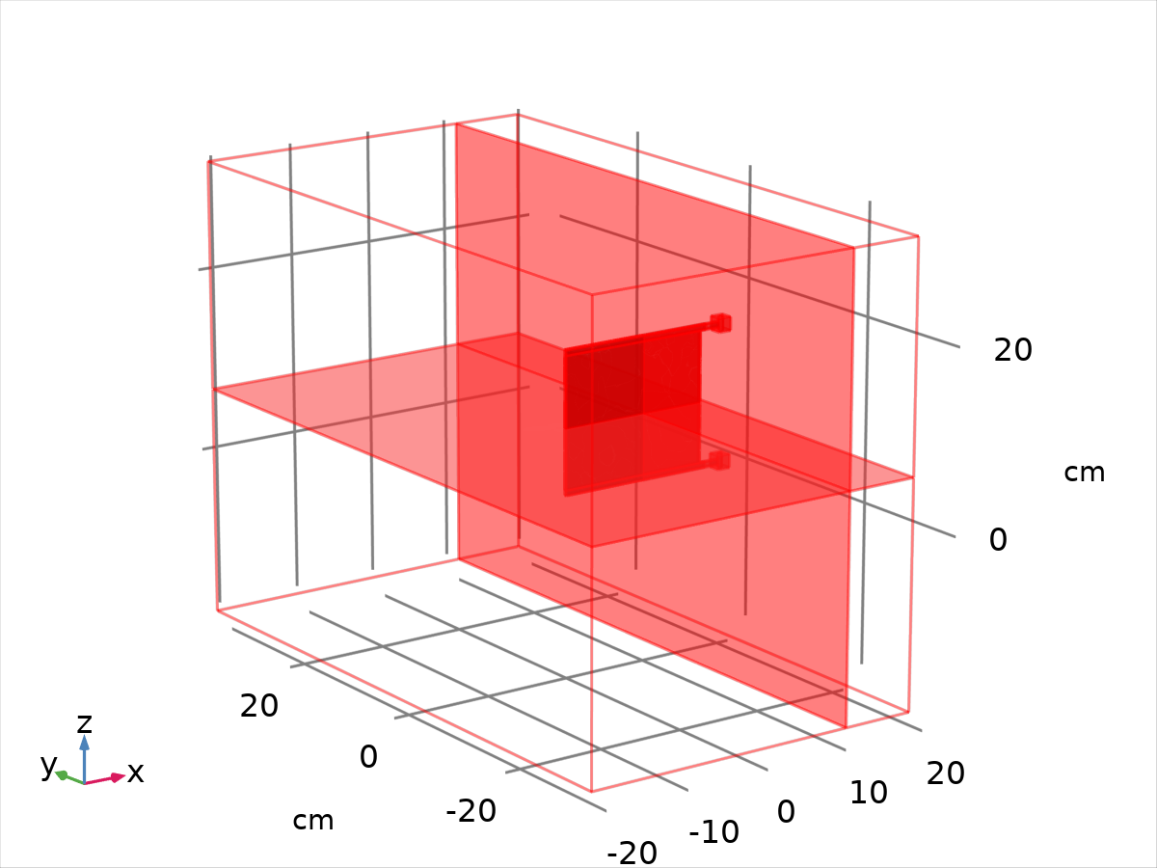
Dataset: Study 1/Solution 1
    - Exterior Walls
Data
Description | Value
Dataset

Parameterization
Description | Value
x- and y-axes | Surface parameters

    - Probe Solution 2
Solution
Description | Value
Solution
Component | Save Point Geometry 1

Dataset: Probe Solution 2
    - Study 1/Refined Mesh Solution 1
Solution
Description | Value
Solution
Component | Save Point Geometry 1

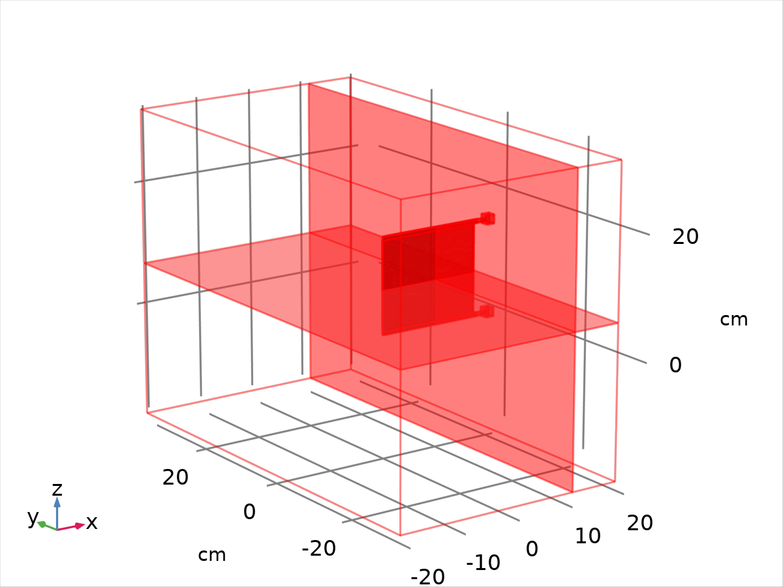
Dataset: Study 1/Refined Mesh Solution 1
  - Derived Values
    - Sway
Output
Evaluated in

Data
Description | Value
Dataset

Expressions
Expression | Unit | Description
spf.T_stressx | N | Total stress, x component
spf.T_stressy | N | Total stress, y component
spf.T_stressz | N | Total stress, z component

Expressions
Name | Value | Unit | Description
mbd.refpntx |  |  | Reference point for moment computation, x component
mbd.refpnty |  |  | Reference point for moment computation, y component
mbd.refpntz |  |  | Reference point for moment computation, z component

Integration settings
Description | Value
Integration order | 4

    - Global Variable Probe 1
Output
Evaluated in

Data
Description | Value
Dataset

Expressions
Expression | Unit | Description
-intop1(spf.T_stressx) | N | Fsway

Expressions
Name | Value | Unit | Description
mbd.refpntx |  |  | Reference point for moment computation, x component
mbd.refpnty |  |  | Reference point for moment computation, y component
mbd.refpntz |  |  | Reference point for moment computation, z component

    - Global Variable Probe 2
Output
Evaluated in

Data
Description | Value
Dataset

Expressions
Expression | Unit | Description
-intop1(spf.T_stressy) | N | Fheave

Expressions
Name | Value | Unit | Description
mbd.refpntx |  |  | Reference point for moment computation, x component
mbd.refpnty |  |  | Reference point for moment computation, y component
mbd.refpntz |  |  | Reference point for moment computation, z component

    - Global Variable Probe 3
Output
Evaluated in

Data
Description | Value
Dataset

Expressions
Expression | Unit | Description
-intop1(spf.T_stressz) | N | Fsurge

Expressions
Name | Value | Unit | Description
mbd.refpntx |  |  | Reference point for moment computation, x component
mbd.refpnty |  |  | Reference point for moment computation, y component
mbd.refpntz |  |  | Reference point for moment computation, z component

  - Tables
    - Probe Table 1
Time (s) | Fsway (N) | Fheave (N) | Fsurge (N)
0.0000 | 5.9091E-14 | -3.8621E-13 | -2.6871E-14
0.0040000 | -1.0610E-4 | 0.034788 | -8.5151E-6
0.0050962 | -7.5209E-4 | 0.13632 | -7.5618E-5
0.0061925 | -0.0014086 | 0.28995 | -1.4088E-4
0.0071791 | -0.0022107 | 0.50623 | -2.1943E-4
0.0080072 | -0.0031188 | 0.76068 | -3.0758E-4
0.0087525 | -0.0040502 | 1.0493 | -3.9469E-4
0.0094233 | -0.0050064 | 1.3648 | -4.8270E-4
0.010094 | -0.0060051 | 1.7311 | -5.7169E-4
0.010765 | -0.0071066 | 2.1558 | -6.6788E-4
0.012106 | -0.010492 | 3.2598 | -9.7357E-4
0.013448 | -0.013802 | 4.5817 | -0.0012285
0.014789 | -0.017675 | 6.1758 | -0.0014851
0.016131 | -0.022544 | 8.0206 | -0.0017530
0.017473 | -0.028677 | 10.068 | -0.0020018
0.018814 | -0.036557 | 12.268 | -0.0022231
0.021497 | -0.059567 | 16.717 | -0.0025309
0.024180 | -0.099057 | 21.111 | -0.0028057
0.026863 | -0.16027 | 25.072 | -0.0028969
0.029547 | -0.24816 | 28.343 | -0.0028228
0.032230 | -0.36510 | 30.781 | -0.0026428
0.034913 | -0.51029 | 32.369 | -0.0024358
0.037596 | -0.68000 | 33.193 | -0.0022671
0.042962 | -1.0769 | 33.601 | -0.0024120
0.048328 | -1.5238 | 32.605 | -0.0027529
0.053694 | -1.9188 | 29.736 | -0.0029098
0.059061 | -2.0936 | 24.107 | -0.0027758
0.064427 | -1.8553 | 15.438 | -0.0024016
0.069793 | -1.0943 | 4.5025 | -0.0019391
0.075159 | 0.10663 | -6.9103 | -0.0014670
0.080525 | 1.4638 | -16.650 | -0.0010685
0.085355 | 2.5212 | -22.593 | -6.9867E-4
0.089702 | 3.0468 | -24.450 | -3.3141E-4
0.093614 | 2.9865 | -22.631 | -3.0578E-4
0.097134 | 2.4138 | -17.952 | -6.6757E-4
0.10066 | 1.3249 | -10.436 | -0.0011869
0.10418 | -0.098585 | -1.3212 | -0.0010957
0.10770 | -1.2576 | 5.7502 | 5.3008E-4
0.11087 | -1.7580 | 8.5919 | 0.0022287
0.11372 | -1.6523 | 7.8037 | 0.0035558
0.11657 | -1.0854 | 4.4432 | 0.0044652
0.11942 | -0.26008 | -0.18897 | 0.0046543
0.12227 | 0.56544 | -4.6153 | 0.0041449
0.12512 | 1.1630 | -7.6509 | 0.0032418
0.12798 | 1.4030 | -8.7157 | 0.0021729
0.13083 | 1.2573 | -7.7805 | 0.0010546
0.13368 | 0.82720 | -5.4576 | 2.5208E-4
0.13653 | 0.27515 | -2.6104 | 2.7397E-5
0.13938 | -0.21835 | -0.13874 | 3.4297E-4
0.14224 | -0.51630 | 1.3155 | 9.6326E-4
0.14509 | -0.55247 | 1.4827 | 0.0016252
0.14794 | -0.34381 | 0.50046 | 0.0021464
0.15079 | 0.028203 | -1.2047 | 0.0024015
0.15364 | 0.44592 | -3.0683 | 0.0023532
0.15649 | 0.79568 | -4.5757 | 0.0020752
0.15935 | 0.99772 | -5.3903 | 0.0016631
0.16220 | 1.0254 | -5.4237 | 0.0012093
0.16505 | 0.90207 | -4.8058 | 8.2970E-4
0.16790 | 0.69259 | -3.8358 | 6.4864E-4
0.17075 | 0.47577 | -2.8576 | 6.9666E-4
0.17361 | 0.32138 | -2.1633 | 9.1958E-4
0.17646 | 0.27312 | -1.9257 | 0.0012128
0.17931 | 0.33683 | -2.1552 | 0.0014774
0.18216 | 0.48833 | -2.7399 | 0.0016494
0.18501 | 0.68159 | -3.4841 | 0.0017017
0.19072 | 0.97345 | -4.5622 | 0.0015588
0.19563 | 1.0729 | -4.8689 | 0.0013311
0.20053 | 1.0318 | -4.6275 | 0.0011633
0.20544 | 0.93613 | -4.1872 | 0.0011617
0.21035 | 0.88284 | -3.9230 | 0.0013092
0.21526 | 0.91610 | -3.9965 | 0.0014964
0.22017 | 1.0190 | -4.3364 | 0.0016224
0.22508 | 1.1368 | -4.7328 | 0.0016567
0.23490 | 1.2581 | -5.1089 | 0.0016575
0.23899 | 1.0728 | -4.4024 | 0.0014518
0.24308 | 1.0409 | -4.2644 | 0.0016745
0.24717 | 1.0980 | -4.4594 | 0.0018358
0.25125 | 1.1899 | -4.7868 | 0.0019203
0.25534 | 1.4554 | -5.7525 | 0.0021908
0.25943 | 1.6179 | -6.3529 | 0.0019405
0.26352 | 1.6392 | -6.4389 | 0.0017378
0.26761 | 1.3137 | -5.2481 | 0.0016049
0.27050 | 1.2264 | -4.9275 | 0.0019191
0.27340 | 1.1965 | -4.8251 | 0.0020849
0.27919 | 1.1194 | -4.5636 | 0.0022067
0.28498 | 1.2340 | -5.0280 | 0.0023678
0.29077 | 1.3329 | -5.4497 | 0.0023845
0.29656 | 1.3791 | -5.6869 | 0.0023613
0.30314 | 1.3433 | -5.6307 | 0.0023427
0.30972 | 1.3249 | -5.6538 | 0.0023867
0.31780 | 1.2535 | -5.5017 | 0.0024017
0.32587 | 1.2500 | -5.6437 | 0.0024432
0.33395 | 1.2352 | -5.7648 | 0.0024226
0.34377 | 1.1397 | -5.5974 | 0.0023666
0.35359 | 1.0987 | -5.6991 | 0.0023378
0.36341 | 1.0400 | -5.7510 | 0.0022489
0.37538 | 0.90397 | -5.5070 | 0.0020960
0.38736 | 0.81716 | -5.5508 | 0.0019508
0.39933 | 0.71009 | -5.5108 | 0.0017408
0.41130 | 0.58584 | -5.3746 | 0.0015138
0.43525 | 0.39235 | -5.7308 | 0.0010496
0.44973 | 0.13312 | -4.4373 | 5.7488E-4
0.46422 | -0.015725 | -3.8569 | 3.2049E-4
0.47870 | -0.12183 | -3.7274 | -1.0715E-4
0.49318 | -0.22373 | -3.3881 | -6.0333E-4
0.50766 | -0.30505 | -2.8369 | -0.0010310
0.52214 | -0.35792 | -2.3031 | -0.0014401
0.53662 | -0.38601 | -1.8242 | -0.0018207
0.55110 | -0.38658 | -1.3180 | -0.0021638
0.56558 | -0.35673 | -0.76997 | -0.0024440
0.58006 | -0.29756 | -0.20228 | -0.0026670
0.59454 | -0.21364 | 0.35623 | -0.0028313
0.60902 | -0.10428 | 0.92455 | -0.0029433
0.62350 | 0.021531 | 1.4652 | -0.0030015
0.63798 | 0.16592 | 2.0094 | -0.0030136
0.66694 | 0.43252 | 2.8559 | -0.0028682
0.69286 | 0.76616 | 3.8845 | -0.0027139
0.71879 | 0.99219 | 4.5159 | -0.0023497
0.74122 | 1.1554 | 5.0239 | -0.0019722
0.76366 | 1.2370 | 5.3587 | -0.0015196
0.78385 | 1.2736 | 5.6475 | -0.0011176
0.80404 | 1.2538 | 5.8520 | -8.8799E-4
0.82424 | 1.1797 | 5.9712 | -6.2426E-4
0.84443 | 1.0622 | 6.0301 | -4.1606E-4
0.86462 | 0.90524 | 6.0163 | -2.8612E-4
0.88481 | 0.71475 | 5.9125 | -2.3712E-4
0.90500 | 0.50340 | 5.7250 | -2.3253E-4
0.92520 | 0.28307 | 5.4518 | -2.5458E-4
0.94539 | 0.062950 | 5.0532 | -3.3700E-4
0.96558 | -0.13835 | 4.5666 | -4.1858E-4
0.98577 | -0.30830 | 3.9784 | -4.7464E-4
1.0060 | -0.43390 | 3.3318 | -4.4726E-4
1.0262 | -0.50714 | 2.6043 | -4.4164E-4
1.0440 | -0.52007 | 1.8796 | -3.8296E-4
1.0619 | -0.49491 | 1.2352 | -2.9203E-4
1.0798 | -0.42084 | 0.52183 | -1.7469E-4
1.0977 | -0.29720 | -0.24739 | -7.3148E-5
1.1155 | -0.14072 | -0.97645 | 2.4995E-5
1.1334 | 0.048771 | -1.7057 | 1.4861E-4
1.1513 | 0.24749 | -2.3537 | 3.2230E-4
1.1691 | 0.46134 | -2.9935 | 5.5482E-4
1.1870 | 0.67490 | -3.5930 | 8.2645E-4
1.2049 | 0.86371 | -4.0931 | 0.0011374
1.2228 | 1.0310 | -4.5437 | 0.0014946
1.2406 | 1.1763 | -4.9704 | 0.0018707
1.2585 | 1.2616 | -5.2553 | 0.0022570
1.2764 | 1.3203 | -5.5368 | 0.0025887
1.2943 | 1.3336 | -5.7540 | 0.0029292
1.3121 | 1.3003 | -5.9009 | 0.0031431
1.3300 | 1.2237 | -5.9787 | 0.0032681
1.3479 | 1.1222 | -6.0526 | 0.0032071
1.3658 | 0.97574 | -6.0056 | 0.0030985
1.3836 | 0.80957 | -5.9237 | 0.0028662
1.4015 | 0.62405 | -5.7689 | 0.0025386
1.4194 | 0.42732 | -5.5356 | 0.0021196
1.4373 | 0.22958 | -5.2273 | 0.0016179
1.4551 | 0.039640 | -4.8338 | 0.0010335
1.4730 | -0.13086 | -4.3824 | 3.9576E-4
1.4909 | -0.27513 | -3.8173 | -2.8304E-4
1.5087 | -0.38197 | -3.2259 | -9.1059E-4
1.5266 | -0.45037 | -2.6374 | -0.0015503
1.5427 | -0.46857 | -1.9611 | -0.0020563
1.5588 | -0.45733 | -1.3809 | -0.0024694
1.5749 | -0.40906 | -0.76052 | -0.0028138
1.5910 | -0.32173 | -0.093495 | -0.0030772
1.6071 | -0.20156 | 0.57847 | -0.0032627
1.6231 | -0.058263 | 1.2195 | -0.0033686
1.6392 | 0.10477 | 1.8418 | -0.0034086
1.6553 | 0.28280 | 2.4487 | -0.0033829
1.6714 | 0.45862 | 2.9918 | -0.0032984
1.6875 | 0.63362 | 3.5077 | -0.0031601
1.7036 | 0.80012 | 3.9903 | -0.0029680
1.7197 | 0.94441 | 4.4107 | -0.0027171
1.7357 | 1.0620 | 4.7738 | -0.0024265
1.7518 | 1.1539 | 5.0999 | -0.0020936
1.7679 | 1.2144 | 5.3796 | -0.0017359
1.7840 | 1.2386 | 5.6019 | -0.0014527
1.8001 | 1.2279 | 5.7737 | -0.0012436
1.8162 | 1.1861 | 5.9074 | -9.9767E-4
1.8323 | 1.1129 | 5.9941 | -7.9441E-4
1.8483 | 1.0121 | 6.0369 | -6.2969E-4
1.8644 | 0.88615 | 6.0302 | -5.0913E-4
1.8805 | 0.73960 | 5.9715 | -4.3710E-4
1.8966 | 0.57772 | 5.8598 | -4.0443E-4
1.9127 | 0.40498 | 5.6843 | -3.8875E-4
1.9288 | 0.22850 | 5.4463 | -3.9291E-4
1.9449 | 0.054888 | 5.1411 | -4.2009E-4
1.9610 | -0.10833 | 4.7704 | -4.6331E-4
1.9770 | -0.25387 | 4.3400 | -4.9423E-4
1.9931 | -0.37513 | 3.8461 | -4.8534E-4
2.0092 | -0.46604 | 3.3063 | -4.3428E-4
2.0253 | -0.52308 | 2.7298 | -4.2322E-4
2.0414 | -0.54499 | 2.1405 | -3.6224E-4
2.0575 | -0.52907 | 1.5177 | -2.6625E-4
2.0736 | -0.47364 | 0.85832 | -1.5817E-4
2.0896 | -0.38057 | 0.18087 | -5.6614E-5
2.1057 | -0.25482 | -0.49277 | 3.4320E-5
2.1218 | -0.10327 | -1.1447 | 1.2936E-4
2.1379 | 0.074702 | -1.8037 | 2.5173E-4
2.1701 | 0.40634 | -2.8165 | 6.0318E-4
2.1978 | 0.80099 | -3.9746 | 0.0010494
2.2255 | 1.0563 | -4.6453 | 0.0015776
2.2496 | 1.2221 | -5.1330 | 0.0021195
2.2736 | 1.3130 | -5.5142 | 0.0025863
2.2929 | 1.3259 | -5.7328 | 0.0029567
2.3122 | 1.2948 | -5.9073 | 0.0031851
2.3315 | 1.2139 | -6.0073 | 0.0032886
2.3509 | 1.0932 | -6.0519 | 0.0032607
2.3702 | 0.93555 | -6.0243 | 0.0030996
2.3895 | 0.74638 | -5.9030 | 0.0028186
2.4088 | 0.54056 | -5.7123 | 0.0024256
2.4281 | 0.32692 | -5.4386 | 0.0019341
2.4474 | 0.11485 | -5.0564 | 0.0013455
2.4667 | -0.079077 | -4.6126 | 6.6458E-4
2.4860 | -0.24697 | -4.0453 | -6.7524E-5
2.5053 | -0.37451 | -3.4177 | -7.7515E-4
2.5246 | -0.45531 | -2.7358 | -0.0014674
2.5419 | -0.48226 | -2.0575 | -0.0020345
2.5593 | -0.47202 | -1.4306 | -0.0024972
2.5767 | -0.41660 | -0.74202 | -0.0028726
2.5940 | -0.31629 | -0.010783 | -0.0031553
2.6114 | -0.18471 | 0.68536 | -0.0033439
2.6288 | -0.015169 | 1.4162 | -0.0034482
2.6462 | 0.16327 | 2.0600 | -0.0034651
2.6635 | 0.35642 | 2.6892 | -0.0034156
2.6809 | 0.54952 | 3.2722 | -0.0032988
2.6983 | 0.73431 | 3.8098 | -0.0031148
2.7156 | 0.89844 | 4.2853 | -0.0028648
2.7330 | 1.0358 | 4.7042 | -0.0025637
2.7504 | 1.1393 | 5.0618 | -0.0022196
2.7678 | 1.2069 | 5.3676 | -0.0018284
2.7851 | 1.2334 | 5.6103 | -0.0015071
2.8025 | 1.2193 | 5.7954 | -0.0012796
2.8199 | 1.1679 | 5.9307 | -0.0010047
2.8372 | 1.0819 | 6.0173 | -7.8272E-4
2.8546 | 0.96336 | 6.0469 | -6.0838E-4
2.8720 | 0.81780 | 6.0196 | -4.8641E-4
2.8893 | 0.65054 | 5.9298 | -4.1975E-4
2.9067 | 0.46805 | 5.7717 | -3.8579E-4
2.9241 | 0.27796 | 5.5406 | -3.7311E-4
2.9415 | 0.088774 | 5.2335 | -3.8604E-4
2.9588 | -0.090382 | 4.8505 | -4.1593E-4
2.9762 | -0.25055 | 4.3899 | -4.4298E-4
2.9936 | -0.38267 | 3.8581 | -4.2651E-4
3.0000 | -0.42311 | 3.3761 | -3.2966E-4
3.0129 | -0.48515 | 3.1497 | -4.0036E-4
3.0244 | -0.52702 | 2.8367 | -3.5606E-4
3.0360 | -0.54790 | 2.3941 | -2.9758E-4
3.0476 | -0.54710 | 1.9149 | -2.3685E-4
3.0707 | -0.51537 | 1.1726 | -1.2756E-4
3.0915 | -0.37334 | 0.10138 | 2.8874E-5
3.1124 | -0.20039 | -0.76974 | 1.2505E-4
3.1332 | 0.010087 | -1.5888 | 2.7164E-4
3.1540 | 0.24160 | -2.3428 | 4.8416E-4
3.1748 | 0.51245 | -3.1694 | 7.4576E-4
3.1957 | 0.74055 | -3.7777 | 0.0010764
3.2165 | 0.95442 | -4.3536 | 0.0014672
3.2373 | 1.1268 | -4.8397 | 0.0019015
3.2581 | 1.2524 | -5.2565 | 0.0023328
3.2790 | 1.3150 | -5.5695 | 0.0026939
3.2998 | 1.3178 | -5.8019 | 0.0030781
3.3206 | 1.2631 | -5.9593 | 0.0032679
3.3415 | 1.1565 | -6.0458 | 0.0033120
3.3623 | 1.0014 | -6.0421 | 0.0032060
3.3831 | 0.81046 | -5.9594 | 0.0029463
3.4039 | 0.59330 | -5.7833 | 0.0025508
3.4248 | 0.36273 | -5.5058 | 0.0020368
3.4456 | 0.13312 | -5.1195 | 0.0014151
3.4664 | -0.079538 | -4.6261 | 6.8795E-4
3.4872 | -0.25976 | -4.0268 | -1.1447E-4
3.5081 | -0.39333 | -3.3452 | -8.8260E-4
3.5289 | -0.47185 | -2.6060 | -0.0016238
3.5474 | -0.48718 | -1.8588 | -0.0022108
3.5659 | -0.46146 | -1.1858 | -0.0026705
3.5844 | -0.38522 | -0.45014 | -0.0030359
3.6029 | -0.25947 | 0.33020 | -0.0032939
3.6214 | -0.099073 | 1.0814 | -0.0034454
3.6399 | 0.092765 | 1.8266 | -0.0035053
3.6584 | 0.28880 | 2.4774 | -0.0034725
3.6769 | 0.50119 | 3.1368 | -0.0033710
3.6954 | 0.70320 | 3.7294 | -0.0031927
3.7140 | 0.87797 | 4.2308 | -0.0029349
3.7325 | 1.0271 | 4.6832 | -0.0026222
3.7510 | 1.1400 | 5.0735 | -0.0022591
3.7695 | 1.2088 | 5.3922 | -0.0018414
3.7880 | 1.2318 | 5.6443 | -0.0015050
3.8065 | 1.2098 | 5.8343 | -0.0012545
3.8250 | 1.1455 | 5.9662 | -9.6289E-4
3.8435 | 1.0420 | 6.0387 | -7.3376E-4
3.8620 | 0.90406 | 6.0485 | -5.6192E-4
3.8805 | 0.73775 | 5.9912 | -4.5228E-4
3.8990 | 0.55015 | 5.8597 | -3.9439E-4
3.9175 | 0.34965 | 5.6463 | -3.6495E-4
3.9360 | 0.14641 | 5.3479 | -3.6446E-4
3.9545 | -0.048734 | 4.9637 | -3.8531E-4
3.9731 | -0.22481 | 4.4944 | -4.1019E-4
3.9916 | -0.37118 | 3.9377 | -3.9648E-4
4.0101 | -0.47809 | 3.3205 | -3.2533E-4

    - Table 2
Sway
Time (s) | Total stress, x component (N) | Total stress, y component (N) | Total stress, z component (N) | Total stress, x component (N) | Total stress, y component (N) | Total stress, z component (N)
0.0000 | 5.1071E-14 | -1.2343E-13 | 8.4338E-14 | 0.0000 | 0.0000 | 0.0000
0.10000 | -1.1700 | 9.4916 | -0.0083444 | 0.0000 | 0.0000 | 0.0000
0.20000 | -0.83680 | 3.8892 | -0.0046958 | 0.0000 | 0.0000 | 0.0000
0.30000 | -1.3452 | 5.5991 | -0.0069872 | 0.0000 | 0.0000 | 0.0000
0.40000 | -0.69821 | 5.4839 | -0.0061774 | 0.0000 | 0.0000 | 0.0000
0.50000 | 0.26706 | 3.0650 | -0.0018963 | 0.0000 | 0.0000 | 0.0000
0.60000 | 0.17444 | -0.57404 | 0.0027688 | 0.0000 | 0.0000 | 0.0000
0.70000 | -0.82482 | -4.0417 | 0.0042278 | 0.0000 | 0.0000 | 0.0000
0.80000 | -1.2603 | -5.8188 | 0.0034454 | 0.0000 | 0.0000 | 0.0000
0.90000 | -0.55639 | -5.7818 | 0.0027480 | 0.0000 | 0.0000 | 0.0000
1.0000 | 0.40280 | -3.5209 | 0.0013104 | 0.0000 | 0.0000 | 0.0000

  - Default Plots
    - Velocity (spf)
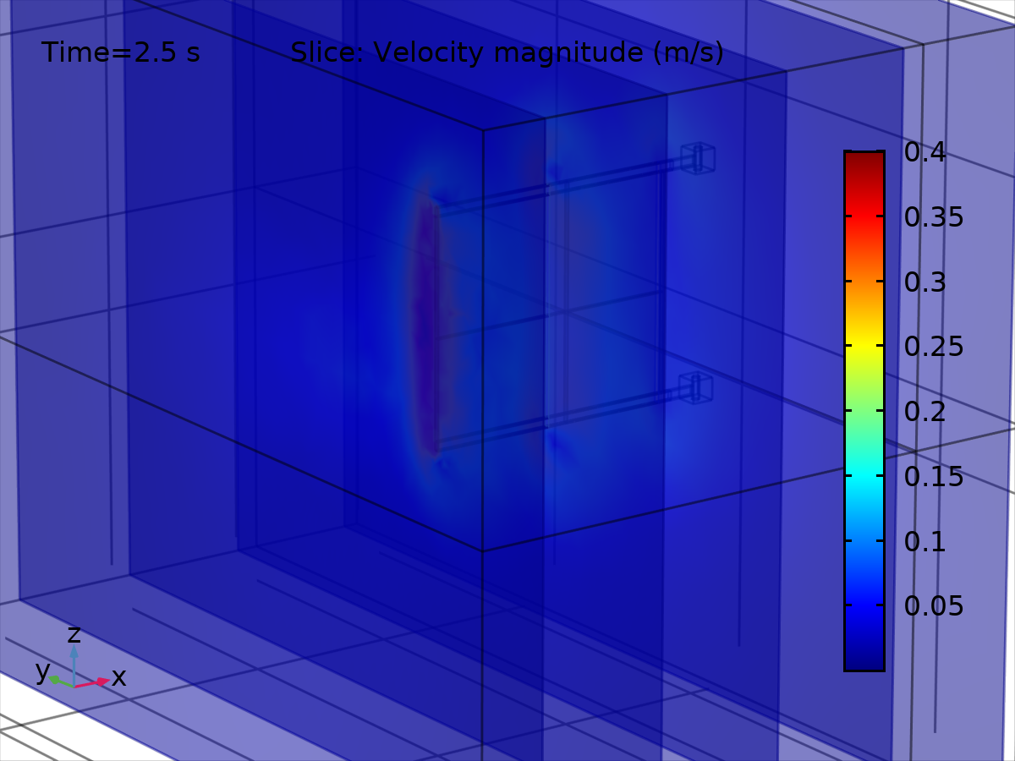
Slice: Velocity magnitude (m/s)
    - Pressure (spf)
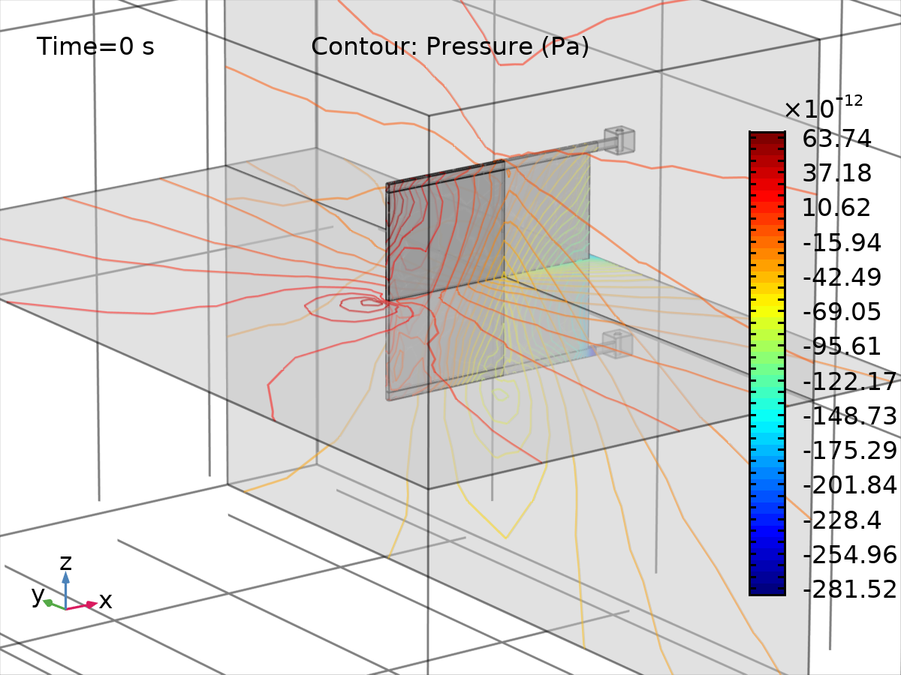
Contour: Pressure (Pa)
    - Displacement (mbd)
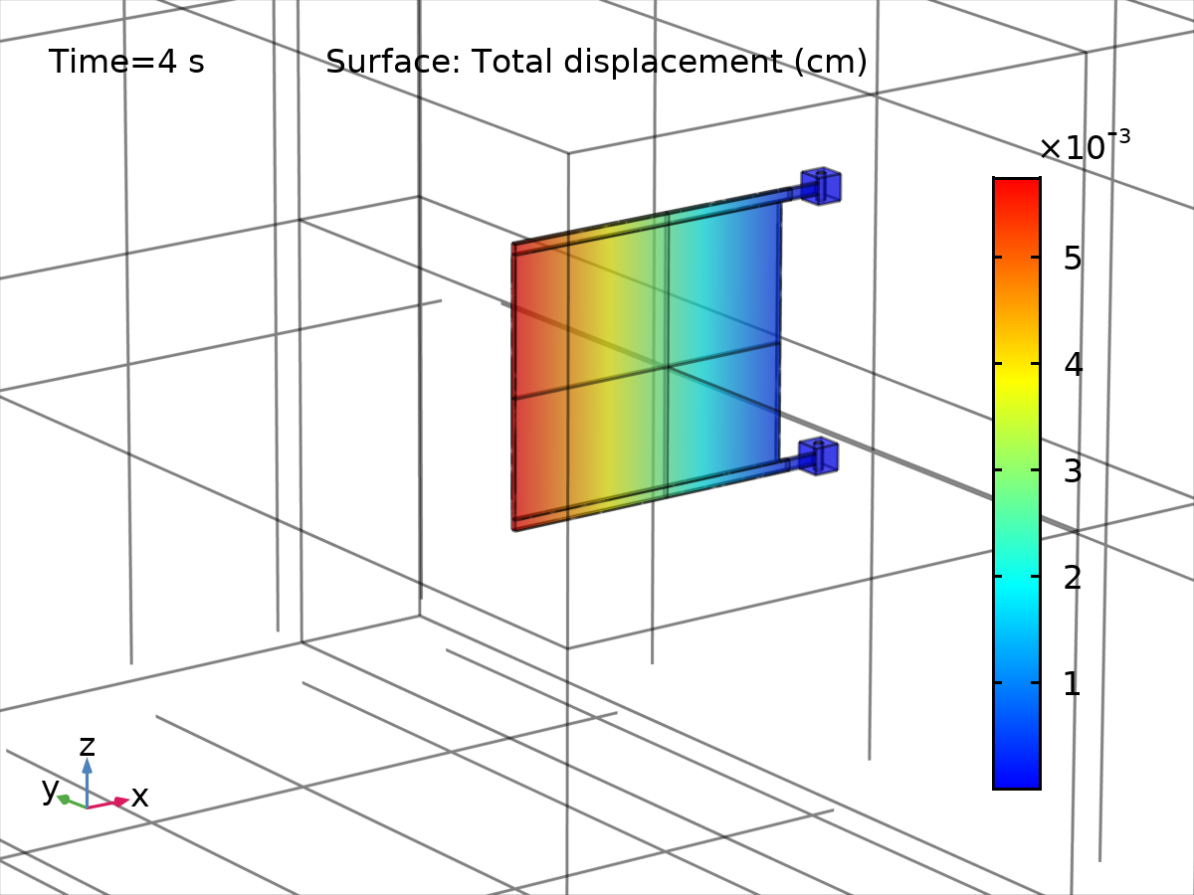
Surface: Total displacement (cm)
    - Velocity (mbd)
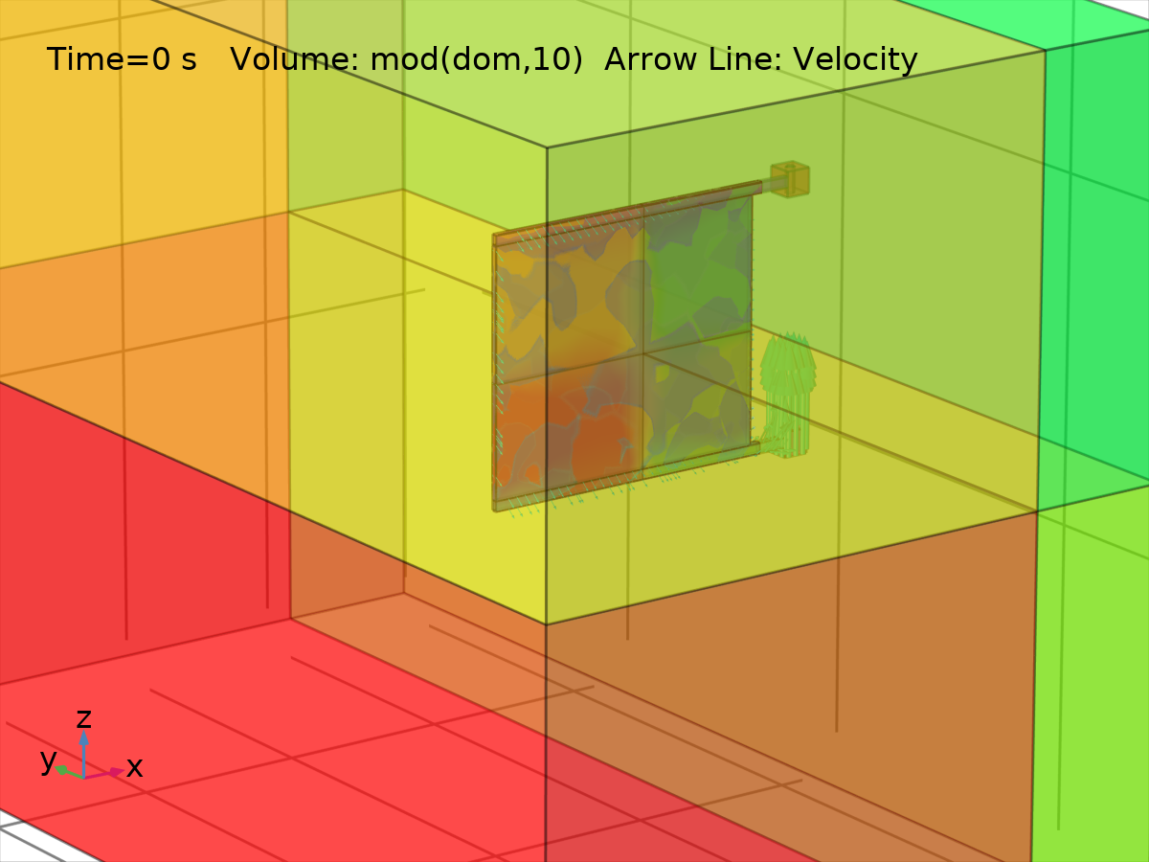
Volume: mod(dom,10) Arrow Line: Velocity
  - Plot Groups
    - Fluid Pressure (xy) & Solid Displacement
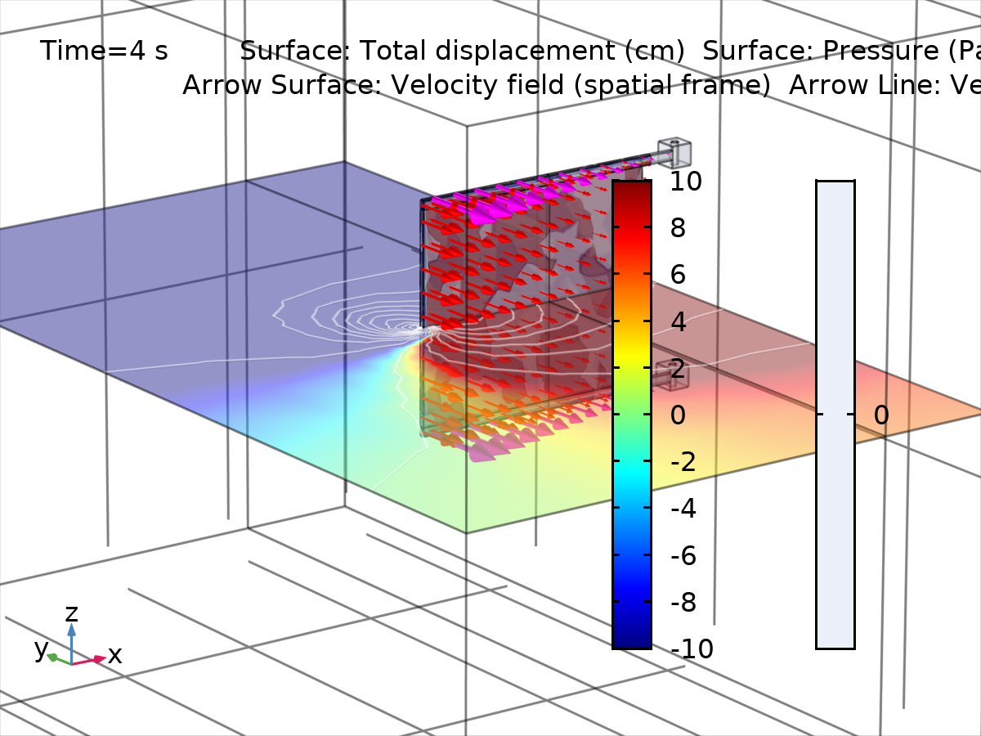
Surface: Total displacement (cm) Surface: Pressure (Pa) Arrow Surface: Velocity field (spatial frame) Arrow Line: Velocity
    - 3D Plot Group 5
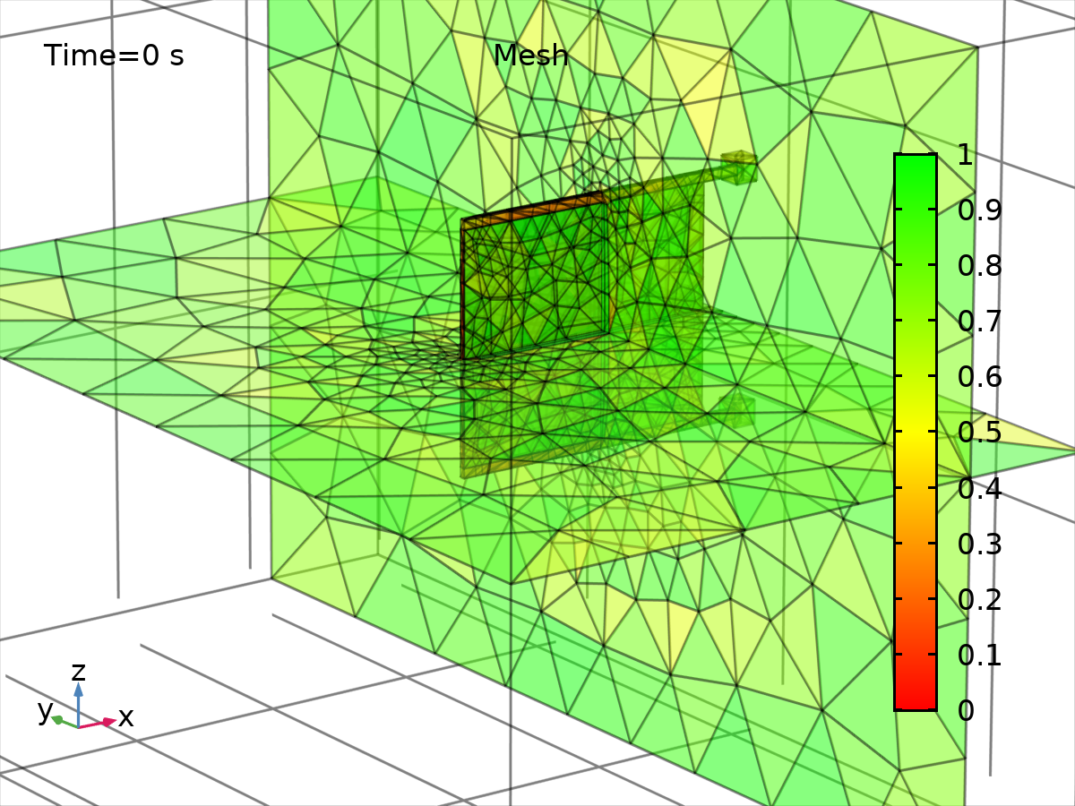
Mesh
    - Fluid Pressure (xz) & Solid Displacement 1
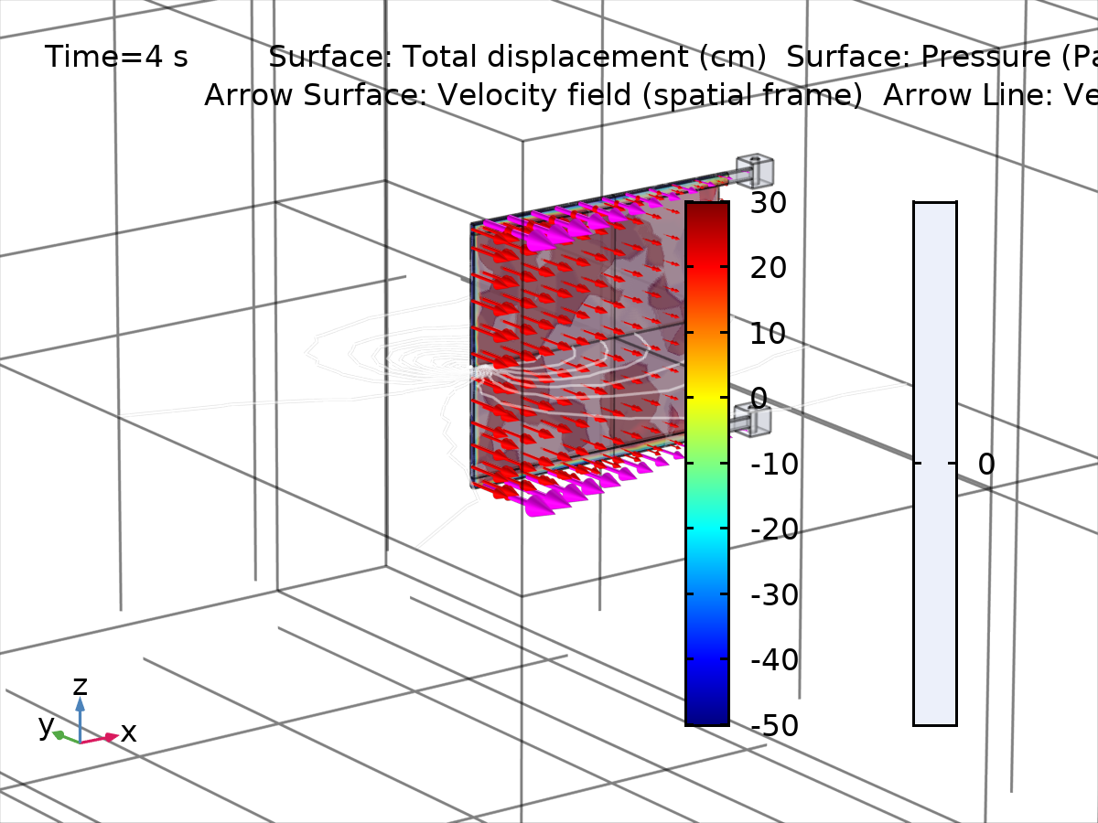
Surface: Total displacement (cm) Surface: Pressure (Pa) Arrow Surface: Velocity field (spatial frame) Arrow Line: Velocity
    - Deformed Mesh
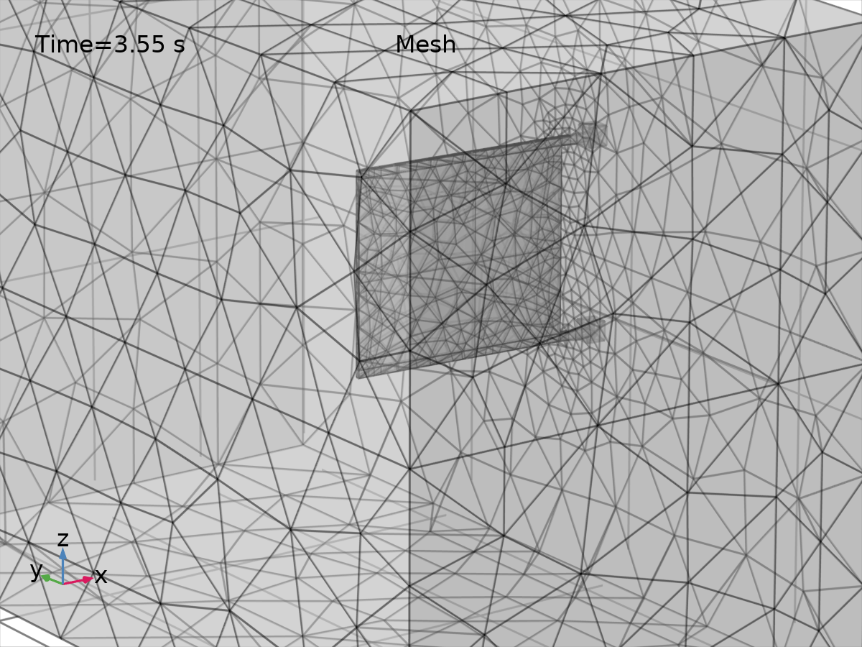
Mesh
    - Probe Plot Group 9
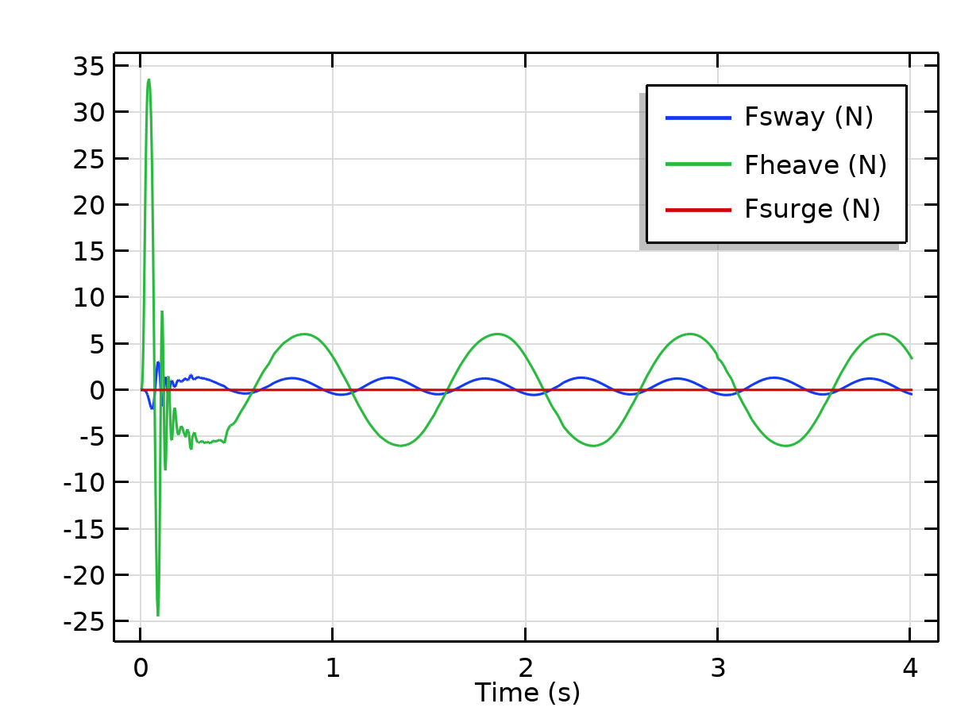
    - 1D Plot Group 10
